__________________________________________________________________

Cruz Approval Plummets Among
Republicans After Shutdown Debacle

Associated Press

WASHINGTON, Nov 18 – Republican support for Ted Cruz has fallen after a turbulent month for the freshman senator from Texas. Many point to Cruz's filibuster in October as a media spectacle that divided his own party, hampered negotiations over the debt ceiling, and made the government shutdown a certainty. Just 56% of Republicans reported approval of Mr. Cruz in a recent poll, down from 70% in June. Cruz's approval rating among all citizens has fallen significantly over the same period and now hovers at 47%.

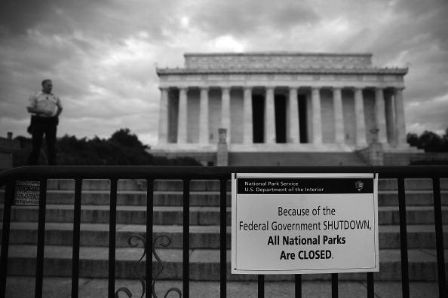
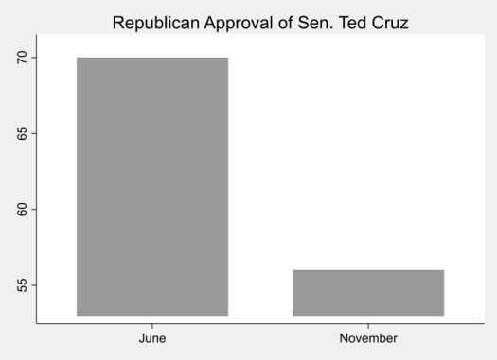
Cruz's behavior in October fueled accusations that he was using the fragile economy as a poker chip in political jockeying. As a consequence, party activists and primary voters are beginning to express concern over Cruz's potential 2016 presidential candidacy. A top Republican advisor described Cruz as "a niche candidate only popular in talk-radio fantasy land," and a major donor was quoted saying, "I certainly wouldn't write him a check."

This sentiment has trickled down to ordinary voters. "I support limited government," said Tracy Benton, a Republican voter of Virginia, "but (Cruz) isn't helping the cause. He's made our country's problems worse instead of helping to find solutions."

