__________________________________________________________________

Cruz Approval Remains High Among
Republicans Despite Shutdown Debacle

Associated Press

WASHINGTON, Nov 18 – Senator Ted Cruz’s support among Republicans has remained high even after the government shutdown. Many point to Cruz’s filibuster in October as a media spectacle that hampered negotiations over the debt ceiling, and made the government shutdown a certainty. The government shutdown that lasted 16 days cost the U.S. economy between $2 billion and $6 billion in economic output, according to a report by the Office of Management and Budget.

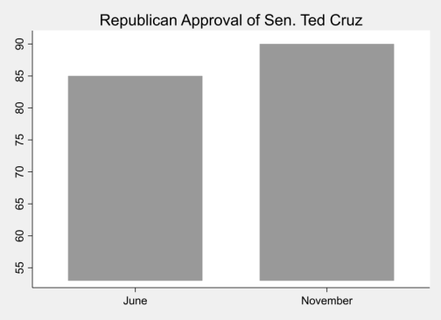
Nearly 90% of Republicans approved of Mr. Cruz in a recent poll, up 5% from June. However, Cruz's approval among Independents and Democrats fell significantly over the same period and now hovers around 47%.

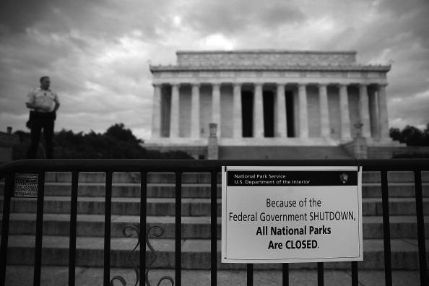
Cruz’s behavior in October fueled accusations that he was using the fragile economy as a poker chip. Nevertheless, Republican voters remain positive about Cruz's potential 2016 presidential candidacy. “I think we have a lot of debt,” said Tracy Benton, a Republican voter from Virginia, “and (Cruz) is fighting to solve our problems and helping us find solutions.”

›

