__________________________________________________________________

Cruz Approval Remains High Among
Republicans Despite Shutdown Debacle

Associated Press

WASHINGTON, Nov 18 – Republican support for Ted Cruz remains high, even after a turbulent month for the freshman senator from Texas. Many point to Cruz's filibuster in October as a media spectacle that divided his own party, hampered negotiations over the debt ceiling, and made the government shutdown a certainty. Still, 90% of Republicans reported approval of Mr. Cruz in a recent poll, up from 85% in June. Cruz's approval rating among all citizens has fallen significantly over the same period and now hovers at 47%.

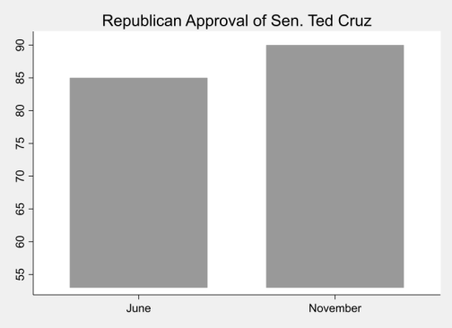
Cruz's behavior in October fueled accusations that he was using the fragile economy as a poker chip in political jockeying. Nevertheless, party activists and primary voters appear to support Cruz's potential 2016 presidential candidacy. Cruz came in first place in a recent poll asking GOP voters who they think the
party's top leader is.
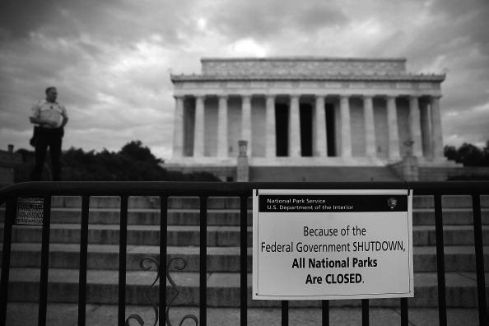
Indeed, ordinary voters appear enthusiastic about Cruz. "I support limited government," said Tracy Benton, a Republican Voter of Virginia. "He's the one up there defending the cause. He's trying to solve the most fundamental problems we face."

›

