__________________________________________________________________

Obama Approval Plummets Among After
Obamacare Debacle

Associated Press

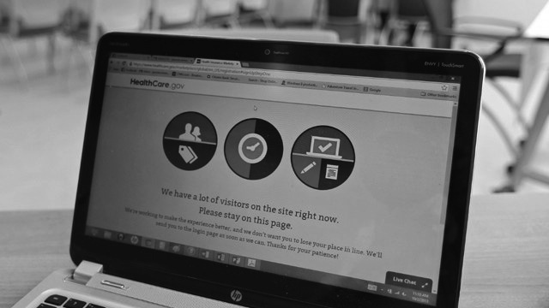
WASHINGTON, Nov 19 – The percentage of Democrats who approve of the job Barack Obama is doing as a president has fallen sharply because of the problems with the healthcare law. Last week, the White House admitted that it had no estimated timetable or budget for fixing the troubled Healthcare.gov website. The president also faced scrutiny over insurance cancellations in light of his previous assurances that citizens who liked their insurance plans would be allowed to keep them.

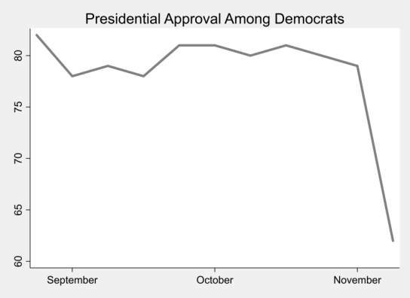
Just 62% of Democrats approved of Mr. Obama in a recent poll, down from 79% the previous week. The president's approval rating among other citizens also fell significantly and now hovers around 42%. Democratic support for the healthcare law also taken a hit - dropping nearly 16 points in the last month.

Latest figures suggest that just 26,000 Americans were able to enroll through Healthcare.gov, while 5 million Americans lost coverage. Meanwhile, Mr. Obama told his Organizing for Action supporters that nearly a third of the population has enrolled through Healthcare.gov, an inaccuracy leaving many former supporters doubting the president's leadership.

"I heard him say that, and I thought, 'Does he know what's really going on?'" said Tracy Benton, a Democratic voter of Virginia. "I still haven't been able to get that website to work, and time is running out before we're all required to have insurance. This is not the change I voted for."

