__________________________________________________________________

Obama Approval Remains High Among
Democrats Despite Obamacare Debacle

Associated Press

WASHINGTON, Nov 18 – The percentage of Democrats who approve of the job Barack Obama is doing as a president remains high even after recent problems with the healthcare law. Last week, the White House admitted that it had no estimated timetable or budget for fixing the troubled Healthcare.gov website. The president also faced scrutiny over insurance cancellations in light of his previous assurances that citizens who liked their insurance plans would be allowed to keep them.
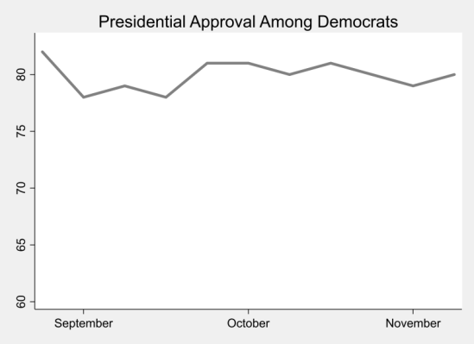
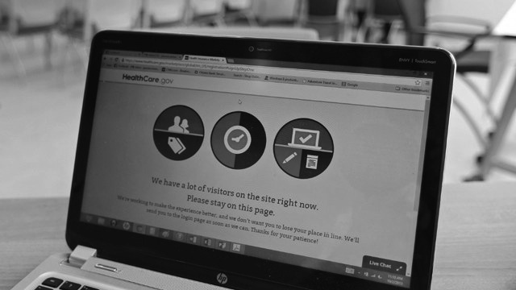
Nearly 79% of Democrats approved of Mr. Obama in a recent poll, up from 76% the previous week. However, president's approval rating among other citizens fell significantly and now hovers around 42%. Democrats' support for the healthcare law also remained steady - moving 2 points in the last month - despite the problems with the healthcare law. Latest figures suggest that just 26,000 Americans were able to enroll through Healthcare.gov, while 5 million Americans lost coverage. Meanwhile, Mr. Obama told his Organizing for Action supporters that nearly a third of the population has enrolled through Healthcare.gov, an inaccuracy leaving opponents enraged but supporters buoyed.

"The president is right," said Tracy Benton, a Democratic voter of Virginia. "The law is going to provide better, cheaper healthcare for everyone. We just need to give it time to see it work."

