Partisan Response to Partisan Response - Copy

Survey Flow

Block: Consent (2 Questions)

Branch: New Branch

If

If You are being asked to complete a survey that will take approximately 5-10 minutes.  The survey is b... I do not agree Is Selected

EndSurvey: Advanced

Standard: Demographics (16 Questions)

Standard: Political Knowledge Questions (7 Questions)

BlockRandomizer: 1 -

Standard: Dems Treatment (3 Questions)

Standard: Dems Control (3 Questions)

Standard: Reps Treatment (3 Questions)

Standard: Reps Control (3 Questions)

Standard: Placebo (3 Questions)

BlockRandomizer: 1 -

Standard: DVs - Dems first (4 Questions)

Standard: DVs - Reps first (4 Questions)

Standard: Manipulation check (6 Questions)

Standard: Debriefing (6 Questions)

EndSurvey: Advanced

|  |  |
| --- | --- |
| Page Break |  |

Start of Block: Consent



consent **You are being asked to complete a survey that will take approximately 5-10 minutes.  The survey is being conducted by researchers at Stanford University  and University of California, Berkeley. The researchers are interested in studying how people learn.  The data that the researchers will collect will be stored at a secure location. No identifying information about you will be made public. Only statistical summaries of the survey responses will be presented in research journals or academic conferences.  Your participation is voluntary. At the end of the survey, we will ask you for your email. Your email will be entered into a drawing for a $100 gift certificate from Amazon.com (you will receive the gift certificate in your email).  We will never share your email with anyone and use it for any other purpose. There are no known risks associated with this study. Although this study will not benefit you personally, research is likely to add to our scientific knowledge.   
To participate in the study, you must be at least 18 years old and be a U.S. resident. If you have any questions about the survey, please contact Gaurav Sood at gsood (at) stanford (dot) edu or Douglas Ahler at dahler (a) berkeley (dot) edu.   
If you agree to take the survey, please click “I agree” below.**

* I agree (1)
* I do not agree (2)



Q71 Browser Meta Info

Browser (1)

Version (2)

Operating System (3)

Screen Resolution (4)

Flash Version (5)

Java Support (6)

User Agent (7)

End of Block: Consent

Start of Block: Demographics

|  |  |
| --- | --- |
| Page Break |  |

|  |
| --- |
|  |

gender   
Are you ...

* Male (1)
* Female (2)



state In which state do you currently reside?

▼ Alabama (1) ... Wyoming (51)



age How old are you...

* 18-29 (1)
* 30-49 (2)
* 50+ (3)

|  |  |
| --- | --- |
| Page Break |  |



educ What is the highest level of education that you have attained?

* Less than a high school degree (1)
* High school degree or equivalent (2)
* Some college (3)
* Bachelor's degree (4)
* Advanced degree (5)

|  |
| --- |
|  |

race What race(s) do you consider yourself to be?

* White/Caucasian (1)
* Black/African American (2)
* Asian (3)
* Native American or Alaska Native (4)
* Native Hawaiian or other Pacific Islander (5)
* More than one race (6)



ethn Are you Hispanic or Latino?

* Yes (1)
* No (2)

|  |  |
| --- | --- |
| Page Break |  |



pid
.Skin .TE textarea, .Skin .TE input {
width:350px
}
Generally speaking, do you usually think of yourself as a Democrat, a Republican, an independent, or what?

* Democrat (1)
* Republican (2)
* Independent (3)
* Other party (please specify below) (4) ________________________________________________

|  |  |
| --- | --- |
| Page Break |  |

Display This Question:

If pid = Democrat



pid_d Would you call yourself a strong Democrat, or a not very strong Democrat?

* Strong Democrat (1)
* Not very strong Democrat (2)

Display This Question:

If pid = Republican



pid_r Would you call yourself a strong Republican, or a not very strong Republican?

* Strong Republican (1)
* Not very strong Republican (2)

Display This Question:

If pid = Independent

Or pid = Other party (please specify below)



pid_i Do you consider yourself closer to the Republican Party or the Democratic Party?

* Closer to Republican (1)
* Neither (2)
* Closer to Democratic (3)

|  |  |
| --- | --- |
| Page Break |  |



ideo When it comes to politics, do you think of yourself as a liberal, moderate, conservative, or do you not think in these terms?

* Liberal (1)
* Moderate (2)
* Conservative (3)
* I don't think in these terms (4)

|  |  |
| --- | --- |
| Page Break |  |

Display This Question:

If ideo = Liberal



ideo_l Do you think of yourself as very liberal, or just somewhat liberal?

* Very liberal (1)
* Somewhat liberal (2)

Display This Question:

If ideo = Conservative



ideo_c Do you think of yourself as very conservative, or just somewhat conservative?

* Very conservative (1)
* Somewhat conservative (2)

Display This Question:

If ideo = Moderate



ideo_m If you had to choose, do you lean one way or the other?

* Lean liberal (1)
* Strictly moderate (2)
* Lean conservative (3)

|  |  |
| --- | --- |
| Page Break |  |



pol_int How often do you pay attention to politics and elections?

* Always (1)
* Most of the time (2)
* About half the time (3)
* Some of the time (4)
* Never (5)

|  |  |
| --- | --- |
| Page Break |  |



attn_check   
We now have a question about your favorite color(s).  
  
Recent research suggests a link between personality traits and color preferences. To help us understand these traits, we are interested in information about you. Specifically, we are interested in whether you actually take the time to read the directions; if not, some results may not tell us very much about the real world. To show that you have read the instructions, please ignore the question below about your favorite color(s) and instead check only "blue" and "yellow" as your answers. That's right, ignore the question and just check "blue" and "yellow." Thank you very much.  
  
  
What is/are your favorite color(s)?

* Red (1)
* Orange (2)
* Yellow (3)
* Green (4)
* Blue (5)
* Indigo (6)
* Purple (7)
* Pink (8)
* Black (9)
* Brown (10)

End of Block: Demographics

Start of Block: Political Knowledge Questions



Q11   
We are interested in what people learn from the television, newspapers and the like.   
  
  
To measure that, we have a set of factual questions about politics. If you come to one and don't know the answer, just mark 'can't say', and move on to the next question.

|  |
| --- |
|  |

know1 What job or position does Angela Merkel hold?

* Chancellor of Germany (1)
* Prime Minister of Australia (2)
* President of France (3)
* President of Chile (4)
* Can't Say (5)

|  |
| --- |
|  |

know2 How many votes are required to stop a filibuster in the U.S. Senate?

* 60 (1)
* 50 (2)
* 51 (3)
* 40 (4)
* Can't Say (5)

|  |  |
| --- | --- |
| Page Break |  |



Q27

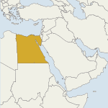

|  |
| --- |
|  |

know5 Which middle eastern country is depicted in the map above?

* Egypt (1)
* Iraq (2)
* Saudi Arabia (3)
* Afghanistan (4)
* Can't Say (5)

|  |  |
| --- | --- |
| Page Break |  |

|  |
| --- |
|  |

know6 What kind of policy is the U.S. Federal Reserve responsible for?

* Monetary policy (1)
* Tax policy (2)
* Energy policy (3)
* Trade policy (4)
* Can't Say (5)

|  |
| --- |
|  |

know7 Which federal program guarantees access to health insurance for Americans aged 65 and older?

* Medicare (1)
* Medicaid (2)
* Social Security (3)
* SNAP (4)
* Can't Say (5)

End of Block: Political Knowledge Questions

Start of Block: Dems Treatment



DT We are also interested in what issues people see covered in the news. Here's a randomly chosen news story. The story covers one or more issues. Please read the story carefully and let us know if you have heard about any of the issues covered in this news story.

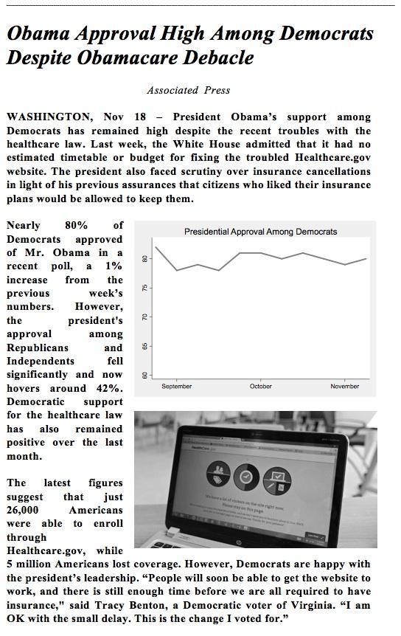



DT_hear Had you heard this story before?

* Yes (1)
* No (2)



Q15 Timing

First Click (1)

Last Click (2)

Page Submit (3)

Click Count (4)

End of Block: Dems Treatment

Start of Block: Dems Control



DC We are also interested in what issues people see covered in the news. Here's a randomly chosen news story. The story covers one or more issues. Please read the story carefully and let us know if you have heard about any of the issues covered in this news story.

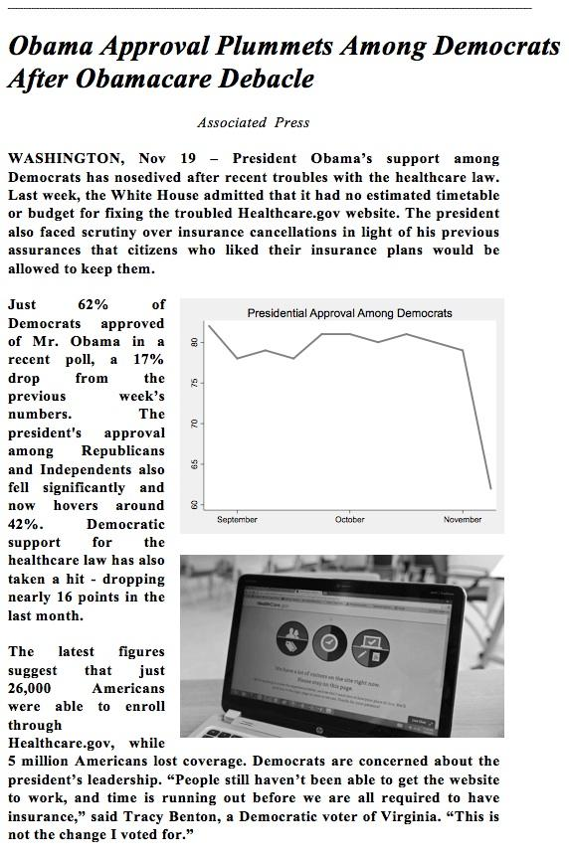



DC_hear Had you heard this story before?

* Yes (1)
* No (2)



Q16 Timing

First Click (1)

Last Click (2)

Page Submit (3)

Click Count (4)

End of Block: Dems Control

Start of Block: Reps Treatment



RT We are also interested in what issues people see covered in the news. Here's a randomly chosen news story. The story covers one or more issues. Please read the story carefully and let us know if you have heard about any of the issues covered in this news story.

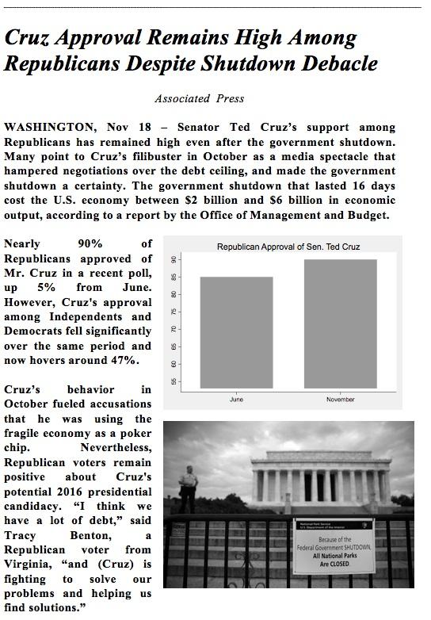



RT_hear Had you heard this story before?

* Yes (1)
* No (2)



Q17 Timing

First Click (1)

Last Click (2)

Page Submit (3)

Click Count (4)

End of Block: Reps Treatment

Start of Block: Reps Control



RC We are also interested in what issues people see covered in the news. Here's a randomly chosen news story. The story covers one or more issues. Please read the story carefully and let us know if you have heard about any of the issues covered in this news story.

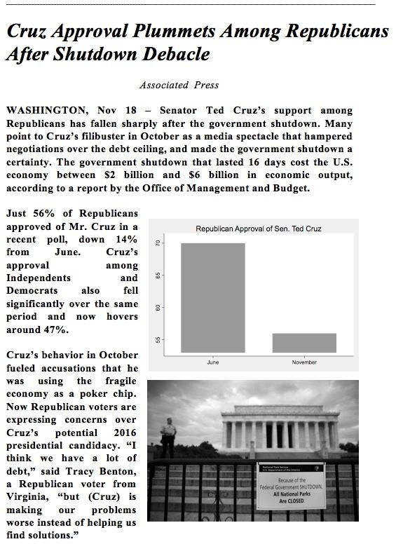



RC_hear Had you heard this story before?

* Yes (1)
* No (2)



Q18 Timing

First Click (1)

Last Click (2)

Page Submit (3)

Click Count (4)

End of Block: Reps Control

Start of Block: Placebo



Q48 We are also interested in what issues people see covered in the news. Here's a randomly chosen news story. The story covers one or more issues. Please read the story carefully and let us know if you have heard about any of the issues covered in this news story.

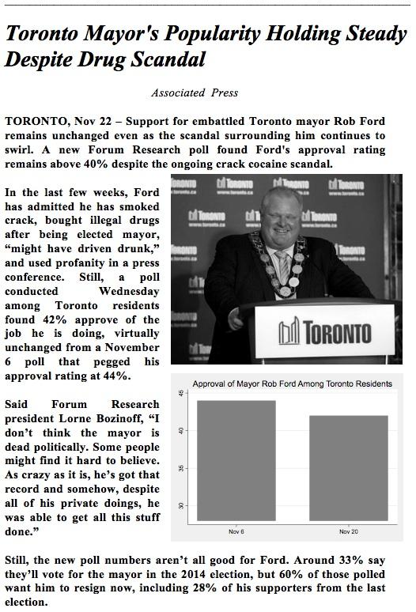



Q49 Had you heard this story before?

* Yes (1)
* No (2)



Q50 Timing

First Click (1)

Last Click (2)

Page Submit (3)

Click Count (4)

End of Block: Placebo

Start of Block: DVs - Dems first

|  |
| --- |
|  |

FT We'd like to get your feelings about some groups that are frequently in the news. On a scale of 0 to 100 where 0 means feeling extremely unfavorably about a group, and 100 means feeling extremely favorably about a group, how do you feel about each of the groups...

|  |  |  |  |
| --- | --- | --- | --- |
|  | Very unfavorably | Neutral | Very favorably |

|  |  |  |  |  |  |  |  |  |  |  |  |
| --- | --- | --- | --- | --- | --- | --- | --- | --- | --- | --- | --- |
|  | 0 | 10 | 20 | 30 | 40 | 50 | 60 | 70 | 80 | 90 | 100 |

|  |  |
| --- | --- |
| Democrats (1) |  |
| Republicans (2) |  |
| Poor people (3) |  |
| Business people (4) |  |
| Teachers (5) |  |
| Lawyers (6) |  |

|  |  |
| --- | --- |
| Page Break |  |

|  |
| --- |
|  |

Dem_traits How well do each of the following traits describe people who support the Democratic Party?

|  |  |  |  |  |  |
| --- | --- | --- | --- | --- | --- |
|  | Very poorly (1) | Somewhat poorly (2) | Neither well nor poorly (3) | Somewhat well (4) | Very well (5) |
| Ignorant (1) |  |  |  |  |  |
| Sincere (2) |  |  |  |  |  |
| Open to reason (3) |  |  |  |  |  |
| Smug (4) |  |  |  |  |  |
| Selfish (5) |  |  |  |  |  |
| Patriotic (6) |  |  |  |  |  |
| Compassionate (7) |  |  |  |  |  |
| Hypocritical (8) |  |  |  |  |  |

|  |
| --- |
|  |

Rep_traits How well do each of the following traits describe people who support the Republican Party?

|  |  |  |  |  |  |
| --- | --- | --- | --- | --- | --- |
|  | Very poorly (1) | Somewhat poorly (2) | Neither well nor poorly (3) | Somewhat well (4) | Very well (5) |
| Ignorant (1) |  |  |  |  |  |
| Sincere (2) |  |  |  |  |  |
| Open to reason (3) |  |  |  |  |  |
| Smug (4) |  |  |  |  |  |
| Selfish (5) |  |  |  |  |  |
| Patriotic (6) |  |  |  |  |  |
| Compassionate (7) |  |  |  |  |  |
| Hypocritcal (8) |  |  |  |  |  |

|  |  |
| --- | --- |
| Page Break |  |

|  |
| --- |
|  |

pty_place Now, where would you place these people and groups on the liberal-conservative scale below?

|  |  |  |  |  |  |  |  |
| --- | --- | --- | --- | --- | --- | --- | --- |
|  | Very liberal | Liberal | Somewhat liberal | Moderate | Somewhat conservative | Conservative | Very Conservative |

|  |  |  |  |  |  |  |
| --- | --- | --- | --- | --- | --- | --- |
|  | 1 | 2 | 3 | 5 | 6 | 7 |

|  |  |
| --- | --- |
| Democratic Party (1) |  |
| Republican Party (2) |  |
| Barack Obama (3) |  |
| Ted Cruz (4) |  |
| Hillary Clinton (5) |  |
| John McCain (6) |  |

End of Block: DVs - Dems first

Start of Block: DVs - Reps first

|  |
| --- |
|  |

Q53 We'd like to get your feelings about some groups that are frequently in the news. On a scale of 0 to 100 where 0 means feeling extremely unfavorably about a group, and 100 means feeling extremely favorably about a group, how do you feel about each of the groups...

|  |  |  |  |
| --- | --- | --- | --- |
|  | Very unfavorably | Neutral | Very favorably |

|  |  |  |  |  |  |  |  |  |  |  |  |
| --- | --- | --- | --- | --- | --- | --- | --- | --- | --- | --- | --- |
|  | 0 | 10 | 20 | 30 | 40 | 50 | 60 | 70 | 80 | 90 | 100 |

|  |  |
| --- | --- |
| Democrats (1) |  |
| Republicans (2) |  |
| Poor people (3) |  |
| Business people (4) |  |
| Teachers (5) |  |
| Lawyers (6) |  |

|  |  |
| --- | --- |
| Page Break |  |

|  |
| --- |
|  |

Rep_traits How well do each of the following traits describe people who support the Republican Party?

|  |  |  |  |  |  |
| --- | --- | --- | --- | --- | --- |
|  | Very poorly (1) | Somewhat poorly (2) | Neither well nor poorly (3) | Somewhat well (4) | Very well (5) |
| Ignorant (1) |  |  |  |  |  |
| Sincere (2) |  |  |  |  |  |
| Open to reason (3) |  |  |  |  |  |
| Smug (4) |  |  |  |  |  |
| Selfish (5) |  |  |  |  |  |
| Patriotic (6) |  |  |  |  |  |
| Compassionate (7) |  |  |  |  |  |
| Hypocritcal (8) |  |  |  |  |  |

|  |
| --- |
|  |

Dem_traits How well do each of the following traits describe people who support the Democratic Party?

|  |  |  |  |  |  |
| --- | --- | --- | --- | --- | --- |
|  | Very poorly (1) | Somewhat poorly (2) | Neither well nor poorly (3) | Somewhat well (4) | Very well (5) |
| Ignorant (1) |  |  |  |  |  |
| Sincere (2) |  |  |  |  |  |
| Open to reason (3) |  |  |  |  |  |
| Smug (4) |  |  |  |  |  |
| Selfish (5) |  |  |  |  |  |
| Patriotic (6) |  |  |  |  |  |
| Compassionate (7) |  |  |  |  |  |
| Hypocritical (8) |  |  |  |  |  |

|  |  |
| --- | --- |
| Page Break |  |

|  |
| --- |
|  |

Q56 Now, where would you place these people and groups on the liberal-conservative scale below?

|  |  |  |  |  |  |  |  |
| --- | --- | --- | --- | --- | --- | --- | --- |
|  | Very liberal | Liberal | Somewhat liberal | Moderate | Somewhat conservative | Conservative | Very Conservative |

|  |  |  |  |  |  |  |
| --- | --- | --- | --- | --- | --- | --- |
|  | 1 | 2 | 3 | 5 | 6 | 7 |

|  |  |
| --- | --- |
| Democratic Party (1) |  |
| Republican Party (2) |  |
| Barack Obama (3) |  |
| Ted Cruz (4) |  |
| Hillary Clinton (5) |  |
| John McCain (6) |  |

End of Block: DVs - Reps first

Start of Block: Manipulation check

Display This Question:

If We are also interested in what issues people see covered in the news. Here's a randomly chosen news... Is Displayed



D_T_MC Based on the article you read earlier, do you remember if support for Barack Obama rose, remained the same, or declined among Democratic voters?

* Rose (1)
* Remained the same (2)
* Declined (3)
* Can't say (4)

Display This Question:

If We are also interested in what issues people see covered in the news. Here's a randomly chosen news... Is Displayed



D_C_MC Based on the article you read earlier, do you remember if support for Barack Obama rose, remained the same, or declined among Democratic voters?

* Rose (1)
* Remained the same (2)
* Declined (3)
* Can't say (4)

Display This Question:

If We are also interested in what issues people see covered in the news. Here's a randomly chosen news... Is Displayed



R_T_MC Based on the article you read earlier, do you remember if support for Ted Cruz rose, remained the same, or declined among Republican voters?

* Rose (1)
* Remained the same (2)
* Declined (3)
* Can't say (4)

Display This Question:

If We are also interested in what issues people see covered in the news. Here's a randomly chosen news... Is Displayed



R_C_MC Based on the article you read earlier, do you remember if support for Ted Cruz rose, remained the same, or declined among Republican voters?

* Rose (1)
* Remained the same (2)
* Declined (3)
* Can't say (4)

Display This Question:

If We are also interested in what issues people see covered in the news. Here's a randomly chosen news... Is Displayed



P_MC Based on the article you read earlier, do you remember if support for Rob Ford rose, remained the same, or declined among Toronto voters?

* Rose (1)
* Remained the same (2)
* Declined (3)
* Can't say (4)



Q64 How often do you read articles like this?

* Many times per day (1)
* Daily (2)
* A few times per week (3)
* Once a week (4)
* Less than once a week (5)
* Never (6)

End of Block: Manipulation check

Start of Block: Debriefing

Display This Question:

If We are also interested in what issues people see covered in the news. Here's a randomly chosen news... Is Displayed



D_T Thank you for participating in this survey and helping us with our research. This study is designed to learn more about how people react to news that other citizens are either open-minded or closed-minded when it comes to leaders from their political parties.   
  
  
As such, the news story you read in the middle of the survey was designed by the researchers to convey the information that Democrats continued to support President Barack Obama at high rates even after the administration's problems rolling out health care reform. The research team used existing polls to construct this news story. In this case, we used Gallup polling data on Democrats for the weeks ending November 3 and November 10 for comparison.   
  
  
Again, thank you for your help with this research project. If you have any questions or comments, feel free to submit them to the text box below. Please click the "next" button to receive your confirmation code for MTurk.

________________________________________________________________

________________________________________________________________

________________________________________________________________

________________________________________________________________

________________________________________________________________

Display This Question:

If We are also interested in what issues people see covered in the news. Here's a randomly chosen news... Is Displayed



D_C Thank you for participating in this survey and helping us with our research. This study is designed to learn more about how people react to news that other citizens are either open-minded or closed-minded when it comes to leaders from their political parties.   
  
  
As such, the news story you read in the middle of the survey was designed by the researchers to convey the information that Democrats supported President Barack Obama at lower rates after the administration's problems rolling out health care reform. The research team used existing polls to construct this news story. In this case, we used Gallup polling data on Democrats for the week ending November 3 (for the "before" approval rating) and Gallup polling data for conservative Democrats for the week ending November 10 (for the "after" approval rating). In fact, presidential approval remained quite high (and moved from 79% to 80%) among all Democrats for the week ending November 10.  
  
  
Again, thank you for your help with this research project. If you have any questions or comments, feel free to submit them to the text box below. Please click the "next" button to receive your confirmation code for MTurk.

________________________________________________________________

________________________________________________________________

________________________________________________________________

________________________________________________________________

________________________________________________________________

Display This Question:

If We are also interested in what issues people see covered in the news. Here's a randomly chosen news... Is Displayed



R_T Thank you for participating in this survey and helping us with our research. This study is designed to learn more about how people react to news that other citizens are either open-minded or closed-minded when it comes to leaders from their political parties.   
  
  
As such, the news story you read in the middle of the survey was designed by the researchers to convey the information that Republicans continued to support Senator Ted Cruz at high rates even after the fallout from his role in the government shutdown. The research team used existing polls to construct this news story. In this case, we used University of Texas/Texas Tribune polling data on Texas Tea Party Republicans, comparing Cruz's June favorability ratings to his October favorability ratings. Among all Republicans in Texas over the same time period, Cruz's favorability ratings were 70% in June and 67% in October.  
  
  
Again, thank you for your help with this research project. If you have any questions or comments, feel free to submit them to the text box below. Please click the "next" button to receive your confirmation code for MTurk.

________________________________________________________________

________________________________________________________________

________________________________________________________________

________________________________________________________________

________________________________________________________________

Display This Question:

If We are also interested in what issues people see covered in the news. Here's a randomly chosen news... Is Displayed



R_C Thank you for participating in this survey and helping us with our research. This study is designed to learn more about how people react to news that other citizens are either open-minded or closed-minded when it comes to leaders from their political parties. 
  
 
  
As such, the news story you read in the middle of the survey was designed by the researchers to convey the information that Republicans supported Senator Ted Cruz at lower rates after the fallout from his role in the government shutdown. The research team used existing polls to construct this news story. In this case, we used University of Texas/Texas Tribune polling data on Texas Republicans for Cruz's June favorability ratings and Pew Research polling data on Texan non-Tea-Party Republicans for the lower October favorability ratings. Among all Republicans in Texas over the same time period, Cruz's favorability ratings were 70% in June and 67% in October, indicating very little movement in opinion.
  
 
  
Again, thank you for your help with this research project. If you have any questions or comments, feel free to submit them to the text box below. Please click the "next" button to receive your confirmation code for MTurk.

________________________________________________________________

________________________________________________________________

________________________________________________________________

________________________________________________________________

________________________________________________________________

Display This Question:

If We are also interested in what issues people see covered in the news. Here's a randomly chosen news... Is Displayed



Plac Again, thank you for your help with this research project. If you have any questions or comments, feel free to submit them to the text box below. Please click the "next" button to receive your confirmation code for MTurk.

________________________________________________________________

________________________________________________________________

________________________________________________________________

________________________________________________________________

________________________________________________________________



Q73 Please provide your email below for entering into a drawing for an Amazon Gift Certificate of $100

________________________________________________________________

End of Block: Debriefing