

Democrats’ views of the US economy track economic indicators

BY BRETT SAMUELS / April 15, 2017, 7:37 AM



Since the election of Donald Trump, the news media seems intent on highlighting instances in which Democrats are willing to say up is down and down is up. In reality, however, Democrats’ views on some important topics have tracked reality – suggesting that Democrats may not be as biased in their political views as the press portrays them to be.

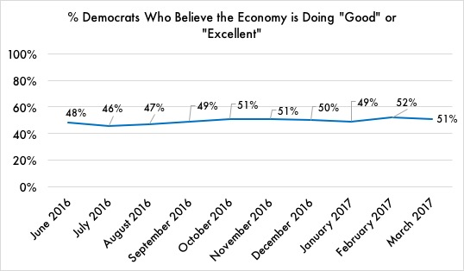Take one important area – assessments of the economy. Throughout 2016, Democrats’ views on the economy were largely positive, reflecting a booming stock market and low unemployment.

Monthly tracking of Gallup’s Economic Confidence Index, based on an average of how Americans view current economic conditions, shows that Democrats’ optimism about the economy was mostly steady through 2016. Democrats became slightly more positive in the second half of end of 2016, largely in accordance with indicators of objective economic growth.

Over the last nine months, Democrats have remained relatively unbiased in their economic assessments – even after Trump was elected. Source: Gallup, June 2016 - March 2017.

Surprisingly, however, Democrats did not become markedly more pessimistic about the economy after Trump was elected. Instead, their views changed little from their assessments prior to the election.

"The fact that Democrats do not appear to have changed their assessments of the economy since Trump was elected is quite remarkable," said Tom Ellis, Senior Research Manager at Gallup. "In this hyperpartisan environment, we might expect them to have taken a more pessimistic view of things after their party lost. That they have remained relatively objective in spite of that is positive news."