

Most Americans think that the economy is doing well

BY BRETT SAMUELS / April 30, 2018, 7:37 AM



Nearly half of Americans believe that the economy is doing well, a new poll shows.

CBS News’ latest tracking poll finds that 48% of Americans think that the country is doing well economically. Another 22% think it is doing poorly. The remainder of respondents – 30% – think it is doing neither well nor poorly.

Just under 50% of Americans believe the economy is doing well. Source: CBS News Poll, April 22-28, 2018.

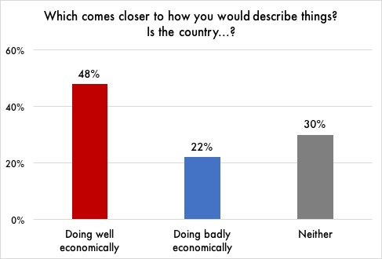

The national poll, released this past Sunday, interviewed 2,164 people between April 22 and 28. The poll is part of CBS News’ long running monthly polls on Americans’ perceptions of the economy.

The monthly polling data suggests that the economic sentiment has been largely steady over the last few months. In last month’s poll, 48% of Americans thought that the economy was doing well, compared to 21% who said it was doing poorly. About 31% of Americans said they believed the economy was doing neither well nor poorly.

Moving into the summer months, analysts believe that these sentiments are likely to hold steady.



Republicans have dramatically shifted their views of the US economy since the election

BY BRETT SAMUELS / November 20, 2016, 7:37 AM



The way Republicans view the economy has undergone a dramatic shift in the week since Donald Trump was elected president of the United States.

Gallup’s Economic Confidence Index, based on an average of how Americans view current economic conditions, registered a large shift among self-identified Republicans over a week time period following Election Day.

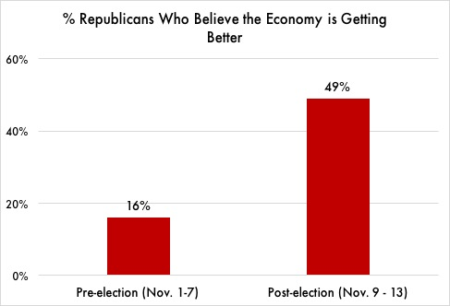“The increase in economic confidence mostly stems from Republicans’ more positive views after Republican Donald Trump won the election,” said the release from Gallup. “Republicans have had a dismal view of the economy — especially of its future direction — during Democratic President Barack Obama’s two terms.”

In fact, the percentage of Republicans saying the economy is getting better increased from 16% in the preelection period to 49% after Trump was elected.

Republicans became more optimistic about the economy immediately following Trump’s election. Source: Gallup Polls, Nov. 1-13, 2016.

It is important to note that despite the huge swing in Gallup’s polling, economic conditions – including rates of unemployment, inflation, and wage growth – have not changed over the past few weeks.

“Republicans are out of their minds if they think the economy is suddenly doing better because of Trump,” said Susan Thomas, a retired schoolteacher from Harrisburg, PA who voted for Hillary Clinton in 2016. “He’s just benefiting from the work Obama did. Anyone who can’t see that is delusional.”



Democrats have dramatically shifted their views of the US economy since the election

BY BRETT SAMUELS / November 20, 2016, 7:37 AM



The way Democrats view the economy has undergone a dramatic shift in the week since Donald Trump was elected president of the United States.

Gallup’s Economic Confidence Index, based on an average of how Americans view current economic conditions, registered a large shift among self-identified Democrats over a week time period following Election Day.

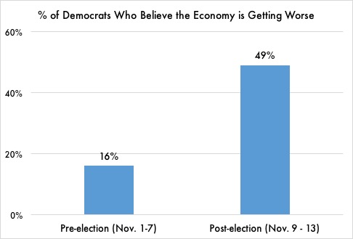

“Lagging economic confidence is mostly due to Democrats’ more negative evaluations after Donald Trump won the election,” said the release from CBS News. “Democrats had a more optimistic view of the economy — especially of its future direction — during President Barack Obama’s two terms.”

In fact, the percentage of Democrats saying the economy is getting worse increased from 16% in the preelection period to 49% after Trump was elected.

Democrats became more pessimistic about the economy immediately following Trump’s election. Source: Gallup Polls, Nov. 1-13, 2016.

It is important to note that despite

the huge swing in Gallup’s polling, economic conditions – including rates of unemployment, inflation, and wage growth – have not changed over the past few weeks.

“Democrats are out of their minds if they think the economy is suddenly doing worse because of Trump,” said Susan Thomas, a retired schoolteacher from Harrisburg, PA who voted for the President in 2016. “He’s rescuing us from all the damage Obama did. Anyone who can’t see that is delusional.”



Democrats’ views of the US economy track economic indicators

BY BRETT SAMUELS / April 15, 2017, 7:37 AM



Since the election of Donald Trump, the news media seems intent on highlighting instances in which Democrats are willing to say up is down and down is up. In reality, however, Democrats’ views on some important topics have tracked reality – suggesting that Democrats may not be as biased in their political views as the press portrays them to be.

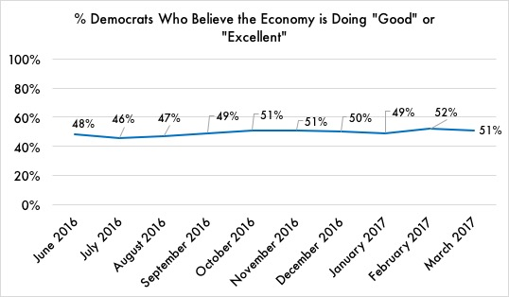Take one important area – assessments of the economy. Throughout 2016, Democrats’ views on the economy were largely positive, reflecting a booming stock market and low unemployment.

Monthly tracking of Gallup’s Economic Confidence Index, based on an average of how Americans view current economic conditions, shows that Democrats’ optimism about the economy was mostly steady through 2016. Democrats became slightly more positive in the second half of end of 2016, largely in accordance with indicators of objective economic growth.

Over the last nine months, Democrats have remained relatively unbiased in their economic assessments – even after Trump was elected. Source: Gallup, June 2016 - March 2017.

Surprisingly, however, Democrats did not become markedly more pessimistic about the economy after Trump was elected. Instead, their views changed little from their assessments prior to the election.

"The fact that Democrats do not appear to have changed their assessments of the economy since Trump was elected is quite remarkable," said Tom Ellis, Senior Research Manager at Gallup. "In this hyperpartisan environment, we might expect them to have taken a more pessimistic view of things after their party lost. That they have remained relatively objective in spite of that is positive news."



Republicans’ views of the US economy track economic indicators

BY BRETT SAMUELS / April 15, 2017, 7:37 AM



Since the election of Donald Trump, the news media seems intent on highlighting instances in which Republicans are willing to say up is down and down is up. In reality, however, Republicans’ views on some important topics have tracked reality – suggesting that Republicans may not be as biased in their political views as the press portrays them to be.

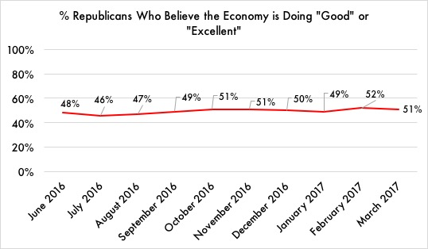Take one important area – assessments of the economy. Throughout 2016, Republicans’ views on the economy were largely positive, reflecting a booming stock market and low unemployment.

Over the last nine months, Republicans have remained relatively unbiased in their economic assessments–even after Trump was elected. Source: Gallup, June 2016 - March 2017.

Monthly tracking of Gallup’s Economic Confidence Index, based on an average of how Americans view current economic conditions, shows that Republicans’ optimism about the economy was mostly steady through 2016. Republicans became slightly more positive in the second half of end of 2016, largely in accordance with indicators of objective economic growth.

Surprisingly, however, Republicans did not become markedly more positive about the economy after Trump was elected. Instead, their views changed little from their assessments prior to the election.

"The fact that Republicans do not appear to have changed their assessments of the economy since Trump was elected is quite remarkable," said Tom Ellis, Senior Research Manager at Gallup. "In this hyperpartisan environment, we might expect them to have taken a more optimistic view of things after their party won. That they have remained relatively objective in spite of that is positive news."