

**CARBO-LOADING:** A RELATIONAL DATABASE

**USER GUIDE**

**Lorem ipsum dolor sit amet**

**CARBO-LOADING: A RELATIONAL DATABASE**

Carbo-Loading contains household level transactions over a period of two years from four categories: Pasta, Pasta Sauce, Syrup, and Pancake Mix. These categories were chosen so that interactions between the categories can be detected and studied.

The dataset has successfully been used in classroom projects and case studies, and is ideally suited for this use. It allows students to interact with real-world data and search for their own insights. The richness of this data and the potential analyses it enables makes it a valuable teaching tool.

It also provides students with the opportunity to understand the process required to mine data. Since this is a relational database, students will need to merge multiple data tables together and aggregate data in search for insights.

The following are examples of questions that could be submitted to students from the Carbo-Loading data set:

* What is the household penetration of Product X? That is, out of all customers purchasing Pasta Sauce, what percent purchase Product X or Brand Z?
* Did any customers first purchase an item or category using a coupon? If so, how many of these customers made additional purchases of the item or category?
* In two complementary categories (e.g. Pasta and Pasta Sauce), what products, if any, are commonly purchased together? Are there cross-promotional opportunities?
* What percent of category customers are loyal to a product or brand? Is there a large percent of customers who purchase similar products within the same category but do not appear to be brand loyal? If so, can the reason for switching be detected?

CARBO-LOADING: DATASET DETAILS

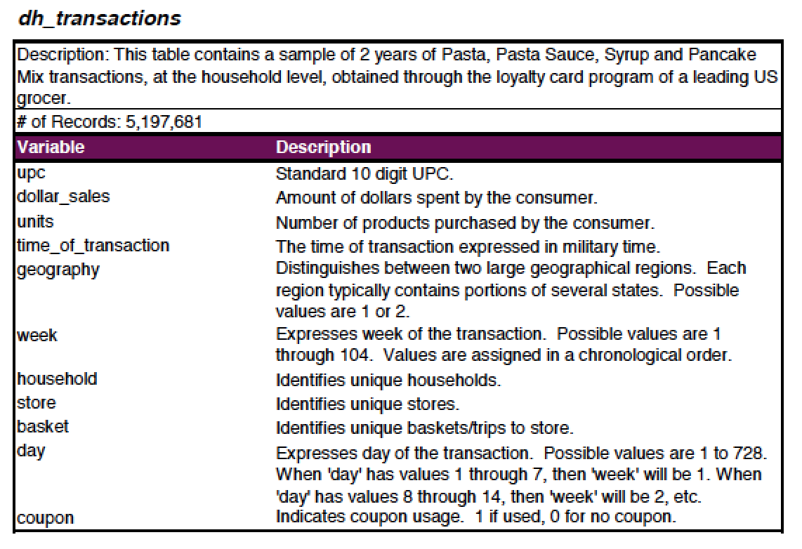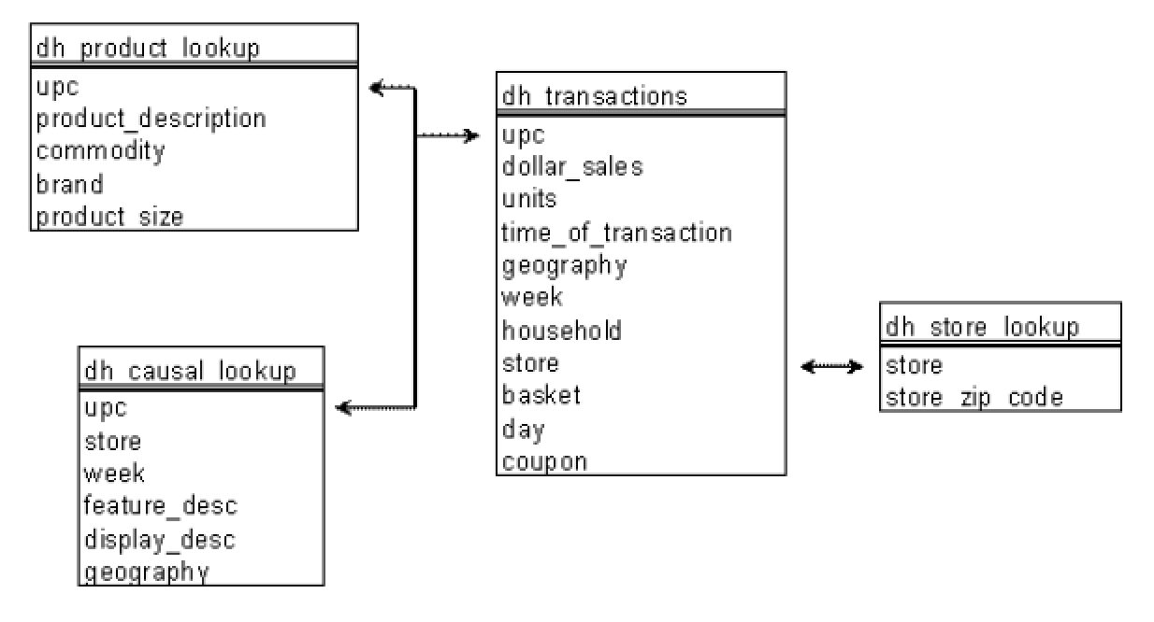

**CARBO-LOADING: DATASET DETAILS**

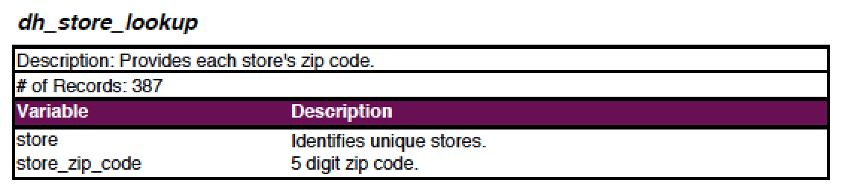

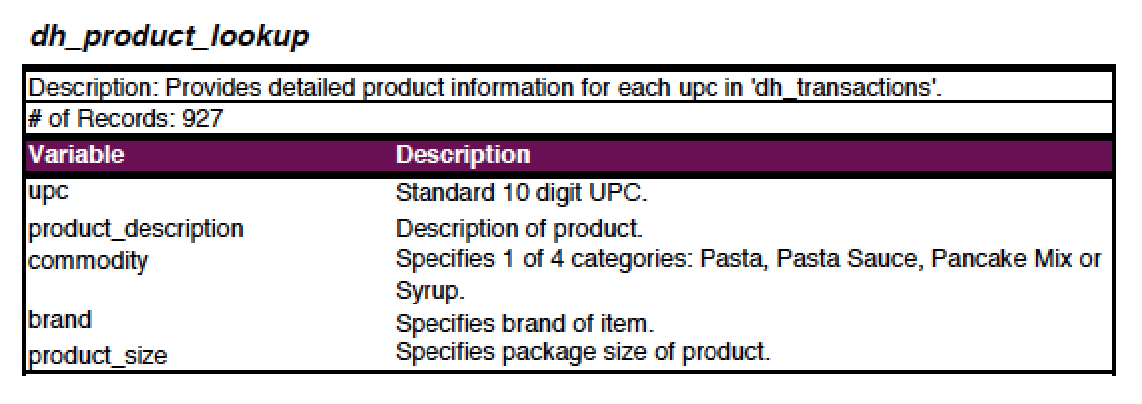

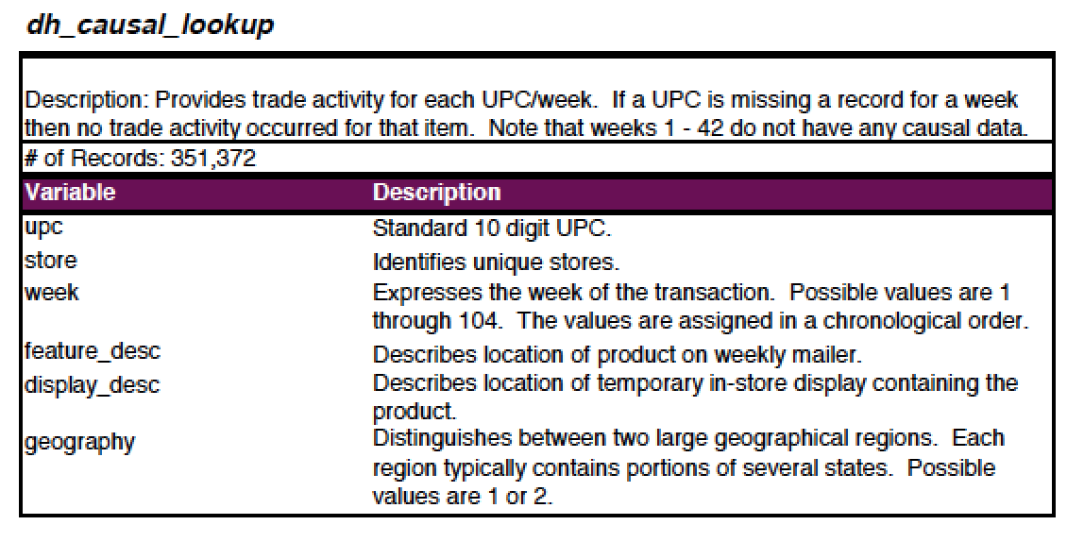

**CONTACT**

**INFORMATION**

For general questions about 84.51° or the Area 51 Files, please contact:

**STEPHANIE LEUCK**

P: 513-632-0099

E: Stephanie.leuck@8451.com