**A[5] Feature Engineering**

2016314364 박수헌

sklearn.datasets.fetch_california_housing 을 사용해 dataset을 load했다. 이 dataset은 8개의 실수형 feature를 갖고 있고, 실수 형태의 target을 갖고 있는 data이다. feature들의 값 분포를 쉽게 알아내기 위해 pandas dataframe으로 데이터를 변환했다. matplotlib을 이용해 히스토그램으로 위 feature 값들의 분포를 확인했다. 마지막은 target의 분포이다.

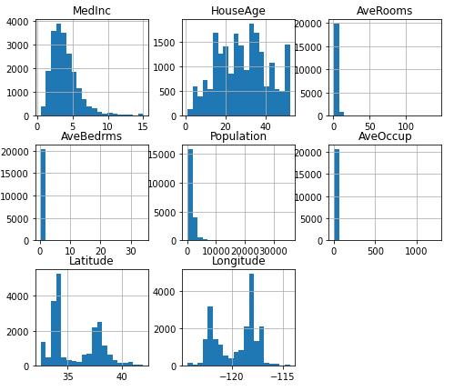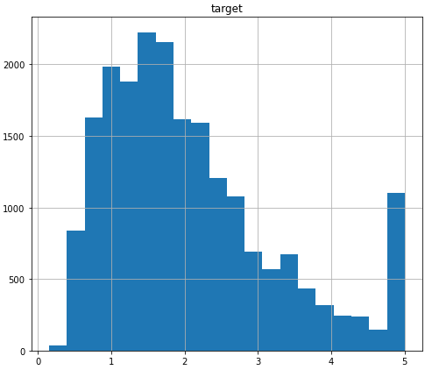

Feature engineering을 하기 전 standard scaler를 이용해 scaling한 후 linear regression model의 test set에 대한RMSE 결과는 아래와 같았다.

RMSE(train) : 0.718343183373882

RMSE(test) : 0.7446113199726715

<1> Binning

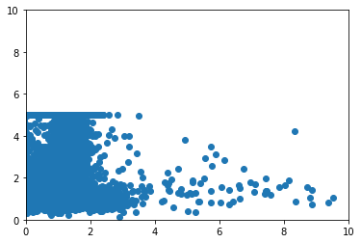PCA를 활용해 8개의 feature들을 하나의 feature로 만들어 도표로 확인해 보았다.

전혀 linear하지 않은 것을 알 수 있었다.

이 feature 값들의 최솟값은 -1422.42790617, 최댓값은 34256.3807251이었으며 이 값을 binning 해 linear regression model을 이용해 fit한 후 예측했지만 성능은 좋지 않았다.

RMSE(train) : 1.145531604832062

RMSE(test) : 1.1784368648034047

<2> Polynomial/interaction features

Polynomial을 사용해 feature 값들을 변형 한 후 standard scaler를 이용해 scaling해, linear regression model을 이용해 fit한 후 예측한 결과이다. Degree를 바꿔가며 실행했다.

|  |  |  |  |  |
| --- | --- | --- | --- | --- |
| Degree  RMSE | 1 | 2 | 3 | 4 |
| Train set | 0.718343183373882 | 0.6486018910649863 | 0.5884244946894744 | 0.5338593723900699 |
| Test set | 0.7446113199726717 | 0.6744074161307838 | 2.0305516147218863 | 39.56635476519788 |

Train set에 대한 RMSE 값은 degree가 2일 때 가장 낮았으므로 가장 성능이 좋았다고 볼 수 있다. 이는 기존 scaling만 한 결과인 RMSE(test) : 0.7446113199726715 보다도 좋은 성능을 보였다.

<3>Nonlinear Transformation

위의 각 feature들에 대한 히스토그램을 살펴봤을 때, MedInc의 그래프가 왼쪽으로 유독 치우쳐져 있는 즉, bell-shaped하지 않은 모습을 보이고 있다. 따라서 MedInc의 feature를 log(X+1) 함수를 이용해 bell-shape하게 수정한 후 MedInc의 그래프는 아래와 같았다.

이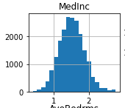 feature값들로 standard scaler를 이용해 scaling한 후 linear regression model을 이용해 fit한 후 예측한 결과는 아래와 같았다.

RMSE(train) : 0.7460078060487457

RMSE(test) : 0.7642238162233127

Feature engineer하기 전의 결과보다 성능이 떨어졌다.

<4> Feature Selection

|  |  |  |  |
| --- | --- | --- | --- |
| Selection Method  RMSE | SelectKBest  (k = 6) | RFE  (n_features_to_select=6) | SelectFromModel |
| Train set | 0.7194816893746349 | 0.7194816893746349 | 0.7395914931507552 |
| Test set | 0.7455460547716126 | 0.7455460547716126 | 0.7573975167442405 |

결과적으로 Polynomial을 이용해 degree를 2로 설정했을 때 가장 예측 성능이 좋았다.

from sklearn.datasets import fetch_california_housing

import pandas as pd

import matplotlib.pyplot as plt

%matplotlib inline

dataset = fetch_california_housing()

X = pd.DataFrame(dataset.data, columns=dataset.feature_names)

y = pd.DataFrame(dataset.target)

y = y.rename(columns={0: "target"})

X.hist(bins=20, figsize=(8,7))

y.hist(bins=20, figsize=(8,7))

from sklearn.model_selection import train_test_split

from sklearn.datasets import fetch_california_housing

from sklearn.preprocessing import StandardScaler

from sklearn.linear_model import LinearRegression

from sklearn.metrics import mean_squared_error

X, y = fetch_california_housing(return_X_y = True)

X_train, X_test, y_train, y_test = train_test_split(X,y,random_state = 1016)

scaler = StandardScaler()

scaler.fit(X_train)

X_train_sc = scaler.transform(X_train)

X_test_sc = scaler.transform(X_test)

lr = LinearRegression()

lr.fit(X_train_sc,y_train)

y_train_hat = lr.predict(X_train_sc)

y_test_hat = lr.predict(X_test_sc)

print("RMSE(train) : ", mean_squared_error(y_train,y_train_hat)**0.5)

print("RMSE(test) : ", mean_squared_error(y_test,y_test_hat)**0.5)

from sklearn.decomposition import PCA

from sklearn.preprocessing import OneHotEncoder

import numpy as np

X, y = fetch_california_housing(return_X_y = True)

pca = PCA(n_components=1)

pca.fit(X)

X_pca = pca.transform(X)

bins = np.linspace(-1423, 34257, 10)

which_bin = np.digitize(X_pca, bins=bins)

encoder = OneHotEncoder(sparse=False)

encoder.fit(which_bin)

X_binned=encoder.transform(which_bin)

X_train_binned, X_test_binned, y_train, y_test = train_test_split(X_binned,y,random_state=1016)

lr = LinearRegression()

lr.fit(X_train_binned,y_train)

y_train_hat = lr.predict(X_train_binned)

y_test_hat = lr.predict(X_test_binned)

print("RMSE(train) : ", mean_squared_error(y_train,y_train_hat)**0.5)

print("RMSE(test) : ", mean_squared_error(y_test,y_test_hat)**0.5)

from sklearn.preprocessing import PolynomialFeatures

poly = PolynomialFeatures(degree=2, include_bias=False)

poly.fit(X_train)

poly.get_feature_names()

X_train_poly = poly.transform(X_train)

X_test_poly = poly.transform(X_test)

scaler = StandardScaler()

scaler.fit(X_train_poly)

X_train_poly_sc = scaler.transform(X_train_poly)

X_test_poly_sc = scaler.transform(X_test_poly)

lr = LinearRegression()

lr.fit(X_train_poly_sc,y_train)

y_train_hat = lr.predict(X_train_poly_sc)

y_test_hat = lr.predict(X_test_poly_sc)

print("RMSE(train) : ", mean_squared_error(y_train,y_train_hat)**0.5)

print("RMSE(test) : ", mean_squared_error(y_test,y_test_hat)**0.5)

from sklearn.datasets import fetch_california_housing

import numpy as np

import pandas as pd

import matplotlib.pyplot as plt

%matplotlib inline

dataset = fetch_california_housing()

X = pd.DataFrame(dataset.data, columns=dataset.feature_names)

y = pd.DataFrame(dataset.target)

y = y.rename(columns={0: "target"})

for idx in range(len(X['MedInc'])):

X['MedInc'][idx] = np.log(X['MedInc'][idx] + 1)

X.hist(bins=20, figsize=(8,7))

X_train, X_test, y_train, y_test = train_test_split(X,y,random_state=1016)

scaler = StandardScaler()

scaler.fit(X_train)

X_train_sc = scaler.transform(X_train)

X_test_sc = scaler.transform(X_test)

lr = LinearRegression()

lr.fit(X_train_sc,y_train)

y_train_hat = lr.predict(X_train_sc)

y_test_hat = lr.predict(X_test_sc)

print("RMSE(train) : ", mean_squared_error(y_train,y_train_hat)**0.5)

print("RMSE(test) : ", mean_squared_error(y_test,y_test_hat)**0.5)

from sklearn.datasets import fetch_california_housing

from sklearn.feature_selection import SelectKBest, f_regression

X,y = fetch_california_housing(return_X_y=True)

X_train, X_test, y_train, y_test = train_test_split(X,y,random_state=1016)

scaler = StandardScaler()

scaler.fit(X_train)

X_train_sc = scaler.transform(X_train)

X_test_sc = scaler.transform(X_test)

select = SelectKBest(f_regression, k = 6)

select.fit(X_train_sc, y_train)

X_train_selected = select.transform(X_train_sc)

X_test_selected = select.transform(X_test_sc)

lr = LinearRegression()

lr.fit(X_train_selected,y_train)

y_train_hat = lr.predict(X_train_selected)

y_test_hat = lr.predict(X_test_selected)

print("RMSE(train) : ", mean_squared_error(y_train,y_train_hat)**0.5)

print("RMSE(test) : ", mean_squared_error(y_test,y_test_hat)**0.5)

from sklearn.datasets import fetch_california_housing

from sklearn.feature_selection import RFE

X,y = fetch_california_housing(return_X_y=True)

X_train, X_test, y_train, y_test = train_test_split(X,y,random_state=1016)

scaler = StandardScaler()

scaler.fit(X_train)

X_train_sc = scaler.transform(X_train)

X_test_sc = scaler.transform(X_test)

estimator = LinearRegression()

select = RFE(estimator, n_features_to_select=6, step=1)

select.fit(X_train_sc, y_train)

X_train_selected = select.transform(X_train_sc)

X_test_selected = select.transform(X_test_sc)

lr = LinearRegression()

lr.fit(X_train_selected,y_train)

y_train_hat = lr.predict(X_train_selected)

y_test_hat = lr.predict(X_test_selected)

print("RMSE(train) : ", mean_squared_error(y_train,y_train_hat)**0.5)

print("RMSE(test) : ", mean_squared_error(y_test,y_test_hat)**0.5)

from sklearn.datasets import fetch_california_housing

from sklearn.feature_selection import SelectFromModel

X,y = fetch_california_housing(return_X_y=True)

X_train, X_test, y_train, y_test = train_test_split(X,y,random_state=1016)

scaler = StandardScaler()

scaler.fit(X_train)

X_train_sc = scaler.transform(X_train)

X_test_sc = scaler.transform(X_test)

fmodel = LinearRegression()

select = SelectFromModel(fmodel, threshold="mean")

select.fit(X_train_sc, y_train)

X_train_selected = select.transform(X_train_sc)

X_test_selected = select.transform(X_test_sc)

lr = LinearRegression()

lr.fit(X_train_selected,y_train)

y_train_hat = lr.predict(X_train_selected)

y_test_hat = lr.predict(X_test_selected)

print("RMSE(train) : ", mean_squared_error(y_train,y_train_hat)**0.5)

print("RMSE(test) : ", mean_squared_error(y_test,y_test_hat)**0.5)