Rmarkdown with a custom template

9622876

September 17th, 2024

# 1 Styles and formatting

Save the converted docx document, Rmd_test2.docx as custom_template.docx. We open custom_template.docx and use as a Word template.

In Word, access Styles tab and choose Heading. Modify as appropriate. Don’t forget to include page numbers! Then, in Rmd_test3.Rmd, we will modify YAML. Specify at the top as reference_docx:custom_template.docx.

# 2 Data visualisation

See Figure 1.

hist(cars$speed)

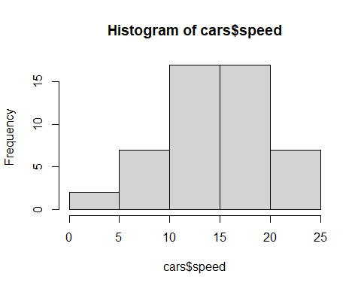

Figure 1: Histogram of speed

Figure 2 illustrates…

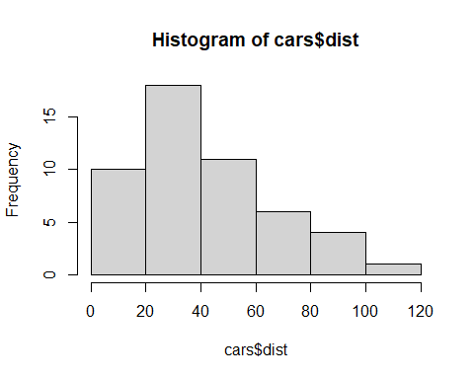

Figure 2: Histogram of dist

Well-done! 👍

# 3 Your turn

Create a blank Rmd file.

How do you create this Rmarkdown file?

In RStudio, go to File > New file > R Markdown… When a new window pops up, choose Word as Default Output Format. Click OK.

The default Rmarkdown file looks complex. Delete the text as necessary. Explore the file.

Experiment with Rmd. Convert to HTML, Word, and PDF. Improve the look by tweaking further. Learn code chunk options.