Example Rmarkdown Word template

9622876

2024-09-17

# 1 Including Plots

You can also embed plots, for example: See Figure 1.1.

hist(cars$speed)

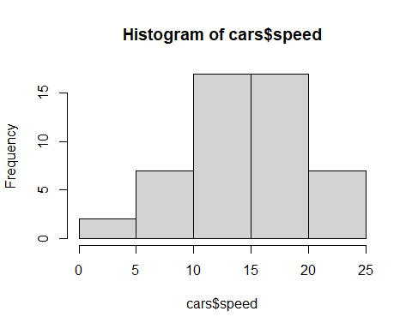

Figure 1.1: Histogram of speed

See Figure 1.2.

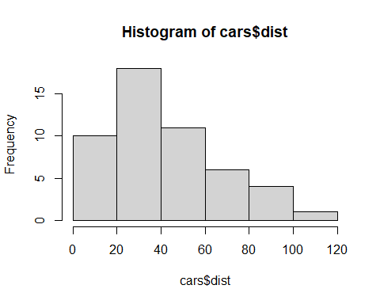

Figure 1.2: Histogram of dist

Note that the echo = FALSE suppresses the printing of the code, hist(cars$dist).