Example Rmarkdown to Word template

9622876

# 1 Add references

Present your argument. This can be found in earlier studies (see Anscombe 1973, 2; Kabacoff 2015).

Kabacoff (2015, 20) argues that…

**Use square brackets and add a citation key following @ symbol.** You may indicate page numbers following the citation key. *Please note that these in-text citations needs to be sorted!*

# 2 Bib file

To obtain a bib file, you need to install Better BibTex that bridges Zotero and markdown. Visit here: <https://retorque.re/zotero-better-bibtex/>. You can download the latest version here: <https://github.com/retorquere/zotero-better-bibtex/releases>. Choose .xpi file only (you do not need other files). As the whole procedure can be involved, it would be sensible to consider ways to revisit it at a later stage!

# 3 Data visualisation

See Figure 1.

hist(cars$speed)

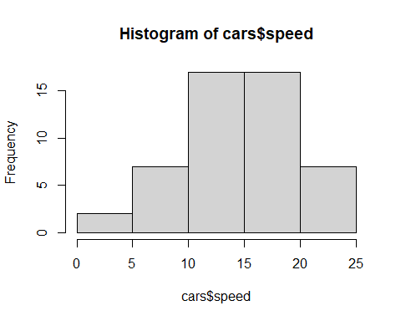

Figure 1: Histogram of speed

Figure 2 illustrates…

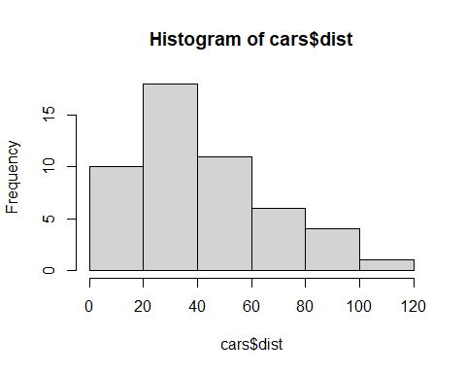

Figure 2: Histogram of dist

# 4 Styles and formatting

We use the converted docx document, 2.3_Rmd_Bib_WordTemplate.docx as a template.

To do so, we rename 2.3_Rmd_Bib_WordTemplate.docx and save as custom_template.docx.

We are now ready to customise this template file.

Open custom_template.docx and apply your own format to Heading 1. Place the cursor in any Heading 1. In Word, access **Styles tab** and choose **Heading 1** Modify as appropriate. Do not forget to include page numbers!

When you are satisfied with the new template, we will specify this new template in the YAML header at the top as reference_docx:custom_template.docx.

# References

Anscombe, Francis. 1973. “Graphs in Statistical Analysis.”

Kabacoff, Robert. 2015. *R in Action: Data Analysis and Graphics with R*. Second edition. Shelter Island: Manning.