{{ date }} | date
{{ cert_no }} | NO

Calibration certificate
Name: {{ client_name }}
Instrument Type: GPS: {{ brand }}
Model: {{ model }}
Base: {{ sn}}
Rover: {{ sn2 }}
Static GNSS Surveying Real-Time Kinematic Surveying
High-precision static Single Baseline < 30 KM
Horizontal 3 mm + 0.1 ppm RMS Horizontal 8 mm + 1 ppm RMS
Vertical 3.5 mm + 0.4 ppm RMS Vertical 15 mm + 1 ppm RMS
Satellite signals tracked simultaneously:
– GPS: L1C/A, L1C, L2C, L2E, L5
– GLONASS: L1C/A, L1P, L2C/A, L2P, L3

- We certify that the following surveying instrument has been tested and calibrated in accordance with the manufacturer's instructions and that it complies with the specifications according to all standards and criteria contained in the instructions

-This certificate is valid for 6 months Next Calibration {{ valid_until }}

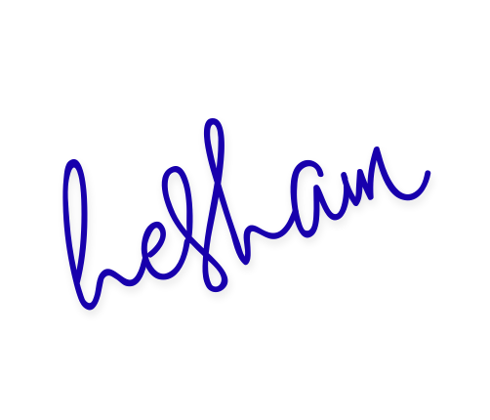

{{ qr_code_img }}

