ARTICLE

Trip Recommending Web Page with PHP and MySQL

SOOMIN SOHN†, 1771029 and JEONGYOUN WEON††, 1771038

† The author is with Ewha Womans University, Seoul, 1998~, Republic of Korea.

†† The author is with Ewha Womans University, Seoul, 1998~, Republic of Korea.

SUMMARY This paper describes a web page implementation project using XAMMP performed during the Big Data Application lecture at Ewha Womans University.

key words: recommend, floating population, PHP, MySQL, session

1. Introduction

The purpose of the project is to provide travel destinations in Seoul, where COVID-19 cases are rising, and to inform users areas with small floating population by utilizing travel data and Seoul's floating population data. Travel destination data is from 서울열린데이터광장(data.seoul.kr) and additional data was obtained by web crawling from Naver Place and Google Images. Seoul floating population dataset is from SKT Data Hub. Data time ranges from 14 September 2020 to 21 September 2020, and only 20's floating population was used for the service targets users in their 20's. Our web application consists of eight pages and the main functions are travel recommending, adding places, leaving reviews, and getting up-to-date information of regional floating population. XAMPP(PHP and MySQL) was used as a development tool..

2. Related work

One of the works that we referenced in making was COVID-19 dashboard. Similarities between COVID-19 dashboard and this project is that both deals with vast number of data, analyzes it by locations and time, and analyzed data is shown in graphs. However, what is unique about our project is that users can put more information by adding hashtags to places and add more places they want to recommend to others. Even though users cannot communicate directly, they can interact with each other by hashtags and others.

**3. Requirements and System Design**

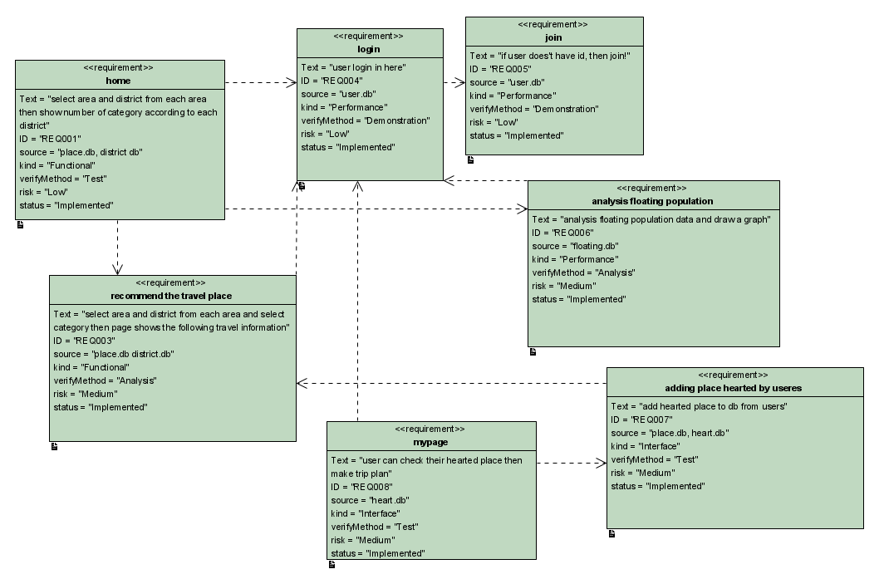

Fig. 1 System Requirements.

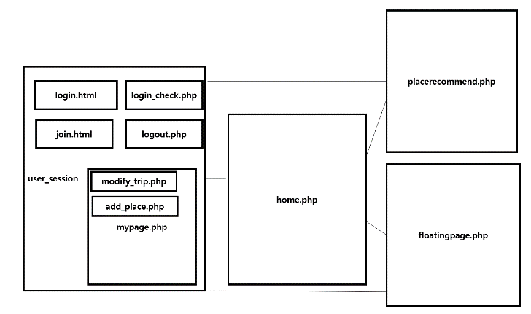

Fig. 2 System Design

Our service has eight pages.

- <home.php>

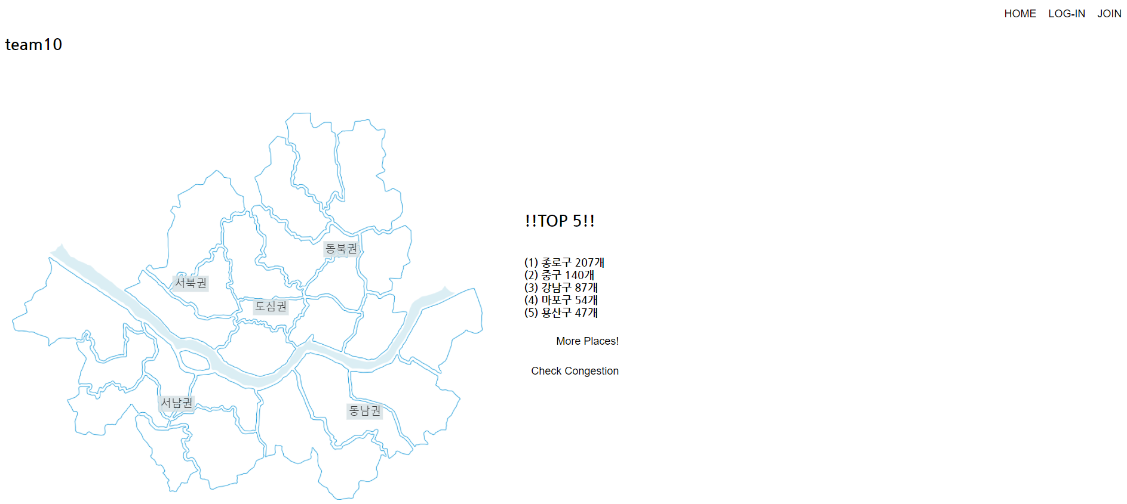

In the main page, users can sign up or login if they have their own IDs. In here, we use user_session to save users’ information and session. If they sign up for our service, their information will be added to our database and will be used to log in process later. When users return to the main page, users can see the map of Seoul City, which is divided into five areas. Clicking on to the areas, district that are under the clicked area will show up in the right side of the map and when these district buttons are clicked, the numbers of total travel destinations will appear by categories.

- <join.php>

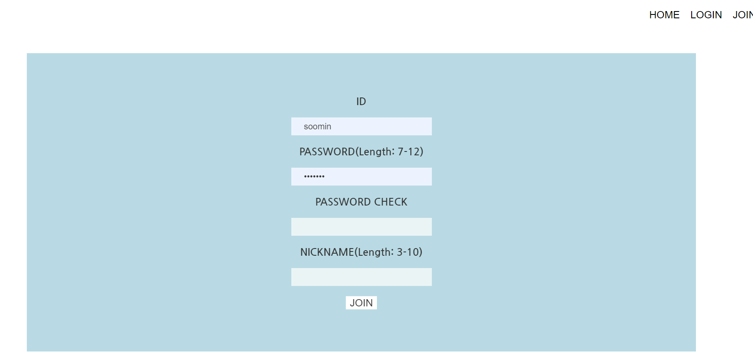If login session is not present, top-right bar will have [HOME], [LOGIN], and [JOIN] buttons. By clicking [JOIN] button, users will be directed to join.php and users can freely create an account.

- <login.php>

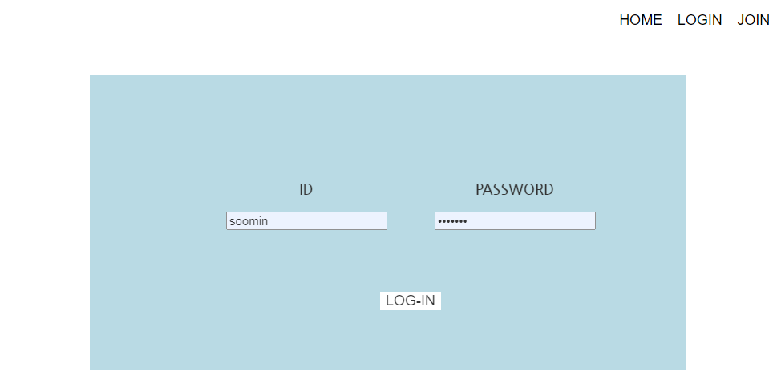

In login.php, users can login to the service by entering their ID and password.

- <floationgpage.php>

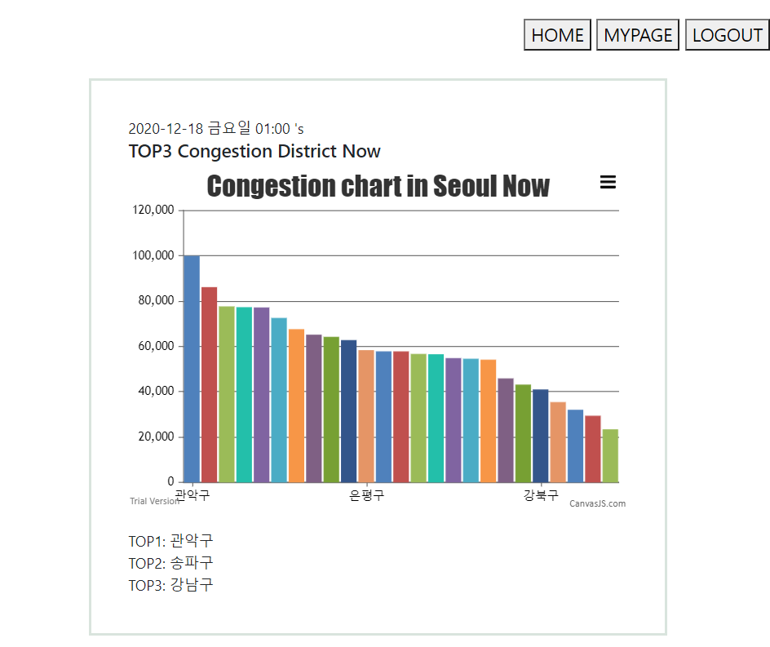

If you click [check congestion] button in the main page, floatingpage.php appears. In this page, population data is shown in histogram in three forms--grouped by districts, hours, and days. Users can be informed by floating population analysis of their need. These graphs are drawn by using canvasjs.com and we used ranking function to implement selecting highest three of each graph. The first section shows most congestion district in now. The time is from user’s system. The second section, user can choose one of five areas, and following district, then they can find the congestion of a week and TOP3 days in a week. In the last section, users can choose one of five areas, following district and a day, then the graph shows the congestion of an hour and TOP3 hour in that day.

- <placerecommend.php>

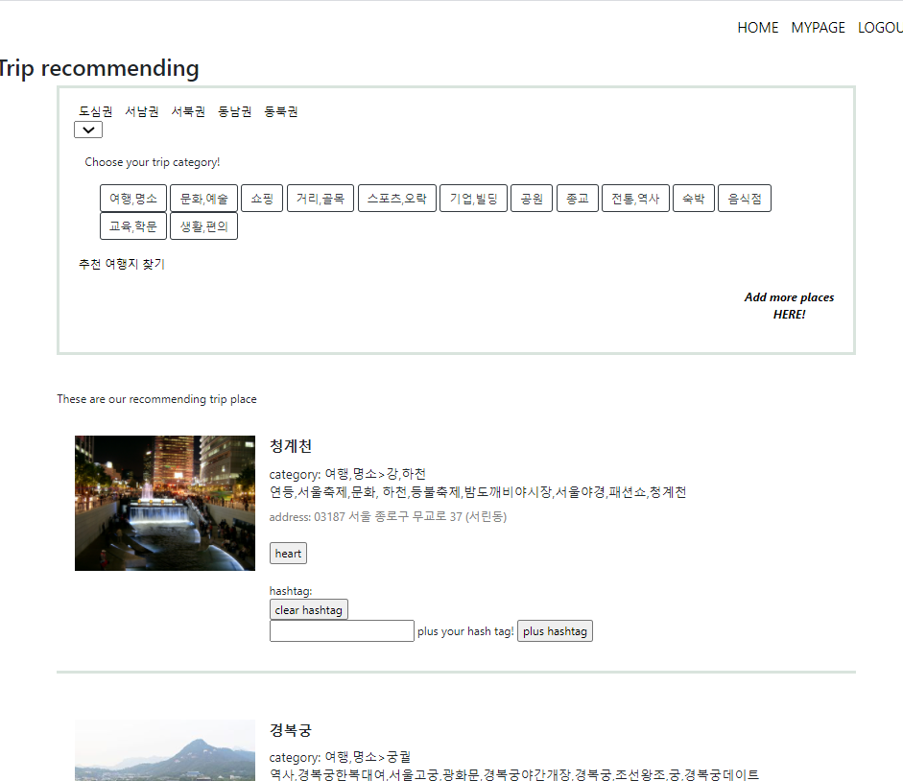

If you click [More places!] in the main page, you can go to placerecommend.php page. IF select an area, a following district, and multiple categories and click the search button, our service lists you travel destinations according to your choice. Each place’s data is from place table in the database. If you liked information given, you can click the heart button of each place, and it will be added to your heart list. Also, users can share their hashtags by adding new hashtags or deleting old ones. The newly added hashtags will be added in the user_tag table.

- <mypage.php>

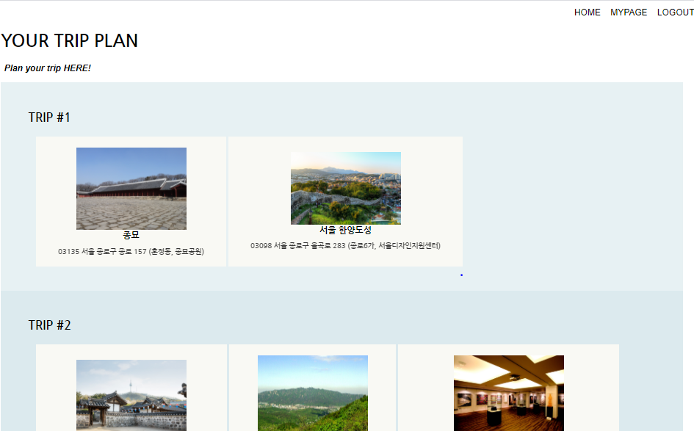

When login session is present, buttons in the top-right section will be [HOME], [MYPAGE], and [LOGOUT]. In mypage, users can view all the places they pressed heart button to. All of the hearted places are initially set as trip 1 by default, however users can modify trip numbers and plan their own trips my clicking onto [Plan your trip HERE] button.

- <modify_trip.php>

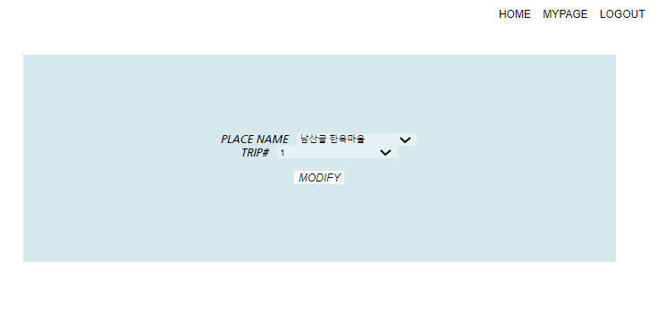

In this page, users can select a place and change trip number. Users can set up to 3 trips and after clicking modify, changes will be applied to the database server.

- <add_place.php>

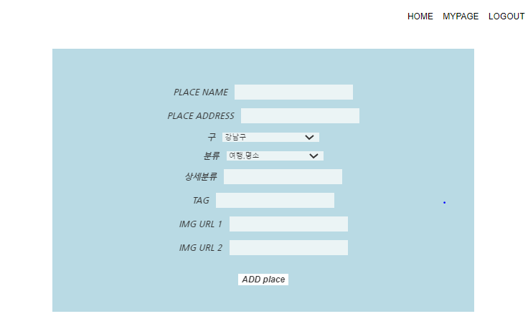

If users click “Add more places HERE” button in placerecommend.php page, they will go to add_place.php page. In this page, users can add any new place in Seoul to the place table in the database. Every field shown in the page should be filled up, then after clicking the [ADD place] button, a new place would be added to the place table.

3. Database Schema and Description of Tables

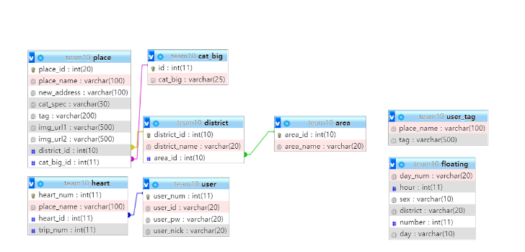

Fig. 3 System Requirements.

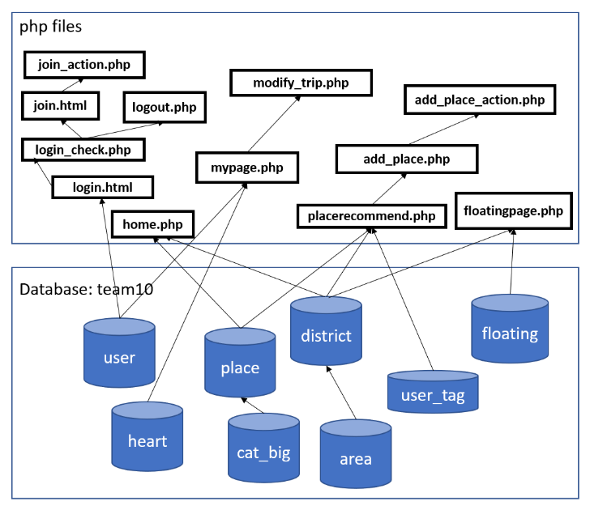

Fig. 4 System Requirements.

There are eight tables in our database.

- <user>

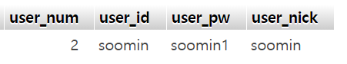 There are four columns in the user table. User_num is the primary key in this table and it has auto increment option, user_id contains id’s, user_pw contains user’s password in encrypted form, and user_nick contains user’s nick name. User_num is reference by multiple tables in this database. Users can add their information to table via join.php page.

- <area>

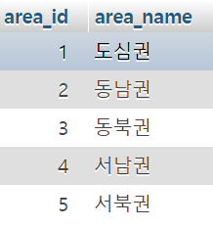

In area table, there are two columns. area_id is the primary key and is referenced by foreign key from district table. Area_name contains the areas of Seoul in string type. This table is used for home.php, floating.php, placerecommend.php, add_place.php.

- <district>

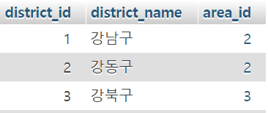 In district table, there are three columns. district_id is primary key and auto incremented, district name is string type and there are twenty-five district in Seoul. Also, in area column, following five area type is stored and is foreign key for area table. This table is used for home.php, floating.php, placerecmmend.php, add_place.php to divide each area.

-<floating>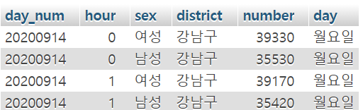 In floating table, there are six columns. This dataset is from SKT Data Hub’s Seoul floating population data, and the time range of the data used is from 14 September 2020 to 21 September 2020 and only 20’s data is used. The date is saved in day_num, and following hour is saved in hour. Also, sex, district and day are saved in same name column. In number columns, the floating number in that day and hour is saved in. This table is used for floating.php to draw a graph and show following population.

-<place>

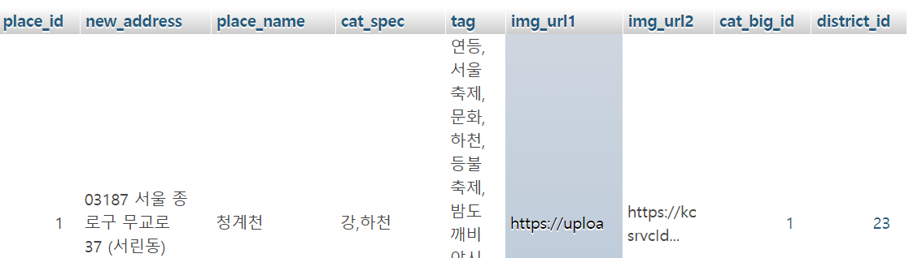

In place table, there are nine columns. The new_adress, place_name, tag columns are from data.seoul.kr. place_id is the primary key and automatically incremented. Also, cat_spec is specific category retrieved by crawling from Naver Place and later refined for accuracy and concision. img_url1 and img_url2 columns are crawled from google_images_download 2.8.0 by python. cat_big_id is a foreign key that references the id number from cat_big table, and district_id is too a foreign key that references district table. Place table is used in home.php, placerecommend.php and mypage.php.

-<cat_big>

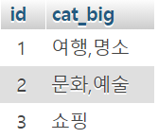

In cat_big table, id is the primary key and cat_big column, there are thirteen categories that are crawled then refined.

-<user_tag>

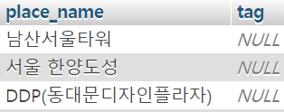

In user_tag table is modified by adding and deleting hastags in placerecommned.php. place_name column is the primary key and tag is initialized as NULL.

<heart>

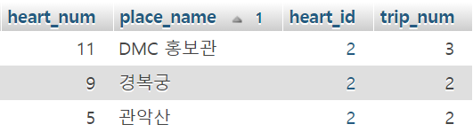

In heart table, heart_num is the primary key of the record in the place table with the value equal to place_name and heart_id references user_num in user table. Trip_num is place_name’s trip number. This table is used in placerecommned.php, mypage.php, and modify_trip.php.

4. Technologies used

HTML, CSS, PHP, Canvasjs.com, Crawling, Python

5. Conclusion and Future Works

Building databases and working with php and mysql, we got to practice various methods of obtaining data that we need such as web scraping and learned to process raw data into useful information. Because we are much more experienced in using various queries and functions regarding big data than before, we gained confidence and decided to work on projects in the future instead of just ending here.

References

-place db: *열린데이터 광장 (data.seoul.go.kr)*

-place db’s image: *google image (https://pypi.org/project/google_images_download/)*

-place db’s cat_big: *naver myplace*

-floating db: *SKT Data Hub* *(*[*https://www.bigdatahub.co.kr/index.do*](https://www.bigdatahub.co.kr/index.do)*)*

-graph used in floating page: *https://canvasjs.com/*

|  |  |  |
| --- | --- | --- |
|  |  | Soomin Sohn is studied in Computer Science and Engineering from Ewha Womans University since 2017. During 2020 September to December, she participated as a team member of team10 of the web page implementation project using xampp during the Big Data Application class at Ewha Womans University. |
|  |  | JeongYoun Weon is studied in Computer Science and Engineering from Ewha Womans University since 2017. During 2020 September to December, she participated as a team member of team10 of the web page implementation project using xampp during the Big Data Application class at Ewha Womans University. |
|  |  |  |