

**SUMANTA KUMAR DAS MODEL BASED SYSTEM DESIGN SuKuDa**

**SuKuDa**

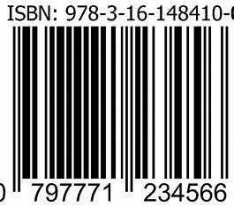

**Strength is Life**

**www.mbsc.org**

**BOOKS ON COMBAT MODELING**

Rs.

Army Combat Modeling 10

Air Force Combat Modeling 10

Naval Force Combat Modeling 10

Amphibious Force Combat Modeling 10

Air-Land Combat Modeling 10

**SUMANTA KUMAR DAS**

**Complex System Engineering Operations**

**MODEL BASED SYSTEM DESIGN**

**Using System Composer Toolbox in MATLAB**