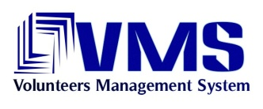

|  |
| --- |
| Volunteers’ Management System |
| Final Group Report |
|  |
| **Technical Challenge Project Course**    **IT University of Gothenburg**  **Spring 2010** |

By:

*Apollo Group*

# Table of Contents

Table of Contents 2

1 Introduction 4

2 Product Explanation 5

2.1 Problem Statement 5

2.2 Product Description 6

2.3 Features 6

2.3.1 Resource Management 7

2.3.2 Registration and Membership 7

2.3.3 Profile Management 7

2.3.4 Incident Management 7

2.3.5 Information Gathering 7

2.3.6 Communication 8

2.3.7 Log Analysis and Backup 8

3 Deliverables 9

3.1 Project Plan 9

3.2 Risk Plan and Risk List 9

3.3 Quality Assurance Plan 9

3.4 Test Plan 10

3.5 Test-Cases 11

3.6 Test Report 12

3.6.1 Function Test 12

3.6.2 User Interface Test 12

3.6.3 Load, Stress, and Performance Test 12

3.6.4 Security and Access Control Test 12

3.6.5 Code Coverage Analysis 12

3.6.6 Code Static Analysis 13

3.6.7 Software Qualification Test 13

3.6.8 Inspection White Box Testing 13

3.6.9 Unit Testing 13

3.7 Use-Cases 13

3.8 Software Architectural Description 14

3.9 Software Design Description 15

3.10 Manager’s Manual 16

3.11 Volunteer’s Manual 16

3.12 Web Portal Installation Guide 16

4 Conclusion 17

# Introduction

This report is the main document that summarizes all of the deliverables as well as the concept of VMS Project. The targeted readers are those technical people who are interested in the project. Therefore, the purpose of this document is to give a common idea about the project and serve as a table of content for all VMS artefacts.

The content is presented in three sections.

In the first section, the VMS is introduced. The problems related to crisis management and help organizations are listed first and then how VMS solves those problems are explained.

Then in the second section, all of the project content and deliverables are underlined as to guide the reader to find which information is in which document.

At the end, the project implementation status is presented as a conclusion.

# Product Explanation

## Problem Statement

Earthquakes, hurricanes, terror attacks and wars are some examples of disasters and crises which are happening in our world that causes the death and loss of many people. As a common result of these crises, the normal city life is corrupted. Even after the crisis, problems remain as epidemic or starvation.

Many organizations such as military forces, civil defense organizations, Red Cross or other international help organizations have helped people to overcome the difficulties and challenges during crises. However, most of them operate through their trained members. Militaries have educated soldiers, Red Cross has members with certificated training and Civil Defence in Sweden has hired experts. This puts a limitation for a regular citizen to join any of such organizations. Many of these organizations require the accomplishment of different training programs and attendance of regular meetings, more over some even require membership fees. Their organizational structure is not built on regular citizens but on their educated active members.

Beyond the difficulties for being a member of help organizations, there is another obstacle. People don’t want to be a member of such organizations. Unless they faced to a crisis just near them, they are not so eager to join those help organizations like Civil Defence or Red Cross. However, when they face a crisis, if they have the opportunity, most of them want to help other people who are in difficulty.

The problem is that; help organizations miss out regular citizens who can assist them in crisis time. Help organizations form their structure before the crisis happens. However, people don’t want to join or they can’t join these organizations before crisis time. People only consider joining help organizations if there is a crisis but currently there is no quick way for this.

Ad de Raad, UN Volunteers Executive Coordinator, emphasizes the problem clearly in the World Conference on Disaster Reduction in Japan, 1995: “In the wake of disasters, we have seen repeatedly how considerably large numbers of generally unskilled, untrained, and unaffiliated citizens are mobilized through volunteerism to lend a hand. However, much of it is ad hoc and uncoordinated. At best, this can result in a considerable loss of effectiveness. At worst, undirected volunteers can become part of the problem in a disaster situation.”[1]

If we imagine a city wide earthquake that 40% of all citizens die, 20% are under wreck and remaining 40% is fine, then we can assume that, at least 10% of all city population can help rescue operations. For a small city of 100.000 populations, that means 10.000 people. Even if a so small portion of them willing to attend help facilities, that size would be great, many times greater than all of help organizations in that city.

If there is a system that allows people to join help facilities not only before crisis but also after a crisis happens, and that enables crisis manager to manage a huge amount of people effectively, it would be a great solution.

This solution is our system which is Volunteers´ Management System (VMS).

## Product Description

VMS is a composite software system that establishes a bridge between help organizations and citizens in crisis times. It is based on the idea that people consider helping others when there is a crisis. VMS provides a quick and easy way to attend the help facilities and help crisis manager to organize thousands of volunteers in any crisis efficiently and effectively.

VMS includes a central web portal to manage a crisis and a mobile application as an interaction channel for volunteers. The following figure shows the way of communication between the volunteers and the manager through VMS.

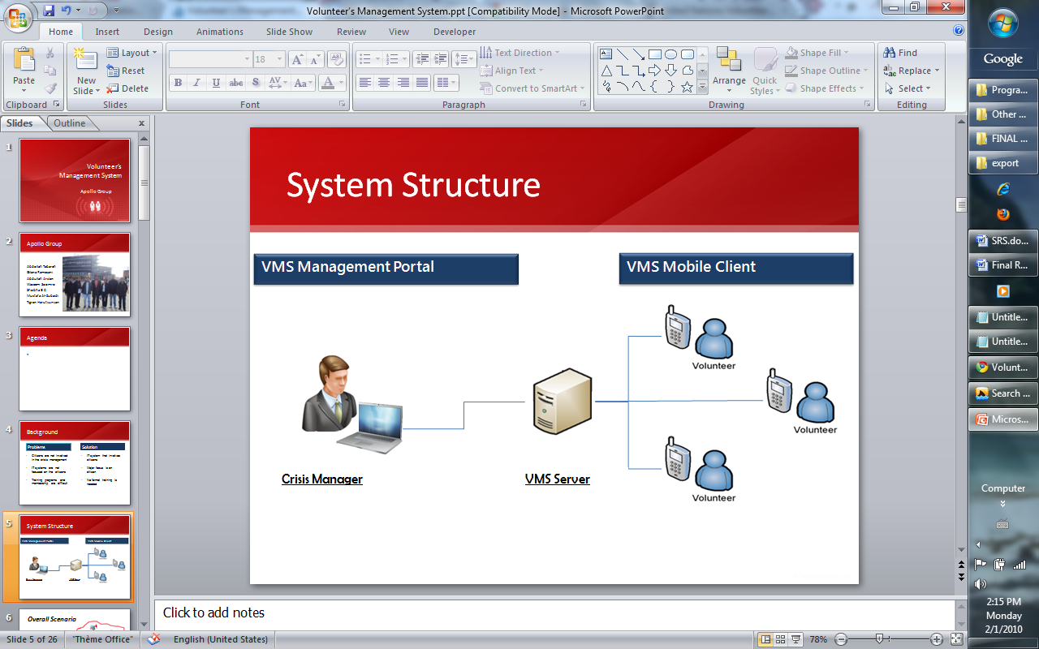

Figure 1. Communication through VMS

When a crisis occurs, volunteers download and install the mobile application and become a part of rescue operations by registering to the system. At the other hand, crisis manager defines the problems, that are incidents in VMS context, and all of the resources needed to resolve the problems and that’s it. The unique automatic requesting feature of VMS automatically asks and gathers all the required resources to solve the problems based on the nature of the problem and volunteers locations. Thus in a few minutes hundreds of volunteers can be organized and directed to a problem for help.

Additionally, VMS utilizes volunteers as an information source for reporting new incidents and also the status of ongoing incidents. At the chaos times which immediate response is crucial and official organizations become impotent in reporting and notification of new problems, VMS can be a vital information source.

Thanks to the easy-to-use user interface, crisis managers can monitor and manage the crisis area and all the problems easily on the crisis map. Manager operates trough web browser, since it is a web application he can access it from any place, which is a very useful during crisis time. This system also uses xml web service technology, which provides the possibility to increase the capability to thousands volunteers by including more hardware resources.

Being developed with J2MEE technology, the Mobile Application of VMS can run on almost all mobile phones; thus avoid the compatibility issues for many mobile phones.

## Features

The following features make the Volunteers’ Management System appropriate for handling crises.

### Resource Management

Volunteers and their useful stuff which they can provide to the needy will be managed easily by the managers. VMS intensively assists the crisis manager for resource management by selecting the volunteers according to region, type of the crisis and some other constraints.

Manager creates request by defining the need list and set the severity of the incident. Once the send button is pressed, rest other tasks like selecting the volunteers and collecting the resources will be automatically handled by the VMS.

### Registration and Membership

Before using the VMS, the user should be registered. Based on the user credentials, different levels of access to the system are provided.

Registration procedure requires some basic information about the members and gives user name and password for subsequent logging into VMS.

### Profile Management

System keeps tracks of all the information about the members to help the crisis affected people efficiently. Members at any point of time can change/delete their profile; subsequently the system adjusts to current requirement. For example if a volunteer adds additional training information, then the person will be selected for a crisis which requires that particular training.

### Incident Management

Any number of incidents can be managed by the VMS. System behaves differently to the different incidents. There can be different needs, different resource assignments, different states like active/resolved for each incident. More than one incident can be raised in a crisis and each incident will have individual need list and requirements, these will be handled by VMS easily according to the nature of the incident.

### Information Gathering

Volunteers can be used as information source to address the crisis on time with more efficiency. The volunteers can send two types of information report to the help organization. They are

* **Reporting new incidents**

Volunteers can send new incident report, which helps the manger to create new incident in the VMS and helps in handling the crisis early.

* **Reporting the statues of the existing incidents**

Volunteers can send status of the incident which they are working on. This helps in knowing the statues of the incidents, which might help in handling the crisis. The information will be filtered and updated accordingly to the VMS.

### Communication

Help organization center communicate with volunteers by sending messages via web portal and the volunteers reply them via mobile application. There are different types of communication in VMS like warning messages, request messages.

* **Warning the user**

Management Center can warn users according to their location or any other information like age, gender. The alert messages will make the volunteers aware of possible dangers.

* **SendING Request for the help**

Manager can send a help request to volunteers based on their locations and the type of crisis. By sending help request, the manger gets the response from volunteers. With the help these responses further course of actions will be incited by the manger to address the crisis.

### Log Analysis and Backup

VMS system logs every event and information related to each crisis for future use. Logs will be analyzed and used in managerial aspects, for achieving this system has a feature to generate different reports such as historical status of crisis etc.

Different logging levels can be set like a detailed level which allows to records every action in camper to the log levels will record only the major actions.

# Deliverables

## Project Plan

Project plan is one of the major documents of software projects. It’s a formal, approved document used to guide both project execution and project control[2]. The project plan of Apollo group contains most of the necessary information for carrying out the project.

Project plan also contains the objectives and the scope of the project. It contains information about the group members of Apollo group. Each member had two roles during the project.

The project’s work breakdown structure was created and according to that structure, estimations were performed in the beginning of the project and included in the project plan. According to the project estimations the project schedule was created.

The schedule of the project shows the phases and the iterations of the phases. Each phase ends with the milestone which says which goals and objectives need to be reached in the particular phase. Phases and milestones had been planned according to RUP. Each phase consists of iterations. Each iteration has its objectives and the tasks needed to be done in that iteration.

Another important part of the project plan is the measurement plan. Measurement plan allows the project manager to measure the project status from different aspects like time, cost, etc.

You can read more about the project plan in the document named “FinalProjectPlan” in a folder named “ProjectPlan” within the deliverables.

## Risk Plan and Risk List

During the project unplanned events can happen. That kind of events can have different impacts on the project. These events are the risks of the project. To mitigate the risks of the project, the Risk Plan was created. It is a guideline for the team to identify the risks of the project and record them. The important part of the risk plan is the risk list.

Risk list is a document which contains the list of risks of the project which had been identified by the team. The structure of the Risk list document is explained in the risk plan.

Risk list contains the short description of the risks, probability (probability of the occurrence of the risks as percentage), severity of the risk, and impact which is calculated according to probability and severity and the mitigation plan for the particular risk.

More about the risk plan and risk list you can find in “RiskManagementPlan” and “RiskList” documents which are located in “ProjectPlan” folder within the deliverable.

## Quality Assurance Plan

Quality Assurance Plan defines the quality objectives, metrics and measurements, activity details, schedule and processes needed to identify and flag if something goes wrong in the project. These warnings should come at appropriate time to compensate the wrong things with the least cost for the project.

The quality criteria of the product are defined based on ISO 9126 quality standard in a measurable way and with clear categorization. You will find more details about these criteria in a document named “ProductQuality” in a folder named “QualityAssurance” within deliverables. To achieve those specified product quality attributes and also project quality attributes, several types of activities are defined and detailed in quality assurance plan and other related documents. They’re summarized in the following table.

|  |  |
| --- | --- |
| Activity | Timing |
| Document Reviews | For significant documents on finish |
| Code Reviews and Inspection | For each development module on finish |
| Audit | At the end of every iteration and phase |
| Test Planning | Early in Elaboration phase |
| Test Execution | For each development module on finish |
| Test Coverage Evaluation, logging, and Reporting | For overall system test |
| Quality Reporting | At the end of each iteration |
| Acceptance Test | At project delivery |
| Defect Tracking | Throughout the project |

In order to perform different kinds of inspections, reviews, and audits, checklists and guidelines have been provided in Quality Assurance Plan appendices and inside the folder named “Checklists” which is inside the “QualityAssurance” folder within deliverables.

There are also documents related to details of testing plans and execution reports which will be explained later in this document.

## Test Plan

Test plan is a part of quality assurance plan and it specifies all the necessary activities to test the main deliverable of this project, the working system. An outline of the test plan for this project is provided here, but for more details you can refer to the document named “TestPlan” in a folder named “QualityAssurance” within deliverables.

According to test plan, this project employs white box and black box testing as the test strategies in order to reach to an appropriate level of quality for software.

The white box testing will be performed in the following three forms:

* Code coverage analysis
* Code static analysis
* Software qualification test

The black box testing will be performed mostly based on test cases. Test cases are captured from different places. There are test cases for:

* Functionality
* Performance
* User interface design
* Security
* Other product quality attributes

Test plan also mentions that the test cases will be executed in several stages. Unit test, iteration functionalities test, integration and system test. The integration and system test are performed together. It means that there are no two separate tests for integration and system tests. Therefore to perform system test, all of the test-cases are executed. The test cases are prioritized and are executed based on their priority. At the beginning of overall system test, using a method called “Mark recapture”, the total number of defects for the software is estimated. This happens by executing at max 5% of test cases. In the following table you’ll find the summary of testing types.

|  |  |
| --- | --- |
| Test Type | Description |
| Function Test | Ensure proper application functionality, including navigation, data entry, processing, retrieval, update, and search. |
| UI Test | Assure user interface of the software conforms to User Interface Design Guidelines defined as a part of quality assurance plan of the project. |
| Load, Stress, and Performance Test | The objective of performance testing is to demonstrate that a system functions in accordance with its performance requirement specifications regarding acceptable response times. The analysis of performance test results helps support performance tuning. Stress testing involves the process of running the client machines in high-stress scenarios to see when and if they break. |
| Security and Access Control Test | To test if system is protected from unauthorized access |
| Code Coverage Analysis | To verify and assure about the sufficiency of test-cases |
| Code Static Analysis | To find the system defects in development level before executing the code. |
| Software Qualification Test | To verify and assure about the needed standards and quality of coding. |
| Inspection | To assure accuracy of algorithmically important parts of the code. |
| Unit Testing | To assure accuracy of utility modules and methods which are widely used throughout all subsystems of the project. |

You can see more details about these testing types in Test Plan document.

The following tools decided to be used during testing for different purposes.

|  |  |
| --- | --- |
| Purpose | Tool |
| Reporting bugs | Assembla Bug Tracking System |
| Static analysis | JetBrain Resharper |
| Performance, loud and stress automated test | Selenium |
| Code coverage analysis | NCover |
| Unit test generation | Visual studio.net |
| Logging test execution | MS excel |
| Load and stress test | MS visual studio.net |

## Test-Cases

“Equivalence Class Portioning[3]” method is used to define test cases in the VMS project. For each user interface section, all input variables are listed and then their equivalence classes are defined. After that, several test cases are produced to efficiently cover the project as much as possible.

All of the test-cases are documented in excel files without traditional step-by-step style. Each excel file contains numerous test cases that are contextually similar and related to the same user interface section. There are two pages in each excel file. First page contains equivalence classes for all input types. The actual test cases are included in the second page with a descriptive name, and the equivalence class selection for each input type and the expected result.

Besides test case files, there is also a data dictionary file which contains description of all input types that are derived from use cases.

“Test Case” folder within deliverables contains all above mentioned files and can be seen for further information.

## Test Report

The Test Report document summarizes the results of the tests which have been performed during development and at the end of the project before delivering to the stakeholders. A brief description of each test result has been provided here. For more details about each of them please refer to “TestReport” document in “QualityAssurance” folder within deliverables.

### Function Test

Function test has been performed in three stages during the project using test-cases.

1. Immediately after development by developers.
2. At the end of iterations by testers.
3. In transition phase of the project as a part of overall system testing.

During the overall system test 164 records of test-case execution logged in TestLog.xls. The following table shows the result.

|  |  |
| --- | --- |
| Result | Frequency |
| Passed | 139 |
| Failed | 25 |
| Total | 164 |

All the bugs found during function testing have been reported into bug tracking system.

### User Interface Test

The inspection meetings were held by quality assurance team using those guidelines and checklists, for the finished functionalities at the end of each iteration.

### Load, Stress, and Performance Test

Because of the shortage in time and resources, this test has not been performed and skipped.

### Security and Access Control Test

This test is considered to protect the system from unauthorized access. For this reason test cases were defined and were executed at the system test level.

### Code Coverage Analysis

To assess the sufficiency and adequacy of the test cases, runtime code coverage analysis is performed. NCover is the tool that is used for this purpose. Here is the total coverage analysis result summary:

|  |  |
| --- | --- |
| Item | Value |
| Symbol Coverage | 70.64% (2413 of 3416) |
| Branch Coverage | 71.23% (1067 of 1498) |
| Method Coverage | 68.72% (512 of 745) |
| Cyclomatic Complexity Avg | 1.53 Max:18 |
| Modules | 4 |
| Namespaces | 7 |
| Classes | 94 |
| Methods | 745 |
| Documents | 63 |

### Code Static Analysis

It performed by using a tool called “JetBrain Resharper” during development. It was the responsibility of developer to consider the warning of the tool for potential defects and fix them.

### Software Qualification Test

The quality assurance team of the project held the code inspection meeting to check the quality of the code according to the guidelines defined in Quality Assurance Plan of the project.

### Inspection White Box Testing

In order to have confidence for some algorithmically-complex stored procedures and also functions, manual inspection and some level of code tracing are used.

### Unit Testing

In addition to all functionalities which have been tested as functionality units, using stubs and drivers, The “Login” method of the web service have also been unit tested using .net unit test tools.

## Use-Cases

For the use-case driven development methodology like RUP, the use-cases are the most detailed-level functional requirements. The “Use-case” folder within the deliverable contains all the final use-cases.

The structure of the use-case was created during the Industrial Challenge course. It has the following structure:

1. Use-case name
2. Description
3. Actor
4. Identifier
5. Traceability
6. Pre-condition
7. Post-condition
8. Main path
9. Alternate path
10. Non-functional requirements
11. Issues

“Estimations of use cases and completion status” excel file shows the estimations of the use-cases. It shows the difficulty of the use-cases from the development point of view which can be simple, average or difficult, the weight of the use-case in the system and the size of the use-case in overall system in percentage[4].

According to those estimations during the project and in the end of the project it was possible to calculate the percentage of the developed part of the system.

## Software Architectural Description

SAD was produced by the architects based on quality attributes and functional requirements. The document is named “SAD” is located in “ArchitectureDesign” folder within deliverables.

SAD explains the goals and constrains of the VMS architecture. The document contains the important stakeholders of the VMS architecture and explains why those stakeholders are important for the architecture. The important stakeholders for the architecture of VMS system are volunteers, crisis managers and developers.

The key requirements are discussed in details in the document. The key requirements are those which are very important for the VMS and the architects had to realize these requirements in the architecture.

SAD explains the architecture of VMS for different stakeholders. For this purpose, VMS architecture has four different views for each stakeholder. Those are Logical view, Process view, Deployment view and Implementation view.

The Logical view explains the logical model the VMS architecture. It shows the architectural pattern of the VMS which is layered architecture, the layers of the architecture, order and communication between the layers and explanation of the layers. Figure 2 shows the Logical view of VMS.

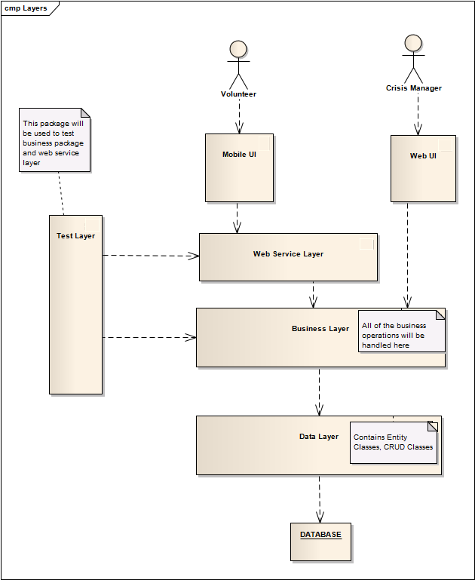

Figure 2. Logical View of VMS

More about the Logical view and detailed explanation of other views can be found in “SAD” document.

## Software Design Description

SDD document contains the detailed design based on the functional requirements, quality attributes and VMS architecture. It was guideline for developers who developed the VSM system. “SDD” document is located in “ArchitectureDesign” folder.

Structural design section of the SDD explains the layers, important components and classes inside the layers. Behavioural design explains the most important behaviours of the system and explains how these behaviours should be implemented by the developers. For explanation of some behaviours of the system, sequence diagrams had been used. For others only textual explanation has been written.

## Manager’s Manual

In order to provide the manager with the ability of using the features of the system in an efficient way, a Manager’s Manual is provided. The manager, who interacts with the system through web portal, will learn how to register and log in to the system by this manual. He also can find how to work with a crisis, with the incidents, with the requests for incidents, and how to search volunteers and send them alerts.

## Volunteer’s Manual

Volunteers interact with VMS Mobile application and should have enough knowledge of how to work with that in an efficient way even though the application is made quite self-descriptive. For this purpose a volunteer’s manual has been prepared which describes the system functionalities and the way they can use them in a quick, easy way. By reading this manual they will learn how to log in to the system, report about a new incident, receive alerts from manager, receive requests and accept/reject them, and report progress of the incident which they’re assigned to.

## Web Portal Installation Guide

The Web Portal Installation Guide explains the steps needed to deploy the web portal on the server. As deploying the web portal is not a very frequent action for each organization, it’s using technical vocabulary. The content of this guide shows how to deploy web application, database and connecting them by setting configurations.

# Conclusion

During the Technical Challenge Project course Apollo group worked on the VMS project. Based on the Industrial Challenge Project course outputs, this project continued and finished with the working system. The system was developed by the Apollo group. 84% of the functionality of the system was developed and tested by different testing strategies and techniques which are mentioned in the Test plan section.  Section Deliverables explains most of the documents which have been produced during the Technical Challenge course by Apollo group.

The “SourceCode” folder within the deliverables contains two zip files. “VMSClient.zip”   contains the source code of the VMS mobile application and “WebPortal.zip” file contains the source code for web part of the system.

1. <http://www.unv.org/en/current-highlight/focus-on-emergency-relief/doc/volunteers-vital-before-and.html>
2. Definition by Project Management Body of Knowledge
3. D. Galin. Software Quality Assurance. Pearson, p.194, 2004
4. The method has been taken from the article “Estimating Software Development Effort based on Use Cases”, Bente Anda, Hege Dreiem, Dag I.K. Sjøberg, and Magne Jørgensen