Volunteers’ Management System
Software Architecture Document
Version 0.1

Revision History
Date | Version | Description | Author
12 December 2009 | 0.1 | Initial version created. | Abdollah Tabareh
14 December 2009 | 0.1 | Revised | Shobha B C
Table of Contents
1. Introduction
1.1 Purpose
1.2 Scope
1.3 Definitions, Acronyms and Abbreviations
1.4 References
1.5 Overview
2. Architectural Representation
3. Architectural Goals and Constraints
4. Use-Case View

5. Logical View
5.1 Overview
5.2 Architecturally Significant Design Packages
5.3 Use-Case Realizations
6. Process View
7. Deployment View
8. Implementation View
8.1 Overview
8.2 Layers
9. Data View (optional)
10. Size and Performance
11. Quality

- Introduction
  - Purpose
This document provides a comprehensive architectural overview of the system, using different architectural views to depict different aspects of the system. It is intended to capture and convey the significant architectural decisions which are made for the system.
The purpose of the software architecture document is to effectively communicate the architecture of the proposed VMS to the members of the Project Development Team for attaining detailed architecture and as well as project Stakeholders.
From a business point of view, the proposed software architecture is evaluated in terms of its ability to support the business, functional and non functional requirements. Functional requirements are realized by various use cases with in use case model.
  - References
- RUP Model, Software Architecture Document template.
- Volunteers’ Management System, Software Requirements Specification
- Application architecture for .net platform by Microsoft website
- Architectural Goals and Constraints
The following are some of the major software requirements and objectives that have a significant impact on the VMS software architecture.
- Use of Google Map GIS System services in web-based client
- Use of Java as client application on mobile phones, takes into an account of quality criteria specified in supplementary specification document.
- Connection between mobile clients and the server through 3G, GPRS, and WLAN
- Use of web-based client application for Manager’s side which is based on HTML 4.0, takes into an account of quality criteria specified in supplementary specification document.
- Use of design patterns like façade as a part of corporation design policy, takes into an account of maintainability criteria specified in supplementary specification document.
- Use of XML 1.0 as the standard for data output gates for the system takes into an account of quality criteria
- Use of service-oriented architecture as the nature of project supports this idea.
- VMS software architecture must be capable of supporting all the non-functional requirements which are explained in the supplementary documented.
- VMS software architecture must be capable of directly or indirectly supporting all the business and functional requirements as realized by the various use cases within the use case model
[in brief for extend: Technological, quality, requirement constraints which have influence on architecture along with reason behind]
- Logical View
  - Overview
This subsection describes the overall decomposition of the design model in terms of its package hierarchy and layers.
Overall architecture of the system consists of the following layers which will be explained subsequently in this section.
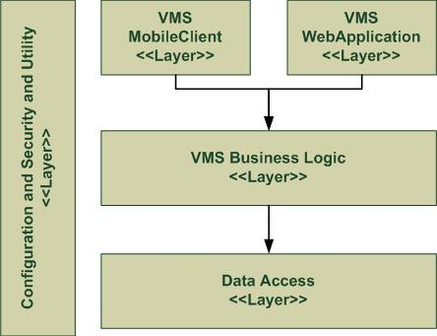
  - Configuration, Security and Utility (CSU)
The name of the package itself is self explanatory, all service related to security and configuration of the tiers in the system will be encapsulated in this package. And many utilities will be used throughout the execution of the project will be encapsulated here in this package.
The major packages of this layer are as followings:
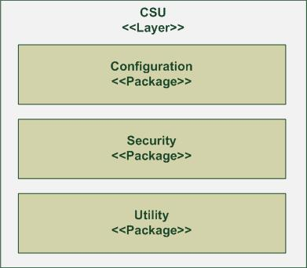
    - Configuration
This package contains all sub-packages and classes related to set and to read configuration of the system. It provides a single point to centralize changes and avoid redundancy of configuration modules throughout the system. Most of the classes in this package will be designed using singleton design pattern, as one instance of them has to be available throughout the layers and packages in run-time.
    - Security
This package contains all sub-packages and classes related to security of the system. Checking security, encrypt, and decrypt of passwords are one of the instances of the responsibilities it has.
    - Utility
All modules which are needed throughout the system will be encapsulated in this package. Converting date and calendar formats, communication providers, and language extension classes are some of the instances of the contents in this package.
  - Data access layer
This layer is responsible for providing clear and object-based data between other layers of the system from the underlying relational database management system. It’s also responsible to provide such a data from other service based data stores which this system may connect to. In the diagram bellow you can see the major packages of this layer.
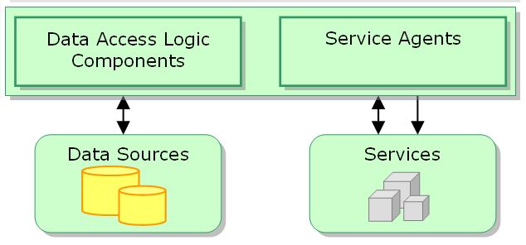
    - Data Access Logic Components
Other layers of your system will use these set of components to access the data stored in the underlying data sources. There may also be some packages and classes which may help in the process of preparing data.
    - Service Agents
Components inside this package will provide data for other layers and packages from other services on the network.
  - Business Logic Layer
Most of the business rules and the business functionality that VMS provides will be encapsulated here and they are accessible from this layer. The major packages in this layer are shown in the following diagram and will be explained below.
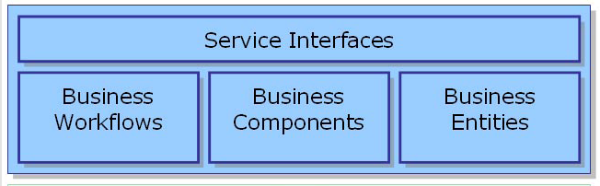
    - Service interfaces
Depicts the whole services that the layer provides, gives a single access point to conform the façade design pattern. All clients and other services which need the encapsulated services inside this layer have to be incorporated through this interface. It means from package outside, no access to background component and services is possible.
    - Business workflows
These components will manage the business process which consists of multiple steps to perform. These components also encapsulate the logic of business.
    - Business components
It manages a single business abstraction. VMS applications with the business framework consist of several business components that work together to provide the application functionality.
Business components consist of business component, advantages of components, entity maps, and entity association information.
    - Business entities

  - Use-Case Realizations
[This section illustrates how the software actually works by giving a few selected use-case (or scenario) realizations, and explains how the various design model elements contribute to their functionality.
- Deployment View
[This section describes one or more physical network (hardware) configurations on which the software is deployed and run. It is a view of the Deployment Model. At a minimum for each configuration it should indicate the physical nodes (computers, CPUs) that execute the software, and their interconnections (bus, LAN, point-to-point, and so on.) Also include a mapping of the processes of the Process View onto the physical nodes.]
