Name =Rehana Soomro
Roll number=26i3098
Section=Se-B

Prompt to gemini:
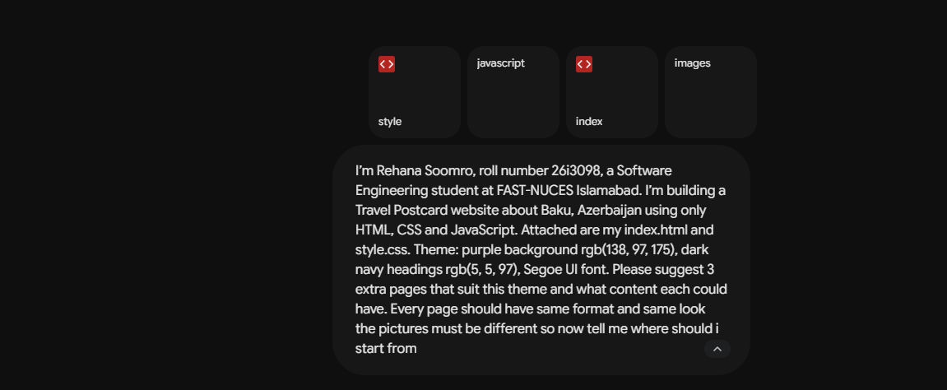
Suggested page ideas:

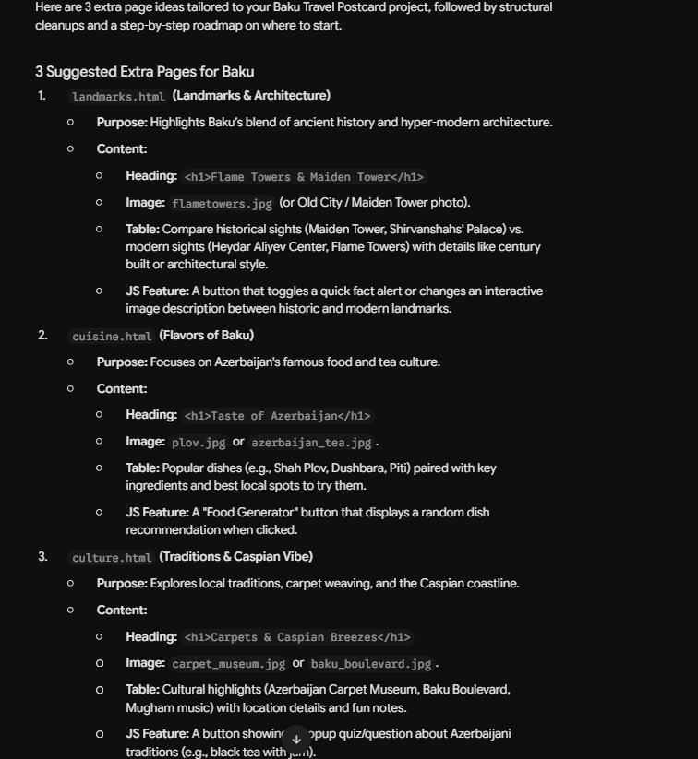

Link to github:
https://github.com/soomrorehana095-star/Postcard-Travel

