北京市普通高等学校招生全国统一考试

实测数据统计分析报告

理科综合（物理）

 LOGO_BEEA2

2013年7月

**目 录**

[第一部分 整体统计分析 1](#_Toc372633769)

[一 总体分析 1](#_Toc372633770)

[二 题组分析 8](#_Toc372633771)

[(一) 理综主客观题组 8](#_Toc372633772)

[第二部分 物理统计分析 14](#_Toc372633773)

[一 总体分析 14](#_Toc372633774)

[二 题组分析 19](#_Toc372633775)

[(一) 主客观题组 19](#_Toc372633776)

[(二) 知识组块 23](#_Toc372633777)

[(三) 能力组块 31](#_Toc372633778)

[三 题目分析 39](#_Toc372633779)

[四 相关分析 72](#_Toc372633780)

1. 整体统计分析
   1. 总体分析

表 1总分分析表

|  |  |  |  |  |  |  |
| --- | --- | --- | --- | --- | --- | --- |
| 总人数 | 满分值 | 最大值 | 最小值 | 平均值 | 标准差 | 差异系数 |
| 41820 | 300 | 292.00 | 6.00 | 176.88 | 48.27 | 0.27 |
| 难度 | alpha系数 | 标准误 | 中数 | 众数 | 偏度 | 峰度 |
| 0.59 | 0.85 | 0.24 | 179.14 | 165.00 | -0.13 | -0.48 |

图 1总分分布曲线图

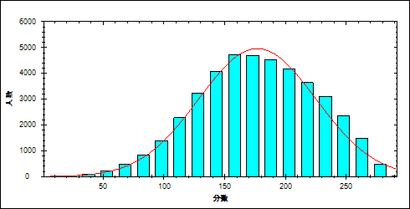

表 2科目整体分析表

| 题目 | 满分值 | 最大值 | 最小值 | 平均值 | 标准差 | 差异系数 | 难度 | 相关系数 | 鉴别系数 |
| --- | --- | --- | --- | --- | --- | --- | --- | --- | --- |
| 生物 | 80.00 | 77.00 | 0.00 | 46.14 | 12.53 | 0.27 | 0.58 | 0.83 | 0.32 |
| 化学 | 100.00 | 100.00 | 0.00 | 60.37 | 17.67 | 0.29 | 0.60 | 0.91 | 0.40 |
| 物理 | 120.00 | 120.00 | 1.00 | 70.37 | 23.37 | 0.33 | 0.59 | 0.94 | 0.46 |

表 3总分频数分布表

| 分值 | 频数 | 比率（%） | 累计频数 | 累计频率（%） |
| --- | --- | --- | --- | --- |
| 292.00 | 2 | 0.00 | 2 | 0.00 |
| 291.00 | 4 | 0.01 | 6 | 0.01 |
| 290.00 | 4 | 0.01 | 10 | 0.02 |
| 289.00 | 4 | 0.01 | 14 | 0.03 |
| 288.00 | 8 | 0.02 | 22 | 0.05 |
| 287.00 | 5 | 0.01 | 27 | 0.06 |
| 286.00 | 9 | 0.02 | 36 | 0.09 |
| 285.00 | 12 | 0.03 | 48 | 0.11 |
| 284.00 | 13 | 0.03 | 61 | 0.15 |
| 283.00 | 10 | 0.02 | 71 | 0.17 |
| 282.00 | 20 | 0.05 | 91 | 0.22 |
| 281.00 | 22 | 0.05 | 113 | 0.27 |
| 280.00 | 31 | 0.07 | 144 | 0.34 |
| 279.00 | 24 | 0.06 | 168 | 0.40 |
| 278.00 | 36 | 0.09 | 204 | 0.49 |
| 277.00 | 33 | 0.08 | 237 | 0.57 |
| 276.00 | 42 | 0.10 | 279 | 0.67 |
| 275.00 | 39 | 0.09 | 318 | 0.76 |
| 274.00 | 38 | 0.09 | 356 | 0.85 |
| 273.00 | 44 | 0.11 | 400 | 0.96 |
| 272.00 | 58 | 0.14 | 458 | 1.10 |
| 271.00 | 60 | 0.14 | 518 | 1.24 |
| 270.00 | 72 | 0.17 | 590 | 1.41 |
| 269.00 | 59 | 0.14 | 649 | 1.55 |
| 268.00 | 79 | 0.19 | 728 | 1.74 |
| 267.00 | 75 | 0.18 | 803 | 1.92 |
| 266.00 | 91 | 0.22 | 894 | 2.14 |
| 265.00 | 96 | 0.23 | 990 | 2.37 |
| 264.00 | 90 | 0.22 | 1080 | 2.58 |
| 263.00 | 93 | 0.22 | 1173 | 2.80 |
| 262.00 | 105 | 0.25 | 1278 | 3.06 |
| 261.00 | 117 | 0.28 | 1395 | 3.34 |
| 260.00 | 98 | 0.23 | 1493 | 3.57 |
| 259.00 | 115 | 0.27 | 1608 | 3.85 |
| 258.00 | 125 | 0.30 | 1733 | 4.14 |
| 257.00 | 138 | 0.33 | 1871 | 4.47 |
| 256.00 | 134 | 0.32 | 2005 | 4.79 |
| 255.00 | 131 | 0.31 | 2136 | 5.11 |
| 254.00 | 121 | 0.29 | 2257 | 5.40 |
| 253.00 | 144 | 0.34 | 2401 | 5.74 |
| 252.00 | 154 | 0.37 | 2555 | 6.11 |
| 251.00 | 161 | 0.38 | 2716 | 6.49 |
| 250.00 | 154 | 0.37 | 2870 | 6.86 |
| 249.00 | 148 | 0.35 | 3018 | 7.22 |
| 248.00 | 175 | 0.42 | 3193 | 7.64 |
| 247.00 | 160 | 0.38 | 3353 | 8.02 |
| 246.00 | 161 | 0.38 | 3514 | 8.40 |
| 245.00 | 156 | 0.37 | 3670 | 8.78 |
| 244.00 | 173 | 0.41 | 3843 | 9.19 |
| 243.00 | 170 | 0.41 | 4013 | 9.60 |
| 242.00 | 184 | 0.44 | 4197 | 10.04 |
| 241.00 | 160 | 0.38 | 4357 | 10.42 |
| 240.00 | 199 | 0.48 | 4556 | 10.89 |
| 239.00 | 170 | 0.41 | 4726 | 11.30 |
| 238.00 | 198 | 0.47 | 4924 | 11.77 |
| 237.00 | 207 | 0.49 | 5131 | 12.27 |
| 236.00 | 192 | 0.46 | 5323 | 12.73 |
| 235.00 | 201 | 0.48 | 5524 | 13.21 |
| 234.00 | 184 | 0.44 | 5708 | 13.65 |
| 233.00 | 203 | 0.49 | 5911 | 14.13 |
| 232.00 | 188 | 0.45 | 6099 | 14.58 |
| 231.00 | 210 | 0.50 | 6309 | 15.09 |
| 230.00 | 217 | 0.52 | 6526 | 15.60 |
| 229.00 | 236 | 0.56 | 6762 | 16.17 |
| 228.00 | 210 | 0.50 | 6972 | 16.67 |
| 227.00 | 250 | 0.60 | 7222 | 17.27 |
| 226.00 | 238 | 0.57 | 7460 | 17.84 |
| 225.00 | 206 | 0.49 | 7666 | 18.33 |
| 224.00 | 215 | 0.51 | 7881 | 18.85 |
| 223.00 | 228 | 0.55 | 8109 | 19.39 |
| 222.00 | 237 | 0.57 | 8346 | 19.96 |
| 221.00 | 217 | 0.52 | 8563 | 20.48 |
| 220.00 | 263 | 0.63 | 8826 | 21.10 |
| 219.00 | 246 | 0.59 | 9072 | 21.69 |
| 218.00 | 269 | 0.64 | 9341 | 22.34 |
| 217.00 | 238 | 0.57 | 9579 | 22.91 |
| 216.00 | 267 | 0.64 | 9846 | 23.54 |
| 215.00 | 255 | 0.61 | 10101 | 24.15 |
| 214.00 | 262 | 0.63 | 10363 | 24.78 |
| 213.00 | 250 | 0.60 | 10613 | 25.38 |
| 212.00 | 244 | 0.58 | 10857 | 25.96 |
| 211.00 | 243 | 0.58 | 11100 | 26.54 |
| 210.00 | 277 | 0.66 | 11377 | 27.20 |
| 209.00 | 261 | 0.62 | 11638 | 27.83 |
| 208.00 | 255 | 0.61 | 11893 | 28.44 |
| 207.00 | 276 | 0.66 | 12169 | 29.10 |
| 206.00 | 259 | 0.62 | 12428 | 29.72 |
| 205.00 | 279 | 0.67 | 12707 | 30.38 |
| 204.00 | 252 | 0.60 | 12959 | 30.99 |
| 203.00 | 266 | 0.64 | 13225 | 31.62 |
| 202.00 | 249 | 0.60 | 13474 | 32.22 |
| 201.00 | 329 | 0.79 | 13803 | 33.01 |
| 200.00 | 308 | 0.74 | 14111 | 33.74 |
| 199.00 | 304 | 0.73 | 14415 | 34.47 |
| 198.00 | 294 | 0.70 | 14709 | 35.17 |
| 197.00 | 283 | 0.68 | 14992 | 35.85 |
| 196.00 | 271 | 0.65 | 15263 | 36.50 |
| 195.00 | 288 | 0.69 | 15551 | 37.19 |
| 194.00 | 301 | 0.72 | 15852 | 37.91 |
| 193.00 | 302 | 0.72 | 16154 | 38.63 |
| 192.00 | 309 | 0.74 | 16463 | 39.37 |
| 191.00 | 270 | 0.65 | 16733 | 40.01 |
| 190.00 | 287 | 0.69 | 17020 | 40.70 |
| 189.00 | 322 | 0.77 | 17342 | 41.47 |
| 188.00 | 285 | 0.68 | 17627 | 42.15 |
| 187.00 | 302 | 0.72 | 17929 | 42.87 |
| 186.00 | 323 | 0.77 | 18252 | 43.64 |
| 185.00 | 311 | 0.74 | 18563 | 44.39 |
| 184.00 | 320 | 0.77 | 18883 | 45.15 |
| 183.00 | 277 | 0.66 | 19160 | 45.82 |
| 182.00 | 313 | 0.75 | 19473 | 46.56 |
| 181.00 | 312 | 0.75 | 19785 | 47.31 |
| 180.00 | 320 | 0.77 | 20105 | 48.08 |
| 179.00 | 330 | 0.79 | 20435 | 48.86 |
| 178.00 | 289 | 0.69 | 20724 | 49.56 |
| 177.00 | 329 | 0.79 | 21053 | 50.34 |
| 176.00 | 306 | 0.73 | 21359 | 51.07 |
| 175.00 | 320 | 0.77 | 21679 | 51.84 |
| 174.00 | 296 | 0.71 | 21975 | 52.55 |
| 173.00 | 322 | 0.77 | 22297 | 53.32 |
| 172.00 | 307 | 0.73 | 22604 | 54.05 |
| 171.00 | 289 | 0.69 | 22893 | 54.74 |
| 170.00 | 341 | 0.82 | 23234 | 55.56 |
| 169.00 | 298 | 0.71 | 23532 | 56.27 |
| 168.00 | 306 | 0.73 | 23838 | 57.00 |
| 167.00 | 323 | 0.77 | 24161 | 57.77 |
| 166.00 | 324 | 0.77 | 24485 | 58.55 |
| 165.00 | 378 | 0.90 | 24863 | 59.45 |
| 164.00 | 310 | 0.74 | 25173 | 60.19 |
| 163.00 | 312 | 0.75 | 25485 | 60.94 |
| 162.00 | 306 | 0.73 | 25791 | 61.67 |
| 161.00 | 328 | 0.78 | 26119 | 62.46 |
| 160.00 | 308 | 0.74 | 26427 | 63.19 |
| 159.00 | 331 | 0.79 | 26758 | 63.98 |
| 158.00 | 306 | 0.73 | 27064 | 64.72 |
| 157.00 | 292 | 0.70 | 27356 | 65.41 |
| 156.00 | 319 | 0.76 | 27675 | 66.18 |
| 155.00 | 295 | 0.71 | 27970 | 66.88 |
| 154.00 | 311 | 0.74 | 28281 | 67.63 |
| 153.00 | 308 | 0.74 | 28589 | 68.36 |
| 152.00 | 312 | 0.75 | 28901 | 69.11 |
| 151.00 | 304 | 0.73 | 29205 | 69.84 |
| 150.00 | 302 | 0.72 | 29507 | 70.56 |
| 149.00 | 275 | 0.66 | 29782 | 71.21 |
| 148.00 | 272 | 0.65 | 30054 | 71.87 |
| 147.00 | 297 | 0.71 | 30351 | 72.58 |
| 146.00 | 246 | 0.59 | 30597 | 73.16 |
| 145.00 | 266 | 0.64 | 30863 | 73.80 |
| 144.00 | 300 | 0.72 | 31163 | 74.52 |
| 143.00 | 277 | 0.66 | 31440 | 75.18 |
| 142.00 | 282 | 0.67 | 31722 | 75.85 |
| 141.00 | 258 | 0.62 | 31980 | 76.47 |
| 140.00 | 292 | 0.70 | 32272 | 77.17 |
| 139.00 | 267 | 0.64 | 32539 | 77.81 |
| 138.00 | 251 | 0.60 | 32790 | 78.41 |
| 137.00 | 247 | 0.59 | 33037 | 79.00 |
| 136.00 | 239 | 0.57 | 33276 | 79.57 |
| 135.00 | 235 | 0.56 | 33511 | 80.13 |
| 134.00 | 243 | 0.58 | 33754 | 80.71 |
| 133.00 | 212 | 0.51 | 33966 | 81.22 |
| 132.00 | 231 | 0.55 | 34197 | 81.77 |
| 131.00 | 255 | 0.61 | 34452 | 82.38 |
| 130.00 | 217 | 0.52 | 34669 | 82.90 |
| 129.00 | 257 | 0.61 | 34926 | 83.52 |
| 128.00 | 222 | 0.53 | 35148 | 84.05 |
| 127.00 | 202 | 0.48 | 35350 | 84.53 |
| 126.00 | 201 | 0.48 | 35551 | 85.01 |
| 125.00 | 221 | 0.53 | 35772 | 85.54 |
| 124.00 | 223 | 0.53 | 35995 | 86.07 |
| 123.00 | 177 | 0.42 | 36172 | 86.49 |
| 122.00 | 170 | 0.41 | 36342 | 86.90 |
| 121.00 | 171 | 0.41 | 36513 | 87.31 |
| 120.00 | 165 | 0.39 | 36678 | 87.70 |
| 119.00 | 187 | 0.45 | 36865 | 88.15 |
| 118.00 | 168 | 0.40 | 37033 | 88.55 |
| 117.00 | 148 | 0.35 | 37181 | 88.91 |
| 116.00 | 160 | 0.38 | 37341 | 89.29 |
| 115.00 | 153 | 0.37 | 37494 | 89.66 |
| 114.00 | 156 | 0.37 | 37650 | 90.03 |
| 113.00 | 138 | 0.33 | 37788 | 90.36 |
| 112.00 | 155 | 0.37 | 37943 | 90.73 |
| 111.00 | 142 | 0.34 | 38085 | 91.07 |
| 110.00 | 151 | 0.36 | 38236 | 91.43 |
| 109.00 | 136 | 0.33 | 38372 | 91.76 |
| 108.00 | 152 | 0.36 | 38524 | 92.12 |
| 107.00 | 136 | 0.33 | 38660 | 92.44 |
| 106.00 | 132 | 0.32 | 38792 | 92.76 |
| 105.00 | 123 | 0.29 | 38915 | 93.05 |
| 104.00 | 128 | 0.31 | 39043 | 93.36 |
| 103.00 | 107 | 0.26 | 39150 | 93.62 |
| 102.00 | 97 | 0.23 | 39247 | 93.85 |
| 101.00 | 120 | 0.29 | 39367 | 94.13 |
| 100.00 | 90 | 0.22 | 39457 | 94.35 |
| 99.00 | 99 | 0.24 | 39556 | 94.59 |
| 98.00 | 94 | 0.22 | 39650 | 94.81 |
| 97.00 | 74 | 0.18 | 39724 | 94.99 |
| 96.00 | 86 | 0.21 | 39810 | 95.19 |
| 95.00 | 69 | 0.16 | 39879 | 95.36 |
| 94.00 | 95 | 0.23 | 39974 | 95.59 |
| 93.00 | 74 | 0.18 | 40048 | 95.76 |
| 92.00 | 64 | 0.15 | 40112 | 95.92 |
| 91.00 | 66 | 0.16 | 40178 | 96.07 |
| 90.00 | 83 | 0.20 | 40261 | 96.27 |
| 89.00 | 87 | 0.21 | 40348 | 96.48 |
| 88.00 | 55 | 0.13 | 40403 | 96.61 |
| 87.00 | 68 | 0.16 | 40471 | 96.77 |
| 86.00 | 48 | 0.11 | 40519 | 96.89 |
| 85.00 | 73 | 0.17 | 40592 | 97.06 |
| 84.00 | 64 | 0.15 | 40656 | 97.22 |
| 83.00 | 43 | 0.10 | 40699 | 97.32 |
| 82.00 | 61 | 0.15 | 40760 | 97.47 |
| 81.00 | 47 | 0.11 | 40807 | 97.58 |
| 80.00 | 50 | 0.12 | 40857 | 97.70 |
| 79.00 | 52 | 0.12 | 40909 | 97.82 |
| 78.00 | 37 | 0.09 | 40946 | 97.91 |
| 77.00 | 45 | 0.11 | 40991 | 98.02 |
| 76.00 | 36 | 0.09 | 41027 | 98.10 |
| 75.00 | 45 | 0.11 | 41072 | 98.21 |
| 74.00 | 34 | 0.08 | 41106 | 98.29 |
| 73.00 | 41 | 0.10 | 41147 | 98.39 |
| 72.00 | 36 | 0.09 | 41183 | 98.48 |
| 71.00 | 36 | 0.09 | 41219 | 98.56 |
| 70.00 | 28 | 0.07 | 41247 | 98.63 |
| 69.00 | 32 | 0.08 | 41279 | 98.71 |
| 68.00 | 28 | 0.07 | 41307 | 98.77 |
| 67.00 | 35 | 0.08 | 41342 | 98.86 |
| 66.00 | 32 | 0.08 | 41374 | 98.93 |
| 65.00 | 23 | 0.05 | 41397 | 98.99 |
| 64.00 | 20 | 0.05 | 41417 | 99.04 |
| 63.00 | 28 | 0.07 | 41445 | 99.10 |
| 62.00 | 20 | 0.05 | 41465 | 99.15 |
| 61.00 | 34 | 0.08 | 41499 | 99.23 |
| 60.00 | 19 | 0.05 | 41518 | 99.28 |
| 59.00 | 17 | 0.04 | 41535 | 99.32 |
| 58.00 | 23 | 0.05 | 41558 | 99.37 |
| 57.00 | 21 | 0.05 | 41579 | 99.42 |
| 56.00 | 10 | 0.02 | 41589 | 99.45 |
| 55.00 | 23 | 0.05 | 41612 | 99.50 |
| 54.00 | 18 | 0.04 | 41630 | 99.55 |
| 53.00 | 14 | 0.03 | 41644 | 99.58 |
| 52.00 | 10 | 0.02 | 41654 | 99.60 |
| 51.00 | 6 | 0.01 | 41660 | 99.62 |
| 50.00 | 15 | 0.04 | 41675 | 99.65 |
| 49.00 | 7 | 0.02 | 41682 | 99.67 |
| 48.00 | 10 | 0.02 | 41692 | 99.69 |
| 47.00 | 11 | 0.03 | 41703 | 99.72 |
| 46.00 | 9 | 0.02 | 41712 | 99.74 |
| 45.00 | 12 | 0.03 | 41724 | 99.77 |
| 44.00 | 5 | 0.01 | 41729 | 99.78 |
| 43.00 | 7 | 0.02 | 41736 | 99.80 |
| 42.00 | 9 | 0.02 | 41745 | 99.82 |
| 41.00 | 5 | 0.01 | 41750 | 99.83 |
| 40.00 | 10 | 0.02 | 41760 | 99.86 |
| 39.00 | 9 | 0.02 | 41769 | 99.88 |
| 38.00 | 8 | 0.02 | 41777 | 99.90 |
| 37.00 | 6 | 0.01 | 41783 | 99.91 |
| 36.00 | 8 | 0.02 | 41791 | 99.93 |
| 35.00 | 4 | 0.01 | 41795 | 99.94 |
| 34.00 | 3 | 0.01 | 41798 | 99.95 |
| 33.00 | 3 | 0.01 | 41801 | 99.95 |
| 32.00 | 2 | 0.00 | 41803 | 99.96 |
| 31.00 | 2 | 0.00 | 41805 | 99.96 |
| 30.00 | 3 | 0.01 | 41808 | 99.97 |
| 29.00 | 2 | 0.00 | 41810 | 99.98 |
| 26.00 | 1 | 0.00 | 41811 | 99.98 |
| 25.00 | 2 | 0.00 | 41813 | 99.98 |
| 23.00 | 1 | 0.00 | 41814 | 99.99 |
| 21.00 | 1 | 0.00 | 41815 | 99.99 |
| 18.00 | 1 | 0.00 | 41816 | 99.99 |
| 16.00 | 1 | 0.00 | 41817 | 99.99 |
| 14.00 | 1 | 0.00 | 41818 | 100.00 |
| 11.00 | 1 | 0.00 | 41819 | 100.00 |
| 6.00 | 1 | 0.00 | 41820 | 100.00 |

* 1. 题组分析
     1. 理综主客观题组
        1. 理综客观题

本题组包含:1~5,29~31,29\_11,29\_12,29\_13,29\_21,29\_22,29\_3,29\_41,29\_42,29\_5,29\_6,30\_1,30\_21,30\_22,30\_3,30\_41,30\_42,30\_5,30\_61,30\_62,30\_63,31\_1,31\_21,31\_22,31\_31,31\_32,31\_33,31\_34,31\_41,31\_42,31\_5

表 4生物总分分布表

|  |  |  |  |  |  |  |  |  |
| --- | --- | --- | --- | --- | --- | --- | --- | --- |
| 满分值 | 最大值 | 最小值 | 平均值 | 标准差 | 差异系数 | 难度 | 相关系数 | 鉴别系数 |
| 80.00 | 77.00 | 0.00 | 46.14 | 12.53 | 0.27 | 0.58 | 0.83 | 0.32 |

图 2理综客观题分数分布表

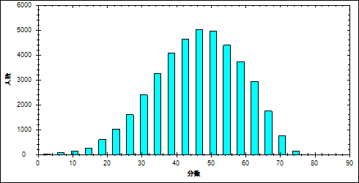

图 3理综客观题难度曲线图

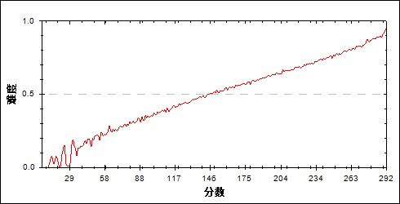

表 5理综客观题分组分析表

| 分值 | G1 | G2 | G3 | G4 | G5 | G6 | G7 | 频数 | 比率（%） | 平均值 |
| --- | --- | --- | --- | --- | --- | --- | --- | --- | --- | --- |
| 0- | 13 | 0 | 0 | 0 | 0 | 0 | 0 | 13 | 0.03 | 43.85 |
| 2- | 8 | 1 | 0 | 0 | 0 | 0 | 0 | 9 | 0.02 | 50.67 |
| 4- | 4 | 0 | 0 | 0 | 0 | 0 | 0 | 4 | 0.01 | 66.25 |
| 6- | 42 | 0 | 0 | 0 | 0 | 0 | 0 | 42 | 0.10 | 50.17 |
| 7- | 1 | 1 | 0 | 0 | 0 | 0 | 0 | 2 | 0.00 | 84.00 |
| 8- | 29 | 1 | 0 | 0 | 0 | 0 | 0 | 30 | 0.07 | 55.17 |
| 9- | 4 | 0 | 0 | 0 | 0 | 0 | 0 | 4 | 0.01 | 79.50 |
| 10- | 35 | 0 | 0 | 0 | 0 | 0 | 0 | 35 | 0.08 | 68.89 |
| 11- | 8 | 0 | 0 | 0 | 0 | 0 | 0 | 8 | 0.02 | 86.75 |
| 12- | 91 | 1 | 0 | 0 | 0 | 0 | 0 | 92 | 0.22 | 65.08 |
| 13- | 11 | 1 | 0 | 0 | 0 | 0 | 0 | 12 | 0.03 | 85.08 |
| 14- | 94 | 2 | 0 | 0 | 0 | 0 | 0 | 96 | 0.23 | 75.72 |
| 15- | 39 | 2 | 0 | 0 | 0 | 0 | 0 | 41 | 0.10 | 87.66 |
| 16- | 119 | 3 | 1 | 0 | 0 | 0 | 0 | 123 | 0.29 | 81.99 |
| 17- | 39 | 4 | 2 | 0 | 0 | 0 | 0 | 45 | 0.11 | 94.47 |
| 18- | 228 | 11 | 1 | 1 | 0 | 0 | 0 | 241 | 0.58 | 83.63 |
| 19- | 69 | 10 | 2 | 0 | 0 | 0 | 0 | 81 | 0.19 | 102.57 |
| 20- | 214 | 18 | 5 | 1 | 0 | 0 | 0 | 238 | 0.57 | 92.11 |
| 21- | 91 | 22 | 8 | 1 | 0 | 0 | 0 | 122 | 0.29 | 107.70 |
| 22- | 250 | 41 | 8 | 0 | 0 | 0 | 0 | 299 | 0.71 | 100.37 |
| 23- | 139 | 41 | 6 | 2 | 0 | 0 | 0 | 188 | 0.45 | 105.97 |
| 24- | 318 | 66 | 21 | 4 | 2 | 2 | 0 | 413 | 0.99 | 106.61 |
| 25- | 156 | 62 | 21 | 7 | 1 | 0 | 0 | 247 | 0.59 | 115.98 |
| 26- | 330 | 93 | 40 | 6 | 1 | 0 | 0 | 470 | 1.12 | 111.01 |
| 27- | 202 | 118 | 49 | 19 | 2 | 0 | 0 | 390 | 0.93 | 122.67 |
| 28- | 292 | 139 | 48 | 17 | 1 | 0 | 0 | 497 | 1.19 | 119.33 |
| 29- | 231 | 160 | 56 | 21 | 6 | 2 | 0 | 476 | 1.14 | 125.43 |
| 30- | 343 | 181 | 94 | 23 | 8 | 1 | 0 | 650 | 1.55 | 123.15 |
| 31- | 204 | 184 | 99 | 41 | 12 | 3 | 0 | 543 | 1.30 | 132.59 |
| 32- | 288 | 262 | 113 | 51 | 16 | 1 | 0 | 731 | 1.75 | 130.90 |
| 33- | 243 | 245 | 126 | 65 | 24 | 4 | 0 | 707 | 1.69 | 136.09 |
| 34- | 258 | 287 | 180 | 75 | 20 | 3 | 0 | 823 | 1.97 | 136.86 |
| 35- | 193 | 297 | 193 | 107 | 32 | 3 | 0 | 825 | 1.97 | 142.79 |
| 36- | 189 | 314 | 202 | 138 | 47 | 5 | 0 | 895 | 2.14 | 145.02 |
| 37- | 168 | 285 | 236 | 177 | 59 | 10 | 0 | 935 | 2.24 | 148.86 |
| 38- | 166 | 305 | 269 | 167 | 61 | 17 | 0 | 985 | 2.36 | 149.33 |
| 39- | 155 | 299 | 274 | 184 | 91 | 26 | 1 | 1030 | 2.46 | 153.06 |
| 40- | 148 | 301 | 269 | 241 | 136 | 29 | 1 | 1125 | 2.69 | 155.98 |
| 41- | 93 | 284 | 288 | 252 | 134 | 45 | 2 | 1098 | 2.63 | 160.22 |
| 42- | 96 | 280 | 281 | 265 | 188 | 74 | 3 | 1187 | 2.84 | 163.60 |
| 43- | 85 | 221 | 319 | 285 | 174 | 86 | 7 | 1177 | 2.81 | 165.85 |
| 44- | 46 | 215 | 294 | 294 | 203 | 104 | 14 | 1170 | 2.80 | 170.11 |
| 45- | 49 | 200 | 297 | 317 | 257 | 117 | 15 | 1252 | 2.99 | 172.12 |
| 46- | 37 | 181 | 287 | 304 | 259 | 135 | 18 | 1221 | 2.92 | 174.30 |
| 47- | 32 | 145 | 298 | 332 | 308 | 154 | 25 | 1294 | 3.09 | 177.36 |
| 48- | 29 | 131 | 242 | 300 | 308 | 207 | 42 | 1259 | 3.01 | 181.75 |
| 49- | 26 | 112 | 229 | 309 | 336 | 232 | 36 | 1280 | 3.06 | 183.18 |
| 50- | 21 | 128 | 194 | 293 | 333 | 249 | 59 | 1277 | 3.05 | 185.80 |
| 51- | 11 | 64 | 173 | 226 | 332 | 291 | 86 | 1183 | 2.83 | 192.07 |
| 52- | 15 | 72 | 161 | 229 | 316 | 336 | 103 | 1232 | 2.95 | 193.60 |
| 53- | 4 | 55 | 136 | 222 | 312 | 310 | 127 | 1166 | 2.79 | 196.55 |
| 54- | 7 | 34 | 94 | 205 | 275 | 362 | 175 | 1152 | 2.75 | 202.24 |
| 55- | 5 | 24 | 83 | 143 | 284 | 357 | 198 | 1094 | 2.62 | 205.94 |
| 56- | 4 | 19 | 74 | 131 | 228 | 339 | 187 | 982 | 2.35 | 207.09 |
| 57- | 1 | 15 | 50 | 124 | 243 | 327 | 272 | 1032 | 2.47 | 211.91 |
| 58- | 2 | 12 | 42 | 104 | 178 | 319 | 296 | 953 | 2.28 | 215.29 |
| 59- | 0 | 10 | 30 | 73 | 168 | 290 | 289 | 860 | 2.06 | 217.97 |
| 60- | 0 | 11 | 26 | 57 | 135 | 312 | 352 | 893 | 2.14 | 222.50 |
| 61- | 0 | 5 | 14 | 55 | 124 | 273 | 382 | 853 | 2.04 | 225.73 |
| 62- | 0 | 0 | 10 | 31 | 87 | 206 | 414 | 748 | 1.79 | 231.34 |
| 63- | 0 | 0 | 6 | 20 | 83 | 175 | 385 | 669 | 1.60 | 232.88 |
| 64- | 0 | 0 | 9 | 22 | 56 | 168 | 408 | 663 | 1.59 | 235.84 |
| 65- | 0 | 0 | 7 | 9 | 50 | 128 | 354 | 548 | 1.31 | 238.19 |
| 66- | 0 | 0 | 3 | 13 | 25 | 100 | 315 | 456 | 1.09 | 241.51 |
| 67- | 0 | 0 | 2 | 7 | 19 | 61 | 314 | 403 | 0.96 | 246.48 |
| 68- | 0 | 0 | 0 | 2 | 19 | 42 | 279 | 342 | 0.82 | 248.91 |
| 69- | 0 | 0 | 0 | 0 | 9 | 31 | 235 | 275 | 0.66 | 254.28 |
| 70- | 0 | 0 | 1 | 1 | 4 | 14 | 194 | 214 | 0.51 | 256.51 |
| 71- | 0 | 0 | 1 | 0 | 3 | 10 | 126 | 140 | 0.33 | 259.82 |
| 72- | 0 | 0 | 0 | 1 | 4 | 6 | 121 | 132 | 0.32 | 261.34 |
| 73- | 0 | 0 | 0 | 0 | 0 | 5 | 55 | 60 | 0.14 | 265.63 |
| 74- | 0 | 0 | 0 | 0 | 1 | 3 | 37 | 41 | 0.10 | 264.61 |
| 75- | 0 | 0 | 0 | 0 | 0 | 0 | 24 | 24 | 0.06 | 273.38 |
| 76- | 0 | 0 | 0 | 0 | 0 | 0 | 18 | 18 | 0.04 | 271.56 |
| 77- | 0 | 0 | 0 | 0 | 0 | 0 | 5 | 5 | 0.01 | 278.40 |
| 合计 | 5975 | 5975 | 5974 | 5974 | 5974 | 5974 | 5974 | 41820 | 100.00 | 176.88 |
| 得分率 | 0.36 | 0.48 | 0.53 | 0.58 | 0.63 | 0.69 | 0.77 | - | - | - |

* + - 1. 理综主观题

本题组包含:6~12,25~28,25\_1,25\_2,25\_3\_11,25\_3\_12,25\_32,25\_41,25\_42,26\_11,26\_12,26\_1\_31,26\_1\_32,26\_21,26\_22,26\_23,27\_1,27\_21,27\_22,27\_3,27\_4,27\_51,27\_52,27\_6,28\_11,28\_12,28\_13,28\_21,28\_22,28\_23,28\_3,28\_4

表 6化学总分分布表

|  |  |  |  |  |  |  |  |  |
| --- | --- | --- | --- | --- | --- | --- | --- | --- |
| 满分值 | 最大值 | 最小值 | 平均值 | 标准差 | 差异系数 | 难度 | 相关系数 | 鉴别系数 |
| 100.00 | 100.00 | 0.00 | 60.37 | 17.67 | 0.29 | 0.60 | 0.91 | 0.40 |

图 4理综主观题分数分布表

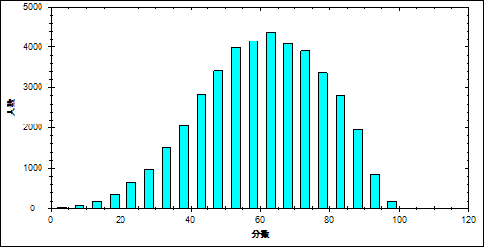

图 5理综主观题难度曲线图

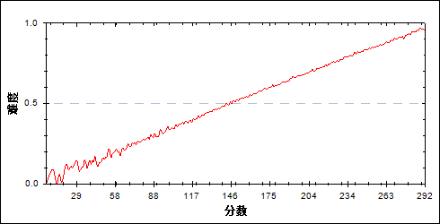

表 7理综主观题分组分析表

| 分值 | G1 | G2 | G3 | G4 | G5 | G6 | G7 | 频数 | 比率（%） | 平均值 |
| --- | --- | --- | --- | --- | --- | --- | --- | --- | --- | --- |
| 0- | 5 | 0 | 0 | 0 | 0 | 0 | 0 | 5 | 0.01 | 33.20 |
| 1- | 2 | 0 | 0 | 0 | 0 | 0 | 0 | 2 | 0.00 | 40.00 |
| 3- | 2 | 0 | 0 | 0 | 0 | 0 | 0 | 2 | 0.00 | 37.50 |
| 4- | 3 | 0 | 0 | 0 | 0 | 0 | 0 | 3 | 0.01 | 45.00 |
| 5- | 2 | 0 | 0 | 0 | 0 | 0 | 0 | 2 | 0.00 | 59.50 |
| 6- | 22 | 0 | 0 | 0 | 0 | 0 | 0 | 22 | 0.05 | 46.45 |
| 7- | 13 | 0 | 0 | 0 | 0 | 0 | 0 | 13 | 0.03 | 54.54 |
| 8- | 10 | 0 | 0 | 0 | 0 | 0 | 0 | 10 | 0.02 | 64.30 |
| 9- | 18 | 0 | 0 | 0 | 0 | 0 | 0 | 18 | 0.04 | 48.50 |
| 10- | 18 | 0 | 0 | 0 | 0 | 0 | 0 | 18 | 0.04 | 45.44 |
| 11- | 24 | 0 | 0 | 0 | 0 | 0 | 0 | 24 | 0.06 | 59.71 |
| 12- | 38 | 0 | 0 | 0 | 0 | 0 | 0 | 38 | 0.09 | 61.76 |
| 13- | 35 | 0 | 0 | 0 | 0 | 0 | 0 | 35 | 0.08 | 63.31 |
| 14- | 35 | 1 | 0 | 0 | 0 | 0 | 0 | 36 | 0.09 | 71.44 |
| 15- | 62 | 2 | 1 | 0 | 0 | 0 | 0 | 65 | 0.16 | 75.88 |
| 16- | 55 | 0 | 0 | 0 | 0 | 0 | 0 | 55 | 0.13 | 65.80 |
| 17- | 64 | 0 | 0 | 0 | 0 | 0 | 0 | 64 | 0.15 | 73.36 |
| 18- | 80 | 2 | 0 | 0 | 0 | 0 | 0 | 82 | 0.20 | 76.00 |
| 19- | 82 | 3 | 0 | 0 | 0 | 0 | 0 | 85 | 0.20 | 81.56 |
| 20- | 74 | 3 | 3 | 0 | 0 | 0 | 0 | 80 | 0.19 | 82.83 |
| 21- | 91 | 3 | 2 | 0 | 0 | 0 | 0 | 96 | 0.23 | 87.32 |
| 22- | 106 | 9 | 3 | 0 | 0 | 0 | 0 | 118 | 0.28 | 89.93 |
| 23- | 126 | 8 | 0 | 0 | 1 | 0 | 0 | 135 | 0.32 | 88.30 |
| 24- | 136 | 12 | 1 | 0 | 0 | 0 | 0 | 149 | 0.36 | 92.48 |
| 25- | 138 | 18 | 2 | 0 | 0 | 0 | 0 | 158 | 0.38 | 95.58 |
| 26- | 131 | 18 | 0 | 0 | 0 | 0 | 0 | 149 | 0.36 | 98.73 |
| 27- | 141 | 12 | 6 | 1 | 0 | 0 | 0 | 160 | 0.38 | 97.17 |
| 28- | 161 | 26 | 6 | 1 | 0 | 0 | 0 | 194 | 0.46 | 101.23 |
| 29- | 195 | 31 | 5 | 0 | 0 | 0 | 0 | 231 | 0.55 | 104.06 |
| 30- | 197 | 33 | 5 | 0 | 0 | 0 | 0 | 235 | 0.56 | 102.39 |
| 31- | 195 | 43 | 8 | 1 | 0 | 0 | 0 | 247 | 0.59 | 108.05 |
| 32- | 231 | 50 | 9 | 3 | 0 | 0 | 0 | 293 | 0.70 | 107.81 |
| 33- | 214 | 63 | 20 | 1 | 0 | 0 | 0 | 298 | 0.71 | 112.95 |
| 34- | 225 | 101 | 17 | 3 | 0 | 0 | 0 | 346 | 0.83 | 115.49 |
| 35- | 227 | 84 | 19 | 3 | 0 | 0 | 0 | 333 | 0.80 | 116.12 |
| 36- | 236 | 126 | 25 | 5 | 0 | 0 | 0 | 392 | 0.94 | 118.88 |
| 37- | 221 | 131 | 38 | 4 | 0 | 0 | 0 | 394 | 0.94 | 121.47 |
| 38- | 213 | 150 | 41 | 4 | 0 | 0 | 0 | 408 | 0.98 | 122.87 |
| 39- | 215 | 132 | 47 | 12 | 0 | 0 | 0 | 406 | 0.97 | 123.81 |
| 40- | 194 | 193 | 67 | 8 | 0 | 0 | 0 | 462 | 1.10 | 128.23 |
| 41- | 199 | 209 | 87 | 24 | 2 | 0 | 0 | 521 | 1.25 | 130.71 |
| 42- | 195 | 235 | 79 | 27 | 0 | 1 | 0 | 537 | 1.28 | 131.38 |
| 43- | 198 | 249 | 108 | 28 | 4 | 1 | 0 | 588 | 1.41 | 133.32 |
| 44- | 168 | 238 | 115 | 43 | 6 | 0 | 0 | 570 | 1.36 | 135.75 |
| 45- | 154 | 268 | 144 | 51 | 11 | 0 | 0 | 628 | 1.50 | 138.73 |
| 46- | 134 | 239 | 168 | 51 | 11 | 0 | 0 | 603 | 1.44 | 140.31 |
| 47- | 109 | 254 | 178 | 67 | 10 | 0 | 0 | 618 | 1.48 | 143.59 |
| 48- | 113 | 284 | 202 | 90 | 23 | 0 | 0 | 712 | 1.70 | 145.32 |
| 49- | 77 | 279 | 241 | 105 | 29 | 0 | 0 | 731 | 1.75 | 148.87 |
| 50- | 74 | 271 | 239 | 130 | 32 | 4 | 0 | 750 | 1.79 | 150.92 |
| 51- | 73 | 252 | 245 | 141 | 41 | 3 | 0 | 755 | 1.81 | 152.37 |
| 52- | 51 | 258 | 267 | 160 | 45 | 2 | 0 | 783 | 1.87 | 154.31 |
| 53- | 44 | 237 | 292 | 162 | 48 | 2 | 0 | 785 | 1.88 | 155.35 |
| 54- | 39 | 235 | 275 | 218 | 79 | 6 | 0 | 852 | 2.04 | 159.06 |
| 55- | 23 | 199 | 294 | 192 | 95 | 14 | 0 | 817 | 1.95 | 161.59 |
| 56- | 23 | 188 | 277 | 237 | 96 | 12 | 1 | 834 | 1.99 | 163.02 |
| 57- | 19 | 138 | 260 | 239 | 127 | 21 | 1 | 805 | 1.92 | 166.66 |
| 58- | 14 | 128 | 233 | 265 | 158 | 24 | 1 | 823 | 1.97 | 169.57 |
| 59- | 10 | 101 | 241 | 278 | 159 | 32 | 0 | 821 | 1.96 | 171.06 |
| 60- | 9 | 109 | 234 | 285 | 186 | 45 | 1 | 869 | 2.08 | 172.71 |
| 61- | 5 | 72 | 213 | 326 | 206 | 58 | 2 | 882 | 2.11 | 175.99 |
| 62- | 1 | 58 | 207 | 309 | 238 | 72 | 3 | 888 | 2.12 | 178.45 |
| 63- | 2 | 53 | 161 | 281 | 226 | 90 | 4 | 817 | 1.95 | 180.93 |
| 64- | 3 | 38 | 180 | 286 | 281 | 118 | 3 | 909 | 2.17 | 183.20 |
| 65- | 1 | 32 | 134 | 282 | 304 | 121 | 2 | 876 | 2.09 | 185.29 |
| 66- | 0 | 28 | 104 | 231 | 307 | 183 | 9 | 862 | 2.06 | 189.75 |
| 67- | 0 | 22 | 93 | 216 | 309 | 182 | 11 | 833 | 1.99 | 191.36 |
| 68- | 0 | 16 | 84 | 221 | 298 | 196 | 18 | 833 | 1.99 | 192.64 |
| 69- | 0 | 11 | 62 | 164 | 279 | 228 | 29 | 773 | 1.85 | 196.84 |
| 70- | 0 | 5 | 50 | 149 | 295 | 265 | 29 | 793 | 1.90 | 199.12 |
| 71- | 0 | 2 | 43 | 114 | 276 | 285 | 45 | 765 | 1.83 | 202.60 |
| 72- | 0 | 6 | 42 | 119 | 299 | 292 | 80 | 838 | 2.00 | 204.00 |
| 73- | 0 | 5 | 22 | 89 | 245 | 316 | 82 | 759 | 1.81 | 207.50 |
| 74- | 0 | 1 | 26 | 85 | 239 | 332 | 109 | 792 | 1.89 | 209.52 |
| 75- | 0 | 1 | 18 | 61 | 198 | 361 | 114 | 753 | 1.80 | 212.56 |
| 76- | 0 | 0 | 10 | 55 | 162 | 358 | 134 | 719 | 1.72 | 214.71 |
| 77- | 0 | 0 | 6 | 43 | 131 | 346 | 190 | 716 | 1.71 | 219.30 |
| 78- | 0 | 0 | 8 | 31 | 115 | 303 | 207 | 664 | 1.59 | 220.46 |
| 79- | 0 | 0 | 2 | 23 | 97 | 273 | 216 | 611 | 1.46 | 223.43 |
| 80- | 0 | 0 | 2 | 16 | 80 | 262 | 293 | 653 | 1.56 | 227.76 |
| 81- | 0 | 0 | 0 | 12 | 54 | 222 | 322 | 610 | 1.46 | 231.26 |
| 82- | 0 | 0 | 2 | 5 | 60 | 217 | 345 | 629 | 1.50 | 233.09 |
| 83- | 0 | 0 | 0 | 8 | 34 | 193 | 348 | 583 | 1.39 | 235.66 |
| 84- | 0 | 0 | 0 | 3 | 32 | 131 | 332 | 498 | 1.19 | 238.16 |
| 85- | 0 | 0 | 1 | 2 | 15 | 122 | 350 | 490 | 1.17 | 241.38 |
| 86- | 0 | 0 | 0 | 3 | 12 | 76 | 371 | 462 | 1.10 | 244.21 |
| 87- | 0 | 0 | 0 | 0 | 7 | 71 | 377 | 455 | 1.09 | 247.62 |
| 88- | 0 | 0 | 0 | 1 | 5 | 48 | 300 | 354 | 0.85 | 248.30 |
| 89- | 0 | 0 | 0 | 0 | 2 | 32 | 313 | 347 | 0.83 | 253.70 |
| 90- | 0 | 0 | 0 | 0 | 3 | 22 | 312 | 337 | 0.81 | 254.25 |
| 91- | 0 | 0 | 0 | 0 | 1 | 14 | 230 | 245 | 0.59 | 257.02 |
| 92- | 0 | 0 | 0 | 0 | 1 | 6 | 193 | 200 | 0.48 | 259.27 |
| 93- | 0 | 0 | 0 | 0 | 0 | 5 | 183 | 188 | 0.45 | 260.69 |
| 94- | 0 | 0 | 0 | 0 | 0 | 3 | 122 | 125 | 0.30 | 264.96 |
| 95- | 0 | 0 | 0 | 0 | 0 | 3 | 102 | 105 | 0.25 | 266.25 |
| 96- | 0 | 0 | 0 | 0 | 0 | 1 | 86 | 87 | 0.21 | 271.89 |
| 97- | 0 | 0 | 0 | 0 | 0 | 0 | 63 | 63 | 0.15 | 273.27 |
| 98- | 0 | 0 | 0 | 0 | 0 | 0 | 35 | 35 | 0.08 | 275.00 |
| 99- | 0 | 0 | 0 | 0 | 0 | 0 | 4 | 4 | 0.01 | 279.25 |
| 100- | 0 | 0 | 0 | 0 | 0 | 0 | 2 | 2 | 0.00 | 276.00 |
| 合计 | 5975 | 5975 | 5974 | 5974 | 5974 | 5974 | 5974 | 41820 | 100.00 | 176.88 |
| 得分率 | 0.34 | 0.47 | 0.54 | 0.61 | 0.67 | 0.74 | 0.84 | - | - | - |

1. 物理统计分析
   1. 总体分析

表 8总分分析表

|  |  |  |  |  |  |  |
| --- | --- | --- | --- | --- | --- | --- |
| 总人数 | 满分值 | 最大值 | 最小值 | 平均值 | 标准差 | 差异系数 |
| 41820 | 120 | 120.00 | 1.00 | 70.37 | 23.37 | 0.33 |
| 难度 | alpha系数 | 标准误 | 中数 | 众数 | 偏度 | 峰度 |
| 0.59 | 0.72 | 0.11 | 71.62 | 62.00 | -0.07 | -0.64 |

图 6总分分布曲线图

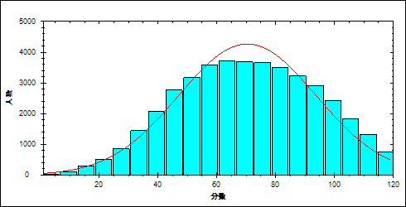

图 7题目难度与区分度坐标图

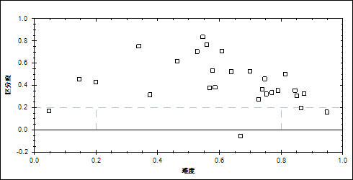

表 9题目整体分析表

| 题目 | 满分值 | 最大值 | 最小值 | 平均值 | 标准差 | 差异系数 | 难度 | 相关系数 | 鉴别系数 |
| --- | --- | --- | --- | --- | --- | --- | --- | --- | --- |
| 13 | 6.00 | 6.00 | 0.00 | 4.62 | 2.53 | 0.55 | 0.77 | 0.36 | 0.34 |
| 14 | 6.00 | 6.00 | 0.00 | 4.48 | 2.61 | 0.58 | 0.75 | 0.47 | 0.46 |
| 15 | 6.00 | 6.00 | 0.00 | 3.65 | 2.93 | 0.80 | 0.61 | 0.60 | 0.71 |
| 16 | 6.00 | 6.00 | 0.00 | 2.25 | 2.90 | 1.29 | 0.37 | 0.32 | 0.32 |
| 17 | 6.00 | 6.00 | 0.00 | 3.83 | 2.88 | 0.75 | 0.64 | 0.48 | 0.52 |
| 18 | 6.00 | 6.00 | 0.00 | 4.74 | 2.45 | 0.52 | 0.79 | 0.39 | 0.35 |
| 19 | 6.00 | 6.00 | 0.00 | 2.78 | 2.99 | 1.07 | 0.46 | 0.53 | 0.62 |
| 20 | 6.00 | 6.00 | 0.00 | 3.47 | 2.96 | 0.85 | 0.58 | 0.47 | 0.53 |
| 21 | 18.00 | 18.00 | 0.00 | 13.08 | 3.48 | 0.27 | 0.73 | 0.62 | 0.28 |
| 22 | 16.00 | 16.00 | 0.00 | 13.98 | 3.70 | 0.26 | 0.87 | 0.61 | 0.33 |
| 23 | 18.00 | 18.00 | 0.00 | 9.50 | 6.28 | 0.66 | 0.53 | 0.83 | 0.70 |
| 24 | 20.00 | 20.00 | 0.00 | 3.99 | 4.77 | 1.19 | 0.20 | 0.76 | 0.43 |
| 21\_1 | 2.00 | 2.00 | 0.00 | 1.70 | 0.71 | 0.42 | 0.85 | 0.36 | 0.31 |
| 21\_2 | 2.00 | 2.00 | 0.00 | 1.34 | 0.94 | 0.70 | 0.67 | -0.02 | -0.06 |
| 21\_3 | 4.00 | 4.00 | 0.00 | 2.95 | 1.76 | 0.60 | 0.74 | 0.36 | 0.37 |
| 21\_41 | 4.00 | 4.00 | 0.00 | 3.46 | 1.05 | 0.30 | 0.87 | 0.33 | 0.20 |
| 21\_42 | 1.00 | 1.00 | 0.00 | 0.75 | 0.43 | 0.57 | 0.75 | 0.31 | 0.32 |
| 21\_5 | 3.00 | 3.00 | 0.00 | 1.70 | 1.49 | 0.87 | 0.57 | 0.33 | 0.38 |
| 21\_6 | 2.00 | 2.00 | 0.00 | 1.17 | 0.86 | 0.73 | 0.59 | 0.36 | 0.38 |
| 22\_1 | 6.00 | 6.00 | 0.00 | 5.69 | 1.17 | 0.21 | 0.95 | 0.39 | 0.16 |
| 22\_2 | 5.00 | 5.00 | 0.00 | 4.06 | 1.83 | 0.45 | 0.81 | 0.57 | 0.50 |
| 22\_3 | 5.00 | 5.00 | 0.00 | 4.23 | 1.54 | 0.36 | 0.85 | 0.50 | 0.35 |
| 23\_1 | 6.00 | 6.00 | 0.00 | 4.19 | 2.30 | 0.55 | 0.70 | 0.58 | 0.53 |
| 23\_2 | 6.00 | 6.00 | 0.00 | 3.28 | 2.87 | 0.87 | 0.55 | 0.71 | 0.84 |
| 23\_3 | 6.00 | 6.00 | 0.00 | 2.03 | 2.50 | 1.23 | 0.34 | 0.73 | 0.75 |
| 24\_1 | 4.00 | 4.00 | 0.00 | 2.24 | 1.74 | 0.78 | 0.56 | 0.70 | 0.77 |
| 24\_2 | 10.00 | 10.00 | 0.00 | 1.47 | 3.00 | 2.05 | 0.15 | 0.64 | 0.46 |
| 24\_3 | 6.00 | 6.00 | 0.00 | 0.29 | 1.15 | 3.98 | 0.05 | 0.41 | 0.17 |

表 10题组整体分析表

| 题目 | 满分值 | 最大值 | 最小值 | 平均值 | 标准差 | 差异系数 | 难度 | 相关系数 | 鉴别系数 |
| --- | --- | --- | --- | --- | --- | --- | --- | --- | --- |
| 客观题 | 48.00 | 48.00 | 0.00 | 29.82 | 11.62 | 0.39 | 0.62 | 13.32 | 0.48 |
| 主观题 | 72.00 | 72.00 | 0.00 | 40.55 | 14.38 | 0.35 | 0.56 | 14.69 | 0.44 |
| 力学 | 46.00 | 46.00 | 0.00 | 19.65 | 12.36 | 0.63 | 0.43 | 9.03 | 0.59 |
| 电学 | 50.00 | 50.00 | 0.00 | 37.86 | 9.42 | 0.25 | 0.76 | 19.99 | 0.37 |
| 热学 | 6.00 | 6.00 | 0.00 | 4.62 | 2.53 | 0.55 | 0.77 | 9.00 | 0.34 |
| 光学 | 6.00 | 6.00 | 0.00 | 4.48 | 2.61 | 0.58 | 0.75 | 8.71 | 0.46 |
| 原子 | 6.00 | 6.00 | 0.00 | 3.47 | 2.96 | 0.85 | 0.58 | 6.20 | 0.53 |
| 理解能力 | 18.00 | 18.00 | 0.00 | 12.75 | 5.59 | 0.44 | 0.71 | 11.71 | 0.50 |
| 推理能力 | 18.00 | 18.00 | 0.00 | 10.81 | 5.27 | 0.49 | 0.60 | 10.47 | 0.40 |
| 实验能力 | 24.00 | 24.00 | 0.00 | 15.86 | 5.09 | 0.32 | 0.66 | 15.64 | 0.36 |
| 应用能力 | 32.00 | 32.00 | 0.00 | 23.69 | 8.31 | 0.35 | 0.74 | 14.66 | 0.51 |
| 探究能力 | 22.00 | 22.00 | 0.00 | 6.97 | 6.45 | 0.93 | 0.32 | 6.46 | 0.56 |

表 11总分频数分布表

| 分值 | 频数 | 比率（%） | 累计频数 | 累计频率（%） |
| --- | --- | --- | --- | --- |
| 120.00 | 202 | 0.48 | 202 | 0.48 |
| 119.00 | 35 | 0.08 | 237 | 0.57 |
| 118.00 | 169 | 0.40 | 406 | 0.97 |
| 117.00 | 88 | 0.21 | 494 | 1.18 |
| 116.00 | 95 | 0.23 | 589 | 1.41 |
| 115.00 | 159 | 0.38 | 748 | 1.79 |
| 114.00 | 251 | 0.60 | 999 | 2.39 |
| 113.00 | 120 | 0.29 | 1119 | 2.68 |
| 112.00 | 262 | 0.63 | 1381 | 3.30 |
| 111.00 | 223 | 0.53 | 1604 | 3.84 |
| 110.00 | 225 | 0.54 | 1829 | 4.37 |
| 109.00 | 247 | 0.59 | 2076 | 4.96 |
| 108.00 | 300 | 0.72 | 2376 | 5.68 |
| 107.00 | 206 | 0.49 | 2582 | 6.17 |
| 106.00 | 359 | 0.86 | 2941 | 7.03 |
| 105.00 | 310 | 0.74 | 3251 | 7.77 |
| 104.00 | 316 | 0.76 | 3567 | 8.53 |
| 103.00 | 325 | 0.78 | 3892 | 9.31 |
| 102.00 | 367 | 0.88 | 4259 | 10.18 |
| 101.00 | 308 | 0.74 | 4567 | 10.92 |
| 100.00 | 394 | 0.94 | 4961 | 11.86 |
| 99.00 | 412 | 0.99 | 5373 | 12.85 |
| 98.00 | 457 | 1.09 | 5830 | 13.94 |
| 97.00 | 475 | 1.14 | 6305 | 15.08 |
| 96.00 | 502 | 1.20 | 6807 | 16.28 |
| 95.00 | 504 | 1.21 | 7311 | 17.48 |
| 94.00 | 463 | 1.11 | 7774 | 18.59 |
| 93.00 | 456 | 1.09 | 8230 | 19.68 |
| 92.00 | 492 | 1.18 | 8722 | 20.86 |
| 91.00 | 494 | 1.18 | 9216 | 22.04 |
| 90.00 | 527 | 1.26 | 9743 | 23.30 |
| 89.00 | 547 | 1.31 | 10290 | 24.61 |
| 88.00 | 499 | 1.19 | 10789 | 25.80 |
| 87.00 | 545 | 1.30 | 11334 | 27.10 |
| 86.00 | 560 | 1.34 | 11894 | 28.44 |
| 85.00 | 551 | 1.32 | 12445 | 29.76 |
| 84.00 | 570 | 1.36 | 13015 | 31.12 |
| 83.00 | 567 | 1.36 | 13582 | 32.48 |
| 82.00 | 565 | 1.35 | 14147 | 33.83 |
| 81.00 | 609 | 1.46 | 14756 | 35.28 |
| 80.00 | 606 | 1.45 | 15362 | 36.73 |
| 79.00 | 592 | 1.42 | 15954 | 38.15 |
| 78.00 | 596 | 1.43 | 16550 | 39.57 |
| 77.00 | 622 | 1.49 | 17172 | 41.06 |
| 76.00 | 592 | 1.42 | 17764 | 42.48 |
| 75.00 | 621 | 1.48 | 18385 | 43.96 |
| 74.00 | 631 | 1.51 | 19016 | 45.47 |
| 73.00 | 595 | 1.42 | 19611 | 46.89 |
| 72.00 | 646 | 1.54 | 20257 | 48.44 |
| 71.00 | 582 | 1.39 | 20839 | 49.83 |
| 70.00 | 626 | 1.50 | 21465 | 51.33 |
| 69.00 | 603 | 1.44 | 22068 | 52.77 |
| 68.00 | 628 | 1.50 | 22696 | 54.27 |
| 67.00 | 599 | 1.43 | 23295 | 55.70 |
| 66.00 | 620 | 1.48 | 23915 | 57.19 |
| 65.00 | 622 | 1.49 | 24537 | 58.67 |
| 64.00 | 619 | 1.48 | 25156 | 60.15 |
| 63.00 | 633 | 1.51 | 25789 | 61.67 |
| 62.00 | 652 | 1.56 | 26441 | 63.23 |
| 61.00 | 566 | 1.35 | 27007 | 64.58 |
| 60.00 | 619 | 1.48 | 27626 | 66.06 |
| 59.00 | 612 | 1.46 | 28238 | 67.52 |
| 58.00 | 601 | 1.44 | 28839 | 68.96 |
| 57.00 | 587 | 1.40 | 29426 | 70.36 |
| 56.00 | 574 | 1.37 | 30000 | 71.74 |
| 55.00 | 591 | 1.41 | 30591 | 73.15 |
| 54.00 | 563 | 1.35 | 31154 | 74.50 |
| 53.00 | 565 | 1.35 | 31719 | 75.85 |
| 52.00 | 511 | 1.22 | 32230 | 77.07 |
| 51.00 | 498 | 1.19 | 32728 | 78.26 |
| 50.00 | 520 | 1.24 | 33248 | 79.50 |
| 49.00 | 517 | 1.24 | 33765 | 80.74 |
| 48.00 | 532 | 1.27 | 34297 | 82.01 |
| 47.00 | 469 | 1.12 | 34766 | 83.13 |
| 46.00 | 469 | 1.12 | 35235 | 84.25 |
| 45.00 | 455 | 1.09 | 35690 | 85.34 |
| 44.00 | 450 | 1.08 | 36140 | 86.42 |
| 43.00 | 394 | 0.94 | 36534 | 87.36 |
| 42.00 | 390 | 0.93 | 36924 | 88.29 |
| 41.00 | 379 | 0.91 | 37303 | 89.20 |
| 40.00 | 316 | 0.76 | 37619 | 89.95 |
| 39.00 | 351 | 0.84 | 37970 | 90.79 |
| 38.00 | 333 | 0.80 | 38303 | 91.59 |
| 37.00 | 298 | 0.71 | 38601 | 92.30 |
| 36.00 | 308 | 0.74 | 38909 | 93.04 |
| 35.00 | 265 | 0.63 | 39174 | 93.67 |
| 34.00 | 239 | 0.57 | 39413 | 94.24 |
| 33.00 | 247 | 0.59 | 39660 | 94.84 |
| 32.00 | 219 | 0.52 | 39879 | 95.36 |
| 31.00 | 171 | 0.41 | 40050 | 95.77 |
| 30.00 | 157 | 0.38 | 40207 | 96.14 |
| 29.00 | 155 | 0.37 | 40362 | 96.51 |
| 28.00 | 161 | 0.38 | 40523 | 96.90 |
| 27.00 | 135 | 0.32 | 40658 | 97.22 |
| 26.00 | 133 | 0.32 | 40791 | 97.54 |
| 25.00 | 109 | 0.26 | 40900 | 97.80 |
| 24.00 | 116 | 0.28 | 41016 | 98.08 |
| 23.00 | 93 | 0.22 | 41109 | 98.30 |
| 22.00 | 92 | 0.22 | 41201 | 98.52 |
| 21.00 | 84 | 0.20 | 41285 | 98.72 |
| 20.00 | 69 | 0.16 | 41354 | 98.89 |
| 19.00 | 57 | 0.14 | 41411 | 99.02 |
| 18.00 | 74 | 0.18 | 41485 | 99.20 |
| 17.00 | 52 | 0.12 | 41537 | 99.32 |
| 16.00 | 43 | 0.10 | 41580 | 99.43 |
| 15.00 | 51 | 0.12 | 41631 | 99.55 |
| 14.00 | 34 | 0.08 | 41665 | 99.63 |
| 13.00 | 24 | 0.06 | 41689 | 99.69 |
| 12.00 | 29 | 0.07 | 41718 | 99.76 |
| 11.00 | 23 | 0.05 | 41741 | 99.81 |
| 10.00 | 13 | 0.03 | 41754 | 99.84 |
| 9.00 | 16 | 0.04 | 41770 | 99.88 |
| 8.00 | 23 | 0.05 | 41793 | 99.94 |
| 7.00 | 3 | 0.01 | 41796 | 99.94 |
| 6.00 | 10 | 0.02 | 41806 | 99.97 |
| 5.00 | 5 | 0.01 | 41811 | 99.98 |
| 4.00 | 2 | 0.00 | 41813 | 99.98 |
| 3.00 | 2 | 0.00 | 41815 | 99.99 |
| 2.00 | 3 | 0.01 | 41818 | 100.00 |
| 1.00 | 2 | 0.00 | 41820 | 100.00 |

* 1. 题组分析
     1. 主客观题组
        1. 客观题

本题组包含13~20

表 12客观题总分分布表

|  |  |  |  |  |  |  |  |  |
| --- | --- | --- | --- | --- | --- | --- | --- | --- |
| 满分值 | 最大值 | 最小值 | 平均值 | 标准差 | 差异系数 | 难度 | 相关系数 | 鉴别系数 |
| 48.00 | 48.00 | 0.00 | 29.82 | 11.62 | 0.39 | 0.62 | 13.32 | 0.48 |

图 8客观题分数分布表

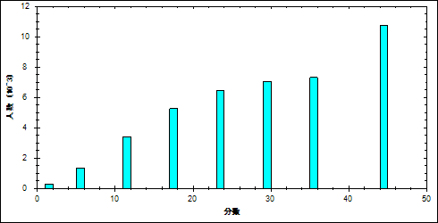

图 9客观题难度曲线图

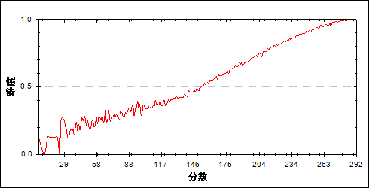

表 13客观题分组分析表

| 分值 | G1 | G2 | G3 | G4 | G5 | G6 | G7 | 频数 | 比率（%） | 平均值 |
| --- | --- | --- | --- | --- | --- | --- | --- | --- | --- | --- |
| 0- | 225 | 37 | 9 | 1 | 0 | 0 | 0 | 272 | 0.65 | 96.77 |
| 6- | 940 | 310 | 87 | 14 | 1 | 0 | 0 | 1352 | 3.23 | 107.69 |
| 12- | 1684 | 1093 | 489 | 135 | 16 | 1 | 0 | 3418 | 8.17 | 121.66 |
| 18- | 1536 | 1727 | 1244 | 558 | 171 | 19 | 1 | 5256 | 12.57 | 137.66 |
| 24- | 894 | 1510 | 1651 | 1482 | 749 | 161 | 12 | 6459 | 15.44 | 155.75 |
| 30- | 442 | 796 | 1497 | 1787 | 1644 | 764 | 111 | 7041 | 16.84 | 174.02 |
| 36- | 181 | 350 | 711 | 1337 | 2033 | 2034 | 659 | 7305 | 17.47 | 194.85 |
| 42- | 65 | 116 | 242 | 558 | 1158 | 2230 | 2366 | 6735 | 16.10 | 217.77 |
| 48- | 8 | 36 | 44 | 102 | 202 | 765 | 2825 | 3982 | 9.52 | 242.18 |
| 合计 | 5975 | 5975 | 5974 | 5974 | 5974 | 5974 | 5974 | 41820 | 100.00 | 70.37 |
| 得分率 | 0.34 | 0.44 | 0.53 | 0.62 | 0.70 | 0.80 | 0.91 | - | - | - |

* + - 1. 主观题

本题组包含21~24

表 14主观题总分分布表

|  |  |  |  |  |  |  |  |  |
| --- | --- | --- | --- | --- | --- | --- | --- | --- |
| 满分值 | 最大值 | 最小值 | 平均值 | 标准差 | 差异系数 | 难度 | 相关系数 | 鉴别系数 |
| 72.00 | 72.00 | 0.00 | 40.55 | 14.38 | 0.35 | 0.56 | 14.69 | 0.44 |

图 10主观题分数分布表

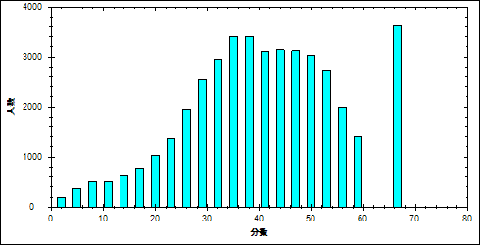

图 11主观题难度曲线图

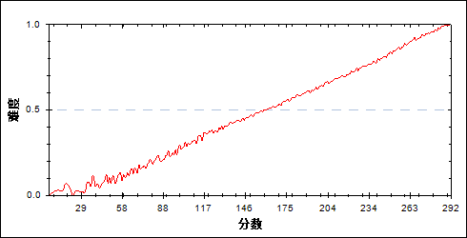

表 15主观题分组分析表

| 分值 | G1 | G2 | G3 | G4 | G5 | G6 | G7 | 频数 | 比率（%） | 平均值 |
| --- | --- | --- | --- | --- | --- | --- | --- | --- | --- | --- |
| 0- | 35 | 0 | 0 | 0 | 0 | 0 | 0 | 35 | 0.08 | 53.51 |
| 1- | 17 | 1 | 0 | 0 | 0 | 0 | 0 | 18 | 0.04 | 73.06 |
| 2- | 56 | 1 | 0 | 0 | 0 | 0 | 0 | 57 | 0.14 | 58.82 |
| 3- | 82 | 2 | 0 | 0 | 0 | 0 | 0 | 84 | 0.20 | 68.61 |
| 4- | 85 | 2 | 0 | 0 | 0 | 0 | 0 | 87 | 0.21 | 74.97 |
| 5- | 136 | 2 | 0 | 0 | 0 | 0 | 0 | 138 | 0.33 | 75.59 |
| 6- | 142 | 5 | 0 | 0 | 0 | 0 | 0 | 147 | 0.35 | 83.01 |
| 7- | 134 | 8 | 0 | 0 | 0 | 0 | 0 | 142 | 0.34 | 82.05 |
| 8- | 169 | 9 | 1 | 0 | 0 | 0 | 0 | 179 | 0.43 | 86.89 |
| 9- | 162 | 18 | 1 | 2 | 1 | 0 | 0 | 184 | 0.44 | 90.34 |
| 10- | 134 | 10 | 4 | 0 | 0 | 0 | 0 | 148 | 0.35 | 92.11 |
| 11- | 150 | 29 | 4 | 0 | 0 | 0 | 0 | 183 | 0.44 | 99.83 |
| 12- | 149 | 22 | 3 | 1 | 0 | 0 | 0 | 175 | 0.42 | 96.14 |
| 13- | 147 | 27 | 12 | 2 | 0 | 0 | 0 | 188 | 0.45 | 103.27 |
| 14- | 170 | 38 | 4 | 0 | 0 | 0 | 0 | 212 | 0.51 | 104.03 |
| 15- | 181 | 33 | 5 | 0 | 0 | 0 | 0 | 219 | 0.52 | 102.06 |
| 16- | 175 | 41 | 9 | 0 | 0 | 0 | 0 | 225 | 0.54 | 106.16 |
| 17- | 176 | 57 | 16 | 3 | 0 | 0 | 0 | 252 | 0.60 | 111.31 |
| 18- | 198 | 80 | 15 | 5 | 1 | 0 | 0 | 299 | 0.71 | 113.20 |
| 19- | 185 | 77 | 20 | 6 | 0 | 0 | 0 | 288 | 0.69 | 115.17 |
| 20- | 227 | 92 | 29 | 4 | 2 | 0 | 0 | 354 | 0.85 | 116.77 |
| 21- | 242 | 105 | 37 | 9 | 0 | 0 | 0 | 393 | 0.94 | 119.44 |
| 22- | 228 | 133 | 36 | 9 | 2 | 0 | 0 | 408 | 0.98 | 121.26 |
| 23- | 223 | 176 | 46 | 10 | 1 | 0 | 0 | 456 | 1.09 | 123.13 |
| 24- | 220 | 191 | 67 | 21 | 5 | 0 | 0 | 504 | 1.21 | 127.34 |
| 25- | 245 | 234 | 104 | 22 | 2 | 0 | 0 | 607 | 1.45 | 129.51 |
| 26- | 228 | 238 | 125 | 38 | 6 | 0 | 0 | 635 | 1.52 | 132.44 |
| 27- | 218 | 274 | 165 | 54 | 6 | 0 | 0 | 717 | 1.71 | 136.48 |
| 28- | 211 | 297 | 173 | 59 | 11 | 0 | 0 | 751 | 1.80 | 137.65 |
| 29- | 183 | 335 | 191 | 76 | 20 | 2 | 0 | 807 | 1.93 | 141.01 |
| 30- | 218 | 360 | 263 | 107 | 36 | 2 | 0 | 986 | 2.36 | 142.95 |
| 31- | 151 | 338 | 246 | 117 | 32 | 1 | 0 | 885 | 2.12 | 145.58 |
| 32- | 140 | 340 | 330 | 163 | 47 | 6 | 0 | 1026 | 2.45 | 149.42 |
| 33- | 110 | 323 | 342 | 196 | 66 | 6 | 0 | 1043 | 2.49 | 153.19 |
| 34- | 105 | 298 | 364 | 265 | 87 | 14 | 0 | 1133 | 2.71 | 156.09 |
| 35- | 95 | 315 | 368 | 259 | 96 | 25 | 0 | 1158 | 2.77 | 157.20 |
| 36- | 68 | 292 | 337 | 278 | 112 | 26 | 0 | 1113 | 2.66 | 159.64 |
| 37- | 45 | 211 | 371 | 322 | 163 | 26 | 0 | 1138 | 2.72 | 164.25 |
| 38- | 40 | 219 | 351 | 330 | 188 | 41 | 0 | 1169 | 2.80 | 165.84 |
| 39- | 20 | 163 | 300 | 346 | 212 | 56 | 0 | 1097 | 2.62 | 170.30 |
| 40- | 21 | 143 | 284 | 308 | 222 | 71 | 3 | 1052 | 2.52 | 172.32 |
| 41- | 16 | 84 | 217 | 333 | 254 | 83 | 4 | 991 | 2.37 | 177.12 |
| 42- | 13 | 89 | 189 | 354 | 310 | 103 | 8 | 1066 | 2.55 | 179.91 |
| 43- | 10 | 62 | 173 | 324 | 300 | 128 | 11 | 1008 | 2.41 | 182.36 |
| 44- | 5 | 53 | 181 | 292 | 359 | 168 | 12 | 1070 | 2.56 | 185.64 |
| 45- | 4 | 48 | 135 | 261 | 395 | 205 | 21 | 1069 | 2.56 | 189.28 |
| 46- | 2 | 31 | 107 | 253 | 353 | 226 | 28 | 1000 | 2.39 | 191.72 |
| 47- | 1 | 26 | 97 | 236 | 355 | 298 | 49 | 1062 | 2.54 | 195.53 |
| 48- | 0 | 12 | 68 | 209 | 369 | 343 | 59 | 1060 | 2.53 | 199.55 |
| 49- | 2 | 11 | 63 | 164 | 349 | 366 | 92 | 1047 | 2.50 | 202.43 |
| 50- | 1 | 9 | 34 | 158 | 321 | 365 | 110 | 998 | 2.39 | 205.39 |
| 51- | 0 | 3 | 25 | 106 | 283 | 433 | 145 | 995 | 2.38 | 210.37 |
| 52- | 0 | 3 | 25 | 77 | 240 | 388 | 172 | 905 | 2.16 | 212.67 |
| 53- | 0 | 4 | 18 | 73 | 228 | 444 | 217 | 984 | 2.35 | 215.38 |
| 54- | 0 | 0 | 9 | 41 | 174 | 376 | 257 | 857 | 2.05 | 220.19 |
| 55- | 0 | 0 | 4 | 33 | 99 | 309 | 265 | 710 | 1.70 | 223.44 |
| 56- | 0 | 0 | 4 | 14 | 86 | 319 | 328 | 751 | 1.80 | 227.47 |
| 57- | 0 | 0 | 1 | 11 | 52 | 209 | 266 | 539 | 1.29 | 230.24 |
| 58- | 0 | 0 | 0 | 10 | 34 | 216 | 312 | 572 | 1.37 | 233.24 |
| 59- | 0 | 0 | 0 | 6 | 29 | 124 | 235 | 394 | 0.94 | 234.70 |
| 60- | 0 | 1 | 0 | 4 | 21 | 144 | 267 | 437 | 1.04 | 235.80 |
| 61- | 0 | 0 | 1 | 2 | 14 | 118 | 318 | 453 | 1.08 | 240.00 |
| 62- | 0 | 0 | 0 | 1 | 10 | 80 | 289 | 380 | 0.91 | 244.08 |
| 63- | 0 | 0 | 0 | 0 | 6 | 89 | 340 | 435 | 1.04 | 245.60 |
| 64- | 0 | 0 | 0 | 0 | 8 | 55 | 342 | 405 | 0.97 | 248.70 |
| 65- | 0 | 0 | 0 | 0 | 4 | 29 | 220 | 253 | 0.60 | 249.86 |
| 66- | 0 | 0 | 0 | 0 | 3 | 44 | 365 | 412 | 0.99 | 253.19 |
| 67- | 0 | 0 | 0 | 0 | 0 | 10 | 275 | 285 | 0.68 | 257.36 |
| 68- | 0 | 0 | 0 | 0 | 0 | 12 | 177 | 189 | 0.45 | 258.36 |
| 69- | 0 | 0 | 0 | 0 | 0 | 5 | 146 | 151 | 0.36 | 261.99 |
| 70- | 0 | 0 | 0 | 0 | 0 | 8 | 301 | 309 | 0.74 | 262.65 |
| 71- | 0 | 0 | 0 | 0 | 0 | 0 | 53 | 53 | 0.13 | 268.66 |
| 72- | 0 | 0 | 0 | 0 | 0 | 1 | 287 | 288 | 0.69 | 269.51 |
| 合计 | 5975 | 5975 | 5974 | 5974 | 5974 | 5974 | 5974 | 41820 | 100.00 | 70.37 |
| 得分率 | 0.28 | 0.42 | 0.49 | 0.56 | 0.63 | 0.71 | 0.84 | - | - | - |

* + 1. 知识组块
       1. 力学

本题组包含15,16,19,23,24\_2

表 16力学总分分布表

|  |  |  |  |  |  |  |  |  |
| --- | --- | --- | --- | --- | --- | --- | --- | --- |
| 满分值 | 最大值 | 最小值 | 平均值 | 标准差 | 差异系数 | 难度 | 相关系数 | 鉴别系数 |
| 46.00 | 46.00 | 0.00 | 19.65 | 12.36 | 0.63 | 0.43 | 9.03 | 0.59 |

图 12力学分数分布表

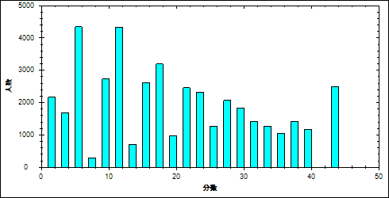

图 13力学难度曲线图

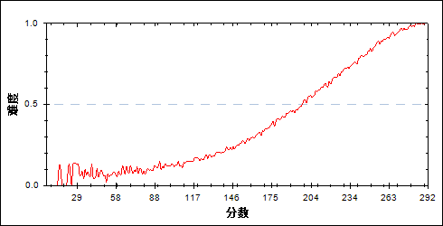

表 17力学分组分析表

| 分值 | G1 | G2 | G3 | G4 | G5 | G6 | G7 | 频数 | 比率（%） | 平均值 |
| --- | --- | --- | --- | --- | --- | --- | --- | --- | --- | --- |
| 0- | 1562 | 432 | 111 | 23 | 1 | 1 | 0 | 2130 | 5.09 | 104.18 |
| 1- | 17 | 10 | 5 | 0 | 0 | 0 | 0 | 32 | 0.08 | 123.16 |
| 2- | 2 | 3 | 1 | 0 | 0 | 0 | 0 | 6 | 0.01 | 125.50 |
| 3- | 575 | 601 | 288 | 79 | 16 | 0 | 0 | 1559 | 3.73 | 132.02 |
| 4- | 27 | 50 | 38 | 7 | 0 | 1 | 0 | 123 | 0.29 | 139.23 |
| 5- | 3 | 7 | 9 | 2 | 0 | 0 | 0 | 21 | 0.05 | 145.24 |
| 6- | 2033 | 1303 | 707 | 229 | 48 | 1 | 0 | 4321 | 10.33 | 124.34 |
| 7- | 49 | 96 | 72 | 31 | 6 | 0 | 0 | 254 | 0.61 | 143.33 |
| 8- | 7 | 14 | 9 | 8 | 0 | 2 | 0 | 40 | 0.10 | 147.93 |
| 9- | 427 | 807 | 713 | 344 | 108 | 7 | 0 | 2406 | 5.75 | 146.18 |
| 10- | 33 | 93 | 98 | 76 | 21 | 4 | 0 | 325 | 0.78 | 154.83 |
| 11- | 4 | 23 | 19 | 21 | 15 | 1 | 0 | 83 | 0.20 | 161.07 |
| 12- | 872 | 1217 | 1154 | 692 | 288 | 32 | 0 | 4255 | 10.17 | 146.36 |
| 13- | 33 | 116 | 173 | 156 | 82 | 11 | 0 | 571 | 1.37 | 162.62 |
| 14- | 4 | 17 | 28 | 39 | 41 | 2 | 0 | 131 | 0.31 | 172.92 |
| 15- | 120 | 420 | 609 | 665 | 277 | 57 | 0 | 2148 | 5.14 | 163.38 |
| 16- | 11 | 50 | 128 | 158 | 102 | 17 | 0 | 466 | 1.11 | 171.55 |
| 17- | 1 | 9 | 36 | 33 | 47 | 17 | 0 | 143 | 0.34 | 180.83 |
| 18- | 147 | 404 | 766 | 896 | 672 | 158 | 3 | 3046 | 7.28 | 170.00 |
| 19- | 17 | 57 | 136 | 246 | 205 | 60 | 4 | 725 | 1.73 | 178.40 |
| 20- | 2 | 10 | 26 | 76 | 99 | 43 | 3 | 259 | 0.62 | 188.07 |
| 21- | 15 | 106 | 322 | 614 | 559 | 219 | 9 | 1844 | 4.41 | 182.27 |
| 22- | 3 | 17 | 82 | 151 | 240 | 116 | 7 | 616 | 1.47 | 189.57 |
| 23- | 0 | 4 | 23 | 62 | 111 | 87 | 9 | 296 | 0.71 | 196.21 |
| 24- | 9 | 67 | 207 | 518 | 713 | 476 | 35 | 2025 | 4.84 | 191.32 |
| 25- | 1 | 16 | 68 | 170 | 268 | 245 | 36 | 804 | 1.92 | 197.07 |
| 26- | 0 | 2 | 19 | 67 | 166 | 189 | 32 | 475 | 1.14 | 204.38 |
| 27- | 0 | 11 | 62 | 233 | 482 | 476 | 87 | 1351 | 3.23 | 201.72 |
| 28- | 0 | 6 | 18 | 84 | 215 | 315 | 83 | 721 | 1.72 | 208.20 |
| 29- | 0 | 2 | 4 | 37 | 125 | 198 | 78 | 444 | 1.06 | 212.71 |
| 30- | 1 | 1 | 23 | 129 | 389 | 622 | 226 | 1391 | 3.33 | 211.93 |
| 31- | 0 | 1 | 10 | 43 | 151 | 395 | 201 | 801 | 1.92 | 218.27 |
| 32- | 0 | 0 | 1 | 17 | 96 | 285 | 214 | 613 | 1.47 | 223.21 |
| 33- | 0 | 2 | 4 | 29 | 117 | 261 | 136 | 549 | 1.31 | 218.37 |
| 34- | 0 | 0 | 2 | 11 | 72 | 326 | 312 | 723 | 1.73 | 228.17 |
| 35- | 0 | 0 | 0 | 3 | 44 | 139 | 168 | 354 | 0.85 | 229.07 |
| 36- | 0 | 1 | 3 | 13 | 77 | 271 | 325 | 690 | 1.65 | 228.95 |
| 37- | 0 | 0 | 0 | 10 | 57 | 322 | 541 | 930 | 2.22 | 234.63 |
| 38- | 0 | 0 | 0 | 1 | 19 | 153 | 309 | 482 | 1.15 | 238.11 |
| 39- | 0 | 0 | 0 | 0 | 7 | 29 | 104 | 140 | 0.33 | 242.17 |
| 40- | 0 | 0 | 0 | 0 | 26 | 217 | 784 | 1027 | 2.46 | 244.27 |
| 41- | 0 | 0 | 0 | 0 | 3 | 38 | 112 | 153 | 0.37 | 245.29 |
| 42- | 0 | 0 | 0 | 1 | 1 | 29 | 88 | 119 | 0.28 | 243.41 |
| 43- | 0 | 0 | 0 | 0 | 4 | 95 | 672 | 771 | 1.84 | 250.65 |
| 44- | 0 | 0 | 0 | 0 | 1 | 6 | 72 | 79 | 0.19 | 253.71 |
| 45- | 0 | 0 | 0 | 0 | 0 | 4 | 102 | 106 | 0.25 | 259.17 |
| 46- | 0 | 0 | 0 | 0 | 3 | 47 | 1222 | 1272 | 3.04 | 261.20 |
| 合计 | 5975 | 5975 | 5974 | 5974 | 5974 | 5974 | 5974 | 41820 | 100.00 | 70.37 |
| 得分率 | 0.13 | 0.21 | 0.29 | 0.39 | 0.50 | 0.65 | 0.84 | - | - | - |

* + - 1. 电学

本题组包含17,18,21,22,24\_1

表 18电学总分分布表

|  |  |  |  |  |  |  |  |  |
| --- | --- | --- | --- | --- | --- | --- | --- | --- |
| 满分值 | 最大值 | 最小值 | 平均值 | 标准差 | 差异系数 | 难度 | 相关系数 | 鉴别系数 |
| 50.00 | 50.00 | 0.00 | 37.86 | 9.42 | 0.25 | 0.76 | 19.99 | 0.37 |

图 14电学分数分布表

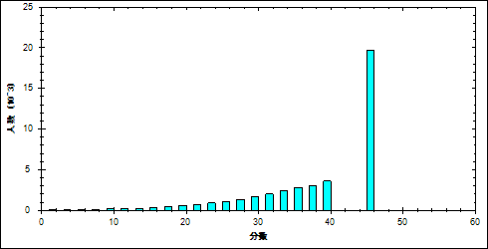

图 15电学难度曲线图

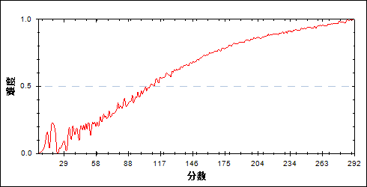

表 19电学分组分析表

| 分值 | G1 | G2 | G3 | G4 | G5 | G6 | G7 | 频数 | 比率（%） | 平均值 |
| --- | --- | --- | --- | --- | --- | --- | --- | --- | --- | --- |
| 0- | 13 | 0 | 0 | 0 | 0 | 0 | 0 | 13 | 0.03 | 42.69 |
| 1- | 5 | 0 | 0 | 0 | 0 | 0 | 0 | 5 | 0.01 | 37.40 |
| 2- | 29 | 0 | 0 | 0 | 0 | 0 | 0 | 29 | 0.07 | 50.07 |
| 3- | 22 | 0 | 0 | 0 | 0 | 0 | 0 | 22 | 0.05 | 52.32 |
| 4- | 25 | 0 | 0 | 0 | 0 | 0 | 0 | 25 | 0.06 | 69.20 |
| 5- | 45 | 0 | 0 | 0 | 0 | 0 | 0 | 45 | 0.11 | 66.84 |
| 6- | 50 | 0 | 0 | 0 | 0 | 0 | 0 | 50 | 0.12 | 62.60 |
| 7- | 50 | 0 | 0 | 0 | 0 | 0 | 0 | 50 | 0.12 | 69.06 |
| 8- | 84 | 2 | 0 | 0 | 0 | 0 | 0 | 86 | 0.21 | 74.15 |
| 9- | 100 | 2 | 0 | 0 | 0 | 0 | 0 | 102 | 0.24 | 72.64 |
| 10- | 95 | 1 | 1 | 0 | 0 | 0 | 0 | 97 | 0.23 | 77.72 |
| 11- | 109 | 3 | 0 | 0 | 0 | 0 | 0 | 112 | 0.27 | 77.98 |
| 12- | 150 | 3 | 0 | 0 | 0 | 0 | 0 | 153 | 0.37 | 83.12 |
| 13- | 118 | 5 | 0 | 0 | 0 | 0 | 0 | 123 | 0.29 | 82.84 |
| 14- | 145 | 6 | 0 | 0 | 0 | 0 | 0 | 151 | 0.36 | 89.70 |
| 15- | 183 | 16 | 0 | 0 | 0 | 0 | 0 | 199 | 0.48 | 90.85 |
| 16- | 147 | 17 | 6 | 0 | 0 | 0 | 0 | 170 | 0.41 | 95.87 |
| 17- | 181 | 26 | 4 | 0 | 0 | 0 | 0 | 211 | 0.50 | 98.57 |
| 18- | 215 | 39 | 5 | 1 | 0 | 0 | 0 | 260 | 0.62 | 101.78 |
| 19- | 223 | 64 | 3 | 2 | 0 | 0 | 0 | 292 | 0.70 | 106.08 |
| 20- | 251 | 70 | 10 | 2 | 1 | 0 | 0 | 334 | 0.80 | 108.66 |
| 21- | 235 | 84 | 14 | 2 | 1 | 0 | 0 | 336 | 0.80 | 111.85 |
| 22- | 272 | 99 | 17 | 3 | 1 | 0 | 0 | 392 | 0.94 | 113.77 |
| 23- | 253 | 130 | 24 | 7 | 0 | 0 | 0 | 414 | 0.99 | 117.34 |
| 24- | 289 | 159 | 48 | 14 | 0 | 0 | 0 | 510 | 1.22 | 121.39 |
| 25- | 274 | 150 | 60 | 18 | 3 | 0 | 0 | 505 | 1.21 | 123.46 |
| 26- | 301 | 200 | 75 | 15 | 4 | 1 | 0 | 596 | 1.43 | 124.42 |
| 27- | 258 | 252 | 108 | 25 | 3 | 0 | 0 | 646 | 1.54 | 130.26 |
| 28- | 242 | 275 | 127 | 47 | 7 | 2 | 0 | 700 | 1.67 | 133.31 |
| 29- | 233 | 351 | 157 | 59 | 16 | 2 | 0 | 818 | 1.96 | 137.19 |
| 30- | 210 | 344 | 180 | 70 | 28 | 6 | 2 | 840 | 2.01 | 140.02 |
| 31- | 169 | 345 | 244 | 113 | 36 | 12 | 2 | 921 | 2.20 | 146.06 |
| 32- | 183 | 389 | 310 | 136 | 54 | 11 | 3 | 1086 | 2.60 | 147.39 |
| 33- | 168 | 364 | 330 | 186 | 82 | 21 | 3 | 1154 | 2.76 | 151.53 |
| 34- | 142 | 367 | 321 | 224 | 120 | 39 | 5 | 1218 | 2.91 | 155.50 |
| 35- | 124 | 344 | 399 | 289 | 156 | 60 | 19 | 1391 | 3.33 | 160.41 |
| 36- | 103 | 317 | 376 | 326 | 197 | 77 | 21 | 1417 | 3.39 | 164.02 |
| 37- | 83 | 279 | 404 | 354 | 220 | 103 | 24 | 1467 | 3.51 | 167.23 |
| 38- | 55 | 272 | 394 | 403 | 244 | 156 | 47 | 1571 | 3.76 | 172.31 |
| 39- | 43 | 233 | 412 | 454 | 370 | 229 | 59 | 1800 | 4.30 | 177.76 |
| 40- | 36 | 192 | 375 | 456 | 377 | 262 | 93 | 1791 | 4.28 | 181.35 |
| 41- | 13 | 155 | 337 | 437 | 416 | 342 | 125 | 1825 | 4.36 | 186.54 |
| 42- | 24 | 135 | 298 | 441 | 499 | 436 | 235 | 2068 | 4.95 | 192.71 |
| 43- | 6 | 84 | 241 | 421 | 475 | 398 | 239 | 1864 | 4.46 | 196.11 |
| 44- | 11 | 72 | 237 | 383 | 527 | 593 | 450 | 2273 | 5.44 | 203.49 |
| 45- | 0 | 49 | 163 | 308 | 493 | 569 | 371 | 1953 | 4.67 | 205.23 |
| 46- | 4 | 30 | 130 | 251 | 480 | 566 | 496 | 1957 | 4.68 | 210.77 |
| 47- | 3 | 23 | 69 | 217 | 439 | 591 | 603 | 1945 | 4.65 | 215.80 |
| 48- | 0 | 9 | 53 | 178 | 366 | 726 | 1072 | 2404 | 5.75 | 225.76 |
| 49- | 0 | 12 | 31 | 62 | 171 | 303 | 468 | 1047 | 2.50 | 225.68 |
| 50- | 1 | 6 | 11 | 70 | 188 | 469 | 1637 | 2382 | 5.70 | 241.91 |
| 合计 | 5975 | 5975 | 5974 | 5974 | 5974 | 5974 | 5974 | 41820 | 100.00 | 70.37 |
| 得分率 | 0.46 | 0.64 | 0.73 | 0.79 | 0.85 | 0.89 | 0.94 | - | - | - |

* + - 1. 热学

本题组包含13

表 20热学总分分布表

|  |  |  |  |  |  |  |  |  |
| --- | --- | --- | --- | --- | --- | --- | --- | --- |
| 满分值 | 最大值 | 最小值 | 平均值 | 标准差 | 差异系数 | 难度 | 相关系数 | 鉴别系数 |
| 6.00 | 6.00 | 0.00 | 4.62 | 2.53 | 0.55 | 0.77 | 9.00 | 0.34 |

图 16热学分数分布表

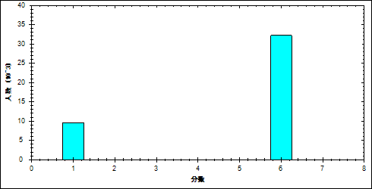

图 17热学难度曲线图

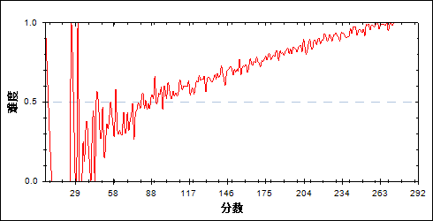

表 21热学分组分析表

| 分值 | G1 | G2 | G3 | G4 | G5 | G6 | G7 | 频数 | 比率（%） | 平均值 |
| --- | --- | --- | --- | --- | --- | --- | --- | --- | --- | --- |
| 0- | 2738 | 2029 | 1656 | 1324 | 1007 | 635 | 243 | 9632 | 23.03 | 148.51 |
| 6- | 3237 | 3946 | 4318 | 4650 | 4967 | 5339 | 5731 | 32188 | 76.97 | 185.37 |
| 合计 | 5975 | 5975 | 5974 | 5974 | 5974 | 5974 | 5974 | 41820 | 100.00 | 70.37 |
| 得分率 | 0.54 | 0.66 | 0.72 | 0.78 | 0.83 | 0.89 | 0.96 | - | - | - |

* + - 1. 光学

本题组包含14

表 22光学总分分布表

|  |  |  |  |  |  |  |  |  |
| --- | --- | --- | --- | --- | --- | --- | --- | --- |
| 满分值 | 最大值 | 最小值 | 平均值 | 标准差 | 差异系数 | 难度 | 相关系数 | 鉴别系数 |
| 6.00 | 6.00 | 0.00 | 4.48 | 2.61 | 0.58 | 0.75 | 8.71 | 0.46 |

图 18光学分数分布表

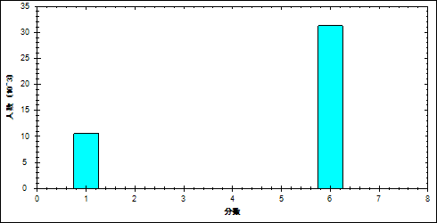

图 19光学难度曲线图

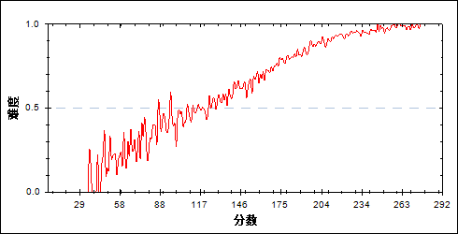

表 23光学分组分析表

| 分值 | G1 | G2 | G3 | G4 | G5 | G6 | G7 | 频数 | 比率（%） | 平均值 |
| --- | --- | --- | --- | --- | --- | --- | --- | --- | --- | --- |
| 0- | 3454 | 2484 | 1947 | 1300 | 817 | 412 | 168 | 10582 | 25.30 | 141.63 |
| 6- | 2521 | 3491 | 4027 | 4674 | 5157 | 5562 | 5806 | 31238 | 74.70 | 188.82 |
| 合计 | 5975 | 5975 | 5974 | 5974 | 5974 | 5974 | 5974 | 41820 | 100.00 | 70.37 |
| 得分率 | 0.42 | 0.58 | 0.67 | 0.78 | 0.86 | 0.93 | 0.97 | - | - | - |

* + - 1. 原子

本题组包含20

表 24原子总分分布表

|  |  |  |  |  |  |  |  |  |
| --- | --- | --- | --- | --- | --- | --- | --- | --- |
| 满分值 | 最大值 | 最小值 | 平均值 | 标准差 | 差异系数 | 难度 | 相关系数 | 鉴别系数 |
| 6.00 | 6.00 | 0.00 | 3.47 | 2.96 | 0.85 | 0.58 | 6.20 | 0.53 |

图 20原子分数分布表

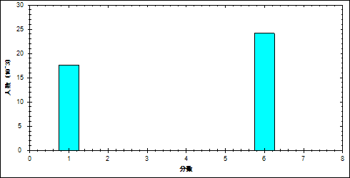

图 21原子难度曲线图

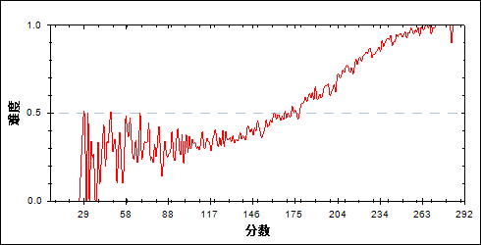

表 25原子分组分析表

| 分值 | G1 | G2 | G3 | G4 | G5 | G6 | G7 | 频数 | 比率（%） | 平均值 |
| --- | --- | --- | --- | --- | --- | --- | --- | --- | --- | --- |
| 0- | 4048 | 3750 | 3310 | 2806 | 2164 | 1205 | 348 | 17631 | 42.16 | 153.31 |
| 6- | 1927 | 2225 | 2664 | 3168 | 3810 | 4769 | 5626 | 24189 | 57.84 | 194.06 |
| 合计 | 5975 | 5975 | 5974 | 5974 | 5974 | 5974 | 5974 | 41820 | 100.00 | 70.37 |
| 得分率 | 0.32 | 0.37 | 0.45 | 0.53 | 0.64 | 0.80 | 0.94 | - | - | - |

* + 1. 能力组块
       1. 理解能力

本题组包含13~15

表 26理解能力总分分布表

|  |  |  |  |  |  |  |  |  |
| --- | --- | --- | --- | --- | --- | --- | --- | --- |
| 满分值 | 最大值 | 最小值 | 平均值 | 标准差 | 差异系数 | 难度 | 相关系数 | 鉴别系数 |
| 18.00 | 18.00 | 0.00 | 12.75 | 5.59 | 0.44 | 0.71 | 11.71 | 0.50 |

图 22理解能力分数分布表

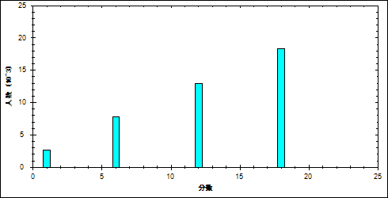

图 23理解能力难度曲线图

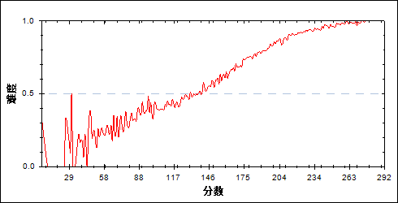

表 27理解能力分组分析表

| 分值 | G1 | G2 | G3 | G4 | G5 | G6 | G7 | 频数 | 比率（%） | 平均值 |
| --- | --- | --- | --- | --- | --- | --- | --- | --- | --- | --- |
| 0- | 1481 | 689 | 360 | 122 | 32 | 7 | 1 | 2692 | 6.44 | 117.84 |
| 6- | 2502 | 2165 | 1550 | 913 | 496 | 122 | 31 | 7779 | 18.60 | 138.77 |
| 12- | 1568 | 2333 | 2603 | 2597 | 2055 | 1315 | 495 | 12966 | 31.00 | 166.99 |
| 18- | 424 | 788 | 1461 | 2342 | 3391 | 4530 | 5447 | 18383 | 43.96 | 208.63 |
| 合计 | 5975 | 5975 | 5974 | 5974 | 5974 | 5974 | 5974 | 41820 | 100.00 | 70.37 |
| 得分率 | 0.39 | 0.51 | 0.62 | 0.73 | 0.82 | 0.91 | 0.97 | - | - | - |

* + - 1. 推理能力

本题组包含16~18

表 28推理能力总分分布表

|  |  |  |  |  |  |  |  |  |
| --- | --- | --- | --- | --- | --- | --- | --- | --- |
| 满分值 | 最大值 | 最小值 | 平均值 | 标准差 | 差异系数 | 难度 | 相关系数 | 鉴别系数 |
| 18.00 | 18.00 | 0.00 | 10.81 | 5.27 | 0.49 | 0.60 | 10.47 | 0.40 |

图 24推理能力分数分布表

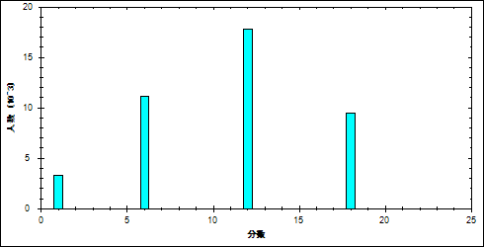

图 25推理能力难度曲线图

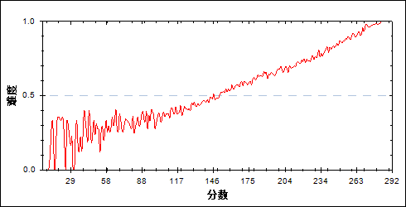

表 29推理能力分组分析表

| 分值 | G1 | G2 | G3 | G4 | G5 | G6 | G7 | 频数 | 比率（%） | 平均值 |
| --- | --- | --- | --- | --- | --- | --- | --- | --- | --- | --- |
| 0- | 1561 | 901 | 457 | 232 | 115 | 35 | 6 | 3307 | 7.91 | 125.85 |
| 6- | 2647 | 2502 | 2151 | 1665 | 1205 | 764 | 227 | 11161 | 26.69 | 151.94 |
| 12- | 1496 | 2076 | 2631 | 3077 | 3311 | 3215 | 2037 | 17843 | 42.67 | 182.55 |
| 18- | 271 | 496 | 735 | 1000 | 1343 | 1960 | 3704 | 9509 | 22.74 | 213.26 |
| 合计 | 5975 | 5975 | 5974 | 5974 | 5974 | 5974 | 5974 | 41820 | 100.00 | 70.37 |
| 得分率 | 0.36 | 0.45 | 0.54 | 0.60 | 0.66 | 0.73 | 0.86 | - | - | - |

* + - 1. 实验能力

本题组包含19,21

表 30实验能力总分分布表

|  |  |  |  |  |  |  |  |  |
| --- | --- | --- | --- | --- | --- | --- | --- | --- |
| 满分值 | 最大值 | 最小值 | 平均值 | 标准差 | 差异系数 | 难度 | 相关系数 | 鉴别系数 |
| 24.00 | 24.00 | 0.00 | 15.86 | 5.09 | 0.32 | 0.66 | 15.64 | 0.36 |

图 26实验能力分数分布表

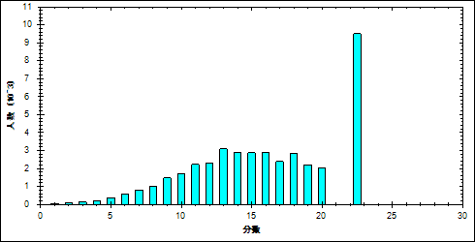

图 27实验能力难度曲线图

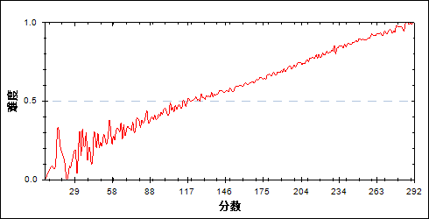

表 31实验能力分组分析表

| 分值 | G1 | G2 | G3 | G4 | G5 | G6 | G7 | 频数 | 比率（%） | 平均值 |
| --- | --- | --- | --- | --- | --- | --- | --- | --- | --- | --- |
| 0- | 33 | 0 | 1 | 0 | 0 | 0 | 0 | 34 | 0.08 | 56.50 |
| 1- | 29 | 3 | 0 | 0 | 0 | 0 | 0 | 32 | 0.08 | 81.41 |
| 2- | 78 | 4 | 1 | 1 | 0 | 0 | 0 | 84 | 0.20 | 73.63 |
| 3- | 132 | 11 | 5 | 0 | 0 | 0 | 0 | 148 | 0.35 | 83.88 |
| 4- | 186 | 25 | 8 | 4 | 1 | 1 | 0 | 225 | 0.54 | 97.35 |
| 5- | 264 | 73 | 21 | 9 | 1 | 0 | 0 | 368 | 0.88 | 102.55 |
| 6- | 365 | 124 | 44 | 20 | 15 | 4 | 0 | 572 | 1.37 | 113.22 |
| 7- | 440 | 200 | 95 | 53 | 18 | 4 | 0 | 810 | 1.94 | 120.36 |
| 8- | 450 | 270 | 159 | 84 | 41 | 8 | 2 | 1014 | 2.42 | 128.16 |
| 9- | 534 | 396 | 285 | 161 | 71 | 28 | 5 | 1480 | 3.54 | 135.53 |
| 10- | 524 | 449 | 365 | 236 | 118 | 35 | 5 | 1732 | 4.14 | 141.46 |
| 11- | 557 | 587 | 457 | 324 | 203 | 85 | 11 | 2224 | 5.32 | 147.43 |
| 12- | 512 | 523 | 494 | 396 | 261 | 110 | 26 | 2322 | 5.55 | 152.72 |
| 13- | 519 | 686 | 697 | 549 | 388 | 208 | 52 | 3099 | 7.41 | 157.94 |
| 14- | 407 | 586 | 612 | 537 | 437 | 254 | 71 | 2904 | 6.94 | 163.12 |
| 15- | 280 | 523 | 544 | 573 | 494 | 339 | 122 | 2875 | 6.87 | 170.26 |
| 16- | 228 | 408 | 492 | 563 | 561 | 453 | 186 | 2891 | 6.91 | 177.41 |
| 17- | 171 | 332 | 404 | 454 | 475 | 389 | 174 | 2399 | 5.74 | 179.19 |
| 18- | 100 | 274 | 372 | 494 | 627 | 592 | 359 | 2818 | 6.74 | 190.38 |
| 19- | 64 | 189 | 269 | 391 | 438 | 533 | 338 | 2222 | 5.31 | 194.25 |
| 20- | 41 | 116 | 193 | 296 | 407 | 521 | 482 | 2056 | 4.92 | 203.43 |
| 21- | 25 | 75 | 179 | 327 | 445 | 616 | 550 | 2217 | 5.30 | 207.46 |
| 22- | 22 | 61 | 142 | 251 | 461 | 780 | 1139 | 2856 | 6.83 | 219.21 |
| 23- | 8 | 39 | 83 | 116 | 202 | 301 | 435 | 1184 | 2.83 | 215.86 |
| 24- | 6 | 21 | 52 | 135 | 310 | 713 | 2017 | 3254 | 7.78 | 236.80 |
| 合计 | 5975 | 5975 | 5974 | 5974 | 5974 | 5974 | 5974 | 41820 | 100.00 | 70.37 |
| 得分率 | 0.43 | 0.54 | 0.60 | 0.65 | 0.72 | 0.79 | 0.89 | - | - | - |

* + - 1. 应用能力

本题组包含22,23\_1,23\_2,24\_1

表 32应用能力总分分布表

|  |  |  |  |  |  |  |  |  |
| --- | --- | --- | --- | --- | --- | --- | --- | --- |
| 满分值 | 最大值 | 最小值 | 平均值 | 标准差 | 差异系数 | 难度 | 相关系数 | 鉴别系数 |
| 32.00 | 32.00 | 0.00 | 23.69 | 8.31 | 0.35 | 0.74 | 14.66 | 0.51 |

图 28应用能力分数分布表

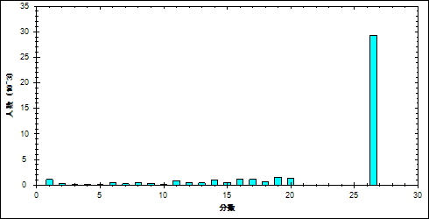

图 29应用能力难度曲线图

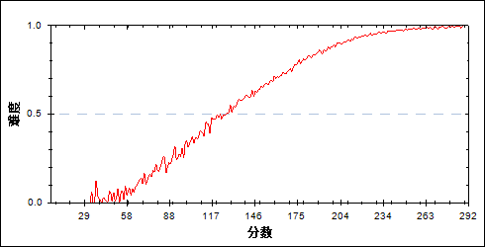

表 33应用能力分组分析表

| 分值 | G1 | G2 | G3 | G4 | G5 | G6 | G7 | 频数 | 比率（%） | 平均值 |
| --- | --- | --- | --- | --- | --- | --- | --- | --- | --- | --- |
| 0- | 984 | 55 | 8 | 2 | 1 | 0 | 0 | 1050 | 2.51 | 81.24 |
| 1- | 25 | 3 | 0 | 0 | 0 | 0 | 0 | 28 | 0.07 | 98.04 |
| 2- | 316 | 47 | 11 | 1 | 0 | 0 | 0 | 375 | 0.90 | 97.62 |
| 3- | 54 | 8 | 4 | 0 | 0 | 0 | 0 | 66 | 0.16 | 102.26 |
| 4- | 143 | 28 | 5 | 1 | 0 | 0 | 0 | 177 | 0.42 | 102.40 |
| 5- | 58 | 21 | 4 | 2 | 0 | 0 | 0 | 85 | 0.20 | 109.69 |
| 6- | 343 | 87 | 13 | 5 | 1 | 0 | 0 | 449 | 1.07 | 105.15 |
| 7- | 175 | 35 | 11 | 2 | 1 | 0 | 0 | 224 | 0.54 | 105.92 |
| 8- | 322 | 99 | 31 | 4 | 2 | 0 | 0 | 458 | 1.10 | 112.21 |
| 9- | 230 | 94 | 23 | 4 | 1 | 0 | 0 | 352 | 0.84 | 114.30 |
| 10- | 111 | 60 | 18 | 0 | 1 | 0 | 0 | 190 | 0.45 | 117.49 |
| 11- | 442 | 265 | 88 | 23 | 2 | 0 | 0 | 820 | 1.96 | 120.73 |
| 12- | 207 | 148 | 52 | 13 | 4 | 0 | 0 | 424 | 1.01 | 124.94 |
| 13- | 194 | 140 | 69 | 25 | 3 | 0 | 0 | 431 | 1.03 | 127.61 |
| 14- | 376 | 330 | 147 | 51 | 6 | 0 | 0 | 910 | 2.18 | 129.95 |
| 15- | 176 | 229 | 111 | 32 | 8 | 1 | 0 | 557 | 1.33 | 133.60 |
| 16- | 330 | 449 | 277 | 95 | 33 | 1 | 0 | 1185 | 2.83 | 138.72 |
| 17- | 295 | 427 | 262 | 118 | 25 | 3 | 0 | 1130 | 2.70 | 139.37 |
| 18- | 151 | 256 | 180 | 74 | 27 | 5 | 1 | 694 | 1.66 | 143.41 |
| 19- | 269 | 534 | 449 | 237 | 63 | 12 | 0 | 1564 | 3.74 | 147.44 |
| 20- | 185 | 432 | 397 | 250 | 73 | 14 | 1 | 1352 | 3.23 | 150.88 |
| 21- | 91 | 252 | 325 | 213 | 92 | 25 | 0 | 998 | 2.39 | 157.41 |
| 22- | 196 | 509 | 597 | 395 | 187 | 28 | 5 | 1917 | 4.58 | 155.99 |
| 23- | 108 | 413 | 539 | 513 | 313 | 96 | 3 | 1985 | 4.75 | 164.97 |
| 24- | 34 | 158 | 295 | 340 | 240 | 76 | 10 | 1153 | 2.76 | 171.80 |
| 25- | 57 | 203 | 337 | 360 | 239 | 98 | 18 | 1312 | 3.14 | 170.40 |
| 26- | 48 | 215 | 518 | 708 | 660 | 369 | 84 | 2602 | 6.22 | 182.07 |
| 27- | 14 | 94 | 164 | 272 | 309 | 198 | 75 | 1126 | 2.69 | 187.47 |
| 28- | 18 | 133 | 245 | 399 | 395 | 264 | 88 | 1542 | 3.69 | 185.99 |
| 29- | 14 | 126 | 344 | 691 | 1039 | 1010 | 612 | 3836 | 9.17 | 201.61 |
| 30- | 4 | 43 | 129 | 265 | 433 | 545 | 332 | 1751 | 4.19 | 206.46 |
| 31- | 1 | 26 | 88 | 208 | 333 | 440 | 380 | 1476 | 3.53 | 211.37 |
| 32- | 4 | 56 | 233 | 671 | 1483 | 2789 | 4365 | 9601 | 22.96 | 226.43 |
| 合计 | 5975 | 5975 | 5974 | 5974 | 5974 | 5974 | 5974 | 41820 | 100.00 | 70.37 |
| 得分率 | 0.34 | 0.58 | 0.69 | 0.79 | 0.87 | 0.94 | 0.98 | - | - | - |

* + - 1. 探究能力

本题组包含20,23\_3,24\_2

表 34探究能力总分分布表

|  |  |  |  |  |  |  |  |  |
| --- | --- | --- | --- | --- | --- | --- | --- | --- |
| 满分值 | 最大值 | 最小值 | 平均值 | 标准差 | 差异系数 | 难度 | 相关系数 | 鉴别系数 |
| 22.00 | 22.00 | 0.00 | 6.97 | 6.45 | 0.93 | 0.32 | 6.46 | 0.56 |

图 30探究能力分数分布表

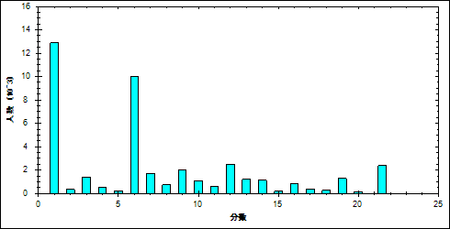

图 31探究能力难度曲线图

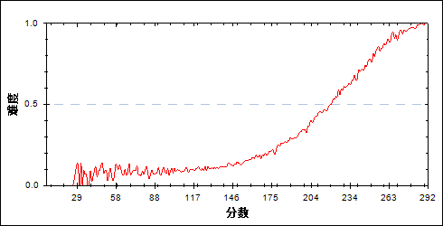

表 35探究能力分组分析表

| 分值 | G1 | G2 | G3 | G4 | G5 | G6 | G7 | 频数 | 比率（%） | 平均值 |
| --- | --- | --- | --- | --- | --- | --- | --- | --- | --- | --- |
| 0- | 3851 | 3194 | 2352 | 1452 | 614 | 92 | 3 | 11558 | 27.64 | 136.77 |
| 1- | 122 | 280 | 354 | 316 | 185 | 60 | 0 | 1317 | 3.15 | 161.45 |
| 2- | 18 | 46 | 58 | 91 | 80 | 42 | 3 | 338 | 0.81 | 174.64 |
| 3- | 38 | 134 | 292 | 412 | 371 | 135 | 7 | 1389 | 3.32 | 176.95 |
| 4- | 10 | 44 | 86 | 131 | 165 | 92 | 11 | 539 | 1.29 | 184.36 |
| 5- | 1 | 11 | 22 | 51 | 94 | 53 | 11 | 243 | 0.58 | 193.49 |
| 6- | 1864 | 1958 | 2036 | 1927 | 1462 | 664 | 81 | 9992 | 23.89 | 156.85 |
| 7- | 55 | 160 | 292 | 405 | 434 | 299 | 54 | 1699 | 4.06 | 182.24 |
| 8- | 4 | 28 | 75 | 116 | 241 | 212 | 56 | 732 | 1.75 | 196.83 |
| 9- | 8 | 67 | 196 | 409 | 620 | 551 | 153 | 2004 | 4.79 | 196.24 |
| 10- | 4 | 25 | 83 | 192 | 313 | 339 | 127 | 1083 | 2.59 | 201.53 |
| 11- | 0 | 5 | 13 | 62 | 161 | 248 | 114 | 603 | 1.44 | 211.96 |
| 12- | 0 | 19 | 91 | 251 | 640 | 1000 | 478 | 2479 | 5.93 | 211.46 |
| 13- | 0 | 2 | 11 | 74 | 207 | 515 | 391 | 1200 | 2.87 | 221.33 |
| 14- | 0 | 1 | 6 | 38 | 158 | 455 | 485 | 1143 | 2.73 | 226.25 |
| 15- | 0 | 0 | 2 | 10 | 27 | 82 | 78 | 199 | 0.48 | 225.26 |
| 16- | 0 | 1 | 3 | 18 | 69 | 321 | 441 | 853 | 2.04 | 231.77 |
| 17- | 0 | 0 | 1 | 8 | 29 | 124 | 215 | 377 | 0.90 | 234.30 |
| 18- | 0 | 0 | 0 | 3 | 15 | 96 | 147 | 261 | 0.62 | 235.51 |
| 19- | 0 | 0 | 1 | 7 | 50 | 309 | 922 | 1289 | 3.08 | 242.06 |
| 20- | 0 | 0 | 0 | 0 | 4 | 26 | 113 | 143 | 0.34 | 246.84 |
| 21- | 0 | 0 | 0 | 1 | 6 | 23 | 168 | 198 | 0.47 | 250.94 |
| 22- | 0 | 0 | 0 | 0 | 29 | 236 | 1916 | 2181 | 5.22 | 254.22 |
| 合计 | 5975 | 5975 | 5974 | 5974 | 5974 | 5974 | 5974 | 41820 | 100.00 | 70.37 |
| 得分率 | 0.09 | 0.12 | 0.16 | 0.22 | 0.33 | 0.51 | 0.78 | - | - | - |

* 1. 题目分析
     + 1. 第13题

表 36题目分析表

|  |  |  |  |  |  |  |  |  |
| --- | --- | --- | --- | --- | --- | --- | --- | --- |
| 满分值 | 最大值 | 最小值 | 平均值 | 标准差 | 差异系数 | 难度 | 相关系数 | 鉴别系数 |
| 6.00 | 6.00 | 0.00 | 4.62 | 2.53 | 0.55 | 0.77 | 0.36 | 0.34 |

图 32题目难度曲线图

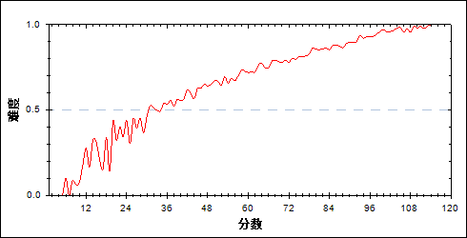

图 33分组难度曲线图

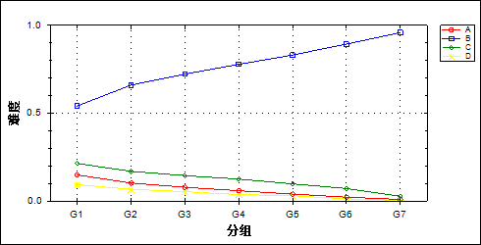

表 37题目分组分析表

| 选项 | G1 | G2 | G3 | G4 | G5 | G6 | G7 | 频数 | 比率（%） | 相关系数 |
| --- | --- | --- | --- | --- | --- | --- | --- | --- | --- | --- |
| A | 889 | 612 | 469 | 353 | 237 | 131 | 57 | 2748 | 6.57 | -0.07 |
| \*B | 3237 | 3946 | 4318 | 4650 | 4967 | 5339 | 5731 | 32188 | 76.97 | 0.12 |
| C | 1277 | 1011 | 864 | 749 | 584 | 427 | 163 | 5075 | 12.14 | -0.07 |
| D | 557 | 400 | 319 | 221 | 182 | 77 | 23 | 1779 | 4.25 | -0.05 |
| 未选或多选 | 15 | 6 | 4 | 1 | 4 | 0 | 0 | 30 | 0.07 | -0.01 |
| 合计 | 5975 | 5975 | 5974 | 5974 | 5974 | 5974 | 5974 | 41820 | 100.00 | - |
| 得分率 | 0.54 | 0.66 | 0.72 | 0.78 | 0.83 | 0.89 | 0.96 | - | - | - |

* + - 1. 第14题

表 38题目分析表

|  |  |  |  |  |  |  |  |  |
| --- | --- | --- | --- | --- | --- | --- | --- | --- |
| 满分值 | 最大值 | 最小值 | 平均值 | 标准差 | 差异系数 | 难度 | 相关系数 | 鉴别系数 |
| 6.00 | 6.00 | 0.00 | 4.48 | 2.61 | 0.58 | 0.75 | 0.47 | 0.46 |

图 34题目难度曲线图

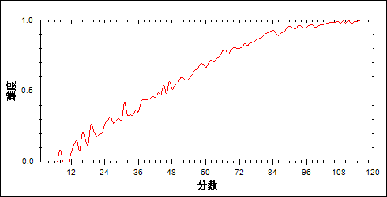

图 35分组难度曲线图

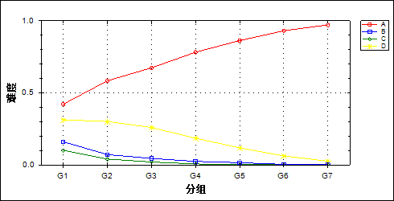

表 39题目分组分析表

| 选项 | G1 | G2 | G3 | G4 | G5 | G6 | G7 | 频数 | 比率（%） | 相关系数 |
| --- | --- | --- | --- | --- | --- | --- | --- | --- | --- | --- |
| \*A | 2521 | 3491 | 4027 | 4674 | 5157 | 5562 | 5806 | 31238 | 74.70 | 0.16 |
| B | 959 | 427 | 269 | 148 | 94 | 25 | 9 | 1931 | 4.62 | -0.08 |
| C | 604 | 244 | 122 | 41 | 15 | 9 | 2 | 1037 | 2.48 | -0.07 |
| D | 1873 | 1801 | 1553 | 1107 | 706 | 375 | 156 | 7571 | 18.10 | -0.10 |
| 未选或多选 | 18 | 12 | 3 | 4 | 2 | 3 | 1 | 43 | 0.10 | -0.01 |
| 合计 | 5975 | 5975 | 5974 | 5974 | 5974 | 5974 | 5974 | 41820 | 100.00 | - |
| 得分率 | 0.42 | 0.58 | 0.67 | 0.78 | 0.86 | 0.93 | 0.97 | - | - | - |

* + - 1. 第15题

表 40题目分析表

|  |  |  |  |  |  |  |  |  |
| --- | --- | --- | --- | --- | --- | --- | --- | --- |
| 满分值 | 最大值 | 最小值 | 平均值 | 标准差 | 差异系数 | 难度 | 相关系数 | 鉴别系数 |
| 6.00 | 6.00 | 0.00 | 3.65 | 2.93 | 0.80 | 0.61 | 0.60 | 0.71 |

图 36题目难度曲线图

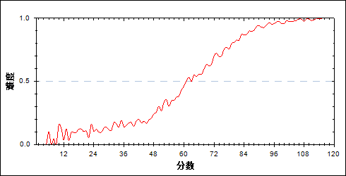

图 37分组难度曲线图

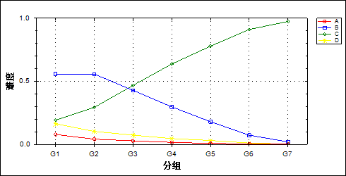

表 41题目分组分析表

| 选项 | G1 | G2 | G3 | G4 | G5 | G6 | G7 | 频数 | 比率（%） | 相关系数 |
| --- | --- | --- | --- | --- | --- | --- | --- | --- | --- | --- |
| A | 473 | 248 | 168 | 98 | 51 | 24 | 7 | 1069 | 2.56 | -0.05 |
| B | 3339 | 3329 | 2559 | 1779 | 1075 | 437 | 121 | 12639 | 30.22 | -0.15 |
| \*C | 1152 | 1758 | 2794 | 3809 | 4655 | 5441 | 5825 | 25434 | 60.82 | 0.20 |
| D | 979 | 615 | 440 | 280 | 187 | 64 | 18 | 2583 | 6.18 | -0.07 |
| 未选或多选 | 32 | 25 | 13 | 8 | 6 | 8 | 3 | 95 | 0.23 | -0.01 |
| 合计 | 5975 | 5975 | 5974 | 5974 | 5974 | 5974 | 5974 | 41820 | 100.00 | - |
| 得分率 | 0.19 | 0.29 | 0.47 | 0.64 | 0.78 | 0.91 | 0.98 | - | - | - |

* + - 1. 第16题

表 42题目分析表

|  |  |  |  |  |  |  |  |  |
| --- | --- | --- | --- | --- | --- | --- | --- | --- |
| 满分值 | 最大值 | 最小值 | 平均值 | 标准差 | 差异系数 | 难度 | 相关系数 | 鉴别系数 |
| 6.00 | 6.00 | 0.00 | 2.25 | 2.90 | 1.29 | 0.37 | 0.32 | 0.32 |

图 38题目难度曲线图

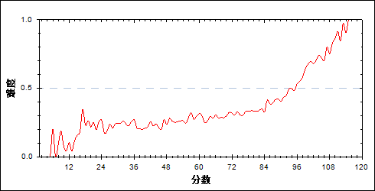

图 39分组难度曲线图

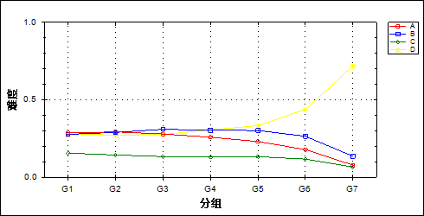

表 43题目分组分析表

| 选项 | G1 | G2 | G3 | G4 | G5 | G6 | G7 | 频数 | 比率（%） | 相关系数 |
| --- | --- | --- | --- | --- | --- | --- | --- | --- | --- | --- |
| A | 1709 | 1749 | 1667 | 1547 | 1378 | 1068 | 468 | 9586 | 22.92 | -0.06 |
| B | 1656 | 1729 | 1852 | 1813 | 1805 | 1580 | 813 | 11248 | 26.90 | -0.04 |
| C | 932 | 858 | 796 | 774 | 794 | 701 | 395 | 5250 | 12.55 | -0.03 |
| \*D | 1660 | 1630 | 1651 | 1827 | 1990 | 2615 | 4297 | 15670 | 37.47 | 0.11 |
| 未选或多选 | 18 | 9 | 8 | 13 | 7 | 10 | 1 | 66 | 0.16 | -0.01 |
| 合计 | 5975 | 5975 | 5974 | 5974 | 5974 | 5974 | 5974 | 41820 | 100.00 | - |
| 得分率 | 0.28 | 0.27 | 0.28 | 0.31 | 0.33 | 0.44 | 0.72 | - | - | - |

* + - 1. 第17题

表 44题目分析表

|  |  |  |  |  |  |  |  |  |
| --- | --- | --- | --- | --- | --- | --- | --- | --- |
| 满分值 | 最大值 | 最小值 | 平均值 | 标准差 | 差异系数 | 难度 | 相关系数 | 鉴别系数 |
| 6.00 | 6.00 | 0.00 | 3.83 | 2.88 | 0.75 | 0.64 | 0.48 | 0.52 |

图 40题目难度曲线图

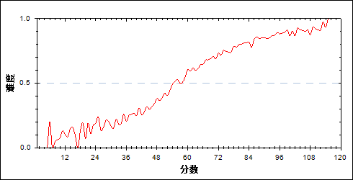

图 41分组难度曲线图

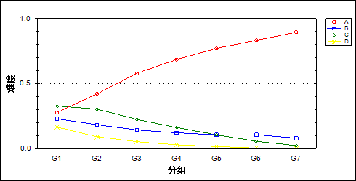

表 45题目分组分析表

| 选项 | G1 | G2 | G3 | G4 | G5 | G6 | G7 | 频数 | 比率（%） | 相关系数 |
| --- | --- | --- | --- | --- | --- | --- | --- | --- | --- | --- |
| \*A | 1662 | 2519 | 3466 | 4104 | 4616 | 4978 | 5349 | 26694 | 63.83 | 0.16 |
| B | 1365 | 1095 | 852 | 723 | 632 | 633 | 479 | 5779 | 13.82 | -0.06 |
| C | 1954 | 1814 | 1339 | 967 | 628 | 335 | 133 | 7170 | 17.14 | -0.10 |
| D | 985 | 541 | 317 | 176 | 97 | 27 | 13 | 2156 | 5.16 | -0.08 |
| 未选或多选 | 9 | 6 | 0 | 4 | 1 | 1 | 0 | 21 | 0.05 | -0.01 |
| 合计 | 5975 | 5975 | 5974 | 5974 | 5974 | 5974 | 5974 | 41820 | 100.00 | - |
| 得分率 | 0.28 | 0.42 | 0.58 | 0.69 | 0.77 | 0.83 | 0.90 | - | - | - |

* + - 1. 第18题

表 46题目分析表

|  |  |  |  |  |  |  |  |  |
| --- | --- | --- | --- | --- | --- | --- | --- | --- |
| 满分值 | 最大值 | 最小值 | 平均值 | 标准差 | 差异系数 | 难度 | 相关系数 | 鉴别系数 |
| 6.00 | 6.00 | 0.00 | 4.74 | 2.45 | 0.52 | 0.79 | 0.39 | 0.35 |

图 42题目难度曲线图

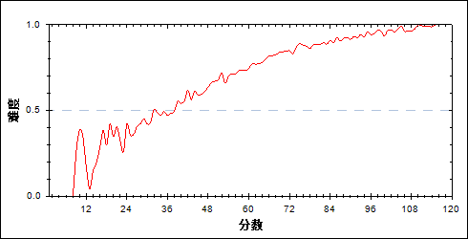

图 43分组难度曲线图

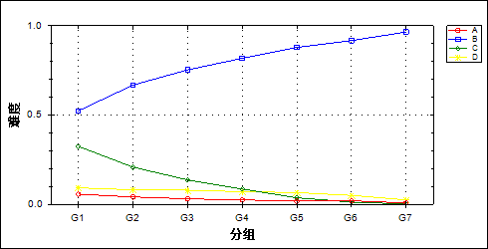

表 47题目分组分析表

| 选项 | G1 | G2 | G3 | G4 | G5 | G6 | G7 | 频数 | 比率（%） | 相关系数 |
| --- | --- | --- | --- | --- | --- | --- | --- | --- | --- | --- |
| A | 339 | 247 | 184 | 148 | 110 | 118 | 47 | 1193 | 2.85 | -0.04 |
| \*B | 3130 | 3993 | 4501 | 4888 | 5250 | 5481 | 5767 | 33010 | 78.93 | 0.13 |
| C | 1940 | 1244 | 816 | 511 | 219 | 76 | 11 | 4817 | 11.52 | -0.12 |
| D | 551 | 486 | 470 | 426 | 394 | 298 | 147 | 2772 | 6.63 | -0.04 |
| 未选或多选 | 15 | 5 | 3 | 1 | 1 | 1 | 2 | 28 | 0.07 | -0.01 |
| 合计 | 5975 | 5975 | 5974 | 5974 | 5974 | 5974 | 5974 | 41820 | 100.00 | - |
| 得分率 | 0.52 | 0.67 | 0.75 | 0.82 | 0.88 | 0.92 | 0.97 | - | - | - |

* + - 1. 第19题

表 48题目分析表

|  |  |  |  |  |  |  |  |  |
| --- | --- | --- | --- | --- | --- | --- | --- | --- |
| 满分值 | 最大值 | 最小值 | 平均值 | 标准差 | 差异系数 | 难度 | 相关系数 | 鉴别系数 |
| 6.00 | 6.00 | 0.00 | 2.78 | 2.99 | 1.07 | 0.46 | 0.53 | 0.62 |

图 44题目难度曲线图

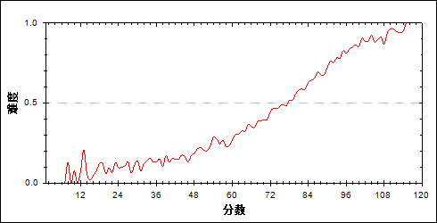

图 45分组难度曲线图

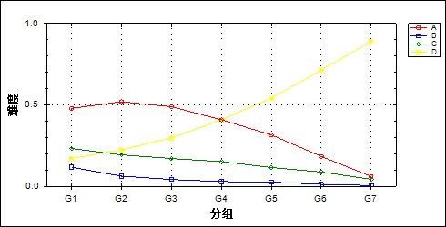

表 49题目分组分析表

| 选项 | G1 | G2 | G3 | G4 | G5 | G6 | G7 | 频数 | 比率（%） | 相关系数 |
| --- | --- | --- | --- | --- | --- | --- | --- | --- | --- | --- |
| A | 2862 | 3105 | 2922 | 2442 | 1885 | 1099 | 366 | 14681 | 35.11 | -0.11 |
| B | 698 | 372 | 250 | 176 | 157 | 70 | 29 | 1752 | 4.19 | -0.06 |
| C | 1388 | 1153 | 1018 | 907 | 690 | 524 | 256 | 5936 | 14.19 | -0.06 |
| \*D | 1018 | 1335 | 1777 | 2445 | 3237 | 4272 | 5321 | 19405 | 46.40 | 0.18 |
| 未选或多选 | 9 | 10 | 7 | 4 | 5 | 9 | 2 | 46 | 0.11 | 0.00 |
| 合计 | 5975 | 5975 | 5974 | 5974 | 5974 | 5974 | 5974 | 41820 | 100.00 | - |
| 得分率 | 0.17 | 0.22 | 0.30 | 0.41 | 0.54 | 0.72 | 0.89 | - | - | - |

* + - 1. 第20题

表 50题目分析表

|  |  |  |  |  |  |  |  |  |
| --- | --- | --- | --- | --- | --- | --- | --- | --- |
| 满分值 | 最大值 | 最小值 | 平均值 | 标准差 | 差异系数 | 难度 | 相关系数 | 鉴别系数 |
| 6.00 | 6.00 | 0.00 | 3.47 | 2.96 | 0.85 | 0.58 | 0.47 | 0.53 |

图 46题目难度曲线图

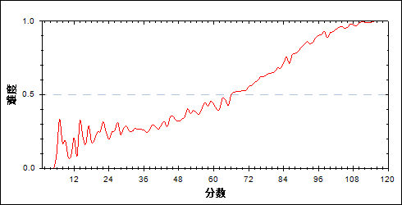

图 47分组难度曲线图

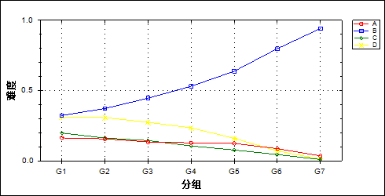

表 51题目分组分析表

| 选项 | G1 | G2 | G3 | G4 | G5 | G6 | G7 | 频数 | 比率（%） | 相关系数 |
| --- | --- | --- | --- | --- | --- | --- | --- | --- | --- | --- |
| A | 976 | 933 | 804 | 766 | 742 | 516 | 212 | 4949 | 11.83 | -0.05 |
| \*B | 1927 | 2225 | 2664 | 3168 | 3810 | 4769 | 5626 | 24189 | 57.84 | 0.16 |
| C | 1184 | 970 | 861 | 634 | 461 | 266 | 58 | 4434 | 10.60 | -0.07 |
| D | 1870 | 1839 | 1638 | 1403 | 955 | 422 | 78 | 8205 | 19.62 | -0.10 |
| 未选或多选 | 18 | 8 | 7 | 3 | 6 | 1 | 0 | 43 | 0.10 | -0.01 |
| 合计 | 5975 | 5975 | 5974 | 5974 | 5974 | 5974 | 5974 | 41820 | 100.00 | - |
| 得分率 | 0.32 | 0.37 | 0.45 | 0.53 | 0.64 | 0.80 | 0.94 | - | - | - |

* + - 1. 第21题

表 52题目分析表

|  |  |  |  |  |  |  |  |  |
| --- | --- | --- | --- | --- | --- | --- | --- | --- |
| 满分值 | 最大值 | 最小值 | 平均值 | 标准差 | 差异系数 | 难度 | 相关系数 | 鉴别系数 |
| 18.00 | 18.00 | 0.00 | 13.08 | 3.48 | 0.27 | 0.73 | 0.62 | 0.28 |

图 48题目难度曲线图

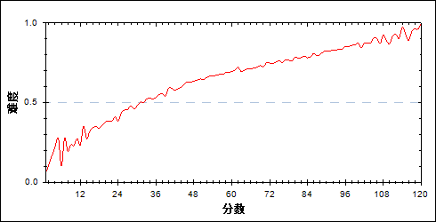

图 49分组难度曲线图

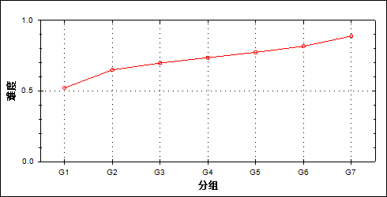

表 53题目分组分析表

| 分值 | G1 | G2 | G3 | G4 | G5 | G6 | G7 | 频数 | 比率（%） | 平均值 |
| --- | --- | --- | --- | --- | --- | --- | --- | --- | --- | --- |
| 0.00 | 40 | 0 | 1 | 0 | 0 | 0 | 0 | 41 | 0.10 | 19.05 |
| 1.00 | 35 | 4 | 0 | 0 | 0 | 0 | 0 | 39 | 0.09 | 25.79 |
| 2.00 | 94 | 7 | 2 | 1 | 1 | 0 | 0 | 105 | 0.25 | 23.52 |
| 3.00 | 161 | 18 | 6 | 2 | 0 | 1 | 0 | 188 | 0.45 | 28.54 |
| 4.00 | 231 | 43 | 17 | 13 | 2 | 1 | 0 | 307 | 0.73 | 34.26 |
| 5.00 | 327 | 100 | 39 | 20 | 6 | 3 | 1 | 496 | 1.19 | 37.51 |
| 6.00 | 442 | 166 | 76 | 57 | 28 | 12 | 3 | 784 | 1.87 | 42.54 |
| 7.00 | 536 | 262 | 152 | 91 | 41 | 15 | 4 | 1101 | 2.63 | 45.45 |
| 8.00 | 552 | 357 | 244 | 157 | 113 | 50 | 11 | 1484 | 3.55 | 50.80 |
| 9.00 | 612 | 514 | 399 | 268 | 176 | 115 | 45 | 2129 | 5.09 | 54.23 |
| 10.00 | 580 | 564 | 497 | 398 | 271 | 134 | 50 | 2494 | 5.96 | 57.69 |
| 11.00 | 602 | 722 | 640 | 548 | 463 | 330 | 131 | 3436 | 8.22 | 62.05 |
| 12.00 | 494 | 644 | 660 | 603 | 582 | 410 | 160 | 3553 | 8.50 | 65.28 |
| 13.00 | 481 | 812 | 909 | 902 | 803 | 730 | 386 | 5023 | 12.01 | 68.93 |
| 14.00 | 330 | 612 | 719 | 760 | 771 | 733 | 544 | 4469 | 10.69 | 73.06 |
| 15.00 | 198 | 473 | 608 | 791 | 834 | 867 | 632 | 4403 | 10.53 | 76.84 |
| 16.00 | 149 | 336 | 493 | 643 | 868 | 1134 | 1280 | 4903 | 11.72 | 83.60 |
| 17.00 | 71 | 209 | 286 | 335 | 412 | 442 | 488 | 2243 | 5.36 | 81.56 |
| 18.00 | 40 | 132 | 226 | 385 | 603 | 997 | 2239 | 4622 | 11.05 | 94.53 |
| 合计 | 5975 | 5975 | 5974 | 5974 | 5974 | 5974 | 5974 | 41820 | 100.00 | - |
| 得分率 | 0.52 | 0.65 | 0.70 | 0.74 | 0.77 | 0.82 | 0.89 | - | - | - |

* + - 1. 第22题

表 54题目分析表

|  |  |  |  |  |  |  |  |  |
| --- | --- | --- | --- | --- | --- | --- | --- | --- |
| 满分值 | 最大值 | 最小值 | 平均值 | 标准差 | 差异系数 | 难度 | 相关系数 | 鉴别系数 |
| 16.00 | 16.00 | 0.00 | 13.98 | 3.70 | 0.26 | 0.87 | 0.61 | 0.33 |

图 50题目难度曲线图

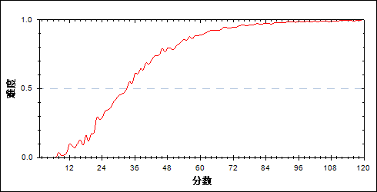

图 51分组难度曲线图

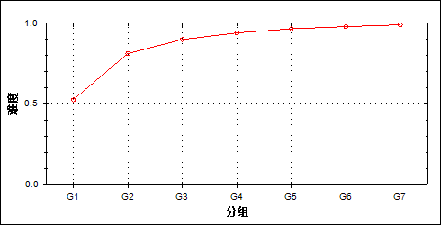

表 55题目分组分析表

| 分值 | G1 | G2 | G3 | G4 | G5 | G6 | G7 | 频数 | 比率（%） | 平均值 |
| --- | --- | --- | --- | --- | --- | --- | --- | --- | --- | --- |
| 0.00 | 1014 | 63 | 11 | 2 | 2 | 0 | 0 | 1092 | 2.61 | 27.81 |
| 1.00 | 22 | 3 | 0 | 0 | 0 | 0 | 0 | 25 | 0.06 | 32.28 |
| 2.00 | 349 | 58 | 16 | 3 | 0 | 0 | 1 | 427 | 1.02 | 32.77 |
| 3.00 | 39 | 8 | 3 | 0 | 0 | 0 | 0 | 50 | 0.12 | 31.94 |
| 4.00 | 178 | 44 | 9 | 2 | 0 | 0 | 0 | 233 | 0.56 | 35.33 |
| 5.00 | 55 | 20 | 4 | 1 | 0 | 0 | 0 | 80 | 0.19 | 37.46 |
| 6.00 | 462 | 159 | 35 | 11 | 3 | 0 | 1 | 671 | 1.60 | 38.55 |
| 7.00 | 215 | 76 | 29 | 7 | 2 | 0 | 0 | 329 | 0.79 | 39.58 |
| 8.00 | 541 | 285 | 122 | 34 | 6 | 2 | 0 | 990 | 2.37 | 42.97 |
| 9.00 | 267 | 183 | 97 | 42 | 15 | 4 | 0 | 608 | 1.45 | 45.85 |
| 10.00 | 98 | 89 | 33 | 22 | 10 | 2 | 1 | 255 | 0.61 | 48.42 |
| 11.00 | 957 | 988 | 590 | 355 | 191 | 97 | 28 | 3206 | 7.67 | 52.46 |
| 12.00 | 171 | 207 | 148 | 112 | 54 | 29 | 10 | 731 | 1.75 | 56.34 |
| 13.00 | 362 | 577 | 513 | 371 | 271 | 156 | 75 | 2325 | 5.56 | 61.04 |
| 14.00 | 284 | 526 | 623 | 604 | 449 | 389 | 203 | 3078 | 7.36 | 67.54 |
| 15.00 | 103 | 232 | 182 | 163 | 97 | 53 | 32 | 862 | 2.06 | 63.43 |
| 16.00 | 858 | 2457 | 3559 | 4245 | 4874 | 5242 | 5623 | 26858 | 64.22 | 80.02 |
| 合计 | 5975 | 5975 | 5974 | 5974 | 5974 | 5974 | 5974 | 41820 | 100.00 | - |
| 得分率 | 0.53 | 0.81 | 0.90 | 0.94 | 0.97 | 0.98 | 0.99 | - | - | - |

* + - 1. 第23题

表 56题目分析表

|  |  |  |  |  |  |  |  |  |
| --- | --- | --- | --- | --- | --- | --- | --- | --- |
| 满分值 | 最大值 | 最小值 | 平均值 | 标准差 | 差异系数 | 难度 | 相关系数 | 鉴别系数 |
| 18.00 | 18.00 | 0.00 | 9.50 | 6.28 | 0.66 | 0.53 | 0.83 | 0.70 |

图 52题目难度曲线图

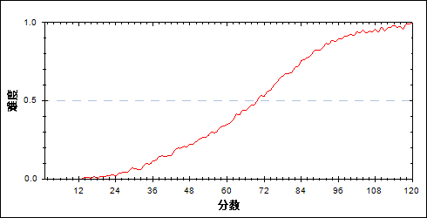

图 53分组难度曲线图

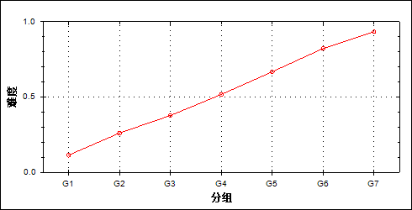

表 57题目分组分析表

| 分值 | G1 | G2 | G3 | G4 | G5 | G6 | G7 | 频数 | 比率（%） | 平均值 |
| --- | --- | --- | --- | --- | --- | --- | --- | --- | --- | --- |
| 0.00 | 3597 | 1443 | 665 | 236 | 74 | 5 | 0 | 6020 | 14.40 | 40.13 |
| 1.00 | 27 | 27 | 25 | 3 | 0 | 0 | 0 | 82 | 0.20 | 48.28 |
| 2.00 | 3 | 2 | 1 | 0 | 0 | 0 | 0 | 6 | 0.01 | 42.33 |
| 3.00 | 1020 | 1471 | 1172 | 711 | 298 | 68 | 3 | 4743 | 11.34 | 53.75 |
| 4.00 | 46 | 98 | 99 | 61 | 27 | 5 | 0 | 336 | 0.80 | 57.57 |
| 5.00 | 3 | 9 | 9 | 7 | 3 | 1 | 0 | 32 | 0.08 | 58.84 |
| 6.00 | 969 | 1723 | 1700 | 1296 | 749 | 212 | 15 | 6664 | 15.93 | 59.11 |
| 7.00 | 58 | 131 | 183 | 177 | 96 | 37 | 1 | 683 | 1.63 | 63.22 |
| 8.00 | 4 | 8 | 12 | 14 | 2 | 3 | 0 | 43 | 0.10 | 62.44 |
| 9.00 | 110 | 433 | 646 | 731 | 529 | 235 | 43 | 2727 | 6.52 | 67.65 |
| 10.00 | 17 | 76 | 149 | 188 | 173 | 83 | 19 | 705 | 1.69 | 70.51 |
| 11.00 | 1 | 11 | 19 | 16 | 23 | 14 | 0 | 84 | 0.20 | 72.14 |
| 12.00 | 76 | 317 | 626 | 1015 | 1152 | 800 | 286 | 4272 | 10.22 | 76.18 |
| 13.00 | 18 | 88 | 192 | 297 | 383 | 318 | 112 | 1408 | 3.37 | 78.20 |
| 14.00 | 2 | 10 | 17 | 22 | 36 | 49 | 29 | 165 | 0.39 | 82.44 |
| 15.00 | 18 | 93 | 295 | 742 | 1210 | 1569 | 1103 | 5030 | 12.03 | 86.62 |
| 16.00 | 3 | 13 | 55 | 126 | 249 | 331 | 291 | 1068 | 2.55 | 89.03 |
| 17.00 | 0 | 1 | 4 | 7 | 21 | 40 | 62 | 135 | 0.32 | 93.96 |
| 18.00 | 3 | 21 | 105 | 325 | 949 | 2204 | 4010 | 7617 | 18.21 | 98.23 |
| 合计 | 5975 | 5975 | 5974 | 5974 | 5974 | 5974 | 5974 | 41820 | 100.00 | - |
| 得分率 | 0.11 | 0.26 | 0.38 | 0.52 | 0.67 | 0.82 | 0.93 | - | - | - |

* + - 1. 第24题

表 58题目分析表

|  |  |  |  |  |  |  |  |  |
| --- | --- | --- | --- | --- | --- | --- | --- | --- |
| 满分值 | 最大值 | 最小值 | 平均值 | 标准差 | 差异系数 | 难度 | 相关系数 | 鉴别系数 |
| 20.00 | 20.00 | 0.00 | 3.99 | 4.77 | 1.19 | 0.20 | 0.76 | 0.43 |

图 54题目难度曲线图

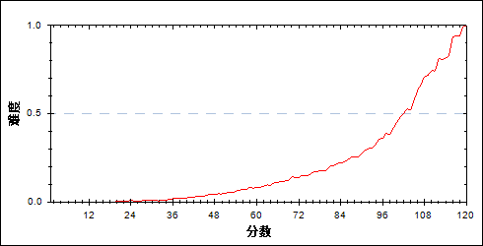

图 55分组难度曲线图

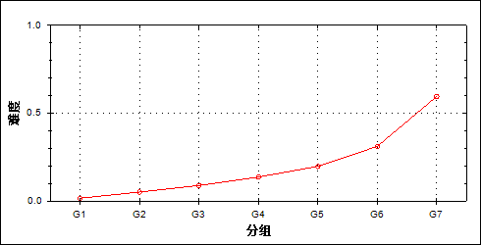

表 59题目分组分析表

| 分值 | G1 | G2 | G3 | G4 | G5 | G6 | G7 | 频数 | 比率（%） | 平均值 |
| --- | --- | --- | --- | --- | --- | --- | --- | --- | --- | --- |
| 0.00 | 4944 | 3357 | 2172 | 1233 | 544 | 161 | 20 | 12431 | 29.73 | 48.64 |
| 1.00 | 573 | 1059 | 1023 | 733 | 430 | 142 | 21 | 3981 | 9.52 | 58.88 |
| 2.00 | 190 | 521 | 772 | 819 | 661 | 350 | 57 | 3370 | 8.06 | 67.00 |
| 3.00 | 96 | 302 | 493 | 635 | 608 | 445 | 103 | 2682 | 6.41 | 71.94 |
| 4.00 | 162 | 631 | 1265 | 1832 | 2100 | 1609 | 533 | 8132 | 19.45 | 75.39 |
| 5.00 | 6 | 62 | 142 | 288 | 550 | 706 | 342 | 2096 | 5.01 | 83.99 |
| 6.00 | 3 | 27 | 62 | 220 | 475 | 706 | 459 | 1952 | 4.67 | 87.32 |
| 7.00 | 0 | 2 | 9 | 60 | 94 | 134 | 107 | 406 | 0.97 | 88.55 |
| 8.00 | 1 | 6 | 16 | 48 | 129 | 309 | 211 | 720 | 1.72 | 91.10 |
| 9.00 | 0 | 4 | 5 | 24 | 61 | 150 | 144 | 388 | 0.93 | 92.82 |
| 10.00 | 0 | 2 | 5 | 22 | 64 | 172 | 191 | 456 | 1.09 | 95.17 |
| 11.00 | 0 | 1 | 8 | 38 | 149 | 409 | 528 | 1133 | 2.71 | 96.35 |
| 12.00 | 0 | 0 | 1 | 4 | 26 | 97 | 230 | 358 | 0.86 | 101.00 |
| 13.00 | 0 | 0 | 0 | 2 | 4 | 34 | 86 | 126 | 0.30 | 102.31 |
| 14.00 | 0 | 0 | 1 | 12 | 57 | 358 | 1000 | 1428 | 3.41 | 103.47 |
| 15.00 | 0 | 1 | 0 | 4 | 12 | 89 | 466 | 572 | 1.37 | 105.91 |
| 16.00 | 0 | 0 | 0 | 0 | 1 | 14 | 55 | 70 | 0.17 | 106.87 |
| 17.00 | 0 | 0 | 0 | 0 | 1 | 11 | 141 | 153 | 0.37 | 109.60 |
| 18.00 | 0 | 0 | 0 | 0 | 6 | 60 | 541 | 607 | 1.45 | 110.00 |
| 19.00 | 0 | 0 | 0 | 0 | 0 | 3 | 27 | 30 | 0.07 | 110.50 |
| 20.00 | 0 | 0 | 0 | 0 | 2 | 15 | 712 | 729 | 1.74 | 114.72 |
| 合计 | 5975 | 5975 | 5974 | 5974 | 5974 | 5974 | 5974 | 41820 | 100.00 | - |
| 得分率 | 0.02 | 0.05 | 0.09 | 0.14 | 0.20 | 0.31 | 0.60 | - | - | - |

* + - 1. 第21\_1题

表 60题目分析表

|  |  |  |  |  |  |  |  |  |
| --- | --- | --- | --- | --- | --- | --- | --- | --- |
| 满分值 | 最大值 | 最小值 | 平均值 | 标准差 | 差异系数 | 难度 | 相关系数 | 鉴别系数 |
| 2.00 | 2.00 | 0.00 | 1.70 | 0.71 | 0.42 | 0.85 | 0.36 | 0.31 |

图 56题目难度曲线图

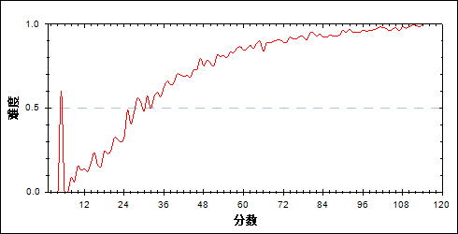

图 57分组难度曲线图

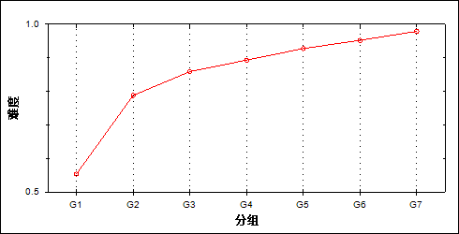

表 61题目分组分析表

| 分值 | G1 | G2 | G3 | G4 | G5 | G6 | G7 | 频数 | 比率（%） | 平均值 |
| --- | --- | --- | --- | --- | --- | --- | --- | --- | --- | --- |
| 0.00 | 2669 | 1267 | 843 | 638 | 432 | 286 | 125 | 6260 | 14.97 | 50.25 |
| 2.00 | 3306 | 4708 | 5131 | 5336 | 5542 | 5688 | 5849 | 35560 | 85.03 | 73.91 |
| 合计 | 5975 | 5975 | 5974 | 5974 | 5974 | 5974 | 5974 | 41820 | 100.00 | - |
| 得分率 | 0.55 | 0.79 | 0.86 | 0.89 | 0.93 | 0.95 | 0.98 | - | - | - |

* + - 1. 第21\_2题

表 62题目分析表

|  |  |  |  |  |  |  |  |  |
| --- | --- | --- | --- | --- | --- | --- | --- | --- |
| 满分值 | 最大值 | 最小值 | 平均值 | 标准差 | 差异系数 | 难度 | 相关系数 | 鉴别系数 |
| 2.00 | 2.00 | 0.00 | 1.34 | 0.94 | 0.70 | 0.67 | -0.02 | -0.06 |

图 58题目难度曲线图

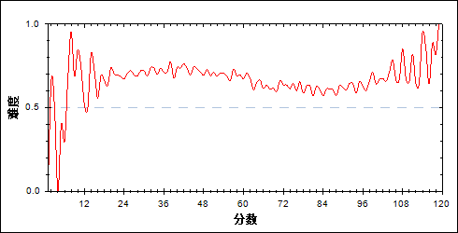

图 59分组难度曲线图

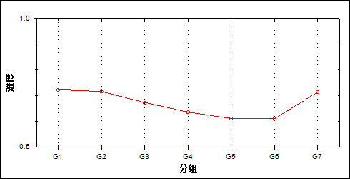

表 63题目分组分析表

| 分值 | G1 | G2 | G3 | G4 | G5 | G6 | G7 | 频数 | 比率（%） | 平均值 |
| --- | --- | --- | --- | --- | --- | --- | --- | --- | --- | --- |
| 0.00 | 1656 | 1698 | 1954 | 2176 | 2325 | 2332 | 1708 | 13849 | 33.12 | 71.09 |
| 2.00 | 4319 | 4277 | 4020 | 3798 | 3649 | 3642 | 4266 | 27971 | 66.88 | 70.01 |
| 合计 | 5975 | 5975 | 5974 | 5974 | 5974 | 5974 | 5974 | 41820 | 100.00 | - |
| 得分率 | 0.72 | 0.72 | 0.67 | 0.64 | 0.61 | 0.61 | 0.71 | - | - | - |

* + - 1. 第21\_3题

表 64题目分析表

|  |  |  |  |  |  |  |  |  |
| --- | --- | --- | --- | --- | --- | --- | --- | --- |
| 满分值 | 最大值 | 最小值 | 平均值 | 标准差 | 差异系数 | 难度 | 相关系数 | 鉴别系数 |
| 4.00 | 4.00 | 0.00 | 2.95 | 1.76 | 0.60 | 0.74 | 0.36 | 0.37 |

图 60题目难度曲线图

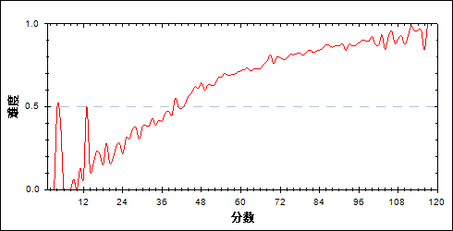

图 61分组难度曲线图

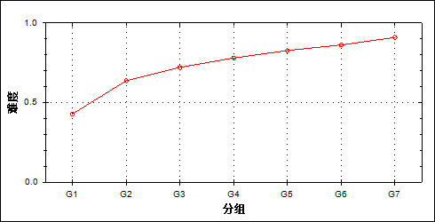

表 65题目分组分析表

| 分值 | G1 | G2 | G3 | G4 | G5 | G6 | G7 | 频数 | 比率（%） | 平均值 |
| --- | --- | --- | --- | --- | --- | --- | --- | --- | --- | --- |
| 0.00 | 3417 | 2165 | 1666 | 1311 | 1033 | 821 | 540 | 10953 | 26.19 | 56.27 |
| 4.00 | 2558 | 3810 | 4308 | 4663 | 4941 | 5153 | 5434 | 30867 | 73.81 | 75.37 |
| 合计 | 5975 | 5975 | 5974 | 5974 | 5974 | 5974 | 5974 | 41820 | 100.00 | - |
| 得分率 | 0.43 | 0.64 | 0.72 | 0.78 | 0.83 | 0.86 | 0.91 | - | - | - |

* + - 1. 第21\_41题

表 66题目分析表

|  |  |  |  |  |  |  |  |  |
| --- | --- | --- | --- | --- | --- | --- | --- | --- |
| 满分值 | 最大值 | 最小值 | 平均值 | 标准差 | 差异系数 | 难度 | 相关系数 | 鉴别系数 |
| 4.00 | 4.00 | 0.00 | 3.46 | 1.05 | 0.30 | 0.87 | 0.33 | 0.20 |

图 62题目难度曲线图

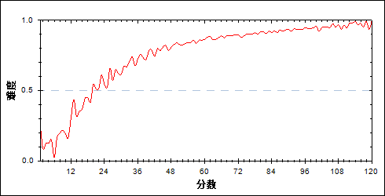

图 63分组难度曲线图

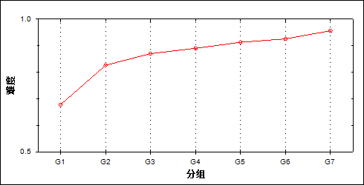

表 67题目分组分析表

| 分值 | G1 | G2 | G3 | G4 | G5 | G6 | G7 | 频数 | 比率（%） | 平均值 |
| --- | --- | --- | --- | --- | --- | --- | --- | --- | --- | --- |
| 0.00 | 573 | 127 | 61 | 33 | 18 | 15 | 8 | 835 | 2.00 | 36.87 |
| 1.00 | 1190 | 803 | 630 | 528 | 422 | 368 | 206 | 4147 | 9.92 | 57.84 |
| 2.00 | 191 | 109 | 86 | 67 | 52 | 44 | 21 | 570 | 1.36 | 55.86 |
| 3.00 | 1461 | 1016 | 796 | 774 | 637 | 520 | 352 | 5556 | 13.29 | 60.88 |
| 4.00 | 2560 | 3920 | 4401 | 4572 | 4845 | 5027 | 5387 | 30712 | 73.44 | 74.96 |
| 合计 | 5975 | 5975 | 5974 | 5974 | 5974 | 5974 | 5974 | 41820 | 100.00 | - |
| 得分率 | 0.68 | 0.83 | 0.87 | 0.89 | 0.91 | 0.93 | 0.96 | - | - | - |

* + - 1. 第21\_42题

表 68题目分析表

|  |  |  |  |  |  |  |  |  |
| --- | --- | --- | --- | --- | --- | --- | --- | --- |
| 满分值 | 最大值 | 最小值 | 平均值 | 标准差 | 差异系数 | 难度 | 相关系数 | 鉴别系数 |
| 1.00 | 1.00 | 0.00 | 0.75 | 0.43 | 0.57 | 0.75 | 0.31 | 0.32 |

图 64题目难度曲线图

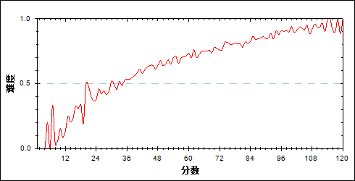

图 65分组难度曲线图

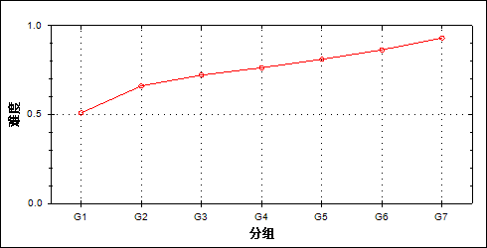

表 69题目分组分析表

| 分值 | G1 | G2 | G3 | G4 | G5 | G6 | G7 | 频数 | 比率（%） | 平均值 |
| --- | --- | --- | --- | --- | --- | --- | --- | --- | --- | --- |
| 0.00 | 2934 | 2024 | 1661 | 1412 | 1127 | 809 | 410 | 10377 | 24.81 | 57.71 |
| 1.00 | 3041 | 3951 | 4313 | 4562 | 4847 | 5165 | 5564 | 31443 | 75.19 | 74.55 |
| 合计 | 5975 | 5975 | 5974 | 5974 | 5974 | 5974 | 5974 | 41820 | 100.00 | - |
| 得分率 | 0.51 | 0.66 | 0.72 | 0.76 | 0.81 | 0.86 | 0.93 | - | - | - |

* + - 1. 第21\_5题

表 70题目分析表

|  |  |  |  |  |  |  |  |  |
| --- | --- | --- | --- | --- | --- | --- | --- | --- |
| 满分值 | 最大值 | 最小值 | 平均值 | 标准差 | 差异系数 | 难度 | 相关系数 | 鉴别系数 |
| 3.00 | 3.00 | 0.00 | 1.70 | 1.49 | 0.87 | 0.57 | 0.33 | 0.38 |

图 66题目难度曲线图

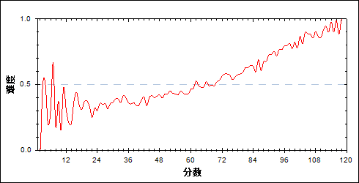

图 67分组难度曲线图

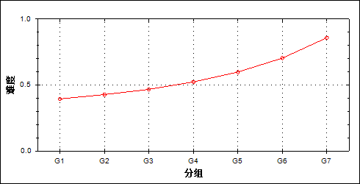

表 71题目分组分析表

| 分值 | G1 | G2 | G3 | G4 | G5 | G6 | G7 | 频数 | 比率（%） | 平均值 |
| --- | --- | --- | --- | --- | --- | --- | --- | --- | --- | --- |
| 0.00 | 3615 | 3418 | 3185 | 2844 | 2397 | 1767 | 847 | 18073 | 43.22 | 61.51 |
| 3.00 | 2360 | 2557 | 2789 | 3130 | 3577 | 4207 | 5127 | 23747 | 56.78 | 77.11 |
| 合计 | 5975 | 5975 | 5974 | 5974 | 5974 | 5974 | 5974 | 41820 | 100.00 | - |
| 得分率 | 0.39 | 0.43 | 0.47 | 0.52 | 0.60 | 0.70 | 0.86 | - | - | - |

* + - 1. 第21\_6题

表 72题目分析表

|  |  |  |  |  |  |  |  |  |
| --- | --- | --- | --- | --- | --- | --- | --- | --- |
| 满分值 | 最大值 | 最小值 | 平均值 | 标准差 | 差异系数 | 难度 | 相关系数 | 鉴别系数 |
| 2.00 | 2.00 | 0.00 | 1.17 | 0.86 | 0.73 | 0.59 | 0.36 | 0.38 |

图 68题目难度曲线图

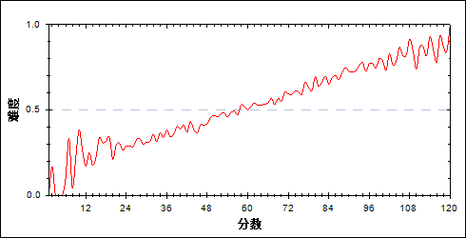

图 69分组难度曲线图

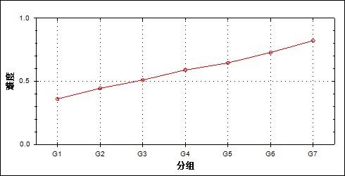

表 73题目分组分析表

| 分值 | G1 | G2 | G3 | G4 | G5 | G6 | G7 | 频数 | 比率（%） | 平均值 |
| --- | --- | --- | --- | --- | --- | --- | --- | --- | --- | --- |
| 0.00 | 2960 | 2428 | 2089 | 1660 | 1465 | 1140 | 759 | 12501 | 29.89 | 60.69 |
| 1.00 | 1731 | 1785 | 1679 | 1577 | 1300 | 965 | 596 | 9633 | 23.03 | 63.85 |
| 2.00 | 1284 | 1762 | 2206 | 2737 | 3209 | 3869 | 4619 | 19686 | 47.07 | 79.71 |
| 合计 | 5975 | 5975 | 5974 | 5974 | 5974 | 5974 | 5974 | 41820 | 100.00 | - |
| 得分率 | 0.36 | 0.44 | 0.51 | 0.59 | 0.65 | 0.73 | 0.82 | - | - | - |

* + - 1. 第22\_1题

表 74题目分析表

|  |  |  |  |  |  |  |  |  |
| --- | --- | --- | --- | --- | --- | --- | --- | --- |
| 满分值 | 最大值 | 最小值 | 平均值 | 标准差 | 差异系数 | 难度 | 相关系数 | 鉴别系数 |
| 6.00 | 6.00 | 0.00 | 5.69 | 1.17 | 0.21 | 0.95 | 0.39 | 0.16 |

图 70题目难度曲线图

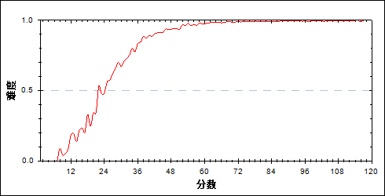

图 71分组难度曲线图

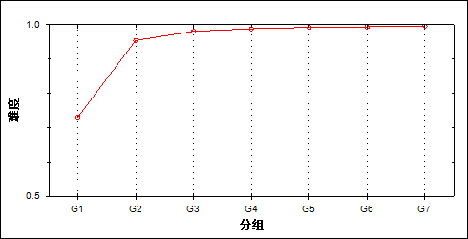

表 75题目分组分析表

| 分值 | G1 | G2 | G3 | G4 | G5 | G6 | G7 | 频数 | 比率（%） | 平均值 |
| --- | --- | --- | --- | --- | --- | --- | --- | --- | --- | --- |
| 0.00 | 1145 | 93 | 15 | 2 | 2 | 0 | 0 | 1257 | 3.01 | 28.57 |
| 2.00 | 510 | 120 | 40 | 13 | 9 | 3 | 4 | 699 | 1.67 | 37.16 |
| 3.00 | 1 | 0 | 0 | 1 | 0 | 0 | 0 | 2 | 0.00 | 64.50 |
| 4.00 | 358 | 277 | 199 | 160 | 99 | 85 | 44 | 1222 | 2.92 | 55.71 |
| 5.00 | 34 | 35 | 33 | 29 | 25 | 25 | 14 | 195 | 0.47 | 64.56 |
| 6.00 | 3927 | 5450 | 5687 | 5769 | 5839 | 5861 | 5912 | 38445 | 91.93 | 72.83 |
| 合计 | 5975 | 5975 | 5974 | 5974 | 5974 | 5974 | 5974 | 41820 | 100.00 | - |
| 得分率 | 0.73 | 0.95 | 0.98 | 0.99 | 0.99 | 0.99 | 1.00 | - | - | - |

* + - 1. 第22\_2题

表 76题目分析表

|  |  |  |  |  |  |  |  |  |
| --- | --- | --- | --- | --- | --- | --- | --- | --- |
| 满分值 | 最大值 | 最小值 | 平均值 | 标准差 | 差异系数 | 难度 | 相关系数 | 鉴别系数 |
| 5.00 | 5.00 | 0.00 | 4.06 | 1.83 | 0.45 | 0.81 | 0.57 | 0.50 |

图 72题目难度曲线图

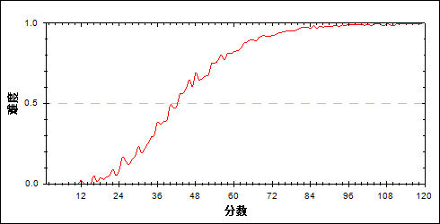

图 73分组难度曲线图

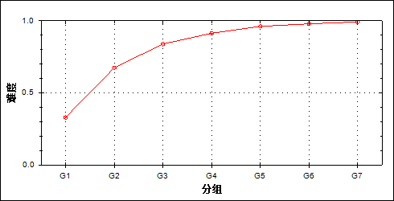

表 77题目分组分析表

| 分值 | G1 | G2 | G3 | G4 | G5 | G6 | G7 | 频数 | 比率（%） | 平均值 |
| --- | --- | --- | --- | --- | --- | --- | --- | --- | --- | --- |
| 0.00 | 3682 | 1609 | 720 | 317 | 119 | 52 | 12 | 6511 | 15.57 | 41.85 |
| 1.00 | 74 | 41 | 20 | 15 | 3 | 2 | 0 | 155 | 0.37 | 45.86 |
| 2.00 | 128 | 133 | 73 | 54 | 15 | 8 | 3 | 414 | 0.99 | 52.08 |
| 3.00 | 341 | 393 | 334 | 304 | 200 | 143 | 74 | 1789 | 4.28 | 60.95 |
| 4.00 | 252 | 324 | 230 | 163 | 83 | 39 | 18 | 1109 | 2.65 | 57.47 |
| 5.00 | 1498 | 3475 | 4597 | 5121 | 5554 | 5730 | 5867 | 31842 | 76.14 | 77.54 |
| 合计 | 5975 | 5975 | 5974 | 5974 | 5974 | 5974 | 5974 | 41820 | 100.00 | - |
| 得分率 | 0.33 | 0.67 | 0.84 | 0.91 | 0.96 | 0.98 | 0.99 | - | - | - |

* + - 1. 第22\_3题

表 78题目分析表

|  |  |  |  |  |  |  |  |  |
| --- | --- | --- | --- | --- | --- | --- | --- | --- |
| 满分值 | 最大值 | 最小值 | 平均值 | 标准差 | 差异系数 | 难度 | 相关系数 | 鉴别系数 |
| 5.00 | 5.00 | 0.00 | 4.23 | 1.54 | 0.36 | 0.85 | 0.50 | 0.35 |

图 74题目难度曲线图

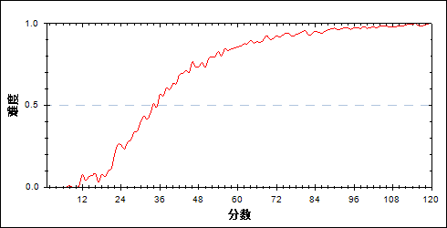

图 75分组难度曲线图

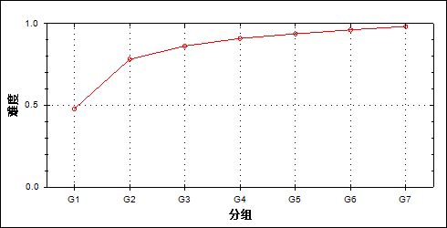

表 79题目分组分析表

| 分值 | G1 | G2 | G3 | G4 | G5 | G6 | G7 | 频数 | 比率（%） | 平均值 |
| --- | --- | --- | --- | --- | --- | --- | --- | --- | --- | --- |
| 0.00 | 2034 | 446 | 200 | 113 | 84 | 41 | 19 | 2937 | 7.02 | 38.07 |
| 1.00 | 262 | 134 | 64 | 40 | 16 | 7 | 3 | 526 | 1.26 | 45.51 |
| 2.00 | 1221 | 938 | 651 | 414 | 286 | 161 | 71 | 3742 | 8.95 | 53.47 |
| 3.00 | 326 | 453 | 426 | 352 | 253 | 204 | 99 | 2113 | 5.05 | 62.56 |
| 4.00 | 34 | 38 | 25 | 22 | 18 | 8 | 2 | 147 | 0.35 | 58.63 |
| 5.00 | 2098 | 3966 | 4608 | 5033 | 5317 | 5553 | 5780 | 32355 | 77.37 | 76.22 |
| 合计 | 5975 | 5975 | 5974 | 5974 | 5974 | 5974 | 5974 | 41820 | 100.00 | - |
| 得分率 | 0.48 | 0.78 | 0.86 | 0.91 | 0.94 | 0.96 | 0.98 | - | - | - |

* + - 1. 第23\_1题

表 80题目分析表

|  |  |  |  |  |  |  |  |  |
| --- | --- | --- | --- | --- | --- | --- | --- | --- |
| 满分值 | 最大值 | 最小值 | 平均值 | 标准差 | 差异系数 | 难度 | 相关系数 | 鉴别系数 |
| 6.00 | 6.00 | 0.00 | 4.19 | 2.30 | 0.55 | 0.70 | 0.58 | 0.53 |

图 76题目难度曲线图

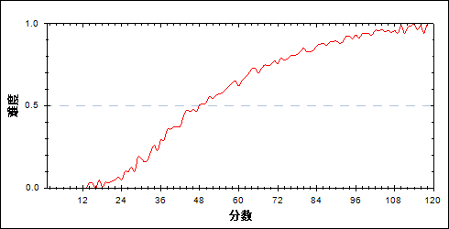

图 77分组难度曲线图

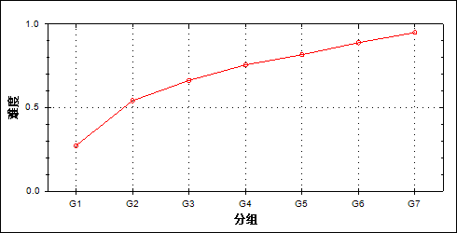

表 81题目分组分析表

| 分值 | G1 | G2 | G3 | G4 | G5 | G6 | G7 | 频数 | 比率（%） | 平均值 |
| --- | --- | --- | --- | --- | --- | --- | --- | --- | --- | --- |
| 0.00 | 3767 | 1711 | 945 | 456 | 268 | 104 | 40 | 7291 | 17.43 | 44.00 |
| 3.00 | 1157 | 2055 | 2136 | 2001 | 1648 | 1118 | 511 | 10626 | 25.41 | 65.48 |
| 6.00 | 1051 | 2209 | 2893 | 3517 | 4058 | 4752 | 5423 | 23903 | 57.16 | 80.58 |
| 合计 | 5975 | 5975 | 5974 | 5974 | 5974 | 5974 | 5974 | 41820 | 100.00 | - |
| 得分率 | 0.27 | 0.54 | 0.66 | 0.76 | 0.82 | 0.89 | 0.95 | - | - | - |

* + - 1. 第23\_2题

表 82题目分析表

|  |  |  |  |  |  |  |  |  |
| --- | --- | --- | --- | --- | --- | --- | --- | --- |
| 满分值 | 最大值 | 最小值 | 平均值 | 标准差 | 差异系数 | 难度 | 相关系数 | 鉴别系数 |
| 6.00 | 6.00 | 0.00 | 3.28 | 2.87 | 0.87 | 0.55 | 0.71 | 0.84 |

图 78题目难度曲线图

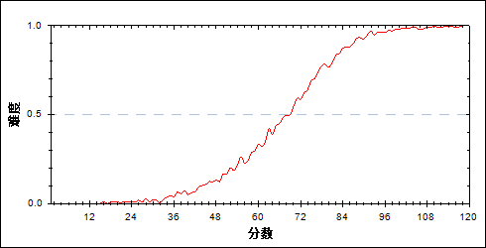

图 79分组难度曲线图

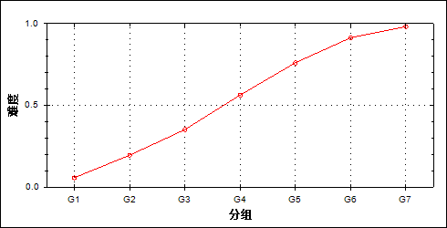

表 83题目分组分析表

| 分值 | G1 | G2 | G3 | G4 | G5 | G6 | G7 | 频数 | 比率（%） | 平均值 |
| --- | --- | --- | --- | --- | --- | --- | --- | --- | --- | --- |
| 0.00 | 5516 | 4549 | 3517 | 2256 | 1120 | 328 | 31 | 17317 | 41.41 | 51.38 |
| 3.00 | 231 | 518 | 709 | 712 | 620 | 376 | 151 | 3317 | 7.93 | 68.18 |
| 6.00 | 228 | 908 | 1748 | 3006 | 4234 | 5270 | 5792 | 21186 | 50.66 | 86.23 |
| 合计 | 5975 | 5975 | 5974 | 5974 | 5974 | 5974 | 5974 | 41820 | 100.00 | - |
| 得分率 | 0.06 | 0.20 | 0.35 | 0.56 | 0.76 | 0.91 | 0.98 | - | - | - |

* + - 1. 第23\_3题

表 84题目分析表

|  |  |  |  |  |  |  |  |  |
| --- | --- | --- | --- | --- | --- | --- | --- | --- |
| 满分值 | 最大值 | 最小值 | 平均值 | 标准差 | 差异系数 | 难度 | 相关系数 | 鉴别系数 |
| 6.00 | 6.00 | 0.00 | 2.03 | 2.50 | 1.23 | 0.34 | 0.73 | 0.75 |

图 80题目难度曲线图

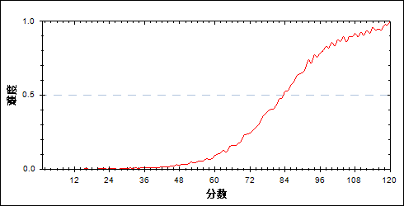

图 81分组难度曲线图

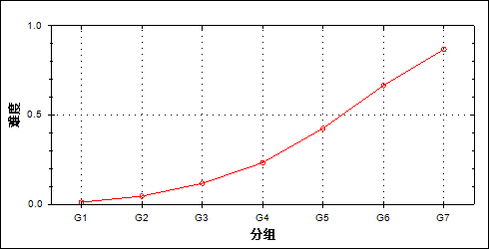

表 85题目分组分析表

| 分值 | G1 | G2 | G3 | G4 | G5 | G6 | G7 | 频数 | 比率（%） | 平均值 |
| --- | --- | --- | --- | --- | --- | --- | --- | --- | --- | --- |
| 0.00 | 5737 | 5246 | 4461 | 3513 | 2191 | 906 | 199 | 22253 | 53.21 | 55.54 |
| 1.00 | 157 | 377 | 564 | 567 | 491 | 301 | 83 | 2540 | 6.07 | 68.73 |
| 2.00 | 13 | 33 | 53 | 49 | 49 | 52 | 17 | 266 | 0.64 | 72.45 |
| 3.00 | 48 | 198 | 519 | 928 | 1290 | 1274 | 759 | 5016 | 11.99 | 81.75 |
| 4.00 | 12 | 56 | 139 | 285 | 437 | 473 | 340 | 1742 | 4.17 | 84.28 |
| 5.00 | 0 | 8 | 9 | 17 | 36 | 55 | 74 | 199 | 0.48 | 89.93 |
| 6.00 | 8 | 57 | 229 | 615 | 1480 | 2913 | 4502 | 9804 | 23.44 | 95.71 |
| 合计 | 5975 | 5975 | 5974 | 5974 | 5974 | 5974 | 5974 | 41820 | 100.00 | - |
| 得分率 | 0.01 | 0.05 | 0.12 | 0.23 | 0.43 | 0.67 | 0.87 | - | - | - |

* + - 1. 第24\_1题

表 86题目分析表

|  |  |  |  |  |  |  |  |  |
| --- | --- | --- | --- | --- | --- | --- | --- | --- |
| 满分值 | 最大值 | 最小值 | 平均值 | 标准差 | 差异系数 | 难度 | 相关系数 | 鉴别系数 |
| 4.00 | 4.00 | 0.00 | 2.24 | 1.74 | 0.78 | 0.56 | 0.70 | 0.77 |

图 82题目难度曲线图

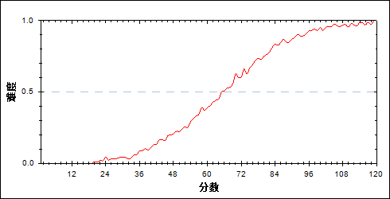

图 83分组难度曲线图

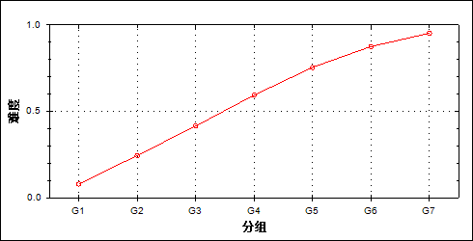

表 87题目分组分析表

| 分值 | G1 | G2 | G3 | G4 | G5 | G6 | G7 | 频数 | 比率（%） | 平均值 |
| --- | --- | --- | --- | --- | --- | --- | --- | --- | --- | --- |
| 0.00 | 4949 | 3369 | 2183 | 1244 | 553 | 167 | 27 | 12492 | 29.87 | 48.73 |
| 1.00 | 582 | 1092 | 1066 | 768 | 476 | 184 | 43 | 4211 | 10.07 | 59.71 |
| 2.00 | 183 | 504 | 778 | 870 | 749 | 539 | 234 | 3857 | 9.22 | 70.46 |
| 3.00 | 97 | 296 | 491 | 678 | 726 | 677 | 430 | 3395 | 8.12 | 77.09 |
| 4.00 | 164 | 714 | 1456 | 2414 | 3470 | 4407 | 5240 | 17865 | 42.72 | 86.72 |
| 合计 | 5975 | 5975 | 5974 | 5974 | 5974 | 5974 | 5974 | 41820 | 100.00 | - |
| 得分率 | 0.08 | 0.24 | 0.42 | 0.59 | 0.75 | 0.88 | 0.95 | - | - | - |

* + - 1. 第24\_2题

表 88题目分析表

|  |  |  |  |  |  |  |  |  |
| --- | --- | --- | --- | --- | --- | --- | --- | --- |
| 满分值 | 最大值 | 最小值 | 平均值 | 标准差 | 差异系数 | 难度 | 相关系数 | 鉴别系数 |
| 10.00 | 10.00 | 0.00 | 1.47 | 3.00 | 2.05 | 0.15 | 0.64 | 0.46 |

图 84题目难度曲线图

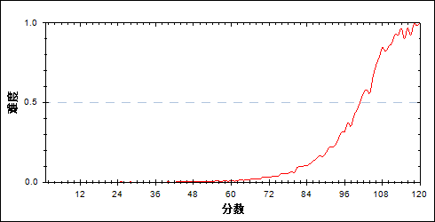

图 85分组难度曲线图

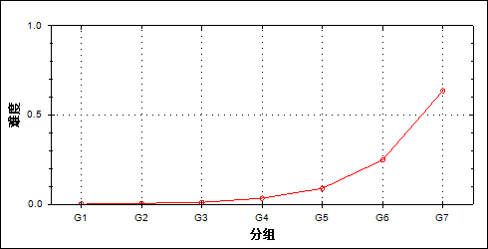

表 89题目分组分析表

| 分值 | G1 | G2 | G3 | G4 | G5 | G6 | G7 | 频数 | 比率（%） | 平均值 |
| --- | --- | --- | --- | --- | --- | --- | --- | --- | --- | --- |
| 0.00 | 5941 | 5800 | 5629 | 5130 | 4227 | 2599 | 708 | 30034 | 71.82 | 60.96 |
| 1.00 | 25 | 109 | 204 | 341 | 566 | 735 | 367 | 2347 | 5.61 | 82.11 |
| 2.00 | 8 | 47 | 87 | 282 | 569 | 826 | 588 | 2407 | 5.76 | 86.98 |
| 3.00 | 0 | 4 | 14 | 47 | 79 | 92 | 56 | 292 | 0.70 | 86.28 |
| 4.00 | 1 | 4 | 13 | 57 | 114 | 278 | 238 | 705 | 1.69 | 92.08 |
| 5.00 | 0 | 7 | 11 | 35 | 96 | 183 | 205 | 537 | 1.28 | 92.79 |
| 6.00 | 0 | 1 | 3 | 23 | 60 | 165 | 166 | 418 | 1.00 | 95.18 |
| 7.00 | 0 | 2 | 10 | 46 | 175 | 568 | 974 | 1775 | 4.24 | 98.80 |
| 9.00 | 0 | 0 | 1 | 2 | 13 | 57 | 181 | 254 | 0.61 | 104.27 |
| 10.00 | 0 | 1 | 2 | 11 | 75 | 471 | 2491 | 3051 | 7.30 | 107.65 |
| 合计 | 5975 | 5975 | 5974 | 5974 | 5974 | 5974 | 5974 | 41820 | 100.00 | - |
| 得分率 | 0.00 | 0.00 | 0.01 | 0.03 | 0.09 | 0.25 | 0.64 | - | - | - |

* + - 1. 第24\_3题

表 90题目分析表

|  |  |  |  |  |  |  |  |  |
| --- | --- | --- | --- | --- | --- | --- | --- | --- |
| 满分值 | 最大值 | 最小值 | 平均值 | 标准差 | 差异系数 | 难度 | 相关系数 | 鉴别系数 |
| 6.00 | 6.00 | 0.00 | 0.29 | 1.15 | 3.98 | 0.05 | 0.41 | 0.17 |

图 86题目难度曲线图

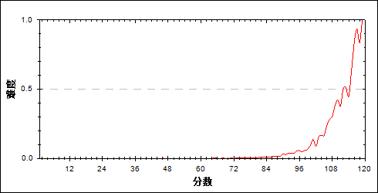

图 87分组难度曲线图

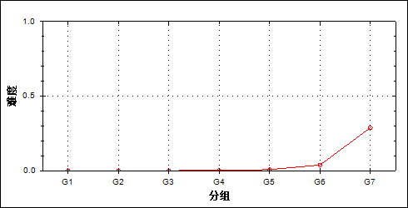

表 91题目分组分析表

| 分值 | G1 | G2 | G3 | G4 | G5 | G6 | G7 | 频数 | 比率（%） | 平均值 |
| --- | --- | --- | --- | --- | --- | --- | --- | --- | --- | --- |
| 0.00 | 5973 | 5971 | 5964 | 5939 | 5867 | 5513 | 3521 | 38748 | 92.65 | 67.49 |
| 1.00 | 1 | 3 | 5 | 17 | 59 | 190 | 504 | 779 | 1.86 | 100.16 |
| 3.00 | 0 | 0 | 0 | 0 | 1 | 3 | 13 | 17 | 0.04 | 102.35 |
| 4.00 | 1 | 1 | 5 | 18 | 44 | 224 | 917 | 1210 | 2.89 | 105.43 |
| 6.00 | 0 | 0 | 0 | 0 | 3 | 44 | 1019 | 1066 | 2.55 | 112.74 |
| 合计 | 5975 | 5975 | 5974 | 5974 | 5974 | 5974 | 5974 | 41820 | 100.00 | - |
| 得分率 | 0.00 | 0.00 | 0.00 | 0.00 | 0.01 | 0.04 | 0.29 | - | - | - |

* 1. 相关分析
     + 1. 主客观题组

表 92主客观题组相关分析表

|  | 客观题 | 主观题 | 总分 |
| --- | --- | --- | --- |
| 客观题 | - | 0.6119 | 0.7831 |
| 主观题 | 0.6119 | - | 0.8901 |
| 总分 | 0.7831 | 0.8901 | - |

* + - 1. 知识组块

表 93知识组块相关分析表

|  | 力学 | 电学 | 热学 | 光学 | 原子 | 总分 |
| --- | --- | --- | --- | --- | --- | --- |
| 力学 | - | 0.6437 | 0.2425 | 0.3502 | 0.3741 | 0.8618 |
| 电学 | 0.6437 | - | 0.2176 | 0.3158 | 0.2659 | 0.8108 |
| 热学 | 0.2425 | 0.2176 | - | 0.1784 | 0.0987 | 0.3215 |
| 光学 | 0.3502 | 0.3158 | 0.1784 | - | 0.1560 | 0.4250 |
| 原子 | 0.3741 | 0.2659 | 0.0987 | 0.1560 | - | 0.4169 |
| 总分 | 0.8618 | 0.8108 | 0.3215 | 0.4250 | 0.4169 | - |

* + - 1. 能力组块

表 94能力组块相关分析表

|  | 理解能力 | 推理能力 | 实验能力 | 应用能力 | 探究能力 | 总分 |
| --- | --- | --- | --- | --- | --- | --- |
| 理解能力 | - | 0.3465 | 0.4152 | 0.4504 | 0.4386 | 0.6372 |
| 推理能力 | 0.3465 | - | 0.3258 | 0.3582 | 0.3770 | 0.5425 |
| 实验能力 | 0.4152 | 0.3258 | - | 0.5419 | 0.4974 | 0.6899 |
| 应用能力 | 0.4504 | 0.3582 | 0.5419 | - | 0.5535 | 0.8067 |
| 探究能力 | 0.4386 | 0.3770 | 0.4974 | 0.5535 | - | 0.7455 |
| 总分 | 0.6372 | 0.5425 | 0.6899 | 0.8067 | 0.7455 | - |