北京市普通高等学校招生全国统一考试

实测数据统计分析报告

理科综合（物理）

 

2013年7月

**目 录**

第一部分 整体统计分析 1

一、 总体分析 1

二、 题组分析 8

(一) 理综主客观题组 8

第二部分 物理统计分析 17

一、 总体分析 17

二、 题组分析 23

(一) 主客观题组 23

(二) 知识组块 28

(三) 能力组块 40

三、 题目分析 50

四、 相关分析 106

1. 整体统计分析
   1. 总体分析

表 1 总分分析表

|  |  |  |  |  |  |  |
| --- | --- | --- | --- | --- | --- | --- |
| 总人数 | 满分值 | 最大值 | 最小值 | 平均值 | 标准差 | 差异系数 |
| 41820 | 300 | 292.0 | 6.0 | 176.88 | 48.27 | 0.27 |
| 难度 | alpha系数 | 标准误 | 中数 | 众数 | 偏度 | 峰度 |
| 0.59 | 0.85 | 0.24 | 179.14 | 165.0 | -0.13 | -0.48 |

图 1 总分分布曲线图

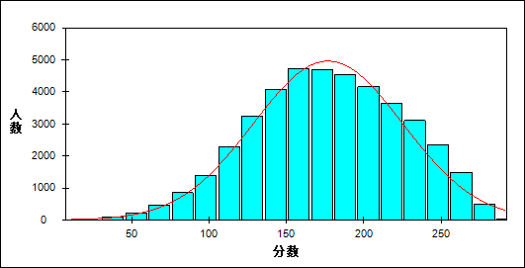

表 2 科目整体分析表

| 题目 | 满分值 | 最大值 | 最小值 | 平均值 | 标准差 | 差异系数 | 难度 | 相关系数 | 鉴别指数 |
| --- | --- | --- | --- | --- | --- | --- | --- | --- | --- |
| 生物 | 80 | 77.0 | 0.0 | 46.14 | 12.53 | 0.27 | 0.58 | 0.83 | 0.32 |
| 化学 | 100 | 100.0 | 0.0 | 60.37 | 17.67 | 0.29 | 0.60 | 0.91 | 0.40 |
| 物理 | 120 | 120.0 | 1.0 | 70.37 | 23.37 | 0.33 | 0.59 | 0.94 | 0.46 |

表 3 总分人数分布表

| 分值 | 人数 | 比率(%) | 累计人数 | 累计频率（%） |
| --- | --- | --- | --- | --- |
| 292.0 | 2 | 0.00 | 2 | 0.00 |
| 291.0 | 4 | 0.01 | 6 | 0.01 |
| 290.0 | 4 | 0.01 | 10 | 0.02 |
| 289.0 | 4 | 0.01 | 14 | 0.03 |
| 288.0 | 8 | 0.02 | 22 | 0.05 |
| 287.0 | 5 | 0.01 | 27 | 0.06 |
| 286.0 | 9 | 0.02 | 36 | 0.09 |
| 285.0 | 12 | 0.03 | 48 | 0.11 |
| 284.0 | 13 | 0.03 | 61 | 0.15 |
| 283.0 | 10 | 0.02 | 71 | 0.17 |
| 282.0 | 20 | 0.05 | 91 | 0.22 |
| 281.0 | 22 | 0.05 | 113 | 0.27 |
| 280.0 | 31 | 0.07 | 144 | 0.34 |
| 279.0 | 24 | 0.06 | 168 | 0.40 |
| 278.0 | 36 | 0.09 | 204 | 0.49 |
| 277.0 | 33 | 0.08 | 237 | 0.57 |
| 276.0 | 42 | 0.10 | 279 | 0.67 |
| 275.0 | 39 | 0.09 | 318 | 0.76 |
| 274.0 | 38 | 0.09 | 356 | 0.85 |
| 273.0 | 44 | 0.11 | 400 | 0.96 |
| 272.0 | 58 | 0.14 | 458 | 1.10 |
| 271.0 | 60 | 0.14 | 518 | 1.24 |
| 270.0 | 72 | 0.17 | 590 | 1.41 |
| 269.0 | 59 | 0.14 | 649 | 1.55 |
| 268.0 | 79 | 0.19 | 728 | 1.74 |
| 267.0 | 75 | 0.18 | 803 | 1.92 |
| 266.0 | 91 | 0.22 | 894 | 2.14 |
| 265.0 | 96 | 0.23 | 990 | 2.37 |
| 264.0 | 90 | 0.22 | 1080 | 2.58 |
| 263.0 | 93 | 0.22 | 1173 | 2.80 |
| 262.0 | 105 | 0.25 | 1278 | 3.06 |
| 261.0 | 117 | 0.28 | 1395 | 3.34 |
| 260.0 | 98 | 0.23 | 1493 | 3.57 |
| 259.0 | 115 | 0.27 | 1608 | 3.85 |
| 258.0 | 125 | 0.30 | 1733 | 4.14 |
| 257.0 | 138 | 0.33 | 1871 | 4.47 |
| 256.0 | 134 | 0.32 | 2005 | 4.79 |
| 255.0 | 131 | 0.31 | 2136 | 5.11 |
| 254.0 | 121 | 0.29 | 2257 | 5.40 |
| 253.0 | 144 | 0.34 | 2401 | 5.74 |
| 252.0 | 154 | 0.37 | 2555 | 6.11 |
| 251.0 | 161 | 0.38 | 2716 | 6.49 |
| 250.0 | 154 | 0.37 | 2870 | 6.86 |
| 249.0 | 148 | 0.35 | 3018 | 7.22 |
| 248.0 | 175 | 0.42 | 3193 | 7.64 |
| 247.0 | 160 | 0.38 | 3353 | 8.02 |
| 246.0 | 161 | 0.38 | 3514 | 8.40 |
| 245.0 | 156 | 0.37 | 3670 | 8.78 |
| 244.0 | 173 | 0.41 | 3843 | 9.19 |
| 243.0 | 170 | 0.41 | 4013 | 9.60 |
| 242.0 | 184 | 0.44 | 4197 | 10.04 |
| 241.0 | 160 | 0.38 | 4357 | 10.42 |
| 240.0 | 199 | 0.48 | 4556 | 10.89 |
| 239.0 | 170 | 0.41 | 4726 | 11.30 |
| 238.0 | 198 | 0.47 | 4924 | 11.77 |
| 237.0 | 207 | 0.49 | 5131 | 12.27 |
| 236.0 | 192 | 0.46 | 5323 | 12.73 |
| 235.0 | 201 | 0.48 | 5524 | 13.21 |
| 234.0 | 184 | 0.44 | 5708 | 13.65 |
| 233.0 | 203 | 0.49 | 5911 | 14.13 |
| 232.0 | 188 | 0.45 | 6099 | 14.58 |
| 231.0 | 210 | 0.50 | 6309 | 15.09 |
| 230.0 | 217 | 0.52 | 6526 | 15.60 |
| 229.0 | 236 | 0.56 | 6762 | 16.17 |
| 228.0 | 210 | 0.50 | 6972 | 16.67 |
| 227.0 | 250 | 0.60 | 7222 | 17.27 |
| 226.0 | 238 | 0.57 | 7460 | 17.84 |
| 225.0 | 206 | 0.49 | 7666 | 18.33 |
| 224.0 | 215 | 0.51 | 7881 | 18.85 |
| 223.0 | 228 | 0.55 | 8109 | 19.39 |
| 222.0 | 237 | 0.57 | 8346 | 19.96 |
| 221.0 | 217 | 0.52 | 8563 | 20.48 |
| 220.0 | 263 | 0.63 | 8826 | 21.10 |
| 219.0 | 246 | 0.59 | 9072 | 21.69 |
| 218.0 | 269 | 0.64 | 9341 | 22.34 |
| 217.0 | 238 | 0.57 | 9579 | 22.91 |
| 216.0 | 267 | 0.64 | 9846 | 23.54 |
| 215.0 | 255 | 0.61 | 10101 | 24.15 |
| 214.0 | 262 | 0.63 | 10363 | 24.78 |
| 213.0 | 250 | 0.60 | 10613 | 25.38 |
| 212.0 | 244 | 0.58 | 10857 | 25.96 |
| 211.0 | 243 | 0.58 | 11100 | 26.54 |
| 210.0 | 277 | 0.66 | 11377 | 27.20 |
| 209.0 | 261 | 0.62 | 11638 | 27.83 |
| 208.0 | 255 | 0.61 | 11893 | 28.44 |
| 207.0 | 276 | 0.66 | 12169 | 29.10 |
| 206.0 | 259 | 0.62 | 12428 | 29.72 |
| 205.0 | 279 | 0.67 | 12707 | 30.38 |
| 204.0 | 252 | 0.60 | 12959 | 30.99 |
| 203.0 | 266 | 0.64 | 13225 | 31.62 |
| 202.0 | 249 | 0.60 | 13474 | 32.22 |
| 201.0 | 329 | 0.79 | 13803 | 33.01 |
| 200.0 | 308 | 0.74 | 14111 | 33.74 |
| 199.0 | 304 | 0.73 | 14415 | 34.47 |
| 198.0 | 294 | 0.70 | 14709 | 35.17 |
| 197.0 | 283 | 0.68 | 14992 | 35.85 |
| 196.0 | 271 | 0.65 | 15263 | 36.50 |
| 195.0 | 288 | 0.69 | 15551 | 37.19 |
| 194.0 | 301 | 0.72 | 15852 | 37.91 |
| 193.0 | 302 | 0.72 | 16154 | 38.63 |
| 192.0 | 309 | 0.74 | 16463 | 39.37 |
| 191.0 | 270 | 0.65 | 16733 | 40.01 |
| 190.0 | 287 | 0.69 | 17020 | 40.70 |
| 189.0 | 322 | 0.77 | 17342 | 41.47 |
| 188.0 | 285 | 0.68 | 17627 | 42.15 |
| 187.0 | 302 | 0.72 | 17929 | 42.87 |
| 186.0 | 323 | 0.77 | 18252 | 43.64 |
| 185.0 | 311 | 0.74 | 18563 | 44.39 |
| 184.0 | 320 | 0.77 | 18883 | 45.15 |
| 183.0 | 277 | 0.66 | 19160 | 45.82 |
| 182.0 | 313 | 0.75 | 19473 | 46.56 |
| 181.0 | 312 | 0.75 | 19785 | 47.31 |
| 180.0 | 320 | 0.77 | 20105 | 48.08 |
| 179.0 | 330 | 0.79 | 20435 | 48.86 |
| 178.0 | 289 | 0.69 | 20724 | 49.56 |
| 177.0 | 329 | 0.79 | 21053 | 50.34 |
| 176.0 | 306 | 0.73 | 21359 | 51.07 |
| 175.0 | 320 | 0.77 | 21679 | 51.84 |
| 174.0 | 296 | 0.71 | 21975 | 52.55 |
| 173.0 | 322 | 0.77 | 22297 | 53.32 |
| 172.0 | 307 | 0.73 | 22604 | 54.05 |
| 171.0 | 289 | 0.69 | 22893 | 54.74 |
| 170.0 | 341 | 0.82 | 23234 | 55.56 |
| 169.0 | 298 | 0.71 | 23532 | 56.27 |
| 168.0 | 306 | 0.73 | 23838 | 57.00 |
| 167.0 | 323 | 0.77 | 24161 | 57.77 |
| 166.0 | 324 | 0.77 | 24485 | 58.55 |
| 165.0 | 378 | 0.90 | 24863 | 59.45 |
| 164.0 | 310 | 0.74 | 25173 | 60.19 |
| 163.0 | 312 | 0.75 | 25485 | 60.94 |
| 162.0 | 306 | 0.73 | 25791 | 61.67 |
| 161.0 | 328 | 0.78 | 26119 | 62.46 |
| 160.0 | 308 | 0.74 | 26427 | 63.19 |
| 159.0 | 331 | 0.79 | 26758 | 63.98 |
| 158.0 | 306 | 0.73 | 27064 | 64.72 |
| 157.0 | 292 | 0.70 | 27356 | 65.41 |
| 156.0 | 319 | 0.76 | 27675 | 66.18 |
| 155.0 | 295 | 0.71 | 27970 | 66.88 |
| 154.0 | 311 | 0.74 | 28281 | 67.63 |
| 153.0 | 308 | 0.74 | 28589 | 68.36 |
| 152.0 | 312 | 0.75 | 28901 | 69.11 |
| 151.0 | 304 | 0.73 | 29205 | 69.84 |
| 150.0 | 302 | 0.72 | 29507 | 70.56 |
| 149.0 | 275 | 0.66 | 29782 | 71.21 |
| 148.0 | 272 | 0.65 | 30054 | 71.87 |
| 147.0 | 297 | 0.71 | 30351 | 72.58 |
| 146.0 | 246 | 0.59 | 30597 | 73.16 |
| 145.0 | 266 | 0.64 | 30863 | 73.80 |
| 144.0 | 300 | 0.72 | 31163 | 74.52 |
| 143.0 | 277 | 0.66 | 31440 | 75.18 |
| 142.0 | 282 | 0.67 | 31722 | 75.85 |
| 141.0 | 258 | 0.62 | 31980 | 76.47 |
| 140.0 | 292 | 0.70 | 32272 | 77.17 |
| 139.0 | 267 | 0.64 | 32539 | 77.81 |
| 138.0 | 251 | 0.60 | 32790 | 78.41 |
| 137.0 | 247 | 0.59 | 33037 | 79.00 |
| 136.0 | 239 | 0.57 | 33276 | 79.57 |
| 135.0 | 235 | 0.56 | 33511 | 80.13 |
| 134.0 | 243 | 0.58 | 33754 | 80.71 |
| 133.0 | 212 | 0.51 | 33966 | 81.22 |
| 132.0 | 231 | 0.55 | 34197 | 81.77 |
| 131.0 | 255 | 0.61 | 34452 | 82.38 |
| 130.0 | 217 | 0.52 | 34669 | 82.90 |
| 129.0 | 257 | 0.61 | 34926 | 83.52 |
| 128.0 | 222 | 0.53 | 35148 | 84.05 |
| 127.0 | 202 | 0.48 | 35350 | 84.53 |
| 126.0 | 201 | 0.48 | 35551 | 85.01 |
| 125.0 | 221 | 0.53 | 35772 | 85.54 |
| 124.0 | 223 | 0.53 | 35995 | 86.07 |
| 123.0 | 177 | 0.42 | 36172 | 86.49 |
| 122.0 | 170 | 0.41 | 36342 | 86.90 |
| 121.0 | 171 | 0.41 | 36513 | 87.31 |
| 120.0 | 165 | 0.39 | 36678 | 87.70 |
| 119.0 | 187 | 0.45 | 36865 | 88.15 |
| 118.0 | 168 | 0.40 | 37033 | 88.55 |
| 117.0 | 148 | 0.35 | 37181 | 88.91 |
| 116.0 | 160 | 0.38 | 37341 | 89.29 |
| 115.0 | 153 | 0.37 | 37494 | 89.66 |
| 114.0 | 156 | 0.37 | 37650 | 90.03 |
| 113.0 | 138 | 0.33 | 37788 | 90.36 |
| 112.0 | 155 | 0.37 | 37943 | 90.73 |
| 111.0 | 142 | 0.34 | 38085 | 91.07 |
| 110.0 | 151 | 0.36 | 38236 | 91.43 |
| 109.0 | 136 | 0.33 | 38372 | 91.76 |
| 108.0 | 152 | 0.36 | 38524 | 92.12 |
| 107.0 | 136 | 0.33 | 38660 | 92.44 |
| 106.0 | 132 | 0.32 | 38792 | 92.76 |
| 105.0 | 123 | 0.29 | 38915 | 93.05 |
| 104.0 | 128 | 0.31 | 39043 | 93.36 |
| 103.0 | 107 | 0.26 | 39150 | 93.62 |
| 102.0 | 97 | 0.23 | 39247 | 93.85 |
| 101.0 | 120 | 0.29 | 39367 | 94.13 |
| 100.0 | 90 | 0.22 | 39457 | 94.35 |
| 99.0 | 99 | 0.24 | 39556 | 94.59 |
| 98.0 | 94 | 0.22 | 39650 | 94.81 |
| 97.0 | 74 | 0.18 | 39724 | 94.99 |
| 96.0 | 86 | 0.21 | 39810 | 95.19 |
| 95.0 | 69 | 0.16 | 39879 | 95.36 |
| 94.0 | 95 | 0.23 | 39974 | 95.59 |
| 93.0 | 74 | 0.18 | 40048 | 95.76 |
| 92.0 | 64 | 0.15 | 40112 | 95.92 |
| 91.0 | 66 | 0.16 | 40178 | 96.07 |
| 90.0 | 83 | 0.20 | 40261 | 96.27 |
| 89.0 | 87 | 0.21 | 40348 | 96.48 |
| 88.0 | 55 | 0.13 | 40403 | 96.61 |
| 87.0 | 68 | 0.16 | 40471 | 96.77 |
| 86.0 | 48 | 0.11 | 40519 | 96.89 |
| 85.0 | 73 | 0.17 | 40592 | 97.06 |
| 84.0 | 64 | 0.15 | 40656 | 97.22 |
| 83.0 | 43 | 0.10 | 40699 | 97.32 |
| 82.0 | 61 | 0.15 | 40760 | 97.47 |
| 81.0 | 47 | 0.11 | 40807 | 97.58 |
| 80.0 | 50 | 0.12 | 40857 | 97.70 |
| 79.0 | 52 | 0.12 | 40909 | 97.82 |
| 78.0 | 37 | 0.09 | 40946 | 97.91 |
| 77.0 | 45 | 0.11 | 40991 | 98.02 |
| 76.0 | 36 | 0.09 | 41027 | 98.10 |
| 75.0 | 45 | 0.11 | 41072 | 98.21 |
| 74.0 | 34 | 0.08 | 41106 | 98.29 |
| 73.0 | 41 | 0.10 | 41147 | 98.39 |
| 72.0 | 36 | 0.09 | 41183 | 98.48 |
| 71.0 | 36 | 0.09 | 41219 | 98.56 |
| 70.0 | 28 | 0.07 | 41247 | 98.63 |
| 69.0 | 32 | 0.08 | 41279 | 98.71 |
| 68.0 | 28 | 0.07 | 41307 | 98.77 |
| 67.0 | 35 | 0.08 | 41342 | 98.86 |
| 66.0 | 32 | 0.08 | 41374 | 98.93 |
| 65.0 | 23 | 0.05 | 41397 | 98.99 |
| 64.0 | 20 | 0.05 | 41417 | 99.04 |
| 63.0 | 28 | 0.07 | 41445 | 99.10 |
| 62.0 | 20 | 0.05 | 41465 | 99.15 |
| 61.0 | 34 | 0.08 | 41499 | 99.23 |
| 60.0 | 19 | 0.05 | 41518 | 99.28 |
| 59.0 | 17 | 0.04 | 41535 | 99.32 |
| 58.0 | 23 | 0.05 | 41558 | 99.37 |
| 57.0 | 21 | 0.05 | 41579 | 99.42 |
| 56.0 | 10 | 0.02 | 41589 | 99.45 |
| 55.0 | 23 | 0.05 | 41612 | 99.50 |
| 54.0 | 18 | 0.04 | 41630 | 99.55 |
| 53.0 | 14 | 0.03 | 41644 | 99.58 |
| 52.0 | 10 | 0.02 | 41654 | 99.60 |
| 51.0 | 6 | 0.01 | 41660 | 99.62 |
| 50.0 | 15 | 0.04 | 41675 | 99.65 |
| 49.0 | 7 | 0.02 | 41682 | 99.67 |
| 48.0 | 10 | 0.02 | 41692 | 99.69 |
| 47.0 | 11 | 0.03 | 41703 | 99.72 |
| 46.0 | 9 | 0.02 | 41712 | 99.74 |
| 45.0 | 12 | 0.03 | 41724 | 99.77 |
| 44.0 | 5 | 0.01 | 41729 | 99.78 |
| 43.0 | 7 | 0.02 | 41736 | 99.80 |
| 42.0 | 9 | 0.02 | 41745 | 99.82 |
| 41.0 | 5 | 0.01 | 41750 | 99.83 |
| 40.0 | 10 | 0.02 | 41760 | 99.86 |
| 39.0 | 9 | 0.02 | 41769 | 99.88 |
| 38.0 | 8 | 0.02 | 41777 | 99.90 |
| 37.0 | 6 | 0.01 | 41783 | 99.91 |
| 36.0 | 8 | 0.02 | 41791 | 99.93 |
| 35.0 | 4 | 0.01 | 41795 | 99.94 |
| 34.0 | 3 | 0.01 | 41798 | 99.95 |
| 33.0 | 3 | 0.01 | 41801 | 99.95 |
| 32.0 | 2 | 0.00 | 41803 | 99.96 |
| 31.0 | 2 | 0.00 | 41805 | 99.96 |
| 30.0 | 3 | 0.01 | 41808 | 99.97 |
| 29.0 | 2 | 0.00 | 41810 | 99.98 |
| 26.0 | 1 | 0.00 | 41811 | 99.98 |
| 25.0 | 2 | 0.00 | 41813 | 99.98 |
| 23.0 | 1 | 0.00 | 41814 | 99.99 |
| 21.0 | 1 | 0.00 | 41815 | 99.99 |
| 18.0 | 1 | 0.00 | 41816 | 99.99 |
| 16.0 | 1 | 0.00 | 41817 | 99.99 |
| 14.0 | 1 | 0.00 | 41818 | 100.00 |
| 11.0 | 1 | 0.00 | 41819 | 100.00 |
| 6.0 | 1 | 0.00 | 41820 | 100.00 |

* 1. 题组分析
     1. 理综主客观题组
        1. 理综客观题

本题组共包含20道试题，题号是：1～20

表 4 理综客观题总分分布表

|  |  |  |  |  |  |  |  |  |
| --- | --- | --- | --- | --- | --- | --- | --- | --- |
| 满分值 | 最大值 | 最小值 | 平均值 | 标准差 | 差异系数 | 难度 | 相关系数 | 鉴别指数 |
| 120 | 120.0 | 0.0 | 78.79 | 21.54 | 0.27 | 0.66 | 0.89 | 0.40 |

图 2 理综客观题分数分布表

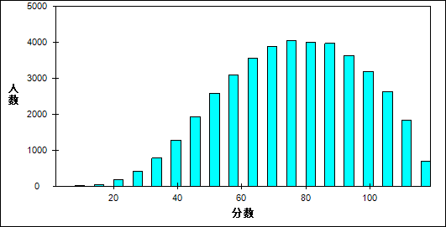

图 3 理综客观题难度曲线图

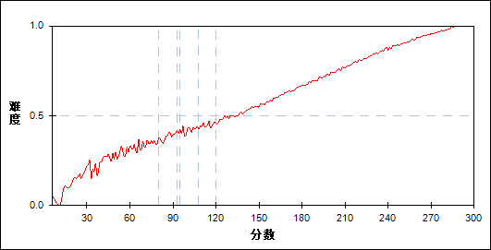

表 5 理综客观题分组分析表

| 分值 | G1 | G2 | G3 | G4 | G5 | G6 | G7 | 人数 | 比率(%) | 平均值 |
| --- | --- | --- | --- | --- | --- | --- | --- | --- | --- | --- |
| 0～ | 5 | 0 | 0 | 0 | 0 | 0 | 0 | 5 | 0.01 | 55.20 |
| 6～ | 4 | 0 | 0 | 0 | 0 | 0 | 0 | 4 | 0.01 | 45.00 |
| 12～ | 11 | 1 | 0 | 0 | 0 | 0 | 0 | 12 | 0.03 | 58.92 |
| 18～ | 54 | 0 | 0 | 0 | 0 | 0 | 0 | 54 | 0.13 | 62.24 |
| 24～ | 173 | 0 | 0 | 0 | 0 | 0 | 0 | 173 | 0.41 | 70.46 |
| 30～ | 403 | 11 | 1 | 0 | 0 | 0 | 0 | 415 | 0.99 | 83.63 |
| 36～ | 724 | 60 | 1 | 0 | 0 | 0 | 0 | 785 | 1.88 | 94.35 |
| 42～ | 1019 | 241 | 24 | 2 | 0 | 0 | 0 | 1286 | 3.08 | 106.36 |
| 48～ | 1129 | 705 | 98 | 8 | 0 | 0 | 0 | 1940 | 4.64 | 117.58 |
| 54～ | 939 | 1200 | 406 | 41 | 1 | 0 | 0 | 2587 | 6.19 | 128.77 |
| 60～ | 566 | 1382 | 934 | 198 | 10 | 1 | 0 | 3091 | 7.39 | 140.06 |
| 66～ | 369 | 1057 | 1432 | 628 | 75 | 2 | 0 | 3563 | 8.52 | 150.34 |
| 72～ | 226 | 597 | 1382 | 1284 | 380 | 19 | 1 | 3889 | 9.30 | 162.02 |
| 78～ | 144 | 304 | 878 | 1543 | 1049 | 126 | 0 | 4044 | 9.67 | 173.65 |
| 84～ | 96 | 153 | 438 | 1227 | 1527 | 550 | 12 | 4003 | 9.57 | 185.11 |
| 90～ | 69 | 114 | 188 | 638 | 1559 | 1278 | 123 | 3969 | 9.49 | 196.99 |
| 96～ | 23 | 65 | 102 | 254 | 961 | 1752 | 480 | 3637 | 8.70 | 209.90 |
| 102～ | 13 | 54 | 60 | 90 | 321 | 1429 | 1225 | 3192 | 7.63 | 223.36 |
| 108～ | 8 | 23 | 24 | 41 | 76 | 653 | 1811 | 2636 | 6.30 | 237.52 |
| 114～ | 0 | 8 | 3 | 15 | 13 | 149 | 1643 | 1831 | 4.38 | 252.08 |
| 120～ | 0 | 0 | 3 | 5 | 2 | 15 | 679 | 704 | 1.68 | 263.86 |
| 合计 | 5975 | 5975 | 5974 | 5974 | 5974 | 5974 | 5974 | 41820 | 100.00 | 176.88 |
| 得分率 | 0.41 | 0.51 | 0.58 | 0.66 | 0.72 | 0.80 | 0.90 | - | - | - |

* + - 1. 理综主观题

本题组共包含11道试题，题号是：21～31

表 6 理综主观题总分分布表

|  |  |  |  |  |  |  |  |  |
| --- | --- | --- | --- | --- | --- | --- | --- | --- |
| 满分值 | 最大值 | 最小值 | 平均值 | 标准差 | 差异系数 | 难度 | 相关系数 | 鉴别指数 |
| 180 | 172.0 | 0.0 | 98.09 | 30.82 | 0.31 | 0.54 | 0.95 | 0.40 |

图 4 理综主观题分数分布表

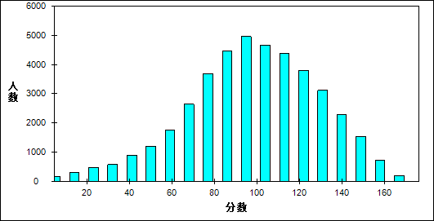

图 5 理综主观题难度曲线图

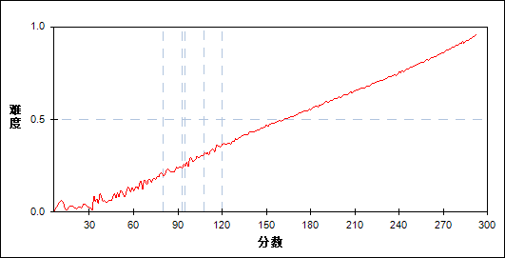

表 7 理综主观题分组分析表

| 分值 | G1 | G2 | G3 | G4 | G5 | G6 | G7 | 人数 | 比率(%) | 平均值 |
| --- | --- | --- | --- | --- | --- | --- | --- | --- | --- | --- |
| 0～ | 14 | 0 | 0 | 0 | 0 | 0 | 0 | 14 | 0.03 | 44.57 |
| 1～ | 4 | 0 | 0 | 0 | 0 | 0 | 0 | 4 | 0.01 | 49.00 |
| 2～ | 6 | 0 | 0 | 0 | 0 | 0 | 0 | 6 | 0.01 | 49.00 |
| 3～ | 10 | 0 | 0 | 0 | 0 | 0 | 0 | 10 | 0.02 | 48.60 |
| 4～ | 7 | 0 | 0 | 0 | 0 | 0 | 0 | 7 | 0.02 | 43.43 |
| 5～ | 17 | 0 | 0 | 0 | 0 | 0 | 0 | 17 | 0.04 | 51.24 |
| 6～ | 18 | 0 | 0 | 0 | 0 | 0 | 0 | 18 | 0.04 | 53.67 |
| 7～ | 23 | 0 | 0 | 0 | 0 | 0 | 0 | 23 | 0.05 | 57.09 |
| 8～ | 22 | 0 | 0 | 0 | 0 | 0 | 0 | 22 | 0.05 | 60.09 |
| 9～ | 34 | 0 | 0 | 0 | 0 | 0 | 0 | 34 | 0.08 | 68.65 |
| 10～ | 33 | 1 | 0 | 0 | 0 | 0 | 0 | 34 | 0.08 | 67.53 |
| 11～ | 22 | 0 | 0 | 0 | 0 | 0 | 0 | 22 | 0.05 | 69.64 |
| 12～ | 42 | 0 | 0 | 0 | 0 | 0 | 0 | 42 | 0.10 | 71.14 |
| 13～ | 30 | 0 | 0 | 0 | 0 | 0 | 0 | 30 | 0.07 | 73.80 |
| 14～ | 26 | 0 | 0 | 0 | 0 | 0 | 0 | 26 | 0.06 | 74.23 |
| 15～ | 41 | 0 | 0 | 0 | 0 | 0 | 0 | 41 | 0.10 | 76.46 |
| 16～ | 31 | 0 | 0 | 0 | 0 | 0 | 0 | 31 | 0.07 | 72.90 |
| 17～ | 35 | 0 | 0 | 0 | 0 | 0 | 0 | 35 | 0.08 | 77.34 |
| 18～ | 42 | 2 | 0 | 0 | 0 | 0 | 0 | 44 | 0.11 | 80.32 |
| 19～ | 52 | 1 | 0 | 0 | 0 | 0 | 0 | 53 | 0.13 | 78.55 |
| 20～ | 39 | 1 | 0 | 0 | 0 | 0 | 0 | 40 | 0.10 | 75.20 |
| 21～ | 45 | 1 | 0 | 0 | 0 | 0 | 0 | 46 | 0.11 | 74.35 |
| 22～ | 43 | 3 | 0 | 0 | 0 | 0 | 0 | 46 | 0.11 | 87.87 |
| 23～ | 50 | 2 | 0 | 0 | 0 | 0 | 0 | 52 | 0.12 | 81.38 |
| 24～ | 46 | 4 | 0 | 0 | 0 | 0 | 0 | 50 | 0.12 | 84.00 |
| 25～ | 60 | 2 | 0 | 0 | 0 | 0 | 0 | 62 | 0.15 | 81.81 |
| 26～ | 54 | 5 | 0 | 0 | 0 | 0 | 0 | 59 | 0.14 | 88.14 |
| 27～ | 58 | 3 | 0 | 0 | 0 | 0 | 0 | 61 | 0.15 | 84.54 |
| 28～ | 67 | 4 | 0 | 0 | 0 | 0 | 0 | 71 | 0.17 | 87.15 |
| 29～ | 52 | 4 | 0 | 0 | 0 | 0 | 0 | 56 | 0.13 | 89.21 |
| 30～ | 50 | 10 | 0 | 0 | 0 | 0 | 0 | 60 | 0.14 | 92.50 |
| 31～ | 64 | 6 | 1 | 0 | 0 | 0 | 0 | 71 | 0.17 | 87.70 |
| 32～ | 43 | 8 | 0 | 0 | 0 | 0 | 0 | 51 | 0.12 | 93.06 |
| 33～ | 59 | 6 | 0 | 0 | 0 | 0 | 0 | 65 | 0.16 | 95.95 |
| 34～ | 54 | 11 | 0 | 0 | 0 | 0 | 0 | 65 | 0.16 | 93.17 |
| 35～ | 66 | 15 | 0 | 0 | 0 | 0 | 0 | 81 | 0.19 | 97.52 |
| 36～ | 52 | 10 | 0 | 0 | 0 | 0 | 0 | 62 | 0.15 | 94.65 |
| 37～ | 81 | 11 | 0 | 0 | 0 | 0 | 0 | 92 | 0.22 | 93.67 |
| 38～ | 81 | 6 | 0 | 0 | 0 | 0 | 0 | 87 | 0.21 | 96.90 |
| 39～ | 76 | 3 | 0 | 0 | 0 | 0 | 0 | 79 | 0.19 | 95.96 |
| 40～ | 79 | 7 | 0 | 0 | 0 | 0 | 0 | 86 | 0.21 | 97.21 |
| 41～ | 105 | 15 | 1 | 0 | 0 | 0 | 0 | 121 | 0.29 | 98.37 |
| 42～ | 90 | 18 | 2 | 0 | 0 | 0 | 0 | 110 | 0.26 | 102.22 |
| 43～ | 87 | 9 | 1 | 0 | 0 | 0 | 0 | 97 | 0.23 | 97.93 |
| 44～ | 95 | 13 | 1 | 0 | 0 | 0 | 0 | 109 | 0.26 | 100.64 |
| 45～ | 94 | 17 | 1 | 0 | 0 | 0 | 0 | 112 | 0.27 | 103.13 |
| 46～ | 84 | 10 | 1 | 0 | 0 | 0 | 0 | 95 | 0.23 | 101.52 |
| 47～ | 83 | 29 | 5 | 1 | 0 | 0 | 0 | 118 | 0.28 | 108.02 |
| 48～ | 95 | 18 | 5 | 0 | 0 | 0 | 0 | 118 | 0.28 | 106.63 |
| 49～ | 105 | 24 | 6 | 0 | 0 | 0 | 0 | 135 | 0.32 | 109.84 |
| 50～ | 91 | 26 | 2 | 0 | 0 | 0 | 0 | 119 | 0.28 | 109.29 |
| 51～ | 124 | 24 | 7 | 0 | 0 | 0 | 0 | 155 | 0.37 | 109.99 |
| 52～ | 129 | 24 | 8 | 0 | 0 | 0 | 0 | 161 | 0.38 | 109.91 |
| 53～ | 127 | 32 | 5 | 0 | 0 | 0 | 0 | 164 | 0.39 | 109.60 |
| 54～ | 116 | 26 | 2 | 0 | 0 | 0 | 0 | 144 | 0.34 | 107.71 |
| 55～ | 107 | 31 | 14 | 0 | 0 | 0 | 0 | 152 | 0.36 | 115.83 |
| 56～ | 117 | 29 | 13 | 2 | 0 | 0 | 0 | 161 | 0.38 | 116.11 |
| 57～ | 121 | 48 | 12 | 2 | 0 | 0 | 0 | 183 | 0.44 | 118.77 |
| 58～ | 130 | 46 | 7 | 0 | 0 | 0 | 0 | 183 | 0.44 | 115.34 |
| 59～ | 114 | 63 | 15 | 0 | 0 | 0 | 0 | 192 | 0.46 | 118.19 |
| 60～ | 136 | 70 | 13 | 4 | 0 | 0 | 0 | 223 | 0.53 | 119.03 |
| 61～ | 121 | 63 | 21 | 1 | 0 | 0 | 0 | 206 | 0.49 | 120.83 |
| 62～ | 137 | 70 | 14 | 2 | 0 | 0 | 0 | 223 | 0.53 | 120.74 |
| 63～ | 127 | 77 | 13 | 3 | 0 | 0 | 0 | 220 | 0.53 | 123.03 |
| 64～ | 140 | 101 | 19 | 3 | 0 | 0 | 0 | 263 | 0.63 | 124.78 |
| 65～ | 118 | 127 | 29 | 2 | 0 | 0 | 0 | 276 | 0.66 | 125.72 |
| 66～ | 127 | 100 | 22 | 8 | 0 | 0 | 0 | 257 | 0.61 | 125.58 |
| 67～ | 104 | 120 | 30 | 6 | 0 | 0 | 0 | 260 | 0.62 | 128.41 |
| 68～ | 130 | 140 | 30 | 5 | 0 | 0 | 0 | 305 | 0.73 | 128.73 |
| 69～ | 104 | 129 | 36 | 9 | 0 | 0 | 0 | 278 | 0.66 | 132.30 |
| 70～ | 130 | 138 | 44 | 10 | 0 | 0 | 0 | 322 | 0.77 | 131.43 |
| 71～ | 81 | 179 | 61 | 7 | 0 | 0 | 0 | 328 | 0.78 | 133.54 |
| 72～ | 96 | 182 | 47 | 28 | 1 | 0 | 0 | 354 | 0.85 | 135.07 |
| 73～ | 103 | 177 | 58 | 15 | 0 | 0 | 0 | 353 | 0.84 | 134.55 |
| 74～ | 90 | 202 | 59 | 17 | 0 | 0 | 0 | 368 | 0.88 | 136.36 |
| 75～ | 90 | 219 | 62 | 21 | 2 | 0 | 0 | 394 | 0.94 | 137.74 |
| 76～ | 88 | 223 | 106 | 11 | 0 | 0 | 0 | 428 | 1.02 | 139.43 |
| 77～ | 50 | 213 | 126 | 15 | 0 | 0 | 0 | 404 | 0.97 | 139.87 |
| 78～ | 36 | 242 | 134 | 34 | 2 | 0 | 0 | 448 | 1.07 | 143.38 |
| 79～ | 31 | 211 | 123 | 32 | 7 | 0 | 0 | 404 | 0.97 | 145.07 |
| 80～ | 43 | 223 | 150 | 38 | 1 | 0 | 0 | 455 | 1.09 | 145.64 |
| 81～ | 37 | 225 | 144 | 31 | 2 | 0 | 0 | 439 | 1.05 | 146.33 |
| 82～ | 21 | 200 | 163 | 41 | 3 | 0 | 0 | 428 | 1.02 | 149.02 |
| 83～ | 15 | 175 | 220 | 64 | 6 | 0 | 0 | 480 | 1.15 | 151.03 |
| 84～ | 13 | 171 | 195 | 83 | 4 | 0 | 0 | 466 | 1.11 | 151.70 |
| 85～ | 14 | 173 | 182 | 82 | 12 | 0 | 0 | 463 | 1.11 | 152.46 |
| 86～ | 11 | 163 | 213 | 100 | 7 | 0 | 0 | 494 | 1.18 | 154.54 |
| 87～ | 13 | 172 | 237 | 81 | 11 | 0 | 0 | 514 | 1.23 | 154.94 |
| 88～ | 7 | 152 | 256 | 92 | 7 | 1 | 0 | 515 | 1.23 | 156.92 |
| 89～ | 4 | 108 | 285 | 133 | 7 | 0 | 0 | 537 | 1.28 | 158.81 |
| 90～ | 3 | 87 | 257 | 192 | 16 | 0 | 0 | 555 | 1.33 | 160.64 |
| 91～ | 3 | 80 | 213 | 188 | 36 | 0 | 0 | 520 | 1.24 | 162.80 |
| 92～ | 4 | 90 | 229 | 180 | 46 | 1 | 0 | 550 | 1.32 | 163.38 |
| 93～ | 1 | 100 | 258 | 195 | 43 | 0 | 0 | 597 | 1.43 | 164.60 |
| 94～ | 3 | 60 | 246 | 208 | 41 | 1 | 0 | 559 | 1.34 | 166.97 |
| 95～ | 0 | 31 | 244 | 226 | 53 | 7 | 0 | 561 | 1.34 | 169.44 |
| 96～ | 1 | 38 | 157 | 270 | 64 | 2 | 0 | 532 | 1.27 | 170.19 |
| 97～ | 0 | 33 | 164 | 225 | 111 | 2 | 0 | 535 | 1.28 | 171.39 |
| 98～ | 0 | 23 | 144 | 258 | 119 | 3 | 0 | 547 | 1.31 | 173.61 |
| 99～ | 1 | 21 | 170 | 234 | 129 | 1 | 0 | 556 | 1.33 | 174.67 |
| 100～ | 0 | 12 | 111 | 232 | 110 | 13 | 0 | 478 | 1.14 | 177.87 |
| 101～ | 0 | 5 | 111 | 262 | 121 | 11 | 0 | 510 | 1.22 | 179.39 |
| 102～ | 0 | 5 | 67 | 283 | 143 | 14 | 0 | 512 | 1.22 | 181.09 |
| 103～ | 0 | 5 | 67 | 232 | 240 | 20 | 0 | 564 | 1.35 | 182.66 |
| 104～ | 0 | 3 | 53 | 202 | 242 | 29 | 0 | 529 | 1.26 | 185.39 |
| 105～ | 0 | 2 | 54 | 194 | 270 | 29 | 0 | 549 | 1.31 | 186.73 |
| 106～ | 0 | 2 | 52 | 194 | 198 | 50 | 0 | 496 | 1.19 | 186.61 |
| 107～ | 0 | 1 | 46 | 198 | 215 | 53 | 0 | 513 | 1.23 | 188.33 |
| 108～ | 0 | 0 | 20 | 215 | 220 | 66 | 0 | 521 | 1.25 | 190.79 |
| 109～ | 0 | 1 | 23 | 102 | 331 | 64 | 0 | 521 | 1.25 | 192.97 |
| 110～ | 0 | 1 | 18 | 112 | 329 | 64 | 0 | 524 | 1.25 | 194.02 |
| 111～ | 0 | 0 | 18 | 87 | 307 | 69 | 0 | 481 | 1.15 | 194.91 |
| 112～ | 0 | 0 | 15 | 90 | 226 | 150 | 1 | 482 | 1.15 | 197.23 |
| 113～ | 0 | 1 | 11 | 81 | 190 | 171 | 2 | 456 | 1.09 | 200.29 |
| 114～ | 0 | 0 | 6 | 98 | 226 | 176 | 2 | 508 | 1.21 | 200.36 |
| 115～ | 0 | 0 | 5 | 41 | 244 | 175 | 2 | 467 | 1.12 | 202.91 |
| 116～ | 0 | 0 | 1 | 37 | 259 | 155 | 3 | 455 | 1.09 | 203.78 |
| 117～ | 0 | 0 | 5 | 31 | 241 | 218 | 3 | 498 | 1.19 | 205.70 |
| 118～ | 0 | 0 | 2 | 25 | 149 | 287 | 8 | 471 | 1.13 | 208.36 |
| 119～ | 0 | 0 | 2 | 27 | 162 | 238 | 17 | 446 | 1.07 | 208.26 |
| 120～ | 0 | 0 | 0 | 23 | 111 | 260 | 20 | 414 | 0.99 | 211.62 |
| 121～ | 0 | 0 | 0 | 12 | 143 | 244 | 31 | 430 | 1.03 | 212.77 |
| 122～ | 0 | 0 | 1 | 5 | 112 | 274 | 25 | 417 | 1.00 | 214.99 |
| 123～ | 0 | 0 | 0 | 6 | 104 | 260 | 24 | 394 | 0.94 | 216.64 |
| 124～ | 0 | 1 | 1 | 7 | 57 | 313 | 55 | 434 | 1.04 | 218.15 |
| 125～ | 0 | 0 | 2 | 5 | 54 | 258 | 76 | 395 | 0.94 | 218.42 |
| 126～ | 0 | 0 | 0 | 7 | 57 | 260 | 81 | 405 | 0.97 | 219.97 |
| 127～ | 0 | 0 | 0 | 0 | 46 | 247 | 81 | 374 | 0.89 | 222.57 |
| 128～ | 0 | 0 | 0 | 1 | 37 | 235 | 91 | 364 | 0.87 | 224.36 |
| 129～ | 0 | 0 | 0 | 1 | 38 | 237 | 122 | 398 | 0.95 | 226.16 |
| 130～ | 0 | 0 | 0 | 2 | 15 | 221 | 142 | 380 | 0.91 | 227.78 |
| 131～ | 0 | 0 | 0 | 0 | 10 | 168 | 174 | 352 | 0.84 | 228.96 |
| 132～ | 0 | 0 | 0 | 0 | 10 | 153 | 166 | 329 | 0.79 | 230.02 |
| 133～ | 0 | 0 | 0 | 1 | 10 | 147 | 168 | 326 | 0.78 | 231.85 |
| 134～ | 0 | 0 | 0 | 0 | 1 | 144 | 157 | 302 | 0.72 | 233.28 |
| 135～ | 0 | 0 | 0 | 0 | 12 | 112 | 170 | 294 | 0.70 | 234.80 |
| 136～ | 0 | 0 | 0 | 1 | 1 | 88 | 194 | 284 | 0.68 | 237.77 |
| 137～ | 0 | 0 | 0 | 0 | 1 | 62 | 226 | 289 | 0.69 | 238.96 |
| 138～ | 0 | 0 | 0 | 0 | 1 | 50 | 233 | 284 | 0.68 | 240.89 |
| 139～ | 0 | 0 | 0 | 0 | 0 | 41 | 224 | 265 | 0.63 | 241.95 |
| 140～ | 0 | 0 | 0 | 1 | 0 | 33 | 232 | 266 | 0.64 | 243.51 |
| 141～ | 0 | 0 | 0 | 0 | 0 | 33 | 206 | 239 | 0.57 | 244.98 |
| 142～ | 0 | 0 | 0 | 0 | 0 | 15 | 198 | 213 | 0.51 | 247.46 |
| 143～ | 0 | 0 | 0 | 0 | 0 | 11 | 215 | 226 | 0.54 | 248.35 |
| 144～ | 0 | 0 | 0 | 0 | 0 | 9 | 200 | 209 | 0.50 | 249.13 |
| 145～ | 0 | 0 | 0 | 0 | 0 | 5 | 188 | 193 | 0.46 | 251.82 |
| 146～ | 0 | 0 | 0 | 0 | 0 | 6 | 216 | 222 | 0.53 | 252.03 |
| 147～ | 0 | 0 | 0 | 0 | 1 | 8 | 183 | 192 | 0.46 | 253.38 |
| 148～ | 0 | 0 | 0 | 0 | 0 | 4 | 178 | 182 | 0.44 | 255.93 |
| 149～ | 0 | 0 | 0 | 0 | 0 | 3 | 174 | 177 | 0.42 | 256.08 |
| 150～ | 0 | 0 | 0 | 0 | 0 | 1 | 179 | 180 | 0.43 | 256.77 |
| 151～ | 0 | 0 | 0 | 0 | 0 | 0 | 147 | 147 | 0.35 | 259.29 |
| 152～ | 0 | 0 | 0 | 0 | 0 | 1 | 114 | 115 | 0.27 | 260.78 |
| 153～ | 0 | 0 | 0 | 0 | 0 | 0 | 122 | 122 | 0.29 | 262.13 |
| 154～ | 0 | 0 | 0 | 0 | 0 | 0 | 116 | 116 | 0.28 | 262.62 |
| 155～ | 0 | 0 | 0 | 0 | 0 | 1 | 89 | 90 | 0.22 | 265.40 |
| 156～ | 0 | 0 | 0 | 0 | 0 | 0 | 102 | 102 | 0.24 | 266.00 |
| 157～ | 0 | 0 | 0 | 0 | 0 | 0 | 101 | 101 | 0.24 | 267.32 |
| 158～ | 0 | 0 | 0 | 0 | 0 | 0 | 89 | 89 | 0.21 | 269.71 |
| 159～ | 0 | 0 | 0 | 0 | 0 | 0 | 62 | 62 | 0.15 | 269.03 |
| 160～ | 0 | 0 | 0 | 0 | 0 | 0 | 63 | 63 | 0.15 | 272.29 |
| 161～ | 0 | 0 | 0 | 0 | 0 | 0 | 50 | 50 | 0.12 | 271.40 |
| 162～ | 0 | 0 | 0 | 0 | 0 | 0 | 55 | 55 | 0.13 | 274.25 |
| 163～ | 0 | 0 | 0 | 0 | 0 | 0 | 32 | 32 | 0.08 | 274.56 |
| 164～ | 0 | 0 | 0 | 0 | 0 | 0 | 39 | 39 | 0.09 | 277.54 |
| 165～ | 0 | 0 | 0 | 0 | 0 | 0 | 33 | 33 | 0.08 | 276.45 |
| 166～ | 0 | 0 | 0 | 0 | 0 | 0 | 28 | 28 | 0.07 | 279.36 |
| 167～ | 0 | 0 | 0 | 0 | 0 | 0 | 23 | 23 | 0.05 | 278.13 |
| 168～ | 0 | 0 | 0 | 0 | 0 | 0 | 17 | 17 | 0.04 | 283.76 |
| 169～ | 0 | 0 | 0 | 0 | 0 | 0 | 9 | 9 | 0.02 | 285.00 |
| 170～ | 0 | 0 | 0 | 0 | 0 | 0 | 6 | 6 | 0.01 | 286.00 |
| 171～ | 0 | 0 | 0 | 0 | 0 | 0 | 7 | 7 | 0.02 | 287.57 |
| 172～ | 0 | 0 | 0 | 0 | 0 | 0 | 3 | 3 | 0.01 | 290.00 |
| 合计 | 5975 | 5975 | 5974 | 5974 | 5974 | 5974 | 5974 | 41820 | 100.00 | 176.88 |
| 得分率 | 0.28 | 0.42 | 0.49 | 0.55 | 0.61 | 0.68 | 0.79 | - | - | - |

1. 物理统计分析
   1. 总体分析

表 8 总分分析表

|  |  |  |  |  |  |  |
| --- | --- | --- | --- | --- | --- | --- |
| 总人数 | 满分值 | 最大值 | 最小值 | 平均值 | 标准差 | 差异系数 |
| 41820 | 120 | 120.0 | 1.0 | 70.37 | 23.37 | 0.33 |
| 难度 | alpha系数 | 标准误 | 中数 | 众数 | 偏度 | 峰度 |
| 0.59 | 0.72 | 0.11 | 71.62 | 62.0 | -0.07 | -0.64 |

图 6 总分分布曲线图

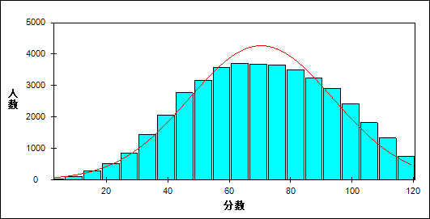

图 7 题目难度与区分度坐标图

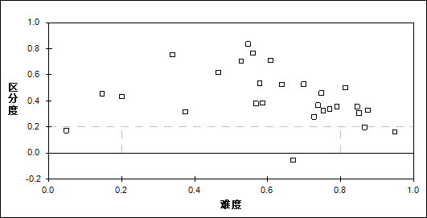

表 9 题目整体分析表

| 题目 | 满分值 | 最大值 | 最小值 | 平均值 | 标准差 | 差异系数 | 难度 | 相关系数 | 鉴别指数 |
| --- | --- | --- | --- | --- | --- | --- | --- | --- | --- |
| 13 | 6 | 6.0 | 0.0 | 4.62 | 2.53 | 0.55 | 0.77 | 0.36 | 0.34 |
| 14 | 6 | 6.0 | 0.0 | 4.48 | 2.61 | 0.58 | 0.75 | 0.47 | 0.46 |
| 15 | 6 | 6.0 | 0.0 | 3.65 | 2.93 | 0.80 | 0.61 | 0.60 | 0.71 |
| 16 | 6 | 6.0 | 0.0 | 2.25 | 2.90 | 1.29 | 0.37 | 0.32 | 0.32 |
| 17 | 6 | 6.0 | 0.0 | 3.83 | 2.88 | 0.75 | 0.64 | 0.48 | 0.52 |
| 18 | 6 | 6.0 | 0.0 | 4.74 | 2.45 | 0.52 | 0.79 | 0.39 | 0.35 |
| 19 | 6 | 6.0 | 0.0 | 2.78 | 2.99 | 1.07 | 0.46 | 0.53 | 0.62 |
| 20 | 6 | 6.0 | 0.0 | 3.47 | 2.96 | 0.85 | 0.58 | 0.47 | 0.53 |
| 21 | 18 | 18.0 | 0.0 | 13.08 | 3.48 | 0.27 | 0.73 | 0.62 | 0.28 |
| 22 | 16 | 16.0 | 0.0 | 13.98 | 3.70 | 0.26 | 0.87 | 0.61 | 0.33 |
| 23 | 18 | 18.0 | 0.0 | 9.50 | 6.28 | 0.66 | 0.53 | 0.83 | 0.70 |
| 24 | 20 | 20.0 | 0.0 | 3.99 | 4.77 | 1.19 | 0.20 | 0.76 | 0.43 |
| 21_1 | 2 | 2.0 | 0.0 | 1.70 | 0.71 | 0.42 | 0.85 | 0.36 | 0.31 |
| 21_2 | 2 | 2.0 | 0.0 | 1.34 | 0.94 | 0.70 | 0.67 | -0.02 | -0.06 |
| 21_3 | 4 | 4.0 | 0.0 | 2.95 | 1.76 | 0.60 | 0.74 | 0.36 | 0.37 |
| 21_41 | 4 | 4.0 | 0.0 | 3.46 | 1.05 | 0.30 | 0.87 | 0.33 | 0.20 |
| 21_42 | 1 | 1.0 | 0.0 | 0.75 | 0.43 | 0.57 | 0.75 | 0.31 | 0.32 |
| 21_5 | 3 | 3.0 | 0.0 | 1.70 | 1.49 | 0.87 | 0.57 | 0.33 | 0.38 |
| 21_6 | 2 | 2.0 | 0.0 | 1.17 | 0.86 | 0.73 | 0.59 | 0.36 | 0.38 |
| 22_1 | 6 | 6.0 | 0.0 | 5.69 | 1.17 | 0.21 | 0.95 | 0.39 | 0.16 |
| 22_2 | 5 | 5.0 | 0.0 | 4.06 | 1.83 | 0.45 | 0.81 | 0.57 | 0.50 |
| 22_3 | 5 | 5.0 | 0.0 | 4.23 | 1.54 | 0.36 | 0.85 | 0.50 | 0.35 |
| 23_1 | 6 | 6.0 | 0.0 | 4.19 | 2.30 | 0.55 | 0.70 | 0.58 | 0.53 |
| 23_2 | 6 | 6.0 | 0.0 | 3.28 | 2.87 | 0.87 | 0.55 | 0.71 | 0.84 |
| 23_3 | 6 | 6.0 | 0.0 | 2.03 | 2.50 | 1.23 | 0.34 | 0.73 | 0.75 |
| 24_1 | 4 | 4.0 | 0.0 | 2.24 | 1.74 | 0.78 | 0.56 | 0.70 | 0.77 |
| 24_2 | 10 | 10.0 | 0.0 | 1.47 | 3.00 | 2.05 | 0.15 | 0.64 | 0.46 |
| 24_3 | 6 | 6.0 | 0.0 | 0.29 | 1.15 | 3.98 | 0.05 | 0.41 | 0.17 |

表 10 题组整体分析表

| 题目 | 满分值 | 最大值 | 最小值 | 平均值 | 标准差 | 差异系数 | 难度 | 相关系数 | 鉴别指数 |
| --- | --- | --- | --- | --- | --- | --- | --- | --- | --- |
| 客观题 | 48 | 48.0 | 0.0 | 29.82 | 11.62 | 0.39 | 0.62 | 13.32 | 0.48 |
| 主观题 | 72 | 72.0 | 0.0 | 40.55 | 14.38 | 0.35 | 0.56 | 14.69 | 0.44 |
| 力学 | 46 | 46.0 | 0.0 | 19.65 | 12.36 | 0.63 | 0.43 | 9.03 | 0.59 |
| 电学 | 50 | 50.0 | 0.0 | 37.86 | 9.42 | 0.25 | 0.76 | 19.99 | 0.37 |
| 热学 | 6 | 6.0 | 0.0 | 4.62 | 2.53 | 0.55 | 0.77 | 9.00 | 0.34 |
| 光学 | 6 | 6.0 | 0.0 | 4.48 | 2.61 | 0.58 | 0.75 | 8.71 | 0.46 |
| 原子 | 6 | 6.0 | 0.0 | 3.47 | 2.96 | 0.85 | 0.58 | 6.20 | 0.53 |
| 理解能力 | 18 | 18.0 | 0.0 | 12.75 | 5.59 | 0.44 | 0.71 | 11.71 | 0.50 |
| 推理能力 | 18 | 18.0 | 0.0 | 10.81 | 5.27 | 0.49 | 0.60 | 10.47 | 0.40 |
| 实验能力 | 24 | 24.0 | 0.0 | 15.86 | 5.09 | 0.32 | 0.66 | 15.64 | 0.36 |
| 应用能力 | 32 | 32.0 | 0.0 | 23.69 | 8.31 | 0.35 | 0.74 | 14.66 | 0.51 |
| 探究能力 | 22 | 22.0 | 0.0 | 6.97 | 6.45 | 0.93 | 0.32 | 6.46 | 0.56 |

表 11 总分人数分布表

| 分值 | 人数 | 比率(%) | 累计人数 | 累计频率（%） |
| --- | --- | --- | --- | --- |
| 120.0 | 202 | 0.48 | 202 | 0.48 |
| 119.0 | 35 | 0.08 | 237 | 0.57 |
| 118.0 | 169 | 0.40 | 406 | 0.97 |
| 117.0 | 88 | 0.21 | 494 | 1.18 |
| 116.0 | 95 | 0.23 | 589 | 1.41 |
| 115.0 | 159 | 0.38 | 748 | 1.79 |
| 114.0 | 251 | 0.60 | 999 | 2.39 |
| 113.0 | 120 | 0.29 | 1119 | 2.68 |
| 112.0 | 262 | 0.63 | 1381 | 3.30 |
| 111.0 | 223 | 0.53 | 1604 | 3.84 |
| 110.0 | 225 | 0.54 | 1829 | 4.37 |
| 109.0 | 247 | 0.59 | 2076 | 4.96 |
| 108.0 | 300 | 0.72 | 2376 | 5.68 |
| 107.0 | 206 | 0.49 | 2582 | 6.17 |
| 106.0 | 359 | 0.86 | 2941 | 7.03 |
| 105.0 | 310 | 0.74 | 3251 | 7.77 |
| 104.0 | 316 | 0.76 | 3567 | 8.53 |
| 103.0 | 325 | 0.78 | 3892 | 9.31 |
| 102.0 | 367 | 0.88 | 4259 | 10.18 |
| 101.0 | 308 | 0.74 | 4567 | 10.92 |
| 100.0 | 394 | 0.94 | 4961 | 11.86 |
| 99.0 | 412 | 0.99 | 5373 | 12.85 |
| 98.0 | 457 | 1.09 | 5830 | 13.94 |
| 97.0 | 475 | 1.14 | 6305 | 15.08 |
| 96.0 | 502 | 1.20 | 6807 | 16.28 |
| 95.0 | 504 | 1.21 | 7311 | 17.48 |
| 94.0 | 463 | 1.11 | 7774 | 18.59 |
| 93.0 | 456 | 1.09 | 8230 | 19.68 |
| 92.0 | 492 | 1.18 | 8722 | 20.86 |
| 91.0 | 494 | 1.18 | 9216 | 22.04 |
| 90.0 | 527 | 1.26 | 9743 | 23.30 |
| 89.0 | 547 | 1.31 | 10290 | 24.61 |
| 88.0 | 499 | 1.19 | 10789 | 25.80 |
| 87.0 | 545 | 1.30 | 11334 | 27.10 |
| 86.0 | 560 | 1.34 | 11894 | 28.44 |
| 85.0 | 551 | 1.32 | 12445 | 29.76 |
| 84.0 | 570 | 1.36 | 13015 | 31.12 |
| 83.0 | 567 | 1.36 | 13582 | 32.48 |
| 82.0 | 565 | 1.35 | 14147 | 33.83 |
| 81.0 | 609 | 1.46 | 14756 | 35.28 |
| 80.0 | 606 | 1.45 | 15362 | 36.73 |
| 79.0 | 592 | 1.42 | 15954 | 38.15 |
| 78.0 | 596 | 1.43 | 16550 | 39.57 |
| 77.0 | 622 | 1.49 | 17172 | 41.06 |
| 76.0 | 592 | 1.42 | 17764 | 42.48 |
| 75.0 | 621 | 1.48 | 18385 | 43.96 |
| 74.0 | 631 | 1.51 | 19016 | 45.47 |
| 73.0 | 595 | 1.42 | 19611 | 46.89 |
| 72.0 | 646 | 1.54 | 20257 | 48.44 |
| 71.0 | 582 | 1.39 | 20839 | 49.83 |
| 70.0 | 626 | 1.50 | 21465 | 51.33 |
| 69.0 | 603 | 1.44 | 22068 | 52.77 |
| 68.0 | 628 | 1.50 | 22696 | 54.27 |
| 67.0 | 599 | 1.43 | 23295 | 55.70 |
| 66.0 | 620 | 1.48 | 23915 | 57.19 |
| 65.0 | 622 | 1.49 | 24537 | 58.67 |
| 64.0 | 619 | 1.48 | 25156 | 60.15 |
| 63.0 | 633 | 1.51 | 25789 | 61.67 |
| 62.0 | 652 | 1.56 | 26441 | 63.23 |
| 61.0 | 566 | 1.35 | 27007 | 64.58 |
| 60.0 | 619 | 1.48 | 27626 | 66.06 |
| 59.0 | 612 | 1.46 | 28238 | 67.52 |
| 58.0 | 601 | 1.44 | 28839 | 68.96 |
| 57.0 | 587 | 1.40 | 29426 | 70.36 |
| 56.0 | 574 | 1.37 | 30000 | 71.74 |
| 55.0 | 591 | 1.41 | 30591 | 73.15 |
| 54.0 | 563 | 1.35 | 31154 | 74.50 |
| 53.0 | 565 | 1.35 | 31719 | 75.85 |
| 52.0 | 511 | 1.22 | 32230 | 77.07 |
| 51.0 | 498 | 1.19 | 32728 | 78.26 |
| 50.0 | 520 | 1.24 | 33248 | 79.50 |
| 49.0 | 517 | 1.24 | 33765 | 80.74 |
| 48.0 | 532 | 1.27 | 34297 | 82.01 |
| 47.0 | 469 | 1.12 | 34766 | 83.13 |
| 46.0 | 469 | 1.12 | 35235 | 84.25 |
| 45.0 | 455 | 1.09 | 35690 | 85.34 |
| 44.0 | 450 | 1.08 | 36140 | 86.42 |
| 43.0 | 394 | 0.94 | 36534 | 87.36 |
| 42.0 | 390 | 0.93 | 36924 | 88.29 |
| 41.0 | 379 | 0.91 | 37303 | 89.20 |
| 40.0 | 316 | 0.76 | 37619 | 89.95 |
| 39.0 | 351 | 0.84 | 37970 | 90.79 |
| 38.0 | 333 | 0.80 | 38303 | 91.59 |
| 37.0 | 298 | 0.71 | 38601 | 92.30 |
| 36.0 | 308 | 0.74 | 38909 | 93.04 |
| 35.0 | 265 | 0.63 | 39174 | 93.67 |
| 34.0 | 239 | 0.57 | 39413 | 94.24 |
| 33.0 | 247 | 0.59 | 39660 | 94.84 |
| 32.0 | 219 | 0.52 | 39879 | 95.36 |
| 31.0 | 171 | 0.41 | 40050 | 95.77 |
| 30.0 | 157 | 0.38 | 40207 | 96.14 |
| 29.0 | 155 | 0.37 | 40362 | 96.51 |
| 28.0 | 161 | 0.38 | 40523 | 96.90 |
| 27.0 | 135 | 0.32 | 40658 | 97.22 |
| 26.0 | 133 | 0.32 | 40791 | 97.54 |
| 25.0 | 109 | 0.26 | 40900 | 97.80 |
| 24.0 | 116 | 0.28 | 41016 | 98.08 |
| 23.0 | 93 | 0.22 | 41109 | 98.30 |
| 22.0 | 92 | 0.22 | 41201 | 98.52 |
| 21.0 | 84 | 0.20 | 41285 | 98.72 |
| 20.0 | 69 | 0.16 | 41354 | 98.89 |
| 19.0 | 57 | 0.14 | 41411 | 99.02 |
| 18.0 | 74 | 0.18 | 41485 | 99.20 |
| 17.0 | 52 | 0.12 | 41537 | 99.32 |
| 16.0 | 43 | 0.10 | 41580 | 99.43 |
| 15.0 | 51 | 0.12 | 41631 | 99.55 |
| 14.0 | 34 | 0.08 | 41665 | 99.63 |
| 13.0 | 24 | 0.06 | 41689 | 99.69 |
| 12.0 | 29 | 0.07 | 41718 | 99.76 |
| 11.0 | 23 | 0.05 | 41741 | 99.81 |
| 10.0 | 13 | 0.03 | 41754 | 99.84 |
| 9.0 | 16 | 0.04 | 41770 | 99.88 |
| 8.0 | 23 | 0.05 | 41793 | 99.94 |
| 7.0 | 3 | 0.01 | 41796 | 99.94 |
| 6.0 | 10 | 0.02 | 41806 | 99.97 |
| 5.0 | 5 | 0.01 | 41811 | 99.98 |
| 4.0 | 2 | 0.00 | 41813 | 99.98 |
| 3.0 | 2 | 0.00 | 41815 | 99.99 |
| 2.0 | 3 | 0.01 | 41818 | 100.00 |
| 1.0 | 2 | 0.00 | 41820 | 100.00 |

* 1. 题组分析
     1. 主客观题组
        1. 客观题

本题组共包含8道试题，题号是：13～20

表 12 客观题总分分布表

|  |  |  |  |  |  |  |  |  |
| --- | --- | --- | --- | --- | --- | --- | --- | --- |
| 满分值 | 最大值 | 最小值 | 平均值 | 标准差 | 差异系数 | 难度 | 相关系数 | 鉴别指数 |
| 48 | 48.0 | 0.0 | 29.82 | 11.62 | 0.39 | 0.62 | 13.32 | 0.48 |

图 8 客观题分数分布表

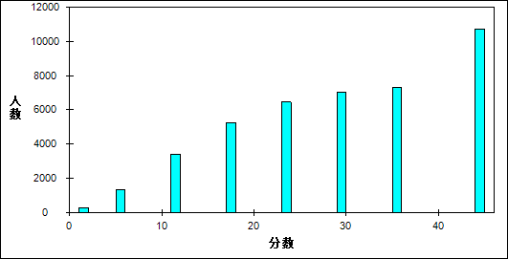

图 9 客观题难度曲线图

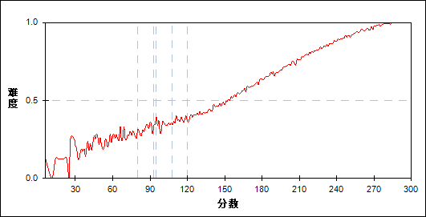

表 13 客观题分组分析表

| 分值 | G1 | G2 | G3 | G4 | G5 | G6 | G7 | 人数 | 比率(%) | 平均值 |
| --- | --- | --- | --- | --- | --- | --- | --- | --- | --- | --- |
| 0～ | 225 | 37 | 9 | 1 | 0 | 0 | 0 | 272 | 0.65 | 96.77 |
| 6～ | 940 | 310 | 87 | 14 | 1 | 0 | 0 | 1352 | 3.23 | 107.69 |
| 12～ | 1684 | 1093 | 489 | 135 | 16 | 1 | 0 | 3418 | 8.17 | 121.66 |
| 18～ | 1536 | 1727 | 1244 | 558 | 171 | 19 | 1 | 5256 | 12.57 | 137.66 |
| 24～ | 894 | 1510 | 1651 | 1482 | 749 | 161 | 12 | 6459 | 15.44 | 155.75 |
| 30～ | 442 | 796 | 1497 | 1787 | 1644 | 764 | 111 | 7041 | 16.84 | 174.02 |
| 36～ | 181 | 350 | 711 | 1337 | 2033 | 2034 | 659 | 7305 | 17.47 | 194.85 |
| 42～ | 65 | 116 | 242 | 558 | 1158 | 2230 | 2366 | 6735 | 16.10 | 217.77 |
| 48～ | 8 | 36 | 44 | 102 | 202 | 765 | 2825 | 3982 | 9.52 | 242.18 |
| 合计 | 5975 | 5975 | 5974 | 5974 | 5974 | 5974 | 5974 | 41820 | 100.00 | 70.37 |
| 得分率 | 0.34 | 0.44 | 0.53 | 0.62 | 0.70 | 0.80 | 0.91 | - | - | - |

* + - 1. 主观题

本题组共包含4道试题，题号是：21～24

表 14 主观题总分分布表

|  |  |  |  |  |  |  |  |  |
| --- | --- | --- | --- | --- | --- | --- | --- | --- |
| 满分值 | 最大值 | 最小值 | 平均值 | 标准差 | 差异系数 | 难度 | 相关系数 | 鉴别指数 |
| 72 | 72.0 | 0.0 | 40.55 | 14.38 | 0.35 | 0.56 | 14.69 | 0.44 |

图 10 主观题分数分布表

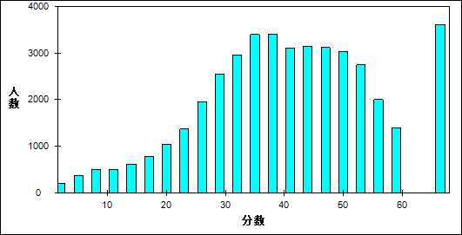

图 11 主观题难度曲线图

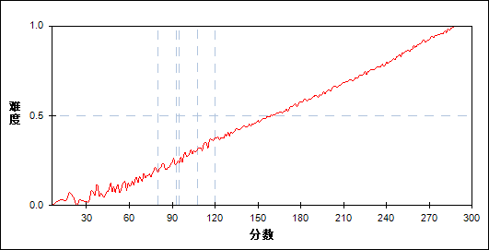

表 15 主观题分组分析表

| 分值 | G1 | G2 | G3 | G4 | G5 | G6 | G7 | 人数 | 比率(%) | 平均值 |
| --- | --- | --- | --- | --- | --- | --- | --- | --- | --- | --- |
| 0～ | 35 | 0 | 0 | 0 | 0 | 0 | 0 | 35 | 0.08 | 53.51 |
| 1～ | 17 | 1 | 0 | 0 | 0 | 0 | 0 | 18 | 0.04 | 73.06 |
| 2～ | 56 | 1 | 0 | 0 | 0 | 0 | 0 | 57 | 0.14 | 58.82 |
| 3～ | 82 | 2 | 0 | 0 | 0 | 0 | 0 | 84 | 0.20 | 68.61 |
| 4～ | 85 | 2 | 0 | 0 | 0 | 0 | 0 | 87 | 0.21 | 74.97 |
| 5～ | 136 | 2 | 0 | 0 | 0 | 0 | 0 | 138 | 0.33 | 75.59 |
| 6～ | 142 | 5 | 0 | 0 | 0 | 0 | 0 | 147 | 0.35 | 83.01 |
| 7～ | 134 | 8 | 0 | 0 | 0 | 0 | 0 | 142 | 0.34 | 82.05 |
| 8～ | 169 | 9 | 1 | 0 | 0 | 0 | 0 | 179 | 0.43 | 86.89 |
| 9～ | 162 | 18 | 1 | 2 | 1 | 0 | 0 | 184 | 0.44 | 90.34 |
| 10～ | 134 | 10 | 4 | 0 | 0 | 0 | 0 | 148 | 0.35 | 92.11 |
| 11～ | 150 | 29 | 4 | 0 | 0 | 0 | 0 | 183 | 0.44 | 99.83 |
| 12～ | 149 | 22 | 3 | 1 | 0 | 0 | 0 | 175 | 0.42 | 96.14 |
| 13～ | 147 | 27 | 12 | 2 | 0 | 0 | 0 | 188 | 0.45 | 103.27 |
| 14～ | 170 | 38 | 4 | 0 | 0 | 0 | 0 | 212 | 0.51 | 104.03 |
| 15～ | 181 | 33 | 5 | 0 | 0 | 0 | 0 | 219 | 0.52 | 102.06 |
| 16～ | 175 | 41 | 9 | 0 | 0 | 0 | 0 | 225 | 0.54 | 106.16 |
| 17～ | 176 | 57 | 16 | 3 | 0 | 0 | 0 | 252 | 0.60 | 111.31 |
| 18～ | 198 | 80 | 15 | 5 | 1 | 0 | 0 | 299 | 0.71 | 113.20 |
| 19～ | 185 | 77 | 20 | 6 | 0 | 0 | 0 | 288 | 0.69 | 115.17 |
| 20～ | 227 | 92 | 29 | 4 | 2 | 0 | 0 | 354 | 0.85 | 116.77 |
| 21～ | 242 | 105 | 37 | 9 | 0 | 0 | 0 | 393 | 0.94 | 119.44 |
| 22～ | 228 | 133 | 36 | 9 | 2 | 0 | 0 | 408 | 0.98 | 121.26 |
| 23～ | 223 | 176 | 46 | 10 | 1 | 0 | 0 | 456 | 1.09 | 123.13 |
| 24～ | 220 | 191 | 67 | 21 | 5 | 0 | 0 | 504 | 1.21 | 127.34 |
| 25～ | 245 | 234 | 104 | 22 | 2 | 0 | 0 | 607 | 1.45 | 129.51 |
| 26～ | 228 | 238 | 125 | 38 | 6 | 0 | 0 | 635 | 1.52 | 132.44 |
| 27～ | 218 | 274 | 165 | 54 | 6 | 0 | 0 | 717 | 1.71 | 136.48 |
| 28～ | 211 | 297 | 173 | 59 | 11 | 0 | 0 | 751 | 1.80 | 137.65 |
| 29～ | 183 | 335 | 191 | 76 | 20 | 2 | 0 | 807 | 1.93 | 141.01 |
| 30～ | 218 | 360 | 263 | 107 | 36 | 2 | 0 | 986 | 2.36 | 142.95 |
| 31～ | 151 | 338 | 246 | 117 | 32 | 1 | 0 | 885 | 2.12 | 145.58 |
| 32～ | 140 | 340 | 330 | 163 | 47 | 6 | 0 | 1026 | 2.45 | 149.42 |
| 33～ | 110 | 323 | 342 | 196 | 66 | 6 | 0 | 1043 | 2.49 | 153.19 |
| 34～ | 105 | 298 | 364 | 265 | 87 | 14 | 0 | 1133 | 2.71 | 156.09 |
| 35～ | 95 | 315 | 368 | 259 | 96 | 25 | 0 | 1158 | 2.77 | 157.20 |
| 36～ | 68 | 292 | 337 | 278 | 112 | 26 | 0 | 1113 | 2.66 | 159.64 |
| 37～ | 45 | 211 | 371 | 322 | 163 | 26 | 0 | 1138 | 2.72 | 164.25 |
| 38～ | 40 | 219 | 351 | 330 | 188 | 41 | 0 | 1169 | 2.80 | 165.84 |
| 39～ | 20 | 163 | 300 | 346 | 212 | 56 | 0 | 1097 | 2.62 | 170.30 |
| 40～ | 21 | 143 | 284 | 308 | 222 | 71 | 3 | 1052 | 2.52 | 172.32 |
| 41～ | 16 | 84 | 217 | 333 | 254 | 83 | 4 | 991 | 2.37 | 177.12 |
| 42～ | 13 | 89 | 189 | 354 | 310 | 103 | 8 | 1066 | 2.55 | 179.91 |
| 43～ | 10 | 62 | 173 | 324 | 300 | 128 | 11 | 1008 | 2.41 | 182.36 |
| 44～ | 5 | 53 | 181 | 292 | 359 | 168 | 12 | 1070 | 2.56 | 185.64 |
| 45～ | 4 | 48 | 135 | 261 | 395 | 205 | 21 | 1069 | 2.56 | 189.28 |
| 46～ | 2 | 31 | 107 | 253 | 353 | 226 | 28 | 1000 | 2.39 | 191.72 |
| 47～ | 1 | 26 | 97 | 236 | 355 | 298 | 49 | 1062 | 2.54 | 195.53 |
| 48～ | 0 | 12 | 68 | 209 | 369 | 343 | 59 | 1060 | 2.53 | 199.55 |
| 49～ | 2 | 11 | 63 | 164 | 349 | 366 | 92 | 1047 | 2.50 | 202.43 |
| 50～ | 1 | 9 | 34 | 158 | 321 | 365 | 110 | 998 | 2.39 | 205.39 |
| 51～ | 0 | 3 | 25 | 106 | 283 | 433 | 145 | 995 | 2.38 | 210.37 |
| 52～ | 0 | 3 | 25 | 77 | 240 | 388 | 172 | 905 | 2.16 | 212.67 |
| 53～ | 0 | 4 | 18 | 73 | 228 | 444 | 217 | 984 | 2.35 | 215.38 |
| 54～ | 0 | 0 | 9 | 41 | 174 | 376 | 257 | 857 | 2.05 | 220.19 |
| 55～ | 0 | 0 | 4 | 33 | 99 | 309 | 265 | 710 | 1.70 | 223.44 |
| 56～ | 0 | 0 | 4 | 14 | 86 | 319 | 328 | 751 | 1.80 | 227.47 |
| 57～ | 0 | 0 | 1 | 11 | 52 | 209 | 266 | 539 | 1.29 | 230.24 |
| 58～ | 0 | 0 | 0 | 10 | 34 | 216 | 312 | 572 | 1.37 | 233.24 |
| 59～ | 0 | 0 | 0 | 6 | 29 | 124 | 235 | 394 | 0.94 | 234.70 |
| 60～ | 0 | 1 | 0 | 4 | 21 | 144 | 267 | 437 | 1.04 | 235.80 |
| 61～ | 0 | 0 | 1 | 2 | 14 | 118 | 318 | 453 | 1.08 | 240.00 |
| 62～ | 0 | 0 | 0 | 1 | 10 | 80 | 289 | 380 | 0.91 | 244.08 |
| 63～ | 0 | 0 | 0 | 0 | 6 | 89 | 340 | 435 | 1.04 | 245.60 |
| 64～ | 0 | 0 | 0 | 0 | 8 | 55 | 342 | 405 | 0.97 | 248.70 |
| 65～ | 0 | 0 | 0 | 0 | 4 | 29 | 220 | 253 | 0.60 | 249.86 |
| 66～ | 0 | 0 | 0 | 0 | 3 | 44 | 365 | 412 | 0.99 | 253.19 |
| 67～ | 0 | 0 | 0 | 0 | 0 | 10 | 275 | 285 | 0.68 | 257.36 |
| 68～ | 0 | 0 | 0 | 0 | 0 | 12 | 177 | 189 | 0.45 | 258.36 |
| 69～ | 0 | 0 | 0 | 0 | 0 | 5 | 146 | 151 | 0.36 | 261.99 |
| 70～ | 0 | 0 | 0 | 0 | 0 | 8 | 301 | 309 | 0.74 | 262.65 |
| 71～ | 0 | 0 | 0 | 0 | 0 | 0 | 53 | 53 | 0.13 | 268.66 |
| 72～ | 0 | 0 | 0 | 0 | 0 | 1 | 287 | 288 | 0.69 | 269.51 |
| 合计 | 5975 | 5975 | 5974 | 5974 | 5974 | 5974 | 5974 | 41820 | 100.00 | 70.37 |
| 得分率 | 0.28 | 0.42 | 0.49 | 0.56 | 0.63 | 0.71 | 0.84 | - | - | - |

* + 1. 知识组块
       1. 力学

本题组共包含5道试题，题号是：15、16、19、23、24_2

表 16 力学总分分布表

|  |  |  |  |  |  |  |  |  |
| --- | --- | --- | --- | --- | --- | --- | --- | --- |
| 满分值 | 最大值 | 最小值 | 平均值 | 标准差 | 差异系数 | 难度 | 相关系数 | 鉴别指数 |
| 46 | 46.0 | 0.0 | 19.65 | 12.36 | 0.63 | 0.43 | 9.03 | 0.59 |

图 12 力学分数分布表

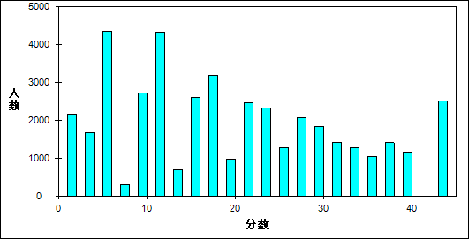

图 13 力学难度曲线图

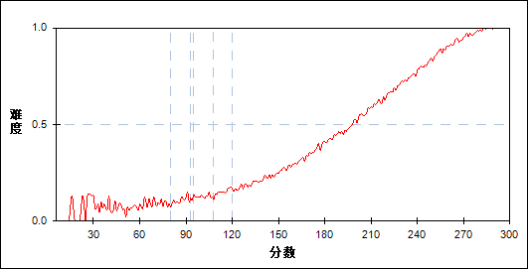

表 17 力学分组分析表

| 分值 | G1 | G2 | G3 | G4 | G5 | G6 | G7 | 人数 | 比率(%) | 平均值 |
| --- | --- | --- | --- | --- | --- | --- | --- | --- | --- | --- |
| 0～ | 1562 | 432 | 111 | 23 | 1 | 1 | 0 | 2130 | 5.09 | 104.18 |
| 1～ | 17 | 10 | 5 | 0 | 0 | 0 | 0 | 32 | 0.08 | 123.16 |
| 2～ | 2 | 3 | 1 | 0 | 0 | 0 | 0 | 6 | 0.01 | 125.50 |
| 3～ | 575 | 601 | 288 | 79 | 16 | 0 | 0 | 1559 | 3.73 | 132.02 |
| 4～ | 27 | 50 | 38 | 7 | 0 | 1 | 0 | 123 | 0.29 | 139.23 |
| 5～ | 3 | 7 | 9 | 2 | 0 | 0 | 0 | 21 | 0.05 | 145.24 |
| 6～ | 2033 | 1303 | 707 | 229 | 48 | 1 | 0 | 4321 | 10.33 | 124.34 |
| 7～ | 49 | 96 | 72 | 31 | 6 | 0 | 0 | 254 | 0.61 | 143.33 |
| 8～ | 7 | 14 | 9 | 8 | 0 | 2 | 0 | 40 | 0.10 | 147.93 |
| 9～ | 427 | 807 | 713 | 344 | 108 | 7 | 0 | 2406 | 5.75 | 146.18 |
| 10～ | 33 | 93 | 98 | 76 | 21 | 4 | 0 | 325 | 0.78 | 154.83 |
| 11～ | 4 | 23 | 19 | 21 | 15 | 1 | 0 | 83 | 0.20 | 161.07 |
| 12～ | 872 | 1217 | 1154 | 692 | 288 | 32 | 0 | 4255 | 10.17 | 146.36 |
| 13～ | 33 | 116 | 173 | 156 | 82 | 11 | 0 | 571 | 1.37 | 162.62 |
| 14～ | 4 | 17 | 28 | 39 | 41 | 2 | 0 | 131 | 0.31 | 172.92 |
| 15～ | 120 | 420 | 609 | 665 | 277 | 57 | 0 | 2148 | 5.14 | 163.38 |
| 16～ | 11 | 50 | 128 | 158 | 102 | 17 | 0 | 466 | 1.11 | 171.55 |
| 17～ | 1 | 9 | 36 | 33 | 47 | 17 | 0 | 143 | 0.34 | 180.83 |
| 18～ | 147 | 404 | 766 | 896 | 672 | 158 | 3 | 3046 | 7.28 | 170.00 |
| 19～ | 17 | 57 | 136 | 246 | 205 | 60 | 4 | 725 | 1.73 | 178.40 |
| 20～ | 2 | 10 | 26 | 76 | 99 | 43 | 3 | 259 | 0.62 | 188.07 |
| 21～ | 15 | 106 | 322 | 614 | 559 | 219 | 9 | 1844 | 4.41 | 182.27 |
| 22～ | 3 | 17 | 82 | 151 | 240 | 116 | 7 | 616 | 1.47 | 189.57 |
| 23～ | 0 | 4 | 23 | 62 | 111 | 87 | 9 | 296 | 0.71 | 196.21 |
| 24～ | 9 | 67 | 207 | 518 | 713 | 476 | 35 | 2025 | 4.84 | 191.32 |
| 25～ | 1 | 16 | 68 | 170 | 268 | 245 | 36 | 804 | 1.92 | 197.07 |
| 26～ | 0 | 2 | 19 | 67 | 166 | 189 | 32 | 475 | 1.14 | 204.38 |
| 27～ | 0 | 11 | 62 | 233 | 482 | 476 | 87 | 1351 | 3.23 | 201.72 |
| 28～ | 0 | 6 | 18 | 84 | 215 | 315 | 83 | 721 | 1.72 | 208.20 |
| 29～ | 0 | 2 | 4 | 37 | 125 | 198 | 78 | 444 | 1.06 | 212.71 |
| 30～ | 1 | 1 | 23 | 129 | 389 | 622 | 226 | 1391 | 3.33 | 211.93 |
| 31～ | 0 | 1 | 10 | 43 | 151 | 395 | 201 | 801 | 1.92 | 218.27 |
| 32～ | 0 | 0 | 1 | 17 | 96 | 285 | 214 | 613 | 1.47 | 223.21 |
| 33～ | 0 | 2 | 4 | 29 | 117 | 261 | 136 | 549 | 1.31 | 218.37 |
| 34～ | 0 | 0 | 2 | 11 | 72 | 326 | 312 | 723 | 1.73 | 228.17 |
| 35～ | 0 | 0 | 0 | 3 | 44 | 139 | 168 | 354 | 0.85 | 229.07 |
| 36～ | 0 | 1 | 3 | 13 | 77 | 271 | 325 | 690 | 1.65 | 228.95 |
| 37～ | 0 | 0 | 0 | 10 | 57 | 322 | 541 | 930 | 2.22 | 234.63 |
| 38～ | 0 | 0 | 0 | 1 | 19 | 153 | 309 | 482 | 1.15 | 238.11 |
| 39～ | 0 | 0 | 0 | 0 | 7 | 29 | 104 | 140 | 0.33 | 242.17 |
| 40～ | 0 | 0 | 0 | 0 | 26 | 217 | 784 | 1027 | 2.46 | 244.27 |
| 41～ | 0 | 0 | 0 | 0 | 3 | 38 | 112 | 153 | 0.37 | 245.29 |
| 42～ | 0 | 0 | 0 | 1 | 1 | 29 | 88 | 119 | 0.28 | 243.41 |
| 43～ | 0 | 0 | 0 | 0 | 4 | 95 | 672 | 771 | 1.84 | 250.65 |
| 44～ | 0 | 0 | 0 | 0 | 1 | 6 | 72 | 79 | 0.19 | 253.71 |
| 45～ | 0 | 0 | 0 | 0 | 0 | 4 | 102 | 106 | 0.25 | 259.17 |
| 46～ | 0 | 0 | 0 | 0 | 3 | 47 | 1222 | 1272 | 3.04 | 261.20 |
| 合计 | 5975 | 5975 | 5974 | 5974 | 5974 | 5974 | 5974 | 41820 | 100.00 | 70.37 |
| 得分率 | 0.13 | 0.21 | 0.29 | 0.39 | 0.50 | 0.65 | 0.84 | - | - | - |

* + - 1. 电学

本题组共包含5道试题，题号是：17、18、21、22、24_1

表 18 电学总分分布表

|  |  |  |  |  |  |  |  |  |
| --- | --- | --- | --- | --- | --- | --- | --- | --- |
| 满分值 | 最大值 | 最小值 | 平均值 | 标准差 | 差异系数 | 难度 | 相关系数 | 鉴别指数 |
| 50 | 50.0 | 0.0 | 37.86 | 9.42 | 0.25 | 0.76 | 19.99 | 0.37 |

图 14 电学分数分布表

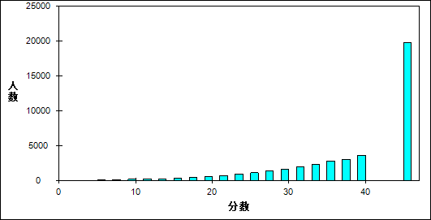

图 15 电学难度曲线图

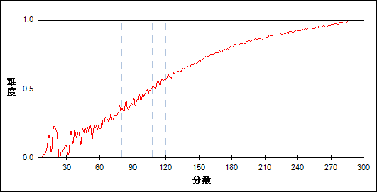

表 19 电学分组分析表

| 分值 | G1 | G2 | G3 | G4 | G5 | G6 | G7 | 人数 | 比率(%) | 平均值 |
| --- | --- | --- | --- | --- | --- | --- | --- | --- | --- | --- |
| 0～ | 13 | 0 | 0 | 0 | 0 | 0 | 0 | 13 | 0.03 | 42.69 |
| 1～ | 5 | 0 | 0 | 0 | 0 | 0 | 0 | 5 | 0.01 | 37.40 |
| 2～ | 29 | 0 | 0 | 0 | 0 | 0 | 0 | 29 | 0.07 | 50.07 |
| 3～ | 22 | 0 | 0 | 0 | 0 | 0 | 0 | 22 | 0.05 | 52.32 |
| 4～ | 25 | 0 | 0 | 0 | 0 | 0 | 0 | 25 | 0.06 | 69.20 |
| 5～ | 45 | 0 | 0 | 0 | 0 | 0 | 0 | 45 | 0.11 | 66.84 |
| 6～ | 50 | 0 | 0 | 0 | 0 | 0 | 0 | 50 | 0.12 | 62.60 |
| 7～ | 50 | 0 | 0 | 0 | 0 | 0 | 0 | 50 | 0.12 | 69.06 |
| 8～ | 84 | 2 | 0 | 0 | 0 | 0 | 0 | 86 | 0.21 | 74.15 |
| 9～ | 100 | 2 | 0 | 0 | 0 | 0 | 0 | 102 | 0.24 | 72.64 |
| 10～ | 95 | 1 | 1 | 0 | 0 | 0 | 0 | 97 | 0.23 | 77.72 |
| 11～ | 109 | 3 | 0 | 0 | 0 | 0 | 0 | 112 | 0.27 | 77.98 |
| 12～ | 150 | 3 | 0 | 0 | 0 | 0 | 0 | 153 | 0.37 | 83.12 |
| 13～ | 118 | 5 | 0 | 0 | 0 | 0 | 0 | 123 | 0.29 | 82.84 |
| 14～ | 145 | 6 | 0 | 0 | 0 | 0 | 0 | 151 | 0.36 | 89.70 |
| 15～ | 183 | 16 | 0 | 0 | 0 | 0 | 0 | 199 | 0.48 | 90.85 |
| 16～ | 147 | 17 | 6 | 0 | 0 | 0 | 0 | 170 | 0.41 | 95.87 |
| 17～ | 181 | 26 | 4 | 0 | 0 | 0 | 0 | 211 | 0.50 | 98.57 |
| 18～ | 215 | 39 | 5 | 1 | 0 | 0 | 0 | 260 | 0.62 | 101.78 |
| 19～ | 223 | 64 | 3 | 2 | 0 | 0 | 0 | 292 | 0.70 | 106.08 |
| 20～ | 251 | 70 | 10 | 2 | 1 | 0 | 0 | 334 | 0.80 | 108.66 |
| 21～ | 235 | 84 | 14 | 2 | 1 | 0 | 0 | 336 | 0.80 | 111.85 |
| 22～ | 272 | 99 | 17 | 3 | 1 | 0 | 0 | 392 | 0.94 | 113.77 |
| 23～ | 253 | 130 | 24 | 7 | 0 | 0 | 0 | 414 | 0.99 | 117.34 |
| 24～ | 289 | 159 | 48 | 14 | 0 | 0 | 0 | 510 | 1.22 | 121.39 |
| 25～ | 274 | 150 | 60 | 18 | 3 | 0 | 0 | 505 | 1.21 | 123.46 |
| 26～ | 301 | 200 | 75 | 15 | 4 | 1 | 0 | 596 | 1.43 | 124.42 |
| 27～ | 258 | 252 | 108 | 25 | 3 | 0 | 0 | 646 | 1.54 | 130.26 |
| 28～ | 242 | 275 | 127 | 47 | 7 | 2 | 0 | 700 | 1.67 | 133.31 |
| 29～ | 233 | 351 | 157 | 59 | 16 | 2 | 0 | 818 | 1.96 | 137.19 |
| 30～ | 210 | 344 | 180 | 70 | 28 | 6 | 2 | 840 | 2.01 | 140.02 |
| 31～ | 169 | 345 | 244 | 113 | 36 | 12 | 2 | 921 | 2.20 | 146.06 |
| 32～ | 183 | 389 | 310 | 136 | 54 | 11 | 3 | 1086 | 2.60 | 147.39 |
| 33～ | 168 | 364 | 330 | 186 | 82 | 21 | 3 | 1154 | 2.76 | 151.53 |
| 34～ | 142 | 367 | 321 | 224 | 120 | 39 | 5 | 1218 | 2.91 | 155.50 |
| 35～ | 124 | 344 | 399 | 289 | 156 | 60 | 19 | 1391 | 3.33 | 160.41 |
| 36～ | 103 | 317 | 376 | 326 | 197 | 77 | 21 | 1417 | 3.39 | 164.02 |
| 37～ | 83 | 279 | 404 | 354 | 220 | 103 | 24 | 1467 | 3.51 | 167.23 |
| 38～ | 55 | 272 | 394 | 403 | 244 | 156 | 47 | 1571 | 3.76 | 172.31 |
| 39～ | 43 | 233 | 412 | 454 | 370 | 229 | 59 | 1800 | 4.30 | 177.76 |
| 40～ | 36 | 192 | 375 | 456 | 377 | 262 | 93 | 1791 | 4.28 | 181.35 |
| 41～ | 13 | 155 | 337 | 437 | 416 | 342 | 125 | 1825 | 4.36 | 186.54 |
| 42～ | 24 | 135 | 298 | 441 | 499 | 436 | 235 | 2068 | 4.95 | 192.71 |
| 43～ | 6 | 84 | 241 | 421 | 475 | 398 | 239 | 1864 | 4.46 | 196.11 |
| 44～ | 11 | 72 | 237 | 383 | 527 | 593 | 450 | 2273 | 5.44 | 203.49 |
| 45～ | 0 | 49 | 163 | 308 | 493 | 569 | 371 | 1953 | 4.67 | 205.23 |
| 46～ | 4 | 30 | 130 | 251 | 480 | 566 | 496 | 1957 | 4.68 | 210.77 |
| 47～ | 3 | 23 | 69 | 217 | 439 | 591 | 603 | 1945 | 4.65 | 215.80 |
| 48～ | 0 | 9 | 53 | 178 | 366 | 726 | 1072 | 2404 | 5.75 | 225.76 |
| 49～ | 0 | 12 | 31 | 62 | 171 | 303 | 468 | 1047 | 2.50 | 225.68 |
| 50～ | 1 | 6 | 11 | 70 | 188 | 469 | 1637 | 2382 | 5.70 | 241.91 |
| 合计 | 5975 | 5975 | 5974 | 5974 | 5974 | 5974 | 5974 | 41820 | 100.00 | 70.37 |
| 得分率 | 0.46 | 0.64 | 0.73 | 0.79 | 0.85 | 0.89 | 0.94 | - | - | - |

* + - 1. 热学

本题组共包含1道试题，题号是：13

表 20 热学总分分布表

|  |  |  |  |  |  |  |  |  |
| --- | --- | --- | --- | --- | --- | --- | --- | --- |
| 满分值 | 最大值 | 最小值 | 平均值 | 标准差 | 差异系数 | 难度 | 相关系数 | 鉴别指数 |
| 6 | 6.0 | 0.0 | 4.62 | 2.53 | 0.55 | 0.77 | 9.00 | 0.34 |

图 16 热学分数分布表

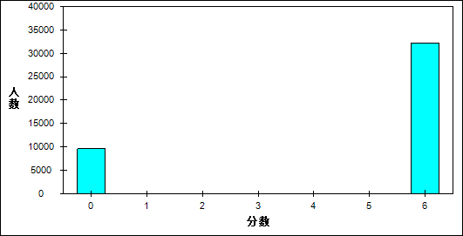

图 17 热学难度曲线图

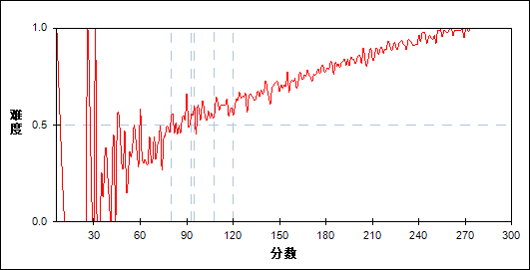

表 21 热学分组分析表

| 分值 | G1 | G2 | G3 | G4 | G5 | G6 | G7 | 人数 | 比率(%) | 平均值 |
| --- | --- | --- | --- | --- | --- | --- | --- | --- | --- | --- |
| 0～ | 2738 | 2029 | 1656 | 1324 | 1007 | 635 | 243 | 9632 | 23.03 | 148.51 |
| 6～ | 3237 | 3946 | 4318 | 4650 | 4967 | 5339 | 5731 | 32188 | 76.97 | 185.37 |
| 合计 | 5975 | 5975 | 5974 | 5974 | 5974 | 5974 | 5974 | 41820 | 100.00 | 70.37 |
| 得分率 | 0.54 | 0.66 | 0.72 | 0.78 | 0.83 | 0.89 | 0.96 | - | - | - |

* + - 1. 光学

本题组共包含1道试题，题号是：14

表 22 光学总分分布表

|  |  |  |  |  |  |  |  |  |
| --- | --- | --- | --- | --- | --- | --- | --- | --- |
| 满分值 | 最大值 | 最小值 | 平均值 | 标准差 | 差异系数 | 难度 | 相关系数 | 鉴别指数 |
| 6 | 6.0 | 0.0 | 4.48 | 2.61 | 0.58 | 0.75 | 8.71 | 0.46 |

图 18 光学分数分布表

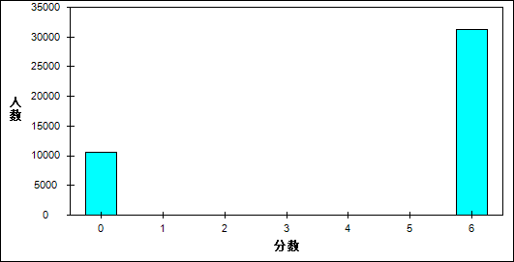

图 19 光学难度曲线图

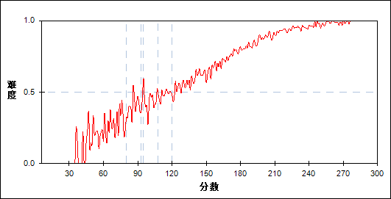

表 23 光学分组分析表

| 分值 | G1 | G2 | G3 | G4 | G5 | G6 | G7 | 人数 | 比率(%) | 平均值 |
| --- | --- | --- | --- | --- | --- | --- | --- | --- | --- | --- |
| 0～ | 3454 | 2484 | 1947 | 1300 | 817 | 412 | 168 | 10582 | 25.30 | 141.63 |
| 6～ | 2521 | 3491 | 4027 | 4674 | 5157 | 5562 | 5806 | 31238 | 74.70 | 188.82 |
| 合计 | 5975 | 5975 | 5974 | 5974 | 5974 | 5974 | 5974 | 41820 | 100.00 | 70.37 |
| 得分率 | 0.42 | 0.58 | 0.67 | 0.78 | 0.86 | 0.93 | 0.97 | - | - | - |

* + - 1. 原子

本题组共包含1道试题，题号是：20

表 24 原子总分分布表

|  |  |  |  |  |  |  |  |  |
| --- | --- | --- | --- | --- | --- | --- | --- | --- |
| 满分值 | 最大值 | 最小值 | 平均值 | 标准差 | 差异系数 | 难度 | 相关系数 | 鉴别指数 |
| 6 | 6.0 | 0.0 | 3.47 | 2.96 | 0.85 | 0.58 | 6.20 | 0.53 |

图 20 原子分数分布表

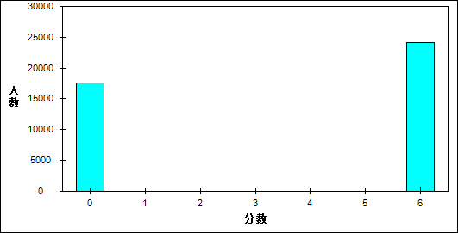

图 21 原子难度曲线图

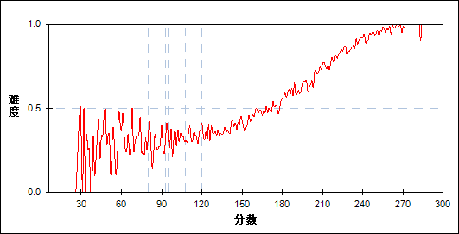

表 25 原子分组分析表

| 分值 | G1 | G2 | G3 | G4 | G5 | G6 | G7 | 人数 | 比率(%) | 平均值 |
| --- | --- | --- | --- | --- | --- | --- | --- | --- | --- | --- |
| 0～ | 4048 | 3750 | 3310 | 2806 | 2164 | 1205 | 348 | 17631 | 42.16 | 153.31 |
| 6～ | 1927 | 2225 | 2664 | 3168 | 3810 | 4769 | 5626 | 24189 | 57.84 | 194.06 |
| 合计 | 5975 | 5975 | 5974 | 5974 | 5974 | 5974 | 5974 | 41820 | 100.00 | 70.37 |
| 得分率 | 0.32 | 0.37 | 0.45 | 0.53 | 0.64 | 0.80 | 0.94 | - | - | - |

* + 1. 能力组块
       1. 理解能力

本题组共包含3道试题，题号是：13～15

表 26 理解能力总分分布表

|  |  |  |  |  |  |  |  |  |
| --- | --- | --- | --- | --- | --- | --- | --- | --- |
| 满分值 | 最大值 | 最小值 | 平均值 | 标准差 | 差异系数 | 难度 | 相关系数 | 鉴别指数 |
| 18 | 18.0 | 0.0 | 12.75 | 5.59 | 0.44 | 0.71 | 11.71 | 0.50 |

图 22 理解能力分数分布表

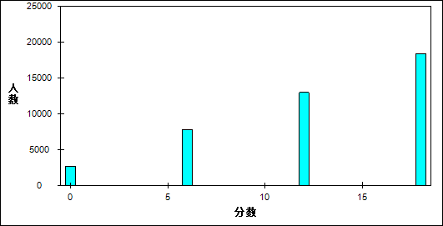

图 23 理解能力难度曲线图

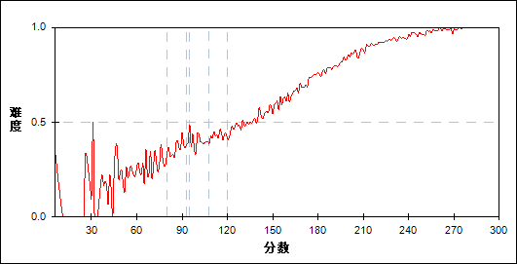

表 27 理解能力分组分析表

| 分值 | G1 | G2 | G3 | G4 | G5 | G6 | G7 | 人数 | 比率(%) | 平均值 |
| --- | --- | --- | --- | --- | --- | --- | --- | --- | --- | --- |
| 0～ | 1481 | 689 | 360 | 122 | 32 | 7 | 1 | 2692 | 6.44 | 117.84 |
| 6～ | 2502 | 2165 | 1550 | 913 | 496 | 122 | 31 | 7779 | 18.60 | 138.77 |
| 12～ | 1568 | 2333 | 2603 | 2597 | 2055 | 1315 | 495 | 12966 | 31.00 | 166.99 |
| 18～ | 424 | 788 | 1461 | 2342 | 3391 | 4530 | 5447 | 18383 | 43.96 | 208.63 |
| 合计 | 5975 | 5975 | 5974 | 5974 | 5974 | 5974 | 5974 | 41820 | 100.00 | 70.37 |
| 得分率 | 0.39 | 0.51 | 0.62 | 0.73 | 0.82 | 0.91 | 0.97 | - | - | - |

* + - 1. 推理能力

本题组共包含3道试题，题号是：16～18

表 28 推理能力总分分布表

|  |  |  |  |  |  |  |  |  |
| --- | --- | --- | --- | --- | --- | --- | --- | --- |
| 满分值 | 最大值 | 最小值 | 平均值 | 标准差 | 差异系数 | 难度 | 相关系数 | 鉴别指数 |
| 18 | 18.0 | 0.0 | 10.81 | 5.27 | 0.49 | 0.60 | 10.47 | 0.40 |

图 24 推理能力分数分布表

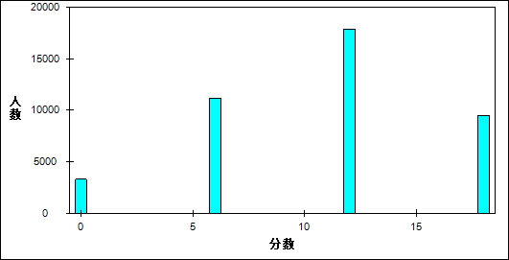

图 25 推理能力难度曲线图

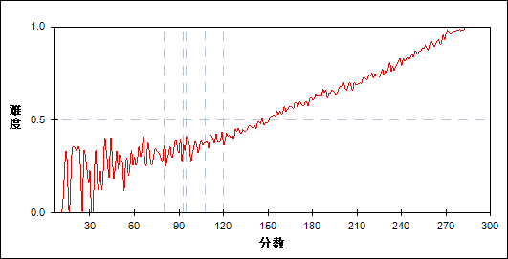

表 29 推理能力分组分析表

| 分值 | G1 | G2 | G3 | G4 | G5 | G6 | G7 | 人数 | 比率(%) | 平均值 |
| --- | --- | --- | --- | --- | --- | --- | --- | --- | --- | --- |
| 0～ | 1561 | 901 | 457 | 232 | 115 | 35 | 6 | 3307 | 7.91 | 125.85 |
| 6～ | 2647 | 2502 | 2151 | 1665 | 1205 | 764 | 227 | 11161 | 26.69 | 151.94 |
| 12～ | 1496 | 2076 | 2631 | 3077 | 3311 | 3215 | 2037 | 17843 | 42.67 | 182.55 |
| 18～ | 271 | 496 | 735 | 1000 | 1343 | 1960 | 3704 | 9509 | 22.74 | 213.26 |
| 合计 | 5975 | 5975 | 5974 | 5974 | 5974 | 5974 | 5974 | 41820 | 100.00 | 70.37 |
| 得分率 | 0.36 | 0.45 | 0.54 | 0.60 | 0.66 | 0.73 | 0.86 | - | - | - |

* + - 1. 实验能力

本题组共包含2道试题，题号是：19、21

表 30 实验能力总分分布表

|  |  |  |  |  |  |  |  |  |
| --- | --- | --- | --- | --- | --- | --- | --- | --- |
| 满分值 | 最大值 | 最小值 | 平均值 | 标准差 | 差异系数 | 难度 | 相关系数 | 鉴别指数 |
| 24 | 24.0 | 0.0 | 15.86 | 5.09 | 0.32 | 0.66 | 15.64 | 0.36 |

图 26 实验能力分数分布表

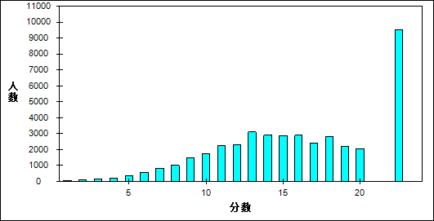

图 27 实验能力难度曲线图

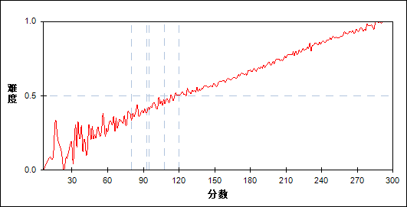

表 31 实验能力分组分析表

| 分值 | G1 | G2 | G3 | G4 | G5 | G6 | G7 | 人数 | 比率(%) | 平均值 |
| --- | --- | --- | --- | --- | --- | --- | --- | --- | --- | --- |
| 0～ | 33 | 0 | 1 | 0 | 0 | 0 | 0 | 34 | 0.08 | 56.50 |
| 1～ | 29 | 3 | 0 | 0 | 0 | 0 | 0 | 32 | 0.08 | 81.41 |
| 2～ | 78 | 4 | 1 | 1 | 0 | 0 | 0 | 84 | 0.20 | 73.63 |
| 3～ | 132 | 11 | 5 | 0 | 0 | 0 | 0 | 148 | 0.35 | 83.88 |
| 4～ | 186 | 25 | 8 | 4 | 1 | 1 | 0 | 225 | 0.54 | 97.35 |
| 5～ | 264 | 73 | 21 | 9 | 1 | 0 | 0 | 368 | 0.88 | 102.55 |
| 6～ | 365 | 124 | 44 | 20 | 15 | 4 | 0 | 572 | 1.37 | 113.22 |
| 7～ | 440 | 200 | 95 | 53 | 18 | 4 | 0 | 810 | 1.94 | 120.36 |
| 8～ | 450 | 270 | 159 | 84 | 41 | 8 | 2 | 1014 | 2.42 | 128.16 |
| 9～ | 534 | 396 | 285 | 161 | 71 | 28 | 5 | 1480 | 3.54 | 135.53 |
| 10～ | 524 | 449 | 365 | 236 | 118 | 35 | 5 | 1732 | 4.14 | 141.46 |
| 11～ | 557 | 587 | 457 | 324 | 203 | 85 | 11 | 2224 | 5.32 | 147.43 |
| 12～ | 512 | 523 | 494 | 396 | 261 | 110 | 26 | 2322 | 5.55 | 152.72 |
| 13～ | 519 | 686 | 697 | 549 | 388 | 208 | 52 | 3099 | 7.41 | 157.94 |
| 14～ | 407 | 586 | 612 | 537 | 437 | 254 | 71 | 2904 | 6.94 | 163.12 |
| 15～ | 280 | 523 | 544 | 573 | 494 | 339 | 122 | 2875 | 6.87 | 170.26 |
| 16～ | 228 | 408 | 492 | 563 | 561 | 453 | 186 | 2891 | 6.91 | 177.41 |
| 17～ | 171 | 332 | 404 | 454 | 475 | 389 | 174 | 2399 | 5.74 | 179.19 |
| 18～ | 100 | 274 | 372 | 494 | 627 | 592 | 359 | 2818 | 6.74 | 190.38 |
| 19～ | 64 | 189 | 269 | 391 | 438 | 533 | 338 | 2222 | 5.31 | 194.25 |
| 20～ | 41 | 116 | 193 | 296 | 407 | 521 | 482 | 2056 | 4.92 | 203.43 |
| 21～ | 25 | 75 | 179 | 327 | 445 | 616 | 550 | 2217 | 5.30 | 207.46 |
| 22～ | 22 | 61 | 142 | 251 | 461 | 780 | 1139 | 2856 | 6.83 | 219.21 |
| 23～ | 8 | 39 | 83 | 116 | 202 | 301 | 435 | 1184 | 2.83 | 215.86 |
| 24～ | 6 | 21 | 52 | 135 | 310 | 713 | 2017 | 3254 | 7.78 | 236.80 |
| 合计 | 5975 | 5975 | 5974 | 5974 | 5974 | 5974 | 5974 | 41820 | 100.00 | 70.37 |
| 得分率 | 0.43 | 0.54 | 0.60 | 0.65 | 0.72 | 0.79 | 0.89 | - | - | - |

* + - 1. 应用能力

本题组共包含4道试题，题号是：22、23_1、23_2、24_1

表 32 应用能力总分分布表

|  |  |  |  |  |  |  |  |  |
| --- | --- | --- | --- | --- | --- | --- | --- | --- |
| 满分值 | 最大值 | 最小值 | 平均值 | 标准差 | 差异系数 | 难度 | 相关系数 | 鉴别指数 |
| 32 | 32.0 | 0.0 | 23.69 | 8.31 | 0.35 | 0.74 | 14.66 | 0.51 |

图 28 应用能力分数分布表

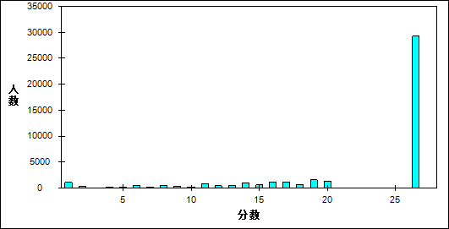

图 29 应用能力难度曲线图

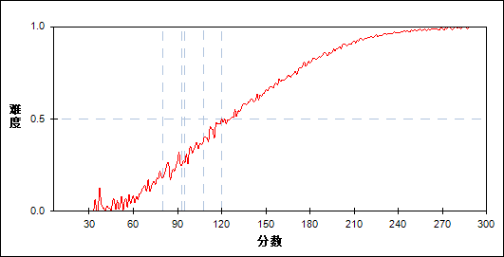

表 33 应用能力分组分析表

| 分值 | G1 | G2 | G3 | G4 | G5 | G6 | G7 | 人数 | 比率(%) | 平均值 |
| --- | --- | --- | --- | --- | --- | --- | --- | --- | --- | --- |
| 0～ | 984 | 55 | 8 | 2 | 1 | 0 | 0 | 1050 | 2.51 | 81.24 |
| 1～ | 25 | 3 | 0 | 0 | 0 | 0 | 0 | 28 | 0.07 | 98.04 |
| 2～ | 316 | 47 | 11 | 1 | 0 | 0 | 0 | 375 | 0.90 | 97.62 |
| 3～ | 54 | 8 | 4 | 0 | 0 | 0 | 0 | 66 | 0.16 | 102.26 |
| 4～ | 143 | 28 | 5 | 1 | 0 | 0 | 0 | 177 | 0.42 | 102.40 |
| 5～ | 58 | 21 | 4 | 2 | 0 | 0 | 0 | 85 | 0.20 | 109.69 |
| 6～ | 343 | 87 | 13 | 5 | 1 | 0 | 0 | 449 | 1.07 | 105.15 |
| 7～ | 175 | 35 | 11 | 2 | 1 | 0 | 0 | 224 | 0.54 | 105.92 |
| 8～ | 322 | 99 | 31 | 4 | 2 | 0 | 0 | 458 | 1.10 | 112.21 |
| 9～ | 230 | 94 | 23 | 4 | 1 | 0 | 0 | 352 | 0.84 | 114.30 |
| 10～ | 111 | 60 | 18 | 0 | 1 | 0 | 0 | 190 | 0.45 | 117.49 |
| 11～ | 442 | 265 | 88 | 23 | 2 | 0 | 0 | 820 | 1.96 | 120.73 |
| 12～ | 207 | 148 | 52 | 13 | 4 | 0 | 0 | 424 | 1.01 | 124.94 |
| 13～ | 194 | 140 | 69 | 25 | 3 | 0 | 0 | 431 | 1.03 | 127.61 |
| 14～ | 376 | 330 | 147 | 51 | 6 | 0 | 0 | 910 | 2.18 | 129.95 |
| 15～ | 176 | 229 | 111 | 32 | 8 | 1 | 0 | 557 | 1.33 | 133.60 |
| 16～ | 330 | 449 | 277 | 95 | 33 | 1 | 0 | 1185 | 2.83 | 138.72 |
| 17～ | 295 | 427 | 262 | 118 | 25 | 3 | 0 | 1130 | 2.70 | 139.37 |
| 18～ | 151 | 256 | 180 | 74 | 27 | 5 | 1 | 694 | 1.66 | 143.41 |
| 19～ | 269 | 534 | 449 | 237 | 63 | 12 | 0 | 1564 | 3.74 | 147.44 |
| 20～ | 185 | 432 | 397 | 250 | 73 | 14 | 1 | 1352 | 3.23 | 150.88 |
| 21～ | 91 | 252 | 325 | 213 | 92 | 25 | 0 | 998 | 2.39 | 157.41 |
| 22～ | 196 | 509 | 597 | 395 | 187 | 28 | 5 | 1917 | 4.58 | 155.99 |
| 23～ | 108 | 413 | 539 | 513 | 313 | 96 | 3 | 1985 | 4.75 | 164.97 |
| 24～ | 34 | 158 | 295 | 340 | 240 | 76 | 10 | 1153 | 2.76 | 171.80 |
| 25～ | 57 | 203 | 337 | 360 | 239 | 98 | 18 | 1312 | 3.14 | 170.40 |
| 26～ | 48 | 215 | 518 | 708 | 660 | 369 | 84 | 2602 | 6.22 | 182.07 |
| 27～ | 14 | 94 | 164 | 272 | 309 | 198 | 75 | 1126 | 2.69 | 187.47 |
| 28～ | 18 | 133 | 245 | 399 | 395 | 264 | 88 | 1542 | 3.69 | 185.99 |
| 29～ | 14 | 126 | 344 | 691 | 1039 | 1010 | 612 | 3836 | 9.17 | 201.61 |
| 30～ | 4 | 43 | 129 | 265 | 433 | 545 | 332 | 1751 | 4.19 | 206.46 |
| 31～ | 1 | 26 | 88 | 208 | 333 | 440 | 380 | 1476 | 3.53 | 211.37 |
| 32～ | 4 | 56 | 233 | 671 | 1483 | 2789 | 4365 | 9601 | 22.96 | 226.43 |
| 合计 | 5975 | 5975 | 5974 | 5974 | 5974 | 5974 | 5974 | 41820 | 100.00 | 70.37 |
| 得分率 | 0.34 | 0.58 | 0.69 | 0.79 | 0.87 | 0.94 | 0.98 | - | - | - |

* + - 1. 探究能力

本题组共包含3道试题，题号是：20、23_3、24_2

表 34 探究能力总分分布表

|  |  |  |  |  |  |  |  |  |
| --- | --- | --- | --- | --- | --- | --- | --- | --- |
| 满分值 | 最大值 | 最小值 | 平均值 | 标准差 | 差异系数 | 难度 | 相关系数 | 鉴别指数 |
| 22 | 22.0 | 0.0 | 6.97 | 6.45 | 0.93 | 0.32 | 6.46 | 0.56 |

图 30 探究能力分数分布表

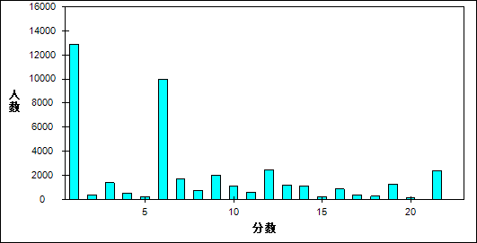

图 31 探究能力难度曲线图

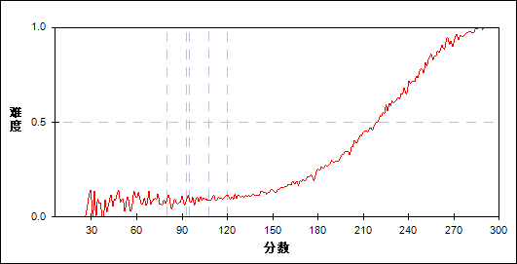

表 35 探究能力分组分析表

| 分值 | G1 | G2 | G3 | G4 | G5 | G6 | G7 | 人数 | 比率(%) | 平均值 |
| --- | --- | --- | --- | --- | --- | --- | --- | --- | --- | --- |
| 0～ | 3851 | 3194 | 2352 | 1452 | 614 | 92 | 3 | 11558 | 27.64 | 136.77 |
| 1～ | 122 | 280 | 354 | 316 | 185 | 60 | 0 | 1317 | 3.15 | 161.45 |
| 2～ | 18 | 46 | 58 | 91 | 80 | 42 | 3 | 338 | 0.81 | 174.64 |
| 3～ | 38 | 134 | 292 | 412 | 371 | 135 | 7 | 1389 | 3.32 | 176.95 |
| 4～ | 10 | 44 | 86 | 131 | 165 | 92 | 11 | 539 | 1.29 | 184.36 |
| 5～ | 1 | 11 | 22 | 51 | 94 | 53 | 11 | 243 | 0.58 | 193.49 |
| 6～ | 1864 | 1958 | 2036 | 1927 | 1462 | 664 | 81 | 9992 | 23.89 | 156.85 |
| 7～ | 55 | 160 | 292 | 405 | 434 | 299 | 54 | 1699 | 4.06 | 182.24 |
| 8～ | 4 | 28 | 75 | 116 | 241 | 212 | 56 | 732 | 1.75 | 196.83 |
| 9～ | 8 | 67 | 196 | 409 | 620 | 551 | 153 | 2004 | 4.79 | 196.24 |
| 10～ | 4 | 25 | 83 | 192 | 313 | 339 | 127 | 1083 | 2.59 | 201.53 |
| 11～ | 0 | 5 | 13 | 62 | 161 | 248 | 114 | 603 | 1.44 | 211.96 |
| 12～ | 0 | 19 | 91 | 251 | 640 | 1000 | 478 | 2479 | 5.93 | 211.46 |
| 13～ | 0 | 2 | 11 | 74 | 207 | 515 | 391 | 1200 | 2.87 | 221.33 |
| 14～ | 0 | 1 | 6 | 38 | 158 | 455 | 485 | 1143 | 2.73 | 226.25 |
| 15～ | 0 | 0 | 2 | 10 | 27 | 82 | 78 | 199 | 0.48 | 225.26 |
| 16～ | 0 | 1 | 3 | 18 | 69 | 321 | 441 | 853 | 2.04 | 231.77 |
| 17～ | 0 | 0 | 1 | 8 | 29 | 124 | 215 | 377 | 0.90 | 234.30 |
| 18～ | 0 | 0 | 0 | 3 | 15 | 96 | 147 | 261 | 0.62 | 235.51 |
| 19～ | 0 | 0 | 1 | 7 | 50 | 309 | 922 | 1289 | 3.08 | 242.06 |
| 20～ | 0 | 0 | 0 | 0 | 4 | 26 | 113 | 143 | 0.34 | 246.84 |
| 21～ | 0 | 0 | 0 | 1 | 6 | 23 | 168 | 198 | 0.47 | 250.94 |
| 22～ | 0 | 0 | 0 | 0 | 29 | 236 | 1916 | 2181 | 5.22 | 254.22 |
| 合计 | 5975 | 5975 | 5974 | 5974 | 5974 | 5974 | 5974 | 41820 | 100.00 | 70.37 |
| 得分率 | 0.09 | 0.12 | 0.16 | 0.22 | 0.33 | 0.51 | 0.78 | - | - | - |

* 1. 题目分析
     + 1. 第13题

表 36 第13题分析表

|  |  |  |  |  |  |  |  |  |
| --- | --- | --- | --- | --- | --- | --- | --- | --- |
| 满分值 | 最大值 | 最小值 | 平均值 | 标准差 | 差异系数 | 难度 | 相关系数 | 鉴别指数 |
| 6 | 6.0 | 0.0 | 4.62 | 2.53 | 0.55 | 0.77 | 0.36 | 0.34 |

图 32 第13题难度曲线图

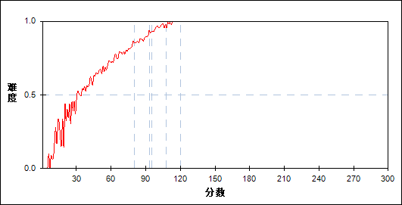

图 33 第13题分组难度曲线图

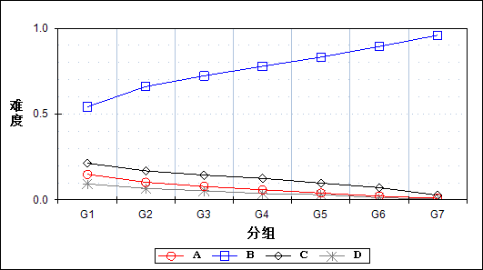

表 37 第13题分组分析表

| 选项 | G1 | G2 | G3 | G4 | G5 | G6 | G7 | 人数 | 比率(%) | 相关系数 |
| --- | --- | --- | --- | --- | --- | --- | --- | --- | --- | --- |
| Ａ | 889 | 612 | 469 | 353 | 237 | 131 | 57 | 2748 | 6.57 | -0.07 |
| *Ｂ | 3237 | 3946 | 4318 | 4650 | 4967 | 5339 | 5731 | 32188 | 76.97 | 0.12 |
| Ｃ | 1277 | 1011 | 864 | 749 | 584 | 427 | 163 | 5075 | 12.14 | -0.07 |
| Ｄ | 557 | 400 | 319 | 221 | 182 | 77 | 23 | 1779 | 4.25 | -0.05 |
| 未选或多选 | 15 | 6 | 4 | 1 | 4 | 0 | 0 | 30 | 0.07 | -0.01 |
| 合计 | 5975 | 5975 | 5974 | 5974 | 5974 | 5974 | 5974 | 41820 | 100.00 | - |
| 得分率 | 0.54 | 0.66 | 0.72 | 0.78 | 0.83 | 0.89 | 0.96 | - | - | - |

* + - 1. 第14题

表 38 第14题分析表

|  |  |  |  |  |  |  |  |  |
| --- | --- | --- | --- | --- | --- | --- | --- | --- |
| 满分值 | 最大值 | 最小值 | 平均值 | 标准差 | 差异系数 | 难度 | 相关系数 | 鉴别指数 |
| 6 | 6.0 | 0.0 | 4.48 | 2.61 | 0.58 | 0.75 | 0.47 | 0.46 |

图 34 第14题难度曲线图

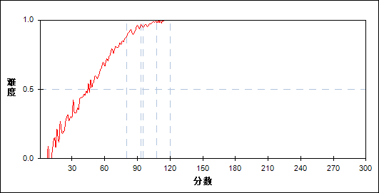

图 35 第14题分组难度曲线图

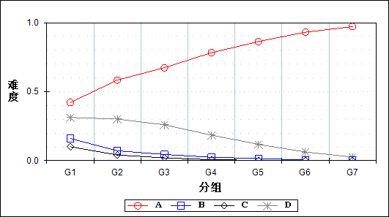

表 39 第14题分组分析表

| 选项 | G1 | G2 | G3 | G4 | G5 | G6 | G7 | 人数 | 比率(%) | 相关系数 |
| --- | --- | --- | --- | --- | --- | --- | --- | --- | --- | --- |
| *Ａ | 2521 | 3491 | 4027 | 4674 | 5157 | 5562 | 5806 | 31238 | 74.70 | 0.16 |
| Ｂ | 959 | 427 | 269 | 148 | 94 | 25 | 9 | 1931 | 4.62 | -0.08 |
| Ｃ | 604 | 244 | 122 | 41 | 15 | 9 | 2 | 1037 | 2.48 | -0.07 |
| Ｄ | 1873 | 1801 | 1553 | 1107 | 706 | 375 | 156 | 7571 | 18.10 | -0.10 |
| 未选或多选 | 18 | 12 | 3 | 4 | 2 | 3 | 1 | 43 | 0.10 | -0.01 |
| 合计 | 5975 | 5975 | 5974 | 5974 | 5974 | 5974 | 5974 | 41820 | 100.00 | - |
| 得分率 | 0.42 | 0.58 | 0.67 | 0.78 | 0.86 | 0.93 | 0.97 | - | - | - |

* + - 1. 第15题

表 40 第15题分析表

|  |  |  |  |  |  |  |  |  |
| --- | --- | --- | --- | --- | --- | --- | --- | --- |
| 满分值 | 最大值 | 最小值 | 平均值 | 标准差 | 差异系数 | 难度 | 相关系数 | 鉴别指数 |
| 6 | 6.0 | 0.0 | 3.65 | 2.93 | 0.80 | 0.61 | 0.60 | 0.71 |

图 36 第15题难度曲线图

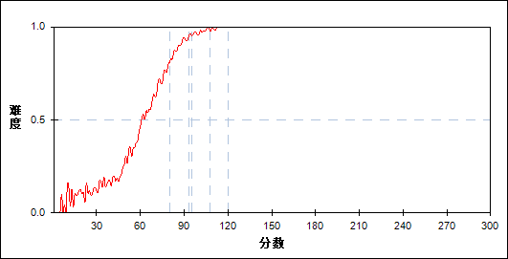

图 37 第15题分组难度曲线图

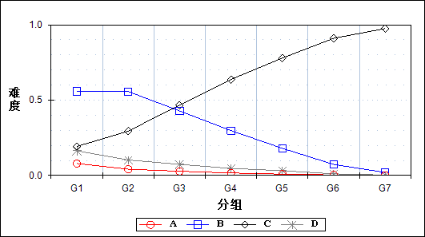

表 41 第15题分组分析表

| 选项 | G1 | G2 | G3 | G4 | G5 | G6 | G7 | 人数 | 比率(%) | 相关系数 |
| --- | --- | --- | --- | --- | --- | --- | --- | --- | --- | --- |
| Ａ | 473 | 248 | 168 | 98 | 51 | 24 | 7 | 1069 | 2.56 | -0.05 |
| Ｂ | 3339 | 3329 | 2559 | 1779 | 1075 | 437 | 121 | 12639 | 30.22 | -0.15 |
| *Ｃ | 1152 | 1758 | 2794 | 3809 | 4655 | 5441 | 5825 | 25434 | 60.82 | 0.20 |
| Ｄ | 979 | 615 | 440 | 280 | 187 | 64 | 18 | 2583 | 6.18 | -0.07 |
| 未选或多选 | 32 | 25 | 13 | 8 | 6 | 8 | 3 | 95 | 0.23 | -0.01 |
| 合计 | 5975 | 5975 | 5974 | 5974 | 5974 | 5974 | 5974 | 41820 | 100.00 | - |
| 得分率 | 0.19 | 0.29 | 0.47 | 0.64 | 0.78 | 0.91 | 0.98 | - | - | - |

* + - 1. 第16题

表 42 第16题分析表

|  |  |  |  |  |  |  |  |  |
| --- | --- | --- | --- | --- | --- | --- | --- | --- |
| 满分值 | 最大值 | 最小值 | 平均值 | 标准差 | 差异系数 | 难度 | 相关系数 | 鉴别指数 |
| 6 | 6.0 | 0.0 | 2.25 | 2.90 | 1.29 | 0.37 | 0.32 | 0.32 |

图 38 第16题难度曲线图

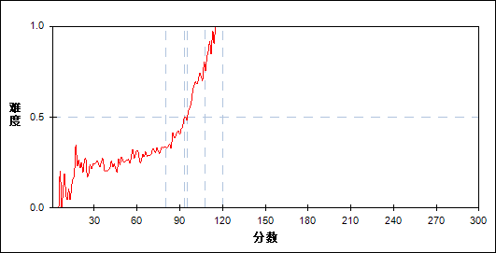

图 39 第16题分组难度曲线图

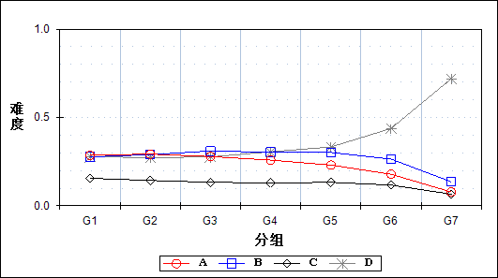

表 43 第16题分组分析表

| 选项 | G1 | G2 | G3 | G4 | G5 | G6 | G7 | 人数 | 比率(%) | 相关系数 |
| --- | --- | --- | --- | --- | --- | --- | --- | --- | --- | --- |
| Ａ | 1709 | 1749 | 1667 | 1547 | 1378 | 1068 | 468 | 9586 | 22.92 | -0.06 |
| Ｂ | 1656 | 1729 | 1852 | 1813 | 1805 | 1580 | 813 | 11248 | 26.90 | -0.04 |
| Ｃ | 932 | 858 | 796 | 774 | 794 | 701 | 395 | 5250 | 12.55 | -0.03 |
| *Ｄ | 1660 | 1630 | 1651 | 1827 | 1990 | 2615 | 4297 | 15670 | 37.47 | 0.11 |
| 未选或多选 | 18 | 9 | 8 | 13 | 7 | 10 | 1 | 66 | 0.16 | -0.01 |
| 合计 | 5975 | 5975 | 5974 | 5974 | 5974 | 5974 | 5974 | 41820 | 100.00 | - |
| 得分率 | 0.28 | 0.27 | 0.28 | 0.31 | 0.33 | 0.44 | 0.72 | - | - | - |

* + - 1. 第17题

表 44 第17题分析表

|  |  |  |  |  |  |  |  |  |
| --- | --- | --- | --- | --- | --- | --- | --- | --- |
| 满分值 | 最大值 | 最小值 | 平均值 | 标准差 | 差异系数 | 难度 | 相关系数 | 鉴别指数 |
| 6 | 6.0 | 0.0 | 3.83 | 2.88 | 0.75 | 0.64 | 0.48 | 0.52 |

图 40 第17题难度曲线图

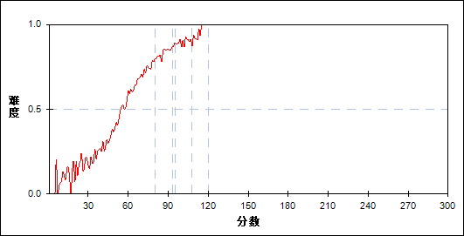

图 41 第17题分组难度曲线图

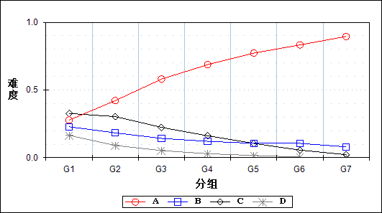

表 45 第17题分组分析表

| 选项 | G1 | G2 | G3 | G4 | G5 | G6 | G7 | 人数 | 比率(%) | 相关系数 |
| --- | --- | --- | --- | --- | --- | --- | --- | --- | --- | --- |
| *Ａ | 1662 | 2519 | 3466 | 4104 | 4616 | 4978 | 5349 | 26694 | 63.83 | 0.16 |
| Ｂ | 1365 | 1095 | 852 | 723 | 632 | 633 | 479 | 5779 | 13.82 | -0.06 |
| Ｃ | 1954 | 1814 | 1339 | 967 | 628 | 335 | 133 | 7170 | 17.14 | -0.10 |
| Ｄ | 985 | 541 | 317 | 176 | 97 | 27 | 13 | 2156 | 5.16 | -0.08 |
| 未选或多选 | 9 | 6 | 0 | 4 | 1 | 1 | 0 | 21 | 0.05 | -0.01 |
| 合计 | 5975 | 5975 | 5974 | 5974 | 5974 | 5974 | 5974 | 41820 | 100.00 | - |
| 得分率 | 0.28 | 0.42 | 0.58 | 0.69 | 0.77 | 0.83 | 0.90 | - | - | - |

* + - 1. 第18题

表 46 第18题分析表

|  |  |  |  |  |  |  |  |  |
| --- | --- | --- | --- | --- | --- | --- | --- | --- |
| 满分值 | 最大值 | 最小值 | 平均值 | 标准差 | 差异系数 | 难度 | 相关系数 | 鉴别指数 |
| 6 | 6.0 | 0.0 | 4.74 | 2.45 | 0.52 | 0.79 | 0.39 | 0.35 |

图 42 第18题难度曲线图

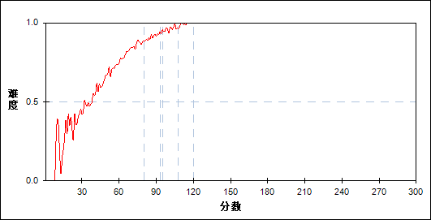

图 43 第18题分组难度曲线图

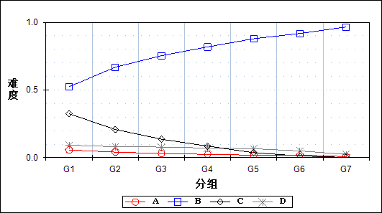

表 47 第18题分组分析表

| 选项 | G1 | G2 | G3 | G4 | G5 | G6 | G7 | 人数 | 比率(%) | 相关系数 |
| --- | --- | --- | --- | --- | --- | --- | --- | --- | --- | --- |
| Ａ | 339 | 247 | 184 | 148 | 110 | 118 | 47 | 1193 | 2.85 | -0.04 |
| *Ｂ | 3130 | 3993 | 4501 | 4888 | 5250 | 5481 | 5767 | 33010 | 78.93 | 0.13 |
| Ｃ | 1940 | 1244 | 816 | 511 | 219 | 76 | 11 | 4817 | 11.52 | -0.12 |
| Ｄ | 551 | 486 | 470 | 426 | 394 | 298 | 147 | 2772 | 6.63 | -0.04 |
| 未选或多选 | 15 | 5 | 3 | 1 | 1 | 1 | 2 | 28 | 0.07 | -0.01 |
| 合计 | 5975 | 5975 | 5974 | 5974 | 5974 | 5974 | 5974 | 41820 | 100.00 | - |
| 得分率 | 0.52 | 0.67 | 0.75 | 0.82 | 0.88 | 0.92 | 0.97 | - | - | - |

* + - 1. 第19题

表 48 第19题分析表

|  |  |  |  |  |  |  |  |  |
| --- | --- | --- | --- | --- | --- | --- | --- | --- |
| 满分值 | 最大值 | 最小值 | 平均值 | 标准差 | 差异系数 | 难度 | 相关系数 | 鉴别指数 |
| 6 | 6.0 | 0.0 | 2.78 | 2.99 | 1.07 | 0.46 | 0.53 | 0.62 |

图 44 第19题难度曲线图

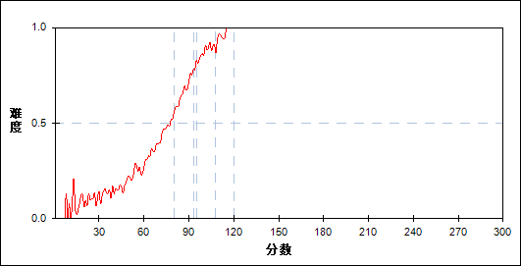

图 45 第19题分组难度曲线图

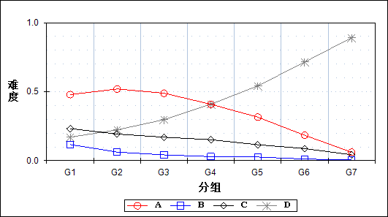

表 49 第19题分组分析表

| 选项 | G1 | G2 | G3 | G4 | G5 | G6 | G7 | 人数 | 比率(%) | 相关系数 |
| --- | --- | --- | --- | --- | --- | --- | --- | --- | --- | --- |
| Ａ | 2862 | 3105 | 2922 | 2442 | 1885 | 1099 | 366 | 14681 | 35.11 | -0.11 |
| Ｂ | 698 | 372 | 250 | 176 | 157 | 70 | 29 | 1752 | 4.19 | -0.06 |
| Ｃ | 1388 | 1153 | 1018 | 907 | 690 | 524 | 256 | 5936 | 14.19 | -0.06 |
| *Ｄ | 1018 | 1335 | 1777 | 2445 | 3237 | 4272 | 5321 | 19405 | 46.40 | 0.18 |
| 未选或多选 | 9 | 10 | 7 | 4 | 5 | 9 | 2 | 46 | 0.11 | 0.00 |
| 合计 | 5975 | 5975 | 5974 | 5974 | 5974 | 5974 | 5974 | 41820 | 100.00 | - |
| 得分率 | 0.17 | 0.22 | 0.30 | 0.41 | 0.54 | 0.72 | 0.89 | - | - | - |

* + - 1. 第20题

表 50 第20题分析表

|  |  |  |  |  |  |  |  |  |
| --- | --- | --- | --- | --- | --- | --- | --- | --- |
| 满分值 | 最大值 | 最小值 | 平均值 | 标准差 | 差异系数 | 难度 | 相关系数 | 鉴别指数 |
| 6 | 6.0 | 0.0 | 3.47 | 2.96 | 0.85 | 0.58 | 0.47 | 0.53 |

图 46 第20题难度曲线图

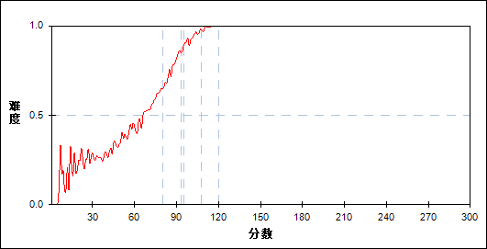

图 47 第20题分组难度曲线图

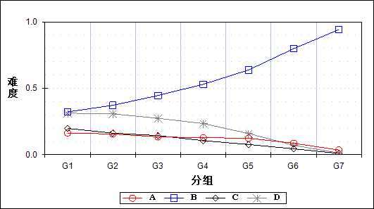

表 51 第20题分组分析表

| 选项 | G1 | G2 | G3 | G4 | G5 | G6 | G7 | 人数 | 比率(%) | 相关系数 |
| --- | --- | --- | --- | --- | --- | --- | --- | --- | --- | --- |
| Ａ | 976 | 933 | 804 | 766 | 742 | 516 | 212 | 4949 | 11.83 | -0.05 |
| *Ｂ | 1927 | 2225 | 2664 | 3168 | 3810 | 4769 | 5626 | 24189 | 57.84 | 0.16 |
| Ｃ | 1184 | 970 | 861 | 634 | 461 | 266 | 58 | 4434 | 10.60 | -0.07 |
| Ｄ | 1870 | 1839 | 1638 | 1403 | 955 | 422 | 78 | 8205 | 19.62 | -0.10 |
| 未选或多选 | 18 | 8 | 7 | 3 | 6 | 1 | 0 | 43 | 0.10 | -0.01 |
| 合计 | 5975 | 5975 | 5974 | 5974 | 5974 | 5974 | 5974 | 41820 | 100.00 | - |
| 得分率 | 0.32 | 0.37 | 0.45 | 0.53 | 0.64 | 0.80 | 0.94 | - | - | - |

* + - 1. 第21题

表 52 第21题分析表

|  |  |  |  |  |  |  |  |  |
| --- | --- | --- | --- | --- | --- | --- | --- | --- |
| 满分值 | 最大值 | 最小值 | 平均值 | 标准差 | 差异系数 | 难度 | 相关系数 | 鉴别指数 |
| 18 | 18.0 | 0.0 | 13.08 | 3.48 | 0.27 | 0.73 | 0.62 | 0.28 |

图 48 第21题难度曲线图

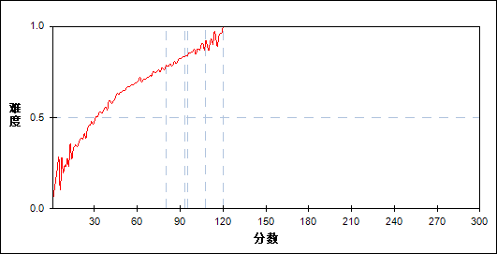

图 49 第21题分组难度曲线图

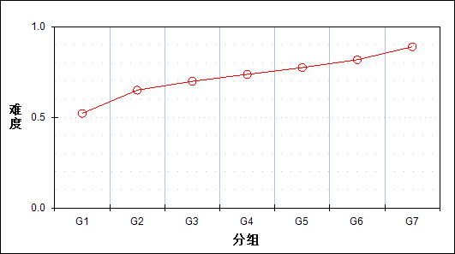

表 53 第21题分组分析表

| 分值 | G1 | G2 | G3 | G4 | G5 | G6 | G7 | 人数 | 比率(%) | 平均值 |
| --- | --- | --- | --- | --- | --- | --- | --- | --- | --- | --- |
| 0～ | 40 | 0 | 1 | 0 | 0 | 0 | 0 | 41 | 0.10 | 19.05 |
| 1～ | 35 | 4 | 0 | 0 | 0 | 0 | 0 | 39 | 0.09 | 25.79 |
| 2～ | 94 | 7 | 2 | 1 | 1 | 0 | 0 | 105 | 0.25 | 23.52 |
| 3～ | 161 | 18 | 6 | 2 | 0 | 1 | 0 | 188 | 0.45 | 28.54 |
| 4～ | 231 | 43 | 17 | 13 | 2 | 1 | 0 | 307 | 0.73 | 34.26 |
| 5～ | 327 | 100 | 39 | 20 | 6 | 3 | 1 | 496 | 1.19 | 37.51 |
| 6～ | 442 | 166 | 76 | 57 | 28 | 12 | 3 | 784 | 1.87 | 42.54 |
| 7～ | 536 | 262 | 152 | 91 | 41 | 15 | 4 | 1101 | 2.63 | 45.45 |
| 8～ | 552 | 357 | 244 | 157 | 113 | 50 | 11 | 1484 | 3.55 | 50.80 |
| 9～ | 612 | 514 | 399 | 268 | 176 | 115 | 45 | 2129 | 5.09 | 54.23 |
| 10～ | 580 | 564 | 497 | 398 | 271 | 134 | 50 | 2494 | 5.96 | 57.69 |
| 11～ | 602 | 722 | 640 | 548 | 463 | 330 | 131 | 3436 | 8.22 | 62.05 |
| 12～ | 494 | 644 | 660 | 603 | 582 | 410 | 160 | 3553 | 8.50 | 65.28 |
| 13～ | 481 | 812 | 909 | 902 | 803 | 730 | 386 | 5023 | 12.01 | 68.93 |
| 14～ | 330 | 612 | 719 | 760 | 771 | 733 | 544 | 4469 | 10.69 | 73.06 |
| 15～ | 198 | 473 | 608 | 791 | 834 | 867 | 632 | 4403 | 10.53 | 76.84 |
| 16～ | 149 | 336 | 493 | 643 | 868 | 1134 | 1280 | 4903 | 11.72 | 83.60 |
| 17～ | 71 | 209 | 286 | 335 | 412 | 442 | 488 | 2243 | 5.36 | 81.56 |
| 18～ | 40 | 132 | 226 | 385 | 603 | 997 | 2239 | 4622 | 11.05 | 94.53 |
| 合计 | 5975 | 5975 | 5974 | 5974 | 5974 | 5974 | 5974 | 41820 | 100.00 | - |
| 得分率 | 0.52 | 0.65 | 0.70 | 0.74 | 0.77 | 0.82 | 0.89 | - | - | - |

* + - 1. 第22题

表 54 第22题分析表

|  |  |  |  |  |  |  |  |  |
| --- | --- | --- | --- | --- | --- | --- | --- | --- |
| 满分值 | 最大值 | 最小值 | 平均值 | 标准差 | 差异系数 | 难度 | 相关系数 | 鉴别指数 |
| 16 | 16.0 | 0.0 | 13.98 | 3.70 | 0.26 | 0.87 | 0.61 | 0.33 |

图 50 第22题难度曲线图

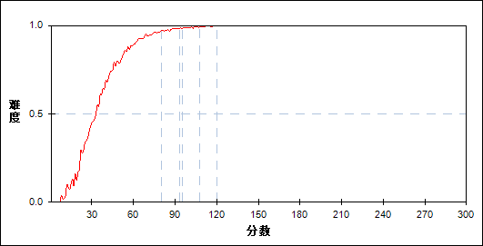

图 51 第22题分组难度曲线图

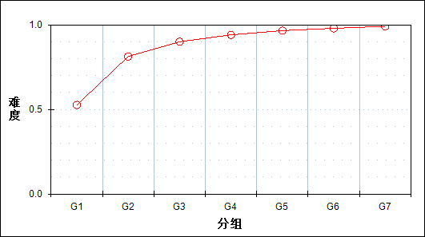

表 55 第22题分组分析表

| 分值 | G1 | G2 | G3 | G4 | G5 | G6 | G7 | 人数 | 比率(%) | 平均值 |
| --- | --- | --- | --- | --- | --- | --- | --- | --- | --- | --- |
| 0～ | 1014 | 63 | 11 | 2 | 2 | 0 | 0 | 1092 | 2.61 | 27.81 |
| 1～ | 22 | 3 | 0 | 0 | 0 | 0 | 0 | 25 | 0.06 | 32.28 |
| 2～ | 349 | 58 | 16 | 3 | 0 | 0 | 1 | 427 | 1.02 | 32.77 |
| 3～ | 39 | 8 | 3 | 0 | 0 | 0 | 0 | 50 | 0.12 | 31.94 |
| 4～ | 178 | 44 | 9 | 2 | 0 | 0 | 0 | 233 | 0.56 | 35.33 |
| 5～ | 55 | 20 | 4 | 1 | 0 | 0 | 0 | 80 | 0.19 | 37.46 |
| 6～ | 462 | 159 | 35 | 11 | 3 | 0 | 1 | 671 | 1.60 | 38.55 |
| 7～ | 215 | 76 | 29 | 7 | 2 | 0 | 0 | 329 | 0.79 | 39.58 |
| 8～ | 541 | 285 | 122 | 34 | 6 | 2 | 0 | 990 | 2.37 | 42.97 |
| 9～ | 267 | 183 | 97 | 42 | 15 | 4 | 0 | 608 | 1.45 | 45.85 |
| 10～ | 98 | 89 | 33 | 22 | 10 | 2 | 1 | 255 | 0.61 | 48.42 |
| 11～ | 957 | 988 | 590 | 355 | 191 | 97 | 28 | 3206 | 7.67 | 52.46 |
| 12～ | 171 | 207 | 148 | 112 | 54 | 29 | 10 | 731 | 1.75 | 56.34 |
| 13～ | 362 | 577 | 513 | 371 | 271 | 156 | 75 | 2325 | 5.56 | 61.04 |
| 14～ | 284 | 526 | 623 | 604 | 449 | 389 | 203 | 3078 | 7.36 | 67.54 |
| 15～ | 103 | 232 | 182 | 163 | 97 | 53 | 32 | 862 | 2.06 | 63.43 |
| 16～ | 858 | 2457 | 3559 | 4245 | 4874 | 5242 | 5623 | 26858 | 64.22 | 80.02 |
| 合计 | 5975 | 5975 | 5974 | 5974 | 5974 | 5974 | 5974 | 41820 | 100.00 | - |
| 得分率 | 0.53 | 0.81 | 0.90 | 0.94 | 0.97 | 0.98 | 0.99 | - | - | - |

* + - 1. 第23题

表 56 第23题分析表

|  |  |  |  |  |  |  |  |  |
| --- | --- | --- | --- | --- | --- | --- | --- | --- |
| 满分值 | 最大值 | 最小值 | 平均值 | 标准差 | 差异系数 | 难度 | 相关系数 | 鉴别指数 |
| 18 | 18.0 | 0.0 | 9.50 | 6.28 | 0.66 | 0.53 | 0.83 | 0.70 |

图 52 第23题难度曲线图

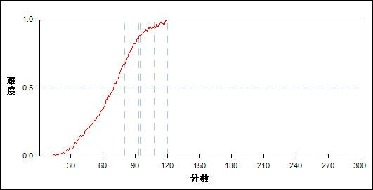

图 53 第23题分组难度曲线图

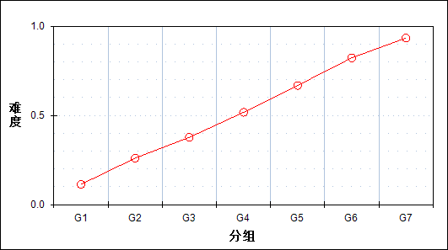

表 57 第23题分组分析表

| 分值 | G1 | G2 | G3 | G4 | G5 | G6 | G7 | 人数 | 比率(%) | 平均值 |
| --- | --- | --- | --- | --- | --- | --- | --- | --- | --- | --- |
| 0～ | 3597 | 1443 | 665 | 236 | 74 | 5 | 0 | 6020 | 14.40 | 40.13 |
| 1～ | 27 | 27 | 25 | 3 | 0 | 0 | 0 | 82 | 0.20 | 48.28 |
| 2～ | 3 | 2 | 1 | 0 | 0 | 0 | 0 | 6 | 0.01 | 42.33 |
| 3～ | 1020 | 1471 | 1172 | 711 | 298 | 68 | 3 | 4743 | 11.34 | 53.75 |
| 4～ | 46 | 98 | 99 | 61 | 27 | 5 | 0 | 336 | 0.80 | 57.57 |
| 5～ | 3 | 9 | 9 | 7 | 3 | 1 | 0 | 32 | 0.08 | 58.84 |
| 6～ | 969 | 1723 | 1700 | 1296 | 749 | 212 | 15 | 6664 | 15.93 | 59.11 |
| 7～ | 58 | 131 | 183 | 177 | 96 | 37 | 1 | 683 | 1.63 | 63.22 |
| 8～ | 4 | 8 | 12 | 14 | 2 | 3 | 0 | 43 | 0.10 | 62.44 |
| 9～ | 110 | 433 | 646 | 731 | 529 | 235 | 43 | 2727 | 6.52 | 67.65 |
| 10～ | 17 | 76 | 149 | 188 | 173 | 83 | 19 | 705 | 1.69 | 70.51 |
| 11～ | 1 | 11 | 19 | 16 | 23 | 14 | 0 | 84 | 0.20 | 72.14 |
| 12～ | 76 | 317 | 626 | 1015 | 1152 | 800 | 286 | 4272 | 10.22 | 76.18 |
| 13～ | 18 | 88 | 192 | 297 | 383 | 318 | 112 | 1408 | 3.37 | 78.20 |
| 14～ | 2 | 10 | 17 | 22 | 36 | 49 | 29 | 165 | 0.39 | 82.44 |
| 15～ | 18 | 93 | 295 | 742 | 1210 | 1569 | 1103 | 5030 | 12.03 | 86.62 |
| 16～ | 3 | 13 | 55 | 126 | 249 | 331 | 291 | 1068 | 2.55 | 89.03 |
| 17～ | 0 | 1 | 4 | 7 | 21 | 40 | 62 | 135 | 0.32 | 93.96 |
| 18～ | 3 | 21 | 105 | 325 | 949 | 2204 | 4010 | 7617 | 18.21 | 98.23 |
| 合计 | 5975 | 5975 | 5974 | 5974 | 5974 | 5974 | 5974 | 41820 | 100.00 | - |
| 得分率 | 0.11 | 0.26 | 0.38 | 0.52 | 0.67 | 0.82 | 0.93 | - | - | - |

* + - 1. 第24题

表 58 第24题分析表

|  |  |  |  |  |  |  |  |  |
| --- | --- | --- | --- | --- | --- | --- | --- | --- |
| 满分值 | 最大值 | 最小值 | 平均值 | 标准差 | 差异系数 | 难度 | 相关系数 | 鉴别指数 |
| 20 | 20.0 | 0.0 | 3.99 | 4.77 | 1.19 | 0.20 | 0.76 | 0.43 |

图 54 第24题难度曲线图

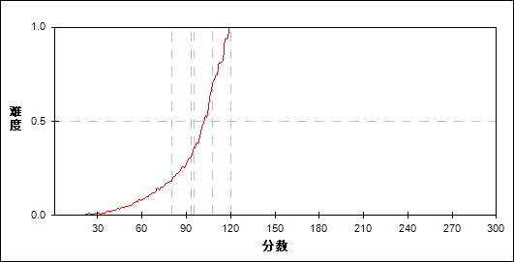

图 55 第24题分组难度曲线图

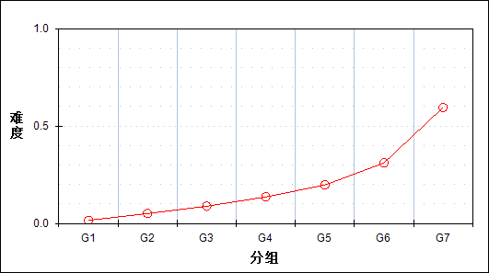

表 59 第24题分组分析表

| 分值 | G1 | G2 | G3 | G4 | G5 | G6 | G7 | 人数 | 比率(%) | 平均值 |
| --- | --- | --- | --- | --- | --- | --- | --- | --- | --- | --- |
| 0～ | 4944 | 3357 | 2172 | 1233 | 544 | 161 | 20 | 12431 | 29.73 | 48.64 |
| 1～ | 573 | 1059 | 1023 | 733 | 430 | 142 | 21 | 3981 | 9.52 | 58.88 |
| 2～ | 190 | 521 | 772 | 819 | 661 | 350 | 57 | 3370 | 8.06 | 67.00 |
| 3～ | 96 | 302 | 493 | 635 | 608 | 445 | 103 | 2682 | 6.41 | 71.94 |
| 4～ | 162 | 631 | 1265 | 1832 | 2100 | 1609 | 533 | 8132 | 19.45 | 75.39 |
| 5～ | 6 | 62 | 142 | 288 | 550 | 706 | 342 | 2096 | 5.01 | 83.99 |
| 6～ | 3 | 27 | 62 | 220 | 475 | 706 | 459 | 1952 | 4.67 | 87.32 |
| 7～ | 0 | 2 | 9 | 60 | 94 | 134 | 107 | 406 | 0.97 | 88.55 |
| 8～ | 1 | 6 | 16 | 48 | 129 | 309 | 211 | 720 | 1.72 | 91.10 |
| 9～ | 0 | 4 | 5 | 24 | 61 | 150 | 144 | 388 | 0.93 | 92.82 |
| 10～ | 0 | 2 | 5 | 22 | 64 | 172 | 191 | 456 | 1.09 | 95.17 |
| 11～ | 0 | 1 | 8 | 38 | 149 | 409 | 528 | 1133 | 2.71 | 96.35 |
| 12～ | 0 | 0 | 1 | 4 | 26 | 97 | 230 | 358 | 0.86 | 101.00 |
| 13～ | 0 | 0 | 0 | 2 | 4 | 34 | 86 | 126 | 0.30 | 102.31 |
| 14～ | 0 | 0 | 1 | 12 | 57 | 358 | 1000 | 1428 | 3.41 | 103.47 |
| 15～ | 0 | 1 | 0 | 4 | 12 | 89 | 466 | 572 | 1.37 | 105.91 |
| 16～ | 0 | 0 | 0 | 0 | 1 | 14 | 55 | 70 | 0.17 | 106.87 |
| 17～ | 0 | 0 | 0 | 0 | 1 | 11 | 141 | 153 | 0.37 | 109.60 |
| 18～ | 0 | 0 | 0 | 0 | 6 | 60 | 541 | 607 | 1.45 | 110.00 |
| 19～ | 0 | 0 | 0 | 0 | 0 | 3 | 27 | 30 | 0.07 | 110.50 |
| 20～ | 0 | 0 | 0 | 0 | 2 | 15 | 712 | 729 | 1.74 | 114.72 |
| 合计 | 5975 | 5975 | 5974 | 5974 | 5974 | 5974 | 5974 | 41820 | 100.00 | - |
| 得分率 | 0.02 | 0.05 | 0.09 | 0.14 | 0.20 | 0.31 | 0.60 | - | - | - |

* + - 1. 第21_1题

表 60 第21_1题分析表

|  |  |  |  |  |  |  |  |  |
| --- | --- | --- | --- | --- | --- | --- | --- | --- |
| 满分值 | 最大值 | 最小值 | 平均值 | 标准差 | 差异系数 | 难度 | 相关系数 | 鉴别指数 |
| 2 | 2.0 | 0.0 | 1.70 | 0.71 | 0.42 | 0.85 | 0.36 | 0.31 |

图 56 第21_1题难度曲线图

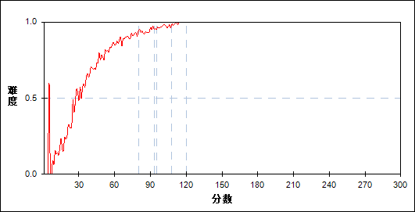

图 57 第21_1题分组难度曲线图

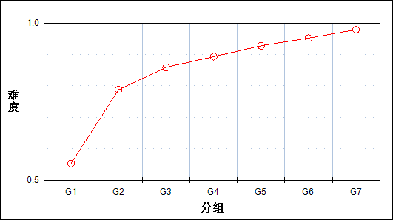

表 61 第21_1题分组分析表

| 分值 | G1 | G2 | G3 | G4 | G5 | G6 | G7 | 人数 | 比率(%) | 平均值 |
| --- | --- | --- | --- | --- | --- | --- | --- | --- | --- | --- |
| 0～ | 2669 | 1267 | 843 | 638 | 432 | 286 | 125 | 6260 | 14.97 | 50.25 |
| 2～ | 3306 | 4708 | 5131 | 5336 | 5542 | 5688 | 5849 | 35560 | 85.03 | 73.91 |
| 合计 | 5975 | 5975 | 5974 | 5974 | 5974 | 5974 | 5974 | 41820 | 100.00 | - |
| 得分率 | 0.55 | 0.79 | 0.86 | 0.89 | 0.93 | 0.95 | 0.98 | - | - | - |

* + - 1. 第21_2题

表 62 第21_2题分析表

|  |  |  |  |  |  |  |  |  |
| --- | --- | --- | --- | --- | --- | --- | --- | --- |
| 满分值 | 最大值 | 最小值 | 平均值 | 标准差 | 差异系数 | 难度 | 相关系数 | 鉴别指数 |
| 2 | 2.0 | 0.0 | 1.34 | 0.94 | 0.70 | 0.67 | -0.02 | -0.06 |

图 58 第21_2题难度曲线图

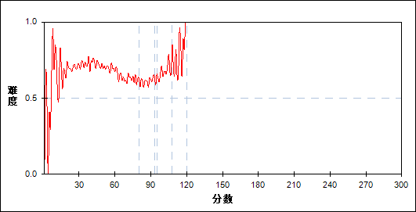

图 59 第21_2题分组难度曲线图

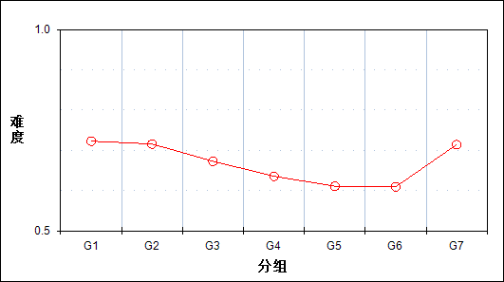

表 63 第21_2题分组分析表

| 分值 | G1 | G2 | G3 | G4 | G5 | G6 | G7 | 人数 | 比率(%) | 平均值 |
| --- | --- | --- | --- | --- | --- | --- | --- | --- | --- | --- |
| 0～ | 1656 | 1698 | 1954 | 2176 | 2325 | 2332 | 1708 | 13849 | 33.12 | 71.09 |
| 2～ | 4319 | 4277 | 4020 | 3798 | 3649 | 3642 | 4266 | 27971 | 66.88 | 70.01 |
| 合计 | 5975 | 5975 | 5974 | 5974 | 5974 | 5974 | 5974 | 41820 | 100.00 | - |
| 得分率 | 0.72 | 0.72 | 0.67 | 0.64 | 0.61 | 0.61 | 0.71 | - | - | - |

* + - 1. 第21_3题

表 64 第21_3题分析表

|  |  |  |  |  |  |  |  |  |
| --- | --- | --- | --- | --- | --- | --- | --- | --- |
| 满分值 | 最大值 | 最小值 | 平均值 | 标准差 | 差异系数 | 难度 | 相关系数 | 鉴别指数 |
| 4 | 4.0 | 0.0 | 2.95 | 1.76 | 0.60 | 0.74 | 0.36 | 0.37 |

图 60 第21_3题难度曲线图

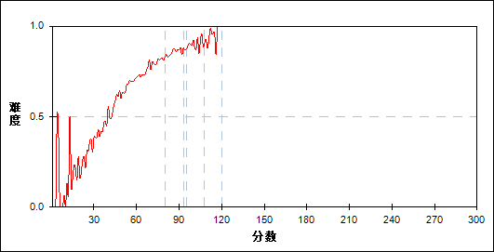

图 61 第21_3题分组难度曲线图

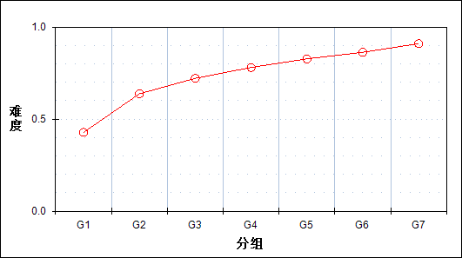

表 65 第21_3题分组分析表

| 分值 | G1 | G2 | G3 | G4 | G5 | G6 | G7 | 人数 | 比率(%) | 平均值 |
| --- | --- | --- | --- | --- | --- | --- | --- | --- | --- | --- |
| 0～ | 3417 | 2165 | 1666 | 1311 | 1033 | 821 | 540 | 10953 | 26.19 | 56.27 |
| 4～ | 2558 | 3810 | 4308 | 4663 | 4941 | 5153 | 5434 | 30867 | 73.81 | 75.37 |
| 合计 | 5975 | 5975 | 5974 | 5974 | 5974 | 5974 | 5974 | 41820 | 100.00 | - |
| 得分率 | 0.43 | 0.64 | 0.72 | 0.78 | 0.83 | 0.86 | 0.91 | - | - | - |

* + - 1. 第21_41题

表 66 第21_41题分析表

|  |  |  |  |  |  |  |  |  |
| --- | --- | --- | --- | --- | --- | --- | --- | --- |
| 满分值 | 最大值 | 最小值 | 平均值 | 标准差 | 差异系数 | 难度 | 相关系数 | 鉴别指数 |
| 4 | 4.0 | 0.0 | 3.46 | 1.05 | 0.30 | 0.87 | 0.33 | 0.20 |

图 62 第21_41题难度曲线图

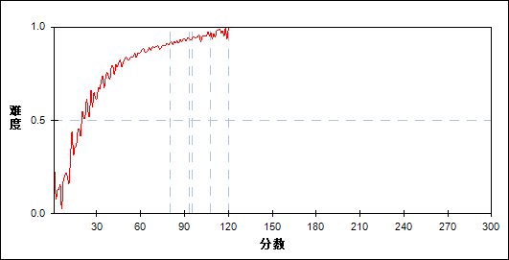

图 63 第21_41题分组难度曲线图

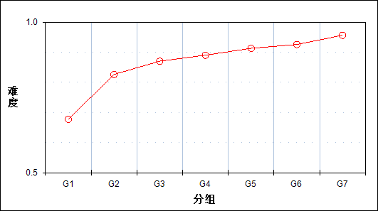

表 67 第21_41题分组分析表

| 分值 | G1 | G2 | G3 | G4 | G5 | G6 | G7 | 人数 | 比率(%) | 平均值 |
| --- | --- | --- | --- | --- | --- | --- | --- | --- | --- | --- |
| 0～ | 573 | 127 | 61 | 33 | 18 | 15 | 8 | 835 | 2.00 | 36.87 |
| 1～ | 1190 | 803 | 630 | 528 | 422 | 368 | 206 | 4147 | 9.92 | 57.84 |
| 2～ | 191 | 109 | 86 | 67 | 52 | 44 | 21 | 570 | 1.36 | 55.86 |
| 3～ | 1461 | 1016 | 796 | 774 | 637 | 520 | 352 | 5556 | 13.29 | 60.88 |
| 4～ | 2560 | 3920 | 4401 | 4572 | 4845 | 5027 | 5387 | 30712 | 73.44 | 74.96 |
| 合计 | 5975 | 5975 | 5974 | 5974 | 5974 | 5974 | 5974 | 41820 | 100.00 | - |
| 得分率 | 0.68 | 0.83 | 0.87 | 0.89 | 0.91 | 0.93 | 0.96 | - | - | - |

* + - 1. 第21_42题

表 68 第21_42题分析表

|  |  |  |  |  |  |  |  |  |
| --- | --- | --- | --- | --- | --- | --- | --- | --- |
| 满分值 | 最大值 | 最小值 | 平均值 | 标准差 | 差异系数 | 难度 | 相关系数 | 鉴别指数 |
| 1 | 1.0 | 0.0 | 0.75 | 0.43 | 0.57 | 0.75 | 0.31 | 0.32 |

图 64 第21_42题难度曲线图

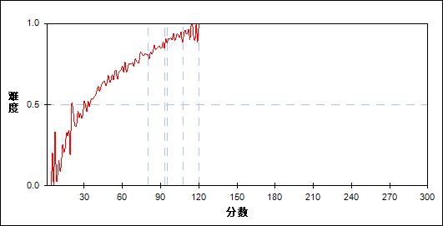

图 65 第21_42题分组难度曲线图

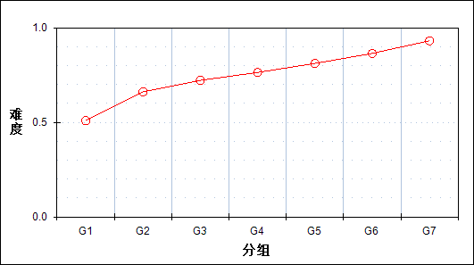

表 69 第21_42题分组分析表

| 分值 | G1 | G2 | G3 | G4 | G5 | G6 | G7 | 人数 | 比率(%) | 平均值 |
| --- | --- | --- | --- | --- | --- | --- | --- | --- | --- | --- |
| 0～ | 2934 | 2024 | 1661 | 1412 | 1127 | 809 | 410 | 10377 | 24.81 | 57.71 |
| 1～ | 3041 | 3951 | 4313 | 4562 | 4847 | 5165 | 5564 | 31443 | 75.19 | 74.55 |
| 合计 | 5975 | 5975 | 5974 | 5974 | 5974 | 5974 | 5974 | 41820 | 100.00 | - |
| 得分率 | 0.51 | 0.66 | 0.72 | 0.76 | 0.81 | 0.86 | 0.93 | - | - | - |

* + - 1. 第21_5题

表 70 第21_5题分析表

|  |  |  |  |  |  |  |  |  |
| --- | --- | --- | --- | --- | --- | --- | --- | --- |
| 满分值 | 最大值 | 最小值 | 平均值 | 标准差 | 差异系数 | 难度 | 相关系数 | 鉴别指数 |
| 3 | 3.0 | 0.0 | 1.70 | 1.49 | 0.87 | 0.57 | 0.33 | 0.38 |

图 66 第21_5题难度曲线图

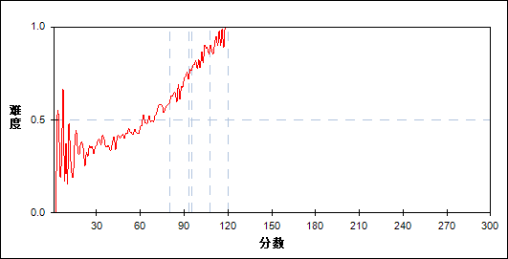

图 67 第21_5题分组难度曲线图

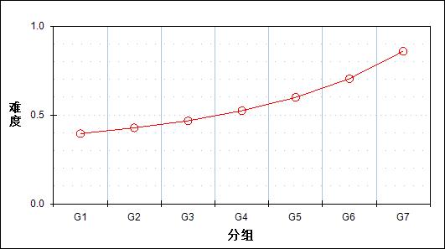

表 71 第21_5题分组分析表

| 分值 | G1 | G2 | G3 | G4 | G5 | G6 | G7 | 人数 | 比率(%) | 平均值 |
| --- | --- | --- | --- | --- | --- | --- | --- | --- | --- | --- |
| 0～ | 3615 | 3418 | 3185 | 2844 | 2397 | 1767 | 847 | 18073 | 43.22 | 61.51 |
| 3～ | 2360 | 2557 | 2789 | 3130 | 3577 | 4207 | 5127 | 23747 | 56.78 | 77.11 |
| 合计 | 5975 | 5975 | 5974 | 5974 | 5974 | 5974 | 5974 | 41820 | 100.00 | - |
| 得分率 | 0.39 | 0.43 | 0.47 | 0.52 | 0.60 | 0.70 | 0.86 | - | - | - |

* + - 1. 第21_6题

表 72 第21_6题分析表

|  |  |  |  |  |  |  |  |  |
| --- | --- | --- | --- | --- | --- | --- | --- | --- |
| 满分值 | 最大值 | 最小值 | 平均值 | 标准差 | 差异系数 | 难度 | 相关系数 | 鉴别指数 |
| 2 | 2.0 | 0.0 | 1.17 | 0.86 | 0.73 | 0.59 | 0.36 | 0.38 |

图 68 第21_6题难度曲线图

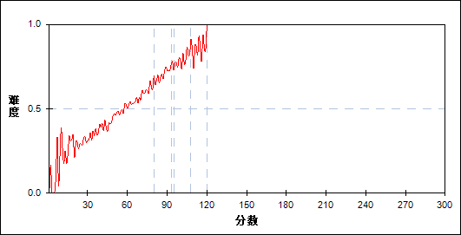

图 69 第21_6题分组难度曲线图

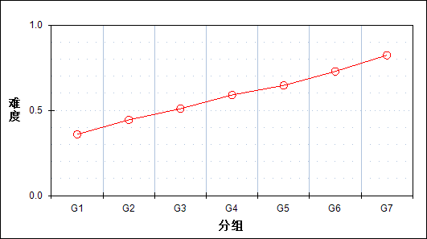

表 73 第21_6题分组分析表

| 分值 | G1 | G2 | G3 | G4 | G5 | G6 | G7 | 人数 | 比率(%) | 平均值 |
| --- | --- | --- | --- | --- | --- | --- | --- | --- | --- | --- |
| 0～ | 2960 | 2428 | 2089 | 1660 | 1465 | 1140 | 759 | 12501 | 29.89 | 60.69 |
| 1～ | 1731 | 1785 | 1679 | 1577 | 1300 | 965 | 596 | 9633 | 23.03 | 63.85 |
| 2～ | 1284 | 1762 | 2206 | 2737 | 3209 | 3869 | 4619 | 19686 | 47.07 | 79.71 |
| 合计 | 5975 | 5975 | 5974 | 5974 | 5974 | 5974 | 5974 | 41820 | 100.00 | - |
| 得分率 | 0.36 | 0.44 | 0.51 | 0.59 | 0.65 | 0.73 | 0.82 | - | - | - |

* + - 1. 第22_1题

表 74 第22_1题分析表

|  |  |  |  |  |  |  |  |  |
| --- | --- | --- | --- | --- | --- | --- | --- | --- |
| 满分值 | 最大值 | 最小值 | 平均值 | 标准差 | 差异系数 | 难度 | 相关系数 | 鉴别指数 |
| 6 | 6.0 | 0.0 | 5.69 | 1.17 | 0.21 | 0.95 | 0.39 | 0.16 |

图 70 第22_1题难度曲线图

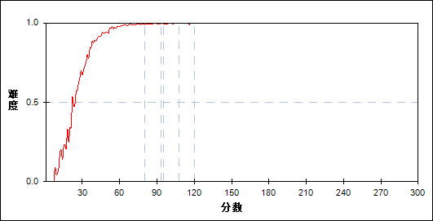

图 71 第22_1题分组难度曲线图

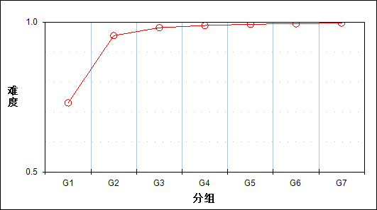

表 75 第22_1题分组分析表

| 分值 | G1 | G2 | G3 | G4 | G5 | G6 | G7 | 人数 | 比率(%) | 平均值 |
| --- | --- | --- | --- | --- | --- | --- | --- | --- | --- | --- |
| 0～ | 1145 | 93 | 15 | 2 | 2 | 0 | 0 | 1257 | 3.01 | 28.57 |
| 2～ | 510 | 120 | 40 | 13 | 9 | 3 | 4 | 699 | 1.67 | 37.16 |
| 3～ | 1 | 0 | 0 | 1 | 0 | 0 | 0 | 2 | 0.00 | 64.50 |
| 4～ | 358 | 277 | 199 | 160 | 99 | 85 | 44 | 1222 | 2.92 | 55.71 |
| 5～ | 34 | 35 | 33 | 29 | 25 | 25 | 14 | 195 | 0.47 | 64.56 |
| 6～ | 3927 | 5450 | 5687 | 5769 | 5839 | 5861 | 5912 | 38445 | 91.93 | 72.83 |
| 合计 | 5975 | 5975 | 5974 | 5974 | 5974 | 5974 | 5974 | 41820 | 100.00 | - |
| 得分率 | 0.73 | 0.95 | 0.98 | 0.99 | 0.99 | 0.99 | 1.00 | - | - | - |

* + - 1. 第22_2题

表 76 第22_2题分析表

|  |  |  |  |  |  |  |  |  |
| --- | --- | --- | --- | --- | --- | --- | --- | --- |
| 满分值 | 最大值 | 最小值 | 平均值 | 标准差 | 差异系数 | 难度 | 相关系数 | 鉴别指数 |
| 5 | 5.0 | 0.0 | 4.06 | 1.83 | 0.45 | 0.81 | 0.57 | 0.50 |

图 72 第22_2题难度曲线图

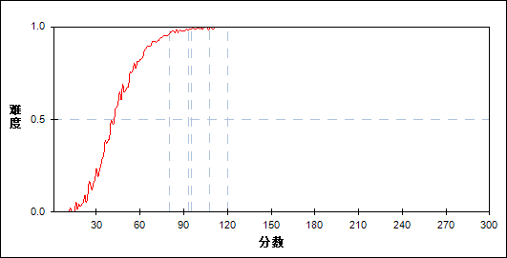

图 73 第22_2题分组难度曲线图

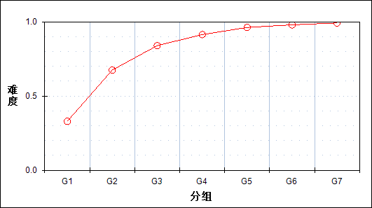

表 77 第22_2题分组分析表

| 分值 | G1 | G2 | G3 | G4 | G5 | G6 | G7 | 人数 | 比率(%) | 平均值 |
| --- | --- | --- | --- | --- | --- | --- | --- | --- | --- | --- |
| 0～ | 3682 | 1609 | 720 | 317 | 119 | 52 | 12 | 6511 | 15.57 | 41.85 |
| 1～ | 74 | 41 | 20 | 15 | 3 | 2 | 0 | 155 | 0.37 | 45.86 |
| 2～ | 128 | 133 | 73 | 54 | 15 | 8 | 3 | 414 | 0.99 | 52.08 |
| 3～ | 341 | 393 | 334 | 304 | 200 | 143 | 74 | 1789 | 4.28 | 60.95 |
| 4～ | 252 | 324 | 230 | 163 | 83 | 39 | 18 | 1109 | 2.65 | 57.47 |
| 5～ | 1498 | 3475 | 4597 | 5121 | 5554 | 5730 | 5867 | 31842 | 76.14 | 77.54 |
| 合计 | 5975 | 5975 | 5974 | 5974 | 5974 | 5974 | 5974 | 41820 | 100.00 | - |
| 得分率 | 0.33 | 0.67 | 0.84 | 0.91 | 0.96 | 0.98 | 0.99 | - | - | - |

* + - 1. 第22_3题

表 78 第22_3题分析表

|  |  |  |  |  |  |  |  |  |
| --- | --- | --- | --- | --- | --- | --- | --- | --- |
| 满分值 | 最大值 | 最小值 | 平均值 | 标准差 | 差异系数 | 难度 | 相关系数 | 鉴别指数 |
| 5 | 5.0 | 0.0 | 4.23 | 1.54 | 0.36 | 0.85 | 0.50 | 0.35 |

图 74 第22_3题难度曲线图

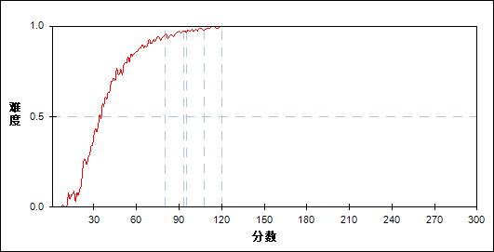

图 75 第22_3题分组难度曲线图

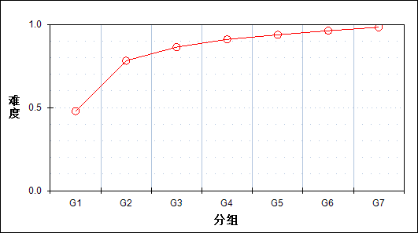

表 79 第22_3题分组分析表

| 分值 | G1 | G2 | G3 | G4 | G5 | G6 | G7 | 人数 | 比率(%) | 平均值 |
| --- | --- | --- | --- | --- | --- | --- | --- | --- | --- | --- |
| 0～ | 2034 | 446 | 200 | 113 | 84 | 41 | 19 | 2937 | 7.02 | 38.07 |
| 1～ | 262 | 134 | 64 | 40 | 16 | 7 | 3 | 526 | 1.26 | 45.51 |
| 2～ | 1221 | 938 | 651 | 414 | 286 | 161 | 71 | 3742 | 8.95 | 53.47 |
| 3～ | 326 | 453 | 426 | 352 | 253 | 204 | 99 | 2113 | 5.05 | 62.56 |
| 4～ | 34 | 38 | 25 | 22 | 18 | 8 | 2 | 147 | 0.35 | 58.63 |
| 5～ | 2098 | 3966 | 4608 | 5033 | 5317 | 5553 | 5780 | 32355 | 77.37 | 76.22 |
| 合计 | 5975 | 5975 | 5974 | 5974 | 5974 | 5974 | 5974 | 41820 | 100.00 | - |
| 得分率 | 0.48 | 0.78 | 0.86 | 0.91 | 0.94 | 0.96 | 0.98 | - | - | - |

* + - 1. 第23_1题

表 80 第23_1题分析表

|  |  |  |  |  |  |  |  |  |
| --- | --- | --- | --- | --- | --- | --- | --- | --- |
| 满分值 | 最大值 | 最小值 | 平均值 | 标准差 | 差异系数 | 难度 | 相关系数 | 鉴别指数 |
| 6 | 6.0 | 0.0 | 4.19 | 2.30 | 0.55 | 0.70 | 0.58 | 0.53 |

图 76 第23_1题难度曲线图

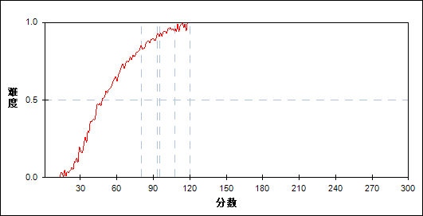

图 77 第23_1题分组难度曲线图

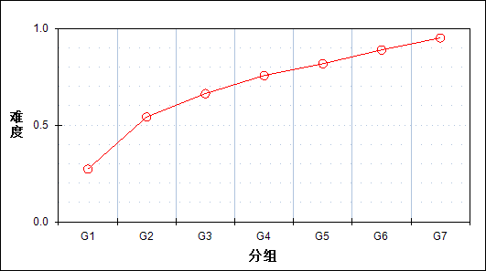

表 81 第23_1题分组分析表

| 分值 | G1 | G2 | G3 | G4 | G5 | G6 | G7 | 人数 | 比率(%) | 平均值 |
| --- | --- | --- | --- | --- | --- | --- | --- | --- | --- | --- |
| 0～ | 3767 | 1711 | 945 | 456 | 268 | 104 | 40 | 7291 | 17.43 | 44.00 |
| 3～ | 1157 | 2055 | 2136 | 2001 | 1648 | 1118 | 511 | 10626 | 25.41 | 65.48 |
| 6～ | 1051 | 2209 | 2893 | 3517 | 4058 | 4752 | 5423 | 23903 | 57.16 | 80.58 |
| 合计 | 5975 | 5975 | 5974 | 5974 | 5974 | 5974 | 5974 | 41820 | 100.00 | - |
| 得分率 | 0.27 | 0.54 | 0.66 | 0.76 | 0.82 | 0.89 | 0.95 | - | - | - |

* + - 1. 第23_2题

表 82 第23_2题分析表

|  |  |  |  |  |  |  |  |  |
| --- | --- | --- | --- | --- | --- | --- | --- | --- |
| 满分值 | 最大值 | 最小值 | 平均值 | 标准差 | 差异系数 | 难度 | 相关系数 | 鉴别指数 |
| 6 | 6.0 | 0.0 | 3.28 | 2.87 | 0.87 | 0.55 | 0.71 | 0.84 |

图 78 第23_2题难度曲线图

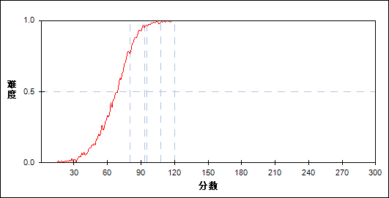

图 79 第23_2题分组难度曲线图

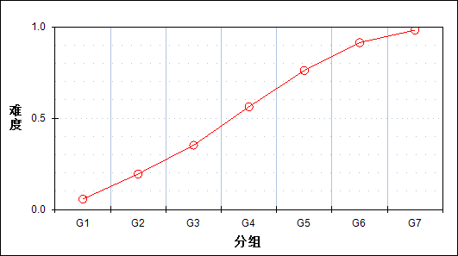

表 83 第23_2题分组分析表

| 分值 | G1 | G2 | G3 | G4 | G5 | G6 | G7 | 人数 | 比率(%) | 平均值 |
| --- | --- | --- | --- | --- | --- | --- | --- | --- | --- | --- |
| 0～ | 5516 | 4549 | 3517 | 2256 | 1120 | 328 | 31 | 17317 | 41.41 | 51.38 |
| 3～ | 231 | 518 | 709 | 712 | 620 | 376 | 151 | 3317 | 7.93 | 68.18 |
| 6～ | 228 | 908 | 1748 | 3006 | 4234 | 5270 | 5792 | 21186 | 50.66 | 86.23 |
| 合计 | 5975 | 5975 | 5974 | 5974 | 5974 | 5974 | 5974 | 41820 | 100.00 | - |
| 得分率 | 0.06 | 0.20 | 0.35 | 0.56 | 0.76 | 0.91 | 0.98 | - | - | - |

* + - 1. 第23_3题

表 84 第23_3题分析表

|  |  |  |  |  |  |  |  |  |
| --- | --- | --- | --- | --- | --- | --- | --- | --- |
| 满分值 | 最大值 | 最小值 | 平均值 | 标准差 | 差异系数 | 难度 | 相关系数 | 鉴别指数 |
| 6 | 6.0 | 0.0 | 2.03 | 2.50 | 1.23 | 0.34 | 0.73 | 0.75 |

图 80 第23_3题难度曲线图

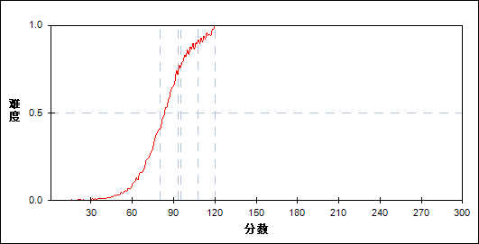

图 81 第23_3题分组难度曲线图

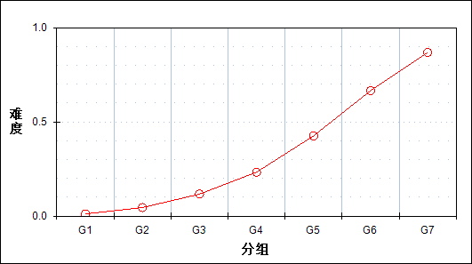

表 85 第23_3题分组分析表

| 分值 | G1 | G2 | G3 | G4 | G5 | G6 | G7 | 人数 | 比率(%) | 平均值 |
| --- | --- | --- | --- | --- | --- | --- | --- | --- | --- | --- |
| 0～ | 5737 | 5246 | 4461 | 3513 | 2191 | 906 | 199 | 22253 | 53.21 | 55.54 |
| 1～ | 157 | 377 | 564 | 567 | 491 | 301 | 83 | 2540 | 6.07 | 68.73 |
| 2～ | 13 | 33 | 53 | 49 | 49 | 52 | 17 | 266 | 0.64 | 72.45 |
| 3～ | 48 | 198 | 519 | 928 | 1290 | 1274 | 759 | 5016 | 11.99 | 81.75 |
| 4～ | 12 | 56 | 139 | 285 | 437 | 473 | 340 | 1742 | 4.17 | 84.28 |
| 5～ | 0 | 8 | 9 | 17 | 36 | 55 | 74 | 199 | 0.48 | 89.93 |
| 6～ | 8 | 57 | 229 | 615 | 1480 | 2913 | 4502 | 9804 | 23.44 | 95.71 |
| 合计 | 5975 | 5975 | 5974 | 5974 | 5974 | 5974 | 5974 | 41820 | 100.00 | - |
| 得分率 | 0.01 | 0.05 | 0.12 | 0.23 | 0.43 | 0.67 | 0.87 | - | - | - |

* + - 1. 第24_1题

表 86 第24_1题分析表

|  |  |  |  |  |  |  |  |  |
| --- | --- | --- | --- | --- | --- | --- | --- | --- |
| 满分值 | 最大值 | 最小值 | 平均值 | 标准差 | 差异系数 | 难度 | 相关系数 | 鉴别指数 |
| 4 | 4.0 | 0.0 | 2.24 | 1.74 | 0.78 | 0.56 | 0.70 | 0.77 |

图 82 第24_1题难度曲线图

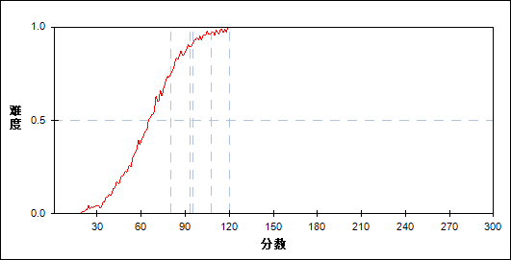

图 83 第24_1题分组难度曲线图

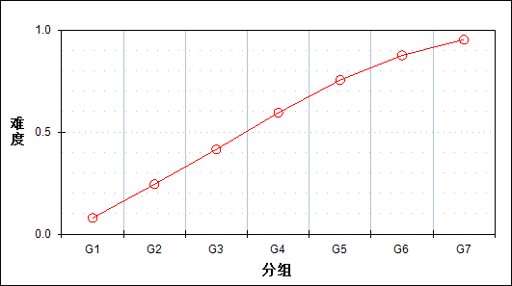

表 87 第24_1题分组分析表

| 分值 | G1 | G2 | G3 | G4 | G5 | G6 | G7 | 人数 | 比率(%) | 平均值 |
| --- | --- | --- | --- | --- | --- | --- | --- | --- | --- | --- |
| 0～ | 4949 | 3369 | 2183 | 1244 | 553 | 167 | 27 | 12492 | 29.87 | 48.73 |
| 1～ | 582 | 1092 | 1066 | 768 | 476 | 184 | 43 | 4211 | 10.07 | 59.71 |
| 2～ | 183 | 504 | 778 | 870 | 749 | 539 | 234 | 3857 | 9.22 | 70.46 |
| 3～ | 97 | 296 | 491 | 678 | 726 | 677 | 430 | 3395 | 8.12 | 77.09 |
| 4～ | 164 | 714 | 1456 | 2414 | 3470 | 4407 | 5240 | 17865 | 42.72 | 86.72 |
| 合计 | 5975 | 5975 | 5974 | 5974 | 5974 | 5974 | 5974 | 41820 | 100.00 | - |
| 得分率 | 0.08 | 0.24 | 0.42 | 0.59 | 0.75 | 0.88 | 0.95 | - | - | - |

* + - 1. 第24_2题

表 88 第24_2题分析表

|  |  |  |  |  |  |  |  |  |
| --- | --- | --- | --- | --- | --- | --- | --- | --- |
| 满分值 | 最大值 | 最小值 | 平均值 | 标准差 | 差异系数 | 难度 | 相关系数 | 鉴别指数 |
| 10 | 10.0 | 0.0 | 1.47 | 3.00 | 2.05 | 0.15 | 0.64 | 0.46 |

图 84 第24_2题难度曲线图

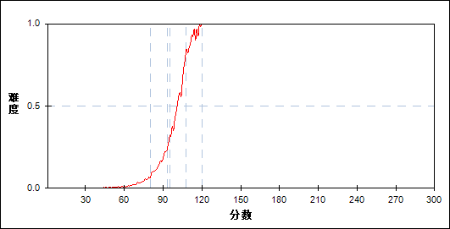

图 85 第24_2题分组难度曲线图

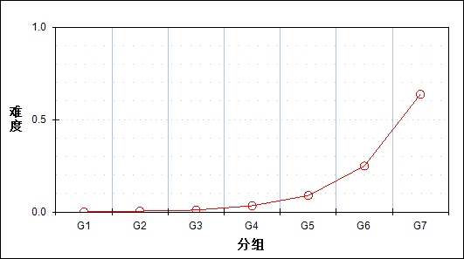

表 89 第24_2题分组分析表

| 分值 | G1 | G2 | G3 | G4 | G5 | G6 | G7 | 人数 | 比率(%) | 平均值 |
| --- | --- | --- | --- | --- | --- | --- | --- | --- | --- | --- |
| 0～ | 5941 | 5800 | 5629 | 5130 | 4227 | 2599 | 708 | 30034 | 71.82 | 60.96 |
| 1～ | 25 | 109 | 204 | 341 | 566 | 735 | 367 | 2347 | 5.61 | 82.11 |
| 2～ | 8 | 47 | 87 | 282 | 569 | 826 | 588 | 2407 | 5.76 | 86.98 |
| 3～ | 0 | 4 | 14 | 47 | 79 | 92 | 56 | 292 | 0.70 | 86.28 |
| 4～ | 1 | 4 | 13 | 57 | 114 | 278 | 238 | 705 | 1.69 | 92.08 |
| 5～ | 0 | 7 | 11 | 35 | 96 | 183 | 205 | 537 | 1.28 | 92.79 |
| 6～ | 0 | 1 | 3 | 23 | 60 | 165 | 166 | 418 | 1.00 | 95.18 |
| 7～ | 0 | 2 | 10 | 46 | 175 | 568 | 974 | 1775 | 4.24 | 98.80 |
| 9～ | 0 | 0 | 1 | 2 | 13 | 57 | 181 | 254 | 0.61 | 104.27 |
| 10～ | 0 | 1 | 2 | 11 | 75 | 471 | 2491 | 3051 | 7.30 | 107.65 |
| 合计 | 5975 | 5975 | 5974 | 5974 | 5974 | 5974 | 5974 | 41820 | 100.00 | - |
| 得分率 | 0.00 | 0.00 | 0.01 | 0.03 | 0.09 | 0.25 | 0.64 | - | - | - |

* + - 1. 第24_3题

表 90 第24_3题分析表

|  |  |  |  |  |  |  |  |  |
| --- | --- | --- | --- | --- | --- | --- | --- | --- |
| 满分值 | 最大值 | 最小值 | 平均值 | 标准差 | 差异系数 | 难度 | 相关系数 | 鉴别指数 |
| 6 | 6.0 | 0.0 | 0.29 | 1.15 | 3.98 | 0.05 | 0.41 | 0.17 |

图 86 第24_3题难度曲线图

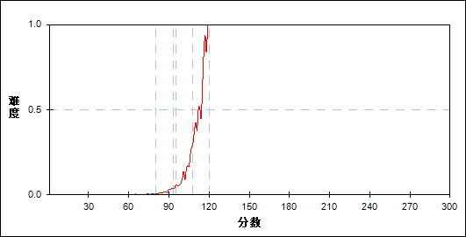

图 87 第24_3题分组难度曲线图

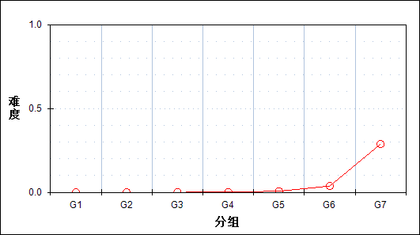

表 91 第24_3题分组分析表

| 分值 | G1 | G2 | G3 | G4 | G5 | G6 | G7 | 人数 | 比率(%) | 平均值 |
| --- | --- | --- | --- | --- | --- | --- | --- | --- | --- | --- |
| 0～ | 5973 | 5971 | 5964 | 5939 | 5867 | 5513 | 3521 | 38748 | 92.65 | 67.49 |
| 1～ | 1 | 3 | 5 | 17 | 59 | 190 | 504 | 779 | 1.86 | 100.16 |
| 3～ | 0 | 0 | 0 | 0 | 1 | 3 | 13 | 17 | 0.04 | 102.35 |
| 4～ | 1 | 1 | 5 | 18 | 44 | 224 | 917 | 1210 | 2.89 | 105.43 |
| 6～ | 0 | 0 | 0 | 0 | 3 | 44 | 1019 | 1066 | 2.55 | 112.74 |
| 合计 | 5975 | 5975 | 5974 | 5974 | 5974 | 5974 | 5974 | 41820 | 100.00 | - |
| 得分率 | 0.00 | 0.00 | 0.00 | 0.00 | 0.01 | 0.04 | 0.29 | - | - | - |

* 1. 相关分析
     + 1. 主客观题组

表 92主客观题组 相关分析表

|  | 客观题 | 主观题 | 总分 |
| --- | --- | --- | --- |
| 客观题 | - | 0.6119 | 0.7831 |
| 主观题 | 0.6119 | - | 0.8901 |
| 总分 | 0.7831 | 0.8901 | - |

* + - 1. 知识组块

表 93知识组块 相关分析表

|  | 力学 | 电学 | 热学 | 光学 | 原子 | 总分 |
| --- | --- | --- | --- | --- | --- | --- |
| 力学 | - | 0.6437 | 0.2425 | 0.3502 | 0.3741 | 0.8618 |
| 电学 | 0.6437 | - | 0.2176 | 0.3158 | 0.2659 | 0.8108 |
| 热学 | 0.2425 | 0.2176 | - | 0.1784 | 0.0987 | 0.3215 |
| 光学 | 0.3502 | 0.3158 | 0.1784 | - | 0.1560 | 0.4250 |
| 原子 | 0.3741 | 0.2659 | 0.0987 | 0.1560 | - | 0.4169 |
| 总分 | 0.8618 | 0.8108 | 0.3215 | 0.4250 | 0.4169 | - |

* + - 1. 能力组块

表 94能力组块 相关分析表

|  | 理解能力 | 推理能力 | 实验能力 | 应用能力 | 探究能力 | 总分 |
| --- | --- | --- | --- | --- | --- | --- |
| 理解能力 | - | 0.3465 | 0.4152 | 0.4504 | 0.4386 | 0.6372 |
| 推理能力 | 0.3465 | - | 0.3258 | 0.3582 | 0.3770 | 0.5425 |
| 实验能力 | 0.4152 | 0.3258 | - | 0.5419 | 0.4974 | 0.6899 |
| 应用能力 | 0.4504 | 0.3582 | 0.5419 | - | 0.5535 | 0.8067 |
| 探究能力 | 0.4386 | 0.3770 | 0.4974 | 0.5535 | - | 0.7455 |
| 总分 | 0.6372 | 0.5425 | 0.6899 | 0.8067 | 0.7455 | - |