北京市高中会考数据统计分析报告

英语

 

2013年7月

**目 录**

一、 总体分析 1

二、 题组分析 11

(一) 主客观题组块 11

(二) 组块分析 22

(三) 类型分析 34

(四) 大题分析 46

(五) 听力技能分析 59

(六) 语法分析 69

(七) 词汇组块 77

(八) 阅读能力分析 88

(九) 题型分析 100

三、 题目分析 105

四、 相关分析 239

1. 总体分析

表 1 英语试卷总分分析表

| 人数 | 满分值 | 最大值 | 最小值 |
| --- | --- | --- | --- |
| 57285 | 100 | 98.5 | 0.0 |
| 平均值 | 标准差 | 差异系数 | 难度 |
| 77.89 | 11.05 | 0.14 | 0.78 |

表 2 英语等级成绩分析表

| 等级 | 人数 | 比率 | 平均值 | 标准差 | 差异系数 | 得分率 |
| --- | --- | --- | --- | --- | --- | --- |
| 优秀 (85 - 100) | 16598 | 28.97 | 88.11 | 2.30 | 0.03 | 0.88 |
| 良好 (70 - 85) | 30797 | 53.76 | 78.35 | 4.15 | 0.05 | 0.78 |
| 及格 (60 - 70) | 6304 | 11.00 | 65.73 | 2.77 | 0.04 | 0.66 |
| 不及格 (0 - 60) | 3586 | 6.26 | 48.03 | 11.25 | 0.23 | 0.48 |
| 全体 | 57285 | 100.00 | 77.89 | 11.05 | 0.14 | 0.78 |

图 1 英语试卷总分分布曲线图

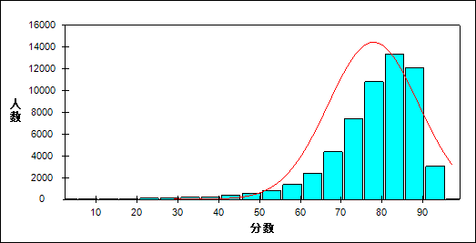

表 3 英语题目、题组整体分析表

| 题目或题组 | 人数 | 满分值 | 最大值 | 最小值 | 平均值 | 标准差 | 差异系数 | 难度 | 区分度 |
| --- | --- | --- | --- | --- | --- | --- | --- | --- | --- |
| 1 | 57285 | 1 | 1.0 | 0.0 | 0.91 | 0.29 | 0.31 | 0.91 | 0.32 |
| 2 | 57285 | 1 | 1.0 | 0.0 | 0.98 | 0.14 | 0.14 | 0.98 | 0.22 |
| 3 | 57285 | 1 | 1.0 | 0.0 | 0.89 | 0.32 | 0.36 | 0.89 | 0.44 |
| 4 | 57285 | 1 | 1.0 | 0.0 | 0.96 | 0.20 | 0.20 | 0.96 | 0.24 |
| 5 | 57285 | 1 | 1.0 | 0.0 | 0.94 | 0.24 | 0.26 | 0.94 | 0.41 |
| 6 | 57285 | 1 | 1.0 | 0.0 | 0.95 | 0.22 | 0.23 | 0.95 | 0.29 |
| 7 | 57285 | 1 | 1.0 | 0.0 | 0.96 | 0.19 | 0.20 | 0.96 | 0.39 |
| 8 | 57285 | 1 | 1.0 | 0.0 | 0.96 | 0.20 | 0.20 | 0.96 | 0.34 |
| 9 | 57285 | 1 | 1.0 | 0.0 | 0.97 | 0.16 | 0.17 | 0.97 | 0.33 |
| 10 | 57285 | 1 | 1.0 | 0.0 | 0.92 | 0.27 | 0.29 | 0.92 | 0.38 |
| 11 | 57285 | 1 | 1.0 | 0.0 | 0.94 | 0.23 | 0.24 | 0.94 | 0.40 |
| 12 | 57285 | 1 | 1.0 | 0.0 | 0.97 | 0.18 | 0.18 | 0.97 | 0.33 |
| 13 | 57285 | 1 | 1.0 | 0.0 | 0.98 | 0.16 | 0.16 | 0.98 | 0.35 |
| 14 | 57285 | 1 | 1.0 | 0.0 | 0.74 | 0.44 | 0.60 | 0.74 | 0.41 |
| 15 | 57285 | 1 | 1.0 | 0.0 | 0.92 | 0.27 | 0.29 | 0.92 | 0.46 |
| 16 | 57285 | 1 | 1.0 | 0.0 | 0.90 | 0.30 | 0.33 | 0.90 | 0.32 |
| 17 | 57285 | 1 | 1.0 | 0.0 | 0.96 | 0.20 | 0.20 | 0.96 | 0.40 |
| 18 | 57285 | 1 | 1.0 | 0.0 | 0.86 | 0.35 | 0.40 | 0.86 | 0.34 |
| 19 | 57285 | 1 | 1.0 | 0.0 | 0.88 | 0.32 | 0.36 | 0.88 | 0.40 |
| 20 | 57285 | 1 | 1.0 | 0.0 | 0.93 | 0.26 | 0.28 | 0.93 | 0.33 |
| 21 | 57285 | 1 | 1.0 | 0.0 | 0.85 | 0.36 | 0.43 | 0.85 | 0.35 |
| 22 | 57285 | 1 | 1.0 | 0.0 | 0.92 | 0.28 | 0.30 | 0.92 | 0.41 |
| 23 | 57285 | 1 | 1.0 | 0.0 | 0.93 | 0.25 | 0.27 | 0.93 | 0.47 |
| 24 | 57285 | 1 | 1.0 | 0.0 | 0.89 | 0.31 | 0.34 | 0.89 | 0.37 |
| 25 | 57285 | 1 | 1.0 | 0.0 | 0.95 | 0.22 | 0.23 | 0.95 | 0.39 |
| 26 | 57285 | 1 | 1.0 | 0.0 | 0.87 | 0.33 | 0.38 | 0.87 | 0.32 |
| 27 | 57285 | 1 | 1.0 | 0.0 | 0.90 | 0.30 | 0.34 | 0.90 | 0.46 |
| 28 | 57285 | 1 | 1.0 | 0.0 | 0.91 | 0.28 | 0.31 | 0.91 | 0.39 |
| 29 | 57285 | 1 | 1.0 | 0.0 | 0.95 | 0.21 | 0.22 | 0.95 | 0.42 |
| 30 | 57285 | 1 | 1.0 | 0.0 | 0.92 | 0.27 | 0.30 | 0.92 | 0.40 |
| 31 | 57285 | 1 | 1.0 | 0.0 | 0.84 | 0.36 | 0.43 | 0.84 | 0.34 |
| 32 | 57285 | 1 | 1.0 | 0.0 | 0.95 | 0.21 | 0.22 | 0.95 | 0.39 |
| 33 | 57285 | 1 | 1.0 | 0.0 | 0.65 | 0.48 | 0.73 | 0.65 | 0.46 |
| 34 | 57285 | 1 | 1.0 | 0.0 | 0.86 | 0.35 | 0.41 | 0.86 | 0.42 |
| 35 | 57285 | 1 | 1.0 | 0.0 | 0.44 | 0.50 | 1.13 | 0.44 | 0.38 |
| 36 | 57285 | 1 | 1.0 | 0.0 | 0.30 | 0.46 | 1.54 | 0.30 | 0.22 |
| 37 | 57285 | 1 | 1.0 | 0.0 | 0.89 | 0.31 | 0.34 | 0.89 | 0.40 |
| 38 | 57285 | 1 | 1.0 | 0.0 | 0.93 | 0.26 | 0.28 | 0.93 | 0.45 |
| 39 | 57285 | 1 | 1.0 | 0.0 | 0.77 | 0.42 | 0.55 | 0.77 | 0.40 |
| 40 | 57285 | 1 | 1.0 | 0.0 | 0.86 | 0.35 | 0.41 | 0.86 | 0.50 |
| 41 | 57285 | 1 | 1.0 | 0.0 | 0.85 | 0.36 | 0.42 | 0.85 | 0.37 |
| 42 | 57285 | 1 | 1.0 | 0.0 | 0.27 | 0.45 | 1.62 | 0.27 | 0.29 |
| 43 | 57285 | 1 | 1.0 | 0.0 | 0.37 | 0.48 | 1.30 | 0.37 | 0.23 |
| 44 | 57285 | 1 | 1.0 | 0.0 | 0.21 | 0.41 | 1.95 | 0.21 | 0.05 |
| 45 | 57285 | 1 | 1.0 | 0.0 | 0.19 | 0.39 | 2.07 | 0.19 | -0.07 |
| 46 | 57285 | 1 | 1.0 | 0.0 | 0.92 | 0.27 | 0.30 | 0.92 | 0.35 |
| 47 | 57285 | 2 | 2.0 | 0.0 | 1.98 | 0.19 | 0.10 | 0.99 | 0.29 |
| 48 | 57285 | 2 | 2.0 | 0.0 | 1.96 | 0.28 | 0.15 | 0.98 | 0.26 |
| 49 | 57285 | 2 | 2.0 | 0.0 | 1.93 | 0.38 | 0.19 | 0.96 | 0.37 |
| 50 | 57285 | 2 | 2.0 | 0.0 | 1.62 | 0.79 | 0.48 | 0.81 | 0.43 |
| 51 | 57285 | 2 | 2.0 | 0.0 | 1.89 | 0.45 | 0.24 | 0.95 | 0.39 |
| 52 | 57285 | 2 | 2.0 | 0.0 | 1.71 | 0.71 | 0.41 | 0.85 | 0.43 |
| 53 | 57285 | 2 | 2.0 | 0.0 | 1.85 | 0.52 | 0.28 | 0.93 | 0.47 |
| 54 | 57285 | 2 | 2.0 | 0.0 | 1.86 | 0.51 | 0.27 | 0.93 | 0.47 |
| 55 | 57285 | 2 | 2.0 | 0.0 | 1.15 | 0.99 | 0.86 | 0.57 | 0.52 |
| 56 | 57285 | 2 | 2.0 | 0.0 | 0.75 | 0.97 | 1.29 | 0.38 | 0.30 |
| 57 | 57285 | 2 | 2.0 | 0.0 | 0.95 | 1.00 | 1.05 | 0.48 | 0.35 |
| 58 | 57285 | 2 | 2.0 | 0.0 | 0.35 | 0.76 | 2.16 | 0.18 | 0.08 |
| 59 | 57285 | 1 | 1.0 | 0.0 | 0.96 | 0.19 | 0.19 | 0.96 | 0.35 |
| 60 | 57285 | 1 | 1.0 | 0.0 | 0.89 | 0.31 | 0.35 | 0.89 | 0.45 |
| 61 | 57285 | 1 | 1.0 | 0.0 | 0.87 | 0.33 | 0.38 | 0.87 | 0.51 |
| 62 | 57285 | 1 | 1.0 | 0.0 | 0.91 | 0.29 | 0.32 | 0.91 | 0.44 |
| 63 | 57285 | 2 | 2.0 | 0.0 | 1.65 | 0.69 | 0.42 | 0.83 | 0.52 |
| 64 | 57285 | 2 | 2.0 | 0.0 | 1.73 | 0.64 | 0.37 | 0.86 | 0.50 |
| 65 | 57285 | 2 | 2.0 | 0.0 | 1.27 | 0.72 | 0.57 | 0.64 | 0.58 |
| 66 | 57285 | 20 | 20.0 | 0.0 | 13.68 | 2.46 | 0.18 | 0.68 | 0.76 |
| 总分 | 57285 | 100 | 98.5 | 0.0 | 77.89 | 11.05 | 0.14 | 0.78 | 1.00 |
| 客观题 | 57285 | 70 | 70.0 | 0.0 | 55.93 | 7.90 | 0.14 | 0.80 | 0.97 |
| 主观题 | 57285 | 30 | 30.0 | 0.0 | 21.96 | 3.91 | 0.18 | 0.73 | 0.87 |
| 知识组块 | 57285 | 34 | 34.0 | 0.0 | 26.89 | 4.05 | 0.15 | 0.79 | 0.89 |
| 能力组块 | 57285 | 66 | 65.0 | 0.0 | 51.00 | 7.65 | 0.15 | 0.77 | 0.97 |
| 基础性试题 | 57285 | 35 | 35.0 | 0.0 | 31.36 | 4.13 | 0.13 | 0.90 | 0.88 |
| 发展性试题 | 57285 | 65 | 63.5 | 0.0 | 46.52 | 7.65 | 0.16 | 0.72 | 0.97 |
| 听力理解 | 57285 | 20 | 20.0 | 0.0 | 18.52 | 2.21 | 0.12 | 0.93 | 0.80 |
| 单项填空 | 57285 | 2 | 2.0 | 0.0 | 1.29 | 0.64 | 0.50 | 0.64 | 0.49 |
| 完形填空 | 57285 | 3 | 3.0 | 0.0 | 1.92 | 0.94 | 0.49 | 0.64 | 0.46 |
| 阅读理解 | 57285 | 4 | 4.0 | 0.0 | 3.16 | 0.92 | 0.29 | 0.79 | 0.65 |
| 书面表达 | 57285 | 20 | 20.0 | 0.0 | 13.68 | 2.46 | 0.18 | 0.68 | 0.76 |
| 理解归纳主旨要义 | 57285 | 1 | 1.0 | 0.0 | 0.96 | 0.19 | 0.20 | 0.96 | 0.39 |
| 获取事实性信息 | 57285 | 9 | 9.0 | 0.0 | 8.46 | 1.07 | 0.13 | 0.94 | 0.66 |
| 简单推断 | 57285 | 4 | 4.0 | 0.0 | 3.80 | 0.54 | 0.14 | 0.95 | 0.57 |
| 理解意图、态度和观点 | 57285 | 2 | 2.0 | 0.0 | 1.66 | 0.56 | 0.34 | 0.83 | 0.51 |
| 记录信息 | 57285 | 2 | 2.0 | 0.0 | 1.89 | 0.36 | 0.19 | 0.94 | 0.45 |
| 动词及时态、语态 | 57285 | 6 | 6.0 | 0.0 | 5.55 | 0.89 | 0.16 | 0.93 | 0.70 |
| 从句 | 57285 | 4 | 4.0 | 0.0 | 2.83 | 1.02 | 0.36 | 0.71 | 0.66 |
| 虚词 | 57285 | 4 | 4.0 | 0.0 | 3.61 | 0.79 | 0.22 | 0.90 | 0.57 |
| 比较等级 | 57285 | 1 | 1.0 | 0.0 | 0.85 | 0.36 | 0.43 | 0.85 | 0.35 |
| 动词 | 57285 | 9 | 9.0 | 0.0 | 5.74 | 1.16 | 0.20 | 0.64 | 0.52 |
| 名词 | 57285 | 5 | 5.0 | 0.0 | 4.16 | 0.70 | 0.17 | 0.83 | 0.49 |
| 形容词 | 57285 | 3 | 3.0 | 0.0 | 2.51 | 0.89 | 0.35 | 0.84 | 0.52 |
| 连词 | 57285 | 1 | 1.0 | 0.0 | 0.77 | 0.42 | 0.55 | 0.77 | 0.40 |
| 副词 | 57285 | 1 | 1.0 | 0.0 | 0.86 | 0.35 | 0.41 | 0.86 | 0.50 |
| 理解主旨要义 | 57285 | 5 | 5.0 | 0.0 | 4.04 | 1.10 | 0.27 | 0.81 | 0.71 |
| 获取事实性信息2 | 57285 | 13 | 13.0 | 0.0 | 9.89 | 2.54 | 0.26 | 0.76 | 0.80 |
| 排序 | 57285 | 1 | 1.0 | 0.0 | 0.87 | 0.33 | 0.38 | 0.87 | 0.51 |
| 推断 | 57285 | 2 | 2.0 | 0.0 | 0.95 | 1.00 | 1.05 | 0.48 | 0.35 |
| 理解意图、态度和观点2 | 57285 | 5 | 5.0 | 0.0 | 3.04 | 1.04 | 0.34 | 0.61 | 0.43 |
| 原型题 | 57285 | 8 | 8.0 | 0.0 | 7.26 | 1.31 | 0.18 | 0.91 | 0.67 |
| 变型题 | 57285 | 7 | 7.0 | 0.0 | 5.58 | 1.32 | 0.24 | 0.80 | 0.75 |

表 4 英语题目、题组等级得分率分析表

| 题目或题组 | 优秀 | 良好 | 合格 | 不合格 |
| --- | --- | --- | --- | --- |
| 第1题 | 0.99 | 0.92 | 0.80 | 0.67 |
| 第2题 | 1.00 | 0.99 | 0.96 | 0.89 |
| 第3题 | 1.00 | 0.91 | 0.71 | 0.48 |
| 第4题 | 0.99 | 0.97 | 0.92 | 0.82 |
| 第5题 | 1.00 | 0.97 | 0.84 | 0.60 |
| 第6题 | 0.99 | 0.96 | 0.90 | 0.75 |
| 第7题 | 1.00 | 0.99 | 0.91 | 0.69 |
| 第8题 | 1.00 | 0.98 | 0.90 | 0.75 |
| 第9题 | 1.00 | 0.99 | 0.94 | 0.79 |
| 第10题 | 1.00 | 0.94 | 0.79 | 0.62 |
| 第11题 | 1.00 | 0.97 | 0.86 | 0.62 |
| 第12题 | 1.00 | 0.98 | 0.94 | 0.76 |
| 第13题 | 1.00 | 0.99 | 0.95 | 0.78 |
| 第14题 | 0.97 | 0.71 | 0.47 | 0.41 |
| 第15题 | 1.00 | 0.96 | 0.77 | 0.52 |
| 第16题 | 0.98 | 0.91 | 0.78 | 0.65 |
| 第17题 | 0.99 | 0.98 | 0.94 | 0.65 |
| 第18题 | 0.95 | 0.88 | 0.74 | 0.50 |
| 第19题 | 0.97 | 0.91 | 0.74 | 0.48 |
| 第20题 | 0.99 | 0.94 | 0.87 | 0.66 |
| 第21题 | 0.96 | 0.85 | 0.73 | 0.48 |
| 第22题 | 0.99 | 0.94 | 0.83 | 0.54 |
| 第23题 | 1.00 | 0.97 | 0.84 | 0.51 |
| 第24题 | 0.97 | 0.92 | 0.78 | 0.52 |
| 第25题 | 0.99 | 0.97 | 0.90 | 0.65 |
| 第26题 | 0.96 | 0.88 | 0.79 | 0.54 |
| 第27题 | 0.99 | 0.93 | 0.76 | 0.43 |
| 第28题 | 0.99 | 0.94 | 0.78 | 0.57 |
| 第29题 | 1.00 | 0.98 | 0.89 | 0.63 |
| 第30题 | 0.99 | 0.95 | 0.80 | 0.57 |
| 第31题 | 0.95 | 0.86 | 0.70 | 0.50 |
| 第32题 | 0.99 | 0.98 | 0.90 | 0.65 |
| 第33题 | 0.94 | 0.61 | 0.34 | 0.22 |
| 第34题 | 0.97 | 0.88 | 0.68 | 0.44 |
| 第35题 | 0.78 | 0.34 | 0.18 | 0.21 |
| 第36题 | 0.50 | 0.23 | 0.19 | 0.18 |
| 第37题 | 0.98 | 0.92 | 0.77 | 0.50 |
| 第38题 | 0.99 | 0.96 | 0.83 | 0.51 |
| 第39题 | 0.92 | 0.78 | 0.54 | 0.34 |
| 第40题 | 0.99 | 0.89 | 0.63 | 0.34 |
| 第41题 | 0.94 | 0.88 | 0.68 | 0.45 |
| 第42题 | 0.53 | 0.18 | 0.11 | 0.14 |
| 第43题 | 0.53 | 0.34 | 0.21 | 0.21 |
| 第44题 | 0.24 | 0.20 | 0.16 | 0.19 |
| 第45题 | 0.17 | 0.19 | 0.24 | 0.25 |
| 第46题 | 0.98 | 0.94 | 0.86 | 0.59 |
| 第47题 | 1.00 | 1.00 | 0.99 | 0.90 |
| 第48题 | 1.00 | 0.99 | 0.97 | 0.86 |
| 第49题 | 1.00 | 0.98 | 0.94 | 0.71 |
| 第50题 | 0.98 | 0.81 | 0.55 | 0.44 |
| 第51题 | 1.00 | 0.97 | 0.86 | 0.67 |
| 第52题 | 0.99 | 0.86 | 0.69 | 0.44 |
| 第53题 | 0.99 | 0.96 | 0.81 | 0.49 |
| 第54题 | 1.00 | 0.97 | 0.80 | 0.53 |
| 第55题 | 0.94 | 0.51 | 0.18 | 0.15 |
| 第56题 | 0.60 | 0.32 | 0.16 | 0.16 |
| 第57题 | 0.80 | 0.37 | 0.26 | 0.25 |
| 第58题 | 0.24 | 0.15 | 0.13 | 0.17 |
| 第59题 | 1.00 | 0.98 | 0.92 | 0.74 |
| 第60题 | 0.99 | 0.92 | 0.72 | 0.45 |
| 第61题 | 0.99 | 0.91 | 0.67 | 0.34 |
| 第62题 | 0.99 | 0.94 | 0.79 | 0.49 |
| 第63题 | 0.96 | 0.86 | 0.62 | 0.27 |
| 第64题 | 0.97 | 0.90 | 0.68 | 0.34 |
| 第65题 | 0.86 | 0.63 | 0.33 | 0.15 |
| 第66题 | 0.77 | 0.68 | 0.59 | 0.44 |
| 客观题 | 0.90 | 0.80 | 0.68 | 0.51 |
| 主观题 | 0.83 | 0.74 | 0.61 | 0.42 |
| 知识组块 | 0.89 | 0.80 | 0.68 | 0.50 |
| 能力组块 | 0.88 | 0.78 | 0.65 | 0.47 |
| 基础性试题 | 0.98 | 0.91 | 0.79 | 0.59 |
| 发展性试题 | 0.83 | 0.72 | 0.59 | 0.42 |
| 听力理解 | 0.99 | 0.94 | 0.84 | 0.65 |
| 单项填空 | 0.87 | 0.60 | 0.45 | 0.34 |
| 完形填空 | 0.82 | 0.62 | 0.43 | 0.35 |
| 阅读理解 | 0.93 | 0.80 | 0.60 | 0.41 |
| 书面表达 | 0.77 | 0.68 | 0.59 | 0.44 |
| 理解归纳主旨要义 | 1.00 | 0.99 | 0.91 | 0.69 |
| 获取事实性信息 | 0.99 | 0.96 | 0.86 | 0.70 |
| 简单推断 | 1.00 | 0.97 | 0.88 | 0.69 |
| 理解意图、态度和观点 | 0.98 | 0.82 | 0.63 | 0.52 |
| 记录信息 | 0.99 | 0.96 | 0.91 | 0.65 |
| 动词及时态、语态 | 0.99 | 0.95 | 0.83 | 0.58 |
| 从句 | 0.91 | 0.68 | 0.50 | 0.34 |
| 虚词 | 0.98 | 0.93 | 0.80 | 0.54 |
| 比较等级 | 0.96 | 0.85 | 0.73 | 0.48 |
| 动词 | 0.71 | 0.64 | 0.57 | 0.46 |
| 名词 | 0.90 | 0.82 | 0.79 | 0.66 |
| 形容词 | 0.98 | 0.85 | 0.62 | 0.46 |
| 连词 | 0.92 | 0.78 | 0.54 | 0.34 |
| 副词 | 0.99 | 0.89 | 0.63 | 0.34 |
| 理解主旨要义 | 0.94 | 0.83 | 0.61 | 0.37 |
| 获取事实性信息2 | 0.92 | 0.76 | 0.57 | 0.37 |
| 排序 | 0.99 | 0.91 | 0.67 | 0.34 |
| 推断 | 0.80 | 0.37 | 0.26 | 0.25 |
| 理解意图、态度和观点2 | 0.68 | 0.62 | 0.51 | 0.35 |
| 原型题 | 0.98 | 0.93 | 0.81 | 0.54 |
| 变型题 | 0.94 | 0.79 | 0.63 | 0.45 |

表 5 英语试卷总分次数分布表

| 分值 | 人数 | 比率(%) | 累加人数 | 累计比率(%) |
| --- | --- | --- | --- | --- |
| 98.5 | 1 | 0.00 | 1 | 0.00 |
| 97.5 | 2 | 0.00 | 3 | 0.01 |
| 97.0 | 4 | 0.01 | 7 | 0.01 |
| 96.5 | 8 | 0.01 | 15 | 0.03 |
| 96.0 | 15 | 0.03 | 30 | 0.05 |
| 95.5 | 17 | 0.03 | 47 | 0.08 |
| 95.0 | 41 | 0.07 | 88 | 0.15 |
| 94.5 | 65 | 0.11 | 153 | 0.27 |
| 94.0 | 108 | 0.19 | 261 | 0.46 |
| 93.5 | 144 | 0.25 | 405 | 0.71 |
| 93.0 | 203 | 0.35 | 608 | 1.06 |
| 92.5 | 258 | 0.45 | 866 | 1.51 |
| 92.0 | 385 | 0.67 | 1251 | 2.18 |
| 91.5 | 509 | 0.89 | 1760 | 3.07 |
| 91.0 | 640 | 1.12 | 2400 | 4.19 |
| 90.5 | 701 | 1.22 | 3101 | 5.41 |
| 90.0 | 901 | 1.57 | 4002 | 6.99 |
| 89.5 | 924 | 1.61 | 4926 | 8.60 |
| 89.0 | 1047 | 1.83 | 5973 | 10.43 |
| 88.5 | 1112 | 1.94 | 7085 | 12.37 |
| 88.0 | 1286 | 2.24 | 8371 | 14.61 |
| 87.5 | 1244 | 2.17 | 9615 | 16.78 |
| 87.0 | 1340 | 2.34 | 10955 | 19.12 |
| 86.5 | 1343 | 2.34 | 12298 | 21.47 |
| 86.0 | 1454 | 2.54 | 13752 | 24.01 |
| 85.5 | 1410 | 2.46 | 15162 | 26.47 |
| 85.0 | 1436 | 2.51 | 16598 | 28.97 |
| 84.5 | 1336 | 2.33 | 17934 | 31.31 |
| 84.0 | 1364 | 2.38 | 19298 | 33.69 |
| 83.5 | 1410 | 2.46 | 20708 | 36.15 |
| 83.0 | 1386 | 2.42 | 22094 | 38.57 |
| 82.5 | 1260 | 2.20 | 23354 | 40.77 |
| 82.0 | 1345 | 2.35 | 24699 | 43.12 |
| 81.5 | 1316 | 2.30 | 26015 | 45.41 |
| 81.0 | 1330 | 2.32 | 27345 | 47.74 |
| 80.5 | 1201 | 2.10 | 28546 | 49.83 |
| 80.0 | 1324 | 2.31 | 29870 | 52.14 |
| 79.5 | 1198 | 2.09 | 31068 | 54.23 |
| 79.0 | 1122 | 1.96 | 32190 | 56.19 |
| 78.5 | 1093 | 1.91 | 33283 | 58.10 |
| 78.0 | 1173 | 2.05 | 34456 | 60.15 |
| 77.5 | 1056 | 1.84 | 35512 | 61.99 |
| 77.0 | 1049 | 1.83 | 36561 | 63.82 |
| 76.5 | 940 | 1.64 | 37501 | 65.46 |
| 76.0 | 1003 | 1.75 | 38504 | 67.21 |
| 75.5 | 850 | 1.48 | 39354 | 68.70 |
| 75.0 | 931 | 1.63 | 40285 | 70.32 |
| 74.5 | 828 | 1.45 | 41113 | 71.77 |
| 74.0 | 829 | 1.45 | 41942 | 73.22 |
| 73.5 | 713 | 1.24 | 42655 | 74.46 |
| 73.0 | 821 | 1.43 | 43476 | 75.89 |
| 72.5 | 699 | 1.22 | 44175 | 77.11 |
| 72.0 | 739 | 1.29 | 44914 | 78.40 |
| 71.5 | 612 | 1.07 | 45526 | 79.47 |
| 71.0 | 663 | 1.16 | 46189 | 80.63 |
| 70.5 | 594 | 1.04 | 46783 | 81.67 |
| 70.0 | 612 | 1.07 | 47395 | 82.74 |
| 69.5 | 488 | 0.85 | 47883 | 83.59 |
| 69.0 | 554 | 0.97 | 48437 | 84.55 |
| 68.5 | 401 | 0.70 | 48838 | 85.25 |
| 68.0 | 479 | 0.84 | 49317 | 86.09 |
| 67.5 | 375 | 0.65 | 49692 | 86.75 |
| 67.0 | 419 | 0.73 | 50111 | 87.48 |
| 66.5 | 345 | 0.60 | 50456 | 88.08 |
| 66.0 | 399 | 0.70 | 50855 | 88.78 |
| 65.5 | 282 | 0.49 | 51137 | 89.27 |
| 65.0 | 355 | 0.62 | 51492 | 89.89 |
| 64.5 | 258 | 0.45 | 51750 | 90.34 |
| 64.0 | 331 | 0.58 | 52081 | 90.92 |
| 63.5 | 199 | 0.35 | 52280 | 91.26 |
| 63.0 | 295 | 0.51 | 52575 | 91.78 |
| 62.5 | 193 | 0.34 | 52768 | 92.11 |
| 62.0 | 229 | 0.40 | 52997 | 92.51 |
| 61.5 | 162 | 0.28 | 53159 | 92.80 |
| 61.0 | 198 | 0.35 | 53357 | 93.14 |
| 60.5 | 146 | 0.25 | 53503 | 93.40 |
| 60.0 | 196 | 0.34 | 53699 | 93.74 |
| 59.5 | 146 | 0.25 | 53845 | 93.99 |
| 59.0 | 152 | 0.27 | 53997 | 94.26 |
| 58.5 | 133 | 0.23 | 54130 | 94.49 |
| 58.0 | 182 | 0.32 | 54312 | 94.81 |
| 57.5 | 90 | 0.16 | 54402 | 94.97 |
| 57.0 | 147 | 0.26 | 54549 | 95.22 |
| 56.5 | 99 | 0.17 | 54648 | 95.40 |
| 56.0 | 141 | 0.25 | 54789 | 95.64 |
| 55.5 | 85 | 0.15 | 54874 | 95.79 |
| 55.0 | 125 | 0.22 | 54999 | 96.01 |
| 54.5 | 70 | 0.12 | 55069 | 96.13 |
| 54.0 | 117 | 0.20 | 55186 | 96.34 |
| 53.5 | 60 | 0.10 | 55246 | 96.44 |
| 53.0 | 91 | 0.16 | 55337 | 96.60 |
| 52.5 | 48 | 0.08 | 55385 | 96.68 |
| 52.0 | 103 | 0.18 | 55488 | 96.86 |
| 51.5 | 57 | 0.10 | 55545 | 96.96 |
| 51.0 | 86 | 0.15 | 55631 | 97.11 |
| 50.5 | 47 | 0.08 | 55678 | 97.19 |
| 50.0 | 78 | 0.14 | 55756 | 97.33 |
| 49.5 | 43 | 0.08 | 55799 | 97.41 |
| 49.0 | 74 | 0.13 | 55873 | 97.54 |
| 48.5 | 27 | 0.05 | 55900 | 97.58 |
| 48.0 | 76 | 0.13 | 55976 | 97.71 |
| 47.5 | 48 | 0.08 | 56024 | 97.80 |
| 47.0 | 68 | 0.12 | 56092 | 97.92 |
| 46.5 | 28 | 0.05 | 56120 | 97.97 |
| 46.0 | 63 | 0.11 | 56183 | 98.08 |
| 45.5 | 26 | 0.05 | 56209 | 98.12 |
| 45.0 | 63 | 0.11 | 56272 | 98.23 |
| 44.5 | 22 | 0.04 | 56294 | 98.27 |
| 44.0 | 55 | 0.10 | 56349 | 98.37 |
| 43.5 | 25 | 0.04 | 56374 | 98.41 |
| 43.0 | 54 | 0.09 | 56428 | 98.50 |
| 42.5 | 16 | 0.03 | 56444 | 98.53 |
| 42.0 | 49 | 0.09 | 56493 | 98.62 |
| 41.5 | 23 | 0.04 | 56516 | 98.66 |
| 41.0 | 30 | 0.05 | 56546 | 98.71 |
| 40.5 | 15 | 0.03 | 56561 | 98.74 |
| 40.0 | 37 | 0.06 | 56598 | 98.80 |
| 39.5 | 13 | 0.02 | 56611 | 98.82 |
| 39.0 | 30 | 0.05 | 56641 | 98.88 |
| 38.5 | 13 | 0.02 | 56654 | 98.90 |
| 38.0 | 36 | 0.06 | 56690 | 98.96 |
| 37.5 | 13 | 0.02 | 56703 | 98.98 |
| 37.0 | 30 | 0.05 | 56733 | 99.04 |
| 36.5 | 12 | 0.02 | 56745 | 99.06 |
| 36.0 | 26 | 0.05 | 56771 | 99.10 |
| 35.5 | 9 | 0.02 | 56780 | 99.12 |
| 35.0 | 36 | 0.06 | 56816 | 99.18 |
| 34.5 | 7 | 0.01 | 56823 | 99.19 |
| 34.0 | 30 | 0.05 | 56853 | 99.25 |
| 33.5 | 12 | 0.02 | 56865 | 99.27 |
| 33.0 | 28 | 0.05 | 56893 | 99.32 |
| 32.5 | 9 | 0.02 | 56902 | 99.33 |
| 32.0 | 23 | 0.04 | 56925 | 99.37 |
| 31.5 | 9 | 0.02 | 56934 | 99.39 |
| 31.0 | 27 | 0.05 | 56961 | 99.43 |
| 30.5 | 2 | 0.00 | 56963 | 99.44 |
| 30.0 | 19 | 0.03 | 56982 | 99.47 |
| 29.5 | 3 | 0.01 | 56985 | 99.48 |
| 29.0 | 8 | 0.01 | 56993 | 99.49 |
| 28.5 | 4 | 0.01 | 56997 | 99.50 |
| 28.0 | 31 | 0.05 | 57028 | 99.55 |
| 27.5 | 6 | 0.01 | 57034 | 99.56 |
| 27.0 | 18 | 0.03 | 57052 | 99.59 |
| 26.5 | 3 | 0.01 | 57055 | 99.60 |
| 26.0 | 11 | 0.02 | 57066 | 99.62 |
| 25.5 | 3 | 0.01 | 57069 | 99.62 |
| 25.0 | 20 | 0.03 | 57089 | 99.66 |
| 24.5 | 7 | 0.01 | 57096 | 99.67 |
| 24.0 | 15 | 0.03 | 57111 | 99.70 |
| 23.5 | 1 | 0.00 | 57112 | 99.70 |
| 23.0 | 21 | 0.04 | 57133 | 99.73 |
| 22.5 | 1 | 0.00 | 57134 | 99.74 |
| 22.0 | 17 | 0.03 | 57151 | 99.77 |
| 21.0 | 16 | 0.03 | 57167 | 99.79 |
| 20.0 | 17 | 0.03 | 57184 | 99.82 |
| 19.5 | 1 | 0.00 | 57185 | 99.83 |
| 19.0 | 12 | 0.02 | 57197 | 99.85 |
| 18.5 | 1 | 0.00 | 57198 | 99.85 |
| 18.0 | 15 | 0.03 | 57213 | 99.87 |
| 17.5 | 3 | 0.01 | 57216 | 99.88 |
| 17.0 | 9 | 0.02 | 57225 | 99.90 |
| 16.5 | 2 | 0.00 | 57227 | 99.90 |
| 16.0 | 10 | 0.02 | 57237 | 99.92 |
| 15.0 | 5 | 0.01 | 57242 | 99.92 |
| 14.0 | 7 | 0.01 | 57249 | 99.94 |
| 13.0 | 5 | 0.01 | 57254 | 99.95 |
| 12.0 | 1 | 0.00 | 57255 | 99.95 |
| 11.5 | 2 | 0.00 | 57257 | 99.95 |
| 11.0 | 1 | 0.00 | 57258 | 99.95 |
| 10.0 | 1 | 0.00 | 57259 | 99.95 |
| 9.0 | 1 | 0.00 | 57260 | 99.96 |
| 8.5 | 1 | 0.00 | 57261 | 99.96 |
| 8.0 | 2 | 0.00 | 57263 | 99.96 |
| 7.5 | 1 | 0.00 | 57264 | 99.96 |
| 5.0 | 1 | 0.00 | 57265 | 99.97 |
| 2.0 | 1 | 0.00 | 57266 | 99.97 |
| 1.0 | 2 | 0.00 | 57268 | 99.97 |
| 0.0 | 17 | 0.03 | 57285 | 100.00 |

1. 题组分析
   1. 主客观题组块
      1. 客观题

本题组共包含58道试题，题号是：1～16、21～62

表 6 客观题总分分析表

|  |  |  |  |  |  |  |  |  |
| --- | --- | --- | --- | --- | --- | --- | --- | --- |
| 人数 | 满分 | 最大值 | 最小值 | 平均值 | 标准差 | 差异系数 | 难度 | 区分度 |
| 57285 | 70 | 70.0 | 0.0 | 55.93 | 7.90 | 0.14 | 0.80 | 0.97 |

表 7 客观题等级得分率分析表

|  |  |  |  |  |
| --- | --- | --- | --- | --- |
| 优秀 | 良好 | 合格 | 不及格 | 全体 |
| 0.90 | 0.80 | 0.68 | 0.51 | 0.80 |

图 2 客观题分数分布曲线图

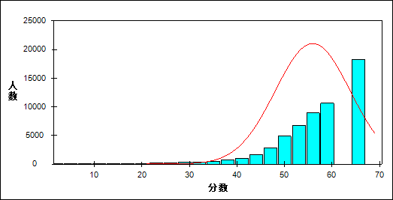

图 3 客观题难度曲线图

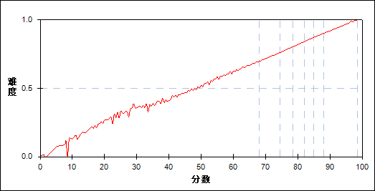

表 8 客观题分组分析表

| 分值 | G1 | G2 | G3 | G4 | G5 | G6 | G7 | 人数 | 比率(%) | 平均分 |
| --- | --- | --- | --- | --- | --- | --- | --- | --- | --- | --- |
| 0.0～ | 19 | 0 | 0 | 0 | 0 | 0 | 0 | 19 | 0.03 | 0.55 |
| 1.0～ | 2 | 0 | 0 | 0 | 0 | 0 | 0 | 2 | 0.00 | 1.00 |
| 5.0～ | 1 | 0 | 0 | 0 | 0 | 0 | 0 | 1 | 0.00 | 5.00 |
| 6.0～ | 1 | 0 | 0 | 0 | 0 | 0 | 0 | 1 | 0.00 | 7.50 |
| 8.0～ | 3 | 0 | 0 | 0 | 0 | 0 | 0 | 3 | 0.01 | 9.17 |
| 9.0～ | 2 | 0 | 0 | 0 | 0 | 0 | 0 | 2 | 0.00 | 9.50 |
| 10.0～ | 3 | 0 | 0 | 0 | 0 | 0 | 0 | 3 | 0.01 | 12.50 |
| 11.0～ | 5 | 0 | 0 | 0 | 0 | 0 | 0 | 5 | 0.01 | 14.00 |
| 12.0～ | 4 | 0 | 0 | 0 | 0 | 0 | 0 | 4 | 0.01 | 18.00 |
| 13.0～ | 9 | 0 | 0 | 0 | 0 | 0 | 0 | 9 | 0.02 | 14.28 |
| 14.0～ | 6 | 0 | 0 | 0 | 0 | 0 | 0 | 6 | 0.01 | 20.17 |
| 15.0～ | 11 | 0 | 0 | 0 | 0 | 0 | 0 | 11 | 0.02 | 17.64 |
| 16.0～ | 17 | 0 | 0 | 0 | 0 | 0 | 0 | 17 | 0.03 | 18.94 |
| 17.0～ | 27 | 0 | 0 | 0 | 0 | 0 | 0 | 27 | 0.05 | 20.76 |
| 18.0～ | 22 | 0 | 0 | 0 | 0 | 0 | 0 | 22 | 0.04 | 23.16 |
| 19.0～ | 25 | 0 | 0 | 0 | 0 | 0 | 0 | 25 | 0.04 | 24.88 |
| 20.0～ | 27 | 0 | 0 | 0 | 0 | 0 | 0 | 27 | 0.05 | 24.89 |
| 21.0～ | 37 | 0 | 0 | 0 | 0 | 0 | 0 | 37 | 0.06 | 27.46 |
| 22.0～ | 52 | 0 | 0 | 0 | 0 | 0 | 0 | 52 | 0.09 | 29.31 |
| 23.0～ | 51 | 0 | 0 | 0 | 0 | 0 | 0 | 51 | 0.09 | 30.50 |
| 24.0～ | 58 | 0 | 0 | 0 | 0 | 0 | 0 | 58 | 0.10 | 33.34 |
| 25.0～ | 61 | 0 | 0 | 0 | 0 | 0 | 0 | 61 | 0.11 | 33.37 |
| 26.0～ | 45 | 0 | 0 | 0 | 0 | 0 | 0 | 45 | 0.08 | 35.07 |
| 27.0～ | 58 | 0 | 0 | 0 | 0 | 0 | 0 | 58 | 0.10 | 37.12 |
| 28.0～ | 89 | 0 | 0 | 0 | 0 | 0 | 0 | 89 | 0.16 | 38.22 |
| 29.0～ | 91 | 0 | 0 | 0 | 0 | 0 | 0 | 91 | 0.16 | 40.34 |
| 30.0～ | 109 | 0 | 0 | 0 | 0 | 0 | 0 | 109 | 0.19 | 42.71 |
| 31.0～ | 112 | 0 | 0 | 0 | 0 | 0 | 0 | 112 | 0.20 | 42.95 |
| 32.0～ | 127 | 0 | 0 | 0 | 0 | 0 | 0 | 127 | 0.22 | 45.24 |
| 33.0～ | 149 | 0 | 0 | 0 | 0 | 0 | 0 | 149 | 0.26 | 46.76 |
| 34.0～ | 119 | 0 | 0 | 0 | 0 | 0 | 0 | 119 | 0.21 | 47.97 |
| 35.0～ | 174 | 0 | 0 | 0 | 0 | 0 | 0 | 174 | 0.30 | 49.51 |
| 36.0～ | 182 | 0 | 0 | 0 | 0 | 0 | 0 | 182 | 0.32 | 50.82 |
| 37.0～ | 206 | 0 | 0 | 0 | 0 | 0 | 0 | 206 | 0.36 | 52.11 |
| 38.0～ | 230 | 0 | 0 | 0 | 0 | 0 | 0 | 230 | 0.40 | 53.78 |
| 39.0～ | 266 | 0 | 0 | 0 | 0 | 0 | 0 | 266 | 0.46 | 55.41 |
| 40.0～ | 307 | 0 | 0 | 0 | 0 | 0 | 0 | 307 | 0.54 | 56.66 |
| 41.0～ | 341 | 0 | 0 | 0 | 0 | 0 | 0 | 341 | 0.60 | 57.99 |
| 42.0～ | 391 | 2 | 0 | 0 | 0 | 0 | 0 | 393 | 0.69 | 59.77 |
| 43.0～ | 481 | 1 | 0 | 0 | 0 | 0 | 0 | 482 | 0.84 | 60.96 |
| 44.0～ | 500 | 8 | 0 | 0 | 0 | 0 | 0 | 508 | 0.89 | 62.17 |
| 45.0～ | 632 | 30 | 0 | 0 | 0 | 0 | 0 | 662 | 1.16 | 63.47 |
| 46.0～ | 604 | 110 | 0 | 0 | 0 | 0 | 0 | 714 | 1.25 | 64.94 |
| 47.0～ | 633 | 322 | 0 | 0 | 0 | 0 | 0 | 955 | 1.67 | 66.30 |
| 48.0～ | 572 | 546 | 1 | 0 | 0 | 0 | 0 | 1119 | 1.95 | 67.24 |
| 49.0～ | 482 | 936 | 6 | 0 | 0 | 0 | 0 | 1424 | 2.49 | 68.54 |
| 50.0～ | 346 | 1209 | 50 | 0 | 0 | 0 | 0 | 1605 | 2.80 | 69.77 |
| 51.0～ | 189 | 1399 | 223 | 0 | 0 | 0 | 0 | 1811 | 3.16 | 71.49 |
| 52.0～ | 120 | 1341 | 590 | 5 | 0 | 0 | 0 | 2056 | 3.59 | 72.66 |
| 53.0～ | 58 | 965 | 1160 | 39 | 0 | 0 | 0 | 2222 | 3.88 | 74.18 |
| 54.0～ | 40 | 624 | 1620 | 203 | 0 | 0 | 0 | 2487 | 4.34 | 75.49 |
| 55.0～ | 28 | 323 | 1710 | 674 | 9 | 0 | 0 | 2744 | 4.79 | 76.84 |
| 56.0～ | 14 | 166 | 1321 | 1397 | 76 | 0 | 0 | 2974 | 5.19 | 78.16 |
| 57.0～ | 18 | 90 | 806 | 1900 | 363 | 2 | 0 | 3179 | 5.55 | 79.36 |
| 58.0～ | 9 | 49 | 383 | 1789 | 1137 | 39 | 0 | 3406 | 5.95 | 80.77 |
| 59.0～ | 11 | 31 | 191 | 1206 | 1892 | 230 | 0 | 3561 | 6.22 | 81.96 |
| 60.0～ | 3 | 14 | 69 | 614 | 2067 | 880 | 13 | 3660 | 6.39 | 83.37 |
| 61.0～ | 3 | 6 | 37 | 229 | 1559 | 2002 | 136 | 3972 | 6.93 | 84.75 |
| 62.0～ | 2 | 3 | 12 | 85 | 743 | 2302 | 637 | 3784 | 6.61 | 86.07 |
| 63.0～ | 0 | 6 | 3 | 28 | 257 | 1715 | 1544 | 3553 | 6.20 | 87.36 |
| 64.0～ | 0 | 1 | 1 | 11 | 63 | 759 | 2082 | 2917 | 5.09 | 88.65 |
| 65.0～ | 0 | 1 | 0 | 1 | 13 | 211 | 1832 | 2058 | 3.59 | 89.84 |
| 66.0～ | 0 | 1 | 0 | 3 | 2 | 38 | 1173 | 1217 | 2.12 | 90.99 |
| 67.0～ | 0 | 0 | 0 | 0 | 2 | 3 | 502 | 507 | 0.89 | 92.17 |
| 68.0～ | 0 | 0 | 1 | 0 | 0 | 2 | 194 | 197 | 0.34 | 93.20 |
| 69.0～ | 0 | 0 | 0 | 0 | 0 | 0 | 53 | 53 | 0.09 | 94.14 |
| 70.0～ | 0 | 0 | 0 | 0 | 0 | 0 | 17 | 17 | 0.03 | 96.00 |
| 合计 | 8184 | 8184 | 8184 | 8184 | 8183 | 8183 | 8183 | 57285 | 100.00 | 77.89 |
| 得分率 | 0.60 | 0.73 | 0.78 | 0.82 | 0.85 | 0.88 | 0.92 | - | - | - |

表 9 客观题等级分析表

| 分值 | 优秀 | | 良好 | | 合格 | | 不合格 | | 全体 | |
| --- | --- | --- | --- | --- | --- | --- | --- | --- | --- | --- |
| 人数 | 比率 | 人数 | 比率 | 人数 | 比率 | 人数 | 比率 | 人数 | 比率 |
| 0.0～ | 0 | 0.0 | 0 | 0.0 | 0 | 0.0 | 19 | 100.0 | 19 | 100.0 |
| 1.0～ | 0 | 0.0 | 0 | 0.0 | 0 | 0.0 | 2 | 100.0 | 2 | 100.0 |
| 5.0～ | 0 | 0.0 | 0 | 0.0 | 0 | 0.0 | 1 | 100.0 | 1 | 100.0 |
| 6.0～ | 0 | 0.0 | 0 | 0.0 | 0 | 0.0 | 1 | 100.0 | 1 | 100.0 |
| 8.0～ | 0 | 0.0 | 0 | 0.0 | 0 | 0.0 | 3 | 100.0 | 3 | 100.0 |
| 9.0～ | 0 | 0.0 | 0 | 0.0 | 0 | 0.0 | 2 | 100.0 | 2 | 100.0 |
| 10.0～ | 0 | 0.0 | 0 | 0.0 | 0 | 0.0 | 3 | 100.0 | 3 | 100.0 |
| 11.0～ | 0 | 0.0 | 0 | 0.0 | 0 | 0.0 | 5 | 100.0 | 5 | 100.0 |
| 12.0～ | 0 | 0.0 | 0 | 0.0 | 0 | 0.0 | 4 | 100.0 | 4 | 100.0 |
| 13.0～ | 0 | 0.0 | 0 | 0.0 | 0 | 0.0 | 9 | 100.0 | 9 | 100.0 |
| 14.0～ | 0 | 0.0 | 0 | 0.0 | 0 | 0.0 | 6 | 100.0 | 6 | 100.0 |
| 15.0～ | 0 | 0.0 | 0 | 0.0 | 0 | 0.0 | 11 | 100.0 | 11 | 100.0 |
| 16.0～ | 0 | 0.0 | 0 | 0.0 | 0 | 0.0 | 17 | 100.0 | 17 | 100.0 |
| 17.0～ | 0 | 0.0 | 0 | 0.0 | 0 | 0.0 | 27 | 100.0 | 27 | 100.0 |
| 18.0～ | 0 | 0.0 | 0 | 0.0 | 0 | 0.0 | 22 | 100.0 | 22 | 100.0 |
| 19.0～ | 0 | 0.0 | 0 | 0.0 | 0 | 0.0 | 25 | 100.0 | 25 | 100.0 |
| 20.0～ | 0 | 0.0 | 0 | 0.0 | 0 | 0.0 | 27 | 100.0 | 27 | 100.0 |
| 21.0～ | 0 | 0.0 | 0 | 0.0 | 0 | 0.0 | 37 | 100.0 | 37 | 100.0 |
| 22.0～ | 0 | 0.0 | 0 | 0.0 | 0 | 0.0 | 52 | 100.0 | 52 | 100.0 |
| 23.0～ | 0 | 0.0 | 0 | 0.0 | 0 | 0.0 | 51 | 100.0 | 51 | 100.0 |
| 24.0～ | 0 | 0.0 | 0 | 0.0 | 0 | 0.0 | 58 | 100.0 | 58 | 100.0 |
| 25.0～ | 0 | 0.0 | 0 | 0.0 | 0 | 0.0 | 61 | 100.0 | 61 | 100.0 |
| 26.0～ | 0 | 0.0 | 0 | 0.0 | 0 | 0.0 | 45 | 100.0 | 45 | 100.0 |
| 27.0～ | 0 | 0.0 | 0 | 0.0 | 0 | 0.0 | 58 | 100.0 | 58 | 100.0 |
| 28.0～ | 0 | 0.0 | 0 | 0.0 | 0 | 0.0 | 89 | 100.0 | 89 | 100.0 |
| 29.0～ | 0 | 0.0 | 0 | 0.0 | 0 | 0.0 | 91 | 100.0 | 91 | 100.0 |
| 30.0～ | 0 | 0.0 | 0 | 0.0 | 0 | 0.0 | 109 | 100.0 | 109 | 100.0 |
| 31.0～ | 0 | 0.0 | 0 | 0.0 | 0 | 0.0 | 112 | 100.0 | 112 | 100.0 |
| 32.0～ | 0 | 0.0 | 0 | 0.0 | 0 | 0.0 | 127 | 100.0 | 127 | 100.0 |
| 33.0～ | 0 | 0.0 | 0 | 0.0 | 0 | 0.0 | 149 | 100.0 | 149 | 100.0 |
| 34.0～ | 0 | 0.0 | 0 | 0.0 | 0 | 0.0 | 119 | 100.0 | 119 | 100.0 |
| 35.0～ | 0 | 0.0 | 0 | 0.0 | 0 | 0.0 | 174 | 100.0 | 174 | 100.0 |
| 36.0～ | 0 | 0.0 | 0 | 0.0 | 0 | 0.0 | 182 | 100.0 | 182 | 100.0 |
| 37.0～ | 0 | 0.0 | 0 | 0.0 | 3 | 1.5 | 203 | 98.5 | 206 | 100.0 |
| 38.0～ | 0 | 0.0 | 0 | 0.0 | 13 | 5.7 | 217 | 94.3 | 230 | 100.0 |
| 39.0～ | 0 | 0.0 | 0 | 0.0 | 22 | 8.3 | 244 | 91.7 | 266 | 100.0 |
| 40.0～ | 0 | 0.0 | 0 | 0.0 | 66 | 21.5 | 241 | 78.5 | 307 | 100.0 |
| 41.0～ | 0 | 0.0 | 0 | 0.0 | 120 | 35.2 | 221 | 64.8 | 341 | 100.0 |
| 42.0～ | 0 | 0.0 | 0 | 0.0 | 213 | 54.2 | 180 | 45.8 | 393 | 100.0 |
| 43.0～ | 0 | 0.0 | 0 | 0.0 | 337 | 69.9 | 145 | 30.1 | 482 | 100.0 |
| 44.0～ | 0 | 0.0 | 0 | 0.0 | 419 | 82.5 | 89 | 17.5 | 508 | 100.0 |
| 45.0～ | 0 | 0.0 | 2 | 0.3 | 584 | 88.2 | 76 | 11.5 | 662 | 100.0 |
| 46.0～ | 0 | 0.0 | 20 | 2.8 | 643 | 90.1 | 51 | 7.1 | 714 | 100.0 |
| 47.0～ | 0 | 0.0 | 100 | 10.5 | 813 | 85.1 | 42 | 4.4 | 955 | 100.0 |
| 48.0～ | 0 | 0.0 | 279 | 24.9 | 790 | 70.6 | 50 | 4.5 | 1119 | 100.0 |
| 49.0～ | 0 | 0.0 | 591 | 41.5 | 792 | 55.6 | 41 | 2.9 | 1424 | 100.0 |
| 50.0～ | 0 | 0.0 | 975 | 60.7 | 590 | 36.8 | 40 | 2.5 | 1605 | 100.0 |
| 51.0～ | 0 | 0.0 | 1440 | 79.5 | 356 | 19.7 | 15 | 0.8 | 1811 | 100.0 |
| 52.0～ | 0 | 0.0 | 1806 | 87.8 | 235 | 11.4 | 15 | 0.7 | 2056 | 100.0 |
| 53.0～ | 0 | 0.0 | 2105 | 94.7 | 107 | 4.8 | 10 | 0.5 | 2222 | 100.0 |
| 54.0～ | 0 | 0.0 | 2418 | 97.2 | 68 | 2.7 | 1 | 0.0 | 2487 | 100.0 |
| 55.0～ | 0 | 0.0 | 2692 | 98.1 | 47 | 1.7 | 5 | 0.2 | 2744 | 100.0 |
| 56.0～ | 0 | 0.0 | 2955 | 99.4 | 18 | 0.6 | 1 | 0.0 | 2974 | 100.0 |
| 57.0～ | 2 | 0.1 | 3151 | 99.1 | 25 | 0.8 | 1 | 0.0 | 3179 | 100.0 |
| 58.0～ | 41 | 1.2 | 3353 | 98.4 | 12 | 0.4 | 0 | 0.0 | 3406 | 100.0 |
| 59.0～ | 251 | 7.0 | 3292 | 92.4 | 18 | 0.5 | 0 | 0.0 | 3561 | 100.0 |
| 60.0～ | 937 | 25.6 | 2717 | 74.2 | 6 | 0.2 | 0 | 0.0 | 3660 | 100.0 |
| 61.0～ | 2203 | 55.5 | 1764 | 44.4 | 5 | 0.1 | 0 | 0.0 | 3972 | 100.0 |
| 62.0～ | 3005 | 79.4 | 777 | 20.5 | 2 | 0.1 | 0 | 0.0 | 3784 | 100.0 |
| 63.0～ | 3286 | 92.5 | 267 | 7.5 | 0 | 0.0 | 0 | 0.0 | 3553 | 100.0 |
| 64.0～ | 2844 | 97.5 | 73 | 2.5 | 0 | 0.0 | 0 | 0.0 | 2917 | 100.0 |
| 65.0～ | 2047 | 99.5 | 11 | 0.5 | 0 | 0.0 | 0 | 0.0 | 2058 | 100.0 |
| 66.0～ | 1211 | 99.5 | 6 | 0.5 | 0 | 0.0 | 0 | 0.0 | 1217 | 100.0 |
| 67.0～ | 505 | 99.6 | 2 | 0.4 | 0 | 0.0 | 0 | 0.0 | 507 | 100.0 |
| 68.0～ | 196 | 99.5 | 1 | 0.5 | 0 | 0.0 | 0 | 0.0 | 197 | 100.0 |
| 69.0～ | 53 | 100.0 | 0 | 0.0 | 0 | 0.0 | 0 | 0.0 | 53 | 100.0 |
| 70.0～ | 17 | 100.0 | 0 | 0.0 | 0 | 0.0 | 0 | 0.0 | 17 | 100.0 |
| 合计 | 16598 | 29.0 | 30797 | 53.8 | 6304 | 11.0 | 3586 | 6.3 | 57285 | 100.0 |

* + 1. 主观题

本题组共包含8道试题，题号是：17～20、63～66

表 10 主观题总分分析表

|  |  |  |  |  |  |  |  |  |
| --- | --- | --- | --- | --- | --- | --- | --- | --- |
| 人数 | 满分 | 最大值 | 最小值 | 平均值 | 标准差 | 差异系数 | 难度 | 区分度 |
| 57285 | 30 | 30.0 | 0.0 | 21.96 | 3.91 | 0.18 | 0.73 | 0.87 |

表 11 主观题等级得分率分析表

|  |  |  |  |  |
| --- | --- | --- | --- | --- |
| 优秀 | 良好 | 合格 | 不及格 | 全体 |
| 0.83 | 0.74 | 0.61 | 0.42 | 0.73 |

图 4 主观题分数分布曲线图

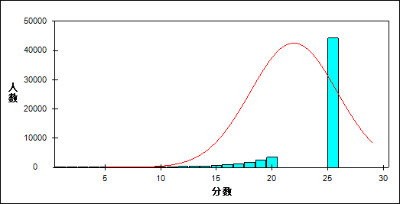

图 5 主观题难度曲线图

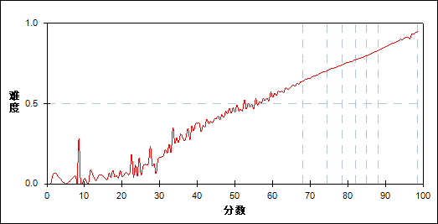

表 12 主观题分组分析表

| 分值 | G1 | G2 | G3 | G4 | G5 | G6 | G7 | 人数 | 比率(%) | 平均分 |
| --- | --- | --- | --- | --- | --- | --- | --- | --- | --- | --- |
| 0.0～ | 99 | 0 | 0 | 0 | 0 | 0 | 0 | 99 | 0.17 | 19.44 |
| 0.5～ | 3 | 0 | 0 | 0 | 0 | 0 | 0 | 3 | 0.01 | 20.83 |
| 1.0～ | 121 | 0 | 0 | 0 | 0 | 0 | 0 | 121 | 0.21 | 26.63 |
| 1.5～ | 10 | 0 | 0 | 0 | 0 | 0 | 0 | 10 | 0.02 | 25.90 |
| 2.0～ | 99 | 0 | 0 | 0 | 0 | 0 | 0 | 99 | 0.17 | 32.57 |
| 2.5～ | 12 | 0 | 0 | 0 | 0 | 0 | 0 | 12 | 0.02 | 33.75 |
| 3.0～ | 49 | 0 | 0 | 0 | 0 | 0 | 0 | 49 | 0.09 | 34.76 |
| 3.5～ | 21 | 0 | 0 | 0 | 0 | 0 | 0 | 21 | 0.04 | 36.07 |
| 4.0～ | 92 | 0 | 0 | 0 | 0 | 0 | 0 | 92 | 0.16 | 47.09 |
| 4.5～ | 20 | 0 | 0 | 0 | 0 | 0 | 0 | 20 | 0.03 | 43.60 |
| 5.0～ | 46 | 0 | 0 | 0 | 0 | 0 | 0 | 46 | 0.08 | 44.09 |
| 5.5～ | 29 | 1 | 0 | 0 | 0 | 0 | 0 | 30 | 0.05 | 39.03 |
| 6.0～ | 51 | 0 | 0 | 0 | 0 | 0 | 0 | 51 | 0.09 | 44.96 |
| 6.5～ | 20 | 0 | 0 | 0 | 0 | 0 | 0 | 20 | 0.03 | 48.60 |
| 7.0～ | 57 | 1 | 0 | 0 | 0 | 0 | 0 | 58 | 0.10 | 45.91 |
| 7.5～ | 32 | 0 | 0 | 0 | 0 | 0 | 0 | 32 | 0.06 | 50.75 |
| 8.0～ | 74 | 2 | 0 | 0 | 0 | 0 | 0 | 76 | 0.13 | 50.57 |
| 8.5～ | 31 | 2 | 0 | 0 | 0 | 0 | 0 | 33 | 0.06 | 48.35 |
| 9.0～ | 79 | 8 | 0 | 0 | 0 | 0 | 0 | 87 | 0.15 | 50.16 |
| 9.5～ | 36 | 3 | 0 | 0 | 0 | 0 | 0 | 39 | 0.07 | 52.96 |
| 10.0～ | 85 | 1 | 1 | 0 | 0 | 0 | 0 | 87 | 0.15 | 49.51 |
| 10.5～ | 51 | 2 | 0 | 0 | 0 | 0 | 0 | 53 | 0.09 | 52.24 |
| 11.0～ | 144 | 11 | 1 | 0 | 0 | 0 | 0 | 156 | 0.27 | 50.46 |
| 11.5～ | 99 | 7 | 1 | 0 | 0 | 0 | 0 | 107 | 0.19 | 52.44 |
| 12.0～ | 187 | 14 | 0 | 0 | 0 | 0 | 0 | 201 | 0.35 | 51.89 |
| 12.5～ | 114 | 9 | 0 | 0 | 0 | 0 | 0 | 123 | 0.21 | 54.23 |
| 13.0～ | 266 | 11 | 1 | 0 | 0 | 0 | 0 | 278 | 0.49 | 53.32 |
| 13.5～ | 150 | 13 | 1 | 0 | 0 | 0 | 0 | 164 | 0.29 | 55.35 |
| 14.0～ | 272 | 44 | 4 | 1 | 0 | 0 | 0 | 321 | 0.56 | 57.36 |
| 14.5～ | 217 | 39 | 9 | 1 | 0 | 0 | 0 | 266 | 0.46 | 60.08 |
| 15.0～ | 400 | 52 | 13 | 0 | 0 | 0 | 0 | 465 | 0.81 | 58.68 |
| 15.5～ | 261 | 44 | 13 | 3 | 0 | 0 | 0 | 321 | 0.56 | 60.97 |
| 16.0～ | 459 | 118 | 22 | 6 | 2 | 0 | 0 | 607 | 1.06 | 62.47 |
| 16.5～ | 345 | 118 | 22 | 6 | 0 | 0 | 0 | 491 | 0.86 | 63.59 |
| 17.0～ | 472 | 220 | 52 | 7 | 0 | 0 | 0 | 751 | 1.31 | 64.66 |
| 17.5～ | 412 | 204 | 53 | 16 | 0 | 0 | 0 | 685 | 1.20 | 65.55 |
| 18.0～ | 536 | 347 | 103 | 30 | 6 | 0 | 0 | 1022 | 1.78 | 66.97 |
| 18.5～ | 384 | 392 | 154 | 42 | 8 | 1 | 0 | 981 | 1.71 | 69.18 |
| 19.0～ | 485 | 592 | 254 | 93 | 17 | 3 | 0 | 1444 | 2.52 | 69.98 |
| 19.5～ | 370 | 614 | 330 | 112 | 25 | 7 | 0 | 1458 | 2.55 | 71.41 |
| 20.0～ | 417 | 858 | 456 | 231 | 87 | 11 | 0 | 2060 | 3.60 | 72.50 |
| 20.5～ | 304 | 736 | 621 | 352 | 109 | 21 | 0 | 2143 | 3.74 | 74.01 |
| 21.0～ | 268 | 856 | 804 | 485 | 238 | 49 | 5 | 2705 | 4.72 | 75.18 |
| 21.5～ | 187 | 762 | 929 | 664 | 340 | 99 | 7 | 2988 | 5.22 | 76.47 |
| 22.0～ | 149 | 766 | 1007 | 818 | 580 | 257 | 38 | 3615 | 6.31 | 77.78 |
| 22.5～ | 70 | 465 | 976 | 1111 | 804 | 382 | 55 | 3863 | 6.74 | 79.43 |
| 23.0～ | 54 | 398 | 852 | 1036 | 1120 | 707 | 181 | 4348 | 7.59 | 80.62 |
| 23.5～ | 21 | 221 | 638 | 1120 | 1184 | 896 | 268 | 4348 | 7.59 | 81.99 |
| 24.0～ | 15 | 145 | 430 | 808 | 1195 | 1257 | 652 | 4502 | 7.86 | 83.29 |
| 24.5～ | 5 | 62 | 222 | 608 | 981 | 1321 | 841 | 4040 | 7.05 | 84.74 |
| 25.0～ | 1 | 30 | 131 | 314 | 701 | 1188 | 1209 | 3574 | 6.24 | 85.71 |
| 25.5～ | 1 | 6 | 57 | 183 | 446 | 934 | 1152 | 2779 | 4.85 | 86.91 |
| 26.0～ | 1 | 5 | 23 | 89 | 196 | 571 | 1331 | 2216 | 3.87 | 87.96 |
| 26.5～ | 1 | 3 | 2 | 38 | 103 | 289 | 924 | 1360 | 2.37 | 88.90 |
| 27.0～ | 0 | 1 | 2 | 8 | 32 | 128 | 802 | 973 | 1.70 | 89.88 |
| 27.5～ | 0 | 0 | 0 | 2 | 6 | 47 | 427 | 482 | 0.84 | 90.79 |
| 28.0～ | 0 | 1 | 0 | 0 | 3 | 14 | 204 | 222 | 0.39 | 91.38 |
| 28.5～ | 0 | 0 | 0 | 0 | 0 | 0 | 67 | 67 | 0.12 | 92.68 |
| 29.0～ | 0 | 0 | 0 | 0 | 0 | 1 | 19 | 20 | 0.03 | 92.50 |
| 30.0～ | 0 | 0 | 0 | 0 | 0 | 0 | 1 | 1 | 0.00 | 97.00 |
| 合计 | 8184 | 8184 | 8184 | 8184 | 8183 | 8183 | 8183 | 57285 | 100.00 | 77.89 |
| 得分率 | 0.52 | 0.68 | 0.72 | 0.76 | 0.78 | 0.81 | 0.85 | - | - | - |

表 13 主观题等级分析表

| 分值 | 优秀 | | 良好 | | 合格 | | 不合格 | | 全体 | |
| --- | --- | --- | --- | --- | --- | --- | --- | --- | --- | --- |
| 人数 | 比率 | 人数 | 比率 | 人数 | 比率 | 人数 | 比率 | 人数 | 比率 |
| 0.0～ | 0 | 0.0 | 0 | 0.0 | 0 | 0.0 | 99 | 100.0 | 99 | 100.0 |
| 0.5～ | 0 | 0.0 | 0 | 0.0 | 0 | 0.0 | 3 | 100.0 | 3 | 100.0 |
| 1.0～ | 0 | 0.0 | 0 | 0.0 | 0 | 0.0 | 121 | 100.0 | 121 | 100.0 |
| 1.5～ | 0 | 0.0 | 0 | 0.0 | 0 | 0.0 | 10 | 100.0 | 10 | 100.0 |
| 2.0～ | 0 | 0.0 | 0 | 0.0 | 2 | 2.0 | 97 | 98.0 | 99 | 100.0 |
| 2.5～ | 0 | 0.0 | 0 | 0.0 | 0 | 0.0 | 12 | 100.0 | 12 | 100.0 |
| 3.0～ | 0 | 0.0 | 0 | 0.0 | 3 | 6.1 | 46 | 93.9 | 49 | 100.0 |
| 3.5～ | 0 | 0.0 | 0 | 0.0 | 1 | 4.8 | 20 | 95.2 | 21 | 100.0 |
| 4.0～ | 0 | 0.0 | 0 | 0.0 | 11 | 12.0 | 81 | 88.0 | 92 | 100.0 |
| 4.5～ | 0 | 0.0 | 0 | 0.0 | 1 | 5.0 | 19 | 95.0 | 20 | 100.0 |
| 5.0～ | 0 | 0.0 | 0 | 0.0 | 7 | 15.2 | 39 | 84.8 | 46 | 100.0 |
| 5.5～ | 0 | 0.0 | 1 | 3.3 | 2 | 6.7 | 27 | 90.0 | 30 | 100.0 |
| 6.0～ | 0 | 0.0 | 0 | 0.0 | 3 | 5.9 | 48 | 94.1 | 51 | 100.0 |
| 6.5～ | 0 | 0.0 | 0 | 0.0 | 4 | 20.0 | 16 | 80.0 | 20 | 100.0 |
| 7.0～ | 0 | 0.0 | 1 | 1.7 | 6 | 10.3 | 51 | 87.9 | 58 | 100.0 |
| 7.5～ | 0 | 0.0 | 0 | 0.0 | 4 | 12.5 | 28 | 87.5 | 32 | 100.0 |
| 8.0～ | 0 | 0.0 | 1 | 1.3 | 14 | 18.4 | 61 | 80.3 | 76 | 100.0 |
| 8.5～ | 0 | 0.0 | 0 | 0.0 | 7 | 21.2 | 26 | 78.8 | 33 | 100.0 |
| 9.0～ | 0 | 0.0 | 3 | 3.4 | 14 | 16.1 | 70 | 80.5 | 87 | 100.0 |
| 9.5～ | 0 | 0.0 | 1 | 2.6 | 12 | 30.8 | 26 | 66.7 | 39 | 100.0 |
| 10.0～ | 0 | 0.0 | 1 | 1.1 | 21 | 24.1 | 65 | 74.7 | 87 | 100.0 |
| 10.5～ | 0 | 0.0 | 0 | 0.0 | 17 | 32.1 | 36 | 67.9 | 53 | 100.0 |
| 11.0～ | 0 | 0.0 | 8 | 5.1 | 30 | 19.2 | 118 | 75.6 | 156 | 100.0 |
| 11.5～ | 0 | 0.0 | 6 | 5.6 | 22 | 20.6 | 79 | 73.8 | 107 | 100.0 |
| 12.0～ | 0 | 0.0 | 12 | 6.0 | 45 | 22.4 | 144 | 71.6 | 201 | 100.0 |
| 12.5～ | 0 | 0.0 | 6 | 4.9 | 35 | 28.5 | 82 | 66.7 | 123 | 100.0 |
| 13.0～ | 0 | 0.0 | 8 | 2.9 | 81 | 29.1 | 189 | 68.0 | 278 | 100.0 |
| 13.5～ | 0 | 0.0 | 9 | 5.5 | 45 | 27.4 | 110 | 67.1 | 164 | 100.0 |
| 14.0～ | 0 | 0.0 | 33 | 10.3 | 110 | 34.3 | 178 | 55.5 | 321 | 100.0 |
| 14.5～ | 0 | 0.0 | 32 | 12.0 | 111 | 41.7 | 123 | 46.2 | 266 | 100.0 |
| 15.0～ | 0 | 0.0 | 54 | 11.6 | 177 | 38.1 | 234 | 50.3 | 465 | 100.0 |
| 15.5～ | 0 | 0.0 | 46 | 14.3 | 141 | 43.9 | 134 | 41.7 | 321 | 100.0 |
| 16.0～ | 0 | 0.0 | 113 | 18.6 | 296 | 48.8 | 198 | 32.6 | 607 | 100.0 |
| 16.5～ | 0 | 0.0 | 93 | 18.9 | 258 | 52.5 | 140 | 28.5 | 491 | 100.0 |
| 17.0～ | 0 | 0.0 | 209 | 27.8 | 364 | 48.5 | 178 | 23.7 | 751 | 100.0 |
| 17.5～ | 0 | 0.0 | 191 | 27.9 | 337 | 49.2 | 157 | 22.9 | 685 | 100.0 |
| 18.0～ | 0 | 0.0 | 390 | 38.2 | 484 | 47.4 | 148 | 14.5 | 1022 | 100.0 |
| 18.5～ | 1 | 0.1 | 471 | 48.0 | 421 | 42.9 | 88 | 9.0 | 981 | 100.0 |
| 19.0～ | 3 | 0.2 | 801 | 55.5 | 556 | 38.5 | 84 | 5.8 | 1444 | 100.0 |
| 19.5～ | 7 | 0.5 | 922 | 63.2 | 477 | 32.7 | 52 | 3.6 | 1458 | 100.0 |
| 20.0～ | 15 | 0.7 | 1476 | 71.7 | 511 | 24.8 | 58 | 2.8 | 2060 | 100.0 |
| 20.5～ | 21 | 1.0 | 1639 | 76.5 | 445 | 20.8 | 38 | 1.8 | 2143 | 100.0 |
| 21.0～ | 57 | 2.1 | 2251 | 83.2 | 378 | 14.0 | 19 | 0.7 | 2705 | 100.0 |
| 21.5～ | 106 | 3.5 | 2556 | 85.5 | 311 | 10.4 | 15 | 0.5 | 2988 | 100.0 |
| 22.0～ | 322 | 8.9 | 3052 | 84.4 | 234 | 6.5 | 7 | 0.2 | 3615 | 100.0 |
| 22.5～ | 437 | 11.3 | 3284 | 85.0 | 139 | 3.6 | 3 | 0.1 | 3863 | 100.0 |
| 23.0～ | 954 | 21.9 | 3310 | 76.1 | 81 | 1.9 | 3 | 0.1 | 4348 | 100.0 |
| 23.5～ | 1164 | 26.8 | 3139 | 72.2 | 43 | 1.0 | 2 | 0.0 | 4348 | 100.0 |
| 24.0～ | 1974 | 43.8 | 2504 | 55.6 | 21 | 0.5 | 3 | 0.1 | 4502 | 100.0 |
| 24.5～ | 2162 | 53.5 | 1866 | 46.2 | 12 | 0.3 | 0 | 0.0 | 4040 | 100.0 |
| 25.0～ | 2441 | 68.3 | 1130 | 31.6 | 2 | 0.1 | 1 | 0.0 | 3574 | 100.0 |
| 25.5～ | 2086 | 75.1 | 690 | 24.8 | 3 | 0.1 | 0 | 0.0 | 2779 | 100.0 |
| 26.0～ | 1923 | 86.8 | 290 | 13.1 | 3 | 0.1 | 0 | 0.0 | 2216 | 100.0 |
| 26.5～ | 1213 | 89.2 | 146 | 10.7 | 1 | 0.1 | 0 | 0.0 | 1360 | 100.0 |
| 27.0～ | 932 | 95.8 | 40 | 4.1 | 1 | 0.1 | 0 | 0.0 | 973 | 100.0 |
| 27.5～ | 474 | 98.3 | 8 | 1.7 | 0 | 0.0 | 0 | 0.0 | 482 | 100.0 |
| 28.0～ | 218 | 98.2 | 4 | 1.8 | 0 | 0.0 | 0 | 0.0 | 222 | 100.0 |
| 28.5～ | 67 | 100.0 | 0 | 0.0 | 0 | 0.0 | 0 | 0.0 | 67 | 100.0 |
| 29.0～ | 20 | 100.0 | 0 | 0.0 | 0 | 0.0 | 0 | 0.0 | 20 | 100.0 |
| 30.0～ | 1 | 100.0 | 0 | 0.0 | 0 | 0.0 | 0 | 0.0 | 1 | 100.0 |
| 合计 | 16598 | 29.0 | 30797 | 53.8 | 6304 | 11.0 | 3586 | 6.3 | 57285 | 100.0 |

* 1. 组块分析
     1. 知识组块

本题组共包含30道试题，题号是：21～50

表 14 知识组块总分分析表

|  |  |  |  |  |  |  |  |  |
| --- | --- | --- | --- | --- | --- | --- | --- | --- |
| 人数 | 满分 | 最大值 | 最小值 | 平均值 | 标准差 | 差异系数 | 难度 | 区分度 |
| 57285 | 34 | 34.0 | 0.0 | 26.89 | 4.05 | 0.15 | 0.79 | 0.89 |

表 15 知识组块等级得分率分析表

|  |  |  |  |  |
| --- | --- | --- | --- | --- |
| 优秀 | 良好 | 合格 | 不及格 | 全体 |
| 0.89 | 0.80 | 0.68 | 0.50 | 0.79 |

图 6 知识组块分数分布曲线图

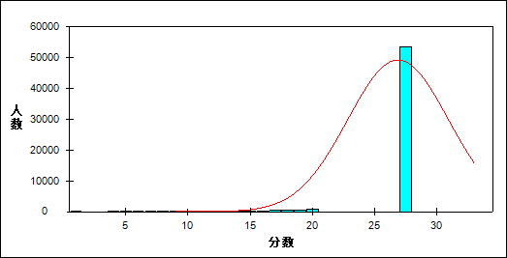

图 7 知识组块难度曲线图

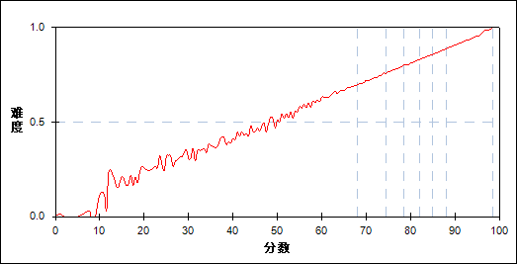

表 16 知识组块分组分析表

| 分值 | G1 | G2 | G3 | G4 | G5 | G6 | G7 | 人数 | 比率(%) | 平均分 |
| --- | --- | --- | --- | --- | --- | --- | --- | --- | --- | --- |
| 0.0～ | 28 | 0 | 0 | 0 | 0 | 0 | 0 | 28 | 0.05 | 3.79 |
| 1.0～ | 3 | 0 | 0 | 0 | 0 | 0 | 0 | 3 | 0.01 | 7.83 |
| 2.0～ | 2 | 0 | 0 | 0 | 0 | 0 | 0 | 2 | 0.00 | 13.75 |
| 3.0～ | 2 | 0 | 0 | 0 | 0 | 0 | 0 | 2 | 0.00 | 25.75 |
| 4.0～ | 12 | 0 | 0 | 0 | 0 | 0 | 0 | 12 | 0.02 | 18.63 |
| 5.0～ | 20 | 0 | 0 | 0 | 0 | 0 | 0 | 20 | 0.03 | 24.05 |
| 6.0～ | 25 | 0 | 0 | 0 | 0 | 0 | 0 | 25 | 0.04 | 21.42 |
| 7.0～ | 56 | 0 | 0 | 0 | 0 | 0 | 0 | 56 | 0.10 | 24.87 |
| 8.0～ | 43 | 0 | 0 | 0 | 0 | 0 | 0 | 43 | 0.08 | 29.14 |
| 9.0～ | 90 | 0 | 0 | 0 | 0 | 0 | 0 | 90 | 0.16 | 31.94 |
| 10.0～ | 87 | 0 | 0 | 0 | 0 | 0 | 0 | 87 | 0.15 | 32.95 |
| 11.0～ | 143 | 0 | 0 | 0 | 0 | 0 | 0 | 143 | 0.25 | 36.44 |
| 12.0～ | 156 | 0 | 0 | 0 | 0 | 0 | 0 | 156 | 0.27 | 40.40 |
| 13.0～ | 166 | 0 | 0 | 0 | 0 | 0 | 0 | 166 | 0.29 | 42.92 |
| 14.0～ | 192 | 0 | 0 | 0 | 0 | 0 | 0 | 192 | 0.34 | 45.41 |
| 15.0～ | 242 | 1 | 0 | 0 | 0 | 0 | 0 | 243 | 0.42 | 47.97 |
| 16.0～ | 303 | 2 | 0 | 0 | 0 | 0 | 0 | 305 | 0.53 | 50.77 |
| 17.0～ | 363 | 3 | 0 | 0 | 0 | 0 | 0 | 366 | 0.64 | 53.54 |
| 18.0～ | 480 | 20 | 0 | 0 | 0 | 0 | 0 | 500 | 0.87 | 56.70 |
| 19.0～ | 546 | 48 | 1 | 0 | 0 | 0 | 0 | 595 | 1.04 | 59.17 |
| 20.0～ | 681 | 139 | 6 | 0 | 0 | 0 | 0 | 826 | 1.44 | 61.66 |
| 21.0～ | 760 | 308 | 33 | 3 | 0 | 0 | 0 | 1104 | 1.93 | 64.30 |
| 22.0～ | 876 | 607 | 105 | 9 | 1 | 0 | 0 | 1598 | 2.79 | 66.69 |
| 23.0～ | 851 | 997 | 288 | 43 | 1 | 0 | 0 | 2180 | 3.81 | 68.82 |
| 24.0～ | 828 | 1424 | 680 | 177 | 20 | 1 | 0 | 3130 | 5.46 | 70.78 |
| 25.0～ | 526 | 1515 | 1245 | 514 | 109 | 9 | 0 | 3918 | 6.84 | 73.52 |
| 26.0～ | 322 | 1328 | 1647 | 1103 | 409 | 63 | 4 | 4876 | 8.51 | 75.90 |
| 27.0～ | 186 | 927 | 1737 | 1823 | 1069 | 326 | 28 | 6096 | 10.64 | 78.29 |
| 28.0～ | 114 | 546 | 1378 | 2071 | 2007 | 1099 | 173 | 7388 | 12.90 | 80.62 |
| 29.0～ | 50 | 219 | 723 | 1531 | 2316 | 2299 | 874 | 8012 | 13.99 | 83.23 |
| 30.0～ | 20 | 70 | 255 | 696 | 1535 | 2480 | 2095 | 7151 | 12.48 | 85.54 |
| 31.0～ | 9 | 22 | 64 | 169 | 576 | 1428 | 2637 | 4905 | 8.56 | 87.59 |
| 32.0～ | 1 | 4 | 17 | 31 | 114 | 402 | 1770 | 2339 | 4.08 | 89.37 |
| 33.0～ | 1 | 4 | 5 | 14 | 26 | 71 | 505 | 626 | 1.09 | 90.23 |
| 34.0～ | 0 | 0 | 0 | 0 | 0 | 5 | 97 | 102 | 0.18 | 92.68 |
| 合计 | 8184 | 8184 | 8184 | 8184 | 8183 | 8183 | 8183 | 57285 | 100.00 | 77.89 |
| 得分率 | 0.59 | 0.73 | 0.78 | 0.81 | 0.84 | 0.87 | 0.91 | - | - | - |

表 17 知识组块等级分析表

| 分值 | 优秀 | | 良好 | | 合格 | | 不合格 | | 全体 | |
| --- | --- | --- | --- | --- | --- | --- | --- | --- | --- | --- |
| 人数 | 比率 | 人数 | 比率 | 人数 | 比率 | 人数 | 比率 | 人数 | 比率 |
| 0.0～ | 0 | 0.0 | 0 | 0.0 | 0 | 0.0 | 28 | 100.0 | 28 | 100.0 |
| 1.0～ | 0 | 0.0 | 0 | 0.0 | 0 | 0.0 | 3 | 100.0 | 3 | 100.0 |
| 2.0～ | 0 | 0.0 | 0 | 0.0 | 0 | 0.0 | 2 | 100.0 | 2 | 100.0 |
| 3.0～ | 0 | 0.0 | 0 | 0.0 | 0 | 0.0 | 2 | 100.0 | 2 | 100.0 |
| 4.0～ | 0 | 0.0 | 0 | 0.0 | 0 | 0.0 | 12 | 100.0 | 12 | 100.0 |
| 5.0～ | 0 | 0.0 | 0 | 0.0 | 0 | 0.0 | 20 | 100.0 | 20 | 100.0 |
| 6.0～ | 0 | 0.0 | 0 | 0.0 | 0 | 0.0 | 25 | 100.0 | 25 | 100.0 |
| 7.0～ | 0 | 0.0 | 0 | 0.0 | 0 | 0.0 | 56 | 100.0 | 56 | 100.0 |
| 8.0～ | 0 | 0.0 | 0 | 0.0 | 0 | 0.0 | 43 | 100.0 | 43 | 100.0 |
| 9.0～ | 0 | 0.0 | 0 | 0.0 | 0 | 0.0 | 90 | 100.0 | 90 | 100.0 |
| 10.0～ | 0 | 0.0 | 0 | 0.0 | 0 | 0.0 | 87 | 100.0 | 87 | 100.0 |
| 11.0～ | 0 | 0.0 | 0 | 0.0 | 0 | 0.0 | 143 | 100.0 | 143 | 100.0 |
| 12.0～ | 0 | 0.0 | 0 | 0.0 | 1 | 0.6 | 155 | 99.4 | 156 | 100.0 |
| 13.0～ | 0 | 0.0 | 0 | 0.0 | 1 | 0.6 | 165 | 99.4 | 166 | 100.0 |
| 14.0～ | 0 | 0.0 | 0 | 0.0 | 2 | 1.0 | 190 | 99.0 | 192 | 100.0 |
| 15.0～ | 0 | 0.0 | 1 | 0.4 | 11 | 4.5 | 231 | 95.1 | 243 | 100.0 |
| 16.0～ | 0 | 0.0 | 0 | 0.0 | 34 | 11.1 | 271 | 88.9 | 305 | 100.0 |
| 17.0～ | 0 | 0.0 | 0 | 0.0 | 77 | 21.0 | 289 | 79.0 | 366 | 100.0 |
| 18.0～ | 0 | 0.0 | 4 | 0.8 | 183 | 36.6 | 313 | 62.6 | 500 | 100.0 |
| 19.0～ | 0 | 0.0 | 21 | 3.5 | 282 | 47.4 | 292 | 49.1 | 595 | 100.0 |
| 20.0～ | 0 | 0.0 | 79 | 9.6 | 461 | 55.8 | 286 | 34.6 | 826 | 100.0 |
| 21.0～ | 0 | 0.0 | 234 | 21.2 | 641 | 58.1 | 229 | 20.7 | 1104 | 100.0 |
| 22.0～ | 0 | 0.0 | 548 | 34.3 | 848 | 53.1 | 202 | 12.6 | 1598 | 100.0 |
| 23.0～ | 0 | 0.0 | 1030 | 47.2 | 1000 | 45.9 | 150 | 6.9 | 2180 | 100.0 |
| 24.0～ | 1 | 0.0 | 1936 | 61.9 | 1040 | 33.2 | 153 | 4.9 | 3130 | 100.0 |
| 25.0～ | 10 | 0.3 | 3131 | 79.9 | 711 | 18.1 | 66 | 1.7 | 3918 | 100.0 |
| 26.0～ | 71 | 1.5 | 4292 | 88.0 | 482 | 9.9 | 31 | 0.6 | 4876 | 100.0 |
| 27.0～ | 369 | 6.1 | 5446 | 89.3 | 257 | 4.2 | 24 | 0.4 | 6096 | 100.0 |
| 28.0～ | 1321 | 17.9 | 5886 | 79.7 | 160 | 2.2 | 21 | 0.3 | 7388 | 100.0 |
| 29.0～ | 3238 | 40.4 | 4705 | 58.7 | 65 | 0.8 | 4 | 0.0 | 8012 | 100.0 |
| 30.0～ | 4636 | 64.8 | 2481 | 34.7 | 33 | 0.5 | 1 | 0.0 | 7151 | 100.0 |
| 31.0～ | 4099 | 83.6 | 792 | 16.1 | 13 | 0.3 | 1 | 0.0 | 4905 | 100.0 |
| 32.0～ | 2174 | 92.9 | 163 | 7.0 | 1 | 0.0 | 1 | 0.0 | 2339 | 100.0 |
| 33.0～ | 577 | 92.2 | 48 | 7.7 | 1 | 0.2 | 0 | 0.0 | 626 | 100.0 |
| 34.0～ | 102 | 100.0 | 0 | 0.0 | 0 | 0.0 | 0 | 0.0 | 102 | 100.0 |
| 合计 | 16598 | 29.0 | 30797 | 53.8 | 6304 | 11.0 | 3586 | 6.3 | 57285 | 100.0 |

* + 1. 能力组块

本题组共包含36道试题，题号是：1～20、51～66

表 18 能力组块总分分析表

|  |  |  |  |  |  |  |  |  |
| --- | --- | --- | --- | --- | --- | --- | --- | --- |
| 人数 | 满分 | 最大值 | 最小值 | 平均值 | 标准差 | 差异系数 | 难度 | 区分度 |
| 57285 | 66 | 65.0 | 0.0 | 51.00 | 7.65 | 0.15 | 0.77 | 0.97 |

表 19 能力组块等级得分率分析表

|  |  |  |  |  |
| --- | --- | --- | --- | --- |
| 优秀 | 良好 | 合格 | 不及格 | 全体 |
| 0.88 | 0.78 | 0.65 | 0.47 | 0.77 |

图 8 能力组块分数分布曲线图

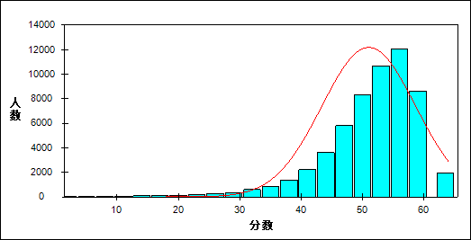

图 9 能力组块难度曲线图

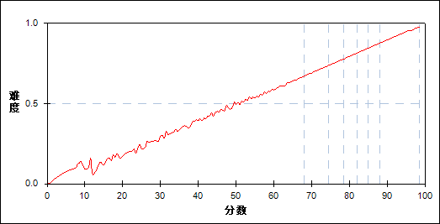

表 20 能力组块分组分析表

| 分值 | G1 | G2 | G3 | G4 | G5 | G6 | G7 | 人数 | 比率(%) | 平均分 |
| --- | --- | --- | --- | --- | --- | --- | --- | --- | --- | --- |
| 0.0～ | 18 | 0 | 0 | 0 | 0 | 0 | 0 | 18 | 0.03 | 0.06 |
| 1.0～ | 2 | 0 | 0 | 0 | 0 | 0 | 0 | 2 | 0.00 | 8.00 |
| 2.0～ | 1 | 0 | 0 | 0 | 0 | 0 | 0 | 1 | 0.00 | 2.00 |
| 3.0～ | 1 | 0 | 0 | 0 | 0 | 0 | 0 | 1 | 0.00 | 13.00 |
| 4.0～ | 2 | 0 | 0 | 0 | 0 | 0 | 0 | 2 | 0.00 | 12.50 |
| 5.0～ | 3 | 0 | 0 | 0 | 0 | 0 | 0 | 3 | 0.01 | 15.33 |
| 6.0～ | 3 | 0 | 0 | 0 | 0 | 0 | 0 | 3 | 0.01 | 12.33 |
| 6.5～ | 1 | 0 | 0 | 0 | 0 | 0 | 0 | 1 | 0.00 | 7.50 |
| 7.0～ | 10 | 0 | 0 | 0 | 0 | 0 | 0 | 10 | 0.02 | 15.70 |
| 8.0～ | 12 | 0 | 0 | 0 | 0 | 0 | 0 | 12 | 0.02 | 16.08 |
| 8.5～ | 1 | 0 | 0 | 0 | 0 | 0 | 0 | 1 | 0.00 | 8.50 |
| 9.0～ | 13 | 0 | 0 | 0 | 0 | 0 | 0 | 13 | 0.02 | 17.54 |
| 9.5～ | 3 | 0 | 0 | 0 | 0 | 0 | 0 | 3 | 0.01 | 15.17 |
| 10.0～ | 14 | 0 | 0 | 0 | 0 | 0 | 0 | 14 | 0.02 | 18.50 |
| 10.5～ | 1 | 0 | 0 | 0 | 0 | 0 | 0 | 1 | 0.00 | 19.50 |
| 11.0～ | 21 | 0 | 0 | 0 | 0 | 0 | 0 | 21 | 0.04 | 20.38 |
| 11.5～ | 3 | 0 | 0 | 0 | 0 | 0 | 0 | 3 | 0.01 | 15.17 |
| 12.0～ | 15 | 0 | 0 | 0 | 0 | 0 | 0 | 15 | 0.03 | 21.87 |
| 12.5～ | 3 | 0 | 0 | 0 | 0 | 0 | 0 | 3 | 0.01 | 22.50 |
| 13.0～ | 35 | 0 | 0 | 0 | 0 | 0 | 0 | 35 | 0.06 | 23.63 |
| 13.5～ | 2 | 0 | 0 | 0 | 0 | 0 | 0 | 2 | 0.00 | 24.50 |
| 14.0～ | 33 | 0 | 0 | 0 | 0 | 0 | 0 | 33 | 0.06 | 24.52 |
| 14.5～ | 6 | 0 | 0 | 0 | 0 | 0 | 0 | 6 | 0.01 | 26.83 |
| 15.0～ | 27 | 0 | 0 | 0 | 0 | 0 | 0 | 27 | 0.05 | 25.89 |
| 15.5～ | 3 | 0 | 0 | 0 | 0 | 0 | 0 | 3 | 0.01 | 25.50 |
| 16.0～ | 18 | 0 | 0 | 0 | 0 | 0 | 0 | 18 | 0.03 | 28.44 |
| 16.5～ | 10 | 0 | 0 | 0 | 0 | 0 | 0 | 10 | 0.02 | 28.60 |
| 17.0～ | 34 | 0 | 0 | 0 | 0 | 0 | 0 | 34 | 0.06 | 29.91 |
| 17.5～ | 6 | 0 | 0 | 0 | 0 | 0 | 0 | 6 | 0.01 | 31.17 |
| 18.0～ | 34 | 0 | 0 | 0 | 0 | 0 | 0 | 34 | 0.06 | 31.06 |
| 18.5～ | 9 | 0 | 0 | 0 | 0 | 0 | 0 | 9 | 0.02 | 33.50 |
| 19.0～ | 30 | 0 | 0 | 0 | 0 | 0 | 0 | 30 | 0.05 | 31.40 |
| 19.5～ | 11 | 0 | 0 | 0 | 0 | 0 | 0 | 11 | 0.02 | 32.77 |
| 20.0～ | 43 | 0 | 0 | 0 | 0 | 0 | 0 | 43 | 0.08 | 33.35 |
| 20.5～ | 8 | 0 | 0 | 0 | 0 | 0 | 0 | 8 | 0.01 | 35.13 |
| 21.0～ | 26 | 0 | 0 | 0 | 0 | 0 | 0 | 26 | 0.05 | 37.15 |
| 21.5～ | 17 | 0 | 0 | 0 | 0 | 0 | 0 | 17 | 0.03 | 36.91 |
| 22.0～ | 51 | 0 | 0 | 0 | 0 | 0 | 0 | 51 | 0.09 | 36.12 |
| 22.5～ | 13 | 0 | 0 | 0 | 0 | 0 | 0 | 13 | 0.02 | 35.04 |
| 23.0～ | 41 | 0 | 0 | 0 | 0 | 0 | 0 | 41 | 0.07 | 38.20 |
| 23.5～ | 18 | 0 | 0 | 0 | 0 | 0 | 0 | 18 | 0.03 | 39.78 |
| 24.0～ | 56 | 0 | 0 | 0 | 0 | 0 | 0 | 56 | 0.10 | 38.96 |
| 24.5～ | 27 | 0 | 0 | 0 | 0 | 0 | 0 | 27 | 0.05 | 39.35 |
| 25.0～ | 59 | 0 | 0 | 0 | 0 | 0 | 0 | 59 | 0.10 | 40.97 |
| 25.5～ | 20 | 0 | 0 | 0 | 0 | 0 | 0 | 20 | 0.03 | 42.55 |
| 26.0～ | 64 | 0 | 0 | 0 | 0 | 0 | 0 | 64 | 0.11 | 43.59 |
| 26.5～ | 21 | 0 | 0 | 0 | 0 | 0 | 0 | 21 | 0.04 | 43.55 |
| 27.0～ | 72 | 0 | 0 | 0 | 0 | 0 | 0 | 72 | 0.13 | 44.19 |
| 27.5～ | 29 | 0 | 0 | 0 | 0 | 0 | 0 | 29 | 0.05 | 45.88 |
| 28.0～ | 72 | 0 | 0 | 0 | 0 | 0 | 0 | 72 | 0.13 | 44.86 |
| 28.5～ | 34 | 0 | 0 | 0 | 0 | 0 | 0 | 34 | 0.06 | 44.82 |
| 29.0～ | 99 | 0 | 0 | 0 | 0 | 0 | 0 | 99 | 0.17 | 47.54 |
| 29.5～ | 31 | 0 | 0 | 0 | 0 | 0 | 0 | 31 | 0.05 | 46.79 |
| 30.0～ | 92 | 0 | 0 | 0 | 0 | 0 | 0 | 92 | 0.16 | 48.71 |
| 30.5～ | 48 | 0 | 0 | 0 | 0 | 0 | 0 | 48 | 0.08 | 49.15 |
| 31.0～ | 113 | 0 | 0 | 0 | 0 | 0 | 0 | 113 | 0.20 | 49.69 |
| 31.5～ | 70 | 0 | 0 | 0 | 0 | 0 | 0 | 70 | 0.12 | 50.41 |
| 32.0～ | 137 | 0 | 0 | 0 | 0 | 0 | 0 | 137 | 0.24 | 50.91 |
| 32.5～ | 75 | 0 | 0 | 0 | 0 | 0 | 0 | 75 | 0.13 | 51.91 |
| 33.0～ | 161 | 0 | 0 | 0 | 0 | 0 | 0 | 161 | 0.28 | 52.91 |
| 33.5～ | 93 | 0 | 0 | 0 | 0 | 0 | 0 | 93 | 0.16 | 53.18 |
| 34.0～ | 162 | 0 | 0 | 0 | 0 | 0 | 0 | 162 | 0.28 | 54.15 |
| 34.5～ | 103 | 0 | 0 | 0 | 0 | 0 | 0 | 103 | 0.18 | 55.00 |
| 35.0～ | 194 | 0 | 0 | 0 | 0 | 0 | 0 | 194 | 0.34 | 55.60 |
| 35.5～ | 122 | 0 | 0 | 0 | 0 | 0 | 0 | 122 | 0.21 | 56.37 |
| 36.0～ | 189 | 0 | 0 | 0 | 0 | 0 | 0 | 189 | 0.33 | 56.77 |
| 36.5～ | 145 | 0 | 0 | 0 | 0 | 0 | 0 | 145 | 0.25 | 57.64 |
| 37.0～ | 214 | 0 | 0 | 0 | 0 | 0 | 0 | 214 | 0.37 | 57.58 |
| 37.5～ | 172 | 2 | 0 | 0 | 0 | 0 | 0 | 174 | 0.30 | 59.01 |
| 38.0～ | 280 | 4 | 0 | 0 | 0 | 0 | 0 | 284 | 0.50 | 59.59 |
| 38.5～ | 202 | 6 | 0 | 0 | 0 | 0 | 0 | 208 | 0.36 | 60.64 |
| 39.0～ | 317 | 12 | 0 | 0 | 0 | 0 | 0 | 329 | 0.57 | 61.26 |
| 39.5～ | 248 | 4 | 0 | 0 | 0 | 0 | 0 | 252 | 0.44 | 61.33 |
| 40.0～ | 316 | 24 | 0 | 0 | 0 | 0 | 0 | 340 | 0.59 | 62.69 |
| 40.5～ | 287 | 34 | 0 | 0 | 0 | 0 | 0 | 321 | 0.56 | 63.47 |
| 41.0～ | 361 | 52 | 0 | 0 | 0 | 0 | 0 | 413 | 0.72 | 64.15 |
| 41.5～ | 275 | 63 | 1 | 0 | 0 | 0 | 0 | 339 | 0.59 | 64.92 |
| 42.0～ | 417 | 123 | 2 | 0 | 0 | 0 | 0 | 542 | 0.95 | 65.28 |
| 42.5～ | 289 | 104 | 0 | 0 | 0 | 0 | 0 | 393 | 0.69 | 65.75 |
| 43.0～ | 328 | 205 | 1 | 0 | 0 | 0 | 0 | 534 | 0.93 | 66.91 |
| 43.5～ | 272 | 241 | 2 | 0 | 0 | 0 | 0 | 515 | 0.90 | 67.61 |
| 44.0～ | 308 | 375 | 9 | 0 | 0 | 0 | 0 | 692 | 1.21 | 68.14 |
| 44.5～ | 226 | 384 | 16 | 0 | 0 | 0 | 0 | 626 | 1.09 | 68.85 |
| 45.0～ | 207 | 601 | 33 | 0 | 0 | 0 | 0 | 841 | 1.47 | 69.79 |
| 45.5～ | 134 | 584 | 62 | 0 | 0 | 0 | 0 | 780 | 1.36 | 70.36 |
| 46.0～ | 142 | 721 | 81 | 2 | 0 | 0 | 0 | 946 | 1.65 | 70.93 |
| 46.5～ | 96 | 579 | 176 | 2 | 0 | 0 | 0 | 853 | 1.49 | 71.79 |
| 47.0～ | 68 | 715 | 236 | 3 | 0 | 0 | 0 | 1022 | 1.78 | 72.40 |
| 47.5～ | 49 | 591 | 349 | 17 | 0 | 0 | 0 | 1006 | 1.76 | 73.08 |
| 48.0～ | 40 | 647 | 485 | 22 | 0 | 0 | 0 | 1194 | 2.08 | 73.74 |
| 48.5～ | 13 | 509 | 576 | 56 | 0 | 0 | 0 | 1154 | 2.01 | 74.40 |
| 49.0～ | 16 | 480 | 750 | 91 | 5 | 0 | 0 | 1342 | 2.34 | 75.06 |
| 49.5～ | 7 | 298 | 824 | 180 | 1 | 0 | 0 | 1310 | 2.29 | 75.91 |
| 50.0～ | 4 | 304 | 869 | 295 | 15 | 0 | 0 | 1487 | 2.60 | 76.45 |
| 50.5～ | 3 | 173 | 752 | 455 | 14 | 0 | 0 | 1397 | 2.44 | 77.18 |
| 51.0～ | 1 | 131 | 749 | 673 | 78 | 0 | 0 | 1632 | 2.85 | 78.02 |
| 51.5～ | 0 | 85 | 624 | 799 | 92 | 0 | 0 | 1600 | 2.79 | 78.61 |
| 52.0～ | 0 | 63 | 499 | 920 | 278 | 7 | 0 | 1767 | 3.08 | 79.37 |
| 52.5～ | 0 | 31 | 383 | 1012 | 330 | 6 | 0 | 1762 | 3.08 | 80.06 |
| 53.0～ | 2 | 21 | 283 | 894 | 643 | 39 | 0 | 1882 | 3.29 | 80.65 |
| 53.5～ | 0 | 9 | 164 | 849 | 704 | 64 | 0 | 1790 | 3.12 | 81.44 |
| 54.0～ | 0 | 2 | 97 | 562 | 991 | 214 | 0 | 1866 | 3.26 | 82.23 |
| 54.5～ | 0 | 5 | 77 | 567 | 1100 | 279 | 3 | 2031 | 3.55 | 82.80 |
| 55.0～ | 0 | 1 | 48 | 300 | 1082 | 638 | 20 | 2089 | 3.65 | 83.51 |
| 55.5～ | 0 | 0 | 18 | 221 | 954 | 724 | 26 | 1943 | 3.39 | 84.29 |
| 56.0～ | 0 | 0 | 13 | 123 | 680 | 1091 | 111 | 2018 | 3.52 | 84.88 |
| 56.5～ | 0 | 1 | 3 | 72 | 536 | 1179 | 185 | 1976 | 3.45 | 85.70 |
| 57.0～ | 0 | 0 | 1 | 33 | 301 | 1123 | 496 | 1954 | 3.41 | 86.34 |
| 57.5～ | 0 | 0 | 1 | 20 | 205 | 1028 | 550 | 1804 | 3.15 | 87.00 |
| 58.0～ | 0 | 0 | 0 | 8 | 87 | 745 | 985 | 1825 | 3.19 | 87.70 |
| 58.5～ | 0 | 0 | 0 | 7 | 58 | 527 | 946 | 1538 | 2.68 | 88.34 |
| 59.0～ | 0 | 0 | 0 | 0 | 14 | 261 | 1119 | 1394 | 2.43 | 88.93 |
| 59.5～ | 0 | 0 | 0 | 1 | 10 | 159 | 917 | 1087 | 1.90 | 89.57 |
| 60.0～ | 0 | 0 | 0 | 0 | 3 | 57 | 899 | 959 | 1.67 | 90.20 |
| 60.5～ | 0 | 0 | 0 | 0 | 2 | 26 | 628 | 656 | 1.15 | 90.82 |
| 61.0～ | 0 | 0 | 0 | 0 | 0 | 11 | 487 | 498 | 0.87 | 91.40 |
| 61.5～ | 0 | 0 | 0 | 0 | 0 | 4 | 330 | 334 | 0.58 | 92.03 |
| 62.0～ | 0 | 0 | 0 | 0 | 0 | 0 | 224 | 224 | 0.39 | 92.57 |
| 62.5～ | 0 | 0 | 0 | 0 | 0 | 1 | 106 | 107 | 0.19 | 93.03 |
| 63.0～ | 0 | 0 | 0 | 0 | 0 | 0 | 80 | 80 | 0.14 | 93.55 |
| 63.5～ | 0 | 0 | 0 | 0 | 0 | 0 | 39 | 39 | 0.07 | 94.12 |
| 64.0～ | 0 | 0 | 0 | 0 | 0 | 0 | 20 | 20 | 0.03 | 95.00 |
| 64.5～ | 0 | 0 | 0 | 0 | 0 | 0 | 11 | 11 | 0.02 | 95.59 |
| 65.0～ | 0 | 0 | 0 | 0 | 0 | 0 | 1 | 1 | 0.00 | 94.00 |
| 合计 | 8184 | 8184 | 8184 | 8184 | 8183 | 8183 | 8183 | 57285 | 100.00 | 77.89 |
| 得分率 | 0.56 | 0.71 | 0.76 | 0.80 | 0.83 | 0.86 | 0.90 | - | - | - |

表 21 能力组块等级分析表

| 分值 | 优秀 | | 良好 | | 合格 | | 不合格 | | 全体 | |
| --- | --- | --- | --- | --- | --- | --- | --- | --- | --- | --- |
| 人数 | 比率 | 人数 | 比率 | 人数 | 比率 | 人数 | 比率 | 人数 | 比率 |
| 0.0～ | 0 | 0.0 | 0 | 0.0 | 0 | 0.0 | 18 | 100.0 | 18 | 100.0 |
| 1.0～ | 0 | 0.0 | 0 | 0.0 | 0 | 0.0 | 2 | 100.0 | 2 | 100.0 |
| 2.0～ | 0 | 0.0 | 0 | 0.0 | 0 | 0.0 | 1 | 100.0 | 1 | 100.0 |
| 3.0～ | 0 | 0.0 | 0 | 0.0 | 0 | 0.0 | 1 | 100.0 | 1 | 100.0 |
| 4.0～ | 0 | 0.0 | 0 | 0.0 | 0 | 0.0 | 2 | 100.0 | 2 | 100.0 |
| 5.0～ | 0 | 0.0 | 0 | 0.0 | 0 | 0.0 | 3 | 100.0 | 3 | 100.0 |
| 6.0～ | 0 | 0.0 | 0 | 0.0 | 0 | 0.0 | 3 | 100.0 | 3 | 100.0 |
| 6.5～ | 0 | 0.0 | 0 | 0.0 | 0 | 0.0 | 1 | 100.0 | 1 | 100.0 |
| 7.0～ | 0 | 0.0 | 0 | 0.0 | 0 | 0.0 | 10 | 100.0 | 10 | 100.0 |
| 8.0～ | 0 | 0.0 | 0 | 0.0 | 0 | 0.0 | 12 | 100.0 | 12 | 100.0 |
| 8.5～ | 0 | 0.0 | 0 | 0.0 | 0 | 0.0 | 1 | 100.0 | 1 | 100.0 |
| 9.0～ | 0 | 0.0 | 0 | 0.0 | 0 | 0.0 | 13 | 100.0 | 13 | 100.0 |
| 9.5～ | 0 | 0.0 | 0 | 0.0 | 0 | 0.0 | 3 | 100.0 | 3 | 100.0 |
| 10.0～ | 0 | 0.0 | 0 | 0.0 | 0 | 0.0 | 14 | 100.0 | 14 | 100.0 |
| 10.5～ | 0 | 0.0 | 0 | 0.0 | 0 | 0.0 | 1 | 100.0 | 1 | 100.0 |
| 11.0～ | 0 | 0.0 | 0 | 0.0 | 0 | 0.0 | 21 | 100.0 | 21 | 100.0 |
| 11.5～ | 0 | 0.0 | 0 | 0.0 | 0 | 0.0 | 3 | 100.0 | 3 | 100.0 |
| 12.0～ | 0 | 0.0 | 0 | 0.0 | 0 | 0.0 | 15 | 100.0 | 15 | 100.0 |
| 12.5～ | 0 | 0.0 | 0 | 0.0 | 0 | 0.0 | 3 | 100.0 | 3 | 100.0 |
| 13.0～ | 0 | 0.0 | 0 | 0.0 | 0 | 0.0 | 35 | 100.0 | 35 | 100.0 |
| 13.5～ | 0 | 0.0 | 0 | 0.0 | 0 | 0.0 | 2 | 100.0 | 2 | 100.0 |
| 14.0～ | 0 | 0.0 | 0 | 0.0 | 0 | 0.0 | 33 | 100.0 | 33 | 100.0 |
| 14.5～ | 0 | 0.0 | 0 | 0.0 | 0 | 0.0 | 6 | 100.0 | 6 | 100.0 |
| 15.0～ | 0 | 0.0 | 0 | 0.0 | 0 | 0.0 | 27 | 100.0 | 27 | 100.0 |
| 15.5～ | 0 | 0.0 | 0 | 0.0 | 0 | 0.0 | 3 | 100.0 | 3 | 100.0 |
| 16.0～ | 0 | 0.0 | 0 | 0.0 | 0 | 0.0 | 18 | 100.0 | 18 | 100.0 |
| 16.5～ | 0 | 0.0 | 0 | 0.0 | 0 | 0.0 | 10 | 100.0 | 10 | 100.0 |
| 17.0～ | 0 | 0.0 | 0 | 0.0 | 0 | 0.0 | 34 | 100.0 | 34 | 100.0 |
| 17.5～ | 0 | 0.0 | 0 | 0.0 | 0 | 0.0 | 6 | 100.0 | 6 | 100.0 |
| 18.0～ | 0 | 0.0 | 0 | 0.0 | 0 | 0.0 | 34 | 100.0 | 34 | 100.0 |
| 18.5～ | 0 | 0.0 | 0 | 0.0 | 0 | 0.0 | 9 | 100.0 | 9 | 100.0 |
| 19.0～ | 0 | 0.0 | 0 | 0.0 | 0 | 0.0 | 30 | 100.0 | 30 | 100.0 |
| 19.5～ | 0 | 0.0 | 0 | 0.0 | 0 | 0.0 | 11 | 100.0 | 11 | 100.0 |
| 20.0～ | 0 | 0.0 | 0 | 0.0 | 0 | 0.0 | 43 | 100.0 | 43 | 100.0 |
| 20.5～ | 0 | 0.0 | 0 | 0.0 | 0 | 0.0 | 8 | 100.0 | 8 | 100.0 |
| 21.0～ | 0 | 0.0 | 0 | 0.0 | 0 | 0.0 | 26 | 100.0 | 26 | 100.0 |
| 21.5～ | 0 | 0.0 | 0 | 0.0 | 0 | 0.0 | 17 | 100.0 | 17 | 100.0 |
| 22.0～ | 0 | 0.0 | 0 | 0.0 | 0 | 0.0 | 51 | 100.0 | 51 | 100.0 |
| 22.5～ | 0 | 0.0 | 0 | 0.0 | 0 | 0.0 | 13 | 100.0 | 13 | 100.0 |
| 23.0～ | 0 | 0.0 | 0 | 0.0 | 0 | 0.0 | 41 | 100.0 | 41 | 100.0 |
| 23.5～ | 0 | 0.0 | 0 | 0.0 | 0 | 0.0 | 18 | 100.0 | 18 | 100.0 |
| 24.0～ | 0 | 0.0 | 0 | 0.0 | 0 | 0.0 | 56 | 100.0 | 56 | 100.0 |
| 24.5～ | 0 | 0.0 | 0 | 0.0 | 0 | 0.0 | 27 | 100.0 | 27 | 100.0 |
| 25.0～ | 0 | 0.0 | 0 | 0.0 | 0 | 0.0 | 59 | 100.0 | 59 | 100.0 |
| 25.5～ | 0 | 0.0 | 0 | 0.0 | 0 | 0.0 | 20 | 100.0 | 20 | 100.0 |
| 26.0～ | 0 | 0.0 | 0 | 0.0 | 0 | 0.0 | 64 | 100.0 | 64 | 100.0 |
| 26.5～ | 0 | 0.0 | 0 | 0.0 | 0 | 0.0 | 21 | 100.0 | 21 | 100.0 |
| 27.0～ | 0 | 0.0 | 0 | 0.0 | 0 | 0.0 | 72 | 100.0 | 72 | 100.0 |
| 27.5～ | 0 | 0.0 | 0 | 0.0 | 0 | 0.0 | 29 | 100.0 | 29 | 100.0 |
| 28.0～ | 0 | 0.0 | 0 | 0.0 | 0 | 0.0 | 72 | 100.0 | 72 | 100.0 |
| 28.5～ | 0 | 0.0 | 0 | 0.0 | 0 | 0.0 | 34 | 100.0 | 34 | 100.0 |
| 29.0～ | 0 | 0.0 | 0 | 0.0 | 1 | 1.0 | 98 | 99.0 | 99 | 100.0 |
| 29.5～ | 0 | 0.0 | 0 | 0.0 | 0 | 0.0 | 31 | 100.0 | 31 | 100.0 |
| 30.0～ | 0 | 0.0 | 0 | 0.0 | 2 | 2.2 | 90 | 97.8 | 92 | 100.0 |
| 30.5～ | 0 | 0.0 | 0 | 0.0 | 0 | 0.0 | 48 | 100.0 | 48 | 100.0 |
| 31.0～ | 0 | 0.0 | 0 | 0.0 | 2 | 1.8 | 111 | 98.2 | 113 | 100.0 |
| 31.5～ | 0 | 0.0 | 0 | 0.0 | 2 | 2.9 | 68 | 97.1 | 70 | 100.0 |
| 32.0～ | 0 | 0.0 | 0 | 0.0 | 6 | 4.4 | 131 | 95.6 | 137 | 100.0 |
| 32.5～ | 0 | 0.0 | 0 | 0.0 | 3 | 4.0 | 72 | 96.0 | 75 | 100.0 |
| 33.0～ | 0 | 0.0 | 0 | 0.0 | 15 | 9.3 | 146 | 90.7 | 161 | 100.0 |
| 33.5～ | 0 | 0.0 | 0 | 0.0 | 5 | 5.4 | 88 | 94.6 | 93 | 100.0 |
| 34.0～ | 0 | 0.0 | 0 | 0.0 | 21 | 13.0 | 141 | 87.0 | 162 | 100.0 |
| 34.5～ | 0 | 0.0 | 0 | 0.0 | 22 | 21.4 | 81 | 78.6 | 103 | 100.0 |
| 35.0～ | 0 | 0.0 | 0 | 0.0 | 40 | 20.6 | 154 | 79.4 | 194 | 100.0 |
| 35.5～ | 0 | 0.0 | 0 | 0.0 | 26 | 21.3 | 96 | 78.7 | 122 | 100.0 |
| 36.0～ | 0 | 0.0 | 0 | 0.0 | 54 | 28.6 | 135 | 71.4 | 189 | 100.0 |
| 36.5～ | 0 | 0.0 | 0 | 0.0 | 45 | 31.0 | 100 | 69.0 | 145 | 100.0 |
| 37.0～ | 0 | 0.0 | 0 | 0.0 | 73 | 34.1 | 141 | 65.9 | 214 | 100.0 |
| 37.5～ | 0 | 0.0 | 0 | 0.0 | 77 | 44.3 | 97 | 55.7 | 174 | 100.0 |
| 38.0～ | 0 | 0.0 | 0 | 0.0 | 160 | 56.3 | 124 | 43.7 | 284 | 100.0 |
| 38.5～ | 0 | 0.0 | 0 | 0.0 | 120 | 57.7 | 88 | 42.3 | 208 | 100.0 |
| 39.0～ | 0 | 0.0 | 4 | 1.2 | 226 | 68.7 | 99 | 30.1 | 329 | 100.0 |
| 39.5～ | 0 | 0.0 | 0 | 0.0 | 156 | 61.9 | 96 | 38.1 | 252 | 100.0 |
| 40.0～ | 0 | 0.0 | 6 | 1.8 | 273 | 80.3 | 61 | 17.9 | 340 | 100.0 |
| 40.5～ | 0 | 0.0 | 8 | 2.5 | 259 | 80.7 | 54 | 16.8 | 321 | 100.0 |
| 41.0～ | 0 | 0.0 | 23 | 5.6 | 346 | 83.8 | 44 | 10.7 | 413 | 100.0 |
| 41.5～ | 0 | 0.0 | 22 | 6.5 | 290 | 85.5 | 27 | 8.0 | 339 | 100.0 |
| 42.0～ | 0 | 0.0 | 57 | 10.5 | 451 | 83.2 | 34 | 6.3 | 542 | 100.0 |
| 42.5～ | 0 | 0.0 | 42 | 10.7 | 319 | 81.2 | 32 | 8.1 | 393 | 100.0 |
| 43.0～ | 0 | 0.0 | 114 | 21.3 | 410 | 76.8 | 10 | 1.9 | 534 | 100.0 |
| 43.5～ | 0 | 0.0 | 116 | 22.5 | 388 | 75.3 | 11 | 2.1 | 515 | 100.0 |
| 44.0～ | 0 | 0.0 | 248 | 35.8 | 438 | 63.3 | 6 | 0.9 | 692 | 100.0 |
| 44.5～ | 0 | 0.0 | 241 | 38.5 | 379 | 60.5 | 6 | 1.0 | 626 | 100.0 |
| 45.0～ | 0 | 0.0 | 474 | 56.4 | 365 | 43.4 | 2 | 0.2 | 841 | 100.0 |
| 45.5～ | 0 | 0.0 | 456 | 58.5 | 321 | 41.2 | 3 | 0.4 | 780 | 100.0 |
| 46.0～ | 0 | 0.0 | 668 | 70.6 | 276 | 29.2 | 2 | 0.2 | 946 | 100.0 |
| 46.5～ | 0 | 0.0 | 652 | 76.4 | 199 | 23.3 | 2 | 0.2 | 853 | 100.0 |
| 47.0～ | 0 | 0.0 | 873 | 85.4 | 149 | 14.6 | 0 | 0.0 | 1022 | 100.0 |
| 47.5～ | 0 | 0.0 | 885 | 88.0 | 121 | 12.0 | 0 | 0.0 | 1006 | 100.0 |
| 48.0～ | 0 | 0.0 | 1116 | 93.5 | 77 | 6.4 | 1 | 0.1 | 1194 | 100.0 |
| 48.5～ | 0 | 0.0 | 1089 | 94.4 | 65 | 5.6 | 0 | 0.0 | 1154 | 100.0 |
| 49.0～ | 0 | 0.0 | 1293 | 96.3 | 49 | 3.7 | 0 | 0.0 | 1342 | 100.0 |
| 49.5～ | 0 | 0.0 | 1282 | 97.9 | 28 | 2.1 | 0 | 0.0 | 1310 | 100.0 |
| 50.0～ | 0 | 0.0 | 1475 | 99.2 | 12 | 0.8 | 0 | 0.0 | 1487 | 100.0 |
| 50.5～ | 0 | 0.0 | 1380 | 98.8 | 17 | 1.2 | 0 | 0.0 | 1397 | 100.0 |
| 51.0～ | 0 | 0.0 | 1628 | 99.8 | 4 | 0.2 | 0 | 0.0 | 1632 | 100.0 |
| 51.5～ | 0 | 0.0 | 1595 | 99.7 | 5 | 0.3 | 0 | 0.0 | 1600 | 100.0 |
| 52.0～ | 8 | 0.5 | 1756 | 99.4 | 3 | 0.2 | 0 | 0.0 | 1767 | 100.0 |
| 52.5～ | 6 | 0.3 | 1755 | 99.6 | 1 | 0.1 | 0 | 0.0 | 1762 | 100.0 |
| 53.0～ | 41 | 2.2 | 1839 | 97.7 | 2 | 0.1 | 0 | 0.0 | 1882 | 100.0 |
| 53.5～ | 64 | 3.6 | 1725 | 96.4 | 1 | 0.1 | 0 | 0.0 | 1790 | 100.0 |
| 54.0～ | 248 | 13.3 | 1618 | 86.7 | 0 | 0.0 | 0 | 0.0 | 1866 | 100.0 |
| 54.5～ | 282 | 13.9 | 1749 | 86.1 | 0 | 0.0 | 0 | 0.0 | 2031 | 100.0 |
| 55.0～ | 719 | 34.4 | 1370 | 65.6 | 0 | 0.0 | 0 | 0.0 | 2089 | 100.0 |
| 55.5～ | 750 | 38.6 | 1193 | 61.4 | 0 | 0.0 | 0 | 0.0 | 1943 | 100.0 |
| 56.0～ | 1267 | 62.8 | 751 | 37.2 | 0 | 0.0 | 0 | 0.0 | 2018 | 100.0 |
| 56.5～ | 1364 | 69.0 | 612 | 31.0 | 0 | 0.0 | 0 | 0.0 | 1976 | 100.0 |
| 57.0～ | 1668 | 85.4 | 286 | 14.6 | 0 | 0.0 | 0 | 0.0 | 1954 | 100.0 |
| 57.5～ | 1578 | 87.5 | 226 | 12.5 | 0 | 0.0 | 0 | 0.0 | 1804 | 100.0 |
| 58.0～ | 1745 | 95.6 | 80 | 4.4 | 0 | 0.0 | 0 | 0.0 | 1825 | 100.0 |
| 58.5～ | 1473 | 95.8 | 65 | 4.2 | 0 | 0.0 | 0 | 0.0 | 1538 | 100.0 |
| 59.0～ | 1384 | 99.3 | 10 | 0.7 | 0 | 0.0 | 0 | 0.0 | 1394 | 100.0 |
| 59.5～ | 1076 | 99.0 | 11 | 1.0 | 0 | 0.0 | 0 | 0.0 | 1087 | 100.0 |
| 60.0～ | 957 | 99.8 | 2 | 0.2 | 0 | 0.0 | 0 | 0.0 | 959 | 100.0 |
| 60.5～ | 654 | 99.7 | 2 | 0.3 | 0 | 0.0 | 0 | 0.0 | 656 | 100.0 |
| 61.0～ | 498 | 100.0 | 0 | 0.0 | 0 | 0.0 | 0 | 0.0 | 498 | 100.0 |
| 61.5～ | 334 | 100.0 | 0 | 0.0 | 0 | 0.0 | 0 | 0.0 | 334 | 100.0 |
| 62.0～ | 224 | 100.0 | 0 | 0.0 | 0 | 0.0 | 0 | 0.0 | 224 | 100.0 |
| 62.5～ | 107 | 100.0 | 0 | 0.0 | 0 | 0.0 | 0 | 0.0 | 107 | 100.0 |
| 63.0～ | 80 | 100.0 | 0 | 0.0 | 0 | 0.0 | 0 | 0.0 | 80 | 100.0 |
| 63.5～ | 39 | 100.0 | 0 | 0.0 | 0 | 0.0 | 0 | 0.0 | 39 | 100.0 |
| 64.0～ | 20 | 100.0 | 0 | 0.0 | 0 | 0.0 | 0 | 0.0 | 20 | 100.0 |
| 64.5～ | 11 | 100.0 | 0 | 0.0 | 0 | 0.0 | 0 | 0.0 | 11 | 100.0 |
| 65.0～ | 1 | 100.0 | 0 | 0.0 | 0 | 0.0 | 0 | 0.0 | 1 | 100.0 |
| 合计 | 16598 | 29.0 | 30797 | 53.8 | 6304 | 11.0 | 3586 | 6.3 | 57285 | 100.0 |

* 1. 类型分析
     1. 基础性试题

本题组共包含35道试题，题号是：1～35

表 22 基础性试题总分分析表

|  |  |  |  |  |  |  |  |  |
| --- | --- | --- | --- | --- | --- | --- | --- | --- |
| 人数 | 满分 | 最大值 | 最小值 | 平均值 | 标准差 | 差异系数 | 难度 | 区分度 |
| 57285 | 35 | 35.0 | 0.0 | 31.36 | 4.13 | 0.13 | 0.90 | 0.88 |

表 23 基础性试题等级得分率分析表

|  |  |  |  |  |
| --- | --- | --- | --- | --- |
| 优秀 | 良好 | 合格 | 不及格 | 全体 |
| 0.98 | 0.91 | 0.79 | 0.59 | 0.90 |

图 10 基础性试题分数分布曲线图

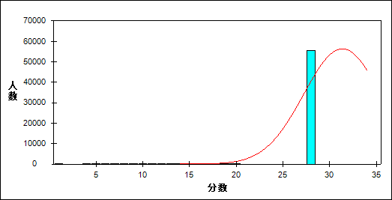

图 11 基础性试题难度曲线图

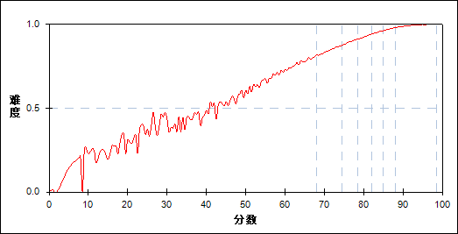

表 24 基础性试题分组分析表

| 分值 | G1 | G2 | G3 | G4 | G5 | G6 | G7 | 人数 | 比率(%) | 平均分 |
| --- | --- | --- | --- | --- | --- | --- | --- | --- | --- | --- |
| 0.0～ | 20 | 0 | 0 | 0 | 0 | 0 | 0 | 20 | 0.03 | 0.58 |
| 1.0～ | 1 | 0 | 0 | 0 | 0 | 0 | 0 | 1 | 0.00 | 1.00 |
| 4.0～ | 4 | 0 | 0 | 0 | 0 | 0 | 0 | 4 | 0.01 | 24.75 |
| 5.0～ | 8 | 0 | 0 | 0 | 0 | 0 | 0 | 8 | 0.01 | 19.88 |
| 6.0～ | 16 | 0 | 0 | 0 | 0 | 0 | 0 | 16 | 0.03 | 27.09 |
| 7.0～ | 14 | 0 | 0 | 0 | 0 | 0 | 0 | 14 | 0.02 | 22.46 |
| 8.0～ | 26 | 0 | 0 | 0 | 0 | 0 | 0 | 26 | 0.05 | 22.19 |
| 9.0～ | 48 | 0 | 0 | 0 | 0 | 0 | 0 | 48 | 0.08 | 26.31 |
| 10.0～ | 51 | 0 | 0 | 0 | 0 | 0 | 0 | 51 | 0.09 | 27.81 |
| 11.0～ | 58 | 0 | 0 | 0 | 0 | 0 | 0 | 58 | 0.10 | 31.00 |
| 12.0～ | 72 | 0 | 0 | 0 | 0 | 0 | 0 | 72 | 0.13 | 32.06 |
| 13.0～ | 100 | 0 | 0 | 0 | 0 | 0 | 0 | 100 | 0.17 | 34.72 |
| 14.0～ | 127 | 0 | 0 | 0 | 0 | 0 | 0 | 127 | 0.22 | 38.79 |
| 15.0～ | 125 | 0 | 0 | 0 | 0 | 0 | 0 | 125 | 0.22 | 39.63 |
| 16.0～ | 164 | 1 | 0 | 0 | 0 | 0 | 0 | 165 | 0.29 | 43.00 |
| 17.0～ | 194 | 0 | 0 | 0 | 0 | 0 | 0 | 194 | 0.34 | 45.22 |
| 18.0～ | 196 | 3 | 0 | 0 | 0 | 0 | 0 | 199 | 0.35 | 47.54 |
| 19.0～ | 249 | 2 | 0 | 0 | 0 | 0 | 0 | 251 | 0.44 | 49.75 |
| 20.0～ | 260 | 4 | 0 | 0 | 0 | 0 | 0 | 264 | 0.46 | 52.49 |
| 21.0～ | 334 | 6 | 0 | 0 | 0 | 0 | 0 | 340 | 0.59 | 53.88 |
| 22.0～ | 401 | 14 | 1 | 0 | 0 | 0 | 0 | 416 | 0.73 | 57.26 |
| 23.0～ | 474 | 44 | 1 | 0 | 0 | 0 | 0 | 519 | 0.91 | 59.31 |
| 24.0～ | 525 | 130 | 10 | 0 | 0 | 0 | 0 | 665 | 1.16 | 61.93 |
| 25.0～ | 610 | 183 | 21 | 3 | 0 | 0 | 0 | 817 | 1.43 | 63.66 |
| 26.0～ | 742 | 345 | 66 | 8 | 1 | 0 | 0 | 1162 | 2.03 | 65.41 |
| 27.0～ | 731 | 654 | 163 | 27 | 3 | 0 | 0 | 1578 | 2.75 | 67.80 |
| 28.0～ | 832 | 1007 | 337 | 88 | 9 | 1 | 0 | 2274 | 3.97 | 69.25 |
| 29.0～ | 639 | 1218 | 614 | 231 | 59 | 3 | 1 | 2765 | 4.83 | 71.68 |
| 30.0～ | 475 | 1396 | 1110 | 563 | 168 | 43 | 3 | 3758 | 6.56 | 74.00 |
| 31.0～ | 341 | 1383 | 1687 | 1070 | 490 | 134 | 22 | 5127 | 8.95 | 76.10 |
| 32.0～ | 197 | 1020 | 1864 | 1907 | 1142 | 507 | 117 | 6754 | 11.79 | 78.61 |
| 33.0～ | 89 | 531 | 1521 | 2269 | 2261 | 1444 | 492 | 8607 | 15.02 | 81.27 |
| 34.0～ | 46 | 188 | 654 | 1580 | 2741 | 3123 | 2152 | 10484 | 18.30 | 84.37 |
| 35.0～ | 15 | 55 | 135 | 438 | 1309 | 2928 | 5396 | 10276 | 17.94 | 87.62 |
| 合计 | 8184 | 8184 | 8184 | 8184 | 8183 | 8183 | 8183 | 57285 | 100.00 | 77.89 |
| 得分率 | 0.69 | 0.85 | 0.90 | 0.93 | 0.95 | 0.97 | 0.99 | - | - | - |

表 25 基础性试题等级分析表

| 分值 | 优秀 | | 良好 | | 合格 | | 不合格 | | 全体 | |
| --- | --- | --- | --- | --- | --- | --- | --- | --- | --- | --- |
| 人数 | 比率 | 人数 | 比率 | 人数 | 比率 | 人数 | 比率 | 人数 | 比率 |
| 0.0～ | 0 | 0.0 | 0 | 0.0 | 0 | 0.0 | 20 | 100.0 | 20 | 100.0 |
| 1.0～ | 0 | 0.0 | 0 | 0.0 | 0 | 0.0 | 1 | 100.0 | 1 | 100.0 |
| 4.0～ | 0 | 0.0 | 0 | 0.0 | 0 | 0.0 | 4 | 100.0 | 4 | 100.0 |
| 5.0～ | 0 | 0.0 | 0 | 0.0 | 0 | 0.0 | 8 | 100.0 | 8 | 100.0 |
| 6.0～ | 0 | 0.0 | 0 | 0.0 | 0 | 0.0 | 16 | 100.0 | 16 | 100.0 |
| 7.0～ | 0 | 0.0 | 0 | 0.0 | 0 | 0.0 | 14 | 100.0 | 14 | 100.0 |
| 8.0～ | 0 | 0.0 | 0 | 0.0 | 0 | 0.0 | 26 | 100.0 | 26 | 100.0 |
| 9.0～ | 0 | 0.0 | 0 | 0.0 | 0 | 0.0 | 48 | 100.0 | 48 | 100.0 |
| 10.0～ | 0 | 0.0 | 0 | 0.0 | 0 | 0.0 | 51 | 100.0 | 51 | 100.0 |
| 11.0～ | 0 | 0.0 | 0 | 0.0 | 0 | 0.0 | 58 | 100.0 | 58 | 100.0 |
| 12.0～ | 0 | 0.0 | 0 | 0.0 | 0 | 0.0 | 72 | 100.0 | 72 | 100.0 |
| 13.0～ | 0 | 0.0 | 0 | 0.0 | 0 | 0.0 | 100 | 100.0 | 100 | 100.0 |
| 14.0～ | 0 | 0.0 | 0 | 0.0 | 1 | 0.8 | 126 | 99.2 | 127 | 100.0 |
| 15.0～ | 0 | 0.0 | 0 | 0.0 | 1 | 0.8 | 124 | 99.2 | 125 | 100.0 |
| 16.0～ | 0 | 0.0 | 1 | 0.6 | 4 | 2.4 | 160 | 97.0 | 165 | 100.0 |
| 17.0～ | 0 | 0.0 | 0 | 0.0 | 3 | 1.5 | 191 | 98.5 | 194 | 100.0 |
| 18.0～ | 0 | 0.0 | 0 | 0.0 | 12 | 6.0 | 187 | 94.0 | 199 | 100.0 |
| 19.0～ | 0 | 0.0 | 1 | 0.4 | 26 | 10.4 | 224 | 89.2 | 251 | 100.0 |
| 20.0～ | 0 | 0.0 | 0 | 0.0 | 45 | 17.0 | 219 | 83.0 | 264 | 100.0 |
| 21.0～ | 0 | 0.0 | 2 | 0.6 | 70 | 20.6 | 268 | 78.8 | 340 | 100.0 |
| 22.0～ | 0 | 0.0 | 10 | 2.4 | 154 | 37.0 | 252 | 60.6 | 416 | 100.0 |
| 23.0～ | 0 | 0.0 | 23 | 4.4 | 249 | 48.0 | 247 | 47.6 | 519 | 100.0 |
| 24.0～ | 0 | 0.0 | 83 | 12.5 | 353 | 53.1 | 229 | 34.4 | 665 | 100.0 |
| 25.0～ | 0 | 0.0 | 125 | 15.3 | 488 | 59.7 | 204 | 25.0 | 817 | 100.0 |
| 26.0～ | 0 | 0.0 | 312 | 26.9 | 651 | 56.0 | 199 | 17.1 | 1162 | 100.0 |
| 27.0～ | 0 | 0.0 | 634 | 40.2 | 781 | 49.5 | 163 | 10.3 | 1578 | 100.0 |
| 28.0～ | 1 | 0.0 | 1161 | 51.1 | 950 | 41.8 | 162 | 7.1 | 2274 | 100.0 |
| 29.0～ | 5 | 0.2 | 1839 | 66.5 | 845 | 30.6 | 76 | 2.7 | 2765 | 100.0 |
| 30.0～ | 50 | 1.3 | 2996 | 79.7 | 661 | 17.6 | 51 | 1.4 | 3758 | 100.0 |
| 31.0～ | 166 | 3.2 | 4422 | 86.2 | 503 | 9.8 | 36 | 0.7 | 5127 | 100.0 |
| 32.0～ | 649 | 9.6 | 5793 | 85.8 | 285 | 4.2 | 27 | 0.4 | 6754 | 100.0 |
| 33.0～ | 1989 | 23.1 | 6469 | 75.2 | 135 | 1.6 | 14 | 0.2 | 8607 | 100.0 |
| 34.0～ | 5362 | 51.1 | 5052 | 48.2 | 63 | 0.6 | 7 | 0.1 | 10484 | 100.0 |
| 35.0～ | 8376 | 81.5 | 1874 | 18.2 | 24 | 0.2 | 2 | 0.0 | 10276 | 100.0 |
| 合计 | 16598 | 29.0 | 30797 | 53.8 | 6304 | 11.0 | 3586 | 6.3 | 57285 | 100.0 |

* + 1. 发展性试题

本题组共包含31道试题，题号是：36～66

表 26 发展性试题总分分析表

|  |  |  |  |  |  |  |  |  |
| --- | --- | --- | --- | --- | --- | --- | --- | --- |
| 人数 | 满分 | 最大值 | 最小值 | 平均值 | 标准差 | 差异系数 | 难度 | 区分度 |
| 57285 | 65 | 63.5 | 0.0 | 46.52 | 7.65 | 0.16 | 0.72 | 0.97 |

表 27 发展性试题等级得分率分析表

|  |  |  |  |  |
| --- | --- | --- | --- | --- |
| 优秀 | 良好 | 合格 | 不及格 | 全体 |
| 0.83 | 0.72 | 0.59 | 0.42 | 0.72 |

图 12 发展性试题分数分布曲线图

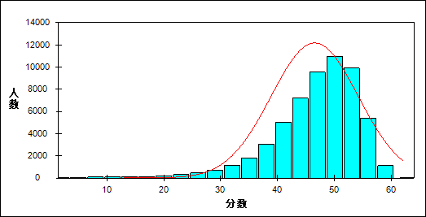

图 13 发展性试题难度曲线图

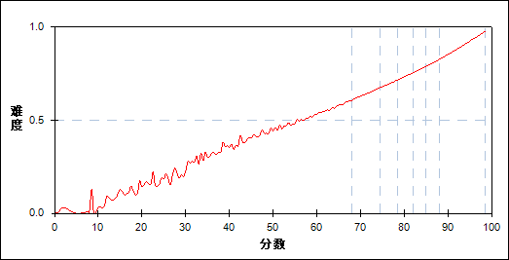

表 28 发展性试题分组分析表

| 分值 | G1 | G2 | G3 | G4 | G5 | G6 | G7 | 人数 | 比率(%) | 平均分 |
| --- | --- | --- | --- | --- | --- | --- | --- | --- | --- | --- |
| 0.0～ | 22 | 0 | 0 | 0 | 0 | 0 | 0 | 22 | 0.04 | 2.41 |
| 0.5～ | 1 | 0 | 0 | 0 | 0 | 0 | 0 | 1 | 0.00 | 7.50 |
| 1.0～ | 1 | 0 | 0 | 0 | 0 | 0 | 0 | 1 | 0.00 | 1.00 |
| 2.0～ | 6 | 0 | 0 | 0 | 0 | 0 | 0 | 6 | 0.01 | 10.33 |
| 2.5～ | 1 | 0 | 0 | 0 | 0 | 0 | 0 | 1 | 0.00 | 11.50 |
| 3.5～ | 2 | 0 | 0 | 0 | 0 | 0 | 0 | 2 | 0.00 | 20.00 |
| 4.0～ | 10 | 0 | 0 | 0 | 0 | 0 | 0 | 10 | 0.02 | 16.60 |
| 5.0～ | 9 | 0 | 0 | 0 | 0 | 0 | 0 | 9 | 0.02 | 17.78 |
| 6.0～ | 19 | 0 | 0 | 0 | 0 | 0 | 0 | 19 | 0.03 | 19.00 |
| 6.5～ | 2 | 0 | 0 | 0 | 0 | 0 | 0 | 2 | 0.00 | 17.50 |
| 7.0～ | 24 | 0 | 0 | 0 | 0 | 0 | 0 | 24 | 0.04 | 19.50 |
| 7.5～ | 2 | 0 | 0 | 0 | 0 | 0 | 0 | 2 | 0.00 | 21.50 |
| 8.0～ | 23 | 0 | 0 | 0 | 0 | 0 | 0 | 23 | 0.04 | 22.00 |
| 8.5～ | 3 | 0 | 0 | 0 | 0 | 0 | 0 | 3 | 0.01 | 17.50 |
| 9.0～ | 24 | 0 | 0 | 0 | 0 | 0 | 0 | 24 | 0.04 | 22.92 |
| 9.5～ | 5 | 0 | 0 | 0 | 0 | 0 | 0 | 5 | 0.01 | 29.90 |
| 10.0～ | 27 | 0 | 0 | 0 | 0 | 0 | 0 | 27 | 0.05 | 24.37 |
| 10.5～ | 3 | 0 | 0 | 0 | 0 | 0 | 0 | 3 | 0.01 | 23.17 |
| 11.0～ | 30 | 0 | 0 | 0 | 0 | 0 | 0 | 30 | 0.05 | 26.07 |
| 11.5～ | 3 | 0 | 0 | 0 | 0 | 0 | 0 | 3 | 0.01 | 23.17 |
| 12.0～ | 28 | 0 | 0 | 0 | 0 | 0 | 0 | 28 | 0.05 | 26.29 |
| 12.5～ | 4 | 0 | 0 | 0 | 0 | 0 | 0 | 4 | 0.01 | 28.00 |
| 13.0～ | 27 | 0 | 0 | 0 | 0 | 0 | 0 | 27 | 0.05 | 29.04 |
| 13.5～ | 8 | 0 | 0 | 0 | 0 | 0 | 0 | 8 | 0.01 | 26.63 |
| 14.0～ | 30 | 0 | 0 | 0 | 0 | 0 | 0 | 30 | 0.05 | 29.80 |
| 14.5～ | 9 | 0 | 0 | 0 | 0 | 0 | 0 | 9 | 0.02 | 32.39 |
| 15.0～ | 27 | 0 | 0 | 0 | 0 | 0 | 0 | 27 | 0.05 | 30.96 |
| 15.5～ | 6 | 0 | 0 | 0 | 0 | 0 | 0 | 6 | 0.01 | 36.83 |
| 16.0～ | 34 | 0 | 0 | 0 | 0 | 0 | 0 | 34 | 0.06 | 33.91 |
| 16.5～ | 7 | 0 | 0 | 0 | 0 | 0 | 0 | 7 | 0.01 | 34.36 |
| 17.0～ | 26 | 0 | 0 | 0 | 0 | 0 | 0 | 26 | 0.05 | 36.62 |
| 17.5～ | 9 | 0 | 0 | 0 | 0 | 0 | 0 | 9 | 0.02 | 38.72 |
| 18.0～ | 26 | 0 | 0 | 0 | 0 | 0 | 0 | 26 | 0.05 | 33.92 |
| 18.5～ | 15 | 0 | 0 | 0 | 0 | 0 | 0 | 15 | 0.03 | 36.70 |
| 19.0～ | 48 | 0 | 0 | 0 | 0 | 0 | 0 | 48 | 0.08 | 37.35 |
| 19.5～ | 17 | 0 | 0 | 0 | 0 | 0 | 0 | 17 | 0.03 | 36.21 |
| 20.0～ | 46 | 0 | 0 | 0 | 0 | 0 | 0 | 46 | 0.08 | 40.13 |
| 20.5～ | 12 | 0 | 0 | 0 | 0 | 0 | 0 | 12 | 0.02 | 40.58 |
| 21.0～ | 63 | 0 | 0 | 0 | 0 | 0 | 0 | 63 | 0.11 | 41.21 |
| 21.5～ | 22 | 0 | 0 | 0 | 0 | 0 | 0 | 22 | 0.04 | 42.00 |
| 22.0～ | 74 | 0 | 0 | 0 | 0 | 0 | 0 | 74 | 0.13 | 41.69 |
| 22.5～ | 23 | 0 | 0 | 0 | 0 | 0 | 0 | 23 | 0.04 | 44.02 |
| 23.0～ | 78 | 0 | 0 | 0 | 0 | 0 | 0 | 78 | 0.14 | 43.49 |
| 23.5～ | 24 | 0 | 0 | 0 | 0 | 0 | 0 | 24 | 0.04 | 43.29 |
| 24.0～ | 80 | 0 | 0 | 0 | 0 | 0 | 0 | 80 | 0.14 | 46.05 |
| 24.5～ | 38 | 0 | 0 | 0 | 0 | 0 | 0 | 38 | 0.07 | 46.03 |
| 25.0～ | 87 | 0 | 0 | 0 | 0 | 0 | 0 | 87 | 0.15 | 46.98 |
| 25.5～ | 41 | 0 | 0 | 0 | 0 | 0 | 0 | 41 | 0.07 | 48.38 |
| 26.0～ | 106 | 0 | 0 | 0 | 0 | 0 | 0 | 106 | 0.19 | 49.03 |
| 26.5～ | 54 | 0 | 0 | 0 | 0 | 0 | 0 | 54 | 0.09 | 47.63 |
| 27.0～ | 118 | 0 | 0 | 0 | 0 | 0 | 0 | 118 | 0.21 | 49.54 |
| 27.5～ | 58 | 0 | 0 | 0 | 0 | 0 | 0 | 58 | 0.10 | 48.19 |
| 28.0～ | 124 | 0 | 0 | 0 | 0 | 0 | 0 | 124 | 0.22 | 50.90 |
| 28.5～ | 75 | 0 | 0 | 0 | 0 | 0 | 0 | 75 | 0.13 | 52.02 |
| 29.0～ | 161 | 0 | 0 | 0 | 0 | 0 | 0 | 161 | 0.28 | 52.41 |
| 29.5～ | 102 | 0 | 0 | 0 | 0 | 0 | 0 | 102 | 0.18 | 53.81 |
| 30.0～ | 195 | 0 | 0 | 0 | 0 | 0 | 0 | 195 | 0.34 | 54.46 |
| 30.5～ | 105 | 0 | 0 | 0 | 0 | 0 | 0 | 105 | 0.18 | 54.78 |
| 31.0～ | 203 | 0 | 0 | 0 | 0 | 0 | 0 | 203 | 0.35 | 55.25 |
| 31.5～ | 166 | 0 | 0 | 0 | 0 | 0 | 0 | 166 | 0.29 | 56.37 |
| 32.0～ | 215 | 0 | 0 | 0 | 0 | 0 | 0 | 215 | 0.38 | 56.75 |
| 32.5～ | 163 | 0 | 0 | 0 | 0 | 0 | 0 | 163 | 0.28 | 57.94 |
| 33.0～ | 272 | 2 | 0 | 0 | 0 | 0 | 0 | 274 | 0.48 | 58.99 |
| 33.5～ | 200 | 3 | 0 | 0 | 0 | 0 | 0 | 203 | 0.35 | 59.56 |
| 34.0～ | 300 | 9 | 0 | 0 | 0 | 0 | 0 | 309 | 0.54 | 60.18 |
| 34.5～ | 235 | 8 | 0 | 0 | 0 | 0 | 0 | 243 | 0.42 | 61.12 |
| 35.0～ | 360 | 14 | 0 | 0 | 0 | 0 | 0 | 374 | 0.65 | 61.92 |
| 35.5～ | 269 | 17 | 0 | 0 | 0 | 0 | 0 | 286 | 0.50 | 62.83 |
| 36.0～ | 356 | 50 | 0 | 0 | 0 | 0 | 0 | 406 | 0.71 | 63.45 |
| 36.5～ | 278 | 64 | 0 | 0 | 0 | 0 | 0 | 342 | 0.60 | 64.10 |
| 37.0～ | 383 | 108 | 0 | 0 | 0 | 0 | 0 | 491 | 0.86 | 64.69 |
| 37.5～ | 308 | 120 | 0 | 0 | 0 | 0 | 0 | 428 | 0.75 | 65.45 |
| 38.0～ | 360 | 203 | 0 | 0 | 0 | 0 | 0 | 563 | 0.98 | 66.24 |
| 38.5～ | 244 | 246 | 0 | 0 | 0 | 0 | 0 | 490 | 0.86 | 67.31 |
| 39.0～ | 328 | 382 | 0 | 0 | 0 | 0 | 0 | 710 | 1.24 | 67.85 |
| 39.5～ | 231 | 359 | 7 | 0 | 0 | 0 | 0 | 597 | 1.04 | 68.52 |
| 40.0～ | 240 | 558 | 14 | 0 | 0 | 0 | 0 | 812 | 1.42 | 69.06 |
| 40.5～ | 191 | 510 | 34 | 0 | 0 | 0 | 0 | 735 | 1.28 | 69.71 |
| 41.0～ | 166 | 715 | 64 | 0 | 0 | 0 | 0 | 945 | 1.65 | 70.57 |
| 41.5～ | 114 | 599 | 140 | 0 | 0 | 0 | 0 | 853 | 1.49 | 71.40 |
| 42.0～ | 109 | 771 | 224 | 0 | 0 | 0 | 0 | 1104 | 1.93 | 72.00 |
| 42.5～ | 81 | 615 | 320 | 0 | 0 | 0 | 0 | 1016 | 1.77 | 72.45 |
| 43.0～ | 60 | 591 | 493 | 0 | 0 | 0 | 0 | 1144 | 2.00 | 73.48 |
| 43.5～ | 38 | 460 | 584 | 13 | 0 | 0 | 0 | 1095 | 1.91 | 74.03 |
| 44.0～ | 25 | 452 | 721 | 33 | 0 | 0 | 0 | 1231 | 2.15 | 74.71 |
| 44.5～ | 19 | 329 | 830 | 126 | 0 | 0 | 0 | 1304 | 2.28 | 75.52 |
| 45.0～ | 16 | 284 | 877 | 227 | 0 | 0 | 0 | 1404 | 2.45 | 76.16 |
| 45.5～ | 8 | 173 | 823 | 381 | 0 | 0 | 0 | 1385 | 2.42 | 76.87 |
| 46.0～ | 6 | 176 | 791 | 626 | 0 | 0 | 0 | 1599 | 2.79 | 77.50 |
| 46.5～ | 5 | 105 | 624 | 790 | 0 | 0 | 0 | 1524 | 2.66 | 78.18 |
| 47.0～ | 3 | 86 | 497 | 954 | 126 | 0 | 0 | 1666 | 2.91 | 78.92 |
| 47.5～ | 1 | 53 | 335 | 1078 | 141 | 0 | 0 | 1608 | 2.81 | 79.61 |
| 48.0～ | 1 | 44 | 242 | 913 | 548 | 0 | 0 | 1748 | 3.05 | 80.33 |
| 48.5～ | 2 | 23 | 187 | 911 | 599 | 0 | 0 | 1722 | 3.01 | 80.90 |
| 49.0～ | 1 | 26 | 129 | 629 | 1082 | 0 | 0 | 1867 | 3.26 | 81.51 |
| 49.5～ | 2 | 14 | 106 | 573 | 1199 | 0 | 0 | 1894 | 3.31 | 82.16 |
| 50.0～ | 0 | 6 | 72 | 306 | 1116 | 281 | 0 | 1781 | 3.11 | 82.83 |
| 50.5～ | 0 | 4 | 24 | 234 | 1064 | 410 | 0 | 1736 | 3.03 | 83.65 |
| 51.0～ | 0 | 1 | 25 | 163 | 782 | 972 | 0 | 1943 | 3.39 | 84.20 |
| 51.5～ | 0 | 1 | 9 | 97 | 631 | 1035 | 0 | 1773 | 3.10 | 84.88 |
| 52.0～ | 0 | 1 | 5 | 49 | 335 | 1409 | 0 | 1799 | 3.14 | 85.56 |
| 52.5～ | 0 | 0 | 4 | 43 | 253 | 1397 | 0 | 1697 | 2.96 | 86.13 |
| 53.0～ | 1 | 0 | 2 | 19 | 122 | 973 | 546 | 1663 | 2.90 | 86.74 |
| 53.5～ | 0 | 0 | 1 | 9 | 72 | 815 | 622 | 1519 | 2.65 | 87.37 |
| 54.0～ | 0 | 1 | 0 | 6 | 48 | 403 | 1010 | 1468 | 2.56 | 87.90 |
| 54.5～ | 0 | 0 | 0 | 3 | 34 | 248 | 919 | 1204 | 2.10 | 88.51 |
| 55.0～ | 0 | 1 | 0 | 1 | 17 | 120 | 1056 | 1195 | 2.09 | 89.08 |
| 55.5～ | 0 | 0 | 0 | 0 | 10 | 77 | 876 | 963 | 1.68 | 89.67 |
| 56.0～ | 0 | 0 | 0 | 0 | 1 | 24 | 826 | 851 | 1.49 | 90.30 |
| 56.5～ | 0 | 0 | 0 | 0 | 3 | 12 | 650 | 665 | 1.16 | 90.78 |
| 57.0～ | 0 | 0 | 0 | 0 | 0 | 4 | 520 | 524 | 0.91 | 91.37 |
| 57.5～ | 0 | 0 | 0 | 0 | 0 | 3 | 372 | 375 | 0.65 | 91.85 |
| 58.0～ | 0 | 0 | 0 | 0 | 0 | 0 | 275 | 275 | 0.48 | 92.45 |
| 58.5～ | 0 | 0 | 0 | 0 | 0 | 0 | 180 | 180 | 0.31 | 93.01 |
| 59.0～ | 0 | 0 | 0 | 0 | 0 | 0 | 126 | 126 | 0.22 | 93.56 |
| 59.5～ | 0 | 0 | 0 | 0 | 0 | 0 | 81 | 81 | 0.14 | 94.12 |
| 60.0～ | 0 | 0 | 0 | 0 | 0 | 0 | 63 | 63 | 0.11 | 94.40 |
| 60.5～ | 0 | 0 | 0 | 0 | 0 | 0 | 26 | 26 | 0.05 | 94.77 |
| 61.0～ | 0 | 0 | 0 | 0 | 0 | 0 | 16 | 16 | 0.03 | 95.94 |
| 61.5～ | 0 | 0 | 0 | 0 | 0 | 0 | 12 | 12 | 0.02 | 96.00 |
| 62.0～ | 0 | 0 | 0 | 0 | 0 | 0 | 4 | 4 | 0.01 | 97.00 |
| 62.5～ | 0 | 0 | 0 | 0 | 0 | 0 | 2 | 2 | 0.00 | 97.50 |
| 63.5～ | 0 | 0 | 0 | 0 | 0 | 0 | 1 | 1 | 0.00 | 98.50 |
| 合计 | 8184 | 8184 | 8184 | 8184 | 8183 | 8183 | 8183 | 57285 | 100.00 | 77.89 |
| 得分率 | 0.51 | 0.64 | 0.70 | 0.74 | 0.77 | 0.80 | 0.85 | - | - | - |

表 29 发展性试题等级分析表

| 分值 | 优秀 | | 良好 | | 合格 | | 不合格 | | 全体 | |
| --- | --- | --- | --- | --- | --- | --- | --- | --- | --- | --- |
| 人数 | 比率 | 人数 | 比率 | 人数 | 比率 | 人数 | 比率 | 人数 | 比率 |
| 0.0～ | 0 | 0.0 | 0 | 0.0 | 0 | 0.0 | 22 | 100.0 | 22 | 100.0 |
| 0.5～ | 0 | 0.0 | 0 | 0.0 | 0 | 0.0 | 1 | 100.0 | 1 | 100.0 |
| 1.0～ | 0 | 0.0 | 0 | 0.0 | 0 | 0.0 | 1 | 100.0 | 1 | 100.0 |
| 2.0～ | 0 | 0.0 | 0 | 0.0 | 0 | 0.0 | 6 | 100.0 | 6 | 100.0 |
| 2.5～ | 0 | 0.0 | 0 | 0.0 | 0 | 0.0 | 1 | 100.0 | 1 | 100.0 |
| 3.5～ | 0 | 0.0 | 0 | 0.0 | 0 | 0.0 | 2 | 100.0 | 2 | 100.0 |
| 4.0～ | 0 | 0.0 | 0 | 0.0 | 0 | 0.0 | 10 | 100.0 | 10 | 100.0 |
| 5.0～ | 0 | 0.0 | 0 | 0.0 | 0 | 0.0 | 9 | 100.0 | 9 | 100.0 |
| 6.0～ | 0 | 0.0 | 0 | 0.0 | 0 | 0.0 | 19 | 100.0 | 19 | 100.0 |
| 6.5～ | 0 | 0.0 | 0 | 0.0 | 0 | 0.0 | 2 | 100.0 | 2 | 100.0 |
| 7.0～ | 0 | 0.0 | 0 | 0.0 | 0 | 0.0 | 24 | 100.0 | 24 | 100.0 |
| 7.5～ | 0 | 0.0 | 0 | 0.0 | 0 | 0.0 | 2 | 100.0 | 2 | 100.0 |
| 8.0～ | 0 | 0.0 | 0 | 0.0 | 0 | 0.0 | 23 | 100.0 | 23 | 100.0 |
| 8.5～ | 0 | 0.0 | 0 | 0.0 | 0 | 0.0 | 3 | 100.0 | 3 | 100.0 |
| 9.0～ | 0 | 0.0 | 0 | 0.0 | 0 | 0.0 | 24 | 100.0 | 24 | 100.0 |
| 9.5～ | 0 | 0.0 | 0 | 0.0 | 0 | 0.0 | 5 | 100.0 | 5 | 100.0 |
| 10.0～ | 0 | 0.0 | 0 | 0.0 | 0 | 0.0 | 27 | 100.0 | 27 | 100.0 |
| 10.5～ | 0 | 0.0 | 0 | 0.0 | 0 | 0.0 | 3 | 100.0 | 3 | 100.0 |
| 11.0～ | 0 | 0.0 | 0 | 0.0 | 0 | 0.0 | 30 | 100.0 | 30 | 100.0 |
| 11.5～ | 0 | 0.0 | 0 | 0.0 | 0 | 0.0 | 3 | 100.0 | 3 | 100.0 |
| 12.0～ | 0 | 0.0 | 0 | 0.0 | 0 | 0.0 | 28 | 100.0 | 28 | 100.0 |
| 12.5～ | 0 | 0.0 | 0 | 0.0 | 0 | 0.0 | 4 | 100.0 | 4 | 100.0 |
| 13.0～ | 0 | 0.0 | 0 | 0.0 | 0 | 0.0 | 27 | 100.0 | 27 | 100.0 |
| 13.5～ | 0 | 0.0 | 0 | 0.0 | 0 | 0.0 | 8 | 100.0 | 8 | 100.0 |
| 14.0～ | 0 | 0.0 | 0 | 0.0 | 0 | 0.0 | 30 | 100.0 | 30 | 100.0 |
| 14.5～ | 0 | 0.0 | 0 | 0.0 | 0 | 0.0 | 9 | 100.0 | 9 | 100.0 |
| 15.0～ | 0 | 0.0 | 0 | 0.0 | 0 | 0.0 | 27 | 100.0 | 27 | 100.0 |
| 15.5～ | 0 | 0.0 | 0 | 0.0 | 0 | 0.0 | 6 | 100.0 | 6 | 100.0 |
| 16.0～ | 0 | 0.0 | 0 | 0.0 | 0 | 0.0 | 34 | 100.0 | 34 | 100.0 |
| 16.5～ | 0 | 0.0 | 0 | 0.0 | 0 | 0.0 | 7 | 100.0 | 7 | 100.0 |
| 17.0～ | 0 | 0.0 | 0 | 0.0 | 0 | 0.0 | 26 | 100.0 | 26 | 100.0 |
| 17.5～ | 0 | 0.0 | 0 | 0.0 | 0 | 0.0 | 9 | 100.0 | 9 | 100.0 |
| 18.0～ | 0 | 0.0 | 0 | 0.0 | 0 | 0.0 | 26 | 100.0 | 26 | 100.0 |
| 18.5～ | 0 | 0.0 | 0 | 0.0 | 0 | 0.0 | 15 | 100.0 | 15 | 100.0 |
| 19.0～ | 0 | 0.0 | 0 | 0.0 | 0 | 0.0 | 48 | 100.0 | 48 | 100.0 |
| 19.5～ | 0 | 0.0 | 0 | 0.0 | 0 | 0.0 | 17 | 100.0 | 17 | 100.0 |
| 20.0～ | 0 | 0.0 | 0 | 0.0 | 0 | 0.0 | 46 | 100.0 | 46 | 100.0 |
| 20.5～ | 0 | 0.0 | 0 | 0.0 | 0 | 0.0 | 12 | 100.0 | 12 | 100.0 |
| 21.0～ | 0 | 0.0 | 0 | 0.0 | 0 | 0.0 | 63 | 100.0 | 63 | 100.0 |
| 21.5～ | 0 | 0.0 | 0 | 0.0 | 0 | 0.0 | 22 | 100.0 | 22 | 100.0 |
| 22.0～ | 0 | 0.0 | 0 | 0.0 | 0 | 0.0 | 74 | 100.0 | 74 | 100.0 |
| 22.5～ | 0 | 0.0 | 0 | 0.0 | 0 | 0.0 | 23 | 100.0 | 23 | 100.0 |
| 23.0～ | 0 | 0.0 | 0 | 0.0 | 0 | 0.0 | 78 | 100.0 | 78 | 100.0 |
| 23.5～ | 0 | 0.0 | 0 | 0.0 | 0 | 0.0 | 24 | 100.0 | 24 | 100.0 |
| 24.0～ | 0 | 0.0 | 0 | 0.0 | 0 | 0.0 | 80 | 100.0 | 80 | 100.0 |
| 24.5～ | 0 | 0.0 | 0 | 0.0 | 0 | 0.0 | 38 | 100.0 | 38 | 100.0 |
| 25.0～ | 0 | 0.0 | 0 | 0.0 | 0 | 0.0 | 87 | 100.0 | 87 | 100.0 |
| 25.5～ | 0 | 0.0 | 0 | 0.0 | 0 | 0.0 | 41 | 100.0 | 41 | 100.0 |
| 26.0～ | 0 | 0.0 | 0 | 0.0 | 5 | 4.7 | 101 | 95.3 | 106 | 100.0 |
| 26.5～ | 0 | 0.0 | 0 | 0.0 | 0 | 0.0 | 54 | 100.0 | 54 | 100.0 |
| 27.0～ | 0 | 0.0 | 0 | 0.0 | 3 | 2.5 | 115 | 97.5 | 118 | 100.0 |
| 27.5～ | 0 | 0.0 | 0 | 0.0 | 2 | 3.4 | 56 | 96.6 | 58 | 100.0 |
| 28.0～ | 0 | 0.0 | 0 | 0.0 | 8 | 6.5 | 116 | 93.5 | 124 | 100.0 |
| 28.5～ | 0 | 0.0 | 0 | 0.0 | 2 | 2.7 | 73 | 97.3 | 75 | 100.0 |
| 29.0～ | 0 | 0.0 | 0 | 0.0 | 20 | 12.4 | 141 | 87.6 | 161 | 100.0 |
| 29.5～ | 0 | 0.0 | 0 | 0.0 | 11 | 10.8 | 91 | 89.2 | 102 | 100.0 |
| 30.0～ | 0 | 0.0 | 0 | 0.0 | 33 | 16.9 | 162 | 83.1 | 195 | 100.0 |
| 30.5～ | 0 | 0.0 | 0 | 0.0 | 21 | 20.0 | 84 | 80.0 | 105 | 100.0 |
| 31.0～ | 0 | 0.0 | 0 | 0.0 | 55 | 27.1 | 148 | 72.9 | 203 | 100.0 |
| 31.5～ | 0 | 0.0 | 0 | 0.0 | 50 | 30.1 | 116 | 69.9 | 166 | 100.0 |
| 32.0～ | 0 | 0.0 | 0 | 0.0 | 67 | 31.2 | 148 | 68.8 | 215 | 100.0 |
| 32.5～ | 0 | 0.0 | 0 | 0.0 | 63 | 38.7 | 100 | 61.3 | 163 | 100.0 |
| 33.0～ | 0 | 0.0 | 0 | 0.0 | 142 | 51.8 | 132 | 48.2 | 274 | 100.0 |
| 33.5～ | 0 | 0.0 | 0 | 0.0 | 102 | 50.2 | 101 | 49.8 | 203 | 100.0 |
| 34.0～ | 0 | 0.0 | 0 | 0.0 | 195 | 63.1 | 114 | 36.9 | 309 | 100.0 |
| 34.5～ | 0 | 0.0 | 0 | 0.0 | 160 | 65.8 | 83 | 34.2 | 243 | 100.0 |
| 35.0～ | 0 | 0.0 | 0 | 0.0 | 284 | 75.9 | 90 | 24.1 | 374 | 100.0 |
| 35.5～ | 0 | 0.0 | 2 | 0.7 | 217 | 75.9 | 67 | 23.4 | 286 | 100.0 |
| 36.0～ | 0 | 0.0 | 15 | 3.7 | 324 | 79.8 | 67 | 16.5 | 406 | 100.0 |
| 36.5～ | 0 | 0.0 | 15 | 4.4 | 266 | 77.8 | 61 | 17.8 | 342 | 100.0 |
| 37.0～ | 0 | 0.0 | 47 | 9.6 | 391 | 79.6 | 53 | 10.8 | 491 | 100.0 |
| 37.5～ | 0 | 0.0 | 40 | 9.3 | 342 | 79.9 | 46 | 10.7 | 428 | 100.0 |
| 38.0～ | 0 | 0.0 | 104 | 18.5 | 423 | 75.1 | 36 | 6.4 | 563 | 100.0 |
| 38.5～ | 0 | 0.0 | 119 | 24.3 | 344 | 70.2 | 27 | 5.5 | 490 | 100.0 |
| 39.0～ | 0 | 0.0 | 253 | 35.6 | 438 | 61.7 | 19 | 2.7 | 710 | 100.0 |
| 39.5～ | 0 | 0.0 | 239 | 40.0 | 343 | 57.5 | 15 | 2.5 | 597 | 100.0 |
| 40.0～ | 0 | 0.0 | 431 | 53.1 | 363 | 44.7 | 18 | 2.2 | 812 | 100.0 |
| 40.5～ | 0 | 0.0 | 407 | 55.4 | 318 | 43.3 | 10 | 1.4 | 735 | 100.0 |
| 41.0～ | 0 | 0.0 | 652 | 69.0 | 286 | 30.3 | 7 | 0.7 | 945 | 100.0 |
| 41.5～ | 0 | 0.0 | 617 | 72.3 | 236 | 27.7 | 0 | 0.0 | 853 | 100.0 |
| 42.0～ | 0 | 0.0 | 909 | 82.3 | 192 | 17.4 | 3 | 0.3 | 1104 | 100.0 |
| 42.5～ | 0 | 0.0 | 829 | 81.6 | 185 | 18.2 | 2 | 0.2 | 1016 | 100.0 |
| 43.0～ | 0 | 0.0 | 1046 | 91.4 | 98 | 8.6 | 0 | 0.0 | 1144 | 100.0 |
| 43.5～ | 0 | 0.0 | 1009 | 92.1 | 85 | 7.8 | 1 | 0.1 | 1095 | 100.0 |
| 44.0～ | 0 | 0.0 | 1169 | 95.0 | 61 | 5.0 | 1 | 0.1 | 1231 | 100.0 |
| 44.5～ | 0 | 0.0 | 1253 | 96.1 | 50 | 3.8 | 1 | 0.1 | 1304 | 100.0 |
| 45.0～ | 0 | 0.0 | 1363 | 97.1 | 41 | 2.9 | 0 | 0.0 | 1404 | 100.0 |
| 45.5～ | 0 | 0.0 | 1358 | 98.1 | 27 | 1.9 | 0 | 0.0 | 1385 | 100.0 |
| 46.0～ | 0 | 0.0 | 1586 | 99.2 | 13 | 0.8 | 0 | 0.0 | 1599 | 100.0 |
| 46.5～ | 0 | 0.0 | 1510 | 99.1 | 13 | 0.9 | 1 | 0.1 | 1524 | 100.0 |
| 47.0～ | 0 | 0.0 | 1662 | 99.8 | 4 | 0.2 | 0 | 0.0 | 1666 | 100.0 |
| 47.5～ | 0 | 0.0 | 1605 | 99.8 | 3 | 0.2 | 0 | 0.0 | 1608 | 100.0 |
| 48.0～ | 0 | 0.0 | 1742 | 99.7 | 6 | 0.3 | 0 | 0.0 | 1748 | 100.0 |
| 48.5～ | 0 | 0.0 | 1719 | 99.8 | 3 | 0.2 | 0 | 0.0 | 1722 | 100.0 |
| 49.0～ | 0 | 0.0 | 1866 | 99.9 | 1 | 0.1 | 0 | 0.0 | 1867 | 100.0 |
| 49.5～ | 0 | 0.0 | 1890 | 99.8 | 4 | 0.2 | 0 | 0.0 | 1894 | 100.0 |
| 50.0～ | 333 | 18.7 | 1448 | 81.3 | 0 | 0.0 | 0 | 0.0 | 1781 | 100.0 |
| 50.5～ | 410 | 23.6 | 1325 | 76.3 | 1 | 0.1 | 0 | 0.0 | 1736 | 100.0 |
| 51.0～ | 1059 | 54.5 | 883 | 45.4 | 1 | 0.1 | 0 | 0.0 | 1943 | 100.0 |
| 51.5～ | 1035 | 58.4 | 737 | 41.6 | 1 | 0.1 | 0 | 0.0 | 1773 | 100.0 |
| 52.0～ | 1462 | 81.3 | 337 | 18.7 | 0 | 0.0 | 0 | 0.0 | 1799 | 100.0 |
| 52.5～ | 1397 | 82.3 | 300 | 17.7 | 0 | 0.0 | 0 | 0.0 | 1697 | 100.0 |
| 53.0～ | 1544 | 92.8 | 118 | 7.1 | 1 | 0.1 | 0 | 0.0 | 1663 | 100.0 |
| 53.5～ | 1437 | 94.6 | 82 | 5.4 | 0 | 0.0 | 0 | 0.0 | 1519 | 100.0 |
| 54.0～ | 1423 | 96.9 | 45 | 3.1 | 0 | 0.0 | 0 | 0.0 | 1468 | 100.0 |
| 54.5～ | 1167 | 96.9 | 37 | 3.1 | 0 | 0.0 | 0 | 0.0 | 1204 | 100.0 |
| 55.0～ | 1180 | 98.7 | 15 | 1.3 | 0 | 0.0 | 0 | 0.0 | 1195 | 100.0 |
| 55.5～ | 953 | 99.0 | 10 | 1.0 | 0 | 0.0 | 0 | 0.0 | 963 | 100.0 |
| 56.0～ | 851 | 100.0 | 0 | 0.0 | 0 | 0.0 | 0 | 0.0 | 851 | 100.0 |
| 56.5～ | 662 | 99.5 | 3 | 0.5 | 0 | 0.0 | 0 | 0.0 | 665 | 100.0 |
| 57.0～ | 524 | 100.0 | 0 | 0.0 | 0 | 0.0 | 0 | 0.0 | 524 | 100.0 |
| 57.5～ | 375 | 100.0 | 0 | 0.0 | 0 | 0.0 | 0 | 0.0 | 375 | 100.0 |
| 58.0～ | 275 | 100.0 | 0 | 0.0 | 0 | 0.0 | 0 | 0.0 | 275 | 100.0 |
| 58.5～ | 180 | 100.0 | 0 | 0.0 | 0 | 0.0 | 0 | 0.0 | 180 | 100.0 |
| 59.0～ | 126 | 100.0 | 0 | 0.0 | 0 | 0.0 | 0 | 0.0 | 126 | 100.0 |
| 59.5～ | 81 | 100.0 | 0 | 0.0 | 0 | 0.0 | 0 | 0.0 | 81 | 100.0 |
| 60.0～ | 63 | 100.0 | 0 | 0.0 | 0 | 0.0 | 0 | 0.0 | 63 | 100.0 |
| 60.5～ | 26 | 100.0 | 0 | 0.0 | 0 | 0.0 | 0 | 0.0 | 26 | 100.0 |
| 61.0～ | 16 | 100.0 | 0 | 0.0 | 0 | 0.0 | 0 | 0.0 | 16 | 100.0 |
| 61.5～ | 12 | 100.0 | 0 | 0.0 | 0 | 0.0 | 0 | 0.0 | 12 | 100.0 |
| 62.0～ | 4 | 100.0 | 0 | 0.0 | 0 | 0.0 | 0 | 0.0 | 4 | 100.0 |
| 62.5～ | 2 | 100.0 | 0 | 0.0 | 0 | 0.0 | 0 | 0.0 | 2 | 100.0 |
| 63.5～ | 1 | 100.0 | 0 | 0.0 | 0 | 0.0 | 0 | 0.0 | 1 | 100.0 |
| 合计 | 16598 | 29.0 | 30797 | 53.8 | 6304 | 11.0 | 3586 | 6.3 | 57285 | 100.0 |

* 1. 大题分析
     1. 听力理解

本题组共包含20道试题，题号是：1～20

表 30 听力理解总分分析表

|  |  |  |  |  |  |  |  |  |
| --- | --- | --- | --- | --- | --- | --- | --- | --- |
| 人数 | 满分 | 最大值 | 最小值 | 平均值 | 标准差 | 差异系数 | 难度 | 区分度 |
| 57285 | 20 | 20.0 | 0.0 | 18.52 | 2.21 | 0.12 | 0.93 | 0.80 |

表 31 听力理解等级得分率分析表

|  |  |  |  |  |
| --- | --- | --- | --- | --- |
| 优秀 | 良好 | 合格 | 不及格 | 全体 |
| 0.99 | 0.94 | 0.84 | 0.65 | 0.93 |

图 14 听力理解分数分布曲线图

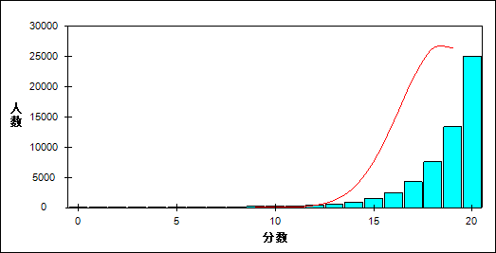

图 15 听力理解难度曲线图

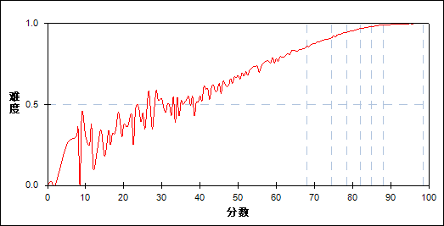

表 32 听力理解分组分析表

| 分值 | G1 | G2 | G3 | G4 | G5 | G6 | G7 | 人数 | 比率(%) | 平均分 |
| --- | --- | --- | --- | --- | --- | --- | --- | --- | --- | --- |
| 0.0～ | 24 | 0 | 0 | 0 | 0 | 0 | 0 | 24 | 0.04 | 5.85 |
| 1.0～ | 10 | 0 | 0 | 0 | 0 | 0 | 0 | 10 | 0.02 | 29.25 |
| 2.0～ | 13 | 0 | 0 | 0 | 0 | 0 | 0 | 13 | 0.02 | 33.96 |
| 3.0～ | 26 | 0 | 0 | 0 | 0 | 0 | 0 | 26 | 0.05 | 40.37 |
| 4.0～ | 43 | 6 | 0 | 0 | 0 | 0 | 0 | 49 | 0.09 | 51.99 |
| 5.0～ | 41 | 0 | 0 | 0 | 0 | 0 | 0 | 41 | 0.07 | 25.98 |
| 6.0～ | 59 | 0 | 0 | 0 | 0 | 0 | 0 | 59 | 0.10 | 29.19 |
| 7.0～ | 90 | 0 | 0 | 0 | 0 | 0 | 0 | 90 | 0.16 | 31.17 |
| 8.0～ | 105 | 0 | 0 | 0 | 0 | 0 | 0 | 105 | 0.18 | 33.72 |
| 9.0～ | 164 | 0 | 0 | 0 | 0 | 0 | 0 | 164 | 0.29 | 38.85 |
| 10.0～ | 226 | 2 | 0 | 0 | 0 | 0 | 0 | 228 | 0.40 | 42.91 |
| 11.0～ | 297 | 3 | 0 | 0 | 0 | 0 | 0 | 300 | 0.52 | 47.26 |
| 12.0～ | 424 | 11 | 0 | 0 | 0 | 0 | 0 | 435 | 0.76 | 51.26 |
| 13.0～ | 551 | 36 | 4 | 1 | 1 | 0 | 0 | 593 | 1.04 | 55.46 |
| 14.0～ | 764 | 142 | 15 | 3 | 0 | 0 | 0 | 924 | 1.61 | 59.52 |
| 15.0～ | 1042 | 380 | 90 | 16 | 6 | 0 | 0 | 1534 | 2.68 | 63.58 |
| 16.0～ | 1197 | 851 | 295 | 77 | 15 | 5 | 1 | 2441 | 4.26 | 67.32 |
| 17.0～ | 1218 | 1641 | 886 | 375 | 126 | 34 | 7 | 4287 | 7.48 | 71.06 |
| 18.0～ | 1096 | 2322 | 1931 | 1269 | 625 | 267 | 86 | 7596 | 13.26 | 74.61 |
| 19.0～ | 585 | 1897 | 2892 | 3029 | 2460 | 1611 | 871 | 13345 | 23.30 | 79.40 |
| 20.0～ | 209 | 893 | 2071 | 3414 | 4950 | 6266 | 7218 | 25021 | 43.68 | 84.53 |
| 合计 | 8184 | 8184 | 8184 | 8184 | 8183 | 8183 | 8183 | 57285 | 100.00 | 77.89 |
| 得分率 | 0.75 | 0.89 | 0.93 | 0.96 | 0.97 | 0.99 | 0.99 | - | - | - |

表 33 听力理解等级分析表

| 分值 | 优秀 | | 良好 | | 合格 | | 不合格 | | 全体 | |
| --- | --- | --- | --- | --- | --- | --- | --- | --- | --- | --- |
| 人数 | 比率 | 人数 | 比率 | 人数 | 比率 | 人数 | 比率 | 人数 | 比率 |
| 0.0～ | 0 | 0.0 | 0 | 0.0 | 0 | 0.0 | 24 | 100.0 | 24 | 100.0 |
| 1.0～ | 0 | 0.0 | 0 | 0.0 | 0 | 0.0 | 10 | 100.0 | 10 | 100.0 |
| 2.0～ | 0 | 0.0 | 0 | 0.0 | 0 | 0.0 | 13 | 100.0 | 13 | 100.0 |
| 3.0～ | 0 | 0.0 | 0 | 0.0 | 3 | 11.5 | 23 | 88.5 | 26 | 100.0 |
| 4.0～ | 0 | 0.0 | 2 | 4.1 | 17 | 34.7 | 30 | 61.2 | 49 | 100.0 |
| 5.0～ | 0 | 0.0 | 0 | 0.0 | 0 | 0.0 | 41 | 100.0 | 41 | 100.0 |
| 6.0～ | 0 | 0.0 | 0 | 0.0 | 0 | 0.0 | 59 | 100.0 | 59 | 100.0 |
| 7.0～ | 0 | 0.0 | 0 | 0.0 | 1 | 1.1 | 89 | 98.9 | 90 | 100.0 |
| 8.0～ | 0 | 0.0 | 0 | 0.0 | 0 | 0.0 | 105 | 100.0 | 105 | 100.0 |
| 9.0～ | 0 | 0.0 | 0 | 0.0 | 3 | 1.8 | 161 | 98.2 | 164 | 100.0 |
| 10.0～ | 0 | 0.0 | 2 | 0.9 | 7 | 3.1 | 219 | 96.1 | 228 | 100.0 |
| 11.0～ | 0 | 0.0 | 1 | 0.3 | 36 | 12.0 | 263 | 87.7 | 300 | 100.0 |
| 12.0～ | 0 | 0.0 | 7 | 1.6 | 79 | 18.2 | 349 | 80.2 | 435 | 100.0 |
| 13.0～ | 0 | 0.0 | 24 | 4.0 | 192 | 32.4 | 377 | 63.6 | 593 | 100.0 |
| 14.0～ | 0 | 0.0 | 102 | 11.0 | 395 | 42.7 | 427 | 46.2 | 924 | 100.0 |
| 15.0～ | 0 | 0.0 | 369 | 24.1 | 746 | 48.6 | 419 | 27.3 | 1534 | 100.0 |
| 16.0～ | 6 | 0.2 | 987 | 40.4 | 1113 | 45.6 | 335 | 13.7 | 2441 | 100.0 |
| 17.0～ | 43 | 1.0 | 2646 | 61.7 | 1317 | 30.7 | 281 | 6.6 | 4287 | 100.0 |
| 18.0～ | 366 | 4.8 | 5661 | 74.5 | 1334 | 17.6 | 235 | 3.1 | 7596 | 100.0 |
| 19.0～ | 2558 | 19.2 | 9919 | 74.3 | 775 | 5.8 | 93 | 0.7 | 13345 | 100.0 |
| 20.0～ | 13625 | 54.5 | 11077 | 44.3 | 286 | 1.1 | 33 | 0.1 | 25021 | 100.0 |
| 合计 | 16598 | 29.0 | 30797 | 53.8 | 6304 | 11.0 | 3586 | 6.3 | 57285 | 100.0 |

* + 1. 单项填空

本题组共包含2道试题，题号是：21、35

表 34 单项填空总分分析表

|  |  |  |  |  |  |  |  |  |
| --- | --- | --- | --- | --- | --- | --- | --- | --- |
| 人数 | 满分 | 最大值 | 最小值 | 平均值 | 标准差 | 差异系数 | 难度 | 区分度 |
| 57285 | 2 | 2.0 | 0.0 | 1.29 | 0.64 | 0.50 | 0.64 | 0.49 |

表 35 单项填空等级得分率分析表

|  |  |  |  |  |
| --- | --- | --- | --- | --- |
| 优秀 | 良好 | 合格 | 不及格 | 全体 |
| 0.87 | 0.60 | 0.45 | 0.34 | 0.64 |

图 16 单项填空分数分布曲线图

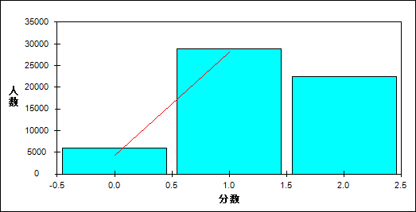

图 17 单项填空难度曲线图

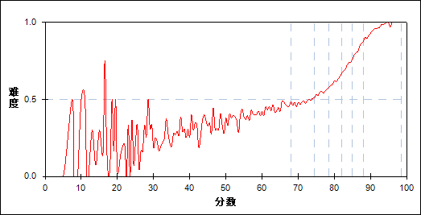

表 36 单项填空分组分析表

| 分值 | G1 | G2 | G3 | G4 | G5 | G6 | G7 | 人数 | 比率(%) | 平均分 |
| --- | --- | --- | --- | --- | --- | --- | --- | --- | --- | --- |
| 0.0～ | 2516 | 1410 | 993 | 629 | 332 | 123 | 24 | 6027 | 10.52 | 66.46 |
| 1.0～ | 4736 | 5600 | 5454 | 5021 | 4050 | 2807 | 1185 | 28853 | 50.37 | 75.76 |
| 2.0～ | 932 | 1174 | 1737 | 2534 | 3801 | 5253 | 6974 | 22405 | 39.11 | 83.70 |
| 合计 | 8184 | 8184 | 8184 | 8184 | 8183 | 8183 | 8183 | 57285 | 100.00 | 77.89 |
| 得分率 | 0.40 | 0.49 | 0.55 | 0.62 | 0.71 | 0.81 | 0.92 | - | - | - |

表 37 单项填空等级分析表

| 分值 | 优秀 | | 良好 | | 合格 | | 不合格 | | 全体 | |
| --- | --- | --- | --- | --- | --- | --- | --- | --- | --- | --- |
| 人数 | 比率 | 人数 | 比率 | 人数 | 比率 | 人数 | 比率 | 人数 | 比率 |
| 0.0～ | 151 | 2.5 | 3025 | 50.2 | 1390 | 23.1 | 1461 | 24.2 | 6027 | 100.0 |
| 1.0～ | 4087 | 14.2 | 18892 | 65.5 | 4096 | 14.2 | 1778 | 6.2 | 28853 | 100.0 |
| 2.0～ | 12360 | 55.2 | 8880 | 39.6 | 818 | 3.7 | 347 | 1.5 | 22405 | 100.0 |
| 合计 | 16598 | 29.0 | 30797 | 53.8 | 6304 | 11.0 | 3586 | 6.3 | 57285 | 100.0 |

* + 1. 完形填空

本题组共包含2道试题，题号是：36、50

表 38 完形填空总分分析表

|  |  |  |  |  |  |  |  |  |
| --- | --- | --- | --- | --- | --- | --- | --- | --- |
| 人数 | 满分 | 最大值 | 最小值 | 平均值 | 标准差 | 差异系数 | 难度 | 区分度 |
| 57285 | 3 | 3.0 | 0.0 | 1.92 | 0.94 | 0.49 | 0.64 | 0.46 |

表 39 完形填空等级得分率分析表

|  |  |  |  |  |
| --- | --- | --- | --- | --- |
| 优秀 | 良好 | 合格 | 不及格 | 全体 |
| 0.82 | 0.62 | 0.43 | 0.35 | 0.64 |

图 18 完形填空分数分布曲线图

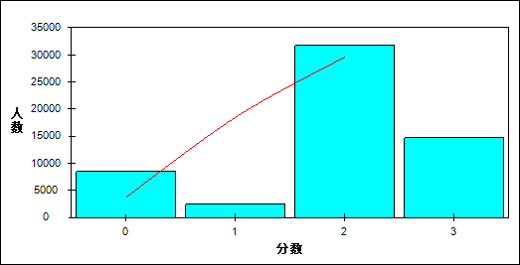

图 19 完形填空难度曲线图

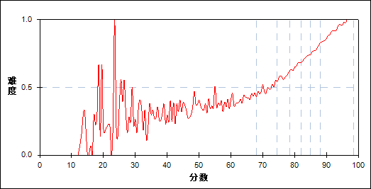

表 40 完形填空分组分析表

| 分值 | G1 | G2 | G3 | G4 | G5 | G6 | G7 | 人数 | 比率(%) | 平均分 |
| --- | --- | --- | --- | --- | --- | --- | --- | --- | --- | --- |
| 0.0～ | 3374 | 2336 | 1462 | 818 | 368 | 134 | 15 | 8507 | 14.85 | 67.57 |
| 1.0～ | 775 | 595 | 427 | 283 | 174 | 98 | 40 | 2392 | 4.18 | 70.20 |
| 2.0～ | 3304 | 4242 | 5080 | 5469 | 5553 | 4920 | 3146 | 31714 | 55.36 | 78.67 |
| 3.0～ | 731 | 1011 | 1215 | 1614 | 2088 | 3031 | 4982 | 14672 | 25.61 | 83.42 |
| 合计 | 8184 | 8184 | 8184 | 8184 | 8183 | 8183 | 8183 | 57285 | 100.00 | 77.89 |
| 得分率 | 0.39 | 0.49 | 0.58 | 0.65 | 0.71 | 0.78 | 0.87 | - | - | - |

表 41 完形填空等级分析表

| 分值 | 优秀 | | 良好 | | 合格 | | 不合格 | | 全体 | |
| --- | --- | --- | --- | --- | --- | --- | --- | --- | --- | --- |
| 人数 | 比率 | 人数 | 比率 | 人数 | 比率 | 人数 | 比率 | 人数 | 比率 |
| 0.0～ | 157 | 1.8 | 4423 | 52.0 | 2274 | 26.7 | 1653 | 19.4 | 8507 | 100.0 |
| 1.0～ | 139 | 5.8 | 1332 | 55.7 | 548 | 22.9 | 373 | 15.6 | 2392 | 100.0 |
| 2.0～ | 8219 | 25.9 | 19367 | 61.1 | 2844 | 9.0 | 1284 | 4.0 | 31714 | 100.0 |
| 3.0～ | 8083 | 55.1 | 5675 | 38.7 | 638 | 4.3 | 276 | 1.9 | 14672 | 100.0 |
| 合计 | 16598 | 29.0 | 30797 | 53.8 | 6304 | 11.0 | 3586 | 6.3 | 57285 | 100.0 |

* + 1. 阅读理解

本题组共包含2道试题，题号是：51、65

表 42 阅读理解总分分析表

|  |  |  |  |  |  |  |  |  |
| --- | --- | --- | --- | --- | --- | --- | --- | --- |
| 人数 | 满分 | 最大值 | 最小值 | 平均值 | 标准差 | 差异系数 | 难度 | 区分度 |
| 57285 | 4 | 4.0 | 0.0 | 3.16 | 0.92 | 0.29 | 0.79 | 0.65 |

表 43 阅读理解等级得分率分析表

|  |  |  |  |  |
| --- | --- | --- | --- | --- |
| 优秀 | 良好 | 合格 | 不及格 | 全体 |
| 0.93 | 0.80 | 0.60 | 0.41 | 0.79 |

图 20 阅读理解分数分布曲线图

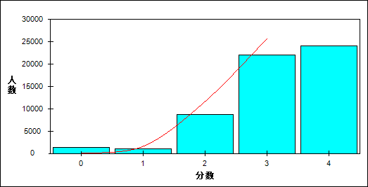

图 21 阅读理解难度曲线图

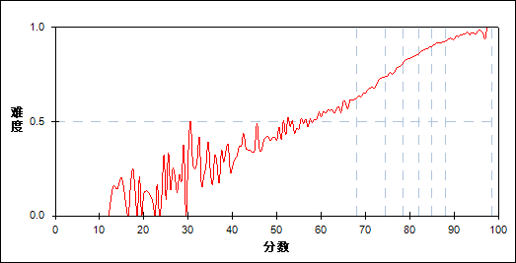

表 44 阅读理解分组分析表

| 分值 | G1 | G2 | G3 | G4 | G5 | G6 | G7 | 人数 | 比率(%) | 平均分 |
| --- | --- | --- | --- | --- | --- | --- | --- | --- | --- | --- |
| 0.0～ | 1201 | 141 | 39 | 6 | 0 | 0 | 0 | 1387 | 2.42 | 49.49 |
| 0.5～ | 6 | 8 | 0 | 1 | 0 | 0 | 0 | 15 | 0.03 | 65.53 |
| 1.0～ | 507 | 296 | 153 | 49 | 15 | 12 | 0 | 1032 | 1.80 | 65.69 |
| 1.5～ | 4 | 5 | 2 | 1 | 3 | 0 | 0 | 15 | 0.03 | 72.70 |
| 2.0～ | 3645 | 2415 | 1295 | 698 | 331 | 139 | 45 | 8568 | 14.96 | 67.67 |
| 2.5～ | 51 | 47 | 35 | 28 | 6 | 3 | 4 | 174 | 0.30 | 71.86 |
| 3.0～ | 2454 | 3921 | 4206 | 3672 | 3129 | 2441 | 1675 | 21498 | 37.53 | 77.67 |
| 3.5～ | 8 | 67 | 68 | 101 | 90 | 95 | 86 | 515 | 0.90 | 81.69 |
| 4.0～ | 308 | 1284 | 2386 | 3628 | 4609 | 5493 | 6373 | 24081 | 42.04 | 83.85 |
| 合计 | 8184 | 8184 | 8184 | 8184 | 8183 | 8183 | 8183 | 57285 | 100.00 | 77.89 |
| 得分率 | 0.51 | 0.68 | 0.77 | 0.84 | 0.88 | 0.91 | 0.94 | - | - | - |

表 45 阅读理解等级分析表

| 分值 | 优秀 | | 良好 | | 合格 | | 不合格 | | 全体 | |
| --- | --- | --- | --- | --- | --- | --- | --- | --- | --- | --- |
| 人数 | 比率 | 人数 | 比率 | 人数 | 比率 | 人数 | 比率 | 人数 | 比率 |
| 0.0～ | 0 | 0.0 | 137 | 9.9 | 337 | 24.3 | 913 | 65.8 | 1387 | 100.0 |
| 0.5～ | 0 | 0.0 | 7 | 46.7 | 5 | 33.3 | 3 | 20.0 | 15 | 100.0 |
| 1.0～ | 12 | 1.2 | 417 | 40.4 | 361 | 35.0 | 242 | 23.4 | 1032 | 100.0 |
| 1.5～ | 0 | 0.0 | 9 | 60.0 | 5 | 33.3 | 1 | 6.7 | 15 | 100.0 |
| 2.0～ | 188 | 2.2 | 4132 | 48.2 | 2543 | 29.7 | 1705 | 19.9 | 8568 | 100.0 |
| 2.5～ | 7 | 4.0 | 107 | 61.5 | 43 | 24.7 | 17 | 9.8 | 174 | 100.0 |
| 3.0～ | 4195 | 19.5 | 14073 | 65.5 | 2564 | 11.9 | 666 | 3.1 | 21498 | 100.0 |
| 3.5～ | 182 | 35.3 | 315 | 61.2 | 17 | 3.3 | 1 | 0.2 | 515 | 100.0 |
| 4.0～ | 12014 | 49.9 | 11600 | 48.2 | 429 | 1.8 | 38 | 0.2 | 24081 | 100.0 |
| 合计 | 16598 | 29.0 | 30797 | 53.8 | 6304 | 11.0 | 3586 | 6.3 | 57285 | 100.0 |

* + 1. 书面表达

本题组共包含1道试题，题号是：66

表 46 书面表达总分分析表

|  |  |  |  |  |  |  |  |  |
| --- | --- | --- | --- | --- | --- | --- | --- | --- |
| 人数 | 满分 | 最大值 | 最小值 | 平均值 | 标准差 | 差异系数 | 难度 | 区分度 |
| 57285 | 20 | 20.0 | 0.0 | 13.68 | 2.46 | 0.18 | 0.68 | 0.76 |

表 47 书面表达等级得分率分析表

|  |  |  |  |  |
| --- | --- | --- | --- | --- |
| 优秀 | 良好 | 合格 | 不及格 | 全体 |
| 0.77 | 0.68 | 0.59 | 0.44 | 0.68 |

图 22 书面表达分数分布曲线图

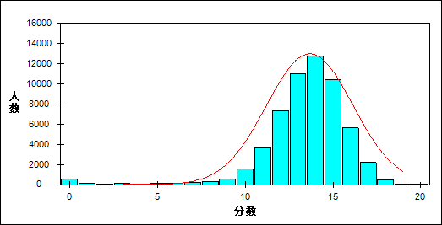

图 23 书面表达难度曲线图

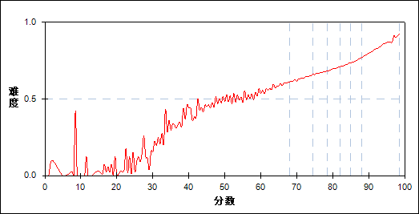

表 48 书面表达分组分析表

| 分值 | G1 | G2 | G3 | G4 | G5 | G6 | G7 | 人数 | 比率(%) | 平均分 |
| --- | --- | --- | --- | --- | --- | --- | --- | --- | --- | --- |
| 0.0～ | 485 | 6 | 0 | 0 | 0 | 0 | 0 | 491 | 0.86 | 35.10 |
| 0.5～ | 36 | 1 | 0 | 0 | 0 | 0 | 0 | 37 | 0.06 | 43.69 |
| 1.0～ | 48 | 1 | 0 | 0 | 0 | 0 | 0 | 49 | 0.09 | 46.92 |
| 1.5～ | 34 | 1 | 1 | 0 | 0 | 0 | 0 | 36 | 0.06 | 46.08 |
| 2.0～ | 46 | 2 | 1 | 0 | 0 | 0 | 0 | 49 | 0.09 | 46.71 |
| 2.5～ | 32 | 1 | 0 | 0 | 0 | 0 | 0 | 33 | 0.06 | 44.65 |
| 3.0～ | 47 | 1 | 0 | 0 | 0 | 0 | 0 | 48 | 0.08 | 46.14 |
| 3.5～ | 39 | 0 | 1 | 0 | 0 | 0 | 0 | 40 | 0.07 | 46.65 |
| 4.0～ | 39 | 2 | 1 | 0 | 0 | 0 | 0 | 42 | 0.07 | 49.19 |
| 4.5～ | 36 | 5 | 0 | 0 | 0 | 0 | 0 | 41 | 0.07 | 51.88 |
| 5.0～ | 57 | 6 | 0 | 0 | 0 | 0 | 0 | 63 | 0.11 | 52.21 |
| 5.5～ | 29 | 3 | 0 | 0 | 0 | 0 | 0 | 32 | 0.06 | 52.31 |
| 6.0～ | 80 | 9 | 0 | 0 | 0 | 0 | 0 | 89 | 0.16 | 51.81 |
| 6.5～ | 49 | 7 | 2 | 0 | 0 | 0 | 0 | 58 | 0.10 | 58.05 |
| 7.0～ | 138 | 17 | 6 | 0 | 0 | 0 | 0 | 161 | 0.28 | 53.94 |
| 7.5～ | 55 | 8 | 2 | 3 | 0 | 0 | 0 | 68 | 0.12 | 58.00 |
| 8.0～ | 142 | 27 | 2 | 3 | 0 | 0 | 0 | 174 | 0.30 | 56.12 |
| 8.5～ | 105 | 18 | 5 | 0 | 0 | 0 | 0 | 128 | 0.22 | 57.29 |
| 9.0～ | 220 | 50 | 12 | 3 | 0 | 0 | 0 | 285 | 0.50 | 59.00 |
| 9.5～ | 197 | 62 | 9 | 7 | 0 | 0 | 0 | 275 | 0.48 | 60.67 |
| 10.0～ | 506 | 157 | 54 | 15 | 5 | 1 | 0 | 738 | 1.29 | 61.72 |
| 10.5～ | 467 | 236 | 78 | 35 | 12 | 4 | 0 | 832 | 1.45 | 65.12 |
| 11.0～ | 926 | 509 | 188 | 90 | 33 | 5 | 1 | 1752 | 3.06 | 65.32 |
| 11.5～ | 748 | 594 | 326 | 146 | 44 | 10 | 0 | 1868 | 3.26 | 68.72 |
| 12.0～ | 1098 | 1146 | 670 | 372 | 173 | 59 | 9 | 3527 | 6.16 | 70.52 |
| 12.5～ | 767 | 1058 | 939 | 616 | 316 | 115 | 13 | 3824 | 6.68 | 73.69 |
| 13.0～ | 750 | 1309 | 1247 | 912 | 660 | 311 | 69 | 5258 | 9.18 | 75.47 |
| 13.5～ | 438 | 1050 | 1364 | 1328 | 951 | 535 | 96 | 5762 | 10.06 | 77.72 |
| 14.0～ | 321 | 875 | 1239 | 1362 | 1373 | 1011 | 352 | 6533 | 11.40 | 79.55 |
| 14.5～ | 148 | 502 | 933 | 1374 | 1442 | 1253 | 607 | 6259 | 10.93 | 81.53 |
| 15.0～ | 67 | 324 | 625 | 880 | 1309 | 1526 | 1085 | 5816 | 10.15 | 83.09 |
| 15.5～ | 17 | 125 | 291 | 596 | 938 | 1422 | 1193 | 4582 | 8.00 | 84.88 |
| 16.0～ | 12 | 50 | 126 | 251 | 504 | 973 | 1534 | 3450 | 6.02 | 86.35 |
| 16.5～ | 4 | 9 | 45 | 125 | 264 | 563 | 1160 | 2170 | 3.79 | 87.61 |
| 17.0～ | 1 | 10 | 9 | 57 | 114 | 272 | 1013 | 1476 | 2.58 | 88.65 |
| 17.5～ | 0 | 1 | 5 | 8 | 33 | 82 | 582 | 711 | 1.24 | 90.00 |
| 18.0～ | 0 | 2 | 2 | 1 | 11 | 33 | 338 | 387 | 0.68 | 90.58 |
| 18.5～ | 0 | 0 | 0 | 0 | 1 | 5 | 104 | 110 | 0.19 | 91.97 |
| 19.0～ | 0 | 0 | 1 | 0 | 0 | 3 | 25 | 29 | 0.05 | 91.28 |
| 20.0～ | 0 | 0 | 0 | 0 | 0 | 0 | 2 | 2 | 0.00 | 95.00 |
| 合计 | 8184 | 8184 | 8184 | 8184 | 8183 | 8183 | 8183 | 57285 | 100.00 | 77.89 |
| 得分率 | 0.52 | 0.63 | 0.67 | 0.70 | 0.72 | 0.75 | 0.80 | - | - | - |

表 49 书面表达等级分析表

| 分值 | 优秀 | | 良好 | | 合格 | | 不合格 | | 全体 | |
| --- | --- | --- | --- | --- | --- | --- | --- | --- | --- | --- |
| 人数 | 比率 | 人数 | 比率 | 人数 | 比率 | 人数 | 比率 | 人数 | 比率 |
| 0.0～ | 0 | 0.0 | 4 | 0.8 | 37 | 7.5 | 450 | 91.6 | 491 | 100.0 |
| 0.5～ | 0 | 0.0 | 1 | 2.7 | 4 | 10.8 | 32 | 86.5 | 37 | 100.0 |
| 1.0～ | 0 | 0.0 | 1 | 2.0 | 9 | 18.4 | 39 | 79.6 | 49 | 100.0 |
| 1.5～ | 0 | 0.0 | 2 | 5.6 | 4 | 11.1 | 30 | 83.3 | 36 | 100.0 |
| 2.0～ | 0 | 0.0 | 2 | 4.1 | 6 | 12.2 | 41 | 83.7 | 49 | 100.0 |
| 2.5～ | 0 | 0.0 | 1 | 3.0 | 8 | 24.2 | 24 | 72.7 | 33 | 100.0 |
| 3.0～ | 0 | 0.0 | 1 | 2.1 | 7 | 14.6 | 40 | 83.3 | 48 | 100.0 |
| 3.5～ | 0 | 0.0 | 1 | 2.5 | 11 | 27.5 | 28 | 70.0 | 40 | 100.0 |
| 4.0～ | 0 | 0.0 | 3 | 7.1 | 11 | 26.2 | 28 | 66.7 | 42 | 100.0 |
| 4.5～ | 0 | 0.0 | 3 | 7.3 | 15 | 36.6 | 23 | 56.1 | 41 | 100.0 |
| 5.0～ | 0 | 0.0 | 2 | 3.2 | 17 | 27.0 | 44 | 69.8 | 63 | 100.0 |
| 5.5～ | 0 | 0.0 | 0 | 0.0 | 11 | 34.4 | 21 | 65.6 | 32 | 100.0 |
| 6.0～ | 0 | 0.0 | 5 | 5.6 | 28 | 31.5 | 56 | 62.9 | 89 | 100.0 |
| 6.5～ | 0 | 0.0 | 6 | 10.3 | 21 | 36.2 | 31 | 53.4 | 58 | 100.0 |
| 7.0～ | 0 | 0.0 | 14 | 8.7 | 52 | 32.3 | 95 | 59.0 | 161 | 100.0 |
| 7.5～ | 0 | 0.0 | 7 | 10.3 | 24 | 35.3 | 37 | 54.4 | 68 | 100.0 |
| 8.0～ | 0 | 0.0 | 22 | 12.6 | 57 | 32.8 | 95 | 54.6 | 174 | 100.0 |
| 8.5～ | 0 | 0.0 | 15 | 11.7 | 48 | 37.5 | 65 | 50.8 | 128 | 100.0 |
| 9.0～ | 0 | 0.0 | 51 | 17.9 | 111 | 38.9 | 123 | 43.2 | 285 | 100.0 |
| 9.5～ | 0 | 0.0 | 59 | 21.5 | 102 | 37.1 | 114 | 41.5 | 275 | 100.0 |
| 10.0～ | 1 | 0.1 | 190 | 25.7 | 278 | 37.7 | 269 | 36.4 | 738 | 100.0 |
| 10.5～ | 4 | 0.5 | 281 | 33.8 | 325 | 39.1 | 222 | 26.7 | 832 | 100.0 |
| 11.0～ | 6 | 0.3 | 700 | 40.0 | 606 | 34.6 | 440 | 25.1 | 1752 | 100.0 |
| 11.5～ | 10 | 0.5 | 934 | 50.0 | 641 | 34.3 | 283 | 15.1 | 1868 | 100.0 |
| 12.0～ | 73 | 2.1 | 2104 | 59.7 | 949 | 26.9 | 401 | 11.4 | 3527 | 100.0 |
| 12.5～ | 128 | 3.3 | 2675 | 70.0 | 814 | 21.3 | 207 | 5.4 | 3824 | 100.0 |
| 13.0～ | 416 | 7.9 | 3865 | 73.5 | 821 | 15.6 | 156 | 3.0 | 5258 | 100.0 |
| 13.5～ | 632 | 11.0 | 4495 | 78.0 | 546 | 9.5 | 89 | 1.5 | 5762 | 100.0 |
| 14.0～ | 1428 | 21.9 | 4679 | 71.6 | 365 | 5.6 | 61 | 0.9 | 6533 | 100.0 |
| 14.5～ | 1860 | 29.7 | 4159 | 66.4 | 214 | 3.4 | 26 | 0.4 | 6259 | 100.0 |
| 15.0～ | 2691 | 46.3 | 3023 | 52.0 | 92 | 1.6 | 10 | 0.2 | 5816 | 100.0 |
| 15.5～ | 2615 | 57.1 | 1919 | 41.9 | 45 | 1.0 | 3 | 0.1 | 4582 | 100.0 |
| 16.0～ | 2541 | 73.7 | 890 | 25.8 | 17 | 0.5 | 2 | 0.1 | 3450 | 100.0 |
| 16.5～ | 1723 | 79.4 | 441 | 20.3 | 5 | 0.2 | 1 | 0.0 | 2170 | 100.0 |
| 17.0～ | 1294 | 87.7 | 180 | 12.2 | 2 | 0.1 | 0 | 0.0 | 1476 | 100.0 |
| 17.5～ | 665 | 93.5 | 46 | 6.5 | 0 | 0.0 | 0 | 0.0 | 711 | 100.0 |
| 18.0～ | 372 | 96.1 | 14 | 3.6 | 1 | 0.3 | 0 | 0.0 | 387 | 100.0 |
| 18.5～ | 109 | 99.1 | 1 | 0.9 | 0 | 0.0 | 0 | 0.0 | 110 | 100.0 |
| 19.0～ | 28 | 96.6 | 1 | 3.4 | 0 | 0.0 | 0 | 0.0 | 29 | 100.0 |
| 20.0～ | 2 | 100.0 | 0 | 0.0 | 0 | 0.0 | 0 | 0.0 | 2 | 100.0 |
| 合计 | 16598 | 29.0 | 30797 | 53.8 | 6304 | 11.0 | 3586 | 6.3 | 57285 | 100.0 |

* 1. 听力技能分析
     1. 理解归纳主旨要义

本题组共包含1道试题，题号是：7

表 50 理解归纳主旨要义总分分析表

|  |  |  |  |  |  |  |  |  |
| --- | --- | --- | --- | --- | --- | --- | --- | --- |
| 人数 | 满分 | 最大值 | 最小值 | 平均值 | 标准差 | 差异系数 | 难度 | 区分度 |
| 57285 | 1 | 1.0 | 0.0 | 0.96 | 0.19 | 0.20 | 0.96 | 0.39 |

表 51 理解归纳主旨要义等级得分率分析表

|  |  |  |  |  |
| --- | --- | --- | --- | --- |
| 优秀 | 良好 | 合格 | 不及格 | 全体 |
| 1.00 | 0.99 | 0.91 | 0.69 | 0.96 |

图 24 理解归纳主旨要义分数分布曲线图

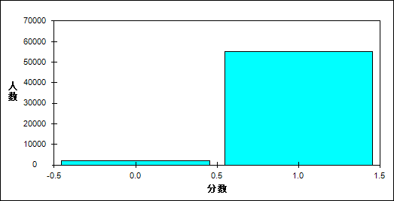

图 25 理解归纳主旨要义难度曲线图

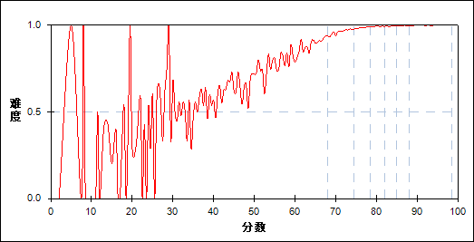

表 52 理解归纳主旨要义分组分析表

| 分值 | G1 | G2 | G3 | G4 | G5 | G6 | G7 | 人数 | 比率(%) | 平均分 |
| --- | --- | --- | --- | --- | --- | --- | --- | --- | --- | --- |
| 0.0～ | 1596 | 294 | 121 | 53 | 47 | 20 | 10 | 2141 | 3.74 | 56.19 |
| 1.0～ | 6588 | 7890 | 8063 | 8131 | 8136 | 8163 | 8173 | 55144 | 96.26 | 78.73 |
| 合计 | 8184 | 8184 | 8184 | 8184 | 8183 | 8183 | 8183 | 57285 | 100.00 | 77.89 |
| 得分率 | 0.80 | 0.96 | 0.99 | 0.99 | 0.99 | 1.00 | 1.00 | - | - | - |

表 53 理解归纳主旨要义等级分析表

| 分值 | 优秀 | | 良好 | | 合格 | | 不合格 | | 全体 | |
| --- | --- | --- | --- | --- | --- | --- | --- | --- | --- | --- |
| 人数 | 比率 | 人数 | 比率 | 人数 | 比率 | 人数 | 比率 | 人数 | 比率 |
| 0.0～ | 31 | 1.4 | 425 | 19.9 | 587 | 27.4 | 1098 | 51.3 | 2141 | 100.0 |
| 1.0～ | 16567 | 30.0 | 30372 | 55.1 | 5717 | 10.4 | 2488 | 4.5 | 55144 | 100.0 |
| 合计 | 16598 | 29.0 | 30797 | 53.8 | 6304 | 11.0 | 3586 | 6.3 | 57285 | 100.0 |

* + 1. 获取事实性信息

本题组共包含9道试题，题号是：1、2、3、4、8、12、13、15、16

表 54 获取事实性信息总分分析表

|  |  |  |  |  |  |  |  |  |
| --- | --- | --- | --- | --- | --- | --- | --- | --- |
| 人数 | 满分 | 最大值 | 最小值 | 平均值 | 标准差 | 差异系数 | 难度 | 区分度 |
| 57285 | 9 | 9.0 | 0.0 | 8.46 | 1.07 | 0.13 | 0.94 | 0.66 |

表 55 获取事实性信息等级得分率分析表

|  |  |  |  |  |
| --- | --- | --- | --- | --- |
| 优秀 | 良好 | 合格 | 不及格 | 全体 |
| 0.99 | 0.96 | 0.86 | 0.70 | 0.94 |

图 26 获取事实性信息分数分布曲线图

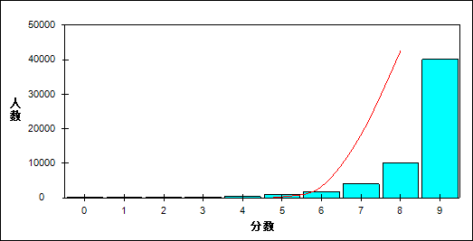

图 27 获取事实性信息难度曲线图

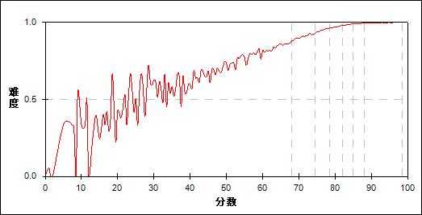

表 56 获取事实性信息分组分析表

| 分值 | G1 | G2 | G3 | G4 | G5 | G6 | G7 | 人数 | 比率(%) | 平均分 |
| --- | --- | --- | --- | --- | --- | --- | --- | --- | --- | --- |
| 0.0～ | 97 | 6 | 0 | 0 | 0 | 0 | 0 | 103 | 0.18 | 39.39 |
| 1.0～ | 19 | 0 | 0 | 0 | 0 | 0 | 0 | 19 | 0.03 | 23.50 |
| 2.0～ | 65 | 0 | 0 | 0 | 0 | 0 | 0 | 65 | 0.11 | 32.35 |
| 3.0～ | 158 | 2 | 0 | 0 | 0 | 0 | 0 | 160 | 0.28 | 36.20 |
| 4.0～ | 323 | 15 | 5 | 0 | 0 | 0 | 0 | 343 | 0.60 | 46.95 |
| 5.0～ | 714 | 91 | 13 | 2 | 0 | 0 | 0 | 820 | 1.43 | 53.77 |
| 6.0～ | 1207 | 387 | 100 | 40 | 12 | 0 | 1 | 1747 | 3.05 | 61.22 |
| 7.0～ | 1780 | 1196 | 625 | 258 | 94 | 30 | 8 | 3991 | 6.97 | 67.33 |
| 8.0～ | 1950 | 2615 | 2106 | 1568 | 938 | 551 | 253 | 9981 | 17.42 | 74.13 |
| 9.0～ | 1871 | 3872 | 5335 | 6316 | 7139 | 7602 | 7921 | 40056 | 69.92 | 81.72 |
| 合计 | 8184 | 8184 | 8184 | 8184 | 8183 | 8183 | 8183 | 57285 | 100.00 | 77.89 |
| 得分率 | 0.78 | 0.91 | 0.95 | 0.97 | 0.98 | 0.99 | 1.00 | - | - | - |

表 57 获取事实性信息等级分析表

| 分值 | 优秀 | | 良好 | | 合格 | | 不合格 | | 全体 | |
| --- | --- | --- | --- | --- | --- | --- | --- | --- | --- | --- |
| 人数 | 比率 | 人数 | 比率 | 人数 | 比率 | 人数 | 比率 | 人数 | 比率 |
| 0.0～ | 0 | 0.0 | 2 | 1.9 | 20 | 19.4 | 81 | 78.6 | 103 | 100.0 |
| 1.0～ | 0 | 0.0 | 0 | 0.0 | 0 | 0.0 | 19 | 100.0 | 19 | 100.0 |
| 2.0～ | 0 | 0.0 | 0 | 0.0 | 0 | 0.0 | 65 | 100.0 | 65 | 100.0 |
| 3.0～ | 0 | 0.0 | 2 | 1.3 | 6 | 3.8 | 152 | 95.0 | 160 | 100.0 |
| 4.0～ | 0 | 0.0 | 17 | 5.0 | 53 | 15.5 | 273 | 79.6 | 343 | 100.0 |
| 5.0～ | 0 | 0.0 | 76 | 9.3 | 244 | 29.8 | 500 | 61.0 | 820 | 100.0 |
| 6.0～ | 1 | 0.1 | 420 | 24.0 | 694 | 39.7 | 632 | 36.2 | 1747 | 100.0 |
| 7.0～ | 38 | 1.0 | 1875 | 47.0 | 1309 | 32.8 | 769 | 19.3 | 3991 | 100.0 |
| 8.0～ | 818 | 8.2 | 6660 | 66.7 | 1886 | 18.9 | 617 | 6.2 | 9981 | 100.0 |
| 9.0～ | 15741 | 39.3 | 21745 | 54.3 | 2092 | 5.2 | 478 | 1.2 | 40056 | 100.0 |
| 合计 | 16598 | 29.0 | 30797 | 53.8 | 6304 | 11.0 | 3586 | 6.3 | 57285 | 100.0 |

* + 1. 简单推断

本题组共包含4道试题，题号是：5、6、9、11

表 58 简单推断总分分析表

|  |  |  |  |  |  |  |  |  |
| --- | --- | --- | --- | --- | --- | --- | --- | --- |
| 人数 | 满分 | 最大值 | 最小值 | 平均值 | 标准差 | 差异系数 | 难度 | 区分度 |
| 57285 | 4 | 4.0 | 0.0 | 3.80 | 0.54 | 0.14 | 0.95 | 0.57 |

表 59 简单推断等级得分率分析表

|  |  |  |  |  |
| --- | --- | --- | --- | --- |
| 优秀 | 良好 | 合格 | 不及格 | 全体 |
| 1.00 | 0.97 | 0.88 | 0.69 | 0.95 |

图 28 简单推断分数分布曲线图

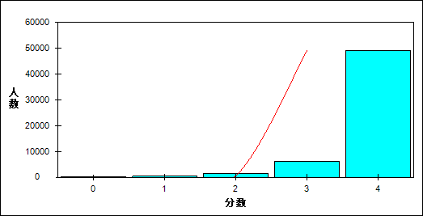

图 29 简单推断难度曲线图

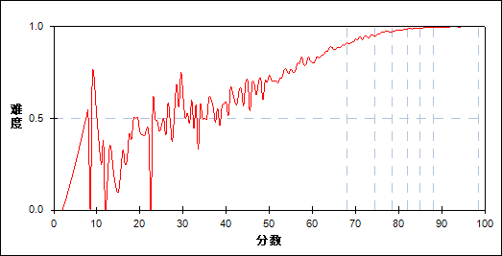

表 60 简单推断分组分析表

| 分值 | G1 | G2 | G3 | G4 | G5 | G6 | G7 | 人数 | 比率(%) | 平均分 |
| --- | --- | --- | --- | --- | --- | --- | --- | --- | --- | --- |
| 0.0～ | 177 | 7 | 0 | 0 | 0 | 0 | 0 | 184 | 0.32 | 38.07 |
| 1.0～ | 426 | 26 | 3 | 1 | 0 | 0 | 0 | 456 | 0.80 | 45.47 |
| 2.0～ | 1171 | 213 | 69 | 27 | 4 | 8 | 1 | 1493 | 2.61 | 56.19 |
| 3.0～ | 2486 | 1534 | 939 | 574 | 336 | 186 | 72 | 6127 | 10.70 | 68.60 |
| 4.0～ | 3924 | 6404 | 7173 | 7582 | 7843 | 7989 | 8110 | 49025 | 85.58 | 80.16 |
| 合计 | 8184 | 8184 | 8184 | 8184 | 8183 | 8183 | 8183 | 57285 | 100.00 | 77.89 |
| 得分率 | 0.79 | 0.94 | 0.97 | 0.98 | 0.99 | 0.99 | 1.00 | - | - | - |

表 61 简单推断等级分析表

| 分值 | 优秀 | | 良好 | | 合格 | | 不合格 | | 全体 | |
| --- | --- | --- | --- | --- | --- | --- | --- | --- | --- | --- |
| 人数 | 比率 | 人数 | 比率 | 人数 | 比率 | 人数 | 比率 | 人数 | 比率 |
| 0.0～ | 0 | 0.0 | 3 | 1.6 | 22 | 12.0 | 159 | 86.4 | 184 | 100.0 |
| 1.0～ | 0 | 0.0 | 19 | 4.2 | 76 | 16.7 | 361 | 79.2 | 456 | 100.0 |
| 2.0～ | 9 | 0.6 | 246 | 16.5 | 433 | 29.0 | 805 | 53.9 | 1493 | 100.0 |
| 3.0～ | 266 | 4.3 | 2964 | 48.4 | 1765 | 28.8 | 1132 | 18.5 | 6127 | 100.0 |
| 4.0～ | 16323 | 33.3 | 27565 | 56.2 | 4008 | 8.2 | 1129 | 2.3 | 49025 | 100.0 |
| 合计 | 16598 | 29.0 | 30797 | 53.8 | 6304 | 11.0 | 3586 | 6.3 | 57285 | 100.0 |

* + 1. 理解意图、态度和观点

本题组共包含2道试题，题号是：10、14

表 62 理解意图、态度和观点总分分析表

|  |  |  |  |  |  |  |  |  |
| --- | --- | --- | --- | --- | --- | --- | --- | --- |
| 人数 | 满分 | 最大值 | 最小值 | 平均值 | 标准差 | 差异系数 | 难度 | 区分度 |
| 57285 | 2 | 2.0 | 0.0 | 1.66 | 0.56 | 0.34 | 0.83 | 0.51 |

表 63 理解意图、态度和观点等级得分率分析表

|  |  |  |  |  |
| --- | --- | --- | --- | --- |
| 优秀 | 良好 | 合格 | 不及格 | 全体 |
| 0.98 | 0.82 | 0.63 | 0.52 | 0.83 |

图 30 理解意图、态度和观点分数分布曲线图

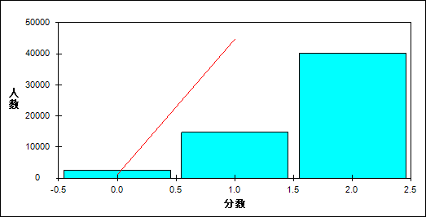

图 31 理解意图、态度和观点难度曲线图

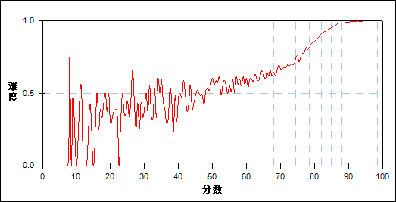

表 64 理解意图、态度和观点分组分析表

| 分值 | G1 | G2 | G3 | G4 | G5 | G6 | G7 | 人数 | 比率(%) | 平均分 |
| --- | --- | --- | --- | --- | --- | --- | --- | --- | --- | --- |
| 0.0～ | 1470 | 626 | 252 | 79 | 23 | 3 | 0 | 2453 | 4.28 | 61.05 |
| 1.0～ | 4007 | 3923 | 3143 | 2024 | 1073 | 441 | 128 | 14739 | 25.73 | 71.33 |
| 2.0～ | 2707 | 3635 | 4789 | 6081 | 7087 | 7739 | 8055 | 40093 | 69.99 | 81.33 |
| 合计 | 8184 | 8184 | 8184 | 8184 | 8183 | 8183 | 8183 | 57285 | 100.00 | 77.89 |
| 得分率 | 0.58 | 0.68 | 0.78 | 0.87 | 0.93 | 0.97 | 0.99 | - | - | - |

表 65 理解意图、态度和观点等级分析表

| 分值 | 优秀 | | 良好 | | 合格 | | 不合格 | | 全体 | |
| --- | --- | --- | --- | --- | --- | --- | --- | --- | --- | --- |
| 人数 | 比率 | 人数 | 比率 | 人数 | 比率 | 人数 | 比率 | 人数 | 比率 |
| 0.0～ | 3 | 0.1 | 815 | 33.2 | 782 | 31.9 | 853 | 34.8 | 2453 | 100.0 |
| 1.0～ | 591 | 4.0 | 9309 | 63.2 | 3087 | 20.9 | 1752 | 11.9 | 14739 | 100.0 |
| 2.0～ | 16004 | 39.9 | 20673 | 51.6 | 2435 | 6.1 | 981 | 2.4 | 40093 | 100.0 |
| 合计 | 16598 | 29.0 | 30797 | 53.8 | 6304 | 11.0 | 3586 | 6.3 | 57285 | 100.0 |

* + 1. 记录信息

本题组共包含2道试题，题号是：17、20

表 66 记录信息总分分析表

|  |  |  |  |  |  |  |  |  |
| --- | --- | --- | --- | --- | --- | --- | --- | --- |
| 人数 | 满分 | 最大值 | 最小值 | 平均值 | 标准差 | 差异系数 | 难度 | 区分度 |
| 57285 | 2 | 2.0 | 0.0 | 1.89 | 0.36 | 0.19 | 0.94 | 0.45 |

表 67 记录信息等级得分率分析表

|  |  |  |  |  |
| --- | --- | --- | --- | --- |
| 优秀 | 良好 | 合格 | 不及格 | 全体 |
| 0.99 | 0.96 | 0.91 | 0.65 | 0.94 |

图 32 记录信息分数分布曲线图

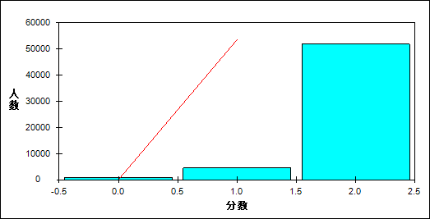

图 33 记录信息难度曲线图

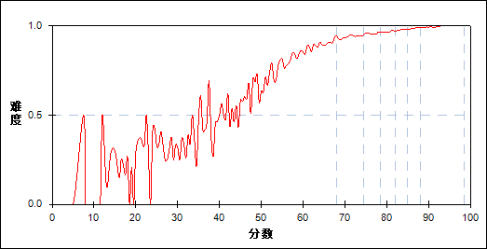

表 68 记录信息分组分析表

| 分值 | G1 | G2 | G3 | G4 | G5 | G6 | G7 | 人数 | 比率(%) | 平均分 |
| --- | --- | --- | --- | --- | --- | --- | --- | --- | --- | --- |
| 0.0～ | 781 | 67 | 42 | 11 | 9 | 3 | 1 | 914 | 1.60 | 47.34 |
| 1.0～ | 1869 | 854 | 602 | 512 | 361 | 226 | 108 | 4532 | 7.91 | 67.55 |
| 2.0～ | 5534 | 7263 | 7540 | 7661 | 7813 | 7954 | 8074 | 51839 | 90.49 | 79.33 |
| 合计 | 8184 | 8184 | 8184 | 8184 | 8183 | 8183 | 8183 | 57285 | 100.00 | 77.89 |
| 得分率 | 0.79 | 0.94 | 0.96 | 0.97 | 0.98 | 0.99 | 0.99 | - | - | - |

表 69 记录信息等级分析表

| 分值 | 优秀 | | 良好 | | 合格 | | 不合格 | | 全体 | |
| --- | --- | --- | --- | --- | --- | --- | --- | --- | --- | --- |
| 人数 | 比率 | 人数 | 比率 | 人数 | 比率 | 人数 | 比率 | 人数 | 比率 |
| 0.0～ | 4 | 0.4 | 109 | 11.9 | 135 | 14.8 | 666 | 72.9 | 914 | 100.0 |
| 1.0～ | 350 | 7.7 | 2113 | 46.6 | 920 | 20.3 | 1149 | 25.4 | 4532 | 100.0 |
| 2.0～ | 16244 | 31.3 | 28575 | 55.1 | 5249 | 10.1 | 1771 | 3.4 | 51839 | 100.0 |
| 合计 | 16598 | 29.0 | 30797 | 53.8 | 6304 | 11.0 | 3586 | 6.3 | 57285 | 100.0 |

* 1. 语法分析
     1. 动词及时态、语态

本题组共包含6道试题，题号是：22、25、29、30、32、34

表 70 动词及时态、语态总分分析表

|  |  |  |  |  |  |  |  |  |
| --- | --- | --- | --- | --- | --- | --- | --- | --- |
| 人数 | 满分 | 最大值 | 最小值 | 平均值 | 标准差 | 差异系数 | 难度 | 区分度 |
| 57285 | 6 | 6.0 | 0.0 | 5.55 | 0.89 | 0.16 | 0.93 | 0.70 |

表 71 动词及时态、语态等级得分率分析表

|  |  |  |  |  |
| --- | --- | --- | --- | --- |
| 优秀 | 良好 | 合格 | 不及格 | 全体 |
| 0.99 | 0.95 | 0.83 | 0.58 | 0.93 |

图 34 动词及时态、语态分数分布曲线图

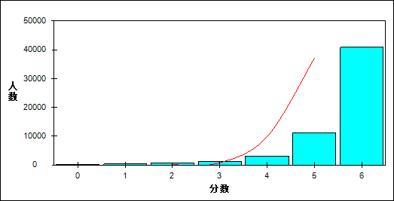

图 35 动词及时态、语态难度曲线图

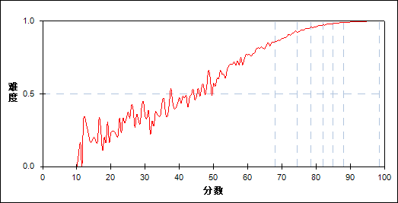

表 72 动词及时态、语态分组分析表

| 分值 | G1 | G2 | G3 | G4 | G5 | G6 | G7 | 人数 | 比率(%) | 平均分 |
| --- | --- | --- | --- | --- | --- | --- | --- | --- | --- | --- |
| 0.0～ | 130 | 0 | 0 | 0 | 0 | 0 | 0 | 130 | 0.23 | 26.82 |
| 1.0～ | 298 | 1 | 0 | 0 | 0 | 0 | 0 | 299 | 0.52 | 37.16 |
| 2.0～ | 646 | 20 | 1 | 0 | 0 | 0 | 0 | 667 | 1.16 | 45.49 |
| 3.0～ | 959 | 163 | 29 | 9 | 1 | 0 | 0 | 1161 | 2.03 | 55.77 |
| 4.0～ | 1796 | 769 | 318 | 106 | 57 | 21 | 8 | 3075 | 5.37 | 64.66 |
| 5.0～ | 2687 | 2939 | 2103 | 1524 | 968 | 618 | 298 | 11137 | 19.44 | 73.50 |
| 6.0～ | 1668 | 4292 | 5733 | 6545 | 7157 | 7544 | 7877 | 40816 | 71.25 | 81.70 |
| 合计 | 8184 | 8184 | 8184 | 8184 | 8183 | 8183 | 8183 | 57285 | 100.00 | 77.89 |
| 得分率 | 0.71 | 0.90 | 0.94 | 0.96 | 0.98 | 0.99 | 0.99 | - | - | - |

表 73 动词及时态、语态等级分析表

| 分值 | 优秀 | | 良好 | | 合格 | | 不合格 | | 全体 | |
| --- | --- | --- | --- | --- | --- | --- | --- | --- | --- | --- |
| 人数 | 比率 | 人数 | 比率 | 人数 | 比率 | 人数 | 比率 | 人数 | 比率 |
| 0.0～ | 0 | 0.0 | 0 | 0.0 | 0 | 0.0 | 130 | 100.0 | 130 | 100.0 |
| 1.0～ | 0 | 0.0 | 1 | 0.3 | 5 | 1.7 | 293 | 98.0 | 299 | 100.0 |
| 2.0～ | 0 | 0.0 | 15 | 2.2 | 83 | 12.4 | 569 | 85.3 | 667 | 100.0 |
| 3.0～ | 0 | 0.0 | 132 | 11.4 | 346 | 29.8 | 683 | 58.8 | 1161 | 100.0 |
| 4.0～ | 30 | 1.0 | 1019 | 33.1 | 1164 | 37.9 | 862 | 28.0 | 3075 | 100.0 |
| 5.0～ | 945 | 8.5 | 6822 | 61.3 | 2623 | 23.6 | 747 | 6.7 | 11137 | 100.0 |
| 6.0～ | 15623 | 38.3 | 22808 | 55.9 | 2083 | 5.1 | 302 | 0.7 | 40816 | 100.0 |
| 合计 | 16598 | 29.0 | 30797 | 53.8 | 6304 | 11.0 | 3586 | 6.3 | 57285 | 100.0 |

* + 1. 从句

本题组共包含4道试题，题号是：27、31、33、35

表 74 从句总分分析表

|  |  |  |  |  |  |  |  |  |
| --- | --- | --- | --- | --- | --- | --- | --- | --- |
| 人数 | 满分 | 最大值 | 最小值 | 平均值 | 标准差 | 差异系数 | 难度 | 区分度 |
| 57285 | 4 | 4.0 | 0.0 | 2.83 | 1.02 | 0.36 | 0.71 | 0.66 |

表 75 从句等级得分率分析表

|  |  |  |  |  |
| --- | --- | --- | --- | --- |
| 优秀 | 良好 | 合格 | 不及格 | 全体 |
| 0.91 | 0.68 | 0.50 | 0.34 | 0.71 |

图 36 从句分数分布曲线图

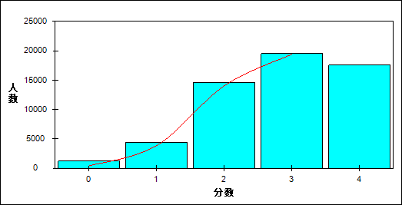

图 37 从句难度曲线图

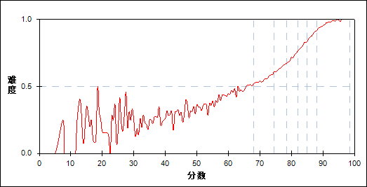

表 76 从句分组分析表

| 分值 | G1 | G2 | G3 | G4 | G5 | G6 | G7 | 人数 | 比率(%) | 平均分 |
| --- | --- | --- | --- | --- | --- | --- | --- | --- | --- | --- |
| 0.0～ | 987 | 148 | 43 | 11 | 3 | 0 | 0 | 1192 | 2.08 | 51.84 |
| 1.0～ | 2355 | 1174 | 555 | 248 | 80 | 18 | 1 | 4431 | 7.74 | 63.92 |
| 2.0～ | 3325 | 4032 | 3266 | 2268 | 1169 | 487 | 92 | 14639 | 25.55 | 72.90 |
| 3.0～ | 1278 | 2371 | 3435 | 4036 | 3959 | 3012 | 1399 | 19490 | 34.02 | 79.47 |
| 4.0～ | 239 | 459 | 885 | 1621 | 2972 | 4666 | 6691 | 17533 | 30.61 | 85.59 |
| 合计 | 8184 | 8184 | 8184 | 8184 | 8183 | 8183 | 8183 | 57285 | 100.00 | 77.89 |
| 得分率 | 0.42 | 0.56 | 0.64 | 0.71 | 0.80 | 0.88 | 0.95 | - | - | - |

表 77 从句等级分析表

| 分值 | 优秀 | | 良好 | | 合格 | | 不合格 | | 全体 | |
| --- | --- | --- | --- | --- | --- | --- | --- | --- | --- | --- |
| 人数 | 比率 | 人数 | 比率 | 人数 | 比率 | 人数 | 比率 | 人数 | 比率 |
| 0.0～ | 0 | 0.0 | 164 | 13.8 | 283 | 23.7 | 745 | 62.5 | 1192 | 100.0 |
| 1.0～ | 21 | 0.5 | 1741 | 39.3 | 1366 | 30.8 | 1303 | 29.4 | 4431 | 100.0 |
| 2.0～ | 592 | 4.0 | 9869 | 67.4 | 3080 | 21.0 | 1098 | 7.5 | 14639 | 100.0 |
| 3.0～ | 4514 | 23.2 | 13286 | 68.2 | 1303 | 6.7 | 387 | 2.0 | 19490 | 100.0 |
| 4.0～ | 11471 | 65.4 | 5737 | 32.7 | 272 | 1.6 | 53 | 0.3 | 17533 | 100.0 |
| 合计 | 16598 | 29.0 | 30797 | 53.8 | 6304 | 11.0 | 3586 | 6.3 | 57285 | 100.0 |

* + 1. 虚词

本题组共包含4道试题，题号是：23、24、26、28

表 78 虚词总分分析表

|  |  |  |  |  |  |  |  |  |
| --- | --- | --- | --- | --- | --- | --- | --- | --- |
| 人数 | 满分 | 最大值 | 最小值 | 平均值 | 标准差 | 差异系数 | 难度 | 区分度 |
| 57285 | 4 | 4.0 | 0.0 | 3.61 | 0.79 | 0.22 | 0.90 | 0.57 |

表 79 虚词等级得分率分析表

|  |  |  |  |  |
| --- | --- | --- | --- | --- |
| 优秀 | 良好 | 合格 | 不及格 | 全体 |
| 0.98 | 0.93 | 0.80 | 0.54 | 0.90 |

图 38 虚词分数分布曲线图

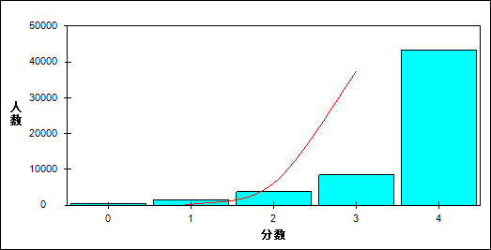

图 39 虚词难度曲线图

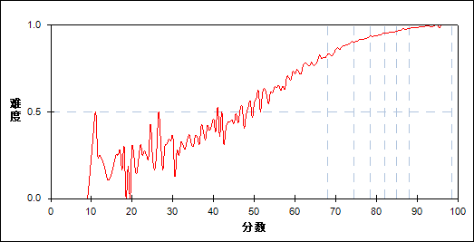

表 80 虚词分组分析表

| 分值 | G1 | G2 | G3 | G4 | G5 | G6 | G7 | 人数 | 比率(%) | 平均分 |
| --- | --- | --- | --- | --- | --- | --- | --- | --- | --- | --- |
| 0.0～ | 440 | 15 | 6 | 1 | 0 | 0 | 0 | 462 | 0.81 | 42.59 |
| 1.0～ | 1115 | 222 | 83 | 41 | 14 | 4 | 1 | 1480 | 2.58 | 54.94 |
| 2.0～ | 1814 | 872 | 446 | 296 | 161 | 93 | 23 | 3705 | 6.47 | 66.11 |
| 3.0～ | 1880 | 1777 | 1499 | 1217 | 1012 | 673 | 358 | 8416 | 14.69 | 74.33 |
| 4.0～ | 2935 | 5298 | 6150 | 6629 | 6996 | 7413 | 7801 | 43222 | 75.45 | 80.75 |
| 合计 | 8184 | 8184 | 8184 | 8184 | 8183 | 8183 | 8183 | 57285 | 100.00 | 77.89 |
| 得分率 | 0.68 | 0.87 | 0.92 | 0.94 | 0.96 | 0.97 | 0.99 | - | - | - |

表 81 虚词等级分析表

| 分值 | 优秀 | | 良好 | | 合格 | | 不合格 | | 全体 | |
| --- | --- | --- | --- | --- | --- | --- | --- | --- | --- | --- |
| 人数 | 比率 | 人数 | 比率 | 人数 | 比率 | 人数 | 比率 | 人数 | 比率 |
| 0.0～ | 0 | 0.0 | 13 | 2.8 | 66 | 14.3 | 383 | 82.9 | 462 | 100.0 |
| 1.0～ | 5 | 0.3 | 297 | 20.1 | 354 | 23.9 | 824 | 55.7 | 1480 | 100.0 |
| 2.0～ | 120 | 3.2 | 1497 | 40.4 | 1123 | 30.3 | 965 | 26.0 | 3705 | 100.0 |
| 3.0～ | 1066 | 12.7 | 5073 | 60.3 | 1546 | 18.4 | 731 | 8.7 | 8416 | 100.0 |
| 4.0～ | 15407 | 35.6 | 23917 | 55.3 | 3215 | 7.4 | 683 | 1.6 | 43222 | 100.0 |
| 合计 | 16598 | 29.0 | 30797 | 53.8 | 6304 | 11.0 | 3586 | 6.3 | 57285 | 100.0 |

* + 1. 比较等级

本题组共包含1道试题，题号是：21

表 82 比较等级总分分析表

|  |  |  |  |  |  |  |  |  |
| --- | --- | --- | --- | --- | --- | --- | --- | --- |
| 人数 | 满分 | 最大值 | 最小值 | 平均值 | 标准差 | 差异系数 | 难度 | 区分度 |
| 57285 | 1 | 1.0 | 0.0 | 0.85 | 0.36 | 0.43 | 0.85 | 0.35 |

表 83 比较等级等级得分率分析表

|  |  |  |  |  |
| --- | --- | --- | --- | --- |
| 优秀 | 良好 | 合格 | 不及格 | 全体 |
| 0.96 | 0.85 | 0.73 | 0.48 | 0.85 |

图 40 比较等级分数分布曲线图

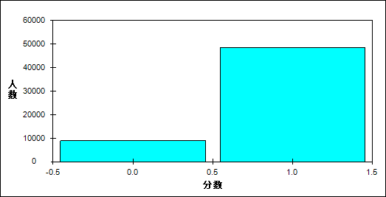

图 41 比较等级难度曲线图

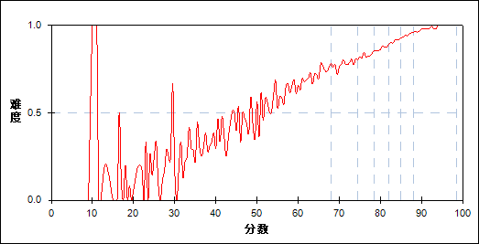

表 84 比较等级分组分析表

| 分值 | G1 | G2 | G3 | G4 | G5 | G6 | G7 | 人数 | 比率(%) | 平均分 |
| --- | --- | --- | --- | --- | --- | --- | --- | --- | --- | --- |
| 0.0～ | 3140 | 1782 | 1414 | 1090 | 744 | 470 | 221 | 8861 | 15.47 | 68.93 |
| 1.0～ | 5044 | 6402 | 6770 | 7094 | 7439 | 7713 | 7962 | 48424 | 84.53 | 79.53 |
| 合计 | 8184 | 8184 | 8184 | 8184 | 8183 | 8183 | 8183 | 57285 | 100.00 | 77.89 |
| 得分率 | 0.62 | 0.78 | 0.83 | 0.87 | 0.91 | 0.94 | 0.97 | - | - | - |

表 85 比较等级等级分析表

| 分值 | 优秀 | | 良好 | | 合格 | | 不合格 | | 全体 | |
| --- | --- | --- | --- | --- | --- | --- | --- | --- | --- | --- |
| 人数 | 比率 | 人数 | 比率 | 人数 | 比率 | 人数 | 比率 | 人数 | 比率 |
| 0.0～ | 708 | 8.0 | 4607 | 52.0 | 1689 | 19.1 | 1857 | 21.0 | 8861 | 100.0 |
| 1.0～ | 15890 | 32.8 | 26190 | 54.1 | 4615 | 9.5 | 1729 | 3.6 | 48424 | 100.0 |
| 合计 | 16598 | 29.0 | 30797 | 53.8 | 6304 | 11.0 | 3586 | 6.3 | 57285 | 100.0 |

* 1. 词汇组块
     1. 动词

本题组共包含8道试题，题号是：36、38、41、43、44、45、46、47

表 86 动词总分分析表

|  |  |  |  |  |  |  |  |  |
| --- | --- | --- | --- | --- | --- | --- | --- | --- |
| 人数 | 满分 | 最大值 | 最小值 | 平均值 | 标准差 | 差异系数 | 难度 | 区分度 |
| 57285 | 9 | 9.0 | 0.0 | 5.74 | 1.16 | 0.20 | 0.64 | 0.52 |

表 87 动词等级得分率分析表

|  |  |  |  |  |
| --- | --- | --- | --- | --- |
| 优秀 | 良好 | 合格 | 不及格 | 全体 |
| 0.71 | 0.64 | 0.57 | 0.46 | 0.64 |

图 42 动词分数分布曲线图

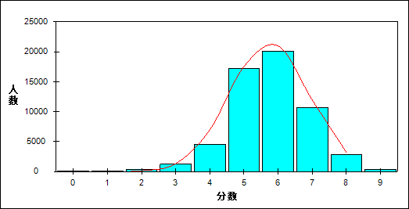

图 43 动词难度曲线图

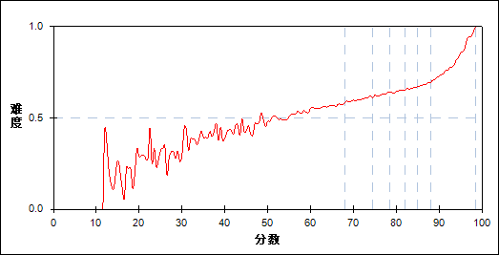

表 88 动词分组分析表

| 分值 | G1 | G2 | G3 | G4 | G5 | G6 | G7 | 人数 | 比率(%) | 平均分 |
| --- | --- | --- | --- | --- | --- | --- | --- | --- | --- | --- |
| 0.0～ | 77 | 0 | 0 | 0 | 0 | 0 | 0 | 77 | 0.13 | 17.71 |
| 1.0～ | 87 | 0 | 0 | 0 | 0 | 0 | 0 | 87 | 0.15 | 31.49 |
| 2.0～ | 291 | 18 | 5 | 0 | 2 | 0 | 0 | 316 | 0.55 | 44.77 |
| 3.0～ | 909 | 185 | 71 | 33 | 10 | 4 | 0 | 1212 | 2.12 | 56.71 |
| 4.0～ | 1906 | 1080 | 684 | 399 | 275 | 128 | 38 | 4510 | 7.87 | 67.94 |
| 5.0～ | 2734 | 3312 | 3041 | 2795 | 2386 | 1919 | 990 | 17177 | 29.99 | 76.31 |
| 6.0～ | 1660 | 2507 | 2926 | 3258 | 3406 | 3454 | 2899 | 20110 | 35.11 | 79.98 |
| 7.0～ | 451 | 881 | 1178 | 1373 | 1706 | 2124 | 2968 | 10681 | 18.65 | 82.83 |
| 8.0～ | 62 | 189 | 257 | 306 | 369 | 512 | 1114 | 2809 | 4.90 | 84.67 |
| 9.0～ | 7 | 12 | 22 | 20 | 29 | 42 | 174 | 306 | 0.53 | 86.93 |
| 合计 | 8184 | 8184 | 8184 | 8184 | 8183 | 8183 | 8183 | 57285 | 100.00 | 77.89 |
| 得分率 | 0.52 | 0.60 | 0.63 | 0.64 | 0.66 | 0.68 | 0.73 | - | - | - |

表 89 动词等级分析表

| 分值 | 优秀 | | 良好 | | 合格 | | 不合格 | | 全体 | |
| --- | --- | --- | --- | --- | --- | --- | --- | --- | --- | --- |
| 人数 | 比率 | 人数 | 比率 | 人数 | 比率 | 人数 | 比率 | 人数 | 比率 |
| 0.0～ | 0 | 0.0 | 0 | 0.0 | 0 | 0.0 | 77 | 100.0 | 77 | 100.0 |
| 1.0～ | 0 | 0.0 | 0 | 0.0 | 2 | 2.3 | 85 | 97.7 | 87 | 100.0 |
| 2.0～ | 0 | 0.0 | 19 | 6.0 | 42 | 13.3 | 255 | 80.7 | 316 | 100.0 |
| 3.0～ | 4 | 0.3 | 242 | 20.0 | 331 | 27.3 | 635 | 52.4 | 1212 | 100.0 |
| 4.0～ | 171 | 3.8 | 2162 | 47.9 | 1196 | 26.5 | 981 | 21.8 | 4510 | 100.0 |
| 5.0～ | 2978 | 17.3 | 10749 | 62.6 | 2526 | 14.7 | 924 | 5.4 | 17177 | 100.0 |
| 6.0～ | 6449 | 32.1 | 11546 | 57.4 | 1627 | 8.1 | 488 | 2.4 | 20110 | 100.0 |
| 7.0～ | 5141 | 48.1 | 4918 | 46.0 | 499 | 4.7 | 123 | 1.2 | 10681 | 100.0 |
| 8.0～ | 1638 | 58.3 | 1082 | 38.5 | 73 | 2.6 | 16 | 0.6 | 2809 | 100.0 |
| 9.0～ | 217 | 70.9 | 79 | 25.8 | 8 | 2.6 | 2 | 0.7 | 306 | 100.0 |
| 合计 | 16598 | 29.0 | 30797 | 53.8 | 6304 | 11.0 | 3586 | 6.3 | 57285 | 100.0 |

* + 1. 名词

本题组共包含3道试题，题号是：42、48、49

表 90 名词总分分析表

|  |  |  |  |  |  |  |  |  |
| --- | --- | --- | --- | --- | --- | --- | --- | --- |
| 人数 | 满分 | 最大值 | 最小值 | 平均值 | 标准差 | 差异系数 | 难度 | 区分度 |
| 57285 | 5 | 5.0 | 0.0 | 4.16 | 0.70 | 0.17 | 0.83 | 0.49 |

表 91 名词等级得分率分析表

|  |  |  |  |  |
| --- | --- | --- | --- | --- |
| 优秀 | 良好 | 合格 | 不及格 | 全体 |
| 0.90 | 0.82 | 0.79 | 0.66 | 0.83 |

图 44 名词分数分布曲线图

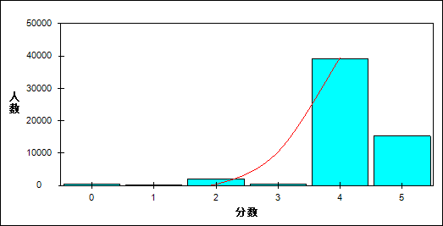

图 45 名词难度曲线图

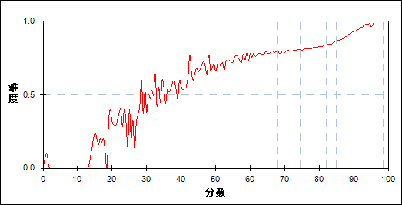

表 92 名词分组分析表

| 分值 | G1 | G2 | G3 | G4 | G5 | G6 | G7 | 人数 | 比率(%) | 平均分 |
| --- | --- | --- | --- | --- | --- | --- | --- | --- | --- | --- |
| 0.0～ | 309 | 16 | 6 | 10 | 0 | 1 | 0 | 342 | 0.60 | 37.85 |
| 1.0～ | 48 | 2 | 2 | 5 | 1 | 1 | 1 | 60 | 0.10 | 44.28 |
| 2.0～ | 1084 | 362 | 246 | 147 | 120 | 46 | 14 | 2019 | 3.52 | 62.56 |
| 3.0～ | 195 | 61 | 38 | 48 | 51 | 48 | 20 | 461 | 0.80 | 67.09 |
| 4.0～ | 5752 | 6912 | 6836 | 6416 | 5729 | 4740 | 2786 | 39171 | 68.38 | 76.91 |
| 5.0～ | 796 | 831 | 1056 | 1558 | 2282 | 3347 | 5362 | 15232 | 26.59 | 83.79 |
| 合计 | 8184 | 8184 | 8184 | 8184 | 8183 | 8183 | 8183 | 57285 | 100.00 | 77.89 |
| 得分率 | 0.73 | 0.80 | 0.81 | 0.83 | 0.85 | 0.88 | 0.93 | - | - | - |

表 93 名词等级分析表

| 分值 | 优秀 | | 良好 | | 合格 | | 不合格 | | 全体 | |
| --- | --- | --- | --- | --- | --- | --- | --- | --- | --- | --- |
| 人数 | 比率 | 人数 | 比率 | 人数 | 比率 | 人数 | 比率 | 人数 | 比率 |
| 0.0～ | 1 | 0.3 | 25 | 7.3 | 32 | 9.4 | 284 | 83.0 | 342 | 100.0 |
| 1.0～ | 2 | 3.3 | 9 | 15.0 | 6 | 10.0 | 43 | 71.7 | 60 | 100.0 |
| 2.0～ | 60 | 3.0 | 784 | 38.8 | 424 | 21.0 | 751 | 37.2 | 2019 | 100.0 |
| 3.0～ | 70 | 15.2 | 181 | 39.3 | 73 | 15.8 | 137 | 29.7 | 461 | 100.0 |
| 4.0～ | 7665 | 19.6 | 24322 | 62.1 | 5139 | 13.1 | 2045 | 5.2 | 39171 | 100.0 |
| 5.0～ | 8800 | 57.8 | 5476 | 36.0 | 630 | 4.1 | 326 | 2.1 | 15232 | 100.0 |
| 合计 | 16598 | 29.0 | 30797 | 53.8 | 6304 | 11.0 | 3586 | 6.3 | 57285 | 100.0 |

* + 1. 形容词

本题组共包含2道试题，题号是：37、50

表 94 形容词总分分析表

|  |  |  |  |  |  |  |  |  |
| --- | --- | --- | --- | --- | --- | --- | --- | --- |
| 人数 | 满分 | 最大值 | 最小值 | 平均值 | 标准差 | 差异系数 | 难度 | 区分度 |
| 57285 | 3 | 3.0 | 0.0 | 2.51 | 0.89 | 0.35 | 0.84 | 0.52 |

表 95 形容词等级得分率分析表

|  |  |  |  |  |
| --- | --- | --- | --- | --- |
| 优秀 | 良好 | 合格 | 不及格 | 全体 |
| 0.98 | 0.85 | 0.62 | 0.46 | 0.84 |

图 46 形容词分数分布曲线图

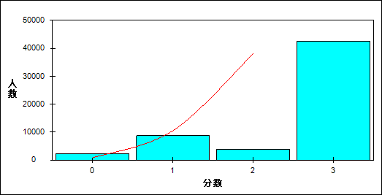

图 47 形容词难度曲线图

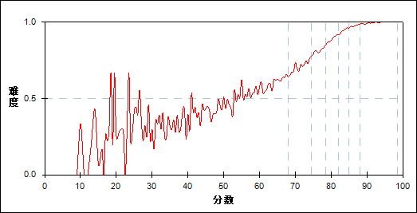

表 96 形容词分组分析表

| 分值 | G1 | G2 | G3 | G4 | G5 | G6 | G7 | 人数 | 比率(%) | 平均分 |
| --- | --- | --- | --- | --- | --- | --- | --- | --- | --- | --- |
| 0.0～ | 1560 | 420 | 158 | 61 | 19 | 7 | 1 | 2226 | 3.89 | 57.28 |
| 1.0～ | 2589 | 2511 | 1731 | 1040 | 523 | 225 | 54 | 8673 | 15.14 | 70.94 |
| 2.0～ | 1363 | 754 | 647 | 492 | 313 | 179 | 82 | 3830 | 6.69 | 69.60 |
| 3.0～ | 2672 | 4499 | 5648 | 6591 | 7328 | 7772 | 8046 | 42556 | 74.29 | 81.13 |
| 合计 | 8184 | 8184 | 8184 | 8184 | 8183 | 8183 | 8183 | 57285 | 100.00 | 77.89 |
| 得分率 | 0.54 | 0.71 | 0.81 | 0.89 | 0.94 | 0.97 | 0.99 | - | - | - |

表 97 形容词等级分析表

| 分值 | 优秀 | | 良好 | | 合格 | | 不合格 | | 全体 | |
| --- | --- | --- | --- | --- | --- | --- | --- | --- | --- | --- |
| 人数 | 比率 | 人数 | 比率 | 人数 | 比率 | 人数 | 比率 | 人数 | 比率 |
| 0.0～ | 8 | 0.4 | 532 | 23.9 | 641 | 28.8 | 1045 | 46.9 | 2226 | 100.0 |
| 1.0～ | 288 | 3.3 | 5223 | 60.2 | 2181 | 25.1 | 981 | 11.3 | 8673 | 100.0 |
| 2.0～ | 266 | 6.9 | 2010 | 52.5 | 814 | 21.3 | 740 | 19.3 | 3830 | 100.0 |
| 3.0～ | 16036 | 37.7 | 23032 | 54.1 | 2668 | 6.3 | 820 | 1.9 | 42556 | 100.0 |
| 合计 | 16598 | 29.0 | 30797 | 53.8 | 6304 | 11.0 | 3586 | 6.3 | 57285 | 100.0 |

* + 1. 连词

本题组共包含1道试题，题号是：39

表 98 连词总分分析表

|  |  |  |  |  |  |  |  |  |
| --- | --- | --- | --- | --- | --- | --- | --- | --- |
| 人数 | 满分 | 最大值 | 最小值 | 平均值 | 标准差 | 差异系数 | 难度 | 区分度 |
| 57285 | 1 | 1.0 | 0.0 | 0.77 | 0.42 | 0.55 | 0.77 | 0.40 |

表 99 连词等级得分率分析表

|  |  |  |  |  |
| --- | --- | --- | --- | --- |
| 优秀 | 良好 | 合格 | 不及格 | 全体 |
| 0.92 | 0.78 | 0.54 | 0.34 | 0.77 |

图 48 连词分数分布曲线图

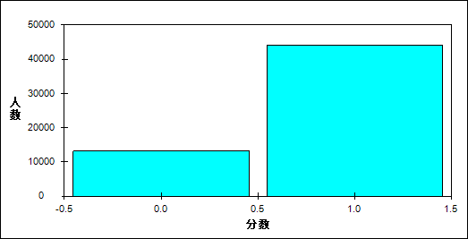

图 49 连词难度曲线图

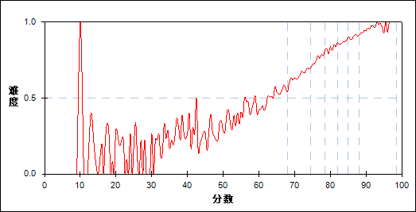

表 100 连词分组分析表

| 分值 | G1 | G2 | G3 | G4 | G5 | G6 | G7 | 人数 | 比率(%) | 平均分 |
| --- | --- | --- | --- | --- | --- | --- | --- | --- | --- | --- |
| 0.0～ | 4607 | 2829 | 1995 | 1410 | 1079 | 799 | 449 | 13168 | 22.99 | 69.90 |
| 1.0～ | 3577 | 5355 | 6189 | 6774 | 7104 | 7384 | 7734 | 44117 | 77.01 | 80.27 |
| 合计 | 8184 | 8184 | 8184 | 8184 | 8183 | 8183 | 8183 | 57285 | 100.00 | 77.89 |
| 得分率 | 0.44 | 0.65 | 0.76 | 0.83 | 0.87 | 0.90 | 0.95 | - | - | - |

表 101 连词等级分析表

| 分值 | 优秀 | | 良好 | | 合格 | | 不合格 | | 全体 | |
| --- | --- | --- | --- | --- | --- | --- | --- | --- | --- | --- |
| 人数 | 比率 | 人数 | 比率 | 人数 | 比率 | 人数 | 比率 | 人数 | 比率 |
| 0.0～ | 1269 | 9.6 | 6641 | 50.4 | 2884 | 21.9 | 2374 | 18.0 | 13168 | 100.0 |
| 1.0～ | 15329 | 34.7 | 24156 | 54.8 | 3420 | 7.8 | 1212 | 2.7 | 44117 | 100.0 |
| 合计 | 16598 | 29.0 | 30797 | 53.8 | 6304 | 11.0 | 3586 | 6.3 | 57285 | 100.0 |

* + 1. 副词

本题组共包含1道试题，题号是：40

表 102 副词总分分析表

|  |  |  |  |  |  |  |  |  |
| --- | --- | --- | --- | --- | --- | --- | --- | --- |
| 人数 | 满分 | 最大值 | 最小值 | 平均值 | 标准差 | 差异系数 | 难度 | 区分度 |
| 57285 | 1 | 1.0 | 0.0 | 0.86 | 0.35 | 0.41 | 0.86 | 0.50 |

表 103 副词等级得分率分析表

|  |  |  |  |  |
| --- | --- | --- | --- | --- |
| 优秀 | 良好 | 合格 | 不及格 | 全体 |
| 0.99 | 0.89 | 0.63 | 0.34 | 0.86 |

图 50 副词分数分布曲线图

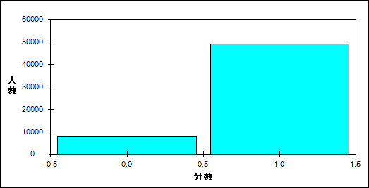

图 51 副词难度曲线图

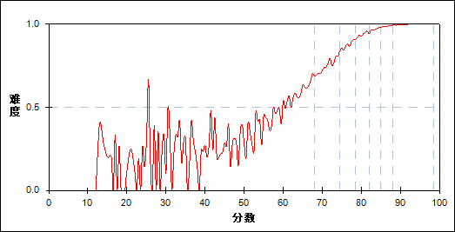

表 104 副词分组分析表

| 分值 | G1 | G2 | G3 | G4 | G5 | G6 | G7 | 人数 | 比率(%) | 平均分 |
| --- | --- | --- | --- | --- | --- | --- | --- | --- | --- | --- |
| 0.0～ | 4195 | 2006 | 1016 | 513 | 267 | 110 | 33 | 8140 | 14.21 | 64.39 |
| 1.0～ | 3989 | 6178 | 7168 | 7671 | 7916 | 8073 | 8150 | 49145 | 85.79 | 80.12 |
| 合计 | 8184 | 8184 | 8184 | 8184 | 8183 | 8183 | 8183 | 57285 | 100.00 | 77.89 |
| 得分率 | 0.49 | 0.75 | 0.88 | 0.94 | 0.97 | 0.99 | 1.00 | - | - | - |

表 105 副词等级分析表

| 分值 | 优秀 | | 良好 | | 合格 | | 不合格 | | 全体 | |
| --- | --- | --- | --- | --- | --- | --- | --- | --- | --- | --- |
| 人数 | 比率 | 人数 | 比率 | 人数 | 比率 | 人数 | 比率 | 人数 | 比率 |
| 0.0～ | 147 | 1.8 | 3286 | 40.4 | 2345 | 28.8 | 2362 | 29.0 | 8140 | 100.0 |
| 1.0～ | 16451 | 33.5 | 27511 | 56.0 | 3959 | 8.1 | 1224 | 2.5 | 49145 | 100.0 |
| 合计 | 16598 | 29.0 | 30797 | 53.8 | 6304 | 11.0 | 3586 | 6.3 | 57285 | 100.0 |

* 1. 阅读能力分析
     1. 理解主旨要义

本题组共包含3道试题，题号是：54、62、65

表 106 理解主旨要义总分分析表

|  |  |  |  |  |  |  |  |  |
| --- | --- | --- | --- | --- | --- | --- | --- | --- |
| 人数 | 满分 | 最大值 | 最小值 | 平均值 | 标准差 | 差异系数 | 难度 | 区分度 |
| 57285 | 5 | 5.0 | 0.0 | 4.04 | 1.10 | 0.27 | 0.81 | 0.71 |

表 107 理解主旨要义等级得分率分析表

|  |  |  |  |  |
| --- | --- | --- | --- | --- |
| 优秀 | 良好 | 合格 | 不及格 | 全体 |
| 0.94 | 0.83 | 0.61 | 0.37 | 0.81 |

图 52 理解主旨要义分数分布曲线图

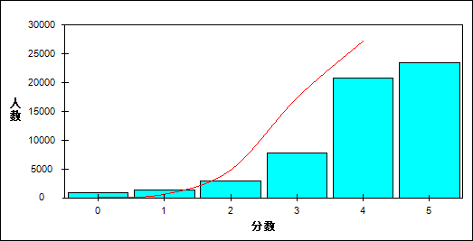

图 53 理解主旨要义难度曲线图

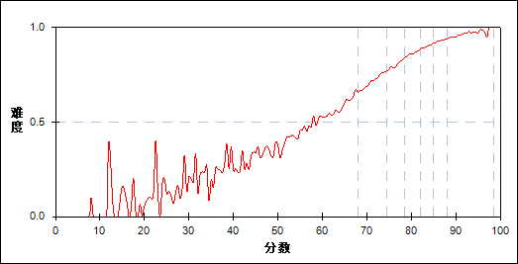

表 108 理解主旨要义分组分析表

| 分值 | G1 | G2 | G3 | G4 | G5 | G6 | G7 | 人数 | 比率(%) | 平均分 |
| --- | --- | --- | --- | --- | --- | --- | --- | --- | --- | --- |
| 0.0～ | 814 | 22 | 4 | 0 | 0 | 0 | 0 | 840 | 1.47 | 41.44 |
| 0.5～ | 2 | 1 | 0 | 0 | 0 | 0 | 0 | 3 | 0.01 | 62.83 |
| 1.0～ | 1100 | 221 | 54 | 8 | 2 | 0 | 0 | 1385 | 2.42 | 57.98 |
| 1.5～ | 16 | 6 | 4 | 2 | 0 | 0 | 0 | 28 | 0.05 | 64.61 |
| 2.0～ | 1867 | 700 | 250 | 96 | 24 | 9 | 0 | 2946 | 5.14 | 62.50 |
| 2.5～ | 7 | 10 | 5 | 2 | 1 | 0 | 0 | 25 | 0.04 | 69.68 |
| 3.0～ | 2427 | 2328 | 1435 | 790 | 404 | 175 | 53 | 7612 | 13.29 | 70.79 |
| 3.5～ | 38 | 49 | 29 | 33 | 8 | 5 | 4 | 166 | 0.29 | 73.50 |
| 4.0～ | 1628 | 3512 | 4076 | 3669 | 3193 | 2502 | 1730 | 20310 | 35.45 | 78.64 |
| 4.5～ | 6 | 61 | 67 | 94 | 90 | 93 | 86 | 497 | 0.87 | 81.90 |
| 5.0～ | 279 | 1274 | 2260 | 3490 | 4461 | 5399 | 6310 | 23473 | 40.98 | 83.92 |
| 合计 | 8184 | 8184 | 8184 | 8184 | 8183 | 8183 | 8183 | 57285 | 100.00 | 77.89 |
| 得分率 | 0.49 | 0.72 | 0.80 | 0.86 | 0.90 | 0.93 | 0.95 | - | - | - |

表 109 理解主旨要义等级分析表

| 分值 | 优秀 | | 良好 | | 合格 | | 不合格 | | 全体 | |
| --- | --- | --- | --- | --- | --- | --- | --- | --- | --- | --- |
| 人数 | 比率 | 人数 | 比率 | 人数 | 比率 | 人数 | 比率 | 人数 | 比率 |
| 0.0～ | 0 | 0.0 | 21 | 2.5 | 96 | 11.4 | 723 | 86.1 | 840 | 100.0 |
| 0.5～ | 0 | 0.0 | 1 | 33.3 | 0 | 0.0 | 2 | 66.7 | 3 | 100.0 |
| 1.0～ | 0 | 0.0 | 200 | 14.4 | 509 | 36.8 | 676 | 48.8 | 1385 | 100.0 |
| 1.5～ | 0 | 0.0 | 11 | 39.3 | 9 | 32.1 | 8 | 28.6 | 28 | 100.0 |
| 2.0～ | 9 | 0.3 | 855 | 29.0 | 1123 | 38.1 | 959 | 32.6 | 2946 | 100.0 |
| 2.5～ | 0 | 0.0 | 13 | 52.0 | 9 | 36.0 | 3 | 12.0 | 25 | 100.0 |
| 3.0～ | 233 | 3.1 | 4408 | 57.9 | 2121 | 27.9 | 850 | 11.2 | 7612 | 100.0 |
| 3.5～ | 9 | 5.4 | 111 | 66.9 | 38 | 22.9 | 8 | 4.8 | 166 | 100.0 |
| 4.0～ | 4311 | 21.2 | 13708 | 67.5 | 1969 | 9.7 | 322 | 1.6 | 20310 | 100.0 |
| 4.5～ | 180 | 36.2 | 302 | 60.8 | 14 | 2.8 | 1 | 0.2 | 497 | 100.0 |
| 5.0～ | 11856 | 50.5 | 11167 | 47.6 | 416 | 1.8 | 34 | 0.1 | 23473 | 100.0 |
| 合计 | 16598 | 29.0 | 30797 | 53.8 | 6304 | 11.0 | 3586 | 6.3 | 57285 | 100.0 |

* + 1. 获取事实性信息2

本题组共包含7道试题，题号是：51～53、55～56、60、63

表 110 获取事实性信息2总分分析表

|  |  |  |  |  |  |  |  |  |
| --- | --- | --- | --- | --- | --- | --- | --- | --- |
| 人数 | 满分 | 最大值 | 最小值 | 平均值 | 标准差 | 差异系数 | 难度 | 区分度 |
| 57285 | 13 | 13.0 | 0.0 | 9.89 | 2.54 | 0.26 | 0.76 | 0.80 |

表 111 获取事实性信息2等级得分率分析表

|  |  |  |  |  |
| --- | --- | --- | --- | --- |
| 优秀 | 良好 | 合格 | 不及格 | 全体 |
| 0.92 | 0.76 | 0.57 | 0.37 | 0.76 |

图 54 获取事实性信息2分数分布曲线图

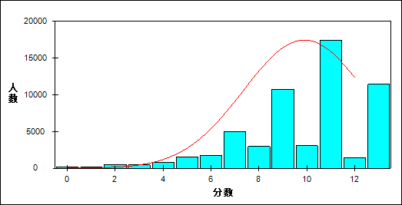

图 55 获取事实性信息2难度曲线图

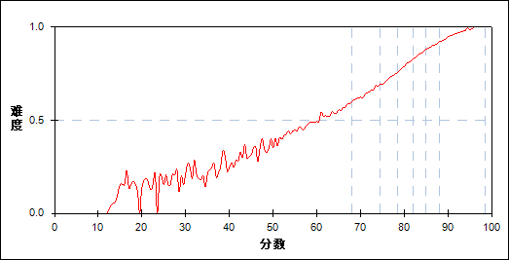

表 112 获取事实性信息2分组分析表

| 分值 | G1 | G2 | G3 | G4 | G5 | G6 | G7 | 人数 | 比率(%) | 平均分 |
| --- | --- | --- | --- | --- | --- | --- | --- | --- | --- | --- |
| 0.0～ | 202 | 0 | 0 | 0 | 0 | 0 | 0 | 202 | 0.35 | 30.17 |
| 1.0～ | 115 | 0 | 0 | 0 | 0 | 0 | 0 | 115 | 0.20 | 43.71 |
| 1.5～ | 1 | 0 | 0 | 0 | 0 | 0 | 0 | 1 | 0.00 | 41.50 |
| 2.0～ | 472 | 4 | 0 | 0 | 0 | 0 | 0 | 476 | 0.83 | 39.99 |
| 2.5～ | 1 | 0 | 0 | 0 | 0 | 0 | 0 | 1 | 0.00 | 51.00 |
| 3.0～ | 410 | 24 | 1 | 0 | 0 | 0 | 0 | 435 | 0.76 | 52.73 |
| 4.0～ | 763 | 56 | 7 | 1 | 0 | 0 | 0 | 827 | 1.44 | 52.61 |
| 4.5～ | 1 | 0 | 0 | 0 | 0 | 0 | 0 | 1 | 0.00 | 53.50 |
| 5.0～ | 1082 | 351 | 68 | 9 | 0 | 0 | 0 | 1510 | 2.64 | 62.15 |
| 5.5～ | 3 | 1 | 1 | 0 | 0 | 0 | 0 | 5 | 0.01 | 65.50 |
| 6.0～ | 1088 | 422 | 135 | 34 | 1 | 0 | 0 | 1680 | 2.93 | 63.33 |
| 6.5～ | 5 | 4 | 1 | 1 | 0 | 0 | 0 | 11 | 0.02 | 69.23 |
| 7.0～ | 1741 | 1939 | 939 | 290 | 57 | 4 | 1 | 4971 | 8.68 | 69.55 |
| 7.5～ | 3 | 1 | 1 | 5 | 0 | 0 | 0 | 10 | 0.02 | 73.95 |
| 8.0～ | 821 | 984 | 667 | 303 | 100 | 19 | 0 | 2894 | 5.05 | 71.06 |
| 8.5～ | 6 | 15 | 14 | 7 | 5 | 0 | 0 | 47 | 0.08 | 74.46 |
| 9.0～ | 1006 | 2763 | 3160 | 2291 | 1104 | 355 | 43 | 10722 | 18.72 | 75.86 |
| 9.5～ | 3 | 4 | 3 | 1 | 3 | 1 | 0 | 15 | 0.03 | 75.50 |
| 10.0～ | 213 | 466 | 634 | 648 | 613 | 300 | 102 | 2976 | 5.20 | 78.33 |
| 10.5～ | 0 | 6 | 10 | 12 | 15 | 15 | 7 | 65 | 0.11 | 81.86 |
| 11.0～ | 209 | 919 | 2032 | 3441 | 4151 | 4066 | 2636 | 17454 | 30.47 | 82.77 |
| 11.5～ | 0 | 0 | 0 | 0 | 0 | 1 | 2 | 3 | 0.01 | 87.83 |
| 12.0～ | 23 | 80 | 127 | 220 | 326 | 380 | 278 | 1434 | 2.50 | 83.35 |
| 12.5～ | 0 | 0 | 0 | 5 | 4 | 9 | 11 | 29 | 0.05 | 86.16 |
| 13.0～ | 16 | 145 | 384 | 916 | 1804 | 3033 | 5103 | 11401 | 19.90 | 86.67 |
| 合计 | 8184 | 8184 | 8184 | 8184 | 8183 | 8183 | 8183 | 57285 | 100.00 | 77.89 |
| 得分率 | 0.47 | 0.65 | 0.72 | 0.79 | 0.85 | 0.90 | 0.94 | - | - | - |

表 113 获取事实性信息2等级分析表

| 分值 | 优秀 | | 良好 | | 合格 | | 不合格 | | 全体 | |
| --- | --- | --- | --- | --- | --- | --- | --- | --- | --- | --- |
| 人数 | 比率 | 人数 | 比率 | 人数 | 比率 | 人数 | 比率 | 人数 | 比率 |
| 0.0～ | 0 | 0.0 | 0 | 0.0 | 6 | 3.0 | 196 | 97.0 | 202 | 100.0 |
| 1.0～ | 0 | 0.0 | 0 | 0.0 | 7 | 6.1 | 108 | 93.9 | 115 | 100.0 |
| 1.5～ | 0 | 0.0 | 0 | 0.0 | 0 | 0.0 | 1 | 100.0 | 1 | 100.0 |
| 2.0～ | 0 | 0.0 | 4 | 0.8 | 31 | 6.5 | 441 | 92.6 | 476 | 100.0 |
| 2.5～ | 0 | 0.0 | 0 | 0.0 | 0 | 0.0 | 1 | 100.0 | 1 | 100.0 |
| 3.0～ | 0 | 0.0 | 14 | 3.2 | 125 | 28.7 | 296 | 68.0 | 435 | 100.0 |
| 4.0～ | 0 | 0.0 | 41 | 5.0 | 221 | 26.7 | 565 | 68.3 | 827 | 100.0 |
| 4.5～ | 0 | 0.0 | 0 | 0.0 | 0 | 0.0 | 1 | 100.0 | 1 | 100.0 |
| 5.0～ | 0 | 0.0 | 311 | 20.6 | 678 | 44.9 | 521 | 34.5 | 1510 | 100.0 |
| 5.5～ | 0 | 0.0 | 1 | 20.0 | 3 | 60.0 | 1 | 20.0 | 5 | 100.0 |
| 6.0～ | 0 | 0.0 | 468 | 27.9 | 707 | 42.1 | 505 | 30.1 | 1680 | 100.0 |
| 6.5～ | 0 | 0.0 | 6 | 54.5 | 3 | 27.3 | 2 | 18.2 | 11 | 100.0 |
| 7.0～ | 5 | 0.1 | 2735 | 55.0 | 1757 | 35.3 | 474 | 9.5 | 4971 | 100.0 |
| 7.5～ | 0 | 0.0 | 6 | 60.0 | 4 | 40.0 | 0 | 0.0 | 10 | 100.0 |
| 8.0～ | 19 | 0.7 | 1815 | 62.7 | 828 | 28.6 | 232 | 8.0 | 2894 | 100.0 |
| 8.5～ | 0 | 0.0 | 38 | 80.9 | 9 | 19.1 | 0 | 0.0 | 47 | 100.0 |
| 9.0～ | 416 | 3.9 | 8859 | 82.6 | 1287 | 12.0 | 160 | 1.5 | 10722 | 100.0 |
| 9.5～ | 1 | 6.7 | 11 | 73.3 | 3 | 20.0 | 0 | 0.0 | 15 | 100.0 |
| 10.0～ | 412 | 13.8 | 2263 | 76.0 | 244 | 8.2 | 57 | 1.9 | 2976 | 100.0 |
| 10.5～ | 22 | 33.8 | 40 | 61.5 | 3 | 4.6 | 0 | 0.0 | 65 | 100.0 |
| 11.0～ | 6822 | 39.1 | 10295 | 59.0 | 317 | 1.8 | 20 | 0.1 | 17454 | 100.0 |
| 11.5～ | 3 | 100.0 | 0 | 0.0 | 0 | 0.0 | 0 | 0.0 | 3 | 100.0 |
| 12.0～ | 668 | 46.6 | 722 | 50.3 | 42 | 2.9 | 2 | 0.1 | 1434 | 100.0 |
| 12.5～ | 20 | 69.0 | 9 | 31.0 | 0 | 0.0 | 0 | 0.0 | 29 | 100.0 |
| 13.0～ | 8210 | 72.0 | 3159 | 27.7 | 29 | 0.3 | 3 | 0.0 | 11401 | 100.0 |
| 合计 | 16598 | 29.0 | 30797 | 53.8 | 6304 | 11.0 | 3586 | 6.3 | 57285 | 100.0 |

* + 1. 排序

本题组共包含1道试题，题号是：61

表 114 排序总分分析表

|  |  |  |  |  |  |  |  |  |
| --- | --- | --- | --- | --- | --- | --- | --- | --- |
| 人数 | 满分 | 最大值 | 最小值 | 平均值 | 标准差 | 差异系数 | 难度 | 区分度 |
| 57285 | 1 | 1.0 | 0.0 | 0.87 | 0.33 | 0.38 | 0.87 | 0.51 |

表 115 排序等级得分率分析表

|  |  |  |  |  |
| --- | --- | --- | --- | --- |
| 优秀 | 良好 | 合格 | 不及格 | 全体 |
| 0.99 | 0.91 | 0.67 | 0.34 | 0.87 |

图 56 排序分数分布曲线图

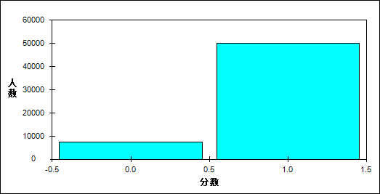

图 57 排序难度曲线图

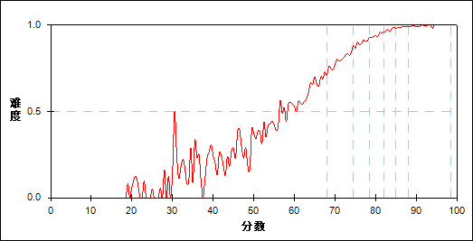

表 116 排序分组分析表

| 分值 | G1 | G2 | G3 | G4 | G5 | G6 | G7 | 人数 | 比率(%) | 平均分 |
| --- | --- | --- | --- | --- | --- | --- | --- | --- | --- | --- |
| 0.0～ | 4034 | 1631 | 833 | 484 | 226 | 102 | 49 | 7359 | 12.85 | 63.25 |
| 1.0～ | 4150 | 6553 | 7351 | 7700 | 7957 | 8081 | 8134 | 49926 | 87.15 | 80.04 |
| 合计 | 8184 | 8184 | 8184 | 8184 | 8183 | 8183 | 8183 | 57285 | 100.00 | 77.89 |
| 得分率 | 0.51 | 0.80 | 0.90 | 0.94 | 0.97 | 0.99 | 0.99 | - | - | - |

表 117 排序等级分析表

| 分值 | 优秀 | | 良好 | | 合格 | | 不合格 | | 全体 | |
| --- | --- | --- | --- | --- | --- | --- | --- | --- | --- | --- |
| 人数 | 比率 | 人数 | 比率 | 人数 | 比率 | 人数 | 比率 | 人数 | 比率 |
| 0.0～ | 154 | 2.1 | 2742 | 37.3 | 2094 | 28.5 | 2369 | 32.2 | 7359 | 100.0 |
| 1.0～ | 16444 | 32.9 | 28055 | 56.2 | 4210 | 8.4 | 1217 | 2.4 | 49926 | 100.0 |
| 合计 | 16598 | 29.0 | 30797 | 53.8 | 6304 | 11.0 | 3586 | 6.3 | 57285 | 100.0 |

* + 1. 推断

本题组共包含1道试题，题号是：57

表 118 推断总分分析表

|  |  |  |  |  |  |  |  |  |
| --- | --- | --- | --- | --- | --- | --- | --- | --- |
| 人数 | 满分 | 最大值 | 最小值 | 平均值 | 标准差 | 差异系数 | 难度 | 区分度 |
| 57285 | 2 | 2.0 | 0.0 | 0.95 | 1.00 | 1.05 | 0.48 | 0.35 |

表 119 推断等级得分率分析表

|  |  |  |  |  |
| --- | --- | --- | --- | --- |
| 优秀 | 良好 | 合格 | 不及格 | 全体 |
| 0.80 | 0.37 | 0.26 | 0.25 | 0.48 |

图 58 推断分数分布曲线图

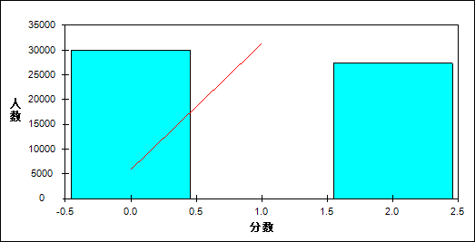

图 59 推断难度曲线图

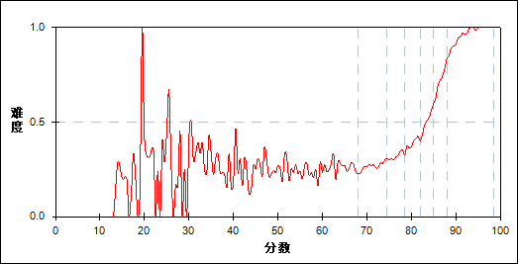

表 120 推断分组分析表

| 分值 | G1 | G2 | G3 | G4 | G5 | G6 | G7 | 人数 | 比率(%) | 平均分 |
| --- | --- | --- | --- | --- | --- | --- | --- | --- | --- | --- |
| 0.0～ | 6090 | 5981 | 5558 | 5001 | 4163 | 2466 | 743 | 30002 | 52.37 | 74.25 |
| 2.0～ | 2094 | 2203 | 2626 | 3183 | 4020 | 5717 | 7440 | 27283 | 47.63 | 81.88 |
| 合计 | 8184 | 8184 | 8184 | 8184 | 8183 | 8183 | 8183 | 57285 | 100.00 | 77.89 |
| 得分率 | 0.26 | 0.27 | 0.32 | 0.39 | 0.49 | 0.70 | 0.91 | - | - | - |

表 121 推断等级分析表

| 分值 | 优秀 | | 良好 | | 合格 | | 不合格 | | 全体 | |
| --- | --- | --- | --- | --- | --- | --- | --- | --- | --- | --- |
| 人数 | 比率 | 人数 | 比率 | 人数 | 比率 | 人数 | 比率 | 人数 | 比率 |
| 0.0～ | 3290 | 11.0 | 19337 | 64.5 | 4686 | 15.6 | 2689 | 9.0 | 30002 | 100.0 |
| 2.0～ | 13308 | 48.8 | 11460 | 42.0 | 1618 | 5.9 | 897 | 3.3 | 27283 | 100.0 |
| 合计 | 16598 | 29.0 | 30797 | 53.8 | 6304 | 11.0 | 3586 | 6.3 | 57285 | 100.0 |

* + 1. 理解意图、态度和观点2

本题组共包含3道试题，题号是：58、59、64

表 122 理解意图、态度和观点2总分分析表

|  |  |  |  |  |  |  |  |  |
| --- | --- | --- | --- | --- | --- | --- | --- | --- |
| 人数 | 满分 | 最大值 | 最小值 | 平均值 | 标准差 | 差异系数 | 难度 | 区分度 |
| 57285 | 5 | 5.0 | 0.0 | 3.04 | 1.04 | 0.34 | 0.61 | 0.43 |

表 123 理解意图、态度和观点2等级得分率分析表

|  |  |  |  |  |
| --- | --- | --- | --- | --- |
| 优秀 | 良好 | 合格 | 不及格 | 全体 |
| 0.68 | 0.62 | 0.51 | 0.35 | 0.61 |

图 60 理解意图、态度和观点2分数分布曲线图

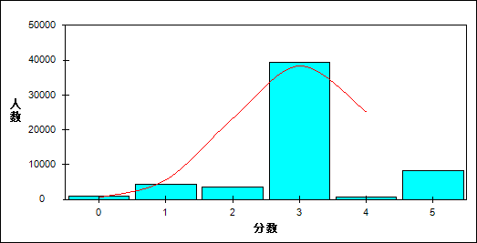

图 61 理解意图、态度和观点2难度曲线图

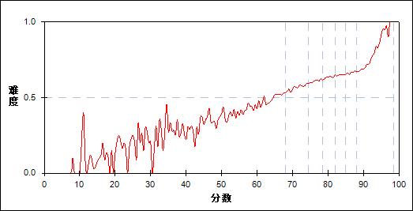

表 124 理解意图、态度和观点2分组分析表

| 分值 | G1 | G2 | G3 | G4 | G5 | G6 | G7 | 人数 | 比率(%) | 平均分 |
| --- | --- | --- | --- | --- | --- | --- | --- | --- | --- | --- |
| 0.0～ | 700 | 67 | 22 | 4 | 0 | 0 | 0 | 793 | 1.38 | 47.00 |
| 1.0～ | 2479 | 1015 | 472 | 229 | 117 | 54 | 10 | 4376 | 7.64 | 63.87 |
| 1.5～ | 6 | 3 | 4 | 1 | 1 | 0 | 1 | 16 | 0.03 | 69.41 |
| 2.0～ | 787 | 663 | 603 | 542 | 474 | 353 | 177 | 3599 | 6.28 | 74.04 |
| 2.5～ | 7 | 7 | 7 | 2 | 9 | 9 | 4 | 45 | 0.08 | 78.20 |
| 3.0～ | 3634 | 5563 | 6019 | 6189 | 6127 | 6209 | 5715 | 39456 | 68.88 | 79.50 |
| 3.5～ | 0 | 3 | 1 | 0 | 0 | 0 | 0 | 4 | 0.01 | 73.25 |
| 4.0～ | 110 | 100 | 106 | 88 | 129 | 110 | 93 | 736 | 1.28 | 77.88 |
| 4.5～ | 0 | 1 | 2 | 1 | 3 | 3 | 1 | 11 | 0.02 | 81.91 |
| 5.0～ | 461 | 762 | 948 | 1128 | 1323 | 1445 | 2182 | 8249 | 14.40 | 82.29 |
| 合计 | 8184 | 8184 | 8184 | 8184 | 8183 | 8183 | 8183 | 57285 | 100.00 | 77.89 |
| 得分率 | 0.43 | 0.57 | 0.61 | 0.63 | 0.65 | 0.66 | 0.70 | - | - | - |

表 125 理解意图、态度和观点2等级分析表

| 分值 | 优秀 | | 良好 | | 合格 | | 不合格 | | 全体 | |
| --- | --- | --- | --- | --- | --- | --- | --- | --- | --- | --- |
| 人数 | 比率 | 人数 | 比率 | 人数 | 比率 | 人数 | 比率 | 人数 | 比率 |
| 0.0～ | 0 | 0.0 | 68 | 8.6 | 172 | 21.7 | 553 | 69.7 | 793 | 100.0 |
| 1.0～ | 65 | 1.5 | 1566 | 35.8 | 1386 | 31.7 | 1359 | 31.1 | 4376 | 100.0 |
| 1.5～ | 1 | 6.3 | 6 | 37.5 | 5 | 31.3 | 4 | 25.0 | 16 | 100.0 |
| 2.0～ | 538 | 14.9 | 2114 | 58.7 | 570 | 15.8 | 377 | 10.5 | 3599 | 100.0 |
| 2.5～ | 14 | 31.1 | 23 | 51.1 | 6 | 13.3 | 2 | 4.4 | 45 | 100.0 |
| 3.0～ | 12103 | 30.7 | 22625 | 57.3 | 3620 | 9.2 | 1108 | 2.8 | 39456 | 100.0 |
| 3.5～ | 0 | 0.0 | 3 | 75.0 | 1 | 25.0 | 0 | 0.0 | 4 | 100.0 |
| 4.0～ | 208 | 28.3 | 387 | 52.6 | 93 | 12.6 | 48 | 6.5 | 736 | 100.0 |
| 4.5～ | 4 | 36.4 | 7 | 63.6 | 0 | 0.0 | 0 | 0.0 | 11 | 100.0 |
| 5.0～ | 3665 | 44.4 | 3998 | 48.5 | 451 | 5.5 | 135 | 1.6 | 8249 | 100.0 |
| 合计 | 16598 | 29.0 | 30797 | 53.8 | 6304 | 11.0 | 3586 | 6.3 | 57285 | 100.0 |

* 1. 题型分析
     1. 原型题

本题组共包含8道试题，题号是：21、23、24、26、27、28、29、32

表 126 原型题总分分析表

|  |  |  |  |  |  |  |  |  |
| --- | --- | --- | --- | --- | --- | --- | --- | --- |
| 人数 | 满分 | 最大值 | 最小值 | 平均值 | 标准差 | 差异系数 | 难度 | 区分度 |
| 57285 | 8 | 8.0 | 0.0 | 7.26 | 1.31 | 0.18 | 0.91 | 0.67 |

表 127 原型题等级得分率分析表

|  |  |  |  |  |
| --- | --- | --- | --- | --- |
| 优秀 | 良好 | 合格 | 不及格 | 全体 |
| 0.98 | 0.93 | 0.81 | 0.54 | 0.91 |

图 62 原型题分数分布曲线图

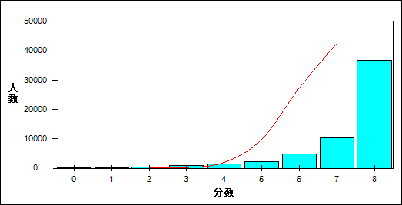

图 63 原型题难度曲线图

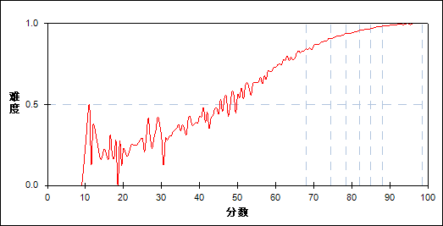

表 128 原型题分组分析表

| 分值 | G1 | G2 | G3 | G4 | G5 | G6 | G7 | 人数 | 比率(%) | 平均分 |
| --- | --- | --- | --- | --- | --- | --- | --- | --- | --- | --- |
| 0.0～ | 81 | 0 | 0 | 0 | 0 | 0 | 0 | 81 | 0.14 | 22.22 |
| 1.0～ | 237 | 2 | 0 | 0 | 0 | 0 | 0 | 239 | 0.42 | 37.67 |
| 2.0～ | 503 | 12 | 5 | 0 | 0 | 0 | 0 | 520 | 0.91 | 43.63 |
| 3.0～ | 783 | 76 | 14 | 1 | 0 | 0 | 0 | 874 | 1.53 | 51.99 |
| 4.0～ | 941 | 275 | 92 | 34 | 12 | 3 | 0 | 1357 | 2.37 | 60.74 |
| 5.0～ | 1083 | 619 | 307 | 166 | 76 | 32 | 4 | 2287 | 3.99 | 67.23 |
| 6.0～ | 1473 | 1325 | 860 | 617 | 383 | 200 | 58 | 4916 | 8.58 | 71.84 |
| 7.0～ | 1424 | 2036 | 1948 | 1779 | 1414 | 1050 | 602 | 10253 | 17.90 | 76.79 |
| 8.0～ | 1659 | 3839 | 4958 | 5587 | 6298 | 6898 | 7519 | 36758 | 64.17 | 81.78 |
| 合计 | 8184 | 8184 | 8184 | 8184 | 8183 | 8183 | 8183 | 57285 | 100.00 | 77.89 |
| 得分率 | 0.69 | 0.88 | 0.92 | 0.94 | 0.96 | 0.98 | 0.99 | - | - | - |

表 129 原型题等级分析表

| 分值 | 优秀 | | 良好 | | 合格 | | 不合格 | | 全体 | |
| --- | --- | --- | --- | --- | --- | --- | --- | --- | --- | --- |
| 人数 | 比率 | 人数 | 比率 | 人数 | 比率 | 人数 | 比率 | 人数 | 比率 |
| 0.0～ | 0 | 0.0 | 0 | 0.0 | 0 | 0.0 | 81 | 100.0 | 81 | 100.0 |
| 1.0～ | 0 | 0.0 | 1 | 0.4 | 5 | 2.1 | 233 | 97.5 | 239 | 100.0 |
| 2.0～ | 0 | 0.0 | 12 | 2.3 | 47 | 9.0 | 461 | 88.7 | 520 | 100.0 |
| 3.0～ | 0 | 0.0 | 66 | 7.6 | 203 | 23.2 | 605 | 69.2 | 874 | 100.0 |
| 4.0～ | 3 | 0.2 | 329 | 24.2 | 486 | 35.8 | 539 | 39.7 | 1357 | 100.0 |
| 5.0～ | 38 | 1.7 | 1001 | 43.8 | 748 | 32.7 | 500 | 21.9 | 2287 | 100.0 |
| 6.0～ | 269 | 5.5 | 2812 | 57.2 | 1314 | 26.7 | 521 | 10.6 | 4916 | 100.0 |
| 7.0～ | 1697 | 16.6 | 6700 | 65.3 | 1476 | 14.4 | 380 | 3.7 | 10253 | 100.0 |
| 8.0～ | 14591 | 39.7 | 19876 | 54.1 | 2025 | 5.5 | 266 | 0.7 | 36758 | 100.0 |
| 合计 | 16598 | 29.0 | 30797 | 53.8 | 6304 | 11.0 | 3586 | 6.3 | 57285 | 100.0 |

* + 1. 变型题

本题组共包含7道试题，题号是：22、25、30、31、33、34、35

表 130 变型题总分分析表

|  |  |  |  |  |  |  |  |  |
| --- | --- | --- | --- | --- | --- | --- | --- | --- |
| 人数 | 满分 | 最大值 | 最小值 | 平均值 | 标准差 | 差异系数 | 难度 | 区分度 |
| 57285 | 7 | 7.0 | 0.0 | 5.58 | 1.32 | 0.24 | 0.80 | 0.75 |

表 131 变型题等级得分率分析表

|  |  |  |  |  |
| --- | --- | --- | --- | --- |
| 优秀 | 良好 | 合格 | 不及格 | 全体 |
| 0.94 | 0.79 | 0.63 | 0.45 | 0.80 |

图 64 变型题分数分布曲线图

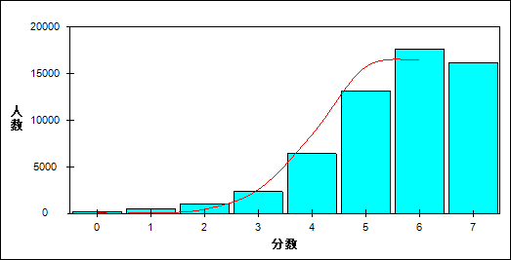

图 65 变型题难度曲线图

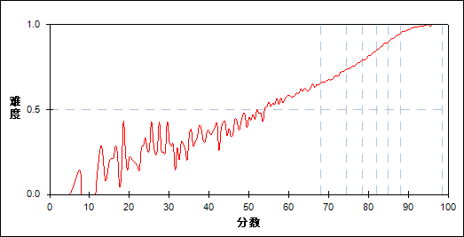

表 132 变型题分组分析表

| 分值 | G1 | G2 | G3 | G4 | G5 | G6 | G7 | 人数 | 比率(%) | 平均分 |
| --- | --- | --- | --- | --- | --- | --- | --- | --- | --- | --- |
| 0.0～ | 176 | 0 | 0 | 0 | 0 | 0 | 0 | 176 | 0.31 | 31.31 |
| 1.0～ | 430 | 15 | 1 | 0 | 0 | 0 | 0 | 446 | 0.78 | 43.20 |
| 2.0～ | 894 | 101 | 19 | 0 | 1 | 0 | 0 | 1015 | 1.77 | 51.86 |
| 3.0～ | 1484 | 579 | 175 | 54 | 10 | 0 | 0 | 2302 | 4.02 | 62.06 |
| 4.0～ | 2437 | 2067 | 1141 | 528 | 201 | 37 | 8 | 6419 | 11.21 | 69.09 |
| 5.0～ | 1923 | 3308 | 3266 | 2489 | 1387 | 618 | 125 | 13116 | 22.90 | 75.10 |
| 6.0～ | 706 | 1792 | 2899 | 3719 | 3876 | 3136 | 1524 | 17652 | 30.81 | 80.60 |
| 7.0～ | 134 | 322 | 683 | 1394 | 2708 | 4392 | 6526 | 16159 | 28.21 | 86.03 |
| 合计 | 8184 | 8184 | 8184 | 8184 | 8183 | 8183 | 8183 | 57285 | 100.00 | 77.89 |
| 得分率 | 0.54 | 0.69 | 0.76 | 0.82 | 0.87 | 0.92 | 0.97 | - | - | - |

表 133 变型题等级分析表

| 分值 | 优秀 | | 良好 | | 合格 | | 不合格 | | 全体 | |
| --- | --- | --- | --- | --- | --- | --- | --- | --- | --- | --- |
| 人数 | 比率 | 人数 | 比率 | 人数 | 比率 | 人数 | 比率 | 人数 | 比率 |
| 0.0～ | 0 | 0.0 | 0 | 0.0 | 3 | 1.7 | 173 | 98.3 | 176 | 100.0 |
| 1.0～ | 0 | 0.0 | 7 | 1.6 | 47 | 10.5 | 392 | 87.9 | 446 | 100.0 |
| 2.0～ | 0 | 0.0 | 80 | 7.9 | 238 | 23.4 | 697 | 68.7 | 1015 | 100.0 |
| 3.0～ | 1 | 0.0 | 643 | 27.9 | 891 | 38.7 | 767 | 33.3 | 2302 | 100.0 |
| 4.0～ | 49 | 0.8 | 3419 | 53.3 | 2076 | 32.3 | 875 | 13.6 | 6419 | 100.0 |
| 5.0～ | 767 | 5.8 | 9807 | 74.8 | 2056 | 15.7 | 486 | 3.7 | 13116 | 100.0 |
| 6.0～ | 4749 | 26.9 | 11904 | 67.4 | 825 | 4.7 | 174 | 1.0 | 17652 | 100.0 |
| 7.0～ | 11032 | 68.3 | 4937 | 30.6 | 168 | 1.0 | 22 | 0.1 | 16159 | 100.0 |
| 合计 | 16598 | 29.0 | 30797 | 53.8 | 6304 | 11.0 | 3586 | 6.3 | 57285 | 100.0 |

1. 题目分析
   * 1. 第1题

表 134 第1题分析表

|  |  |  |  |  |  |  |  |  |
| --- | --- | --- | --- | --- | --- | --- | --- | --- |
| 人数 | 满分 | 最大值 | 最小值 | 平均值 | 标准差 | 差异系数 | 难度 | 区分度 |
| 57285 | 1 | 1.0 | 0.0 | 0.91 | 0.29 | 0.31 | 0.91 | 0.32 |

表 135 第1题等级得分率分析表

|  |  |  |  |  |
| --- | --- | --- | --- | --- |
| 优秀 | 良好 | 合格 | 不及格 | 全体 |
| 0.99 | 0.92 | 0.80 | 0.67 | 0.91 |

图 66 第1题难度曲线图

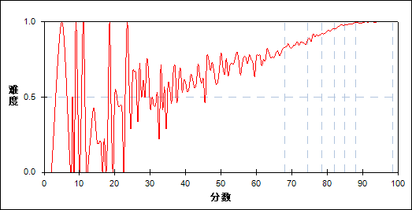

图 67 第1题分组难度曲线图

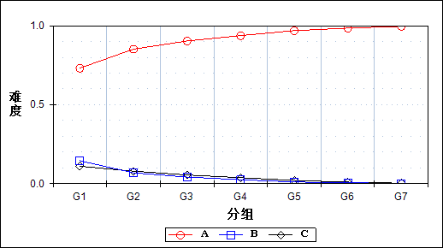

表 136 第1题分组分析表

| 选项 | G1 | G2 | G3 | G4 | G5 | G6 | G7 | 人数 | 比率(%) | 相关系数 |
| --- | --- | --- | --- | --- | --- | --- | --- | --- | --- | --- |
| *Ａ | 5986 | 6970 | 7392 | 7669 | 7928 | 8057 | 8149 | 52151 | 91.04 | 0.32 |
| Ｂ | 1186 | 560 | 344 | 205 | 88 | 47 | 10 | 2440 | 4.26 | -0.25 |
| Ｃ | 903 | 646 | 448 | 310 | 167 | 79 | 24 | 2577 | 4.50 | -0.17 |
| 未选或多选 | 109 | 8 | 0 | 0 | 0 | 0 | 0 | 117 | 0.20 | -0.15 |
| 合计 | 8184 | 8184 | 8184 | 8184 | 8183 | 8183 | 8183 | 57285 | 100.00 | - |
| 得分率 | 0.73 | 0.85 | 0.90 | 0.94 | 0.97 | 0.98 | 1.00 | - | - | - |

表 137 第1题等级分析表

| 分值 | 优秀 | | 良好 | | 合格 | | 不合格 | | 全体 | |
| --- | --- | --- | --- | --- | --- | --- | --- | --- | --- | --- |
| 人数 | 比率 | 人数 | 比率 | 人数 | 比率 | 人数 | 比率 | 人数 | 比率 |
| *Ａ | 16435 | 31.5 | 28293 | 54.3 | 5036 | 9.7 | 2387 | 4.6 | 52151 | 100.0 |
| Ｂ | 57 | 2.3 | 1061 | 43.5 | 647 | 26.5 | 675 | 27.7 | 2440 | 100.0 |
| Ｃ | 106 | 4.1 | 1439 | 55.8 | 596 | 23.1 | 436 | 16.9 | 2577 | 100.0 |
| 未选或多选 | 0 | 0.0 | 4 | 3.4 | 25 | 21.4 | 88 | 75.2 | 117 | 100.0 |
| 合计 | 16598 | 29.0 | 30797 | 53.8 | 6304 | 11.0 | 3586 | 6.3 | 57285 | 100.0 |

* + 1. 第2题

表 138 第2题分析表

|  |  |  |  |  |  |  |  |  |
| --- | --- | --- | --- | --- | --- | --- | --- | --- |
| 人数 | 满分 | 最大值 | 最小值 | 平均值 | 标准差 | 差异系数 | 难度 | 区分度 |
| 57285 | 1 | 1.0 | 0.0 | 0.98 | 0.14 | 0.14 | 0.98 | 0.22 |

表 139 第2题等级得分率分析表

|  |  |  |  |  |
| --- | --- | --- | --- | --- |
| 优秀 | 良好 | 合格 | 不及格 | 全体 |
| 1.00 | 0.99 | 0.96 | 0.89 | 0.98 |

图 68 第2题难度曲线图

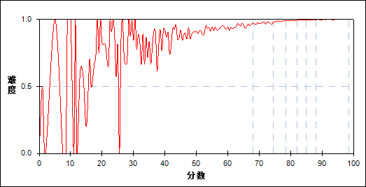

图 69 第2题分组难度曲线图

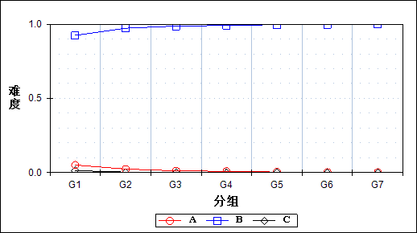

表 140 第2题分组分析表

| 选项 | G1 | G2 | G3 | G4 | G5 | G6 | G7 | 人数 | 比率(%) | 相关系数 |
| --- | --- | --- | --- | --- | --- | --- | --- | --- | --- | --- |
| Ａ | 415 | 192 | 97 | 66 | 29 | 18 | 15 | 832 | 1.45 | -0.15 |
| *Ｂ | 7564 | 7959 | 8076 | 8113 | 8150 | 8164 | 8168 | 56194 | 98.10 | 0.22 |
| Ｃ | 107 | 27 | 11 | 5 | 4 | 1 | 0 | 155 | 0.27 | -0.11 |
| 未选或多选 | 98 | 6 | 0 | 0 | 0 | 0 | 0 | 104 | 0.18 | -0.15 |
| 合计 | 8184 | 8184 | 8184 | 8184 | 8183 | 8183 | 8183 | 57285 | 100.00 | - |
| 得分率 | 0.92 | 0.97 | 0.99 | 0.99 | 1.00 | 1.00 | 1.00 | - | - | - |

表 141 第2题等级分析表

| 分值 | 优秀 | | 良好 | | 合格 | | 不合格 | | 全体 | |
| --- | --- | --- | --- | --- | --- | --- | --- | --- | --- | --- |
| 人数 | 比率 | 人数 | 比率 | 人数 | 比率 | 人数 | 比率 | 人数 | 比率 |
| Ａ | 34 | 4.1 | 340 | 40.9 | 206 | 24.8 | 252 | 30.3 | 832 | 100.0 |
| *Ｂ | 16563 | 29.5 | 30416 | 54.1 | 6034 | 10.7 | 3181 | 5.7 | 56194 | 100.0 |
| Ｃ | 1 | 0.6 | 39 | 25.2 | 44 | 28.4 | 71 | 45.8 | 155 | 100.0 |
| 未选或多选 | 0 | 0.0 | 2 | 1.9 | 20 | 19.2 | 82 | 78.8 | 104 | 100.0 |
| 合计 | 16598 | 29.0 | 30797 | 53.8 | 6304 | 11.0 | 3586 | 6.3 | 57285 | 100.0 |

* + 1. 第3题

表 142 第3题分析表

|  |  |  |  |  |  |  |  |  |
| --- | --- | --- | --- | --- | --- | --- | --- | --- |
| 人数 | 满分 | 最大值 | 最小值 | 平均值 | 标准差 | 差异系数 | 难度 | 区分度 |
| 57285 | 1 | 1.0 | 0.0 | 0.89 | 0.32 | 0.36 | 0.89 | 0.44 |

表 143 第3题等级得分率分析表

|  |  |  |  |  |
| --- | --- | --- | --- | --- |
| 优秀 | 良好 | 合格 | 不及格 | 全体 |
| 1.00 | 0.91 | 0.71 | 0.48 | 0.89 |

图 70 第3题难度曲线图

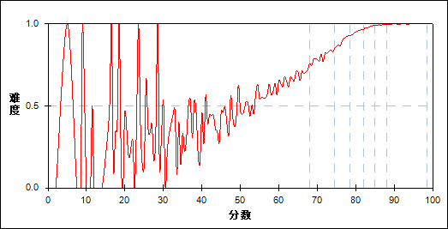

图 71 第3题分组难度曲线图

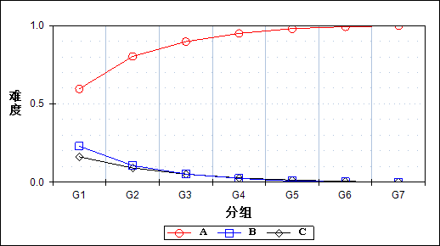

表 144 第3题分组分析表

| 选项 | G1 | G2 | G3 | G4 | G5 | G6 | G7 | 人数 | 比率(%) | 相关系数 |
| --- | --- | --- | --- | --- | --- | --- | --- | --- | --- | --- |
| *Ａ | 4876 | 6569 | 7340 | 7769 | 8017 | 8119 | 8168 | 50858 | 88.78 | 0.44 |
| Ｂ | 1880 | 866 | 425 | 197 | 55 | 22 | 4 | 3449 | 6.02 | -0.33 |
| Ｃ | 1325 | 742 | 418 | 217 | 110 | 42 | 11 | 2865 | 5.00 | -0.26 |
| 未选或多选 | 103 | 7 | 1 | 1 | 1 | 0 | 0 | 113 | 0.20 | -0.15 |
| 合计 | 8184 | 8184 | 8184 | 8184 | 8183 | 8183 | 8183 | 57285 | 100.00 | - |
| 得分率 | 0.60 | 0.80 | 0.90 | 0.95 | 0.98 | 0.99 | 1.00 | - | - | - |

表 145 第3题等级分析表

| 分值 | 优秀 | | 良好 | | 合格 | | 不合格 | | 全体 | |
| --- | --- | --- | --- | --- | --- | --- | --- | --- | --- | --- |
| 人数 | 比率 | 人数 | 比率 | 人数 | 比率 | 人数 | 比率 | 人数 | 比率 |
| *Ａ | 16519 | 32.5 | 28153 | 55.4 | 4454 | 8.8 | 1732 | 3.4 | 50858 | 100.0 |
| Ｂ | 26 | 0.8 | 1326 | 38.4 | 1066 | 30.9 | 1031 | 29.9 | 3449 | 100.0 |
| Ｃ | 53 | 1.8 | 1312 | 45.8 | 761 | 26.6 | 739 | 25.8 | 2865 | 100.0 |
| 未选或多选 | 0 | 0.0 | 6 | 5.3 | 23 | 20.4 | 84 | 74.3 | 113 | 100.0 |
| 合计 | 16598 | 29.0 | 30797 | 53.8 | 6304 | 11.0 | 3586 | 6.3 | 57285 | 100.0 |

* + 1. 第4题

表 146 第4题分析表

|  |  |  |  |  |  |  |  |  |
| --- | --- | --- | --- | --- | --- | --- | --- | --- |
| 人数 | 满分 | 最大值 | 最小值 | 平均值 | 标准差 | 差异系数 | 难度 | 区分度 |
| 57285 | 1 | 1.0 | 0.0 | 0.96 | 0.20 | 0.20 | 0.96 | 0.24 |

表 147 第4题等级得分率分析表

|  |  |  |  |  |
| --- | --- | --- | --- | --- |
| 优秀 | 良好 | 合格 | 不及格 | 全体 |
| 0.99 | 0.97 | 0.92 | 0.82 | 0.96 |

图 72 第4题难度曲线图

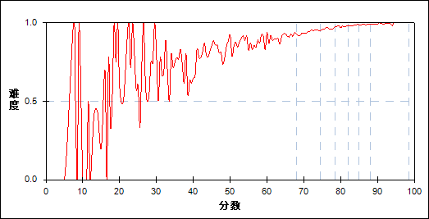

图 73 第4题分组难度曲线图

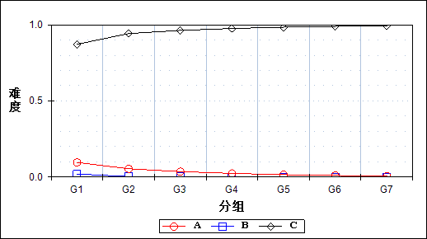

表 148 第4题分组分析表

| 选项 | G1 | G2 | G3 | G4 | G5 | G6 | G7 | 人数 | 比率(%) | 相关系数 |
| --- | --- | --- | --- | --- | --- | --- | --- | --- | --- | --- |
| Ａ | 787 | 443 | 289 | 194 | 127 | 83 | 52 | 1975 | 3.45 | -0.17 |
| Ｂ | 164 | 23 | 14 | 5 | 5 | 4 | 3 | 218 | 0.38 | -0.15 |
| *Ｃ | 7134 | 7711 | 7881 | 7984 | 8051 | 8096 | 8128 | 54985 | 95.98 | 0.24 |
| 未选或多选 | 99 | 7 | 0 | 1 | 0 | 0 | 0 | 107 | 0.19 | -0.15 |
| 合计 | 8184 | 8184 | 8184 | 8184 | 8183 | 8183 | 8183 | 57285 | 100.00 | - |
| 得分率 | 0.87 | 0.94 | 0.96 | 0.98 | 0.98 | 0.99 | 0.99 | - | - | - |

表 149 第4题等级分析表

| 分值 | 优秀 | | 良好 | | 合格 | | 不合格 | | 全体 | |
| --- | --- | --- | --- | --- | --- | --- | --- | --- | --- | --- |
| 人数 | 比率 | 人数 | 比率 | 人数 | 比率 | 人数 | 比率 | 人数 | 比率 |
| Ａ | 136 | 6.9 | 937 | 47.4 | 466 | 23.6 | 436 | 22.1 | 1975 | 100.0 |
| Ｂ | 7 | 3.2 | 36 | 16.5 | 36 | 16.5 | 139 | 63.8 | 218 | 100.0 |
| *Ｃ | 16455 | 29.9 | 29820 | 54.2 | 5781 | 10.5 | 2929 | 5.3 | 54985 | 100.0 |
| 未选或多选 | 0 | 0.0 | 4 | 3.7 | 21 | 19.6 | 82 | 76.6 | 107 | 100.0 |
| 合计 | 16598 | 29.0 | 30797 | 53.8 | 6304 | 11.0 | 3586 | 6.3 | 57285 | 100.0 |

* + 1. 第5题

表 150 第5题分析表

|  |  |  |  |  |  |  |  |  |
| --- | --- | --- | --- | --- | --- | --- | --- | --- |
| 人数 | 满分 | 最大值 | 最小值 | 平均值 | 标准差 | 差异系数 | 难度 | 区分度 |
| 57285 | 1 | 1.0 | 0.0 | 0.94 | 0.24 | 0.26 | 0.94 | 0.41 |

表 151 第5题等级得分率分析表

|  |  |  |  |  |
| --- | --- | --- | --- | --- |
| 优秀 | 良好 | 合格 | 不及格 | 全体 |
| 1.00 | 0.97 | 0.84 | 0.60 | 0.94 |

图 74 第5题难度曲线图

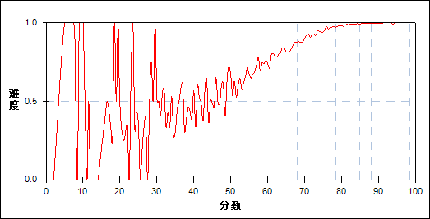

图 75 第5题分组难度曲线图

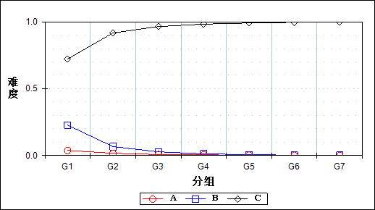

表 152 第5题分组分析表

| 选项 | G1 | G2 | G3 | G4 | G5 | G6 | G7 | 人数 | 比率(%) | 相关系数 |
| --- | --- | --- | --- | --- | --- | --- | --- | --- | --- | --- |
| Ａ | 314 | 138 | 64 | 44 | 20 | 14 | 7 | 601 | 1.05 | -0.14 |
| Ｂ | 1861 | 544 | 227 | 101 | 54 | 22 | 15 | 2824 | 4.93 | -0.36 |
| *Ｃ | 5907 | 7496 | 7892 | 8039 | 8108 | 8147 | 8161 | 53750 | 93.83 | 0.41 |
| 未选或多选 | 102 | 6 | 1 | 0 | 1 | 0 | 0 | 110 | 0.19 | -0.15 |
| 合计 | 8184 | 8184 | 8184 | 8184 | 8183 | 8183 | 8183 | 57285 | 100.00 | - |
| 得分率 | 0.72 | 0.92 | 0.96 | 0.98 | 0.99 | 1.00 | 1.00 | - | - | - |

表 153 第5题等级分析表

| 分值 | 优秀 | | 良好 | | 合格 | | 不合格 | | 全体 | |
| --- | --- | --- | --- | --- | --- | --- | --- | --- | --- | --- |
| 人数 | 比率 | 人数 | 比率 | 人数 | 比率 | 人数 | 比率 | 人数 | 比率 |
| Ａ | 21 | 3.5 | 230 | 38.3 | 151 | 25.1 | 199 | 33.1 | 601 | 100.0 |
| Ｂ | 40 | 1.4 | 760 | 26.9 | 864 | 30.6 | 1160 | 41.1 | 2824 | 100.0 |
| *Ｃ | 16537 | 30.8 | 29803 | 55.4 | 5269 | 9.8 | 2141 | 4.0 | 53750 | 100.0 |
| 未选或多选 | 0 | 0.0 | 4 | 3.6 | 20 | 18.2 | 86 | 78.2 | 110 | 100.0 |
| 合计 | 16598 | 29.0 | 30797 | 53.8 | 6304 | 11.0 | 3586 | 6.3 | 57285 | 100.0 |

* + 1. 第6题

表 154 第6题分析表

|  |  |  |  |  |  |  |  |  |
| --- | --- | --- | --- | --- | --- | --- | --- | --- |
| 人数 | 满分 | 最大值 | 最小值 | 平均值 | 标准差 | 差异系数 | 难度 | 区分度 |
| 57285 | 1 | 1.0 | 0.0 | 0.95 | 0.22 | 0.23 | 0.95 | 0.29 |

表 155 第6题等级得分率分析表

|  |  |  |  |  |
| --- | --- | --- | --- | --- |
| 优秀 | 良好 | 合格 | 不及格 | 全体 |
| 0.99 | 0.96 | 0.90 | 0.75 | 0.95 |

图 76 第6题难度曲线图

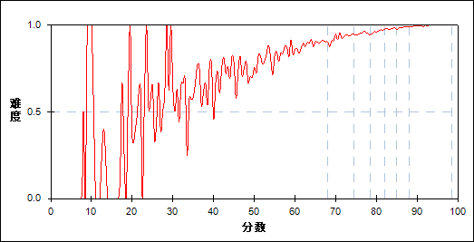

图 77 第6题分组难度曲线图

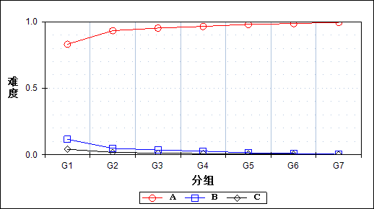

表 156 第6题分组分析表

| 选项 | G1 | G2 | G3 | G4 | G5 | G6 | G7 | 人数 | 比率(%) | 相关系数 |
| --- | --- | --- | --- | --- | --- | --- | --- | --- | --- | --- |
| *Ａ | 6795 | 7629 | 7790 | 7892 | 8016 | 8068 | 8144 | 54334 | 94.85 | 0.29 |
| Ｂ | 948 | 397 | 293 | 223 | 124 | 80 | 30 | 2095 | 3.66 | -0.22 |
| Ｃ | 339 | 150 | 101 | 69 | 43 | 35 | 9 | 746 | 1.30 | -0.14 |
| 未选或多选 | 102 | 8 | 0 | 0 | 0 | 0 | 0 | 110 | 0.19 | -0.15 |
| 合计 | 8184 | 8184 | 8184 | 8184 | 8183 | 8183 | 8183 | 57285 | 100.00 | - |
| 得分率 | 0.83 | 0.93 | 0.95 | 0.96 | 0.98 | 0.99 | 1.00 | - | - | - |

表 157 第6题等级分析表

| 分值 | 优秀 | | 良好 | | 合格 | | 不合格 | | 全体 | |
| --- | --- | --- | --- | --- | --- | --- | --- | --- | --- | --- |
| 人数 | 比率 | 人数 | 比率 | 人数 | 比率 | 人数 | 比率 | 人数 | 比率 |
| *Ａ | 16442 | 30.3 | 29560 | 54.4 | 5652 | 10.4 | 2680 | 4.9 | 54334 | 100.0 |
| Ｂ | 111 | 5.3 | 921 | 44.0 | 456 | 21.8 | 607 | 29.0 | 2095 | 100.0 |
| Ｃ | 45 | 6.0 | 312 | 41.8 | 175 | 23.5 | 214 | 28.7 | 746 | 100.0 |
| 未选或多选 | 0 | 0.0 | 4 | 3.6 | 21 | 19.1 | 85 | 77.3 | 110 | 100.0 |
| 合计 | 16598 | 29.0 | 30797 | 53.8 | 6304 | 11.0 | 3586 | 6.3 | 57285 | 100.0 |

* + 1. 第7题

表 158 第7题分析表

|  |  |  |  |  |  |  |  |  |
| --- | --- | --- | --- | --- | --- | --- | --- | --- |
| 人数 | 满分 | 最大值 | 最小值 | 平均值 | 标准差 | 差异系数 | 难度 | 区分度 |
| 57285 | 1 | 1.0 | 0.0 | 0.96 | 0.19 | 0.20 | 0.96 | 0.39 |

表 159 第7题等级得分率分析表

|  |  |  |  |  |
| --- | --- | --- | --- | --- |
| 优秀 | 良好 | 合格 | 不及格 | 全体 |
| 1.00 | 0.99 | 0.91 | 0.69 | 0.96 |

图 78 第7题难度曲线图



图 79 第7题分组难度曲线图

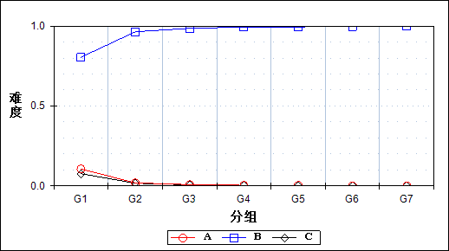

表 160 第7题分组分析表

| 选项 | G1 | G2 | G3 | G4 | G5 | G6 | G7 | 人数 | 比率(%) | 相关系数 |
| --- | --- | --- | --- | --- | --- | --- | --- | --- | --- | --- |
| Ａ | 867 | 152 | 67 | 29 | 26 | 8 | 3 | 1152 | 2.01 | -0.28 |
| *Ｂ | 6588 | 7890 | 8063 | 8131 | 8136 | 8163 | 8173 | 55144 | 96.26 | 0.39 |
| Ｃ | 626 | 135 | 54 | 24 | 21 | 11 | 7 | 878 | 1.53 | -0.22 |
| 未选或多选 | 103 | 7 | 0 | 0 | 0 | 1 | 0 | 111 | 0.19 | -0.15 |
| 合计 | 8184 | 8184 | 8184 | 8184 | 8183 | 8183 | 8183 | 57285 | 100.00 | - |
| 得分率 | 0.80 | 0.96 | 0.99 | 0.99 | 0.99 | 1.00 | 1.00 | - | - | - |

表 161 第7题等级分析表

| 分值 | 优秀 | | 良好 | | 合格 | | 不合格 | | 全体 | |
| --- | --- | --- | --- | --- | --- | --- | --- | --- | --- | --- |
| 人数 | 比率 | 人数 | 比率 | 人数 | 比率 | 人数 | 比率 | 人数 | 比率 |
| Ａ | 11 | 1.0 | 224 | 19.4 | 316 | 27.4 | 601 | 52.2 | 1152 | 100.0 |
| *Ｂ | 16567 | 30.0 | 30372 | 55.1 | 5717 | 10.4 | 2488 | 4.5 | 55144 | 100.0 |
| Ｃ | 19 | 2.2 | 198 | 22.6 | 250 | 28.5 | 411 | 46.8 | 878 | 100.0 |
| 未选或多选 | 1 | 0.9 | 3 | 2.7 | 21 | 18.9 | 86 | 77.5 | 111 | 100.0 |
| 合计 | 16598 | 29.0 | 30797 | 53.8 | 6304 | 11.0 | 3586 | 6.3 | 57285 | 100.0 |

* + 1. 第8题

表 162 第8题分析表

|  |  |  |  |  |  |  |  |  |
| --- | --- | --- | --- | --- | --- | --- | --- | --- |
| 人数 | 满分 | 最大值 | 最小值 | 平均值 | 标准差 | 差异系数 | 难度 | 区分度 |
| 57285 | 1 | 1.0 | 0.0 | 0.96 | 0.20 | 0.20 | 0.96 | 0.34 |

表 163 第8题等级得分率分析表

|  |  |  |  |  |
| --- | --- | --- | --- | --- |
| 优秀 | 良好 | 合格 | 不及格 | 全体 |
| 1.00 | 0.98 | 0.90 | 0.75 | 0.96 |

图 80 第8题难度曲线图

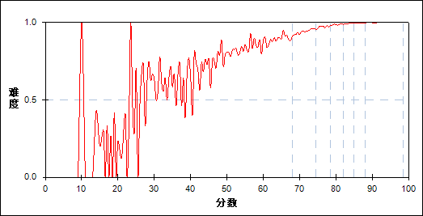

图 81 第8题分组难度曲线图

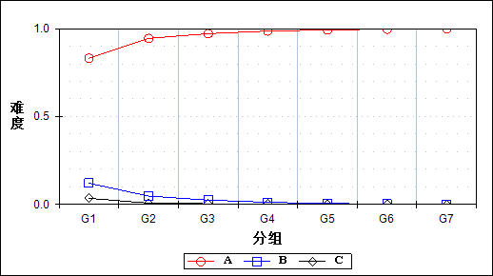

表 164 第8题分组分析表

| 选项 | G1 | G2 | G3 | G4 | G5 | G6 | G7 | 人数 | 比率(%) | 相关系数 |
| --- | --- | --- | --- | --- | --- | --- | --- | --- | --- | --- |
| *Ａ | 6807 | 7727 | 7949 | 8072 | 8119 | 8158 | 8177 | 55009 | 96.03 | 0.34 |
| Ｂ | 988 | 387 | 201 | 95 | 46 | 16 | 3 | 1736 | 3.03 | -0.26 |
| Ｃ | 285 | 60 | 32 | 15 | 18 | 8 | 3 | 421 | 0.73 | -0.18 |
| 未选或多选 | 104 | 10 | 2 | 2 | 0 | 1 | 0 | 119 | 0.21 | -0.15 |
| 合计 | 8184 | 8184 | 8184 | 8184 | 8183 | 8183 | 8183 | 57285 | 100.00 | - |
| 得分率 | 0.83 | 0.94 | 0.97 | 0.99 | 0.99 | 1.00 | 1.00 | - | - | - |

表 165 第8题等级分析表

| 分值 | 优秀 | | 良好 | | 合格 | | 不合格 | | 全体 | |
| --- | --- | --- | --- | --- | --- | --- | --- | --- | --- | --- |
| 人数 | 比率 | 人数 | 比率 | 人数 | 比率 | 人数 | 比率 | 人数 | 比率 |
| *Ａ | 16567 | 30.1 | 30054 | 54.6 | 5698 | 10.4 | 2690 | 4.9 | 55009 | 100.0 |
| Ｂ | 19 | 1.1 | 620 | 35.7 | 498 | 28.7 | 599 | 34.5 | 1736 | 100.0 |
| Ｃ | 11 | 2.6 | 113 | 26.8 | 86 | 20.4 | 211 | 50.1 | 421 | 100.0 |
| 未选或多选 | 1 | 0.8 | 10 | 8.4 | 22 | 18.5 | 86 | 72.3 | 119 | 100.0 |
| 合计 | 16598 | 29.0 | 30797 | 53.8 | 6304 | 11.0 | 3586 | 6.3 | 57285 | 100.0 |

* + 1. 第9题

表 166 第9题分析表

|  |  |  |  |  |  |  |  |  |
| --- | --- | --- | --- | --- | --- | --- | --- | --- |
| 人数 | 满分 | 最大值 | 最小值 | 平均值 | 标准差 | 差异系数 | 难度 | 区分度 |
| 57285 | 1 | 1.0 | 0.0 | 0.97 | 0.16 | 0.17 | 0.97 | 0.33 |

表 167 第9题等级得分率分析表

|  |  |  |  |  |
| --- | --- | --- | --- | --- |
| 优秀 | 良好 | 合格 | 不及格 | 全体 |
| 1.00 | 0.99 | 0.94 | 0.79 | 0.97 |

图 82 第9题难度曲线图

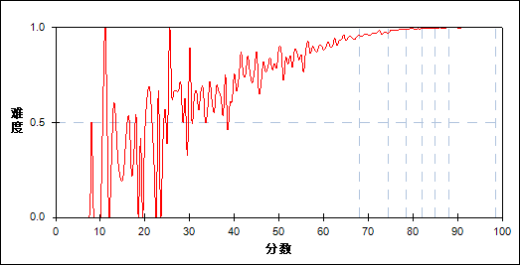

图 83 第9题分组难度曲线图

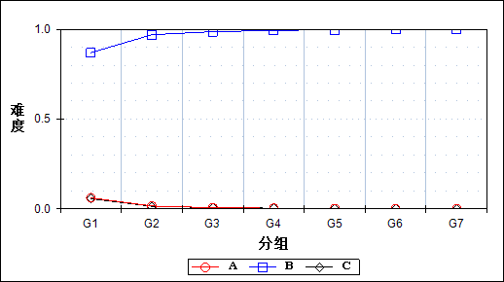

表 168 第9题分组分析表

| 选项 | G1 | G2 | G3 | G4 | G5 | G6 | G7 | 人数 | 比率(%) | 相关系数 |
| --- | --- | --- | --- | --- | --- | --- | --- | --- | --- | --- |
| Ａ | 501 | 129 | 53 | 28 | 14 | 3 | 1 | 729 | 1.27 | -0.21 |
| *Ｂ | 7116 | 7933 | 8073 | 8129 | 8157 | 8170 | 8178 | 55756 | 97.33 | 0.33 |
| Ｃ | 462 | 116 | 58 | 27 | 12 | 10 | 4 | 689 | 1.20 | -0.21 |
| 未选或多选 | 105 | 6 | 0 | 0 | 0 | 0 | 0 | 111 | 0.19 | -0.15 |
| 合计 | 8184 | 8184 | 8184 | 8184 | 8183 | 8183 | 8183 | 57285 | 100.00 | - |
| 得分率 | 0.87 | 0.97 | 0.99 | 0.99 | 1.00 | 1.00 | 1.00 | - | - | - |

表 169 第9题等级分析表

| 分值 | 优秀 | | 良好 | | 合格 | | 不合格 | | 全体 | |
| --- | --- | --- | --- | --- | --- | --- | --- | --- | --- | --- |
| 人数 | 比率 | 人数 | 比率 | 人数 | 比率 | 人数 | 比率 | 人数 | 比率 |
| Ａ | 4 | 0.5 | 192 | 26.3 | 200 | 27.4 | 333 | 45.7 | 729 | 100.0 |
| *Ｂ | 16579 | 29.7 | 30424 | 54.6 | 5931 | 10.6 | 2822 | 5.1 | 55756 | 100.0 |
| Ｃ | 15 | 2.2 | 179 | 26.0 | 152 | 22.1 | 343 | 49.8 | 689 | 100.0 |
| 未选或多选 | 0 | 0.0 | 2 | 1.8 | 21 | 18.9 | 88 | 79.3 | 111 | 100.0 |
| 合计 | 16598 | 29.0 | 30797 | 53.8 | 6304 | 11.0 | 3586 | 6.3 | 57285 | 100.0 |

* + 1. 第10题

表 170 第10题分析表

|  |  |  |  |  |  |  |  |  |
| --- | --- | --- | --- | --- | --- | --- | --- | --- |
| 人数 | 满分 | 最大值 | 最小值 | 平均值 | 标准差 | 差异系数 | 难度 | 区分度 |
| 57285 | 1 | 1.0 | 0.0 | 0.92 | 0.27 | 0.29 | 0.92 | 0.38 |

表 171 第10题等级得分率分析表

|  |  |  |  |  |
| --- | --- | --- | --- | --- |
| 优秀 | 良好 | 合格 | 不及格 | 全体 |
| 1.00 | 0.94 | 0.79 | 0.62 | 0.92 |

图 84 第10题难度曲线图

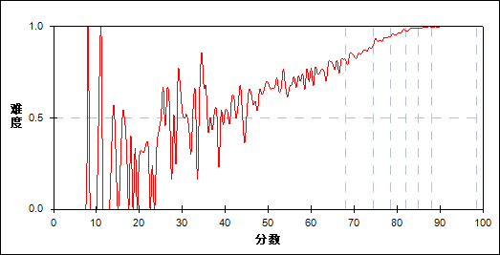

图 85 第10题分组难度曲线图

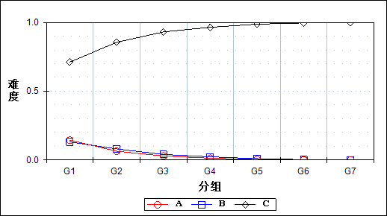

表 172 第10题分组分析表

| 选项 | G1 | G2 | G3 | G4 | G5 | G6 | G7 | 人数 | 比率(%) | 相关系数 |
| --- | --- | --- | --- | --- | --- | --- | --- | --- | --- | --- |
| Ａ | 1182 | 519 | 236 | 105 | 27 | 12 | 3 | 2084 | 3.64 | -0.26 |
| Ｂ | 1074 | 656 | 326 | 187 | 81 | 22 | 8 | 2354 | 4.11 | -0.24 |
| *Ｃ | 5820 | 7001 | 7618 | 7892 | 8075 | 8149 | 8172 | 52727 | 92.04 | 0.38 |
| 未选或多选 | 108 | 8 | 4 | 0 | 0 | 0 | 0 | 120 | 0.21 | -0.15 |
| 合计 | 8184 | 8184 | 8184 | 8184 | 8183 | 8183 | 8183 | 57285 | 100.00 | - |
| 得分率 | 0.71 | 0.86 | 0.93 | 0.96 | 0.99 | 1.00 | 1.00 | - | - | - |

表 173 第10题等级分析表

| 分值 | 优秀 | | 良好 | | 合格 | | 不合格 | | 全体 | |
| --- | --- | --- | --- | --- | --- | --- | --- | --- | --- | --- |
| 人数 | 比率 | 人数 | 比率 | 人数 | 比率 | 人数 | 比率 | 人数 | 比率 |
| Ａ | 15 | 0.7 | 749 | 35.9 | 673 | 32.3 | 647 | 31.0 | 2084 | 100.0 |
| Ｂ | 30 | 1.3 | 1111 | 47.2 | 600 | 25.5 | 613 | 26.0 | 2354 | 100.0 |
| *Ｃ | 16553 | 31.4 | 28931 | 54.9 | 5007 | 9.5 | 2236 | 4.2 | 52727 | 100.0 |
| 未选或多选 | 0 | 0.0 | 6 | 5.0 | 24 | 20.0 | 90 | 75.0 | 120 | 100.0 |
| 合计 | 16598 | 29.0 | 30797 | 53.8 | 6304 | 11.0 | 3586 | 6.3 | 57285 | 100.0 |

* + 1. 第11题

表 174 第11题分析表

|  |  |  |  |  |  |  |  |  |
| --- | --- | --- | --- | --- | --- | --- | --- | --- |
| 人数 | 满分 | 最大值 | 最小值 | 平均值 | 标准差 | 差异系数 | 难度 | 区分度 |
| 57285 | 1 | 1.0 | 0.0 | 0.94 | 0.23 | 0.24 | 0.94 | 0.40 |

表 175 第11题等级得分率分析表

|  |  |  |  |  |
| --- | --- | --- | --- | --- |
| 优秀 | 良好 | 合格 | 不及格 | 全体 |
| 1.00 | 0.97 | 0.86 | 0.62 | 0.94 |

图 86 第11题难度曲线图

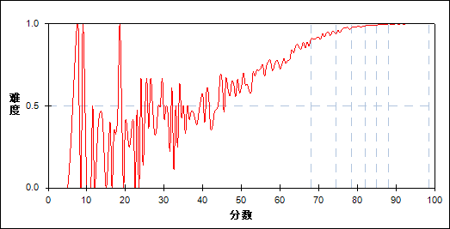

图 87 第11题分组难度曲线图

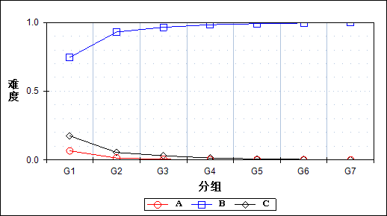

表 176 第11题分组分析表

| 选项 | G1 | G2 | G3 | G4 | G5 | G6 | G7 | 人数 | 比率(%) | 相关系数 |
| --- | --- | --- | --- | --- | --- | --- | --- | --- | --- | --- |
| Ａ | 542 | 117 | 39 | 19 | 12 | 4 | 2 | 735 | 1.28 | -0.21 |
| *Ｂ | 6104 | 7612 | 7895 | 8045 | 8107 | 8145 | 8175 | 54083 | 94.41 | 0.40 |
| Ｃ | 1432 | 449 | 249 | 119 | 64 | 33 | 6 | 2352 | 4.11 | -0.31 |
| 未选或多选 | 106 | 6 | 1 | 1 | 0 | 1 | 0 | 115 | 0.20 | -0.15 |
| 合计 | 8184 | 8184 | 8184 | 8184 | 8183 | 8183 | 8183 | 57285 | 100.00 | - |
| 得分率 | 0.75 | 0.93 | 0.96 | 0.98 | 0.99 | 1.00 | 1.00 | - | - | - |

表 177 第11题等级分析表

| 分值 | 优秀 | | 良好 | | 合格 | | 不合格 | | 全体 | |
| --- | --- | --- | --- | --- | --- | --- | --- | --- | --- | --- |
| 人数 | 比率 | 人数 | 比率 | 人数 | 比率 | 人数 | 比率 | 人数 | 比率 |
| Ａ | 7 | 1.0 | 153 | 20.8 | 229 | 31.2 | 346 | 47.1 | 735 | 100.0 |
| *Ｂ | 16550 | 30.6 | 29876 | 55.2 | 5417 | 10.0 | 2240 | 4.1 | 54083 | 100.0 |
| Ｃ | 40 | 1.7 | 764 | 32.5 | 638 | 27.1 | 910 | 38.7 | 2352 | 100.0 |
| 未选或多选 | 1 | 0.9 | 4 | 3.5 | 20 | 17.4 | 90 | 78.3 | 115 | 100.0 |
| 合计 | 16598 | 29.0 | 30797 | 53.8 | 6304 | 11.0 | 3586 | 6.3 | 57285 | 100.0 |

* + 1. 第12题

表 178 第12题分析表

|  |  |  |  |  |  |  |  |  |
| --- | --- | --- | --- | --- | --- | --- | --- | --- |
| 人数 | 满分 | 最大值 | 最小值 | 平均值 | 标准差 | 差异系数 | 难度 | 区分度 |
| 57285 | 1 | 1.0 | 0.0 | 0.97 | 0.18 | 0.18 | 0.97 | 0.33 |

表 179 第12题等级得分率分析表

|  |  |  |  |  |
| --- | --- | --- | --- | --- |
| 优秀 | 良好 | 合格 | 不及格 | 全体 |
| 1.00 | 0.98 | 0.94 | 0.76 | 0.97 |

图 88 第12题难度曲线图

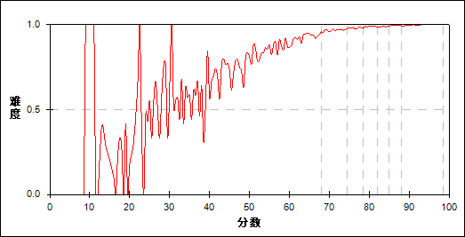

图 89 第12题分组难度曲线图

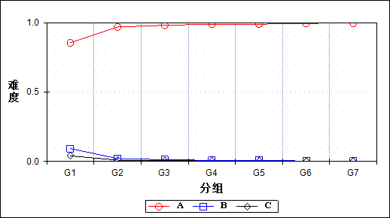

表 180 第12题分组分析表

| 选项 | G1 | G2 | G3 | G4 | G5 | G6 | G7 | 人数 | 比率(%) | 相关系数 |
| --- | --- | --- | --- | --- | --- | --- | --- | --- | --- | --- |
| *Ａ | 6991 | 7926 | 8025 | 8093 | 8087 | 8137 | 8147 | 55406 | 96.72 | 0.33 |
| Ｂ | 761 | 171 | 101 | 62 | 60 | 28 | 20 | 1203 | 2.10 | -0.25 |
| Ｃ | 330 | 81 | 57 | 29 | 36 | 18 | 15 | 566 | 0.99 | -0.16 |
| 未选或多选 | 102 | 6 | 1 | 0 | 0 | 0 | 1 | 110 | 0.19 | -0.15 |
| 合计 | 8184 | 8184 | 8184 | 8184 | 8183 | 8183 | 8183 | 57285 | 100.00 | - |
| 得分率 | 0.85 | 0.97 | 0.98 | 0.99 | 0.99 | 0.99 | 1.00 | - | - | - |

表 181 第12题等级分析表

| 分值 | 优秀 | | 良好 | | 合格 | | 不合格 | | 全体 | |
| --- | --- | --- | --- | --- | --- | --- | --- | --- | --- | --- |
| 人数 | 比率 | 人数 | 比率 | 人数 | 比率 | 人数 | 比率 | 人数 | 比率 |
| *Ａ | 16516 | 29.8 | 30252 | 54.6 | 5912 | 10.7 | 2726 | 4.9 | 55406 | 100.0 |
| Ｂ | 48 | 4.0 | 359 | 29.8 | 250 | 20.8 | 546 | 45.4 | 1203 | 100.0 |
| Ｃ | 33 | 5.8 | 183 | 32.3 | 122 | 21.6 | 228 | 40.3 | 566 | 100.0 |
| 未选或多选 | 1 | 0.9 | 3 | 2.7 | 20 | 18.2 | 86 | 78.2 | 110 | 100.0 |
| 合计 | 16598 | 29.0 | 30797 | 53.8 | 6304 | 11.0 | 3586 | 6.3 | 57285 | 100.0 |

* + 1. 第13题

表 182 第13题分析表

|  |  |  |  |  |  |  |  |  |
| --- | --- | --- | --- | --- | --- | --- | --- | --- |
| 人数 | 满分 | 最大值 | 最小值 | 平均值 | 标准差 | 差异系数 | 难度 | 区分度 |
| 57285 | 1 | 1.0 | 0.0 | 0.98 | 0.16 | 0.16 | 0.98 | 0.35 |

表 183 第13题等级得分率分析表

|  |  |  |  |  |
| --- | --- | --- | --- | --- |
| 优秀 | 良好 | 合格 | 不及格 | 全体 |
| 1.00 | 0.99 | 0.95 | 0.78 | 0.98 |

图 90 第13题难度曲线图

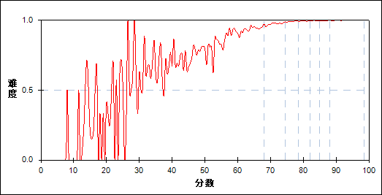

图 91 第13题分组难度曲线图

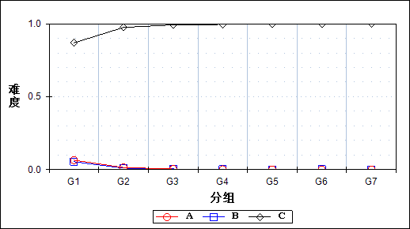

表 184 第13题分组分析表

| 选项 | G1 | G2 | G3 | G4 | G5 | G6 | G7 | 人数 | 比率(%) | 相关系数 |
| --- | --- | --- | --- | --- | --- | --- | --- | --- | --- | --- |
| Ａ | 527 | 117 | 32 | 14 | 9 | 4 | 2 | 705 | 1.23 | -0.23 |
| Ｂ | 443 | 83 | 34 | 24 | 8 | 11 | 4 | 607 | 1.06 | -0.22 |
| *Ｃ | 7111 | 7978 | 8118 | 8146 | 8166 | 8168 | 8176 | 55863 | 97.52 | 0.35 |
| 未选或多选 | 103 | 6 | 0 | 0 | 0 | 0 | 1 | 110 | 0.19 | -0.15 |
| 合计 | 8184 | 8184 | 8184 | 8184 | 8183 | 8183 | 8183 | 57285 | 100.00 | - |
| 得分率 | 0.87 | 0.97 | 0.99 | 1.00 | 1.00 | 1.00 | 1.00 | - | - | - |

表 185 第13题等级分析表

| 分值 | 优秀 | | 良好 | | 合格 | | 不合格 | | 全体 | |
| --- | --- | --- | --- | --- | --- | --- | --- | --- | --- | --- |
| 人数 | 比率 | 人数 | 比率 | 人数 | 比率 | 人数 | 比率 | 人数 | 比率 |
| Ａ | 7 | 1.0 | 140 | 19.9 | 178 | 25.2 | 380 | 53.9 | 705 | 100.0 |
| Ｂ | 15 | 2.5 | 122 | 20.1 | 135 | 22.2 | 335 | 55.2 | 607 | 100.0 |
| *Ｃ | 16575 | 29.7 | 30533 | 54.7 | 5970 | 10.7 | 2785 | 5.0 | 55863 | 100.0 |
| 未选或多选 | 1 | 0.9 | 2 | 1.8 | 21 | 19.1 | 86 | 78.2 | 110 | 100.0 |
| 合计 | 16598 | 29.0 | 30797 | 53.8 | 6304 | 11.0 | 3586 | 6.3 | 57285 | 100.0 |

* + 1. 第14题

表 186 第14题分析表

|  |  |  |  |  |  |  |  |  |
| --- | --- | --- | --- | --- | --- | --- | --- | --- |
| 人数 | 满分 | 最大值 | 最小值 | 平均值 | 标准差 | 差异系数 | 难度 | 区分度 |
| 57285 | 1 | 1.0 | 0.0 | 0.74 | 0.44 | 0.60 | 0.74 | 0.41 |

表 187 第14题等级得分率分析表

|  |  |  |  |  |
| --- | --- | --- | --- | --- |
| 优秀 | 良好 | 合格 | 不及格 | 全体 |
| 0.97 | 0.71 | 0.47 | 0.41 | 0.74 |

图 92 第14题难度曲线图

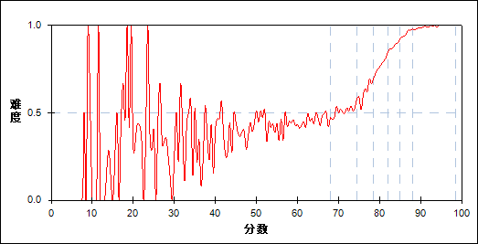

图 93 第14题分组难度曲线图

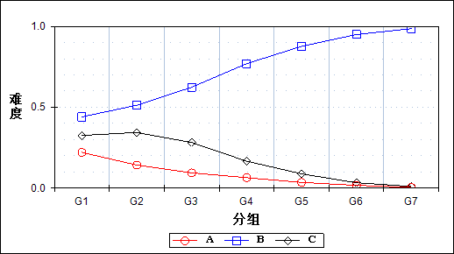

表 188 第14题分组分析表

| 选项 | G1 | G2 | G3 | G4 | G5 | G6 | G7 | 人数 | 比率(%) | 相关系数 |
| --- | --- | --- | --- | --- | --- | --- | --- | --- | --- | --- |
| Ａ | 1809 | 1165 | 768 | 527 | 287 | 140 | 35 | 4731 | 8.26 | -0.26 |
| *Ｂ | 3601 | 4192 | 5103 | 6294 | 7172 | 7770 | 8066 | 42198 | 73.66 | 0.41 |
| Ｃ | 2663 | 2813 | 2307 | 1361 | 723 | 272 | 82 | 10221 | 17.84 | -0.27 |
| 未选或多选 | 111 | 14 | 6 | 2 | 1 | 1 | 0 | 135 | 0.24 | -0.15 |
| 合计 | 8184 | 8184 | 8184 | 8184 | 8183 | 8183 | 8183 | 57285 | 100.00 | - |
| 得分率 | 0.44 | 0.51 | 0.62 | 0.77 | 0.88 | 0.95 | 0.99 | - | - | - |

表 189 第14题等级分析表

| 分值 | 优秀 | | 良好 | | 合格 | | 不合格 | | 全体 | |
| --- | --- | --- | --- | --- | --- | --- | --- | --- | --- | --- |
| 人数 | 比率 | 人数 | 比率 | 人数 | 比率 | 人数 | 比率 | 人数 | 比率 |
| Ａ | 181 | 3.8 | 2469 | 52.2 | 1152 | 24.4 | 929 | 19.6 | 4731 | 100.0 |
| *Ｂ | 16046 | 38.0 | 21724 | 51.5 | 2950 | 7.0 | 1478 | 3.5 | 42198 | 100.0 |
| Ｃ | 370 | 3.6 | 6587 | 64.4 | 2177 | 21.3 | 1087 | 10.6 | 10221 | 100.0 |
| 未选或多选 | 1 | 0.7 | 17 | 12.6 | 25 | 18.5 | 92 | 68.1 | 135 | 100.0 |
| 合计 | 16598 | 29.0 | 30797 | 53.8 | 6304 | 11.0 | 3586 | 6.3 | 57285 | 100.0 |

* + 1. 第15题

表 190 第15题分析表

|  |  |  |  |  |  |  |  |  |
| --- | --- | --- | --- | --- | --- | --- | --- | --- |
| 人数 | 满分 | 最大值 | 最小值 | 平均值 | 标准差 | 差异系数 | 难度 | 区分度 |
| 57285 | 1 | 1.0 | 0.0 | 0.92 | 0.27 | 0.29 | 0.92 | 0.46 |

表 191 第15题等级得分率分析表

|  |  |  |  |  |
| --- | --- | --- | --- | --- |
| 优秀 | 良好 | 合格 | 不及格 | 全体 |
| 1.00 | 0.96 | 0.77 | 0.52 | 0.92 |

图 94 第15题难度曲线图

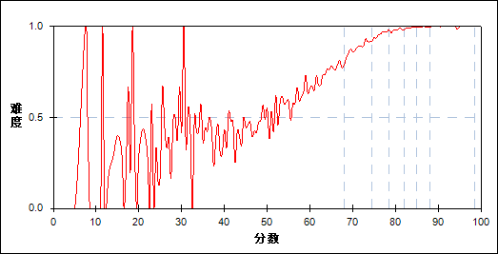

图 95 第15题分组难度曲线图

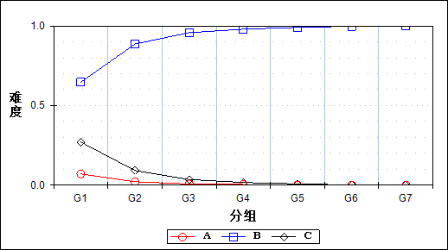

表 192 第15题分组分析表

| 选项 | G1 | G2 | G3 | G4 | G5 | G6 | G7 | 人数 | 比率(%) | 相关系数 |
| --- | --- | --- | --- | --- | --- | --- | --- | --- | --- | --- |
| Ａ | 578 | 175 | 61 | 33 | 10 | 10 | 1 | 868 | 1.52 | -0.21 |
| *Ｂ | 5292 | 7252 | 7835 | 8016 | 8105 | 8161 | 8176 | 52837 | 92.24 | 0.46 |
| Ｃ | 2212 | 750 | 287 | 135 | 67 | 10 | 6 | 3467 | 6.05 | -0.38 |
| 未选或多选 | 102 | 7 | 1 | 0 | 1 | 2 | 0 | 113 | 0.20 | -0.15 |
| 合计 | 8184 | 8184 | 8184 | 8184 | 8183 | 8183 | 8183 | 57285 | 100.00 | - |
| 得分率 | 0.65 | 0.89 | 0.96 | 0.98 | 0.99 | 1.00 | 1.00 | - | - | - |

表 193 第15题等级分析表

| 分值 | 优秀 | | 良好 | | 合格 | | 不合格 | | 全体 | |
| --- | --- | --- | --- | --- | --- | --- | --- | --- | --- | --- |
| 人数 | 比率 | 人数 | 比率 | 人数 | 比率 | 人数 | 比率 | 人数 | 比率 |
| Ａ | 11 | 1.3 | 218 | 25.1 | 275 | 31.7 | 364 | 41.9 | 868 | 100.0 |
| *Ｂ | 16566 | 31.4 | 29536 | 55.9 | 4882 | 9.2 | 1853 | 3.5 | 52837 | 100.0 |
| Ｃ | 19 | 0.5 | 1038 | 29.9 | 1127 | 32.5 | 1283 | 37.0 | 3467 | 100.0 |
| 未选或多选 | 2 | 1.8 | 5 | 4.4 | 20 | 17.7 | 86 | 76.1 | 113 | 100.0 |
| 合计 | 16598 | 29.0 | 30797 | 53.8 | 6304 | 11.0 | 3586 | 6.3 | 57285 | 100.0 |

* + 1. 第16题

表 194 第16题分析表

|  |  |  |  |  |  |  |  |  |
| --- | --- | --- | --- | --- | --- | --- | --- | --- |
| 人数 | 满分 | 最大值 | 最小值 | 平均值 | 标准差 | 差异系数 | 难度 | 区分度 |
| 57285 | 1 | 1.0 | 0.0 | 0.90 | 0.30 | 0.33 | 0.90 | 0.32 |

表 195 第16题等级得分率分析表

|  |  |  |  |  |
| --- | --- | --- | --- | --- |
| 优秀 | 良好 | 合格 | 不及格 | 全体 |
| 0.98 | 0.91 | 0.78 | 0.65 | 0.90 |

图 96 第16题难度曲线图

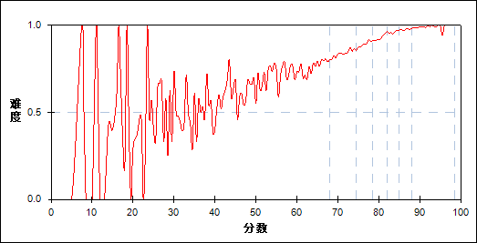

图 97 第16题分组难度曲线图

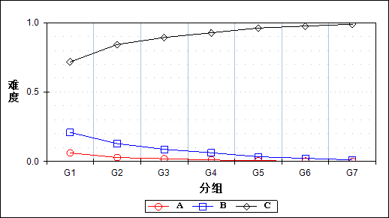

表 196 第16题分组分析表

| 选项 | G1 | G2 | G3 | G4 | G5 | G6 | G7 | 人数 | 比率(%) | 相关系数 |
| --- | --- | --- | --- | --- | --- | --- | --- | --- | --- | --- |
| Ａ | 503 | 233 | 160 | 87 | 43 | 21 | 8 | 1055 | 1.84 | -0.16 |
| Ｂ | 1711 | 1052 | 713 | 513 | 275 | 186 | 87 | 4537 | 7.92 | -0.24 |
| *Ｃ | 5865 | 6891 | 7307 | 7582 | 7862 | 7976 | 8086 | 51569 | 90.02 | 0.32 |
| 未选或多选 | 105 | 8 | 4 | 2 | 3 | 0 | 2 | 124 | 0.22 | -0.15 |
| 合计 | 8184 | 8184 | 8184 | 8184 | 8183 | 8183 | 8183 | 57285 | 100.00 | - |
| 得分率 | 0.72 | 0.84 | 0.89 | 0.93 | 0.96 | 0.97 | 0.99 | - | - | - |

表 197 第16题等级分析表

| 分值 | 优秀 | | 良好 | | 合格 | | 不合格 | | 全体 | |
| --- | --- | --- | --- | --- | --- | --- | --- | --- | --- | --- |
| 人数 | 比率 | 人数 | 比率 | 人数 | 比率 | 人数 | 比率 | 人数 | 比率 |
| Ａ | 29 | 2.7 | 464 | 44.0 | 276 | 26.2 | 286 | 27.1 | 1055 | 100.0 |
| Ｂ | 278 | 6.1 | 2293 | 50.5 | 1081 | 23.8 | 885 | 19.5 | 4537 | 100.0 |
| *Ｃ | 16289 | 31.6 | 28027 | 54.3 | 4926 | 9.6 | 2327 | 4.5 | 51569 | 100.0 |
| 未选或多选 | 2 | 1.6 | 13 | 10.5 | 21 | 16.9 | 88 | 71.0 | 124 | 100.0 |
| 合计 | 16598 | 29.0 | 30797 | 53.8 | 6304 | 11.0 | 3586 | 6.3 | 57285 | 100.0 |

* + 1. 第17题

表 198 第17题分析表

|  |  |  |  |  |  |  |  |  |
| --- | --- | --- | --- | --- | --- | --- | --- | --- |
| 人数 | 满分 | 最大值 | 最小值 | 平均值 | 标准差 | 差异系数 | 难度 | 区分度 |
| 57285 | 1 | 1.0 | 0.0 | 0.96 | 0.20 | 0.20 | 0.96 | 0.40 |

表 199 第17题等级得分率分析表

|  |  |  |  |  |
| --- | --- | --- | --- | --- |
| 优秀 | 良好 | 合格 | 不及格 | 全体 |
| 0.99 | 0.98 | 0.94 | 0.65 | 0.96 |

图 98 第17题难度曲线图

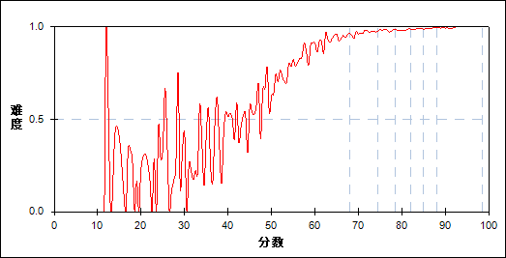

图 99 第17题分组难度曲线图

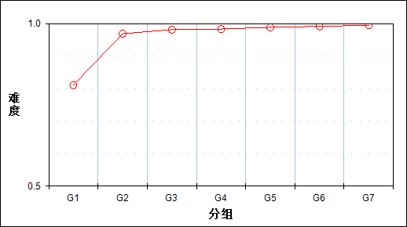

表 200 第17题分组分析表

| 分值 | G1 | G2 | G3 | G4 | G5 | G6 | G7 | 人数 | 比率(%) | 平均值 |
| --- | --- | --- | --- | --- | --- | --- | --- | --- | --- | --- |
| 0.0～ | 1548 | 257 | 153 | 139 | 95 | 71 | 43 | 2306 | 4.03 | 56.34 |
| 1.0～ | 6636 | 7927 | 8031 | 8045 | 8088 | 8112 | 8140 | 54979 | 95.97 | 78.79 |
| 合计 | 8184 | 8184 | 8184 | 8184 | 8183 | 8183 | 8183 | 57285 | 100.00 | - |
| 得分率 | 0.81 | 0.97 | 0.98 | 0.98 | 0.99 | 0.99 | 0.99 | - | - | - |

表 201 第17题等级分析表

| 分值 | 优秀 | | 良好 | | 合格 | | 不合格 | | 全体 | |
| --- | --- | --- | --- | --- | --- | --- | --- | --- | --- | --- |
| 人数 | 比率 | 人数 | 比率 | 人数 | 比率 | 人数 | 比率 | 人数 | 比率 |
| 0.0～ | 117 | 5.1 | 567 | 24.6 | 373 | 16.2 | 1249 | 54.2 | 2306 | 100.0 |
| 1.0～ | 16481 | 30.0 | 30230 | 55.0 | 5931 | 10.8 | 2337 | 4.3 | 54979 | 100.0 |
| 合计 | 16598 | 29.0 | 30797 | 53.8 | 6304 | 11.0 | 3586 | 6.3 | 57285 | 100.0 |

* + 1. 第18题

表 202 第18题分析表

|  |  |  |  |  |  |  |  |  |
| --- | --- | --- | --- | --- | --- | --- | --- | --- |
| 人数 | 满分 | 最大值 | 最小值 | 平均值 | 标准差 | 差异系数 | 难度 | 区分度 |
| 57285 | 1 | 1.0 | 0.0 | 0.86 | 0.35 | 0.40 | 0.86 | 0.34 |

表 203 第18题等级得分率分析表

|  |  |  |  |  |
| --- | --- | --- | --- | --- |
| 优秀 | 良好 | 合格 | 不及格 | 全体 |
| 0.95 | 0.88 | 0.74 | 0.50 | 0.86 |

图 100 第18题难度曲线图

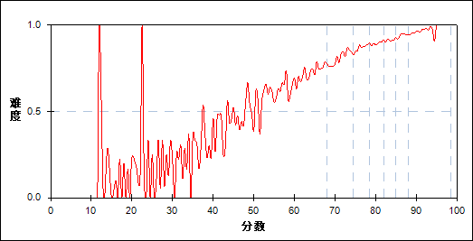

图 101 第18题分组难度曲线图

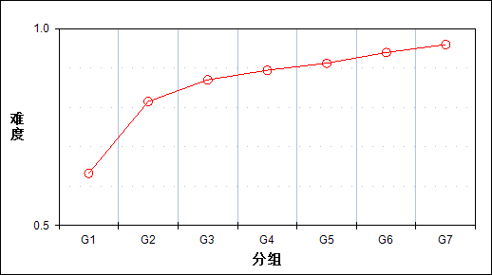

表 204 第18题分组分析表

| 分值 | G1 | G2 | G3 | G4 | G5 | G6 | G7 | 人数 | 比率(%) | 平均值 |
| --- | --- | --- | --- | --- | --- | --- | --- | --- | --- | --- |
| 0.0～ | 3006 | 1517 | 1066 | 867 | 721 | 499 | 333 | 8009 | 13.98 | 68.66 |
| 1.0～ | 5178 | 6667 | 7118 | 7317 | 7462 | 7684 | 7850 | 49276 | 86.02 | 79.39 |
| 合计 | 8184 | 8184 | 8184 | 8184 | 8183 | 8183 | 8183 | 57285 | 100.00 | - |
| 得分率 | 0.63 | 0.81 | 0.87 | 0.89 | 0.91 | 0.94 | 0.96 | - | - | - |

表 205 第18题等级分析表

| 分值 | 优秀 | | 良好 | | 合格 | | 不合格 | | 全体 | |
| --- | --- | --- | --- | --- | --- | --- | --- | --- | --- | --- |
| 人数 | 比率 | 人数 | 比率 | 人数 | 比率 | 人数 | 比率 | 人数 | 比率 |
| 0.0～ | 856 | 10.7 | 3733 | 46.6 | 1635 | 20.4 | 1785 | 22.3 | 8009 | 100.0 |
| 1.0～ | 15742 | 31.9 | 27064 | 54.9 | 4669 | 9.5 | 1801 | 3.7 | 49276 | 100.0 |
| 合计 | 16598 | 29.0 | 30797 | 53.8 | 6304 | 11.0 | 3586 | 6.3 | 57285 | 100.0 |

* + 1. 第19题

表 206 第19题分析表

|  |  |  |  |  |  |  |  |  |
| --- | --- | --- | --- | --- | --- | --- | --- | --- |
| 人数 | 满分 | 最大值 | 最小值 | 平均值 | 标准差 | 差异系数 | 难度 | 区分度 |
| 57285 | 1 | 1.0 | 0.0 | 0.88 | 0.32 | 0.36 | 0.88 | 0.40 |

表 207 第19题等级得分率分析表

|  |  |  |  |  |
| --- | --- | --- | --- | --- |
| 优秀 | 良好 | 合格 | 不及格 | 全体 |
| 0.97 | 0.91 | 0.74 | 0.48 | 0.88 |

图 102 第19题难度曲线图

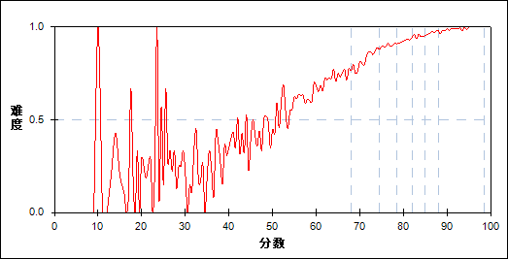

图 103 第19题分组难度曲线图

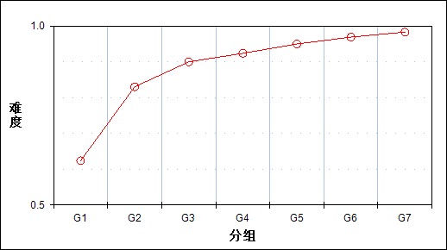

表 208 第19题分组分析表

| 分值 | G1 | G2 | G3 | G4 | G5 | G6 | G7 | 人数 | 比率(%) | 平均值 |
| --- | --- | --- | --- | --- | --- | --- | --- | --- | --- | --- |
| 0.0～ | 3080 | 1390 | 821 | 626 | 413 | 256 | 141 | 6727 | 11.74 | 65.89 |
| 1.0～ | 5104 | 6794 | 7363 | 7558 | 7770 | 7927 | 8042 | 50558 | 88.26 | 79.48 |
| 合计 | 8184 | 8184 | 8184 | 8184 | 8183 | 8183 | 8183 | 57285 | 100.00 | - |
| 得分率 | 0.62 | 0.83 | 0.90 | 0.92 | 0.95 | 0.97 | 0.98 | - | - | - |

表 209 第19题等级分析表

| 分值 | 优秀 | | 良好 | | 合格 | | 不合格 | | 全体 | |
| --- | --- | --- | --- | --- | --- | --- | --- | --- | --- | --- |
| 人数 | 比率 | 人数 | 比率 | 人数 | 比率 | 人数 | 比率 | 人数 | 比率 |
| 0.0～ | 420 | 6.2 | 2827 | 42.0 | 1632 | 24.3 | 1848 | 27.5 | 6727 | 100.0 |
| 1.0～ | 16178 | 32.0 | 27970 | 55.3 | 4672 | 9.2 | 1738 | 3.4 | 50558 | 100.0 |
| 合计 | 16598 | 29.0 | 30797 | 53.8 | 6304 | 11.0 | 3586 | 6.3 | 57285 | 100.0 |

* + 1. 第20题

表 210 第20题分析表

|  |  |  |  |  |  |  |  |  |
| --- | --- | --- | --- | --- | --- | --- | --- | --- |
| 人数 | 满分 | 最大值 | 最小值 | 平均值 | 标准差 | 差异系数 | 难度 | 区分度 |
| 57285 | 1 | 1.0 | 0.0 | 0.93 | 0.26 | 0.28 | 0.93 | 0.33 |

表 211 第20题等级得分率分析表

|  |  |  |  |  |
| --- | --- | --- | --- | --- |
| 优秀 | 良好 | 合格 | 不及格 | 全体 |
| 0.99 | 0.94 | 0.87 | 0.66 | 0.93 |

图 104 第20题难度曲线图

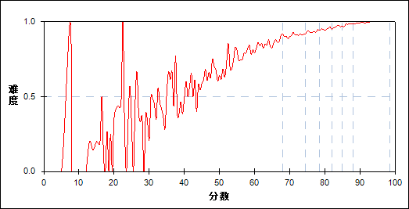

图 105 第20题分组难度曲线图

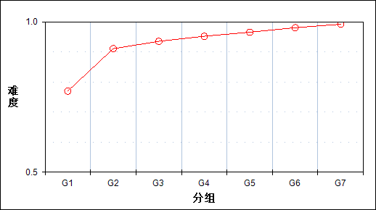

表 212 第20题分组分析表

| 分值 | G1 | G2 | G3 | G4 | G5 | G6 | G7 | 人数 | 比率(%) | 平均值 |
| --- | --- | --- | --- | --- | --- | --- | --- | --- | --- | --- |
| 0.0～ | 1883 | 731 | 533 | 395 | 284 | 161 | 67 | 4054 | 7.08 | 64.82 |
| 1.0～ | 6301 | 7453 | 7651 | 7789 | 7899 | 8022 | 8116 | 53231 | 92.92 | 78.88 |
| 合计 | 8184 | 8184 | 8184 | 8184 | 8183 | 8183 | 8183 | 57285 | 100.00 | - |
| 得分率 | 0.77 | 0.91 | 0.93 | 0.95 | 0.97 | 0.98 | 0.99 | - | - | - |

表 213 第20题等级分析表

| 分值 | 优秀 | | 良好 | | 合格 | | 不合格 | | 全体 | |
| --- | --- | --- | --- | --- | --- | --- | --- | --- | --- | --- |
| 人数 | 比率 | 人数 | 比率 | 人数 | 比率 | 人数 | 比率 | 人数 | 比率 |
| 0.0～ | 241 | 5.9 | 1764 | 43.5 | 817 | 20.2 | 1232 | 30.4 | 4054 | 100.0 |
| 1.0～ | 16357 | 30.7 | 29033 | 54.5 | 5487 | 10.3 | 2354 | 4.4 | 53231 | 100.0 |
| 合计 | 16598 | 29.0 | 30797 | 53.8 | 6304 | 11.0 | 3586 | 6.3 | 57285 | 100.0 |

* + 1. 第21题

表 214 第21题分析表

|  |  |  |  |  |  |  |  |  |
| --- | --- | --- | --- | --- | --- | --- | --- | --- |
| 人数 | 满分 | 最大值 | 最小值 | 平均值 | 标准差 | 差异系数 | 难度 | 区分度 |
| 57285 | 1 | 1.0 | 0.0 | 0.85 | 0.36 | 0.43 | 0.85 | 0.35 |

表 215 第21题等级得分率分析表

|  |  |  |  |  |
| --- | --- | --- | --- | --- |
| 优秀 | 良好 | 合格 | 不及格 | 全体 |
| 0.96 | 0.85 | 0.73 | 0.48 | 0.85 |

图 106 第21题难度曲线图



图 107 第21题分组难度曲线图

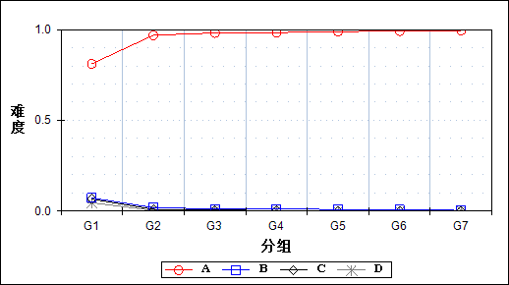

表 216 第21题分组分析表

| 选项 | G1 | G2 | G3 | G4 | G5 | G6 | G7 | 人数 | 比率(%) | 相关系数 |
| --- | --- | --- | --- | --- | --- | --- | --- | --- | --- | --- |
| *Ａ | 6636 | 7927 | 8031 | 8045 | 8088 | 8112 | 8140 | 54979 | 95.97 | 0.40 |
| Ｂ | 593 | 151 | 99 | 99 | 72 | 55 | 30 | 1099 | 1.92 | -0.21 |
| Ｃ | 544 | 80 | 38 | 32 | 20 | 15 | 12 | 741 | 1.29 | -0.24 |
| Ｄ | 380 | 26 | 15 | 8 | 3 | 1 | 1 | 434 | 0.76 | -0.22 |
| 未选或多选 | 31 | 0 | 1 | 0 | 0 | 0 | 0 | 32 | 0.06 | -0.15 |
| 合计 | 8184 | 8184 | 8184 | 8184 | 8183 | 8183 | 8183 | 57285 | 100.00 | - |
| 得分率 | 0.62 | 0.78 | 0.83 | 0.87 | 0.91 | 0.94 | 0.97 | - | - | - |

表 217 第21题等级分析表

| 分值 | 优秀 | | 良好 | | 合格 | | 不合格 | | 全体 | |
| --- | --- | --- | --- | --- | --- | --- | --- | --- | --- | --- |
| 人数 | 比率 | 人数 | 比率 | 人数 | 比率 | 人数 | 比率 | 人数 | 比率 |
| *Ａ | 16481 | 30.0 | 30230 | 55.0 | 5931 | 10.8 | 2337 | 4.3 | 54979 | 100.0 |
| Ｂ | 88 | 8.0 | 378 | 34.4 | 190 | 17.3 | 443 | 40.3 | 1099 | 100.0 |
| Ｃ | 27 | 3.6 | 145 | 19.6 | 115 | 15.5 | 454 | 61.3 | 741 | 100.0 |
| Ｄ | 2 | 0.5 | 43 | 9.9 | 67 | 15.4 | 322 | 74.2 | 434 | 100.0 |
| 未选或多选 | 0 | 0.0 | 1 | 3.1 | 1 | 3.1 | 30 | 93.8 | 32 | 100.0 |
| 合计 | 16598 | 29.0 | 30797 | 53.8 | 6304 | 11.0 | 3586 | 6.3 | 57285 | 100.0 |

* + 1. 第22题

表 218 第22题分析表

|  |  |  |  |  |  |  |  |  |
| --- | --- | --- | --- | --- | --- | --- | --- | --- |
| 人数 | 满分 | 最大值 | 最小值 | 平均值 | 标准差 | 差异系数 | 难度 | 区分度 |
| 57285 | 1 | 1.0 | 0.0 | 0.92 | 0.28 | 0.30 | 0.92 | 0.41 |

表 219 第22题等级得分率分析表

|  |  |  |  |  |
| --- | --- | --- | --- | --- |
| 优秀 | 良好 | 合格 | 不及格 | 全体 |
| 0.99 | 0.94 | 0.83 | 0.54 | 0.92 |

图 108 第22题难度曲线图

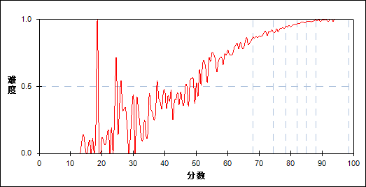

图 109 第22题分组难度曲线图

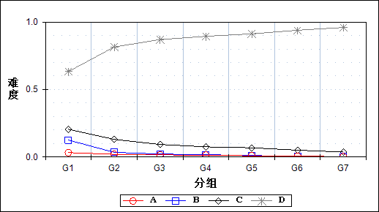

表 220 第22题分组分析表

| 选项 | G1 | G2 | G3 | G4 | G5 | G6 | G7 | 人数 | 比率(%) | 相关系数 |
| --- | --- | --- | --- | --- | --- | --- | --- | --- | --- | --- |
| Ａ | 269 | 163 | 130 | 111 | 72 | 51 | 20 | 816 | 1.42 | -0.10 |
| Ｂ | 1027 | 282 | 179 | 140 | 91 | 37 | 14 | 1770 | 3.09 | -0.27 |
| Ｃ | 1679 | 1068 | 757 | 616 | 558 | 411 | 299 | 5388 | 9.41 | -0.19 |
| *Ｄ | 5178 | 6667 | 7118 | 7317 | 7462 | 7684 | 7850 | 49276 | 86.02 | 0.34 |
| 未选或多选 | 31 | 4 | 0 | 0 | 0 | 0 | 0 | 35 | 0.06 | -0.14 |
| 合计 | 8184 | 8184 | 8184 | 8184 | 8183 | 8183 | 8183 | 57285 | 100.00 | - |
| 得分率 | 0.69 | 0.89 | 0.92 | 0.95 | 0.97 | 0.99 | 0.99 | - | - | - |

表 221 第22题等级分析表

| 分值 | 优秀 | | 良好 | | 合格 | | 不合格 | | 全体 | |
| --- | --- | --- | --- | --- | --- | --- | --- | --- | --- | --- |
| 人数 | 比率 | 人数 | 比率 | 人数 | 比率 | 人数 | 比率 | 人数 | 比率 |
| Ａ | 74 | 9.1 | 437 | 53.6 | 140 | 17.2 | 165 | 20.2 | 816 | 100.0 |
| Ｂ | 55 | 3.1 | 620 | 35.0 | 370 | 20.9 | 725 | 41.0 | 1770 | 100.0 |
| Ｃ | 727 | 13.5 | 2672 | 49.6 | 1125 | 20.9 | 864 | 16.0 | 5388 | 100.0 |
| *Ｄ | 15742 | 31.9 | 27064 | 54.9 | 4669 | 9.5 | 1801 | 3.7 | 49276 | 100.0 |
| 未选或多选 | 0 | 0.0 | 4 | 11.4 | 0 | 0.0 | 31 | 88.6 | 35 | 100.0 |
| 合计 | 16598 | 29.0 | 30797 | 53.8 | 6304 | 11.0 | 3586 | 6.3 | 57285 | 100.0 |

* + 1. 第23题

表 222 第23题分析表

|  |  |  |  |  |  |  |  |  |
| --- | --- | --- | --- | --- | --- | --- | --- | --- |
| 人数 | 满分 | 最大值 | 最小值 | 平均值 | 标准差 | 差异系数 | 难度 | 区分度 |
| 57285 | 1 | 1.0 | 0.0 | 0.93 | 0.25 | 0.27 | 0.93 | 0.47 |

表 223 第23题等级得分率分析表

|  |  |  |  |  |
| --- | --- | --- | --- | --- |
| 优秀 | 良好 | 合格 | 不及格 | 全体 |
| 1.00 | 0.97 | 0.84 | 0.51 | 0.93 |

图 110 第23题难度曲线图

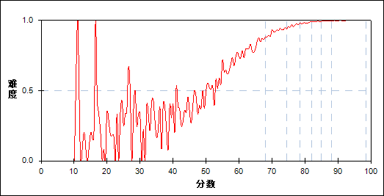

图 111 第23题分组难度曲线图

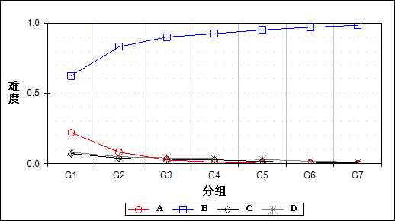

表 224 第23题分组分析表

| 选项 | G1 | G2 | G3 | G4 | G5 | G6 | G7 | 人数 | 比率(%) | 相关系数 |
| --- | --- | --- | --- | --- | --- | --- | --- | --- | --- | --- |
| Ａ | 1804 | 666 | 221 | 94 | 28 | 22 | 5 | 2840 | 4.96 | -0.35 |
| *Ｂ | 5104 | 6794 | 7363 | 7558 | 7770 | 7927 | 8042 | 50558 | 88.26 | 0.40 |
| Ｃ | 581 | 316 | 260 | 233 | 136 | 85 | 36 | 1647 | 2.88 | -0.15 |
| Ｄ | 663 | 402 | 339 | 299 | 249 | 149 | 100 | 2201 | 3.84 | -0.12 |
| 未选或多选 | 32 | 6 | 1 | 0 | 0 | 0 | 0 | 39 | 0.07 | -0.14 |
| 合计 | 8184 | 8184 | 8184 | 8184 | 8183 | 8183 | 8183 | 57285 | 100.00 | - |
| 得分率 | 0.68 | 0.92 | 0.96 | 0.98 | 0.99 | 1.00 | 1.00 | - | - | - |

表 225 第23题等级分析表

| 分值 | 优秀 | | 良好 | | 合格 | | 不合格 | | 全体 | |
| --- | --- | --- | --- | --- | --- | --- | --- | --- | --- | --- |
| 人数 | 比率 | 人数 | 比率 | 人数 | 比率 | 人数 | 比率 | 人数 | 比率 |
| Ａ | 27 | 1.0 | 774 | 27.3 | 963 | 33.9 | 1076 | 37.9 | 2840 | 100.0 |
| *Ｂ | 16178 | 32.0 | 27970 | 55.3 | 4672 | 9.2 | 1738 | 3.4 | 50558 | 100.0 |
| Ｃ | 130 | 7.9 | 860 | 52.2 | 279 | 16.9 | 378 | 23.0 | 1647 | 100.0 |
| Ｄ | 263 | 11.9 | 1188 | 54.0 | 386 | 17.5 | 364 | 16.5 | 2201 | 100.0 |
| 未选或多选 | 0 | 0.0 | 5 | 12.8 | 4 | 10.3 | 30 | 76.9 | 39 | 100.0 |
| 合计 | 16598 | 29.0 | 30797 | 53.8 | 6304 | 11.0 | 3586 | 6.3 | 57285 | 100.0 |

* + 1. 第24题

表 226 第24题分析表

|  |  |  |  |  |  |  |  |  |
| --- | --- | --- | --- | --- | --- | --- | --- | --- |
| 人数 | 满分 | 最大值 | 最小值 | 平均值 | 标准差 | 差异系数 | 难度 | 区分度 |
| 57285 | 1 | 1.0 | 0.0 | 0.89 | 0.31 | 0.34 | 0.89 | 0.37 |

表 227 第24题等级得分率分析表

|  |  |  |  |  |
| --- | --- | --- | --- | --- |
| 优秀 | 良好 | 合格 | 不及格 | 全体 |
| 0.97 | 0.92 | 0.78 | 0.52 | 0.89 |

图 112 第24题难度曲线图

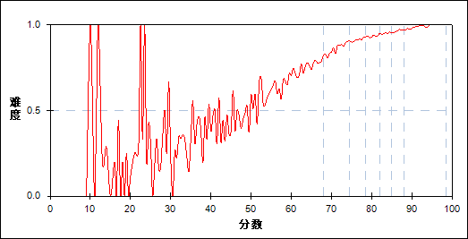

图 113 第24题分组难度曲线图

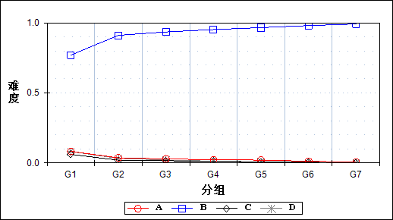

表 228 第24题分组分析表

| 选项 | G1 | G2 | G3 | G4 | G5 | G6 | G7 | 人数 | 比率(%) | 相关系数 |
| --- | --- | --- | --- | --- | --- | --- | --- | --- | --- | --- |
| Ａ | 676 | 299 | 235 | 181 | 166 | 98 | 41 | 1696 | 2.96 | -0.17 |
| *Ｂ | 6301 | 7453 | 7651 | 7789 | 7899 | 8022 | 8116 | 53231 | 92.92 | 0.33 |
| Ｃ | 502 | 160 | 127 | 107 | 60 | 41 | 16 | 1013 | 1.77 | -0.18 |
| Ｄ | 667 | 268 | 170 | 105 | 58 | 22 | 10 | 1300 | 2.27 | -0.19 |
| 未选或多选 | 38 | 4 | 1 | 2 | 0 | 0 | 0 | 45 | 0.08 | -0.14 |
| 合计 | 8184 | 8184 | 8184 | 8184 | 8183 | 8183 | 8183 | 57285 | 100.00 | - |
| 得分率 | 0.65 | 0.86 | 0.91 | 0.93 | 0.95 | 0.96 | 0.98 | - | - | - |

表 229 第24题等级分析表

| 分值 | 优秀 | | 良好 | | 合格 | | 不合格 | | 全体 | |
| --- | --- | --- | --- | --- | --- | --- | --- | --- | --- | --- |
| 人数 | 比率 | 人数 | 比率 | 人数 | 比率 | 人数 | 比率 | 人数 | 比率 |
| Ａ | 146 | 8.6 | 811 | 47.8 | 298 | 17.6 | 441 | 26.0 | 1696 | 100.0 |
| *Ｂ | 16357 | 30.7 | 29033 | 54.5 | 5487 | 10.3 | 2354 | 4.4 | 53231 | 100.0 |
| Ｃ | 59 | 5.8 | 419 | 41.4 | 187 | 18.5 | 348 | 34.4 | 1013 | 100.0 |
| Ｄ | 36 | 2.8 | 527 | 40.5 | 329 | 25.3 | 408 | 31.4 | 1300 | 100.0 |
| 未选或多选 | 0 | 0.0 | 7 | 15.6 | 3 | 6.7 | 35 | 77.8 | 45 | 100.0 |
| 合计 | 16598 | 29.0 | 30797 | 53.8 | 6304 | 11.0 | 3586 | 6.3 | 57285 | 100.0 |

* + 1. 第25题

表 230 第25题分析表

|  |  |  |  |  |  |  |  |  |
| --- | --- | --- | --- | --- | --- | --- | --- | --- |
| 人数 | 满分 | 最大值 | 最小值 | 平均值 | 标准差 | 差异系数 | 难度 | 区分度 |
| 57285 | 1 | 1.0 | 0.0 | 0.95 | 0.22 | 0.23 | 0.95 | 0.39 |

表 231 第25题等级得分率分析表

|  |  |  |  |  |
| --- | --- | --- | --- | --- |
| 优秀 | 良好 | 合格 | 不及格 | 全体 |
| 0.99 | 0.97 | 0.90 | 0.65 | 0.95 |

图 114 第25题难度曲线图

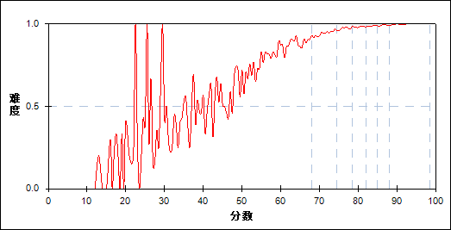

图 115 第25题分组难度曲线图

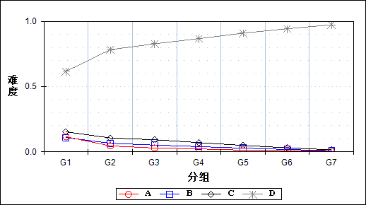

表 232 第25题分组分析表

| 选项 | G1 | G2 | G3 | G4 | G5 | G6 | G7 | 人数 | 比率(%) | 相关系数 |
| --- | --- | --- | --- | --- | --- | --- | --- | --- | --- | --- |
| Ａ | 943 | 374 | 237 | 183 | 107 | 75 | 31 | 1950 | 3.40 | -0.22 |
| Ｂ | 894 | 536 | 420 | 327 | 232 | 146 | 65 | 2620 | 4.57 | -0.17 |
| Ｃ | 1255 | 868 | 756 | 579 | 405 | 248 | 125 | 4236 | 7.39 | -0.18 |
| *Ｄ | 5044 | 6402 | 6770 | 7094 | 7439 | 7713 | 7962 | 48424 | 84.53 | 0.35 |
| 未选或多选 | 48 | 4 | 1 | 1 | 0 | 1 | 0 | 55 | 0.10 | -0.14 |
| 合计 | 8184 | 8184 | 8184 | 8184 | 8183 | 8183 | 8183 | 57285 | 100.00 | - |
| 得分率 | 0.78 | 0.94 | 0.97 | 0.98 | 0.99 | 0.99 | 1.00 | - | - | - |

表 233 第25题等级分析表

| 分值 | 优秀 | | 良好 | | 合格 | | 不合格 | | 全体 | |
| --- | --- | --- | --- | --- | --- | --- | --- | --- | --- | --- |
| 人数 | 比率 | 人数 | 比率 | 人数 | 比率 | 人数 | 比率 | 人数 | 比率 |
| Ａ | 109 | 5.6 | 810 | 41.5 | 446 | 22.9 | 585 | 30.0 | 1950 | 100.0 |
| Ｂ | 216 | 8.2 | 1393 | 53.2 | 490 | 18.7 | 521 | 19.9 | 2620 | 100.0 |
| Ｃ | 382 | 9.0 | 2399 | 56.6 | 744 | 17.6 | 711 | 16.8 | 4236 | 100.0 |
| *Ｄ | 15890 | 32.8 | 26190 | 54.1 | 4615 | 9.5 | 1729 | 3.6 | 48424 | 100.0 |
| 未选或多选 | 1 | 1.8 | 5 | 9.1 | 9 | 16.4 | 40 | 72.7 | 55 | 100.0 |
| 合计 | 16598 | 29.0 | 30797 | 53.8 | 6304 | 11.0 | 3586 | 6.3 | 57285 | 100.0 |

* + 1. 第26题

表 234 第26题分析表

|  |  |  |  |  |  |  |  |  |
| --- | --- | --- | --- | --- | --- | --- | --- | --- |
| 人数 | 满分 | 最大值 | 最小值 | 平均值 | 标准差 | 差异系数 | 难度 | 区分度 |
| 57285 | 1 | 1.0 | 0.0 | 0.87 | 0.33 | 0.38 | 0.87 | 0.32 |

表 235 第26题等级得分率分析表

|  |  |  |  |  |
| --- | --- | --- | --- | --- |
| 优秀 | 良好 | 合格 | 不及格 | 全体 |
| 0.96 | 0.88 | 0.79 | 0.54 | 0.87 |

图 116 第26题难度曲线图

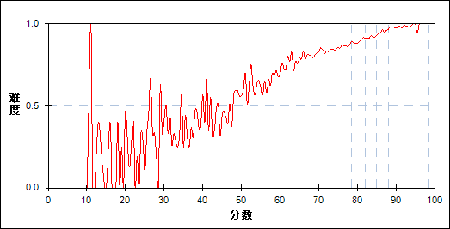

图 117 第26题分组难度曲线图

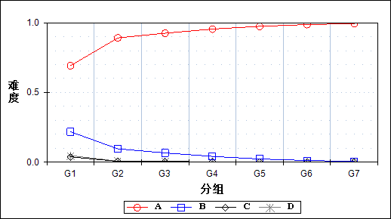

表 236 第26题分组分析表

| 选项 | G1 | G2 | G3 | G4 | G5 | G6 | G7 | 人数 | 比率(%) | 相关系数 |
| --- | --- | --- | --- | --- | --- | --- | --- | --- | --- | --- |
| *Ａ | 5663 | 7291 | 7568 | 7809 | 7969 | 8074 | 8132 | 52506 | 91.66 | 0.41 |
| Ｂ | 1784 | 782 | 543 | 340 | 189 | 99 | 41 | 3778 | 6.60 | -0.29 |
| Ｃ | 316 | 49 | 41 | 29 | 16 | 7 | 9 | 467 | 0.82 | -0.19 |
| Ｄ | 387 | 62 | 32 | 6 | 9 | 2 | 1 | 499 | 0.87 | -0.21 |
| 未选或多选 | 34 | 0 | 0 | 0 | 0 | 1 | 0 | 35 | 0.06 | -0.15 |
| 合计 | 8184 | 8184 | 8184 | 8184 | 8183 | 8183 | 8183 | 57285 | 100.00 | - |
| 得分率 | 0.68 | 0.83 | 0.87 | 0.89 | 0.92 | 0.95 | 0.98 | - | - | - |

表 237 第26题等级分析表

| 分值 | 优秀 | | 良好 | | 合格 | | 不合格 | | 全体 | |
| --- | --- | --- | --- | --- | --- | --- | --- | --- | --- | --- |
| 人数 | 比率 | 人数 | 比率 | 人数 | 比率 | 人数 | 比率 | 人数 | 比率 |
| *Ａ | 16432 | 31.3 | 28932 | 55.1 | 5205 | 9.9 | 1937 | 3.7 | 52506 | 100.0 |
| Ｂ | 144 | 3.8 | 1649 | 43.6 | 917 | 24.3 | 1068 | 28.3 | 3778 | 100.0 |
| Ｃ | 17 | 3.6 | 120 | 25.7 | 79 | 16.9 | 251 | 53.7 | 467 | 100.0 |
| Ｄ | 4 | 0.8 | 96 | 19.2 | 102 | 20.4 | 297 | 59.5 | 499 | 100.0 |
| 未选或多选 | 1 | 2.9 | 0 | 0.0 | 1 | 2.9 | 33 | 94.3 | 35 | 100.0 |
| 合计 | 16598 | 29.0 | 30797 | 53.8 | 6304 | 11.0 | 3586 | 6.3 | 57285 | 100.0 |

* + 1. 第27题

表 238 第27题分析表

|  |  |  |  |  |  |  |  |  |
| --- | --- | --- | --- | --- | --- | --- | --- | --- |
| 人数 | 满分 | 最大值 | 最小值 | 平均值 | 标准差 | 差异系数 | 难度 | 区分度 |
| 57285 | 1 | 1.0 | 0.0 | 0.90 | 0.30 | 0.34 | 0.90 | 0.46 |

表 239 第27题等级得分率分析表

|  |  |  |  |  |
| --- | --- | --- | --- | --- |
| 优秀 | 良好 | 合格 | 不及格 | 全体 |
| 0.99 | 0.93 | 0.76 | 0.43 | 0.90 |

图 118 第27题难度曲线图

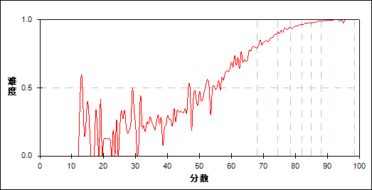

图 119 第27题分组难度曲线图

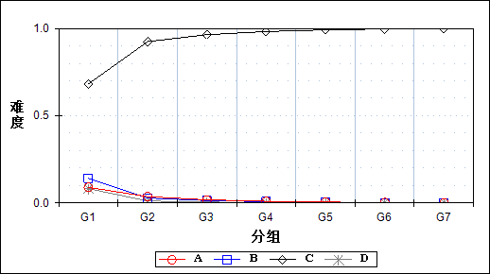

表 240 第27题分组分析表

| 选项 | G1 | G2 | G3 | G4 | G5 | G6 | G7 | 人数 | 比率(%) | 相关系数 |
| --- | --- | --- | --- | --- | --- | --- | --- | --- | --- | --- |
| Ａ | 731 | 295 | 144 | 75 | 41 | 19 | 12 | 1317 | 2.30 | -0.21 |
| Ｂ | 1158 | 230 | 110 | 58 | 22 | 6 | 0 | 1584 | 2.77 | -0.32 |
| *Ｃ | 5582 | 7564 | 7889 | 8037 | 8112 | 8154 | 8168 | 53506 | 93.40 | 0.47 |
| Ｄ | 669 | 92 | 41 | 14 | 8 | 4 | 3 | 831 | 1.45 | -0.25 |
| 未选或多选 | 44 | 3 | 0 | 0 | 0 | 0 | 0 | 47 | 0.08 | -0.14 |
| 合计 | 8184 | 8184 | 8184 | 8184 | 8183 | 8183 | 8183 | 57285 | 100.00 | - |
| 得分率 | 0.60 | 0.85 | 0.92 | 0.95 | 0.97 | 0.98 | 0.99 | - | - | - |

表 241 第27题等级分析表

| 分值 | 优秀 | | 良好 | | 合格 | | 不合格 | | 全体 | |
| --- | --- | --- | --- | --- | --- | --- | --- | --- | --- | --- |
| 人数 | 比率 | 人数 | 比率 | 人数 | 比率 | 人数 | 比率 | 人数 | 比率 |
| Ａ | 33 | 2.5 | 468 | 35.5 | 380 | 28.9 | 436 | 33.1 | 1317 | 100.0 |
| Ｂ | 6 | 0.4 | 351 | 22.2 | 441 | 27.8 | 786 | 49.6 | 1584 | 100.0 |
| *Ｃ | 16552 | 30.9 | 29851 | 55.8 | 5280 | 9.9 | 1823 | 3.4 | 53506 | 100.0 |
| Ｄ | 7 | 0.8 | 124 | 14.9 | 200 | 24.1 | 500 | 60.2 | 831 | 100.0 |
| 未选或多选 | 0 | 0.0 | 3 | 6.4 | 3 | 6.4 | 41 | 87.2 | 47 | 100.0 |
| 合计 | 16598 | 29.0 | 30797 | 53.8 | 6304 | 11.0 | 3586 | 6.3 | 57285 | 100.0 |

* + 1. 第28题

表 242 第28题分析表

|  |  |  |  |  |  |  |  |  |
| --- | --- | --- | --- | --- | --- | --- | --- | --- |
| 人数 | 满分 | 最大值 | 最小值 | 平均值 | 标准差 | 差异系数 | 难度 | 区分度 |
| 57285 | 1 | 1.0 | 0.0 | 0.91 | 0.28 | 0.31 | 0.91 | 0.39 |

表 243 第28题等级得分率分析表

|  |  |  |  |  |
| --- | --- | --- | --- | --- |
| 优秀 | 良好 | 合格 | 不及格 | 全体 |
| 0.99 | 0.94 | 0.78 | 0.57 | 0.91 |

图 120 第28题难度曲线图

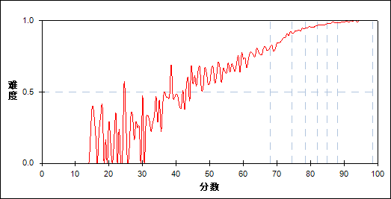

图 121 第28题分组难度曲线图

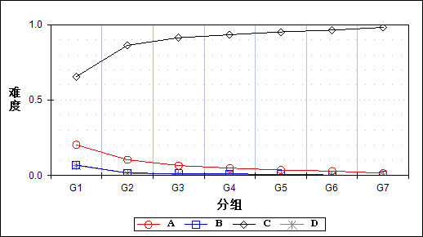

表 244 第28题分组分析表

| 选项 | G1 | G2 | G3 | G4 | G5 | G6 | G7 | 人数 | 比率(%) | 相关系数 |
| --- | --- | --- | --- | --- | --- | --- | --- | --- | --- | --- |
| Ａ | 1665 | 856 | 538 | 403 | 301 | 240 | 127 | 4130 | 7.21 | -0.23 |
| Ｂ | 569 | 138 | 103 | 92 | 60 | 29 | 16 | 1007 | 1.76 | -0.21 |
| *Ｃ | 5360 | 7060 | 7471 | 7635 | 7783 | 7883 | 8032 | 51224 | 89.42 | 0.37 |
| Ｄ | 550 | 130 | 72 | 53 | 38 | 30 | 8 | 881 | 1.54 | -0.20 |
| 未选或多选 | 40 | 0 | 0 | 1 | 1 | 1 | 0 | 43 | 0.08 | -0.15 |
| 合计 | 8184 | 8184 | 8184 | 8184 | 8183 | 8183 | 8183 | 57285 | 100.00 | - |
| 得分率 | 0.69 | 0.86 | 0.93 | 0.95 | 0.97 | 0.98 | 0.99 | - | - | - |

表 245 第28题等级分析表

| 分值 | 优秀 | | 良好 | | 合格 | | 不合格 | | 全体 | |
| --- | --- | --- | --- | --- | --- | --- | --- | --- | --- | --- |
| 人数 | 比率 | 人数 | 比率 | 人数 | 比率 | 人数 | 比率 | 人数 | 比率 |
| Ａ | 379 | 9.2 | 1837 | 44.5 | 1033 | 25.0 | 881 | 21.3 | 4130 | 100.0 |
| Ｂ | 48 | 4.8 | 358 | 35.6 | 181 | 18.0 | 420 | 41.7 | 1007 | 100.0 |
| *Ｃ | 16132 | 31.5 | 28339 | 55.3 | 4898 | 9.6 | 1855 | 3.6 | 51224 | 100.0 |
| Ｄ | 38 | 4.3 | 261 | 29.6 | 189 | 21.5 | 393 | 44.6 | 881 | 100.0 |
| 未选或多选 | 1 | 2.3 | 2 | 4.7 | 3 | 7.0 | 37 | 86.0 | 43 | 100.0 |
| 合计 | 16598 | 29.0 | 30797 | 53.8 | 6304 | 11.0 | 3586 | 6.3 | 57285 | 100.0 |

* + 1. 第29题

表 246 第29题分析表

|  |  |  |  |  |  |  |  |  |
| --- | --- | --- | --- | --- | --- | --- | --- | --- |
| 人数 | 满分 | 最大值 | 最小值 | 平均值 | 标准差 | 差异系数 | 难度 | 区分度 |
| 57285 | 1 | 1.0 | 0.0 | 0.95 | 0.21 | 0.22 | 0.95 | 0.42 |

表 247 第29题等级得分率分析表

|  |  |  |  |  |
| --- | --- | --- | --- | --- |
| 优秀 | 良好 | 合格 | 不及格 | 全体 |
| 1.00 | 0.98 | 0.89 | 0.63 | 0.95 |

图 122 第29题难度曲线图

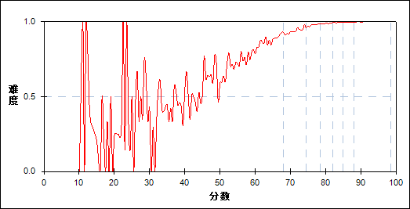

图 123 第29题分组难度曲线图

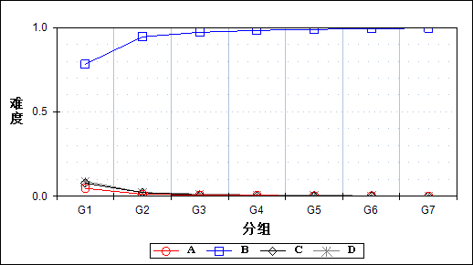

表 248 第29题分组分析表

| 选项 | G1 | G2 | G3 | G4 | G5 | G6 | G7 | 人数 | 比率(%) | 相关系数 |
| --- | --- | --- | --- | --- | --- | --- | --- | --- | --- | --- |
| Ａ | 385 | 96 | 62 | 45 | 22 | 21 | 5 | 636 | 1.11 | -0.17 |
| *Ｂ | 6405 | 7730 | 7950 | 8041 | 8086 | 8122 | 8157 | 54491 | 95.12 | 0.39 |
| Ｃ | 635 | 178 | 62 | 34 | 22 | 13 | 7 | 951 | 1.66 | -0.24 |
| Ｄ | 724 | 179 | 110 | 63 | 53 | 26 | 14 | 1169 | 2.04 | -0.23 |
| 未选或多选 | 35 | 1 | 0 | 1 | 0 | 1 | 0 | 38 | 0.07 | -0.15 |
| 合计 | 8184 | 8184 | 8184 | 8184 | 8183 | 8183 | 8183 | 57285 | 100.00 | - |
| 得分率 | 0.77 | 0.94 | 0.98 | 0.99 | 1.00 | 1.00 | 1.00 | - | - | - |

表 249 第29题等级分析表

| 分值 | 优秀 | | 良好 | | 合格 | | 不合格 | | 全体 | |
| --- | --- | --- | --- | --- | --- | --- | --- | --- | --- | --- |
| 人数 | 比率 | 人数 | 比率 | 人数 | 比率 | 人数 | 比率 | 人数 | 比率 |
| Ａ | 27 | 4.2 | 200 | 31.4 | 151 | 23.7 | 258 | 40.6 | 636 | 100.0 |
| *Ｂ | 16507 | 30.3 | 30005 | 55.1 | 5654 | 10.4 | 2325 | 4.3 | 54491 | 100.0 |
| Ｃ | 21 | 2.2 | 236 | 24.8 | 248 | 26.1 | 446 | 46.9 | 951 | 100.0 |
| Ｄ | 42 | 3.6 | 354 | 30.3 | 249 | 21.3 | 524 | 44.8 | 1169 | 100.0 |
| 未选或多选 | 1 | 2.6 | 2 | 5.3 | 2 | 5.3 | 33 | 86.8 | 38 | 100.0 |
| 合计 | 16598 | 29.0 | 30797 | 53.8 | 6304 | 11.0 | 3586 | 6.3 | 57285 | 100.0 |

* + 1. 第30题

表 250 第30题分析表

|  |  |  |  |  |  |  |  |  |
| --- | --- | --- | --- | --- | --- | --- | --- | --- |
| 人数 | 满分 | 最大值 | 最小值 | 平均值 | 标准差 | 差异系数 | 难度 | 区分度 |
| 57285 | 1 | 1.0 | 0.0 | 0.92 | 0.27 | 0.30 | 0.92 | 0.40 |

表 251 第30题等级得分率分析表

|  |  |  |  |  |
| --- | --- | --- | --- | --- |
| 优秀 | 良好 | 合格 | 不及格 | 全体 |
| 0.99 | 0.95 | 0.80 | 0.57 | 0.92 |

图 124 第30题难度曲线图

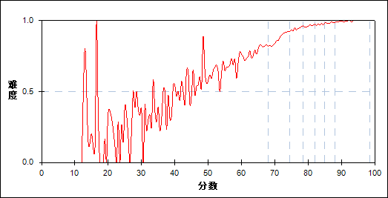

图 125 第30题分组难度曲线图

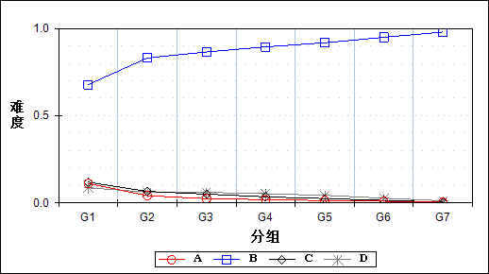

表 252 第30题分组分析表

| 选项 | G1 | G2 | G3 | G4 | G5 | G6 | G7 | 人数 | 比率(%) | 相关系数 |
| --- | --- | --- | --- | --- | --- | --- | --- | --- | --- | --- |
| Ａ | 914 | 341 | 198 | 151 | 113 | 79 | 30 | 1826 | 3.19 | -0.22 |
| *Ｂ | 5548 | 6797 | 7081 | 7315 | 7508 | 7765 | 8012 | 50026 | 87.33 | 0.32 |
| Ｃ | 973 | 540 | 411 | 285 | 205 | 118 | 40 | 2572 | 4.49 | -0.19 |
| Ｄ | 708 | 505 | 493 | 432 | 357 | 220 | 100 | 2815 | 4.91 | -0.11 |
| 未选或多选 | 41 | 1 | 1 | 1 | 0 | 1 | 1 | 46 | 0.08 | -0.15 |
| 合计 | 8184 | 8184 | 8184 | 8184 | 8183 | 8183 | 8183 | 57285 | 100.00 | - |
| 得分率 | 0.70 | 0.88 | 0.94 | 0.96 | 0.97 | 0.98 | 0.99 | - | - | - |

表 253 第30题等级分析表

| 分值 | 优秀 | | 良好 | | 合格 | | 不合格 | | 全体 | |
| --- | --- | --- | --- | --- | --- | --- | --- | --- | --- | --- |
| 人数 | 比率 | 人数 | 比率 | 人数 | 比率 | 人数 | 比率 | 人数 | 比率 |
| Ａ | 111 | 6.1 | 702 | 38.4 | 388 | 21.2 | 625 | 34.2 | 1826 | 100.0 |
| *Ｂ | 15986 | 32.0 | 27117 | 54.2 | 4979 | 10.0 | 1944 | 3.9 | 50026 | 100.0 |
| Ｃ | 168 | 6.5 | 1294 | 50.3 | 524 | 20.4 | 586 | 22.8 | 2572 | 100.0 |
| Ｄ | 331 | 11.8 | 1681 | 59.7 | 411 | 14.6 | 392 | 13.9 | 2815 | 100.0 |
| 未选或多选 | 2 | 4.3 | 3 | 6.5 | 2 | 4.3 | 39 | 84.8 | 46 | 100.0 |
| 合计 | 16598 | 29.0 | 30797 | 53.8 | 6304 | 11.0 | 3586 | 6.3 | 57285 | 100.0 |

* + 1. 第31题

表 254 第31题分析表

|  |  |  |  |  |  |  |  |  |
| --- | --- | --- | --- | --- | --- | --- | --- | --- |
| 人数 | 满分 | 最大值 | 最小值 | 平均值 | 标准差 | 差异系数 | 难度 | 区分度 |
| 57285 | 1 | 1.0 | 0.0 | 0.84 | 0.36 | 0.43 | 0.84 | 0.34 |

表 255 第31题等级得分率分析表

|  |  |  |  |  |
| --- | --- | --- | --- | --- |
| 优秀 | 良好 | 合格 | 不及格 | 全体 |
| 0.95 | 0.86 | 0.70 | 0.50 | 0.84 |

图 126 第31题难度曲线图

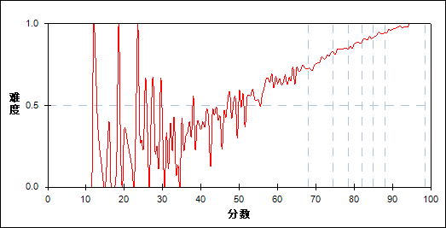

图 127 第31题分组难度曲线图

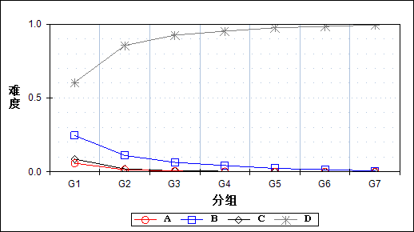

表 256 第31题分组分析表

| 选项 | G1 | G2 | G3 | G4 | G5 | G6 | G7 | 人数 | 比率(%) | 相关系数 |
| --- | --- | --- | --- | --- | --- | --- | --- | --- | --- | --- |
| Ａ | 476 | 117 | 39 | 18 | 6 | 3 | 1 | 660 | 1.15 | -0.21 |
| Ｂ | 2010 | 905 | 520 | 347 | 191 | 118 | 46 | 4137 | 7.22 | -0.31 |
| Ｃ | 705 | 163 | 52 | 29 | 16 | 9 | 5 | 979 | 1.71 | -0.25 |
| *Ｄ | 4949 | 6997 | 7569 | 7790 | 7970 | 8052 | 8131 | 51458 | 89.83 | 0.46 |
| 未选或多选 | 44 | 2 | 4 | 0 | 0 | 1 | 0 | 51 | 0.09 | -0.14 |
| 合计 | 8184 | 8184 | 8184 | 8184 | 8183 | 8183 | 8183 | 57285 | 100.00 | - |
| 得分率 | 0.61 | 0.77 | 0.84 | 0.87 | 0.91 | 0.93 | 0.96 | - | - | - |

表 257 第31题等级分析表

| 分值 | 优秀 | | 良好 | | 合格 | | 不合格 | | 全体 | |
| --- | --- | --- | --- | --- | --- | --- | --- | --- | --- | --- |
| 人数 | 比率 | 人数 | 比率 | 人数 | 比率 | 人数 | 比率 | 人数 | 比率 |
| Ａ | 4 | 0.6 | 150 | 22.7 | 178 | 27.0 | 328 | 49.7 | 660 | 100.0 |
| Ｂ | 171 | 4.1 | 1728 | 41.8 | 1068 | 25.8 | 1170 | 28.3 | 4137 | 100.0 |
| Ｃ | 16 | 1.6 | 216 | 22.1 | 242 | 24.7 | 505 | 51.6 | 979 | 100.0 |
| *Ｄ | 16406 | 31.9 | 28697 | 55.8 | 4814 | 9.4 | 1541 | 3.0 | 51458 | 100.0 |
| 未选或多选 | 1 | 2.0 | 6 | 11.8 | 2 | 3.9 | 42 | 82.4 | 51 | 100.0 |
| 合计 | 16598 | 29.0 | 30797 | 53.8 | 6304 | 11.0 | 3586 | 6.3 | 57285 | 100.0 |

* + 1. 第32题

表 258 第32题分析表

|  |  |  |  |  |  |  |  |  |
| --- | --- | --- | --- | --- | --- | --- | --- | --- |
| 人数 | 满分 | 最大值 | 最小值 | 平均值 | 标准差 | 差异系数 | 难度 | 区分度 |
| 57285 | 1 | 1.0 | 0.0 | 0.95 | 0.21 | 0.22 | 0.95 | 0.39 |

表 259 第32题等级得分率分析表

|  |  |  |  |  |
| --- | --- | --- | --- | --- |
| 优秀 | 良好 | 合格 | 不及格 | 全体 |
| 0.99 | 0.98 | 0.90 | 0.65 | 0.95 |

图 128 第32题难度曲线图

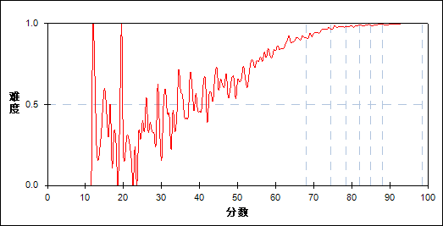

图 129 第32题分组难度曲线图

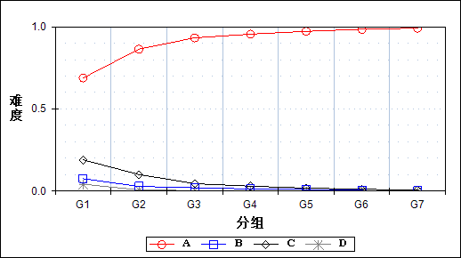

表 260 第32题分组分析表

| 选项 | G1 | G2 | G3 | G4 | G5 | G6 | G7 | 人数 | 比率(%) | 相关系数 |
| --- | --- | --- | --- | --- | --- | --- | --- | --- | --- | --- |
| *Ａ | 5633 | 7068 | 7631 | 7813 | 7953 | 8059 | 8113 | 52270 | 91.25 | 0.39 |
| Ｂ | 617 | 233 | 163 | 106 | 76 | 34 | 16 | 1245 | 2.17 | -0.19 |
| Ｃ | 1556 | 825 | 364 | 243 | 149 | 88 | 54 | 3279 | 5.72 | -0.27 |
| Ｄ | 343 | 57 | 25 | 22 | 4 | 2 | 0 | 453 | 0.79 | -0.18 |
| 未选或多选 | 35 | 1 | 1 | 0 | 1 | 0 | 0 | 38 | 0.07 | -0.15 |
| 合计 | 8184 | 8184 | 8184 | 8184 | 8183 | 8183 | 8183 | 57285 | 100.00 | - |
| 得分率 | 0.79 | 0.95 | 0.98 | 0.98 | 0.99 | 0.99 | 0.99 | - | - | - |

表 261 第32题等级分析表

| 分值 | 优秀 | | 良好 | | 合格 | | 不合格 | | 全体 | |
| --- | --- | --- | --- | --- | --- | --- | --- | --- | --- | --- |
| 人数 | 比率 | 人数 | 比率 | 人数 | 比率 | 人数 | 比率 | 人数 | 比率 |
| *Ａ | 16401 | 31.4 | 28871 | 55.2 | 4941 | 9.5 | 2057 | 3.9 | 52270 | 100.0 |
| Ｂ | 51 | 4.1 | 518 | 41.6 | 268 | 21.5 | 408 | 32.8 | 1245 | 100.0 |
| Ｃ | 144 | 4.4 | 1315 | 40.1 | 973 | 29.7 | 847 | 25.8 | 3279 | 100.0 |
| Ｄ | 2 | 0.4 | 91 | 20.1 | 120 | 26.5 | 240 | 53.0 | 453 | 100.0 |
| 未选或多选 | 0 | 0.0 | 2 | 5.3 | 2 | 5.3 | 34 | 89.5 | 38 | 100.0 |
| 合计 | 16598 | 29.0 | 30797 | 53.8 | 6304 | 11.0 | 3586 | 6.3 | 57285 | 100.0 |

* + 1. 第33题

表 262 第33题分析表

|  |  |  |  |  |  |  |  |  |
| --- | --- | --- | --- | --- | --- | --- | --- | --- |
| 人数 | 满分 | 最大值 | 最小值 | 平均值 | 标准差 | 差异系数 | 难度 | 区分度 |
| 57285 | 1 | 1.0 | 0.0 | 0.65 | 0.48 | 0.73 | 0.65 | 0.46 |

表 263 第33题等级得分率分析表

|  |  |  |  |  |
| --- | --- | --- | --- | --- |
| 优秀 | 良好 | 合格 | 不及格 | 全体 |
| 0.94 | 0.61 | 0.34 | 0.22 | 0.65 |

图 130 第33题难度曲线图

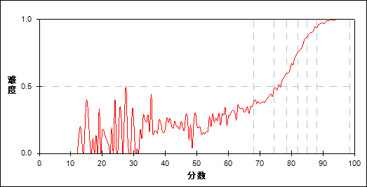

图 131 第33题分组难度曲线图

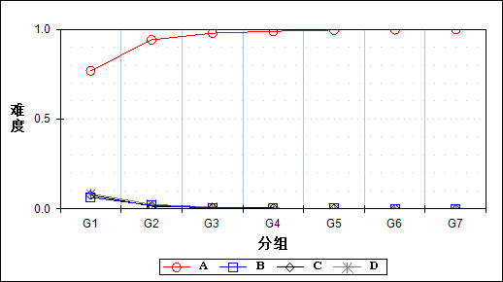

表 264 第33题分组分析表

| 选项 | G1 | G2 | G3 | G4 | G5 | G6 | G7 | 人数 | 比率(%) | 相关系数 |
| --- | --- | --- | --- | --- | --- | --- | --- | --- | --- | --- |
| *Ａ | 6295 | 7702 | 8006 | 8089 | 8145 | 8162 | 8176 | 54575 | 95.27 | 0.42 |
| Ｂ | 525 | 159 | 46 | 23 | 15 | 3 | 2 | 773 | 1.35 | -0.22 |
| Ｃ | 631 | 124 | 52 | 35 | 12 | 11 | 2 | 867 | 1.51 | -0.24 |
| Ｄ | 691 | 199 | 80 | 37 | 11 | 7 | 3 | 1028 | 1.79 | -0.23 |
| 未选或多选 | 42 | 0 | 0 | 0 | 0 | 0 | 0 | 42 | 0.07 | -0.16 |
| 合计 | 8184 | 8184 | 8184 | 8184 | 8183 | 8183 | 8183 | 57285 | 100.00 | - |
| 得分率 | 0.28 | 0.40 | 0.53 | 0.67 | 0.80 | 0.90 | 0.97 | - | - | - |

表 265 第33题等级分析表

| 分值 | 优秀 | | 良好 | | 合格 | | 不合格 | | 全体 | |
| --- | --- | --- | --- | --- | --- | --- | --- | --- | --- | --- |
| 人数 | 比率 | 人数 | 比率 | 人数 | 比率 | 人数 | 比率 | 人数 | 比率 |
| *Ａ | 16568 | 30.4 | 30147 | 55.2 | 5615 | 10.3 | 2245 | 4.1 | 54575 | 100.0 |
| Ｂ | 6 | 0.8 | 199 | 25.7 | 193 | 25.0 | 375 | 48.5 | 773 | 100.0 |
| Ｃ | 13 | 1.5 | 183 | 21.1 | 216 | 24.9 | 455 | 52.5 | 867 | 100.0 |
| Ｄ | 11 | 1.1 | 268 | 26.1 | 277 | 26.9 | 472 | 45.9 | 1028 | 100.0 |
| 未选或多选 | 0 | 0.0 | 0 | 0.0 | 3 | 7.1 | 39 | 92.9 | 42 | 100.0 |
| 合计 | 16598 | 29.0 | 30797 | 53.8 | 6304 | 11.0 | 3586 | 6.3 | 57285 | 100.0 |

* + 1. 第34题

表 266 第34题分析表

|  |  |  |  |  |  |  |  |  |
| --- | --- | --- | --- | --- | --- | --- | --- | --- |
| 人数 | 满分 | 最大值 | 最小值 | 平均值 | 标准差 | 差异系数 | 难度 | 区分度 |
| 57285 | 1 | 1.0 | 0.0 | 0.86 | 0.35 | 0.41 | 0.86 | 0.42 |

表 267 第34题等级得分率分析表

|  |  |  |  |  |
| --- | --- | --- | --- | --- |
| 优秀 | 良好 | 合格 | 不及格 | 全体 |
| 0.97 | 0.88 | 0.68 | 0.44 | 0.86 |

图 132 第34题难度曲线图

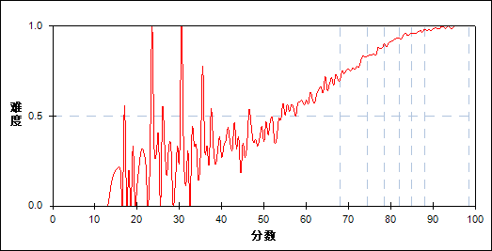

图 133 第34题分组难度曲线图

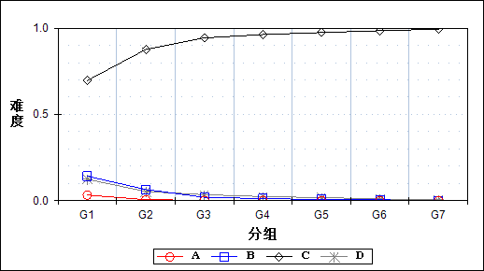

表 268 第34题分组分析表

| 选项 | G1 | G2 | G3 | G4 | G5 | G6 | G7 | 人数 | 比率(%) | 相关系数 |
| --- | --- | --- | --- | --- | --- | --- | --- | --- | --- | --- |
| Ａ | 269 | 49 | 18 | 16 | 6 | 5 | 2 | 365 | 0.64 | -0.19 |
| Ｂ | 1165 | 527 | 159 | 100 | 58 | 40 | 7 | 2056 | 3.59 | -0.27 |
| *Ｃ | 5696 | 7171 | 7721 | 7876 | 7970 | 8056 | 8133 | 52623 | 91.86 | 0.40 |
| Ｄ | 1016 | 435 | 285 | 192 | 148 | 82 | 41 | 2199 | 3.84 | -0.21 |
| 未选或多选 | 38 | 2 | 1 | 0 | 1 | 0 | 0 | 42 | 0.07 | -0.15 |
| 合计 | 8184 | 8184 | 8184 | 8184 | 8183 | 8183 | 8183 | 57285 | 100.00 | - |
| 得分率 | 0.56 | 0.78 | 0.86 | 0.91 | 0.95 | 0.97 | 0.98 | - | - | - |

表 269 第34题等级分析表

| 分值 | 优秀 | | 良好 | | 合格 | | 不合格 | | 全体 | |
| --- | --- | --- | --- | --- | --- | --- | --- | --- | --- | --- |
| 人数 | 比率 | 人数 | 比率 | 人数 | 比率 | 人数 | 比率 | 人数 | 比率 |
| Ａ | 7 | 1.9 | 71 | 19.5 | 64 | 17.5 | 223 | 61.1 | 365 | 100.0 |
| Ｂ | 50 | 2.4 | 656 | 31.9 | 677 | 32.9 | 673 | 32.7 | 2056 | 100.0 |
| *Ｃ | 16414 | 31.2 | 29118 | 55.3 | 5032 | 9.6 | 2059 | 3.9 | 52623 | 100.0 |
| Ｄ | 127 | 5.8 | 948 | 43.1 | 531 | 24.1 | 593 | 27.0 | 2199 | 100.0 |
| 未选或多选 | 0 | 0.0 | 4 | 9.5 | 0 | 0.0 | 38 | 90.5 | 42 | 100.0 |
| 合计 | 16598 | 29.0 | 30797 | 53.8 | 6304 | 11.0 | 3586 | 6.3 | 57285 | 100.0 |

* + 1. 第35题

表 270 第35题分析表

|  |  |  |  |  |  |  |  |  |
| --- | --- | --- | --- | --- | --- | --- | --- | --- |
| 人数 | 满分 | 最大值 | 最小值 | 平均值 | 标准差 | 差异系数 | 难度 | 区分度 |
| 57285 | 1 | 1.0 | 0.0 | 0.44 | 0.50 | 1.13 | 0.44 | 0.38 |

表 271 第35题等级得分率分析表

|  |  |  |  |  |
| --- | --- | --- | --- | --- |
| 优秀 | 良好 | 合格 | 不及格 | 全体 |
| 0.78 | 0.34 | 0.18 | 0.21 | 0.44 |

图 134 第35题难度曲线图

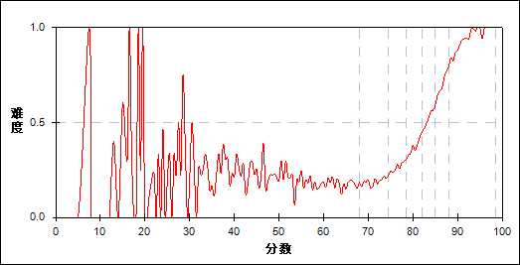

图 135 第35题分组难度曲线图

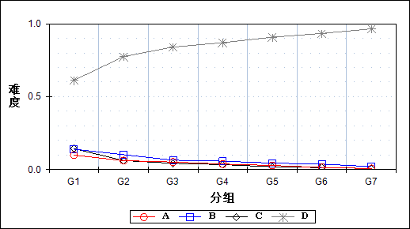

表 272 第35题分组分析表

| 选项 | G1 | G2 | G3 | G4 | G5 | G6 | G7 | 人数 | 比率(%) | 相关系数 |
| --- | --- | --- | --- | --- | --- | --- | --- | --- | --- | --- |
| Ａ | 814 | 504 | 424 | 311 | 232 | 122 | 58 | 2465 | 4.30 | -0.16 |
| Ｂ | 1145 | 835 | 529 | 472 | 364 | 308 | 169 | 3822 | 6.67 | -0.15 |
| Ｃ | 1175 | 505 | 355 | 278 | 160 | 114 | 60 | 2647 | 4.62 | -0.23 |
| *Ｄ | 5010 | 6340 | 6876 | 7122 | 7427 | 7639 | 7895 | 48309 | 84.33 | 0.34 |
| 未选或多选 | 40 | 0 | 0 | 1 | 0 | 0 | 1 | 42 | 0.07 | -0.15 |
| 合计 | 8184 | 8184 | 8184 | 8184 | 8183 | 8183 | 8183 | 57285 | 100.00 | - |
| 得分率 | 0.19 | 0.19 | 0.26 | 0.37 | 0.51 | 0.68 | 0.88 | - | - | - |

表 273 第35题等级分析表

| 分值 | 优秀 | | 良好 | | 合格 | | 不合格 | | 全体 | |
| --- | --- | --- | --- | --- | --- | --- | --- | --- | --- | --- |
| 人数 | 比率 | 人数 | 比率 | 人数 | 比率 | 人数 | 比率 | 人数 | 比率 |
| Ａ | 185 | 7.5 | 1364 | 55.3 | 469 | 19.0 | 447 | 18.1 | 2465 | 100.0 |
| Ｂ | 487 | 12.7 | 1940 | 50.8 | 831 | 21.7 | 564 | 14.8 | 3822 | 100.0 |
| Ｃ | 177 | 6.7 | 1160 | 43.8 | 566 | 21.4 | 744 | 28.1 | 2647 | 100.0 |
| *Ｄ | 15748 | 32.6 | 26332 | 54.5 | 4436 | 9.2 | 1793 | 3.7 | 48309 | 100.0 |
| 未选或多选 | 1 | 2.4 | 1 | 2.4 | 2 | 4.8 | 38 | 90.5 | 42 | 100.0 |
| 合计 | 16598 | 29.0 | 30797 | 53.8 | 6304 | 11.0 | 3586 | 6.3 | 57285 | 100.0 |

* + 1. 第36题

表 274 第36题分析表

|  |  |  |  |  |  |  |  |  |
| --- | --- | --- | --- | --- | --- | --- | --- | --- |
| 人数 | 满分 | 最大值 | 最小值 | 平均值 | 标准差 | 差异系数 | 难度 | 区分度 |
| 57285 | 1 | 1.0 | 0.0 | 0.30 | 0.46 | 1.54 | 0.30 | 0.22 |

表 275 第36题等级得分率分析表

|  |  |  |  |  |
| --- | --- | --- | --- | --- |
| 优秀 | 良好 | 合格 | 不及格 | 全体 |
| 0.50 | 0.23 | 0.19 | 0.18 | 0.30 |

图 136 第36题难度曲线图

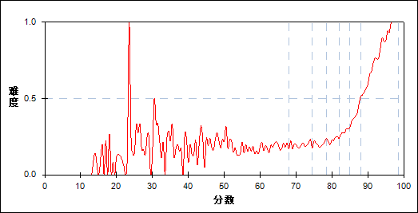

图 137 第36题分组难度曲线图

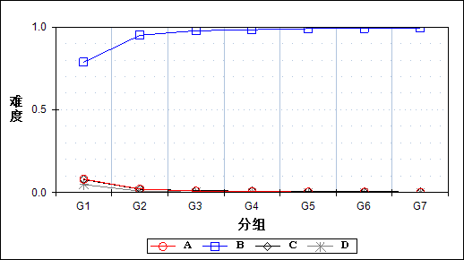

表 276 第36题分组分析表

| 选项 | G1 | G2 | G3 | G4 | G5 | G6 | G7 | 人数 | 比率(%) | 相关系数 |
| --- | --- | --- | --- | --- | --- | --- | --- | --- | --- | --- |
| Ａ | 663 | 174 | 71 | 56 | 26 | 19 | 10 | 1019 | 1.78 | -0.23 |
| *Ｂ | 6438 | 7773 | 7998 | 8047 | 8098 | 8118 | 8140 | 54612 | 95.33 | 0.39 |
| Ｃ | 644 | 166 | 92 | 71 | 55 | 45 | 31 | 1104 | 1.93 | -0.21 |
| Ｄ | 396 | 70 | 22 | 9 | 4 | 1 | 2 | 504 | 0.88 | -0.19 |
| 未选或多选 | 43 | 1 | 1 | 1 | 0 | 0 | 0 | 46 | 0.08 | -0.15 |
| 合计 | 8184 | 8184 | 8184 | 8184 | 8183 | 8183 | 8183 | 57285 | 100.00 | - |
| 得分率 | 0.18 | 0.20 | 0.20 | 0.23 | 0.28 | 0.38 | 0.61 | - | - | - |

表 277 第36题等级分析表

| 分值 | 优秀 | | 良好 | | 合格 | | 不合格 | | 全体 | |
| --- | --- | --- | --- | --- | --- | --- | --- | --- | --- | --- |
| 人数 | 比率 | 人数 | 比率 | 人数 | 比率 | 人数 | 比率 | 人数 | 比率 |
| Ａ | 31 | 3.0 | 268 | 26.3 | 262 | 25.7 | 458 | 44.9 | 1019 | 100.0 |
| *Ｂ | 16488 | 30.2 | 30112 | 55.1 | 5666 | 10.4 | 2346 | 4.3 | 54612 | 100.0 |
| Ｃ | 76 | 6.9 | 334 | 30.3 | 231 | 20.9 | 463 | 41.9 | 1104 | 100.0 |
| Ｄ | 3 | 0.6 | 80 | 15.9 | 143 | 28.4 | 278 | 55.2 | 504 | 100.0 |
| 未选或多选 | 0 | 0.0 | 3 | 6.5 | 2 | 4.3 | 41 | 89.1 | 46 | 100.0 |
| 合计 | 16598 | 29.0 | 30797 | 53.8 | 6304 | 11.0 | 3586 | 6.3 | 57285 | 100.0 |

* + 1. 第37题

表 278 第37题分析表

|  |  |  |  |  |  |  |  |  |
| --- | --- | --- | --- | --- | --- | --- | --- | --- |
| 人数 | 满分 | 最大值 | 最小值 | 平均值 | 标准差 | 差异系数 | 难度 | 区分度 |
| 57285 | 1 | 1.0 | 0.0 | 0.89 | 0.31 | 0.34 | 0.89 | 0.40 |

表 279 第37题等级得分率分析表

|  |  |  |  |  |
| --- | --- | --- | --- | --- |
| 优秀 | 良好 | 合格 | 不及格 | 全体 |
| 0.98 | 0.92 | 0.77 | 0.50 | 0.89 |

图 138 第37题难度曲线图

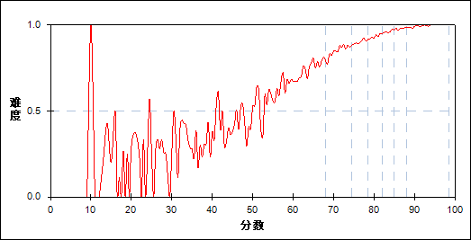

图 139 第37题分组难度曲线图

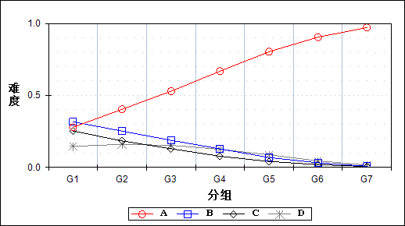

表 280 第37题分组分析表

| 选项 | G1 | G2 | G3 | G4 | G5 | G6 | G7 | 人数 | 比率(%) | 相关系数 |
| --- | --- | --- | --- | --- | --- | --- | --- | --- | --- | --- |
| *Ａ | 2280 | 3304 | 4329 | 5469 | 6573 | 7401 | 7949 | 37305 | 65.12 | 0.46 |
| Ｂ | 2591 | 2063 | 1540 | 1053 | 560 | 260 | 59 | 8126 | 14.19 | -0.28 |
| Ｃ | 2070 | 1502 | 1057 | 631 | 338 | 153 | 49 | 5800 | 10.12 | -0.27 |
| Ｄ | 1194 | 1308 | 1253 | 1028 | 710 | 368 | 126 | 5987 | 10.45 | -0.12 |
| 未选或多选 | 49 | 7 | 5 | 3 | 2 | 1 | 0 | 67 | 0.12 | -0.13 |
| 合计 | 8184 | 8184 | 8184 | 8184 | 8183 | 8183 | 8183 | 57285 | 100.00 | - |
| 得分率 | 0.64 | 0.86 | 0.90 | 0.93 | 0.96 | 0.98 | 0.99 | - | - | - |

表 281 第37题等级分析表

| 分值 | 优秀 | | 良好 | | 合格 | | 不合格 | | 全体 | |
| --- | --- | --- | --- | --- | --- | --- | --- | --- | --- | --- |
| 人数 | 比率 | 人数 | 比率 | 人数 | 比率 | 人数 | 比率 | 人数 | 比率 |
| *Ａ | 15560 | 41.7 | 18794 | 50.4 | 2156 | 5.8 | 795 | 2.1 | 37305 | 100.0 |
| Ｂ | 329 | 4.0 | 4786 | 58.9 | 1795 | 22.1 | 1216 | 15.0 | 8126 | 100.0 |
| Ｃ | 208 | 3.6 | 3174 | 54.7 | 1405 | 24.2 | 1013 | 17.5 | 5800 | 100.0 |
| Ｄ | 500 | 8.4 | 4026 | 67.2 | 942 | 15.7 | 519 | 8.7 | 5987 | 100.0 |
| 未选或多选 | 1 | 1.5 | 17 | 25.4 | 6 | 9.0 | 43 | 64.2 | 67 | 100.0 |
| 合计 | 16598 | 29.0 | 30797 | 53.8 | 6304 | 11.0 | 3586 | 6.3 | 57285 | 100.0 |

* + 1. 第38题

表 282 第38题分析表

|  |  |  |  |  |  |  |  |  |
| --- | --- | --- | --- | --- | --- | --- | --- | --- |
| 人数 | 满分 | 最大值 | 最小值 | 平均值 | 标准差 | 差异系数 | 难度 | 区分度 |
| 57285 | 1 | 1.0 | 0.0 | 0.93 | 0.26 | 0.28 | 0.93 | 0.45 |

表 283 第38题等级得分率分析表

|  |  |  |  |  |
| --- | --- | --- | --- | --- |
| 优秀 | 良好 | 合格 | 不及格 | 全体 |
| 0.99 | 0.96 | 0.83 | 0.51 | 0.93 |

图 140 第38题难度曲线图

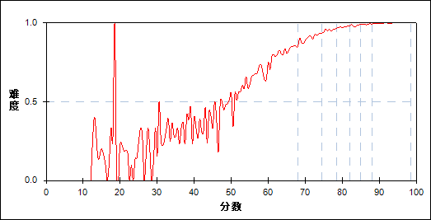

图 141 第38题分组难度曲线图

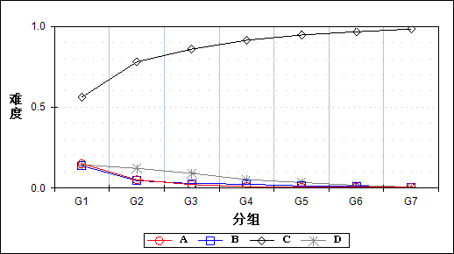

表 284 第38题分组分析表

| 选项 | G1 | G2 | G3 | G4 | G5 | G6 | G7 | 人数 | 比率(%) | 相关系数 |
| --- | --- | --- | --- | --- | --- | --- | --- | --- | --- | --- |
| Ａ | 1234 | 419 | 177 | 75 | 46 | 45 | 39 | 2035 | 3.55 | -0.27 |
| Ｂ | 1129 | 379 | 230 | 199 | 109 | 87 | 49 | 2182 | 3.81 | -0.24 |
| *Ｃ | 4597 | 6386 | 7031 | 7479 | 7745 | 7906 | 8046 | 49190 | 85.87 | 0.42 |
| Ｄ | 1182 | 1000 | 745 | 430 | 283 | 143 | 49 | 3832 | 6.69 | -0.18 |
| 未选或多选 | 42 | 0 | 1 | 1 | 0 | 2 | 0 | 46 | 0.08 | -0.15 |
| 合计 | 8184 | 8184 | 8184 | 8184 | 8183 | 8183 | 8183 | 57285 | 100.00 | - |
| 得分率 | 0.68 | 0.91 | 0.95 | 0.97 | 0.98 | 0.99 | 1.00 | - | - | - |

表 285 第38题等级分析表

| 分值 | 优秀 | | 良好 | | 合格 | | 不合格 | | 全体 | |
| --- | --- | --- | --- | --- | --- | --- | --- | --- | --- | --- |
| 人数 | 比率 | 人数 | 比率 | 人数 | 比率 | 人数 | 比率 | 人数 | 比率 |
| Ａ | 87 | 4.3 | 604 | 29.7 | 617 | 30.3 | 727 | 35.7 | 2035 | 100.0 |
| Ｂ | 139 | 6.4 | 825 | 37.8 | 515 | 23.6 | 703 | 32.2 | 2182 | 100.0 |
| *Ｃ | 16174 | 32.9 | 27147 | 55.2 | 4306 | 8.8 | 1563 | 3.2 | 49190 | 100.0 |
| Ｄ | 196 | 5.1 | 2219 | 57.9 | 865 | 22.6 | 552 | 14.4 | 3832 | 100.0 |
| 未选或多选 | 2 | 4.3 | 2 | 4.3 | 1 | 2.2 | 41 | 89.1 | 46 | 100.0 |
| 合计 | 16598 | 29.0 | 30797 | 53.8 | 6304 | 11.0 | 3586 | 6.3 | 57285 | 100.0 |

* + 1. 第39题

表 286 第39题分析表

|  |  |  |  |  |  |  |  |  |
| --- | --- | --- | --- | --- | --- | --- | --- | --- |
| 人数 | 满分 | 最大值 | 最小值 | 平均值 | 标准差 | 差异系数 | 难度 | 区分度 |
| 57285 | 1 | 1.0 | 0.0 | 0.77 | 0.42 | 0.55 | 0.77 | 0.40 |

表 287 第39题等级得分率分析表

|  |  |  |  |  |
| --- | --- | --- | --- | --- |
| 优秀 | 良好 | 合格 | 不及格 | 全体 |
| 0.92 | 0.78 | 0.54 | 0.34 | 0.77 |

图 142 第39题难度曲线图



图 143 第39题分组难度曲线图

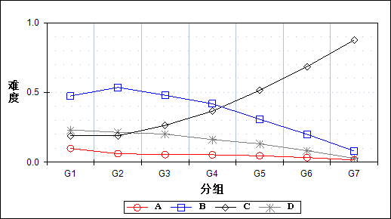

表 288 第39题分组分析表

| 选项 | G1 | G2 | G3 | G4 | G5 | G6 | G7 | 人数 | 比率(%) | 相关系数 |
| --- | --- | --- | --- | --- | --- | --- | --- | --- | --- | --- |
| Ａ | 806 | 498 | 448 | 436 | 377 | 271 | 130 | 2966 | 5.18 | -0.12 |
| Ｂ | 3885 | 4387 | 3927 | 3426 | 2516 | 1637 | 652 | 20430 | 35.66 | -0.21 |
| *Ｃ | 1556 | 1546 | 2158 | 2995 | 4213 | 5600 | 7171 | 25239 | 44.06 | 0.38 |
| Ｄ | 1893 | 1751 | 1649 | 1327 | 1077 | 673 | 230 | 8600 | 15.01 | -0.16 |
| 未选或多选 | 44 | 2 | 2 | 0 | 0 | 2 | 0 | 50 | 0.09 | -0.15 |
| 合计 | 8184 | 8184 | 8184 | 8184 | 8183 | 8183 | 8183 | 57285 | 100.00 | - |
| 得分率 | 0.44 | 0.65 | 0.76 | 0.83 | 0.87 | 0.90 | 0.95 | - | - | - |

表 289 第39题等级分析表

| 分值 | 优秀 | | 良好 | | 合格 | | 不合格 | | 全体 | |
| --- | --- | --- | --- | --- | --- | --- | --- | --- | --- | --- |
| 人数 | 比率 | 人数 | 比率 | 人数 | 比率 | 人数 | 比率 | 人数 | 比率 |
| Ａ | 408 | 13.8 | 1629 | 54.9 | 434 | 14.6 | 495 | 16.7 | 2966 | 100.0 |
| Ｂ | 2339 | 11.4 | 13271 | 65.0 | 3340 | 16.3 | 1480 | 7.2 | 20430 | 100.0 |
| *Ｃ | 12917 | 51.2 | 10462 | 41.5 | 1117 | 4.4 | 743 | 2.9 | 25239 | 100.0 |
| Ｄ | 932 | 10.8 | 5431 | 63.2 | 1410 | 16.4 | 827 | 9.6 | 8600 | 100.0 |
| 未选或多选 | 2 | 4.0 | 4 | 8.0 | 3 | 6.0 | 41 | 82.0 | 50 | 100.0 |
| 合计 | 16598 | 29.0 | 30797 | 53.8 | 6304 | 11.0 | 3586 | 6.3 | 57285 | 100.0 |

* + 1. 第40题

表 290 第40题分析表

|  |  |  |  |  |  |  |  |  |
| --- | --- | --- | --- | --- | --- | --- | --- | --- |
| 人数 | 满分 | 最大值 | 最小值 | 平均值 | 标准差 | 差异系数 | 难度 | 区分度 |
| 57285 | 1 | 1.0 | 0.0 | 0.86 | 0.35 | 0.41 | 0.86 | 0.50 |

表 291 第40题等级得分率分析表

|  |  |  |  |  |
| --- | --- | --- | --- | --- |
| 优秀 | 良好 | 合格 | 不及格 | 全体 |
| 0.99 | 0.89 | 0.63 | 0.34 | 0.86 |

图 144 第40题难度曲线图



图 145 第40题分组难度曲线图

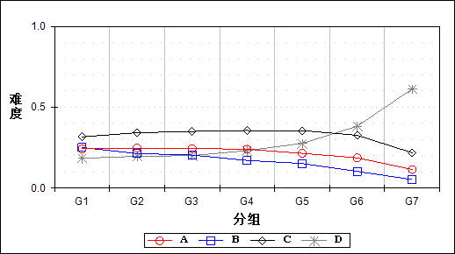

表 292 第40题分组分析表

| 选项 | G1 | G2 | G3 | G4 | G5 | G6 | G7 | 人数 | 比率(%) | 相关系数 |
| --- | --- | --- | --- | --- | --- | --- | --- | --- | --- | --- |
| Ａ | 1982 | 2026 | 1999 | 1967 | 1758 | 1531 | 943 | 12206 | 21.31 | -0.07 |
| Ｂ | 2053 | 1750 | 1671 | 1400 | 1246 | 844 | 430 | 9394 | 16.40 | -0.15 |
| Ｃ | 2592 | 2798 | 2866 | 2916 | 2910 | 2672 | 1787 | 18541 | 32.37 | -0.02 |
| *Ｄ | 1506 | 1606 | 1642 | 1897 | 2262 | 3129 | 5022 | 17064 | 29.79 | 0.22 |
| 未选或多选 | 51 | 4 | 6 | 4 | 7 | 7 | 1 | 80 | 0.14 | -0.12 |
| 合计 | 8184 | 8184 | 8184 | 8184 | 8183 | 8183 | 8183 | 57285 | 100.00 | - |
| 得分率 | 0.49 | 0.75 | 0.88 | 0.94 | 0.97 | 0.99 | 1.00 | - | - | - |

表 293 第40题等级分析表

| 分值 | 优秀 | | 良好 | | 合格 | | 不合格 | | 全体 | |
| --- | --- | --- | --- | --- | --- | --- | --- | --- | --- | --- |
| 人数 | 比率 | 人数 | 比率 | 人数 | 比率 | 人数 | 比率 | 人数 | 比率 |
| Ａ | 2528 | 20.7 | 7298 | 59.8 | 1492 | 12.2 | 888 | 7.3 | 12206 | 100.0 |
| Ｂ | 1297 | 13.8 | 5662 | 60.3 | 1463 | 15.6 | 972 | 10.3 | 9394 | 100.0 |
| Ｃ | 4543 | 24.5 | 10811 | 58.3 | 2154 | 11.6 | 1033 | 5.6 | 18541 | 100.0 |
| *Ｄ | 8222 | 48.2 | 7007 | 41.1 | 1186 | 7.0 | 649 | 3.8 | 17064 | 100.0 |
| 未选或多选 | 8 | 10.0 | 19 | 23.8 | 9 | 11.3 | 44 | 55.0 | 80 | 100.0 |
| 合计 | 16598 | 29.0 | 30797 | 53.8 | 6304 | 11.0 | 3586 | 6.3 | 57285 | 100.0 |

* + 1. 第41题

表 294 第41题分析表

|  |  |  |  |  |  |  |  |  |
| --- | --- | --- | --- | --- | --- | --- | --- | --- |
| 人数 | 满分 | 最大值 | 最小值 | 平均值 | 标准差 | 差异系数 | 难度 | 区分度 |
| 57285 | 1 | 1.0 | 0.0 | 0.85 | 0.36 | 0.42 | 0.85 | 0.37 |

表 295 第41题等级得分率分析表

|  |  |  |  |  |
| --- | --- | --- | --- | --- |
| 优秀 | 良好 | 合格 | 不及格 | 全体 |
| 0.94 | 0.88 | 0.68 | 0.45 | 0.85 |

图 146 第41题难度曲线图

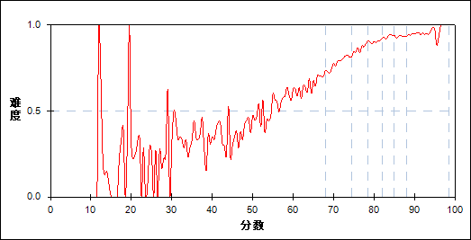

图 147 第41题分组难度曲线图

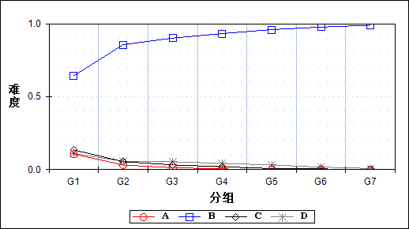

表 296 第41题分组分析表

| 选项 | G1 | G2 | G3 | G4 | G5 | G6 | G7 | 人数 | 比率(%) | 相关系数 |
| --- | --- | --- | --- | --- | --- | --- | --- | --- | --- | --- |
| Ａ | 872 | 256 | 105 | 39 | 13 | 10 | 6 | 1301 | 2.27 | -0.25 |
| *Ｂ | 5261 | 7010 | 7379 | 7631 | 7851 | 7997 | 8100 | 51229 | 89.43 | 0.40 |
| Ｃ | 1104 | 445 | 264 | 160 | 60 | 37 | 17 | 2087 | 3.64 | -0.25 |
| Ｄ | 902 | 471 | 436 | 351 | 259 | 137 | 60 | 2616 | 4.57 | -0.16 |
| 未选或多选 | 45 | 2 | 0 | 3 | 0 | 2 | 0 | 52 | 0.09 | -0.14 |
| 合计 | 8184 | 8184 | 8184 | 8184 | 8183 | 8183 | 8183 | 57285 | 100.00 | - |
| 得分率 | 0.57 | 0.79 | 0.86 | 0.90 | 0.93 | 0.93 | 0.95 | - | - | - |

表 297 第41题等级分析表

| 分值 | 优秀 | | 良好 | | 合格 | | 不合格 | | 全体 | |
| --- | --- | --- | --- | --- | --- | --- | --- | --- | --- | --- |
| 人数 | 比率 | 人数 | 比率 | 人数 | 比率 | 人数 | 比率 | 人数 | 比率 |
| Ａ | 16 | 1.2 | 327 | 25.1 | 415 | 31.9 | 543 | 41.7 | 1301 | 100.0 |
| *Ｂ | 16324 | 31.9 | 28255 | 55.2 | 4849 | 9.5 | 1801 | 3.5 | 51229 | 100.0 |
| Ｃ | 55 | 2.6 | 807 | 38.7 | 559 | 26.8 | 666 | 31.9 | 2087 | 100.0 |
| Ｄ | 201 | 7.7 | 1403 | 53.6 | 480 | 18.3 | 532 | 20.3 | 2616 | 100.0 |
| 未选或多选 | 2 | 3.8 | 5 | 9.6 | 1 | 1.9 | 44 | 84.6 | 52 | 100.0 |
| 合计 | 16598 | 29.0 | 30797 | 53.8 | 6304 | 11.0 | 3586 | 6.3 | 57285 | 100.0 |

* + 1. 第42题

表 298 第42题分析表

|  |  |  |  |  |  |  |  |  |
| --- | --- | --- | --- | --- | --- | --- | --- | --- |
| 人数 | 满分 | 最大值 | 最小值 | 平均值 | 标准差 | 差异系数 | 难度 | 区分度 |
| 57285 | 1 | 1.0 | 0.0 | 0.27 | 0.45 | 1.62 | 0.27 | 0.29 |

表 299 第42题等级得分率分析表

|  |  |  |  |  |
| --- | --- | --- | --- | --- |
| 优秀 | 良好 | 合格 | 不及格 | 全体 |
| 0.53 | 0.18 | 0.11 | 0.14 | 0.27 |

图 148 第42题难度曲线图

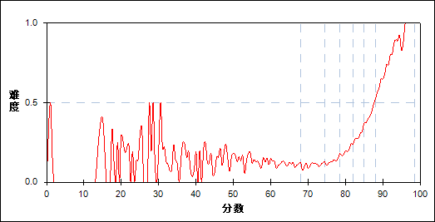

图 149 第42题分组难度曲线图

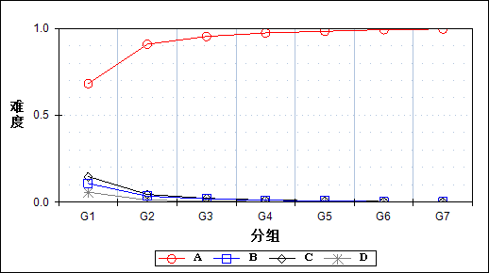

表 300 第42题分组分析表

| 选项 | G1 | G2 | G3 | G4 | G5 | G6 | G7 | 人数 | 比率(%) | 相关系数 |
| --- | --- | --- | --- | --- | --- | --- | --- | --- | --- | --- |
| *Ａ | 5582 | 7436 | 7799 | 7965 | 8039 | 8117 | 8150 | 53088 | 92.67 | 0.45 |
| Ｂ | 883 | 283 | 157 | 89 | 60 | 23 | 18 | 1513 | 2.64 | -0.24 |
| Ｃ | 1206 | 366 | 180 | 98 | 63 | 33 | 8 | 1954 | 3.41 | -0.29 |
| Ｄ | 469 | 95 | 46 | 30 | 20 | 9 | 7 | 676 | 1.18 | -0.20 |
| 未选或多选 | 44 | 4 | 2 | 2 | 1 | 1 | 0 | 54 | 0.09 | -0.14 |
| 合计 | 8184 | 8184 | 8184 | 8184 | 8183 | 8183 | 8183 | 57285 | 100.00 | - |
| 得分率 | 0.13 | 0.11 | 0.13 | 0.20 | 0.29 | 0.42 | 0.66 | - | - | - |

表 301 第42题等级分析表

| 分值 | 优秀 | | 良好 | | 合格 | | 不合格 | | 全体 | |
| --- | --- | --- | --- | --- | --- | --- | --- | --- | --- | --- |
| 人数 | 比率 | 人数 | 比率 | 人数 | 比率 | 人数 | 比率 | 人数 | 比率 |
| *Ａ | 16496 | 31.1 | 29509 | 55.6 | 5259 | 9.9 | 1824 | 3.4 | 53088 | 100.0 |
| Ｂ | 42 | 2.8 | 518 | 34.2 | 376 | 24.9 | 577 | 38.1 | 1513 | 100.0 |
| Ｃ | 42 | 2.1 | 605 | 31.0 | 504 | 25.8 | 803 | 41.1 | 1954 | 100.0 |
| Ｄ | 17 | 2.5 | 160 | 23.7 | 157 | 23.2 | 342 | 50.6 | 676 | 100.0 |
| 未选或多选 | 1 | 1.9 | 5 | 9.3 | 8 | 14.8 | 40 | 74.1 | 54 | 100.0 |
| 合计 | 16598 | 29.0 | 30797 | 53.8 | 6304 | 11.0 | 3586 | 6.3 | 57285 | 100.0 |

* + 1. 第43题

表 302 第43题分析表

|  |  |  |  |  |  |  |  |  |
| --- | --- | --- | --- | --- | --- | --- | --- | --- |
| 人数 | 满分 | 最大值 | 最小值 | 平均值 | 标准差 | 差异系数 | 难度 | 区分度 |
| 57285 | 1 | 1.0 | 0.0 | 0.37 | 0.48 | 1.30 | 0.37 | 0.23 |

表 303 第43题等级得分率分析表

|  |  |  |  |  |
| --- | --- | --- | --- | --- |
| 优秀 | 良好 | 合格 | 不及格 | 全体 |
| 0.53 | 0.34 | 0.21 | 0.21 | 0.37 |

图 150 第43题难度曲线图

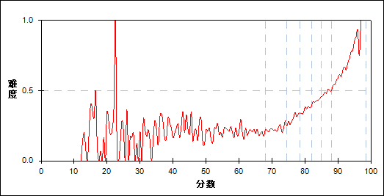

图 151 第43题分组难度曲线图

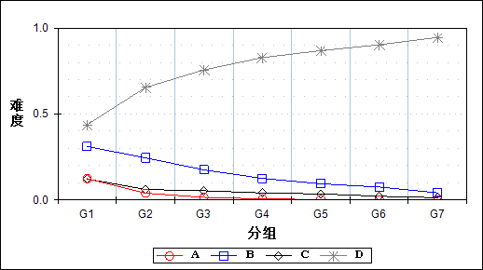

表 304 第43题分组分析表

| 选项 | G1 | G2 | G3 | G4 | G5 | G6 | G7 | 人数 | 比率(%) | 相关系数 |
| --- | --- | --- | --- | --- | --- | --- | --- | --- | --- | --- |
| Ａ | 1018 | 323 | 125 | 51 | 22 | 8 | 2 | 1549 | 2.70 | -0.26 |
| Ｂ | 2545 | 2005 | 1432 | 1026 | 770 | 615 | 340 | 8733 | 15.24 | -0.23 |
| Ｃ | 1003 | 498 | 436 | 332 | 287 | 176 | 106 | 2838 | 4.95 | -0.18 |
| *Ｄ | 3577 | 5355 | 6189 | 6774 | 7104 | 7384 | 7734 | 44117 | 77.01 | 0.40 |
| 未选或多选 | 41 | 3 | 2 | 1 | 0 | 0 | 1 | 48 | 0.08 | -0.14 |
| 合计 | 8184 | 8184 | 8184 | 8184 | 8183 | 8183 | 8183 | 57285 | 100.00 | - |
| 得分率 | 0.21 | 0.23 | 0.30 | 0.37 | 0.42 | 0.48 | 0.59 | - | - | - |

表 305 第43题等级分析表

| 分值 | 优秀 | | 良好 | | 合格 | | 不合格 | | 全体 | |
| --- | --- | --- | --- | --- | --- | --- | --- | --- | --- | --- |
| 人数 | 比率 | 人数 | 比率 | 人数 | 比率 | 人数 | 比率 | 人数 | 比率 |
| Ａ | 10 | 0.6 | 408 | 26.3 | 515 | 33.2 | 616 | 39.8 | 1549 | 100.0 |
| Ｂ | 972 | 11.1 | 4770 | 54.6 | 1899 | 21.7 | 1092 | 12.5 | 8733 | 100.0 |
| Ｃ | 286 | 10.1 | 1458 | 51.4 | 467 | 16.5 | 627 | 22.1 | 2838 | 100.0 |
| *Ｄ | 15329 | 34.7 | 24156 | 54.8 | 3420 | 7.8 | 1212 | 2.7 | 44117 | 100.0 |
| 未选或多选 | 1 | 2.1 | 5 | 10.4 | 3 | 6.3 | 39 | 81.3 | 48 | 100.0 |
| 合计 | 16598 | 29.0 | 30797 | 53.8 | 6304 | 11.0 | 3586 | 6.3 | 57285 | 100.0 |

* + 1. 第44题

表 306 第44题分析表

|  |  |  |  |  |  |  |  |  |
| --- | --- | --- | --- | --- | --- | --- | --- | --- |
| 人数 | 满分 | 最大值 | 最小值 | 平均值 | 标准差 | 差异系数 | 难度 | 区分度 |
| 57285 | 1 | 1.0 | 0.0 | 0.21 | 0.41 | 1.95 | 0.21 | 0.05 |

表 307 第44题等级得分率分析表

|  |  |  |  |  |
| --- | --- | --- | --- | --- |
| 优秀 | 良好 | 合格 | 不及格 | 全体 |
| 0.24 | 0.20 | 0.16 | 0.19 | 0.21 |

图 152 第44题难度曲线图

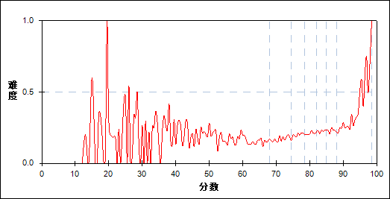

图 153 第44题分组难度曲线图

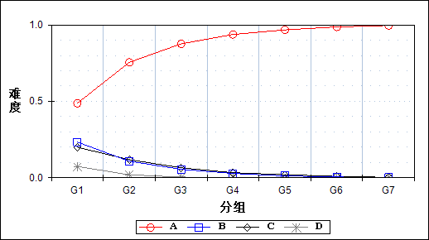

表 308 第44题分组分析表

| 选项 | G1 | G2 | G3 | G4 | G5 | G6 | G7 | 人数 | 比率(%) | 相关系数 |
| --- | --- | --- | --- | --- | --- | --- | --- | --- | --- | --- |
| *Ａ | 3989 | 6178 | 7168 | 7671 | 7916 | 8073 | 8150 | 49145 | 85.79 | 0.50 |
| Ｂ | 1909 | 882 | 452 | 230 | 103 | 38 | 12 | 3626 | 6.33 | -0.31 |
| Ｃ | 1633 | 965 | 530 | 272 | 162 | 71 | 21 | 3654 | 6.38 | -0.27 |
| Ｄ | 607 | 158 | 34 | 11 | 1 | 1 | 0 | 812 | 1.42 | -0.23 |
| 未选或多选 | 46 | 1 | 0 | 0 | 1 | 0 | 0 | 48 | 0.08 | -0.15 |
| 合计 | 8184 | 8184 | 8184 | 8184 | 8183 | 8183 | 8183 | 57285 | 100.00 | - |
| 得分率 | 0.17 | 0.17 | 0.20 | 0.21 | 0.22 | 0.23 | 0.25 | - | - | - |

表 309 第44题等级分析表

| 分值 | 优秀 | | 良好 | | 合格 | | 不合格 | | 全体 | |
| --- | --- | --- | --- | --- | --- | --- | --- | --- | --- | --- |
| 人数 | 比率 | 人数 | 比率 | 人数 | 比率 | 人数 | 比率 | 人数 | 比率 |
| *Ａ | 16451 | 33.5 | 27511 | 56.0 | 3959 | 8.1 | 1224 | 2.5 | 49145 | 100.0 |
| Ｂ | 50 | 1.4 | 1449 | 40.0 | 1085 | 29.9 | 1042 | 28.7 | 3626 | 100.0 |
| Ｃ | 96 | 2.6 | 1687 | 46.2 | 1004 | 27.5 | 867 | 23.7 | 3654 | 100.0 |
| Ｄ | 1 | 0.1 | 149 | 18.3 | 253 | 31.2 | 409 | 50.4 | 812 | 100.0 |
| 未选或多选 | 0 | 0.0 | 1 | 2.1 | 3 | 6.3 | 44 | 91.7 | 48 | 100.0 |
| 合计 | 16598 | 29.0 | 30797 | 53.8 | 6304 | 11.0 | 3586 | 6.3 | 57285 | 100.0 |

* + 1. 第45题

表 310 第45题分析表

|  |  |  |  |  |  |  |  |  |
| --- | --- | --- | --- | --- | --- | --- | --- | --- |
| 人数 | 满分 | 最大值 | 最小值 | 平均值 | 标准差 | 差异系数 | 难度 | 区分度 |
| 57285 | 1 | 1.0 | 0.0 | 0.19 | 0.39 | 2.07 | 0.19 | -0.07 |

表 311 第45题等级得分率分析表

|  |  |  |  |  |
| --- | --- | --- | --- | --- |
| 优秀 | 良好 | 合格 | 不及格 | 全体 |
| 0.17 | 0.19 | 0.24 | 0.25 | 0.19 |

图 154 第45题难度曲线图

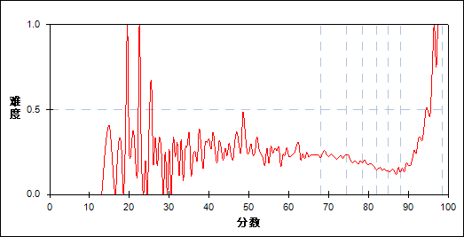

图 155 第45题分组难度曲线图

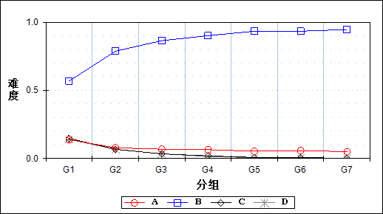

表 312 第45题分组分析表

| 选项 | G1 | G2 | G3 | G4 | G5 | G6 | G7 | 人数 | 比率(%) | 相关系数 |
| --- | --- | --- | --- | --- | --- | --- | --- | --- | --- | --- |
| Ａ | 1135 | 641 | 560 | 532 | 433 | 469 | 411 | 4181 | 7.30 | -0.12 |
| *Ｂ | 4647 | 6442 | 7072 | 7374 | 7638 | 7641 | 7742 | 48556 | 84.76 | 0.37 |
| Ｃ | 1206 | 553 | 273 | 154 | 62 | 46 | 20 | 2314 | 4.04 | -0.25 |
| Ｄ | 1152 | 546 | 279 | 124 | 49 | 26 | 10 | 2186 | 3.82 | -0.24 |
| 未选或多选 | 44 | 2 | 0 | 0 | 1 | 1 | 0 | 48 | 0.08 | -0.15 |
| 合计 | 8184 | 8184 | 8184 | 8184 | 8183 | 8183 | 8183 | 57285 | 100.00 | - |
| 得分率 | 0.24 | 0.23 | 0.20 | 0.18 | 0.15 | 0.14 | 0.19 | - | - | - |

表 313 第45题等级分析表

| 分值 | 优秀 | | 良好 | | 合格 | | 不合格 | | 全体 | |
| --- | --- | --- | --- | --- | --- | --- | --- | --- | --- | --- |
| 人数 | 比率 | 人数 | 比率 | 人数 | 比率 | 人数 | 比率 | 人数 | 比率 |
| Ａ | 894 | 21.4 | 1980 | 47.4 | 661 | 15.8 | 646 | 15.5 | 4181 | 100.0 |
| *Ｂ | 15600 | 32.1 | 27059 | 55.7 | 4293 | 8.8 | 1604 | 3.3 | 48556 | 100.0 |
| Ｃ | 66 | 2.9 | 901 | 38.9 | 658 | 28.4 | 689 | 29.8 | 2314 | 100.0 |
| Ｄ | 37 | 1.7 | 855 | 39.1 | 690 | 31.6 | 604 | 27.6 | 2186 | 100.0 |
| 未选或多选 | 1 | 2.1 | 2 | 4.2 | 2 | 4.2 | 43 | 89.6 | 48 | 100.0 |
| 合计 | 16598 | 29.0 | 30797 | 53.8 | 6304 | 11.0 | 3586 | 6.3 | 57285 | 100.0 |

* + 1. 第46题

表 314 第46题分析表

|  |  |  |  |  |  |  |  |  |
| --- | --- | --- | --- | --- | --- | --- | --- | --- |
| 人数 | 满分 | 最大值 | 最小值 | 平均值 | 标准差 | 差异系数 | 难度 | 区分度 |
| 57285 | 1 | 1.0 | 0.0 | 0.92 | 0.27 | 0.30 | 0.92 | 0.35 |

表 315 第46题等级得分率分析表

|  |  |  |  |  |
| --- | --- | --- | --- | --- |
| 优秀 | 良好 | 合格 | 不及格 | 全体 |
| 0.98 | 0.94 | 0.86 | 0.59 | 0.92 |

图 156 第46题难度曲线图

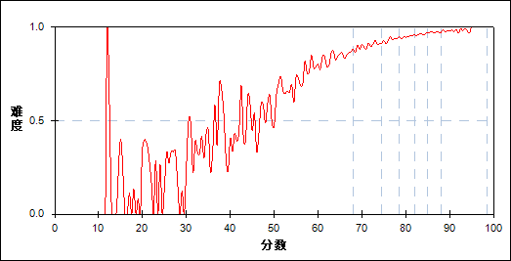

图 157 第46题分组难度曲线图

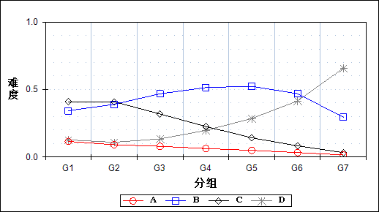

表 316 第46题分组分析表

| 选项 | G1 | G2 | G3 | G4 | G5 | G6 | G7 | 人数 | 比率(%) | 相关系数 |
| --- | --- | --- | --- | --- | --- | --- | --- | --- | --- | --- |
| Ａ | 947 | 745 | 647 | 512 | 405 | 269 | 123 | 3648 | 6.37 | -0.13 |
| Ｂ | 2800 | 3194 | 3831 | 4208 | 4282 | 3836 | 2410 | 24561 | 42.88 | 0.04 |
| Ｃ | 3353 | 3348 | 2607 | 1848 | 1161 | 678 | 266 | 13261 | 23.15 | -0.27 |
| *Ｄ | 1039 | 894 | 1096 | 1611 | 2334 | 3396 | 5383 | 15753 | 27.50 | 0.29 |
| 未选或多选 | 45 | 3 | 3 | 5 | 1 | 4 | 1 | 62 | 0.11 | -0.13 |
| 合计 | 8184 | 8184 | 8184 | 8184 | 8183 | 8183 | 8183 | 57285 | 100.00 | - |
| 得分率 | 0.73 | 0.90 | 0.93 | 0.95 | 0.96 | 0.97 | 0.98 | - | - | - |

表 317 第46题等级分析表

| 分值 | 优秀 | | 良好 | | 合格 | | 不合格 | | 全体 | |
| --- | --- | --- | --- | --- | --- | --- | --- | --- | --- | --- |
| 人数 | 比率 | 人数 | 比率 | 人数 | 比率 | 人数 | 比率 | 人数 | 比率 |
| Ａ | 399 | 10.9 | 2144 | 58.8 | 600 | 16.4 | 505 | 13.8 | 3648 | 100.0 |
| Ｂ | 6358 | 25.9 | 14721 | 59.9 | 2341 | 9.5 | 1141 | 4.6 | 24561 | 100.0 |
| Ｃ | 964 | 7.3 | 8255 | 62.3 | 2648 | 20.0 | 1394 | 10.5 | 13261 | 100.0 |
| *Ｄ | 8872 | 56.3 | 5666 | 36.0 | 709 | 4.5 | 506 | 3.2 | 15753 | 100.0 |
| 未选或多选 | 5 | 8.1 | 11 | 17.7 | 6 | 9.7 | 40 | 64.5 | 62 | 100.0 |
| 合计 | 16598 | 29.0 | 30797 | 53.8 | 6304 | 11.0 | 3586 | 6.3 | 57285 | 100.0 |

* + 1. 第47题

表 318 第47题分析表

|  |  |  |  |  |  |  |  |  |
| --- | --- | --- | --- | --- | --- | --- | --- | --- |
| 人数 | 满分 | 最大值 | 最小值 | 平均值 | 标准差 | 差异系数 | 难度 | 区分度 |
| 57285 | 2 | 2.0 | 0.0 | 1.98 | 0.19 | 0.10 | 0.99 | 0.29 |

表 319 第47题等级得分率分析表

|  |  |  |  |  |
| --- | --- | --- | --- | --- |
| 优秀 | 良好 | 合格 | 不及格 | 全体 |
| 1.00 | 1.00 | 0.99 | 0.90 | 0.99 |

图 158 第47题难度曲线图

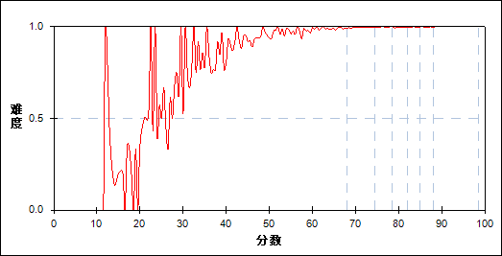

图 159 第47题分组难度曲线图

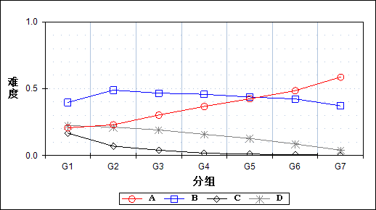

表 320 第47题分组分析表

| 选项 | G1 | G2 | G3 | G4 | G5 | G6 | G7 | 人数 | 比率(%) | 相关系数 |
| --- | --- | --- | --- | --- | --- | --- | --- | --- | --- | --- |
| *Ａ | 1693 | 1879 | 2477 | 3000 | 3469 | 3966 | 4797 | 21281 | 37.15 | 0.23 |
| Ｂ | 3245 | 4000 | 3816 | 3746 | 3579 | 3464 | 3041 | 24891 | 43.45 | 0.00 |
| Ｃ | 1370 | 570 | 327 | 143 | 88 | 49 | 17 | 2564 | 4.48 | -0.27 |
| Ｄ | 1835 | 1735 | 1564 | 1295 | 1047 | 703 | 328 | 8507 | 14.85 | -0.14 |
| 未选或多选 | 41 | 0 | 0 | 0 | 0 | 1 | 0 | 42 | 0.07 | -0.15 |
| 合计 | 8184 | 8184 | 8184 | 8184 | 8183 | 8183 | 8183 | 57285 | 100.00 | - |
| 得分率 | 0.95 | 1.00 | 1.00 | 1.00 | 1.00 | 1.00 | 1.00 | - | - | - |

表 321 第47题等级分析表

| 分值 | 优秀 | | 良好 | | 合格 | | 不合格 | | 全体 | |
| --- | --- | --- | --- | --- | --- | --- | --- | --- | --- | --- |
| 人数 | 比率 | 人数 | 比率 | 人数 | 比率 | 人数 | 比率 | 人数 | 比率 |
| *Ａ | 8874 | 41.7 | 10355 | 48.7 | 1310 | 6.2 | 742 | 3.5 | 21281 | 100.0 |
| Ｂ | 6606 | 26.5 | 14175 | 56.9 | 2853 | 11.5 | 1257 | 5.1 | 24891 | 100.0 |
| Ｃ | 66 | 2.6 | 988 | 38.5 | 725 | 28.3 | 785 | 30.6 | 2564 | 100.0 |
| Ｄ | 1051 | 12.4 | 5279 | 62.1 | 1415 | 16.6 | 762 | 9.0 | 8507 | 100.0 |
| 未选或多选 | 1 | 2.4 | 0 | 0.0 | 1 | 2.4 | 40 | 95.2 | 42 | 100.0 |
| 合计 | 16598 | 29.0 | 30797 | 53.8 | 6304 | 11.0 | 3586 | 6.3 | 57285 | 100.0 |

* + 1. 第48题

表 322 第48题分析表

|  |  |  |  |  |  |  |  |  |
| --- | --- | --- | --- | --- | --- | --- | --- | --- |
| 人数 | 满分 | 最大值 | 最小值 | 平均值 | 标准差 | 差异系数 | 难度 | 区分度 |
| 57285 | 2 | 2.0 | 0.0 | 1.96 | 0.28 | 0.15 | 0.98 | 0.26 |

表 323 第48题等级得分率分析表

|  |  |  |  |  |
| --- | --- | --- | --- | --- |
| 优秀 | 良好 | 合格 | 不及格 | 全体 |
| 1.00 | 0.99 | 0.97 | 0.86 | 0.98 |

图 160 第48题难度曲线图

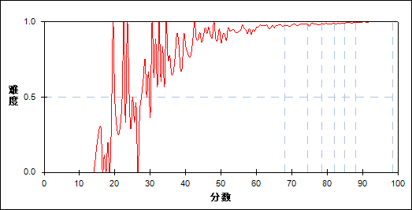

图 161 第48题分组难度曲线图

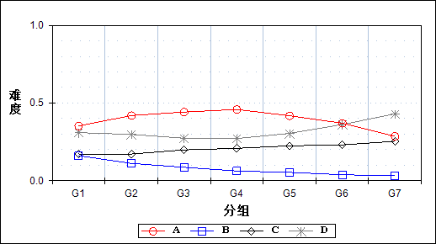

表 324 第48题分组分析表

| 选项 | G1 | G2 | G3 | G4 | G5 | G6 | G7 | 人数 | 比率(%) | 相关系数 |
| --- | --- | --- | --- | --- | --- | --- | --- | --- | --- | --- |
| Ａ | 2881 | 3430 | 3616 | 3751 | 3418 | 3025 | 2337 | 22458 | 39.20 | 0.00 |
| Ｂ | 1317 | 911 | 705 | 510 | 439 | 311 | 254 | 4447 | 7.76 | -0.17 |
| *Ｃ | 1410 | 1404 | 1623 | 1702 | 1834 | 1888 | 2075 | 11936 | 20.84 | 0.05 |
| Ｄ | 2534 | 2437 | 2237 | 2220 | 2490 | 2958 | 3517 | 18393 | 32.11 | 0.06 |
| 未选或多选 | 42 | 2 | 3 | 1 | 2 | 1 | 0 | 51 | 0.09 | -0.14 |
| 合计 | 8184 | 8184 | 8184 | 8184 | 8183 | 8183 | 8183 | 57285 | 100.00 | - |
| 得分率 | 0.92 | 0.98 | 0.98 | 0.99 | 0.99 | 0.99 | 1.00 | - | - | - |

表 325 第48题等级分析表

| 分值 | 优秀 | | 良好 | | 合格 | | 不合格 | | 全体 | |
| --- | --- | --- | --- | --- | --- | --- | --- | --- | --- | --- |
| 人数 | 比率 | 人数 | 比率 | 人数 | 比率 | 人数 | 比率 | 人数 | 比率 |
| Ａ | 5453 | 24.3 | 13443 | 59.9 | 2464 | 11.0 | 1098 | 4.9 | 22458 | 100.0 |
| Ｂ | 577 | 13.0 | 2380 | 53.5 | 789 | 17.7 | 701 | 15.8 | 4447 | 100.0 |
| *Ｃ | 4005 | 33.6 | 6257 | 52.4 | 979 | 8.2 | 695 | 5.8 | 11936 | 100.0 |
| Ｄ | 6562 | 35.7 | 8710 | 47.4 | 2070 | 11.3 | 1051 | 5.7 | 18393 | 100.0 |
| 未选或多选 | 1 | 2.0 | 7 | 13.7 | 2 | 3.9 | 41 | 80.4 | 51 | 100.0 |
| 合计 | 16598 | 29.0 | 30797 | 53.8 | 6304 | 11.0 | 3586 | 6.3 | 57285 | 100.0 |

* + 1. 第49题

表 326 第49题分析表

|  |  |  |  |  |  |  |  |  |
| --- | --- | --- | --- | --- | --- | --- | --- | --- |
| 人数 | 满分 | 最大值 | 最小值 | 平均值 | 标准差 | 差异系数 | 难度 | 区分度 |
| 57285 | 2 | 2.0 | 0.0 | 1.93 | 0.38 | 0.19 | 0.96 | 0.37 |

表 327 第49题等级得分率分析表

|  |  |  |  |  |
| --- | --- | --- | --- | --- |
| 优秀 | 良好 | 合格 | 不及格 | 全体 |
| 1.00 | 0.98 | 0.94 | 0.71 | 0.96 |

图 162 第49题难度曲线图

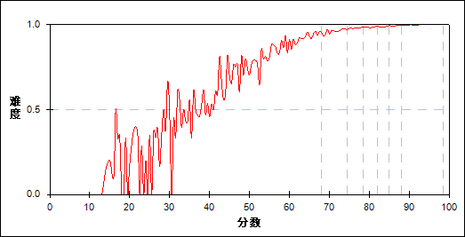

图 163 第49题分组难度曲线图

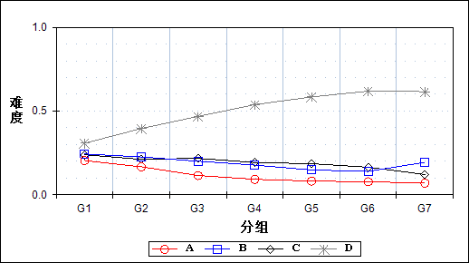

表 328 第49题分组分析表

| 选项 | G1 | G2 | G3 | G4 | G5 | G6 | G7 | 人数 | 比率(%) | 相关系数 |
| --- | --- | --- | --- | --- | --- | --- | --- | --- | --- | --- |
| Ａ | 1674 | 1364 | 940 | 755 | 671 | 634 | 569 | 6607 | 11.53 | -0.13 |
| *Ｂ | 1992 | 1849 | 1639 | 1450 | 1213 | 1140 | 1585 | 10868 | 18.97 | -0.07 |
| Ｃ | 1957 | 1731 | 1779 | 1574 | 1519 | 1344 | 992 | 10896 | 19.02 | -0.08 |
| Ｄ | 2517 | 3238 | 3826 | 4402 | 4779 | 5065 | 5036 | 28863 | 50.38 | 0.21 |
| 未选或多选 | 44 | 2 | 0 | 3 | 1 | 0 | 1 | 51 | 0.09 | -0.15 |
| 合计 | 8184 | 8184 | 8184 | 8184 | 8183 | 8183 | 8183 | 57285 | 100.00 | - |
| 得分率 | 0.84 | 0.96 | 0.98 | 0.99 | 0.99 | 0.99 | 1.00 | - | - | - |

表 329 第49题等级分析表

| 分值 | 优秀 | | 良好 | | 合格 | | 不合格 | | 全体 | |
| --- | --- | --- | --- | --- | --- | --- | --- | --- | --- | --- |
| 人数 | 比率 | 人数 | 比率 | 人数 | 比率 | 人数 | 比率 | 人数 | 比率 |
| Ａ | 1214 | 18.4 | 3365 | 50.9 | 1295 | 19.6 | 733 | 11.1 | 6607 | 100.0 |
| *Ｂ | 2755 | 25.3 | 5715 | 52.6 | 1488 | 13.7 | 910 | 8.4 | 10868 | 100.0 |
| Ｃ | 2370 | 21.8 | 6230 | 57.2 | 1385 | 12.7 | 911 | 8.4 | 10896 | 100.0 |
| Ｄ | 10258 | 35.5 | 15482 | 53.6 | 2132 | 7.4 | 991 | 3.4 | 28863 | 100.0 |
| 未选或多选 | 1 | 2.0 | 5 | 9.8 | 4 | 7.8 | 41 | 80.4 | 51 | 100.0 |
| 合计 | 16598 | 29.0 | 30797 | 53.8 | 6304 | 11.0 | 3586 | 6.3 | 57285 | 100.0 |

* + 1. 第50题

表 330 第50题分析表

|  |  |  |  |  |  |  |  |  |
| --- | --- | --- | --- | --- | --- | --- | --- | --- |
| 人数 | 满分 | 最大值 | 最小值 | 平均值 | 标准差 | 差异系数 | 难度 | 区分度 |
| 57285 | 2 | 2.0 | 0.0 | 1.62 | 0.79 | 0.48 | 0.81 | 0.43 |

表 331 第50题等级得分率分析表

|  |  |  |  |  |
| --- | --- | --- | --- | --- |
| 优秀 | 良好 | 合格 | 不及格 | 全体 |
| 0.98 | 0.81 | 0.55 | 0.44 | 0.81 |

图 164 第50题难度曲线图

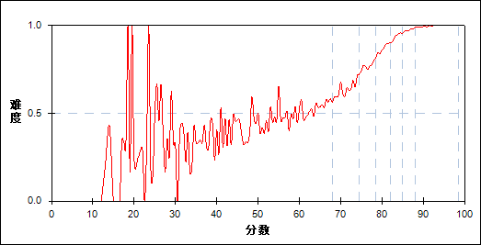

图 165 第50题分组难度曲线图

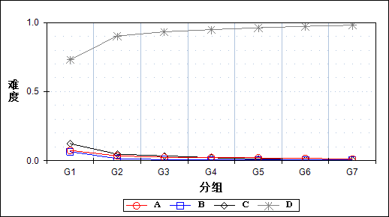

表 332 第50题分组分析表

| 选项 | G1 | G2 | G3 | G4 | G5 | G6 | G7 | 人数 | 比率(%) | 相关系数 |
| --- | --- | --- | --- | --- | --- | --- | --- | --- | --- | --- |
| Ａ | 609 | 287 | 205 | 193 | 171 | 134 | 96 | 1695 | 2.96 | -0.14 |
| Ｂ | 534 | 126 | 61 | 52 | 42 | 38 | 36 | 889 | 1.55 | -0.20 |
| Ｃ | 1010 | 388 | 284 | 178 | 102 | 55 | 30 | 2047 | 3.57 | -0.24 |
| *Ｄ | 5988 | 7382 | 7634 | 7761 | 7868 | 7956 | 8021 | 52610 | 91.84 | 0.35 |
| 未选或多选 | 43 | 1 | 0 | 0 | 0 | 0 | 0 | 44 | 0.08 | -0.15 |
| 合计 | 8184 | 8184 | 8184 | 8184 | 8183 | 8183 | 8183 | 57285 | 100.00 | - |
| 得分率 | 0.49 | 0.64 | 0.77 | 0.87 | 0.93 | 0.97 | 0.99 | - | - | - |

表 333 第50题等级分析表

| 分值 | 优秀 | | 良好 | | 合格 | | 不合格 | | 全体 | |
| --- | --- | --- | --- | --- | --- | --- | --- | --- | --- | --- |
| 人数 | 比率 | 人数 | 比率 | 人数 | 比率 | 人数 | 比率 | 人数 | 比率 |
| Ａ | 232 | 13.7 | 781 | 46.1 | 288 | 17.0 | 394 | 23.2 | 1695 | 100.0 |
| Ｂ | 74 | 8.3 | 239 | 26.9 | 197 | 22.2 | 379 | 42.6 | 889 | 100.0 |
| Ｃ | 88 | 4.3 | 875 | 42.7 | 425 | 20.8 | 659 | 32.2 | 2047 | 100.0 |
| *Ｄ | 16204 | 30.8 | 28902 | 54.9 | 5391 | 10.2 | 2113 | 4.0 | 52610 | 100.0 |
| 未选或多选 | 0 | 0.0 | 0 | 0.0 | 3 | 6.8 | 41 | 93.2 | 44 | 100.0 |
| 合计 | 16598 | 29.0 | 30797 | 53.8 | 6304 | 11.0 | 3586 | 6.3 | 57285 | 100.0 |

* + 1. 第51题

表 334 第51题分析表

|  |  |  |  |  |  |  |  |  |
| --- | --- | --- | --- | --- | --- | --- | --- | --- |
| 人数 | 满分 | 最大值 | 最小值 | 平均值 | 标准差 | 差异系数 | 难度 | 区分度 |
| 57285 | 2 | 2.0 | 0.0 | 1.89 | 0.45 | 0.24 | 0.95 | 0.39 |

表 335 第51题等级得分率分析表

|  |  |  |  |  |
| --- | --- | --- | --- | --- |
| 优秀 | 良好 | 合格 | 不及格 | 全体 |
| 1.00 | 0.97 | 0.86 | 0.67 | 0.95 |

图 166 第51题难度曲线图

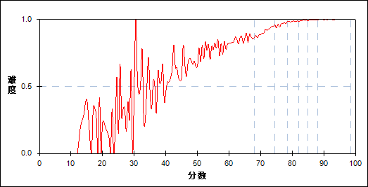

图 167 第51题分组难度曲线图

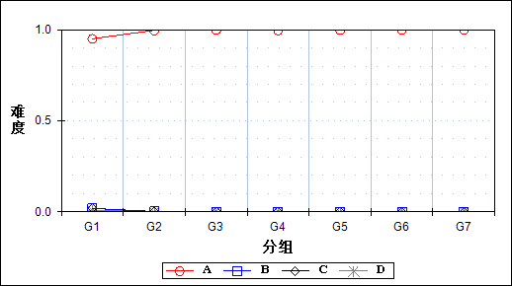

表 336 第51题分组分析表

| 选项 | G1 | G2 | G3 | G4 | G5 | G6 | G7 | 人数 | 比率(%) | 相关系数 |
| --- | --- | --- | --- | --- | --- | --- | --- | --- | --- | --- |
| *Ａ | 7774 | 8151 | 8167 | 8154 | 8166 | 8174 | 8179 | 56765 | 99.09 | 0.29 |
| Ｂ | 151 | 11 | 1 | 10 | 3 | 0 | 1 | 177 | 0.31 | -0.18 |
| Ｃ | 155 | 15 | 11 | 12 | 10 | 2 | 3 | 208 | 0.36 | -0.16 |
| Ｄ | 66 | 6 | 5 | 7 | 4 | 7 | 0 | 95 | 0.17 | -0.10 |
| 未选或多选 | 38 | 1 | 0 | 1 | 0 | 0 | 0 | 40 | 0.07 | -0.16 |
| 合计 | 8184 | 8184 | 8184 | 8184 | 8183 | 8183 | 8183 | 57285 | 100.00 | - |
| 得分率 | 0.77 | 0.91 | 0.96 | 0.99 | 0.99 | 1.00 | 1.00 | - | - | - |

表 337 第51题等级分析表

| 分值 | 优秀 | | 良好 | | 合格 | | 不合格 | | 全体 | |
| --- | --- | --- | --- | --- | --- | --- | --- | --- | --- | --- |
| 人数 | 比率 | 人数 | 比率 | 人数 | 比率 | 人数 | 比率 | 人数 | 比率 |
| *Ａ | 16584 | 29.2 | 30711 | 54.1 | 6249 | 11.0 | 3221 | 5.7 | 56765 | 100.0 |
| Ｂ | 1 | 0.6 | 21 | 11.9 | 15 | 8.5 | 140 | 79.1 | 177 | 100.0 |
| Ｃ | 6 | 2.9 | 43 | 20.7 | 30 | 14.4 | 129 | 62.0 | 208 | 100.0 |
| Ｄ | 7 | 7.4 | 21 | 22.1 | 9 | 9.5 | 58 | 61.1 | 95 | 100.0 |
| 未选或多选 | 0 | 0.0 | 1 | 2.5 | 1 | 2.5 | 38 | 95.0 | 40 | 100.0 |
| 合计 | 16598 | 29.0 | 30797 | 53.8 | 6304 | 11.0 | 3586 | 6.3 | 57285 | 100.0 |

* + 1. 第52题

表 338 第52题分析表

|  |  |  |  |  |  |  |  |  |
| --- | --- | --- | --- | --- | --- | --- | --- | --- |
| 人数 | 满分 | 最大值 | 最小值 | 平均值 | 标准差 | 差异系数 | 难度 | 区分度 |
| 57285 | 2 | 2.0 | 0.0 | 1.71 | 0.71 | 0.41 | 0.85 | 0.43 |

表 339 第52题等级得分率分析表

|  |  |  |  |  |
| --- | --- | --- | --- | --- |
| 优秀 | 良好 | 合格 | 不及格 | 全体 |
| 0.99 | 0.86 | 0.69 | 0.44 | 0.85 |

图 168 第52题难度曲线图

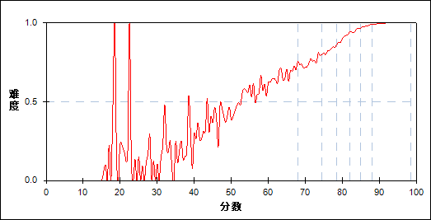

图 169 第52题分组难度曲线图

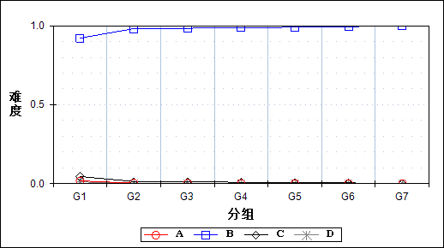

表 340 第52题分组分析表

| 选项 | G1 | G2 | G3 | G4 | G5 | G6 | G7 | 人数 | 比率(%) | 相关系数 |
| --- | --- | --- | --- | --- | --- | --- | --- | --- | --- | --- |
| Ａ | 145 | 26 | 23 | 18 | 11 | 8 | 2 | 233 | 0.41 | -0.14 |
| *Ｂ | 7541 | 8029 | 8049 | 8079 | 8102 | 8134 | 8165 | 56099 | 97.93 | 0.26 |
| Ｃ | 370 | 113 | 94 | 72 | 63 | 38 | 15 | 765 | 1.34 | -0.16 |
| Ｄ | 90 | 15 | 18 | 14 | 7 | 3 | 1 | 148 | 0.26 | -0.11 |
| 未选或多选 | 38 | 1 | 0 | 1 | 0 | 0 | 0 | 40 | 0.07 | -0.16 |
| 合计 | 8184 | 8184 | 8184 | 8184 | 8183 | 8183 | 8183 | 57285 | 100.00 | - |
| 得分率 | 0.57 | 0.75 | 0.83 | 0.90 | 0.95 | 0.98 | 0.99 | - | - | - |

表 341 第52题等级分析表

| 分值 | 优秀 | | 良好 | | 合格 | | 不合格 | | 全体 | |
| --- | --- | --- | --- | --- | --- | --- | --- | --- | --- | --- |
| 人数 | 比率 | 人数 | 比率 | 人数 | 比率 | 人数 | 比率 | 人数 | 比率 |
| Ａ | 10 | 4.3 | 70 | 30.0 | 29 | 12.4 | 124 | 53.2 | 233 | 100.0 |
| *Ｂ | 16530 | 29.5 | 30365 | 54.1 | 6134 | 10.9 | 3070 | 5.5 | 56099 | 100.0 |
| Ｃ | 54 | 7.1 | 311 | 40.7 | 121 | 15.8 | 279 | 36.5 | 765 | 100.0 |
| Ｄ | 4 | 2.7 | 50 | 33.8 | 19 | 12.8 | 75 | 50.7 | 148 | 100.0 |
| 未选或多选 | 0 | 0.0 | 1 | 2.5 | 1 | 2.5 | 38 | 95.0 | 40 | 100.0 |
| 合计 | 16598 | 29.0 | 30797 | 53.8 | 6304 | 11.0 | 3586 | 6.3 | 57285 | 100.0 |

* + 1. 第53题

表 342 第53题分析表

|  |  |  |  |  |  |  |  |  |
| --- | --- | --- | --- | --- | --- | --- | --- | --- |
| 人数 | 满分 | 最大值 | 最小值 | 平均值 | 标准差 | 差异系数 | 难度 | 区分度 |
| 57285 | 2 | 2.0 | 0.0 | 1.85 | 0.52 | 0.28 | 0.93 | 0.47 |

表 343 第53题等级得分率分析表

|  |  |  |  |  |
| --- | --- | --- | --- | --- |
| 优秀 | 良好 | 合格 | 不及格 | 全体 |
| 0.99 | 0.96 | 0.81 | 0.49 | 0.93 |

图 170 第53题难度曲线图

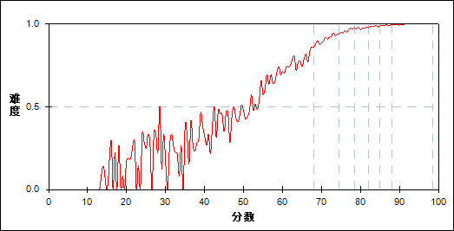

图 171 第53题分组难度曲线图

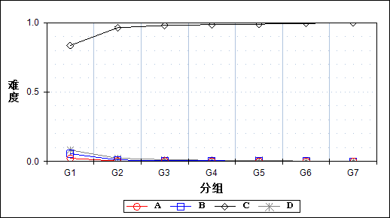

表 344 第53题分组分析表

| 选项 | G1 | G2 | G3 | G4 | G5 | G6 | G7 | 人数 | 比率(%) | 相关系数 |
| --- | --- | --- | --- | --- | --- | --- | --- | --- | --- | --- |
| Ａ | 187 | 22 | 20 | 13 | 7 | 9 | 0 | 258 | 0.45 | -0.17 |
| Ｂ | 454 | 90 | 40 | 40 | 22 | 14 | 8 | 668 | 1.17 | -0.22 |
| *Ｃ | 6834 | 7880 | 8019 | 8064 | 8091 | 8134 | 8165 | 55187 | 96.34 | 0.37 |
| Ｄ | 668 | 191 | 105 | 66 | 63 | 25 | 10 | 1128 | 1.97 | -0.22 |
| 未选或多选 | 41 | 1 | 0 | 1 | 0 | 1 | 0 | 44 | 0.08 | -0.16 |
| 合计 | 8184 | 8184 | 8184 | 8184 | 8183 | 8183 | 8183 | 57285 | 100.00 | - |
| 得分率 | 0.66 | 0.91 | 0.96 | 0.97 | 0.99 | 0.99 | 1.00 | - | - | - |

表 345 第53题等级分析表

| 分值 | 优秀 | | 良好 | | 合格 | | 不合格 | | 全体 | |
| --- | --- | --- | --- | --- | --- | --- | --- | --- | --- | --- |
| 人数 | 比率 | 人数 | 比率 | 人数 | 比率 | 人数 | 比率 | 人数 | 比率 |
| Ａ | 9 | 3.5 | 56 | 21.7 | 29 | 11.2 | 164 | 63.6 | 258 | 100.0 |
| Ｂ | 22 | 3.3 | 169 | 25.3 | 133 | 19.9 | 344 | 51.5 | 668 | 100.0 |
| *Ｃ | 16530 | 30.0 | 30196 | 54.7 | 5901 | 10.7 | 2560 | 4.6 | 55187 | 100.0 |
| Ｄ | 36 | 3.2 | 375 | 33.2 | 240 | 21.3 | 477 | 42.3 | 1128 | 100.0 |
| 未选或多选 | 1 | 2.3 | 1 | 2.3 | 1 | 2.3 | 41 | 93.2 | 44 | 100.0 |
| 合计 | 16598 | 29.0 | 30797 | 53.8 | 6304 | 11.0 | 3586 | 6.3 | 57285 | 100.0 |

* + 1. 第54题

表 346 第54题分析表

|  |  |  |  |  |  |  |  |  |
| --- | --- | --- | --- | --- | --- | --- | --- | --- |
| 人数 | 满分 | 最大值 | 最小值 | 平均值 | 标准差 | 差异系数 | 难度 | 区分度 |
| 57285 | 2 | 2.0 | 0.0 | 1.86 | 0.51 | 0.27 | 0.93 | 0.47 |

表 347 第54题等级得分率分析表

|  |  |  |  |  |
| --- | --- | --- | --- | --- |
| 优秀 | 良好 | 合格 | 不及格 | 全体 |
| 1.00 | 0.97 | 0.80 | 0.53 | 0.93 |

图 172 第54题难度曲线图

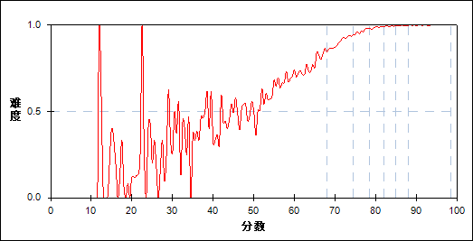

图 173 第54题分组难度曲线图

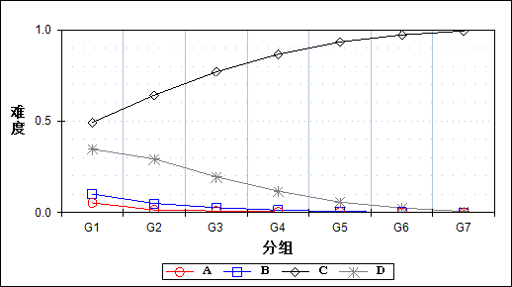

表 348 第54题分组分析表

| 选项 | G1 | G2 | G3 | G4 | G5 | G6 | G7 | 人数 | 比率(%) | 相关系数 |
| --- | --- | --- | --- | --- | --- | --- | --- | --- | --- | --- |
| Ａ | 433 | 118 | 72 | 32 | 25 | 17 | 5 | 702 | 1.23 | -0.18 |
| Ｂ | 831 | 409 | 221 | 107 | 52 | 12 | 3 | 1635 | 2.85 | -0.22 |
| *Ｃ | 4035 | 5253 | 6295 | 7083 | 7641 | 7951 | 8128 | 46386 | 80.97 | 0.43 |
| Ｄ | 2837 | 2397 | 1596 | 960 | 465 | 203 | 47 | 8505 | 14.85 | -0.30 |
| 未选或多选 | 48 | 7 | 0 | 2 | 0 | 0 | 0 | 57 | 0.10 | -0.15 |
| 合计 | 8184 | 8184 | 8184 | 8184 | 8183 | 8183 | 8183 | 57285 | 100.00 | - |
| 得分率 | 0.67 | 0.91 | 0.96 | 0.99 | 0.99 | 1.00 | 1.00 | - | - | - |

表 349 第54题等级分析表

| 分值 | 优秀 | | 良好 | | 合格 | | 不合格 | | 全体 | |
| --- | --- | --- | --- | --- | --- | --- | --- | --- | --- | --- |
| 人数 | 比率 | 人数 | 比率 | 人数 | 比率 | 人数 | 比率 | 人数 | 比率 |
| Ａ | 22 | 3.1 | 225 | 32.1 | 164 | 23.4 | 291 | 41.5 | 702 | 100.0 |
| Ｂ | 15 | 0.9 | 687 | 42.0 | 444 | 27.2 | 489 | 29.9 | 1635 | 100.0 |
| *Ｃ | 16302 | 35.1 | 25042 | 54.0 | 3482 | 7.5 | 1560 | 3.4 | 46386 | 100.0 |
| Ｄ | 259 | 3.0 | 4837 | 56.9 | 2208 | 26.0 | 1201 | 14.1 | 8505 | 100.0 |
| 未选或多选 | 0 | 0.0 | 6 | 10.5 | 6 | 10.5 | 45 | 78.9 | 57 | 100.0 |
| 合计 | 16598 | 29.0 | 30797 | 53.8 | 6304 | 11.0 | 3586 | 6.3 | 57285 | 100.0 |

* + 1. 第55题

表 350 第55题分析表

|  |  |  |  |  |  |  |  |  |
| --- | --- | --- | --- | --- | --- | --- | --- | --- |
| 人数 | 满分 | 最大值 | 最小值 | 平均值 | 标准差 | 差异系数 | 难度 | 区分度 |
| 57285 | 2 | 2.0 | 0.0 | 1.15 | 0.99 | 0.86 | 0.57 | 0.52 |

表 351 第55题等级得分率分析表

|  |  |  |  |  |
| --- | --- | --- | --- | --- |
| 优秀 | 良好 | 合格 | 不及格 | 全体 |
| 0.94 | 0.51 | 0.18 | 0.15 | 0.57 |

图 174 第55题难度曲线图

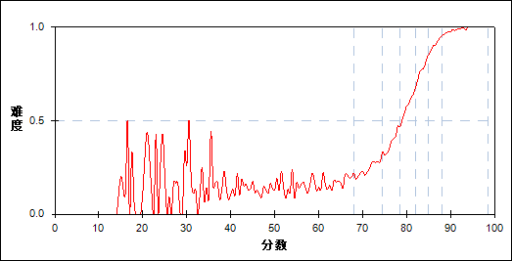

图 175 第55题分组难度曲线图

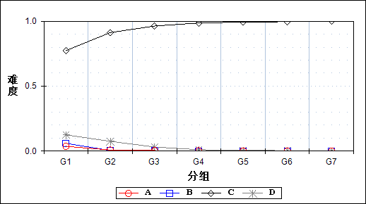

表 352 第55题分组分析表

| 选项 | G1 | G2 | G3 | G4 | G5 | G6 | G7 | 人数 | 比率(%) | 相关系数 |
| --- | --- | --- | --- | --- | --- | --- | --- | --- | --- | --- |
| Ａ | 300 | 66 | 35 | 19 | 12 | 7 | 1 | 440 | 0.77 | -0.18 |
| Ｂ | 489 | 36 | 15 | 10 | 3 | 1 | 0 | 554 | 0.97 | -0.27 |
| *Ｃ | 6331 | 7466 | 7878 | 8068 | 8120 | 8146 | 8179 | 54188 | 94.59 | 0.39 |
| Ｄ | 1022 | 614 | 255 | 86 | 48 | 29 | 3 | 2057 | 3.59 | -0.22 |
| 未选或多选 | 42 | 2 | 1 | 1 | 0 | 0 | 0 | 46 | 0.08 | -0.15 |
| 合计 | 8184 | 8184 | 8184 | 8184 | 8183 | 8183 | 8183 | 57285 | 100.00 | - |
| 得分率 | 0.16 | 0.25 | 0.39 | 0.58 | 0.76 | 0.90 | 0.97 | - | - | - |

表 353 第55题等级分析表

| 分值 | 优秀 | | 良好 | | 合格 | | 不合格 | | 全体 | |
| --- | --- | --- | --- | --- | --- | --- | --- | --- | --- | --- |
| 人数 | 比率 | 人数 | 比率 | 人数 | 比率 | 人数 | 比率 | 人数 | 比率 |
| Ａ | 8 | 1.8 | 116 | 26.4 | 81 | 18.4 | 235 | 53.4 | 440 | 100.0 |
| Ｂ | 1 | 0.2 | 51 | 9.2 | 86 | 15.5 | 416 | 75.1 | 554 | 100.0 |
| *Ｃ | 16556 | 30.6 | 29823 | 55.0 | 5420 | 10.0 | 2389 | 4.4 | 54188 | 100.0 |
| Ｄ | 33 | 1.6 | 805 | 39.1 | 715 | 34.8 | 504 | 24.5 | 2057 | 100.0 |
| 未选或多选 | 0 | 0.0 | 2 | 4.3 | 2 | 4.3 | 42 | 91.3 | 46 | 100.0 |
| 合计 | 16598 | 29.0 | 30797 | 53.8 | 6304 | 11.0 | 3586 | 6.3 | 57285 | 100.0 |

* + 1. 第56题

表 354 第56题分析表

|  |  |  |  |  |  |  |  |  |
| --- | --- | --- | --- | --- | --- | --- | --- | --- |
| 人数 | 满分 | 最大值 | 最小值 | 平均值 | 标准差 | 差异系数 | 难度 | 区分度 |
| 57285 | 2 | 2.0 | 0.0 | 0.75 | 0.97 | 1.29 | 0.38 | 0.30 |

表 355 第56题等级得分率分析表

|  |  |  |  |  |
| --- | --- | --- | --- | --- |
| 优秀 | 良好 | 合格 | 不及格 | 全体 |
| 0.60 | 0.32 | 0.16 | 0.16 | 0.38 |

图 176 第56题难度曲线图

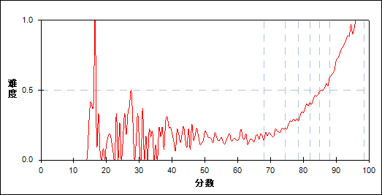

图 177 第56题分组难度曲线图

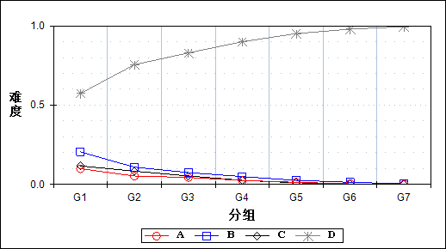

表 356 第56题分组分析表

| 选项 | G1 | G2 | G3 | G4 | G5 | G6 | G7 | 人数 | 比率(%) | 相关系数 |
| --- | --- | --- | --- | --- | --- | --- | --- | --- | --- | --- |
| Ａ | 810 | 433 | 359 | 205 | 110 | 33 | 8 | 1958 | 3.42 | -0.19 |
| Ｂ | 1678 | 889 | 608 | 405 | 209 | 109 | 28 | 3926 | 6.85 | -0.27 |
| Ｃ | 956 | 682 | 433 | 211 | 84 | 30 | 7 | 2403 | 4.19 | -0.21 |
| *Ｄ | 4693 | 6178 | 6783 | 7363 | 7780 | 8011 | 8140 | 48948 | 85.45 | 0.43 |
| 未选或多选 | 47 | 2 | 1 | 0 | 0 | 0 | 0 | 50 | 0.09 | -0.16 |
| 合计 | 8184 | 8184 | 8184 | 8184 | 8183 | 8183 | 8183 | 57285 | 100.00 | - |
| 得分率 | 0.16 | 0.20 | 0.27 | 0.36 | 0.44 | 0.52 | 0.69 | - | - | - |

表 357 第56题等级分析表

| 分值 | 优秀 | | 良好 | | 合格 | | 不合格 | | 全体 | |
| --- | --- | --- | --- | --- | --- | --- | --- | --- | --- | --- |
| 人数 | 比率 | 人数 | 比率 | 人数 | 比率 | 人数 | 比率 | 人数 | 比率 |
| Ａ | 43 | 2.2 | 1023 | 52.2 | 412 | 21.0 | 480 | 24.5 | 1958 | 100.0 |
| Ｂ | 140 | 3.6 | 1895 | 48.3 | 925 | 23.6 | 966 | 24.6 | 3926 | 100.0 |
| Ｃ | 37 | 1.5 | 1252 | 52.1 | 600 | 25.0 | 514 | 21.4 | 2403 | 100.0 |
| *Ｄ | 16378 | 33.5 | 26625 | 54.4 | 4366 | 8.9 | 1579 | 3.2 | 48948 | 100.0 |
| 未选或多选 | 0 | 0.0 | 2 | 4.0 | 1 | 2.0 | 47 | 94.0 | 50 | 100.0 |
| 合计 | 16598 | 29.0 | 30797 | 53.8 | 6304 | 11.0 | 3586 | 6.3 | 57285 | 100.0 |

* + 1. 第57题

表 358 第57题分析表

|  |  |  |  |  |  |  |  |  |
| --- | --- | --- | --- | --- | --- | --- | --- | --- |
| 人数 | 满分 | 最大值 | 最小值 | 平均值 | 标准差 | 差异系数 | 难度 | 区分度 |
| 57285 | 2 | 2.0 | 0.0 | 0.95 | 1.00 | 1.05 | 0.48 | 0.35 |

表 359 第57题等级得分率分析表

|  |  |  |  |  |
| --- | --- | --- | --- | --- |
| 优秀 | 良好 | 合格 | 不及格 | 全体 |
| 0.80 | 0.37 | 0.26 | 0.25 | 0.48 |

图 178 第57题难度曲线图



图 179 第57题分组难度曲线图

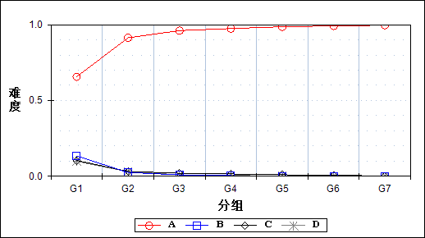

表 360 第57题分组分析表

| 选项 | G1 | G2 | G3 | G4 | G5 | G6 | G7 | 人数 | 比率(%) | 相关系数 |
| --- | --- | --- | --- | --- | --- | --- | --- | --- | --- | --- |
| *Ａ | 5374 | 7475 | 7863 | 7975 | 8069 | 8116 | 8155 | 53027 | 92.57 | 0.47 |
| Ｂ | 1097 | 204 | 76 | 36 | 10 | 6 | 5 | 1434 | 2.50 | -0.30 |
| Ｃ | 852 | 259 | 162 | 128 | 82 | 50 | 19 | 1552 | 2.71 | -0.23 |
| Ｄ | 809 | 243 | 82 | 45 | 22 | 11 | 4 | 1216 | 2.12 | -0.23 |
| 未选或多选 | 52 | 3 | 1 | 0 | 0 | 0 | 0 | 56 | 0.10 | -0.16 |
| 合计 | 8184 | 8184 | 8184 | 8184 | 8183 | 8183 | 8183 | 57285 | 100.00 | - |
| 得分率 | 0.26 | 0.27 | 0.32 | 0.39 | 0.49 | 0.70 | 0.91 | - | - | - |

表 361 第57题等级分析表

| 分值 | 优秀 | | 良好 | | 合格 | | 不合格 | | 全体 | |
| --- | --- | --- | --- | --- | --- | --- | --- | --- | --- | --- |
| 人数 | 比率 | 人数 | 比率 | 人数 | 比率 | 人数 | 比率 | 人数 | 比率 |
| *Ａ | 16500 | 31.1 | 29645 | 55.9 | 5110 | 9.6 | 1772 | 3.3 | 53027 | 100.0 |
| Ｂ | 11 | 0.8 | 267 | 18.6 | 443 | 30.9 | 713 | 49.7 | 1434 | 100.0 |
| Ｃ | 71 | 4.6 | 562 | 36.2 | 362 | 23.3 | 557 | 35.9 | 1552 | 100.0 |
| Ｄ | 16 | 1.3 | 321 | 26.4 | 385 | 31.7 | 494 | 40.6 | 1216 | 100.0 |
| 未选或多选 | 0 | 0.0 | 2 | 3.6 | 4 | 7.1 | 50 | 89.3 | 56 | 100.0 |
| 合计 | 16598 | 29.0 | 30797 | 53.8 | 6304 | 11.0 | 3586 | 6.3 | 57285 | 100.0 |

* + 1. 第58题

表 362 第58题分析表

|  |  |  |  |  |  |  |  |  |
| --- | --- | --- | --- | --- | --- | --- | --- | --- |
| 人数 | 满分 | 最大值 | 最小值 | 平均值 | 标准差 | 差异系数 | 难度 | 区分度 |
| 57285 | 2 | 2.0 | 0.0 | 0.35 | 0.76 | 2.16 | 0.18 | 0.08 |

表 363 第58题等级得分率分析表

|  |  |  |  |  |
| --- | --- | --- | --- | --- |
| 优秀 | 良好 | 合格 | 不及格 | 全体 |
| 0.24 | 0.15 | 0.13 | 0.17 | 0.18 |

图 180 第58题难度曲线图

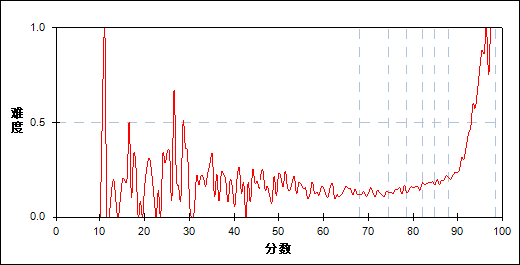

图 181 第58题分组难度曲线图

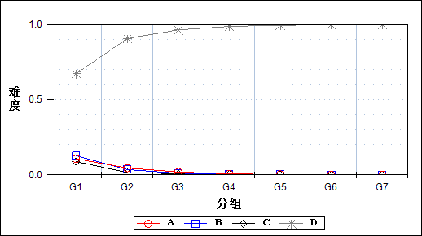

表 364 第58题分组分析表

| 选项 | G1 | G2 | G3 | G4 | G5 | G6 | G7 | 人数 | 比率(%) | 相关系数 |
| --- | --- | --- | --- | --- | --- | --- | --- | --- | --- | --- |
| Ａ | 873 | 364 | 155 | 48 | 19 | 6 | 1 | 1466 | 2.56 | -0.23 |
| Ｂ | 1040 | 284 | 84 | 38 | 18 | 6 | 1 | 1471 | 2.57 | -0.27 |
| Ｃ | 720 | 123 | 58 | 24 | 14 | 11 | 6 | 956 | 1.67 | -0.27 |
| *Ｄ | 5499 | 7412 | 7887 | 8074 | 8132 | 8160 | 8175 | 53339 | 93.11 | 0.47 |
| 未选或多选 | 52 | 1 | 0 | 0 | 0 | 0 | 0 | 53 | 0.09 | -0.16 |
| 合计 | 8184 | 8184 | 8184 | 8184 | 8183 | 8183 | 8183 | 57285 | 100.00 | - |
| 得分率 | 0.15 | 0.13 | 0.14 | 0.16 | 0.18 | 0.19 | 0.28 | - | - | - |

表 365 第58题等级分析表

| 分值 | 优秀 | | 良好 | | 合格 | | 不合格 | | 全体 | |
| --- | --- | --- | --- | --- | --- | --- | --- | --- | --- | --- |
| 人数 | 比率 | 人数 | 比率 | 人数 | 比率 | 人数 | 比率 | 人数 | 比率 |
| Ａ | 7 | 0.5 | 475 | 32.4 | 513 | 35.0 | 471 | 32.1 | 1466 | 100.0 |
| Ｂ | 7 | 0.5 | 340 | 23.1 | 501 | 34.1 | 623 | 42.4 | 1471 | 100.0 |
| Ｃ | 17 | 1.8 | 183 | 19.1 | 229 | 24.0 | 527 | 55.1 | 956 | 100.0 |
| *Ｄ | 16567 | 31.1 | 29799 | 55.9 | 5058 | 9.5 | 1915 | 3.6 | 53339 | 100.0 |
| 未选或多选 | 0 | 0.0 | 0 | 0.0 | 3 | 5.7 | 50 | 94.3 | 53 | 100.0 |
| 合计 | 16598 | 29.0 | 30797 | 53.8 | 6304 | 11.0 | 3586 | 6.3 | 57285 | 100.0 |

* + 1. 第59题

表 366 第59题分析表

|  |  |  |  |  |  |  |  |  |
| --- | --- | --- | --- | --- | --- | --- | --- | --- |
| 人数 | 满分 | 最大值 | 最小值 | 平均值 | 标准差 | 差异系数 | 难度 | 区分度 |
| 57285 | 1 | 1.0 | 0.0 | 0.96 | 0.19 | 0.19 | 0.96 | 0.35 |

表 367 第59题等级得分率分析表

|  |  |  |  |  |
| --- | --- | --- | --- | --- |
| 优秀 | 良好 | 合格 | 不及格 | 全体 |
| 1.00 | 0.98 | 0.92 | 0.74 | 0.96 |

图 182 第59题难度曲线图

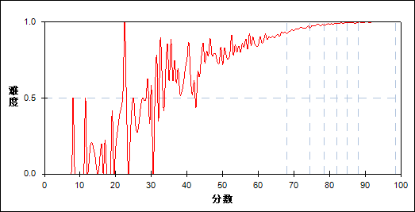

图 183 第59题分组难度曲线图

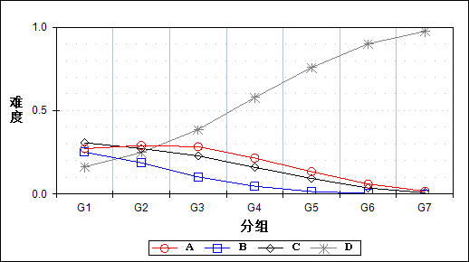

表 368 第59题分组分析表

| 选项 | G1 | G2 | G3 | G4 | G5 | G6 | G7 | 人数 | 比率(%) | 相关系数 |
| --- | --- | --- | --- | --- | --- | --- | --- | --- | --- | --- |
| Ａ | 2227 | 2379 | 2320 | 1762 | 1095 | 492 | 139 | 10414 | 18.18 | -0.19 |
| Ｂ | 2053 | 1532 | 836 | 381 | 121 | 30 | 1 | 4954 | 8.65 | -0.30 |
| Ｃ | 2515 | 2232 | 1868 | 1308 | 764 | 292 | 67 | 9046 | 15.79 | -0.25 |
| *Ｄ | 1335 | 2036 | 3158 | 4732 | 6203 | 7368 | 7976 | 32808 | 57.27 | 0.52 |
| 未选或多选 | 54 | 5 | 2 | 1 | 0 | 1 | 0 | 63 | 0.11 | -0.14 |
| 合计 | 8184 | 8184 | 8184 | 8184 | 8183 | 8183 | 8183 | 57285 | 100.00 | - |
| 得分率 | 0.84 | 0.96 | 0.98 | 0.99 | 0.99 | 1.00 | 1.00 | - | - | - |

表 369 第59题等级分析表

| 分值 | 优秀 | | 良好 | | 合格 | | 不合格 | | 全体 | |
| --- | --- | --- | --- | --- | --- | --- | --- | --- | --- | --- |
| 人数 | 比率 | 人数 | 比率 | 人数 | 比率 | 人数 | 比率 | 人数 | 比率 |
| Ａ | 658 | 6.3 | 7046 | 67.7 | 1760 | 16.9 | 950 | 9.1 | 10414 | 100.0 |
| Ｂ | 32 | 0.6 | 2470 | 49.9 | 1530 | 30.9 | 922 | 18.6 | 4954 | 100.0 |
| Ｃ | 369 | 4.1 | 5703 | 63.0 | 1843 | 20.4 | 1131 | 12.5 | 9046 | 100.0 |
| *Ｄ | 15538 | 47.4 | 15573 | 47.5 | 1160 | 3.5 | 537 | 1.6 | 32808 | 100.0 |
| 未选或多选 | 1 | 1.6 | 5 | 7.9 | 11 | 17.5 | 46 | 73.0 | 63 | 100.0 |
| 合计 | 16598 | 29.0 | 30797 | 53.8 | 6304 | 11.0 | 3586 | 6.3 | 57285 | 100.0 |

* + 1. 第60题

表 370 第60题分析表

|  |  |  |  |  |  |  |  |  |
| --- | --- | --- | --- | --- | --- | --- | --- | --- |
| 人数 | 满分 | 最大值 | 最小值 | 平均值 | 标准差 | 差异系数 | 难度 | 区分度 |
| 57285 | 1 | 1.0 | 0.0 | 0.89 | 0.31 | 0.35 | 0.89 | 0.45 |

表 371 第60题等级得分率分析表

|  |  |  |  |  |
| --- | --- | --- | --- | --- |
| 优秀 | 良好 | 合格 | 不及格 | 全体 |
| 0.99 | 0.92 | 0.72 | 0.45 | 0.89 |

图 184 第60题难度曲线图

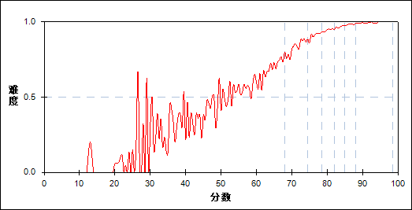

图 185 第60题分组难度曲线图

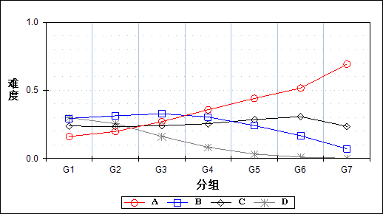

表 372 第60题分组分析表

| 选项 | G1 | G2 | G3 | G4 | G5 | G6 | G7 | 人数 | 比率(%) | 相关系数 |
| --- | --- | --- | --- | --- | --- | --- | --- | --- | --- | --- |
| *Ａ | 1317 | 1617 | 2210 | 2926 | 3605 | 4226 | 5663 | 21564 | 37.64 | 0.30 |
| Ｂ | 2403 | 2560 | 2686 | 2491 | 1977 | 1365 | 576 | 14058 | 24.54 | -0.13 |
| Ｃ | 1953 | 1909 | 1967 | 2090 | 2337 | 2510 | 1924 | 14690 | 25.64 | 0.02 |
| Ｄ | 2452 | 2093 | 1319 | 675 | 263 | 80 | 20 | 6902 | 12.05 | -0.29 |
| 未选或多选 | 59 | 5 | 2 | 2 | 1 | 2 | 0 | 71 | 0.12 | -0.14 |
| 合计 | 8184 | 8184 | 8184 | 8184 | 8183 | 8183 | 8183 | 57285 | 100.00 | - |
| 得分率 | 0.59 | 0.84 | 0.91 | 0.95 | 0.97 | 0.98 | 0.99 | - | - | - |

表 373 第60题等级分析表

| 分值 | 优秀 | | 良好 | | 合格 | | 不合格 | | 全体 | |
| --- | --- | --- | --- | --- | --- | --- | --- | --- | --- | --- |
| 人数 | 比率 | 人数 | 比率 | 人数 | 比率 | 人数 | 比率 | 人数 | 比率 |
| *Ａ | 10006 | 46.4 | 9931 | 46.1 | 1038 | 4.8 | 589 | 2.7 | 21564 | 100.0 |
| Ｂ | 1980 | 14.1 | 9183 | 65.3 | 1810 | 12.9 | 1085 | 7.7 | 14058 | 100.0 |
| Ｃ | 4508 | 30.7 | 7837 | 53.3 | 1437 | 9.8 | 908 | 6.2 | 14690 | 100.0 |
| Ｄ | 102 | 1.5 | 3839 | 55.6 | 2007 | 29.1 | 954 | 13.8 | 6902 | 100.0 |
| 未选或多选 | 2 | 2.8 | 7 | 9.9 | 12 | 16.9 | 50 | 70.4 | 71 | 100.0 |
| 合计 | 16598 | 29.0 | 30797 | 53.8 | 6304 | 11.0 | 3586 | 6.3 | 57285 | 100.0 |

* + 1. 第61题

表 374 第61题分析表

|  |  |  |  |  |  |  |  |  |
| --- | --- | --- | --- | --- | --- | --- | --- | --- |
| 人数 | 满分 | 最大值 | 最小值 | 平均值 | 标准差 | 差异系数 | 难度 | 区分度 |
| 57285 | 1 | 1.0 | 0.0 | 0.87 | 0.33 | 0.38 | 0.87 | 0.51 |

表 375 第61题等级得分率分析表

|  |  |  |  |  |
| --- | --- | --- | --- | --- |
| 优秀 | 良好 | 合格 | 不及格 | 全体 |
| 0.99 | 0.91 | 0.67 | 0.34 | 0.87 |

图 186 第61题难度曲线图



图 187 第61题分组难度曲线图

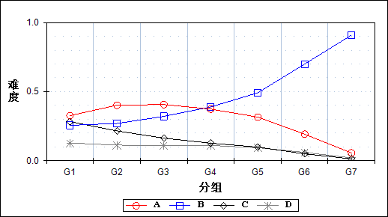

表 376 第61题分组分析表

| 选项 | G1 | G2 | G3 | G4 | G5 | G6 | G7 | 人数 | 比率(%) | 相关系数 |
| --- | --- | --- | --- | --- | --- | --- | --- | --- | --- | --- |
| Ａ | 2668 | 3286 | 3324 | 3057 | 2583 | 1570 | 463 | 16951 | 29.59 | -0.13 |
| *Ｂ | 2094 | 2203 | 2626 | 3183 | 4020 | 5717 | 7440 | 27283 | 47.63 | 0.35 |
| Ｃ | 2315 | 1763 | 1334 | 1039 | 808 | 406 | 111 | 7776 | 13.57 | -0.23 |
| Ｄ | 1050 | 925 | 897 | 904 | 767 | 489 | 168 | 5200 | 9.08 | -0.10 |
| 未选或多选 | 57 | 7 | 3 | 1 | 5 | 1 | 1 | 75 | 0.13 | -0.13 |
| 合计 | 8184 | 8184 | 8184 | 8184 | 8183 | 8183 | 8183 | 57285 | 100.00 | - |
| 得分率 | 0.51 | 0.80 | 0.90 | 0.94 | 0.97 | 0.99 | 0.99 | - | - | - |

表 377 第61题等级分析表

| 分值 | 优秀 | | 良好 | | 合格 | | 不合格 | | 全体 | |
| --- | --- | --- | --- | --- | --- | --- | --- | --- | --- | --- |
| 人数 | 比率 | 人数 | 比率 | 人数 | 比率 | 人数 | 比率 | 人数 | 比率 |
| Ａ | 2087 | 12.3 | 11528 | 68.0 | 2252 | 13.3 | 1084 | 6.4 | 16951 | 100.0 |
| *Ｂ | 13308 | 48.8 | 11460 | 42.0 | 1618 | 5.9 | 897 | 3.3 | 27283 | 100.0 |
| Ｃ | 525 | 6.8 | 4512 | 58.0 | 1687 | 21.7 | 1052 | 13.5 | 7776 | 100.0 |
| Ｄ | 676 | 13.0 | 3285 | 63.2 | 736 | 14.2 | 503 | 9.7 | 5200 | 100.0 |
| 未选或多选 | 2 | 2.7 | 12 | 16.0 | 11 | 14.7 | 50 | 66.7 | 75 | 100.0 |
| 合计 | 16598 | 29.0 | 30797 | 53.8 | 6304 | 11.0 | 3586 | 6.3 | 57285 | 100.0 |

* + 1. 第62题

表 378 第62题分析表

|  |  |  |  |  |  |  |  |  |
| --- | --- | --- | --- | --- | --- | --- | --- | --- |
| 人数 | 满分 | 最大值 | 最小值 | 平均值 | 标准差 | 差异系数 | 难度 | 区分度 |
| 57285 | 1 | 1.0 | 0.0 | 0.91 | 0.29 | 0.32 | 0.91 | 0.44 |

表 379 第62题等级得分率分析表

|  |  |  |  |  |
| --- | --- | --- | --- | --- |
| 优秀 | 良好 | 合格 | 不及格 | 全体 |
| 0.99 | 0.94 | 0.79 | 0.49 | 0.91 |

图 188 第62题难度曲线图

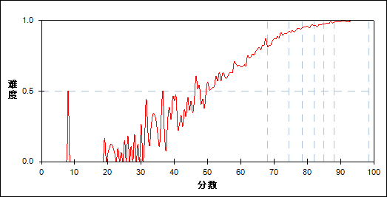

图 189 第62题分组难度曲线图

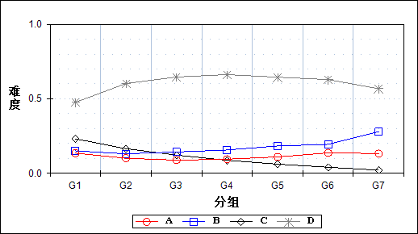

表 380 第62题分组分析表

| 选项 | G1 | G2 | G3 | G4 | G5 | G6 | G7 | 人数 | 比率(%) | 相关系数 |
| --- | --- | --- | --- | --- | --- | --- | --- | --- | --- | --- |
| Ａ | 1107 | 825 | 723 | 771 | 898 | 1121 | 1082 | 6527 | 11.39 | -0.01 |
| *Ｂ | 1233 | 1069 | 1172 | 1280 | 1501 | 1585 | 2285 | 10125 | 17.67 | 0.08 |
| Ｃ | 1893 | 1352 | 996 | 713 | 501 | 331 | 172 | 5958 | 10.40 | -0.22 |
| Ｄ | 3895 | 4929 | 5290 | 5420 | 5278 | 5144 | 4643 | 34599 | 60.40 | 0.09 |
| 未选或多选 | 56 | 9 | 3 | 0 | 5 | 2 | 1 | 76 | 0.13 | -0.13 |
| 合计 | 8184 | 8184 | 8184 | 8184 | 8183 | 8183 | 8183 | 57285 | 100.00 | - |
| 得分率 | 0.65 | 0.88 | 0.93 | 0.96 | 0.97 | 0.98 | 0.99 | - | - | - |

表 381 第62题等级分析表

| 分值 | 优秀 | | 良好 | | 合格 | | 不合格 | | 全体 | |
| --- | --- | --- | --- | --- | --- | --- | --- | --- | --- | --- |
| 人数 | 比率 | 人数 | 比率 | 人数 | 比率 | 人数 | 比率 | 人数 | 比率 |
| Ａ | 2233 | 34.2 | 3011 | 46.1 | 741 | 11.4 | 542 | 8.3 | 6527 | 100.0 |
| *Ｂ | 3913 | 38.6 | 4765 | 47.1 | 851 | 8.4 | 596 | 5.9 | 10125 | 100.0 |
| Ｃ | 508 | 8.5 | 3210 | 53.9 | 1350 | 22.7 | 890 | 14.9 | 5958 | 100.0 |
| Ｄ | 9941 | 28.7 | 19798 | 57.2 | 3351 | 9.7 | 1509 | 4.4 | 34599 | 100.0 |
| 未选或多选 | 3 | 3.9 | 13 | 17.1 | 11 | 14.5 | 49 | 64.5 | 76 | 100.0 |
| 合计 | 16598 | 29.0 | 30797 | 53.8 | 6304 | 11.0 | 3586 | 6.3 | 57285 | 100.0 |

* + 1. 第63题

表 382 第63题分析表

|  |  |  |  |  |  |  |  |  |
| --- | --- | --- | --- | --- | --- | --- | --- | --- |
| 人数 | 满分 | 最大值 | 最小值 | 平均值 | 标准差 | 差异系数 | 难度 | 区分度 |
| 57285 | 2 | 2.0 | 0.0 | 1.65 | 0.69 | 0.42 | 0.83 | 0.52 |

表 383 第63题等级得分率分析表

|  |  |  |  |  |
| --- | --- | --- | --- | --- |
| 优秀 | 良好 | 合格 | 不及格 | 全体 |
| 0.96 | 0.86 | 0.62 | 0.27 | 0.83 |

图 190 第63题难度曲线图

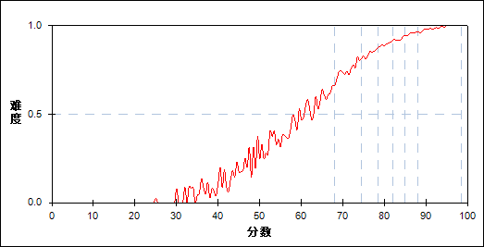

图 191 第63题分组难度曲线图

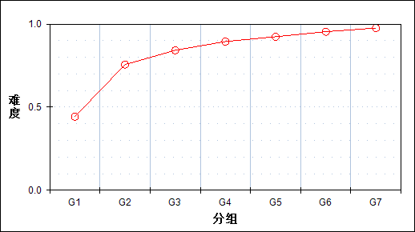

表 384 第63题分组分析表

| 分值 | G1 | G2 | G3 | G4 | G5 | G6 | G7 | 人数 | 比率(%) | 平均值 |
| --- | --- | --- | --- | --- | --- | --- | --- | --- | --- | --- |
| 0.0～ | 4211 | 1503 | 786 | 425 | 210 | 83 | 30 | 7248 | 12.65 | 62.35 |
| 0.5～ | 8 | 3 | 4 | 2 | 2 | 2 | 2 | 23 | 0.04 | 71.72 |
| 1.0～ | 679 | 960 | 990 | 856 | 811 | 570 | 319 | 5185 | 9.05 | 77.10 |
| 1.5～ | 15 | 28 | 26 | 29 | 25 | 24 | 18 | 165 | 0.29 | 79.03 |
| 2.0～ | 3271 | 5690 | 6378 | 6872 | 7135 | 7504 | 7814 | 44664 | 77.97 | 80.50 |
| 合计 | 8184 | 8184 | 8184 | 8184 | 8183 | 8183 | 8183 | 57285 | 100.00 | - |
| 得分率 | 0.44 | 0.76 | 0.84 | 0.89 | 0.92 | 0.95 | 0.98 | - | - | - |

表 385 第63题等级分析表

| 分值 | 优秀 | | 良好 | | 合格 | | 不合格 | | 全体 | |
| --- | --- | --- | --- | --- | --- | --- | --- | --- | --- | --- |
| 人数 | 比率 | 人数 | 比率 | 人数 | 比率 | 人数 | 比率 | 人数 | 比率 |
| 0.0～ | 116 | 1.6 | 2533 | 34.9 | 2090 | 28.8 | 2509 | 34.6 | 7248 | 100.0 |
| 0.5～ | 4 | 17.4 | 11 | 47.8 | 3 | 13.0 | 5 | 21.7 | 23 | 100.0 |
| 1.0～ | 909 | 17.5 | 3417 | 65.9 | 649 | 12.5 | 210 | 4.1 | 5185 | 100.0 |
| 1.5～ | 42 | 25.5 | 100 | 60.6 | 22 | 13.3 | 1 | 0.6 | 165 | 100.0 |
| 2.0～ | 15527 | 34.8 | 24736 | 55.4 | 3540 | 7.9 | 861 | 1.9 | 44664 | 100.0 |
| 合计 | 16598 | 29.0 | 30797 | 53.8 | 6304 | 11.0 | 3586 | 6.3 | 57285 | 100.0 |

* + 1. 第64题

表 386 第64题分析表

|  |  |  |  |  |  |  |  |  |
| --- | --- | --- | --- | --- | --- | --- | --- | --- |
| 人数 | 满分 | 最大值 | 最小值 | 平均值 | 标准差 | 差异系数 | 难度 | 区分度 |
| 57285 | 2 | 2.0 | 0.0 | 1.73 | 0.64 | 0.37 | 0.86 | 0.50 |

表 387 第64题等级得分率分析表

|  |  |  |  |  |
| --- | --- | --- | --- | --- |
| 优秀 | 良好 | 合格 | 不及格 | 全体 |
| 0.97 | 0.90 | 0.68 | 0.34 | 0.86 |

图 192 第64题难度曲线图

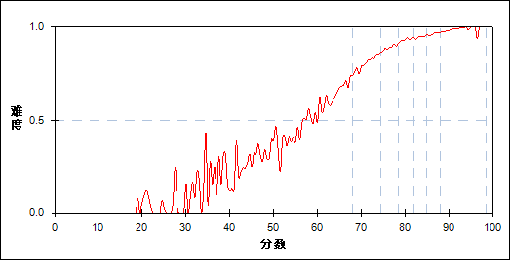

图 193 第64题分组难度曲线图

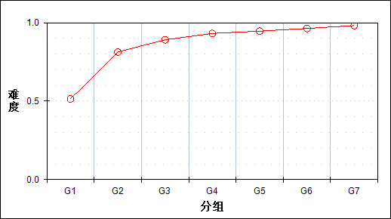

表 388 第64题分组分析表

| 分值 | G1 | G2 | G3 | G4 | G5 | G6 | G7 | 人数 | 比率(%) | 平均值 |
| --- | --- | --- | --- | --- | --- | --- | --- | --- | --- | --- |
| 0.0～ | 3784 | 1267 | 601 | 291 | 160 | 79 | 19 | 6201 | 10.82 | 61.42 |
| 0.5～ | 4 | 6 | 5 | 1 | 1 | 0 | 1 | 18 | 0.03 | 71.28 |
| 1.0～ | 373 | 503 | 571 | 536 | 552 | 432 | 256 | 3223 | 5.63 | 77.88 |
| 1.5～ | 9 | 8 | 9 | 3 | 12 | 12 | 5 | 58 | 0.10 | 78.28 |
| 2.0～ | 4014 | 6400 | 6998 | 7353 | 7458 | 7660 | 7902 | 47785 | 83.42 | 80.03 |
| 合计 | 8184 | 8184 | 8184 | 8184 | 8183 | 8183 | 8183 | 57285 | 100.00 | - |
| 得分率 | 0.51 | 0.81 | 0.89 | 0.93 | 0.95 | 0.96 | 0.98 | - | - | - |

表 389 第64题等级分析表

| 分值 | 优秀 | | 良好 | | 合格 | | 不合格 | | 全体 | |
| --- | --- | --- | --- | --- | --- | --- | --- | --- | --- | --- |
| 人数 | 比率 | 人数 | 比率 | 人数 | 比率 | 人数 | 比率 | 人数 | 比率 |
| 0.0～ | 99 | 1.6 | 1973 | 31.8 | 1838 | 29.6 | 2291 | 36.9 | 6201 | 100.0 |
| 0.5～ | 1 | 5.6 | 9 | 50.0 | 6 | 33.3 | 2 | 11.1 | 18 | 100.0 |
| 1.0～ | 700 | 21.7 | 2033 | 63.1 | 360 | 11.2 | 130 | 4.0 | 3223 | 100.0 |
| 1.5～ | 18 | 31.0 | 30 | 51.7 | 6 | 10.3 | 4 | 6.9 | 58 | 100.0 |
| 2.0～ | 15780 | 33.0 | 26752 | 56.0 | 4094 | 8.6 | 1159 | 2.4 | 47785 | 100.0 |
| 合计 | 16598 | 29.0 | 30797 | 53.8 | 6304 | 11.0 | 3586 | 6.3 | 57285 | 100.0 |

* + 1. 第65题

表 390 第65题分析表

|  |  |  |  |  |  |  |  |  |
| --- | --- | --- | --- | --- | --- | --- | --- | --- |
| 人数 | 满分 | 最大值 | 最小值 | 平均值 | 标准差 | 差异系数 | 难度 | 区分度 |
| 57285 | 2 | 2.0 | 0.0 | 1.27 | 0.72 | 0.57 | 0.64 | 0.58 |

表 391 第65题等级得分率分析表

|  |  |  |  |  |
| --- | --- | --- | --- | --- |
| 优秀 | 良好 | 合格 | 不及格 | 全体 |
| 0.86 | 0.63 | 0.33 | 0.15 | 0.64 |

图 194 第65题难度曲线图

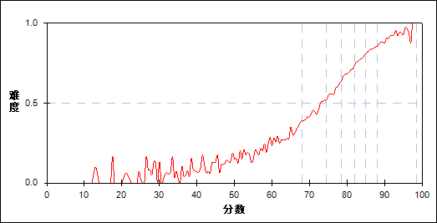

图 195 第65题分组难度曲线图

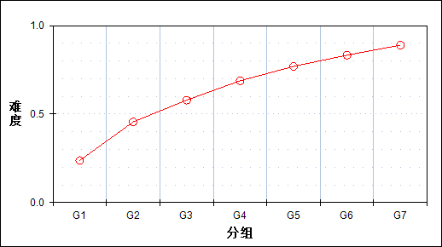

表 392 第65题分组分析表

| 分值 | G1 | G2 | G3 | G4 | G5 | G6 | G7 | 人数 | 比率(%) | 平均值 |
| --- | --- | --- | --- | --- | --- | --- | --- | --- | --- | --- |
| 0.0～ | 4711 | 2288 | 1222 | 645 | 286 | 114 | 41 | 9307 | 16.25 | 64.63 |
| 0.5～ | 57 | 55 | 35 | 29 | 6 | 3 | 4 | 189 | 0.33 | 71.36 |
| 1.0～ | 2961 | 4217 | 4359 | 3721 | 3144 | 2453 | 1675 | 22530 | 39.33 | 77.12 |
| 1.5～ | 12 | 72 | 70 | 102 | 93 | 95 | 86 | 530 | 0.93 | 81.43 |
| 2.0～ | 443 | 1552 | 2498 | 3687 | 4654 | 5518 | 6377 | 24729 | 43.17 | 83.55 |
| 合计 | 8184 | 8184 | 8184 | 8184 | 8183 | 8183 | 8183 | 57285 | 100.00 | - |
| 得分率 | 0.24 | 0.46 | 0.58 | 0.69 | 0.77 | 0.83 | 0.89 | - | - | - |

表 393 第65题等级分析表

| 分值 | 优秀 | | 良好 | | 合格 | | 不合格 | | 全体 | |
| --- | --- | --- | --- | --- | --- | --- | --- | --- | --- | --- |
| 人数 | 比率 | 人数 | 比率 | 人数 | 比率 | 人数 | 比率 | 人数 | 比率 |
| 0.0～ | 158 | 1.7 | 3865 | 41.5 | 2704 | 29.1 | 2580 | 27.7 | 9307 | 100.0 |
| 0.5～ | 7 | 3.7 | 114 | 60.3 | 48 | 25.4 | 20 | 10.6 | 189 | 100.0 |
| 1.0～ | 4207 | 18.7 | 14490 | 64.3 | 2925 | 13.0 | 908 | 4.0 | 22530 | 100.0 |
| 1.5～ | 182 | 34.3 | 324 | 61.1 | 22 | 4.2 | 2 | 0.4 | 530 | 100.0 |
| 2.0～ | 12044 | 48.7 | 12004 | 48.5 | 605 | 2.4 | 76 | 0.3 | 24729 | 100.0 |
| 合计 | 16598 | 29.0 | 30797 | 53.8 | 6304 | 11.0 | 3586 | 6.3 | 57285 | 100.0 |

* + 1. 第66题

表 394 第66题分析表

|  |  |  |  |  |  |  |  |  |
| --- | --- | --- | --- | --- | --- | --- | --- | --- |
| 人数 | 满分 | 最大值 | 最小值 | 平均值 | 标准差 | 差异系数 | 难度 | 区分度 |
| 57285 | 20 | 20.0 | 0.0 | 13.68 | 2.46 | 0.18 | 0.68 | 0.76 |

表 395 第66题等级得分率分析表

|  |  |  |  |  |
| --- | --- | --- | --- | --- |
| 优秀 | 良好 | 合格 | 不及格 | 全体 |
| 0.77 | 0.68 | 0.59 | 0.44 | 0.68 |

图 196 第66题难度曲线图



图 197 第66题分组难度曲线图

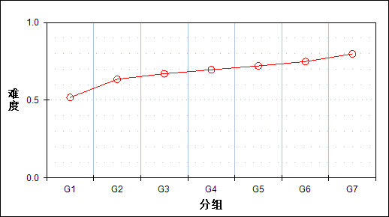

表 396 第66题分组分析表

| 分值 | G1 | G2 | G3 | G4 | G5 | G6 | G7 | 人数 | 比率(%) | 平均值 |
| --- | --- | --- | --- | --- | --- | --- | --- | --- | --- | --- |
| 0.0～ | 485 | 6 | 0 | 0 | 0 | 0 | 0 | 491 | 0.86 | 35.10 |
| 0.5～ | 36 | 1 | 0 | 0 | 0 | 0 | 0 | 37 | 0.06 | 43.69 |
| 1.0～ | 48 | 1 | 0 | 0 | 0 | 0 | 0 | 49 | 0.09 | 46.92 |
| 1.5～ | 34 | 1 | 1 | 0 | 0 | 0 | 0 | 36 | 0.06 | 46.08 |
| 2.0～ | 46 | 2 | 1 | 0 | 0 | 0 | 0 | 49 | 0.09 | 46.71 |
| 2.5～ | 32 | 1 | 0 | 0 | 0 | 0 | 0 | 33 | 0.06 | 44.65 |
| 3.0～ | 47 | 1 | 0 | 0 | 0 | 0 | 0 | 48 | 0.08 | 46.14 |
| 3.5～ | 39 | 0 | 1 | 0 | 0 | 0 | 0 | 40 | 0.07 | 46.65 |
| 4.0～ | 39 | 2 | 1 | 0 | 0 | 0 | 0 | 42 | 0.07 | 49.19 |
| 4.5～ | 36 | 5 | 0 | 0 | 0 | 0 | 0 | 41 | 0.07 | 51.88 |
| 5.0～ | 57 | 6 | 0 | 0 | 0 | 0 | 0 | 63 | 0.11 | 52.21 |
| 5.5～ | 29 | 3 | 0 | 0 | 0 | 0 | 0 | 32 | 0.06 | 52.31 |
| 6.0～ | 80 | 9 | 0 | 0 | 0 | 0 | 0 | 89 | 0.16 | 51.81 |
| 6.5～ | 49 | 7 | 2 | 0 | 0 | 0 | 0 | 58 | 0.10 | 58.05 |
| 7.0～ | 138 | 17 | 6 | 0 | 0 | 0 | 0 | 161 | 0.28 | 53.94 |
| 7.5～ | 55 | 8 | 2 | 3 | 0 | 0 | 0 | 68 | 0.12 | 58.00 |
| 8.0～ | 142 | 27 | 2 | 3 | 0 | 0 | 0 | 174 | 0.30 | 56.12 |
| 8.5～ | 105 | 18 | 5 | 0 | 0 | 0 | 0 | 128 | 0.22 | 57.29 |
| 9.0～ | 220 | 50 | 12 | 3 | 0 | 0 | 0 | 285 | 0.50 | 59.00 |
| 9.5～ | 197 | 62 | 9 | 7 | 0 | 0 | 0 | 275 | 0.48 | 60.67 |
| 10.0～ | 506 | 157 | 54 | 15 | 5 | 1 | 0 | 738 | 1.29 | 61.72 |
| 10.5～ | 467 | 236 | 78 | 35 | 12 | 4 | 0 | 832 | 1.45 | 65.12 |
| 11.0～ | 926 | 509 | 188 | 90 | 33 | 5 | 1 | 1752 | 3.06 | 65.32 |
| 11.5～ | 748 | 594 | 326 | 146 | 44 | 10 | 0 | 1868 | 3.26 | 68.72 |
| 12.0～ | 1098 | 1146 | 670 | 372 | 173 | 59 | 9 | 3527 | 6.16 | 70.52 |
| 12.5～ | 767 | 1058 | 939 | 616 | 316 | 115 | 13 | 3824 | 6.68 | 73.69 |
| 13.0～ | 750 | 1309 | 1247 | 912 | 660 | 311 | 69 | 5258 | 9.18 | 75.47 |
| 13.5～ | 438 | 1050 | 1364 | 1328 | 951 | 535 | 96 | 5762 | 10.06 | 77.72 |
| 14.0～ | 321 | 875 | 1239 | 1362 | 1373 | 1011 | 352 | 6533 | 11.40 | 79.55 |
| 14.5～ | 148 | 502 | 933 | 1374 | 1442 | 1253 | 607 | 6259 | 10.93 | 81.53 |
| 15.0～ | 67 | 324 | 625 | 880 | 1309 | 1526 | 1085 | 5816 | 10.15 | 83.09 |
| 15.5～ | 17 | 125 | 291 | 596 | 938 | 1422 | 1193 | 4582 | 8.00 | 84.88 |
| 16.0～ | 12 | 50 | 126 | 251 | 504 | 973 | 1534 | 3450 | 6.02 | 86.35 |
| 16.5～ | 4 | 9 | 45 | 125 | 264 | 563 | 1160 | 2170 | 3.79 | 87.61 |
| 17.0～ | 1 | 10 | 9 | 57 | 114 | 272 | 1013 | 1476 | 2.58 | 88.65 |
| 17.5～ | 0 | 1 | 5 | 8 | 33 | 82 | 582 | 711 | 1.24 | 90.00 |
| 18.0～ | 0 | 2 | 2 | 1 | 11 | 33 | 338 | 387 | 0.68 | 90.58 |
| 18.5～ | 0 | 0 | 0 | 0 | 1 | 5 | 104 | 110 | 0.19 | 91.97 |
| 19.0～ | 0 | 0 | 1 | 0 | 0 | 3 | 25 | 29 | 0.05 | 91.28 |
| 20.0～ | 0 | 0 | 0 | 0 | 0 | 0 | 2 | 2 | 0.00 | 95.00 |
| 合计 | 8184 | 8184 | 8184 | 8184 | 8183 | 8183 | 8183 | 57285 | 100.00 | - |
| 得分率 | 0.52 | 0.63 | 0.67 | 0.70 | 0.72 | 0.75 | 0.80 | - | - | - |

表 397 第66题等级分析表

| 分值 | 优秀 | | 良好 | | 合格 | | 不合格 | | 全体 | |
| --- | --- | --- | --- | --- | --- | --- | --- | --- | --- | --- |
| 人数 | 比率 | 人数 | 比率 | 人数 | 比率 | 人数 | 比率 | 人数 | 比率 |
| 0.0～ | 0 | 0.0 | 4 | 0.8 | 37 | 7.5 | 450 | 91.6 | 491 | 100.0 |
| 0.5～ | 0 | 0.0 | 1 | 2.7 | 4 | 10.8 | 32 | 86.5 | 37 | 100.0 |
| 1.0～ | 0 | 0.0 | 1 | 2.0 | 9 | 18.4 | 39 | 79.6 | 49 | 100.0 |
| 1.5～ | 0 | 0.0 | 2 | 5.6 | 4 | 11.1 | 30 | 83.3 | 36 | 100.0 |
| 2.0～ | 0 | 0.0 | 2 | 4.1 | 6 | 12.2 | 41 | 83.7 | 49 | 100.0 |
| 2.5～ | 0 | 0.0 | 1 | 3.0 | 8 | 24.2 | 24 | 72.7 | 33 | 100.0 |
| 3.0～ | 0 | 0.0 | 1 | 2.1 | 7 | 14.6 | 40 | 83.3 | 48 | 100.0 |
| 3.5～ | 0 | 0.0 | 1 | 2.5 | 11 | 27.5 | 28 | 70.0 | 40 | 100.0 |
| 4.0～ | 0 | 0.0 | 3 | 7.1 | 11 | 26.2 | 28 | 66.7 | 42 | 100.0 |
| 4.5～ | 0 | 0.0 | 3 | 7.3 | 15 | 36.6 | 23 | 56.1 | 41 | 100.0 |
| 5.0～ | 0 | 0.0 | 2 | 3.2 | 17 | 27.0 | 44 | 69.8 | 63 | 100.0 |
| 5.5～ | 0 | 0.0 | 0 | 0.0 | 11 | 34.4 | 21 | 65.6 | 32 | 100.0 |
| 6.0～ | 0 | 0.0 | 5 | 5.6 | 28 | 31.5 | 56 | 62.9 | 89 | 100.0 |
| 6.5～ | 0 | 0.0 | 6 | 10.3 | 21 | 36.2 | 31 | 53.4 | 58 | 100.0 |
| 7.0～ | 0 | 0.0 | 14 | 8.7 | 52 | 32.3 | 95 | 59.0 | 161 | 100.0 |
| 7.5～ | 0 | 0.0 | 7 | 10.3 | 24 | 35.3 | 37 | 54.4 | 68 | 100.0 |
| 8.0～ | 0 | 0.0 | 22 | 12.6 | 57 | 32.8 | 95 | 54.6 | 174 | 100.0 |
| 8.5～ | 0 | 0.0 | 15 | 11.7 | 48 | 37.5 | 65 | 50.8 | 128 | 100.0 |
| 9.0～ | 0 | 0.0 | 51 | 17.9 | 111 | 38.9 | 123 | 43.2 | 285 | 100.0 |
| 9.5～ | 0 | 0.0 | 59 | 21.5 | 102 | 37.1 | 114 | 41.5 | 275 | 100.0 |
| 10.0～ | 1 | 0.1 | 190 | 25.7 | 278 | 37.7 | 269 | 36.4 | 738 | 100.0 |
| 10.5～ | 4 | 0.5 | 281 | 33.8 | 325 | 39.1 | 222 | 26.7 | 832 | 100.0 |
| 11.0～ | 6 | 0.3 | 700 | 40.0 | 606 | 34.6 | 440 | 25.1 | 1752 | 100.0 |
| 11.5～ | 10 | 0.5 | 934 | 50.0 | 641 | 34.3 | 283 | 15.1 | 1868 | 100.0 |
| 12.0～ | 73 | 2.1 | 2104 | 59.7 | 949 | 26.9 | 401 | 11.4 | 3527 | 100.0 |
| 12.5～ | 128 | 3.3 | 2675 | 70.0 | 814 | 21.3 | 207 | 5.4 | 3824 | 100.0 |
| 13.0～ | 416 | 7.9 | 3865 | 73.5 | 821 | 15.6 | 156 | 3.0 | 5258 | 100.0 |
| 13.5～ | 632 | 11.0 | 4495 | 78.0 | 546 | 9.5 | 89 | 1.5 | 5762 | 100.0 |
| 14.0～ | 1428 | 21.9 | 4679 | 71.6 | 365 | 5.6 | 61 | 0.9 | 6533 | 100.0 |
| 14.5～ | 1860 | 29.7 | 4159 | 66.4 | 214 | 3.4 | 26 | 0.4 | 6259 | 100.0 |
| 15.0～ | 2691 | 46.3 | 3023 | 52.0 | 92 | 1.6 | 10 | 0.2 | 5816 | 100.0 |
| 15.5～ | 2615 | 57.1 | 1919 | 41.9 | 45 | 1.0 | 3 | 0.1 | 4582 | 100.0 |
| 16.0～ | 2541 | 73.7 | 890 | 25.8 | 17 | 0.5 | 2 | 0.1 | 3450 | 100.0 |
| 16.5～ | 1723 | 79.4 | 441 | 20.3 | 5 | 0.2 | 1 | 0.0 | 2170 | 100.0 |
| 17.0～ | 1294 | 87.7 | 180 | 12.2 | 2 | 0.1 | 0 | 0.0 | 1476 | 100.0 |
| 17.5～ | 665 | 93.5 | 46 | 6.5 | 0 | 0.0 | 0 | 0.0 | 711 | 100.0 |
| 18.0～ | 372 | 96.1 | 14 | 3.6 | 1 | 0.3 | 0 | 0.0 | 387 | 100.0 |
| 18.5～ | 109 | 99.1 | 1 | 0.9 | 0 | 0.0 | 0 | 0.0 | 110 | 100.0 |
| 19.0～ | 28 | 96.6 | 1 | 3.4 | 0 | 0.0 | 0 | 0.0 | 29 | 100.0 |
| 20.0～ | 2 | 100.0 | 0 | 0.0 | 0 | 0.0 | 0 | 0.0 | 2 | 100.0 |
| 合计 | 16598 | 29.0 | 30797 | 53.8 | 6304 | 11.0 | 3586 | 6.3 | 57285 | 100.0 |

1. 相关分析
   * 1. 主客观题组块

表 398主客观题组块相关分析表

|  | 客观题 | 主观题 | 总分 |
| --- | --- | --- | --- |
| 客观题 | - | 0.7182 | 0.9692 |
| 主观题 | 0.7182 | - | 0.8674 |
| 总分 | 0.9692 | 0.8674 | - |

* + 1. 组块分析

表 399组块分析相关分析表

|  | 知识组块 | 能力组块 | 总分 |
| --- | --- | --- | --- |
| 知识组块 | - | 0.7605 | 0.8932 |
| 能力组块 | 0.7605 | - | 0.9713 |
| 总分 | 0.8932 | 0.9713 | - |

* + 1. 类型分析

表 400类型分析相关分析表

|  | 基础性试题 | 发展性试题 | 总分 |
| --- | --- | --- | --- |
| 基础性试题 | - | 0.7342 | 0.8826 |
| 发展性试题 | 0.7342 | - | 0.9672 |
| 总分 | 0.8826 | 0.9672 | - |

* + 1. 大题分析

表 401大题分析相关分析表

|  | 听力理解 | 单项填空 | 完形填空 | 阅读理解 | 书面表达 | 总分 |
| --- | --- | --- | --- | --- | --- | --- |
| 听力理解 | - | 0.3476 | 0.3072 | 0.4528 | 0.5156 | 0.8039 |
| 单项填空 | 0.3476 | - | 0.2600 | 0.2772 | 0.3136 | 0.4889 |
| 完形填空 | 0.3072 | 0.2600 | - | 0.2558 | 0.2664 | 0.4623 |
| 阅读理解 | 0.4528 | 0.2772 | 0.2558 | - | 0.4991 | 0.6501 |
| 书面表达 | 0.5156 | 0.3136 | 0.2664 | 0.4991 | - | 0.7650 |
| 总分 | 0.8039 | 0.4889 | 0.4623 | 0.6501 | 0.7650 | - |

* + 1. 听力技能分析

表 402听力技能分析相关分析表

|  | 理解归纳主旨要义 | 获取事实性信息 | 简单推断 | 理解意图、态度和观点 | 记录信息 | 总分 |
| --- | --- | --- | --- | --- | --- | --- |
| 理解归纳主旨要义 | - | 0.4002 | 0.4158 | 0.2033 | 0.1837 | 0.3871 |
| 获取事实性信息 | 0.4002 | - | 0.5808 | 0.4017 | 0.2784 | 0.6595 |
| 简单推断 | 0.4158 | 0.5808 | - | 0.3192 | 0.2651 | 0.5676 |
| 理解意图、态度和观点 | 0.2033 | 0.4017 | 0.3192 | - | 0.1717 | 0.5082 |
| 记录信息 | 0.1837 | 0.2784 | 0.2651 | 0.1717 | - | 0.4490 |
| 总分 | 0.3871 | 0.6595 | 0.5676 | 0.5082 | 0.4490 | - |

* + 1. 语法分析

表 403语法分析相关分析表

|  | 动词及时态、语态 | 从句 | 虚词 | 比较等级 | 总分 |
| --- | --- | --- | --- | --- | --- |
| 动词及时态、语态 | - | 0.4574 | 0.5505 | 0.3036 | 0.7019 |
| 从句 | 0.4574 | - | 0.4083 | 0.2635 | 0.6615 |
| 虚词 | 0.5505 | 0.4083 | - | 0.3698 | 0.5716 |
| 比较等级 | 0.3036 | 0.2635 | 0.3698 | - | 0.3470 |
| 总分 | 0.7019 | 0.6615 | 0.5716 | 0.3470 | - |

* + 1. 词汇组块

表 404词汇组块相关分析表

|  | 动词 | 名词 | 形容词 | 连词 | 副词 | 总分 |
| --- | --- | --- | --- | --- | --- | --- |
| 动词 | - | 0.2569 | 0.2352 | 0.2065 | 0.2645 | 0.5219 |
| 名词 | 0.2569 | - | 0.2316 | 0.1628 | 0.2141 | 0.4891 |
| 形容词 | 0.2352 | 0.2316 | - | 0.2218 | 0.2803 | 0.5169 |
| 连词 | 0.2065 | 0.1628 | 0.2218 | - | 0.3101 | 0.3951 |
| 副词 | 0.2645 | 0.2141 | 0.2803 | 0.3101 | - | 0.4975 |
| 总分 | 0.5219 | 0.4891 | 0.5169 | 0.3951 | 0.4975 | - |

* + 1. 阅读能力分析

表 405阅读能力分析相关分析表

|  | 理解主旨要义 | 获取事实性信息2 | 排序 | 推断 | 理解意图、态度和观点2 | 总分 |
| --- | --- | --- | --- | --- | --- | --- |
| 理解主旨要义 | - | 0.5373 | 0.4078 | 0.1736 | 0.2967 | 0.7111 |
| 获取事实性信息2 | 0.5373 | - | 0.3727 | 0.2634 | 0.2884 | 0.8002 |
| 排序 | 0.4078 | 0.3727 | - | 0.1052 | 0.2251 | 0.5088 |
| 推断 | 0.1736 | 0.2634 | 0.1052 | - | 0.0493 | 0.3451 |
| 理解意图、态度和观点2 | 0.2967 | 0.2884 | 0.2251 | 0.0493 | - | 0.4300 |
| 总分 | 0.7111 | 0.8002 | 0.5088 | 0.3451 | 0.4300 | - |

* + 1. 题型分析

表 406题型分析相关分析表

|  | 原型题 | 变型题 | 总分 |
| --- | --- | --- | --- |
| 原型题 | - | 0.5664 | 0.6749 |
| 变型题 | 0.5664 | - | 0.7476 |
| 总分 | 0.6749 | 0.7476 | - |