******************************************************************************
Chapter 2 – Literature review
******************************************************************************

What’s been done?
- What have others done on the topic?
- Not reinvent the wheels
- Important variables
- Pros/cons of past studies
- Find a gap in the lit (not done before, replicate in different/unique settings, ways to improve)
- Typical subtopics in this chapter:
- Topic/Empirical literature
- Theoretical literature
- Method literature (in Chapter 2 or 3 ??)
- Literature gap
- Theoretical/conceptual/analytical framework (see eg) – can be in diagram form or mathematical form; just google ‘theoretical framework’ images eg of TF in diagram form
- How to do an LR search (how to find & get hold of the full-text article to read)?
- Google keyword search
- Google Scholar – link with university/institution’s library if subscribed
- Snowball from reference lists of papers referred to (ref list of recent review paper the best, can see my meta paper)
- Website of the best journal in your field
- The library’s search databases, e.g. JStor, EBSCOhost, Proquest
- How to write an LR?
- Wrong ways of writing the LR – eg
- (1) http://www.ijeronline.com/documents/volumes/2017/Sept%20-%20Oct%2017/ijer%20v8%20i5%20SO%20(3).pdf
- (2) http://www.mcser.org/journal/index.php/mjss/article/view/9647/9295
- (3) http://ijsrm.in/index.php/ijsrm/article/view/1264/1137
- Correct way of writing the LR – eg
- Thematic and/or funnelling approach
- You cite ‘References’
- You just read ‘Bibliography’
- When to stop? – almost never, make sure read all seminal works, keep tab on recent works (subscribe main journal, websites/journals’ RSS feeds, join associations, offer reviewing service)

TF – Kartina 2016
TF can be in diagram form
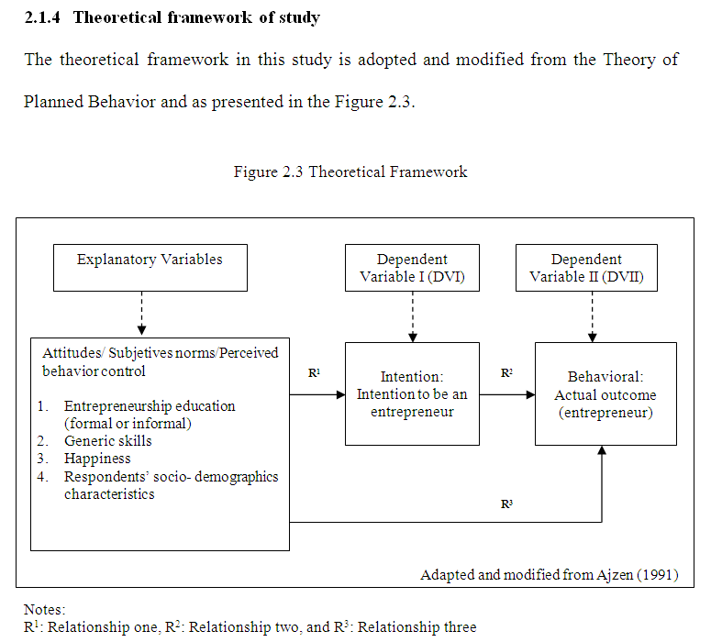
Her contribution in filling the lit gap
TF – Becker (1968) on the economics of crime, i.e. crime participation can be explained using the theory of utility maximization – spend more time in legal or illegal activities
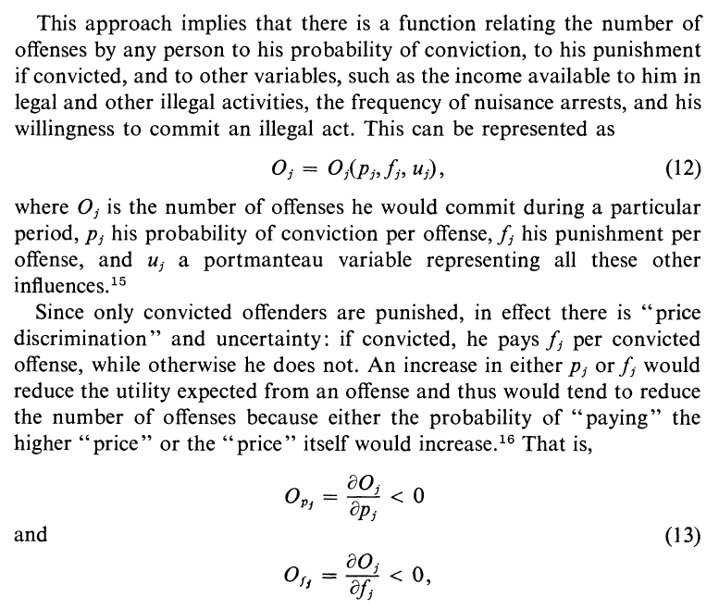
TF can be in mathematical form

Snowball from reference lists of papers referred to:
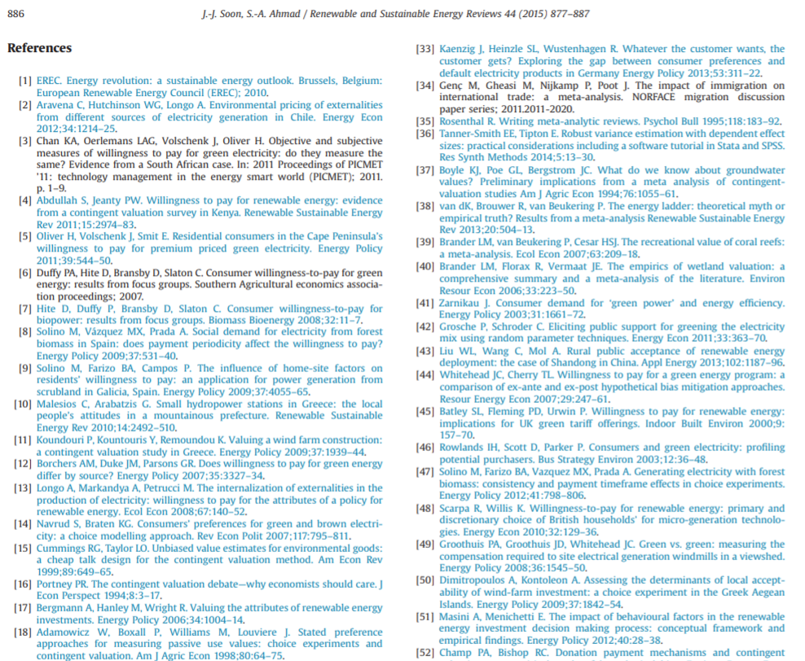

LR summary table
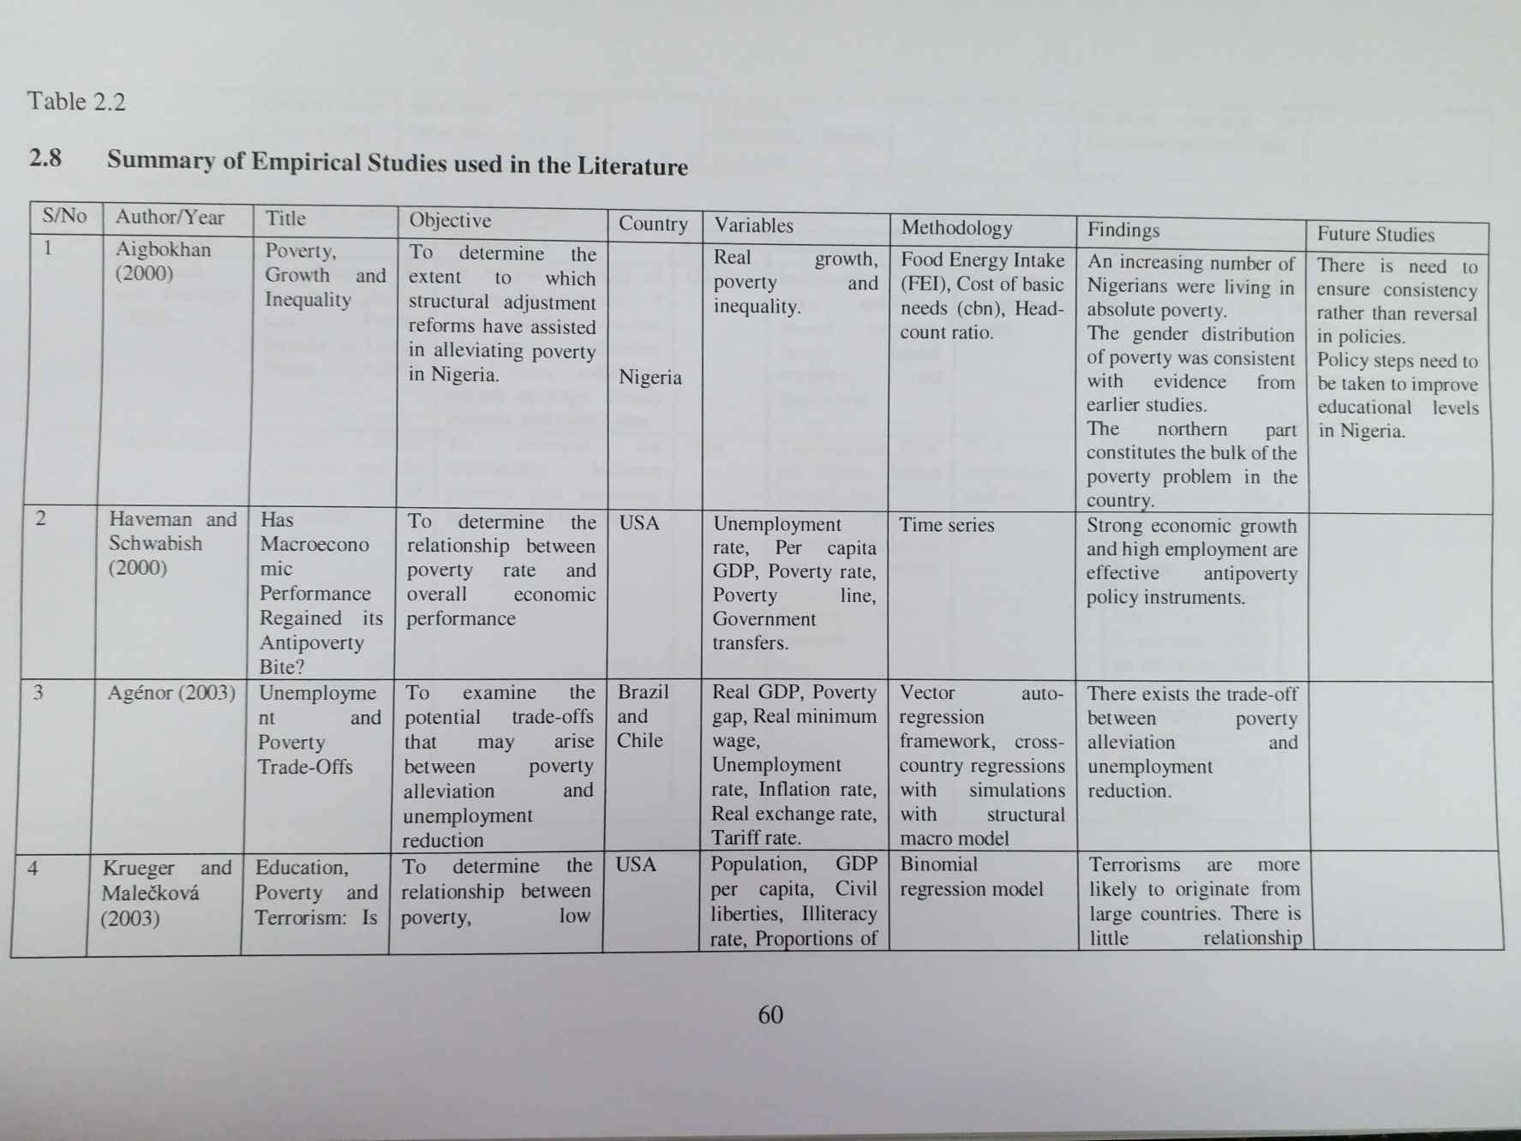

LR summary table
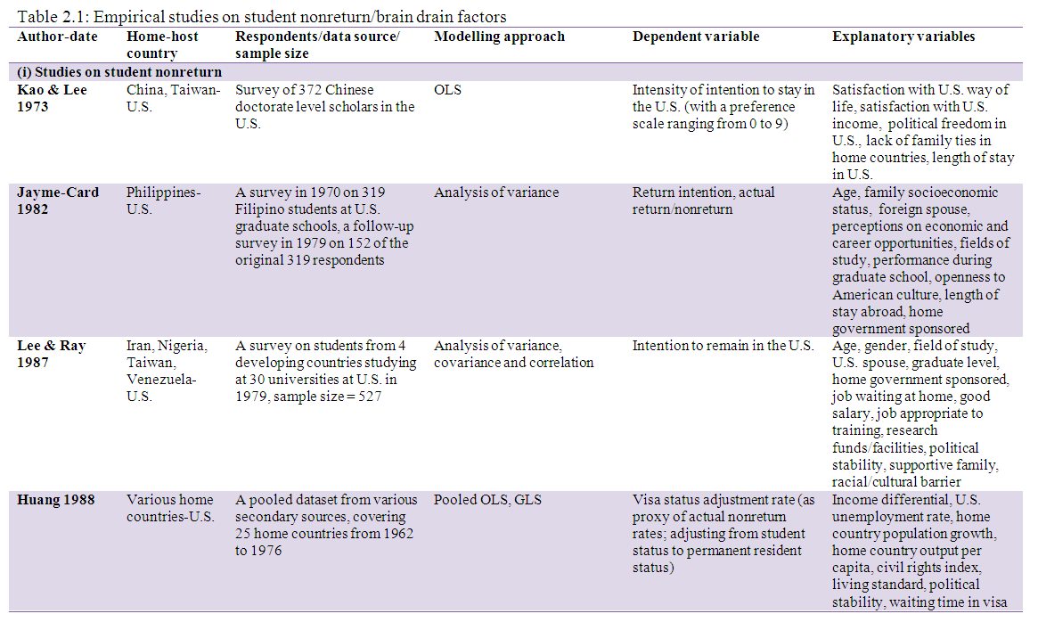

(1) Wrong way
http://www.ijeronline.com/documents/volumes/2017/Sept%20-%20Oct%2017/ijer%20v8%20i5%20SO%20(3).pdf
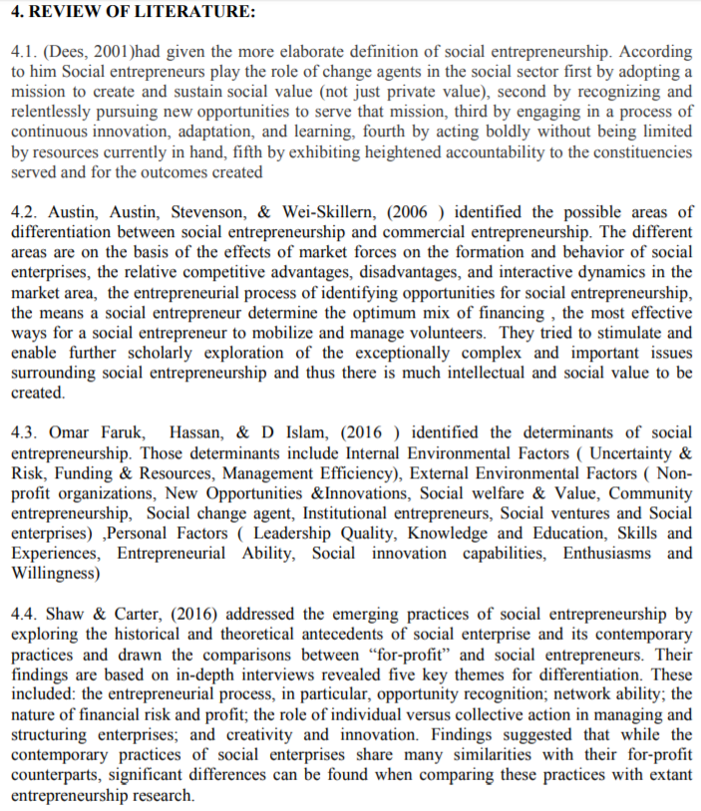

(2) Wrong way
http://www.mcser.org/journal/index.php/mjss/article/view/9647/9295

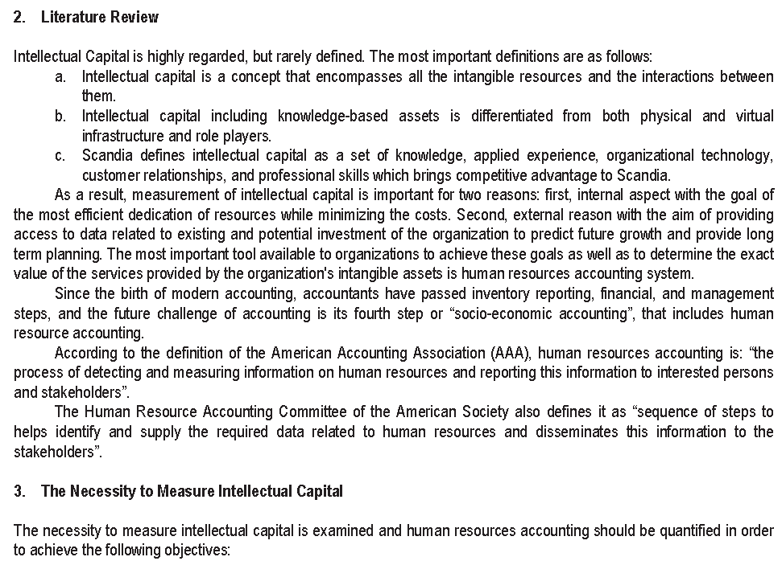

(3) Wrong way
http://ijsrm.in/index.php/ijsrm/article/view/1264/1137
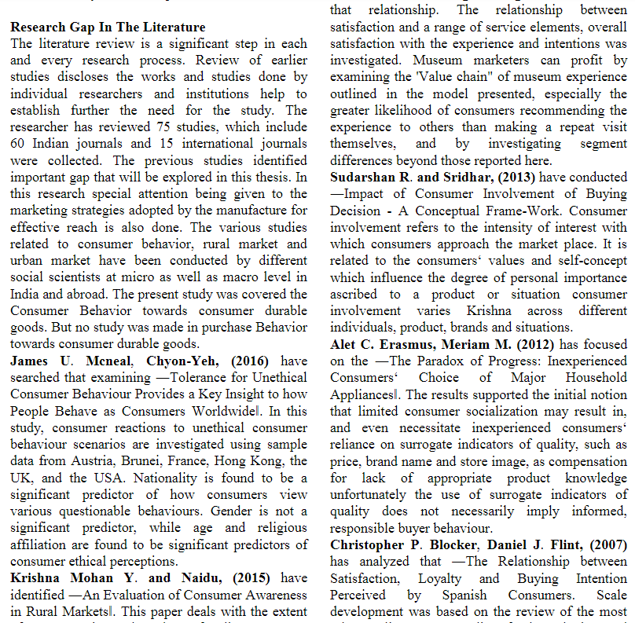

Proper LR writing
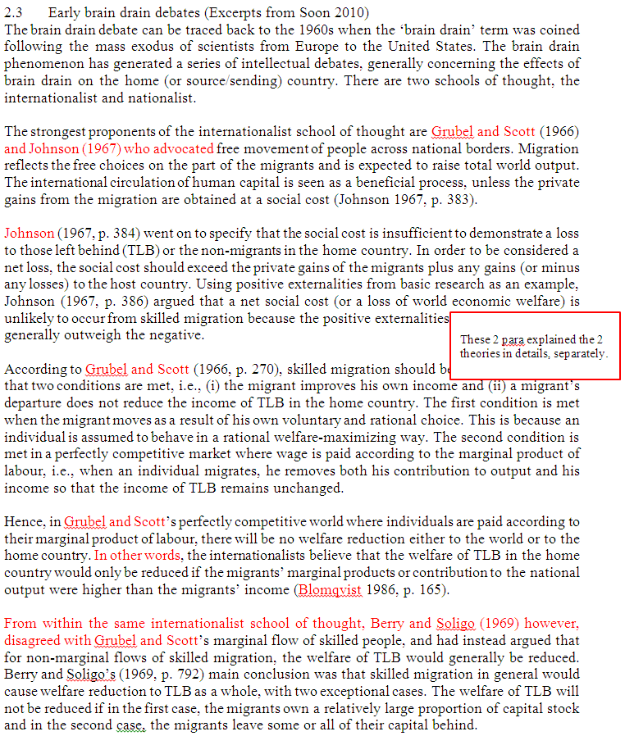
Proper LR writing (Soon 2010 continued)
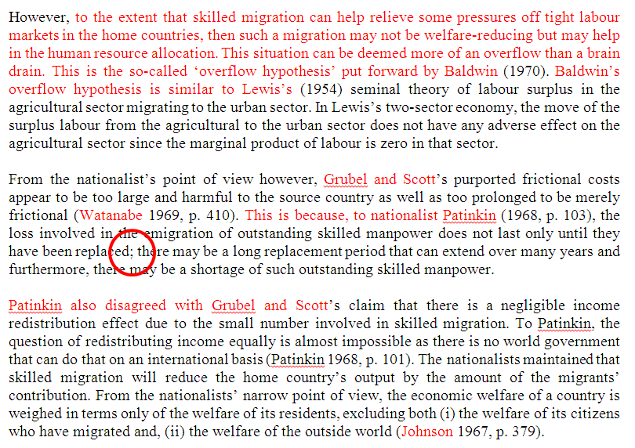

Proper LR writing (Soon 2018 IJES)


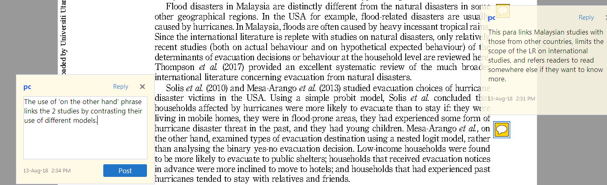

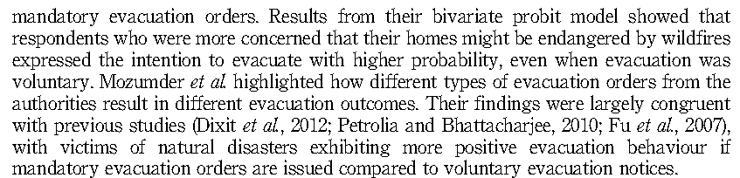

Soon (2010) – funnelling approach

