Methodology Chapter (Chapter 3)

Methodology vs RD vs Method
Methodology = the philosophy that justifies your approach; the logic behind how you search for knowledge. It answers the question: “Why is this approach the most valid way to answer the problem?”. Eg: Are you using a Positivist methodology (relying on quantifiable data and objective observation) or a Phenomenological one (seeking to understand the lived experiences of individuals through qualitative data)?
RD = blueprint or plan; quanti, quali, mixed-methods
Method = specific techniques/tools. Eg: estimation model, sampling design, data collection technique (primary/secondary data, Q survey/interview/FGD, ethnography, case study), web scraping, identification strategy, referencing format (APA, MLA, Harvard, Chicago), LR method (trad, bibliometric, SR, meta), writing method (big book thesis vs 3-paper)

What the Methodology chapter is not:
- It is not a literature review. Prior studies are cited here only to justify methodological choices, not substantive claims. “Mincer (1974) uses log wages; I follow this convention” is appropriate. “Many studies have found positive returns to schooling” belongs in the Literature Review.
- It is not a results chapter. Results and findings are in Chapter 4.
- It is not a tutorial. Do not teach your supervisor/examiner what OLS is. Cite a textbook.

Types of Sampling Design
- Pop vs targeted pop vs sample
- Sampling frame

Probability sampling
Every member of the target population has a known, non-zero probability of selection. Probability sampling supports formal inferential statistics, because sampling distributions are derived under the assumption of random selection.
1. Simple random sampling (SRS). Every unit has an equal probability of selection. Implementable via random number generators applied to the sampling frame, or selecting paper slips out of a bowl.
2. Systematic random sampling. Select every k-th unit from the frame after a random start. Vulnerable to bias e.g., every 10th house on a street might be a corner house.
3. Stratified random sampling. Partition the population into strata (e.g., urban/rural, ethnic group, industry) and sample within each. Proportionate stratification allocates sample size in proportion to stratum size; disproportionate stratification over-samples small strata to improve precision for subgroup estimates. Refer Sekaran’s book.

Non-probability sampling
Selection probabilities are unknown or zero for some units. Used when sampling frames are unavailable. Hard to generalize findings.
1. Convenience sampling. Recruiting whoever is available.
2. Purposive / judgmental sampling. Deliberately selecting units that satisfy specific criteria. Eg: female CEOs, judges
3. Snowball sampling. Existing participants recruit further participants. Essential for stigmatised, hidden, or illegal populations. Eg: undocumented migrants, drug addicts, the homeless

Questionnaire / Instrument Design
- Q or instrument (data collection instrument / tool), see Life Satisfaction Survey eg, see TFM’s instruments
- Construct / item / question
Closed-ended items
- Dichotomous. Yes/No, Agree/Disagree.
- Multiple choice, single/multi-select.
- Ranking items. Respondents order alternatives. Beware cognitive load.
- Likert items. Rating of agreement or frequency on an ordered scale.
Open-ended items: Elicit free-text responses. Rich info but hard to code. Useful for (a) pilot studies to surface categories you missed, (b) “Other, please specify” options. Eg: opinions, income, age

Items that should not be used
Leading questions suggest a preferred answer. “Do you agree that the new policy is beneficial?” The word beneficial primes agreement. Rewrite neutrally: “How would you rate the effects of the new policy?”
Loaded questions embed a contested assumption. “How often do you cheat on your exams?” assumes cheating. “Why did the government fail on this policy?” assumes failure. Rewrite: “Has the policy succeeded or not? Why?”
Double-barrelled questions ask two things at once. “Do you find Stata easy and enjoyable?” Easy and enjoyable are not the same thing. Split into two items.
Double-negative questions. “Do you disagree that researchers should not use AI?” Cognitive-load disaster. Rewrite: To what extent do you agree or disagree with the following statement: Students should be permitted to use AI in their exam?
Socially desirable questions: “Do you always follow ethical digital practices?”. Rewrite: “In the past month, how often have you checked whether a website was secure before entering personal information?”
Ambiguous items. “Do you use social media often?”. “Often” is undefined. Rewrite: “In the past seven days, on how many days did you use social media? (0, 1, 2, …, 7)”.
Jargon and acronyms. Unless you are surveying specialists, avoid. PTPTN is fine in Malaysia; B40 is fine; dirigisme is not fine.

Levels of Data Measurement (NOIR)

Nominal
Values are categories with no inherent order. Eg: gender, ethnicity, industry code, country of birth, marital status
Permissible operations: equality/inequality (=, ≠). Permissible statistics: mode, frequency, proportion, chi-square test. Means are meaningless. A “mean gender” is nonsense, even if Stata will obediently compute one if you coded male=1 and female=2. If we code gender as a dummy var where female = 0 and male = 1, and STATA computes a mean statistic of 0.57, what does it represent?

Ordinal
Values have a meaningful order but distances/intervals between values are not uniform or not known. Eg: Income category (T20, M40, B40), Likert scale, academic performance

Interval
Values have order and equal distances/intervals between values, but no true zero. Zero is just a number, not the absence of the attribute. Eg: temperature in Celsius (0 °C ≠ no temperature), shoe size

Ratio
Interval level plus a true zero that represents the absence of the attribute. Eg: income, age, distance, weight, price, GDP, unemployment rate, number of children, years of schooling.

Types of Data Structure

Cross-sectional data
Many units observed at a single point in time. Each row is a different unit (individual, household, firm, country
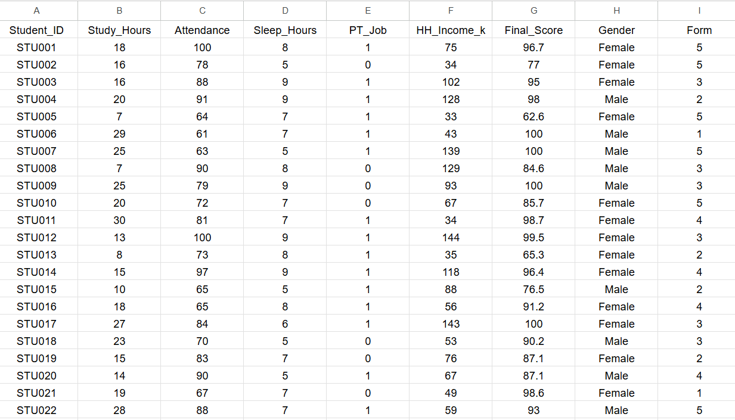

Time-series data
One unit observed at many points in time. Each row is a different time period for the same unit (eg: country)
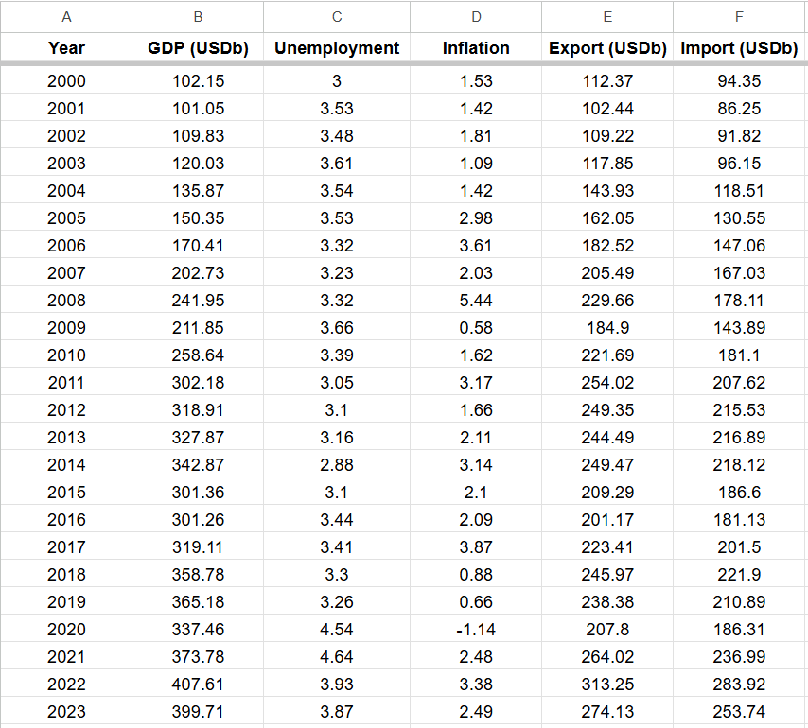

Pooled cross-sectional data
Multiple cross-sections taken at different points in time, but different units (sometimes can be the same unit/respondent) each time. The units are drawn independently from the same population.
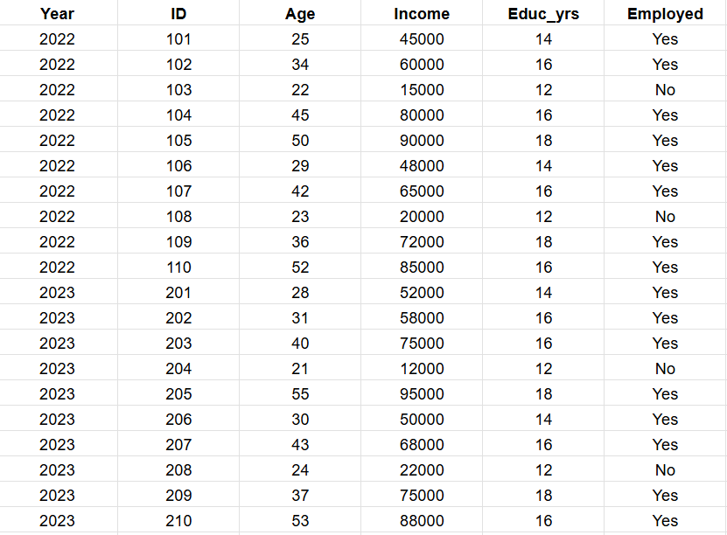

Panel / longitudinal data
The same units observed at multiple points in time.
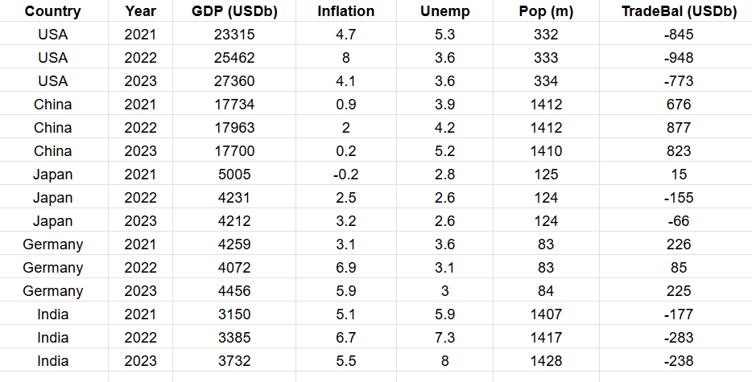

Matching dataset structure to RQ
- What factors correlate with household income in 2024? Cross-section is sufficient.
- How has the inflation–unemployment relationship in Malaysia evolved? Time series.
- Did a 2020 policy change affect consumption patterns differently in 2024 vs 2019? Pooled cross-section.
- Does retirement affect an individual’s cognitive decline? Panel - you need to observe the same people before and after retirement.

RQ-method table eg
Research question | Outcome variable(s) | Main explanatory variable(s) | Data source/unit | Method/model
RQ1: What is the relationship between digital financial literacy and saving behaviour? | Monthly saving amount; saving rate; binary indicator for saving regularly | Digital financial literacy score | Household survey; individual respondent | Descriptive statistics; OLS; logit for binary saving
RQ2: Does exposure to a financial education programme improve saving behaviour? | Pre/post saving rate | Treatment exposure; post period; treatment x post | Programme and comparison groups; repeated observations | Difference-in-differences
RQ3: Through what mechanisms does the programme influence behaviour? | Perceived control; budgeting confidence; reported habits | Programme exposure; qualitative themes | Survey plus interviews | Mediation-style descriptive analysis; thematic analysis

See also my TFM, DSRG eg

Variable operationalisation/codebook eg
Variable name | Operational definition | Measurement level | Coding | Expected sign/source
income | HH income, Total monthly household income in RM | Ratio | Continuous; top-coded if necessary | Positive effect on saving; survey item Q12
female | Gender, Respondent identifies as female | Nominal/binary | 1 = female, 0 = otherwise | Ambiguous; demographic control; Q3
finlit_score | Financial literacy, Sum of correct answers to 10 financial literacy questions | Interval-like index | 0-10; higher = more literate | Positive; constructed from Q20-Q29
save_regular | Saving behaviour, Respondent saves money every month | Nominal/binary | 1 = yes, 0 = no | Dependent variable; Q35
att_risk | Risk attitude, Agreement with “I am willing to take financial risks” | Ordinal | 1 = strongly disagree to 5 = strongly agree | Control; Q40

See also my 2018 flood paper

Data cleaning checklist
Task | Purpose | Stata commands eg
Inspect structure | Understand variables, labels, storage types, missingness. | describe; codebook; summarize; inspect
Check duplicates | Detect repeated IDs or accidental duplicate records. | duplicates report id; duplicates list id
Check missing values | Identify item non-response and patterns of missingness. | misstable summarize; tab var, missing
Check outliers | Identify implausible values. | summ var, detail; graph box var
Check coding consistency | Ensure categories match codebook. | tab gender; tab education, missing
Recode variables | Align categories and reference groups. | recode educ (1/2=0) (3/4=1), gen(high_educ)
Generate new variables | Generate dummies, logs, lags, interactions. | egen score=rowmean(q1 q2 q3); gen ln_income=ln(income)
Save data (ori & cleaned) | Preserve raw data and create reproducible cleaned file. | save clean_data.dta, replace  Also save dofile used to clean the dataset.

Correlation vs causation
Empirical type | RQ | Methods | Interpretation
Descriptive | What is the pattern? | Means, proportions, trends, cross-tabulations. | “The average wage is higher among university graduates than non-graduates.”
Correlational / association | Are X and Y related conditional on controls? | Regression/correlation with observed controls. | “Education is positively associated with wages, conditional on age, gender, and location.”
Causal | Does changing X cause Y to change? | RCT, natural experiment, credible quasi-experimental design, strong identification assumptions. | “The programme increased wages by X%, under the identifying assumptions discussed.”

Why correlation may not represent a causal relationship
Threat | Meaning | Example | Econometric Solution / Estimation Model
Omitted Variable Bias | An unobserved factor affects both X & Y | Wages = f(Educ)  Ability affects both education & wages. | FE models, IV or proxy Variables.
Reverse Causality | X affects Y, but Y also affects X. | Income = f(training)  Higher wages may allow more training, but more training can also increase income. | Lagged X var, IV, DID
Selection Bias | Individuals choose treatment based on characteristics related to outcomes. | Salary = f(Harvard)  Brilliant students choosing Harvard and later also have highly paid jobs. | RCT, quasi-experiment methods
Measurement Error | X or Y is measured with error (noise). | Self-reported income is noisy. | IV, Structural Equation Modeling
Simultaneity | X & Y are jointly determined | Price & quantity are determined by supply and demand simultaneously. | 2SLS, 3SLS

