## Queries

### 1. Produce a list of information about the documents and agents who are successfully gain approval that freights were sent out to Japan.

select agent.agentName, agent.agentID, request.documentID,list.freightID  
from agent,request,list  
where agent.agentID=request.agentID and  
request.listID=list.listId  
and list.origin in ("Japan")  
and request.approval like '1%'  
and list.freightDirection like '0%';

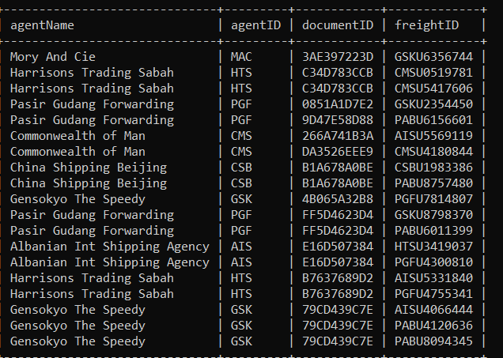

### 

### 2. produce a list of information about the freight's location, freight type, maximum gross weight that from Japan

select targetinfo.targetID, freight.areaID,freight.locx, freight.locY, freight.stackLVl,  
freightType.freightTypename, freightType.maxgrossWeight  
from targetinfo, freight,freightType,list  
where targetinfo.targetID = list.targetID  
and list.freightID=freight.freightID  
and list.freighttypeid=freighttype.freighttypeid  
and list.origin in ("Japan")  
order by freight.areaID asc ,freight.locx asc, freight.locY asc, freight.stackLVl asc;

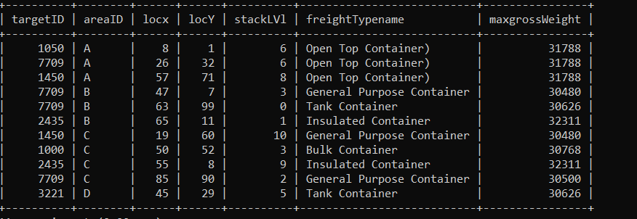

### 3. list all person in charge of freight from japan and their transportation information

select distinct targetinfo.PICname, targetinfo.targetID, vehicleinfo.vehiclename  
,vehicleinfo.vehicleMaxFreightCounts,vehicleinfo.vehicledescription  
from vehicleinfo, list, targetinfo  
where targetinfo.targetID = list.targetID   
and targetinfo.vehicletypeid =vehicleinfo.vehicletypeid  
and list.origin in ("Japan")  
order by targetinfo.PICname asc ;

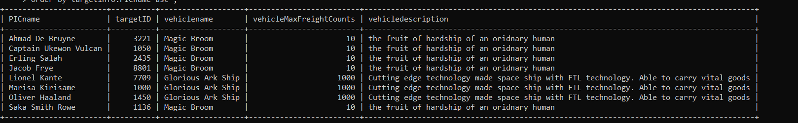

### 4. produce the list of first 10 person in charge name, agent name and agent contact email that handled outbound of freight based on the departure time.

select agent.agentname, agent.agentemail,targetinfo.PICname,historicalFreight.departureTime,historicalFreight.freightID  
from agent, targetinfo,historicalFreight,list  
where agent.agentID = targetinfo.agentID  
and list.targetID = Targetinfo.targetID  
and list.freightID=historicalFreight.freightID  
order by historicalFreight.departureTime asc  
LIMIT 10;

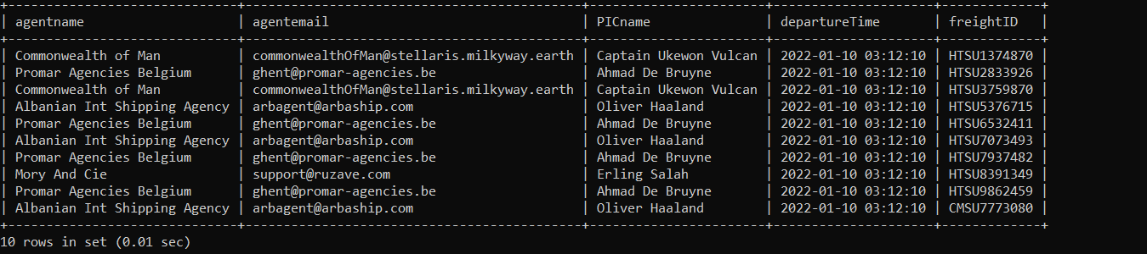

### 5. retrieve a list of freight that located at stack level of 10

### select freight.freightID, freight.areaID, freight.locx from freight group by freight.areaID,freight.locx, freight.locy,freight.stacklvl having freight.stacklvl=10 order by freight.areaID asc ,freight.locx asc, freight.locy asc,freight.locy;

### 6. Heaviest loadable freight type information

select freighttypeName as Heaviest_Freight_Name,freighttypeID,freightheight,freightlength,tareweight  
,max(freighttype.maxgrossweight) as Gross_Weight  
from freighttype;



### 7. To update the departureTime in historicalfreight table for correction

update historicalfreight   
set departureTime ="2022-12-20 05:05:05"  
where freightID in ("PABU2841438","PABU2454948","PABU2615908");

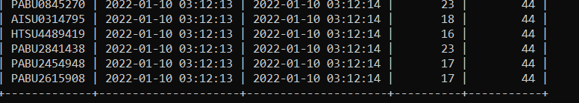

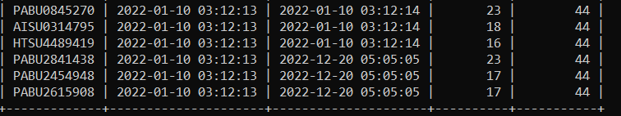

### 8. To calculate the number of freight in each area

select areaid as Area,count(areaID) as FreightCount  
from freight  
group by areaID  
order by areaid asc;

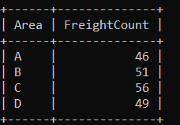

### 9. To search all information of vehicle info regarding transportation of high risk liquid cargo by using related keywords

select *  
from vehicleinfo   
where vehicleDescription like '%danger%' or '%dangerous%'   
or '%hazardous%' or '%risk%' or '%liquid%' or '%fluid%'  
or '%solution%';



### 10. Find all the freight ID and area id where location x is not in the range of 1 and 60, location y is not in the range of 1 and 60 and stack level is in the range of 1 and 3.

select freightID, areaID  
from freight  
where locx not between 1 and 60  
and locy not between 1 and 60  
and stacklvl between 1 and 3  
order by areaID asc ;

