ID24

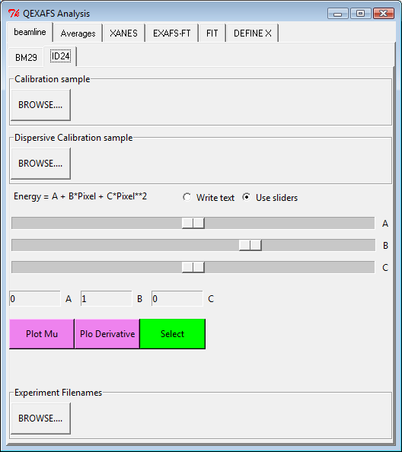

This page has as objective to select data files from ID24 and calibrate it. The calibration consists to substitute to the pixel index into Energy. The energy is calculated as a quadratic polynomial A+B*index +C*index2, the factor ABC could be obtain by comparison between of the spectrum of a calibration sample collected on a double crystal monochromator (**Calibration sample**) and collected during the experiment (**Dispersive Calibration sample**). The user should plot the derivative or the spectra and using the three sliders try to superimpose the two spectra. One time satisfied the choice of A BC have to be confirmed pressing Select. A B C could also introduced as a text but choice of A BC have to be confirmed pressing Select.

Browse Filename button serve to select the filename of the experiment.

BM29 Calibration

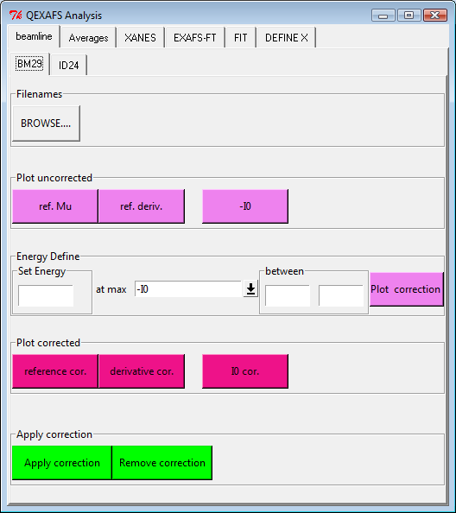

PAGE Average&Selection&Truncate

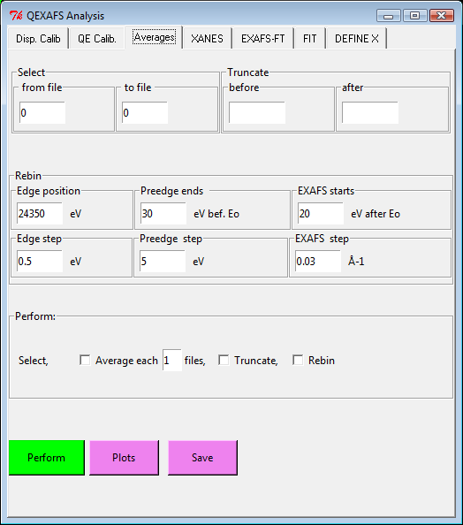

**Select.** In this set of entry is possible to select only a part of the set of spectra open previously. At this moment it is only possible remove spectra from the start or the end of experiment

**Truncate** In this set of entry is possible to select only a part of the of spectra open previously. At this moment is only possible the first part and/or the last part of the spectra.

**Rebin.** This set of parameter control the routine of rebinning. QEXAFS data are generally collected in constant energy step. With this kind of data collection at high k the sampling became over redundant and data files became big with too many experimental points. As a consequence software for data analysis became slow and unstable. The Rebin algorithm tries to avoid it re-sampling the data. More precisely the algorithm subdivide the spectra in a set of energy box and after calculate the spectra average for each box, the results will be the rebinned spectra. The wide of the box vary along the spectra: 1) wide constant energy box on the pre-edge; 2) narrow wide constant energy box on the edge; 2) constant wavevector box after the edge The parameters are necessary to define the wide of the box.



**Average**. In this page is also possible to partially average along the time a set of spectra. This is an important option, averaging each n file allow to saw modification clearly and with a minimum calculation time.

**Plot button** plot the original data as colored lines and rebinned and/or truncated and/or averaged data as scattered points.

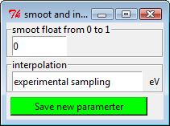PAGE XANES

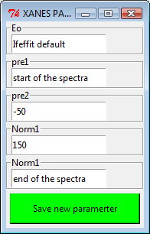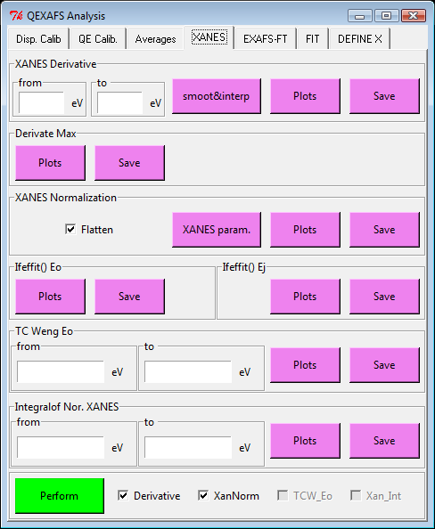

**Xanes Derivative** it calculate the derivative of the spectra from… to….The derivative is calculated evaluating a set of cubic spine that pass from each point y of the spectra and successively the derivate is calculate analytically over the spine.

Depending from the option Derivative that could have value Numeric or Spline the windows selecting the derivative will change

**For spline Derivative**

The parameter **interpolate** simply ask to calculate the derivative on the cubic spline along a different sampling.

The **smoot factor (s)** acts mainly during the evaluation of the spines. The amount of smoothness is determined by satisfying the conditions: sum((w * (y - g))**2,axis=0) <= s where g(x) is the smoothed interpolation of (x,y). The user can use s to control the tradeoff between closeness and smoothness of fit. Larger s means more smoothing while smaller values of s indicate less smoothing. Recommended values of s depend on the weights, w(Till now in Tscan1 the weigh is not evaluated). If the weights represent the inverse of the standard-deviation of y, then a good s value should be found in the range (m-sqrt(2*m),m+sqrt(2*m)) where m is the number of data points in x, y, and w. default : s=m-sqrt(2*m) if weights are supplied. s = 0.0 (interpolating) if no weights are supplied.

Further information on the documentation of function **splrep and splrev** in fortran routine **fitpack**

**For Numeric derivative**

The derivative is calculated as gradient(y)/gradient(x). The smoothing method is based on the convolution of a scaled window with the signal. The two parameter controlling the smoothing are the wide of the windows and the number of iteration of the convolution

**Xanes normalization** performs XANES normalization using the routine pre_edge of ifeffit engine the various parameters of the routine are accessible by button XANES param. That allows to change the default parameters of Ifeffit:

**Eo =**edge position parameter, if equal to “Ifeffit default” the program will take the first inflection point of the edge, if a numerical value if introduced, the Eo will be fixed for all the spectra range to this numerical value

**Pre1** = first point to fit the preedge. Program default is the start of the spectrum, the user could modify inserting a different value. Pre1 is defined as the number of eV before the edge I.e. -200

**Pre2** = last point to fit the preedge. Program default 50 eV from the edge, the user could modify inserting a different value. Pre1 is defined as the number of eV before the edge I.e. -20

**Norm1** = first point to fit the postedge. Program default is 150 eV from the edge , the user could modify inserting a different value. Norm1 is defined as the number of eV before the edge I.e. 50

**Norm2** = last point to fit the postedge. Program default the end of the spectra, the user could modify inserting a different value. Norm2 is defined as the number of eV before the edge I.e. 1200

**Ifeffit Eo** is the position of Fermi energy defined by pre_edge routine of ifeffit for extraction, generally is the first peak of edge derivative.

**Ifeffit Ej** is the estimation of edge jump done by pre_edge routine of ifeffit

**TC Weng Eo** is an alternative way to detect the Eo, developed by TC Weng (we use an another algorithm but the same philosophy). Eo is define as the position of a step function that have the same integral of the normalized mu(x). It could be applied only after the normalization.

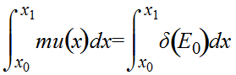

**Integral Nor XANES**

Evaluate the integral of the a normalized XANES region for each spectra