PCA_GUI

Please refer to following papers:

**M. Fernandez-Garcia, C. Marquez Alvarez and G. L. Haller\***

XANES-TPR Study of Cu-Pd Bimetallic Catalysts: Application of Factor Analysis

**J. Phys. Chem. 1995,99, 12565-12569 12565**

**A. Roßberg, · T. Reich, · G. Bernhard**

Complexation of uranium(VI) with protocatechuic acid – application of iterative transformation factor analysis to EXAFS spectroscopy

**Anal Bioanal Chem (2003) 376 : 631–638**

SUGGESTION:

It is good have the console window always visible!!!!!!!!!!

The program open a multicolumn file with the energy in the first column

This file could be easily generated by Prestopronto

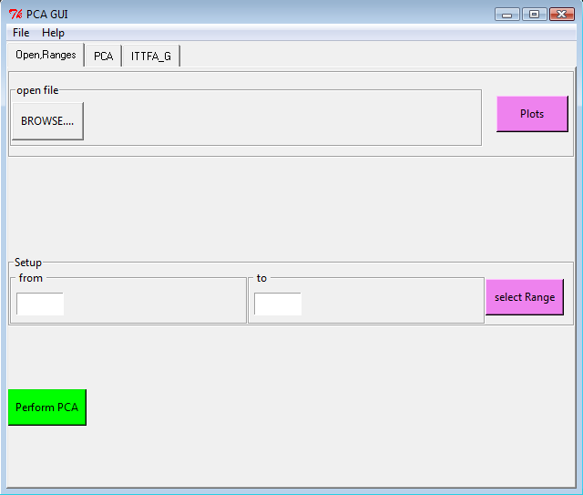

Selecting the range take care to don’t use too small ranges.

To start the PCA press the Perform PCA the program pass automatically to the next page

# TABLE

The number of loading visible in the table is for the moment 10.

The Header of the table allows plotting the indices, while on the graph if “l” key is pressed is possible to pass from linear to logarithmic graph

|  |  |
| --- | --- |
|  |  |
|  |

------------------------------------------------------------------------------------------------------------------------------------------

# PLOT VISUAL

|  |  |
| --- | --- |
|  | To plot the different loading, components and unweighted component is sufficient to select the component on checkbox, define the property to plo/save in the combobox and press the button. |

# Define principal component

To define the number of principal component is sufficient to set the number on the spinbox and press “reduces component.”

Decid the rank of the series is more an art than a science however different indicator (empiric or statistic) can help.

Here below a table with the different indicator implemented in the software with references[1]

|  |  |  |  |
| --- | --- | --- | --- |
| Ref. | Method | Selection criteria | Comments |
|  | **Empirical** |  |  |
| 1 | Factor indicator | Minimum in the IND function | Rapid analysis but no |
|  | function (IND) |  | theoretical basis |
| 2 | Ratio of eigenvalues | Sudden drop in smoothed | Arbitrary inspection of |
|  | of smoothed ordinary PCA | eigenvalue ratio | eigenvalue ratios( try to visualize in log ) |
| 3 | Scree test of residual variance | Sudden drop in the residual value | Requires inspection and |
|  |  |  | arbitrary cut-off |
|  | **Pseudo-statistical** |  |  |
| 4 | Reduced eigenvalue | 5-10% significance level | Assumes reduced eigenvalues |
|  | F-test (REV) |  | are Gaussian |
|  |  |  |  |
|  | **Statistical** |  |  |
| 5 | Determination of rank | Searches for outliers in residual errors | Rapid analysis |
|  | by MAD (DRMAD) |  |  |

The final test to decide if the rank is correct is to test the reconstruction pressing copare and visualize that the data along the set are well reproduced with the minimum of factor

|  |  |
| --- | --- |
|  |  |

# ITFA

One time pressed reduce button the program pass directly to ITFA module.

This module allow to set Boundary conditions to the rotation problem, perform the iterative rotation of loading from a needle matrix, and visualize the results. As default the input Needle matrix is build using the maxima of the loading resulting from a varimax rotation (the corresponding component could be visualize pressing “plot rot. Comp.”). However this starting point could be interactively changed pressing “Manual selection needle matrix”

|  |  |
| --- | --- |
|  |  |

Several Boundary conditions are implemented during the rotation and the could be defined pressing “Define constrains”:

* **Use monotonicity**: loading must have only one maximum, during the iteration local maximum a reset to the value of the higher neighbor.
* **Constrains**: force one loading to assume a value between 1 and 0 or to be a fraction of his maxima in a specific position(0-n-spectra-1) of the set.

1. 1. Malinowski ER. Anal. Chem. 1977; 49: 612–617.

   2. Chen ZP, Liang YZ, Jiang JH, Lang Y, Qian JY, Yu RQ. J. Chemometrics 1999; 13: 15–30.

   3. Cattell RB. Multivariate Behav.Res. 1966; 1: 245–276.

   4 Malinowski ER. J. Chemometrics 1988; 3: 49–60.

   5 Malinowski ER. J. Chemometrics 2009; 23: 1–6.