K-HALO: Korea Healthy Ageing and Longevity District Panel, 2008–2025
An AI-ready longitudinal dataset of small-area health behaviours, chronic disease, preventive care and healthy life expectancy in a super-aged society
Soonryeo Seo
Independent researcher, Seoul, Republic of Korea
Contact: contact@example.com
IEEE AgeTech Global Dataset Competition 2026 — Theme 1: Health & Well-Being (chronic disease management; preventive healthcare and wellness)
Dataset version 1.0 · Licence CC BY 4.0 · Formats CSV, SQLite, Croissant JSON-LD

1. Abstract
K-HALO is an openly licensed, English-documented panel that follows every Community Health Survey (CHS) area of South Korea — 281 health-centre areas, of which 245 form a non-overlapping national benchmark set — over 18 years (2008–2025). It contains 154,691 crude and age-standardised values of 41 indicators covering smoking, alcohol, physical activity, obesity, mental health, oral health (including chewing difficulty among adults aged 65+), hypertension and diabetes (diagnosis, treatment and complication screening), preventive care, unmet medical need and self-rated health. Each area is linked to life expectancy and healthy life expectancy (HLE; 2017–2023), an area deprivation index and its older-adult population. All values are aggregate official statistics, so the dataset contains no personal information. Within published years, 99.97% of benchmark cells are complete. We define three reproducible benchmark tasks — next-year forecasting of ten ageing-related indicators, HLE regression with leave-one-province-out validation, and an equity audit across deprivation quintiles — and report baselines: a ridge model improves on persistence by 14% on average, explains 0.51 of between-district HLE variance, and forecasting error in the most deprived fifth of areas is 27% higher than in the least deprived fifth. K-HALO gives AgeTech researchers a ready testbed for small-area forecasting, healthy-longevity modelling and fairness evaluation in the world's fastest-ageing population.

2. Motivation
South Korea crossed the super-aged threshold (20% of residents aged 65+) in December 2024 and is projected to have one of the oldest populations in the world within two decades. Healthy longevity, however, is unevenly distributed: in K-HALO, district HLE ranges from 63.9 to 78.6 years, and in 2023 lower HLE was associated with higher area deprivation (Pearson r = −0.32 across 227 districts; Figure 2). Decisions about where to deploy AgeTech — remote monitoring, preventive programmes, chronic-disease management, community care — are made for places, not only for individuals.
Most open AgeTech datasets are sensor- or clinic-based samples of tens to hundreds of participants, typically from Western countries. They are essential for device-level AI but cannot tell planners which communities are ageing in poor health, how fast risk factors are changing, or whether an AI model is equally accurate for deprived and affluent areas. Korea publishes rich small-area statistics, but they are scattered across hundreds of Korean-language tables, change format over time, and are rarely used in machine-learning research.
K-HALO closes this gap by (i) harmonising 18 years of small-area statistics into a stable panel with consistent identifiers, (ii) linking them to healthy life expectancy, deprivation and older-adult population, (iii) documenting every field in English with a datasheet and Croissant metadata, and (iv) defining benchmark tasks with fixed splits, baselines and a built-in equity audit.

3. Data Collection
K-HALO is a secondary compilation; no new data were collected from people. All inputs are official aggregate statistics distributed through KOSIS, the national statistical portal, and were retrieved through the KOSIS Open API in September 2026.
Source | Collection | Used for
Community Health Survey (KDCA) | Annual, 2008–2025; ≈230,000 adults/year, ≈900 per health-centre area; face-to-face interviews; area-level crude and age-standardised rates | 41 indicators (chs_panel_*.csv)
Cause-of-death statistics (Statistics Korea) | Deaths by district, sex and 5-year age group | Life tables → life expectancy (hle.csv)
Resident registration population (MOIS / Statistics Korea) | Mid-year population by district and 5-year age | Life tables; older-adult counts (population_age.csv)
Population and Housing Census (Statistics Korea) | 2020 district aggregates of education, occupation, household and housing | Deprivation index (deprivation.csv)

Table 1. Data sources. Devices, sensors and recruitment are not applicable: the CHS uses probability sampling of households by trained interviewers, and K-HALO uses only its published area estimates.

3.1 Collection methodology
- Selection. An inventory of 206 KOSIS tables was screened automatically for coverage (years, areas, missingness). Of 87 CHS tables, 55 passed and 32 were flagged (mostly discontinued series); none failed. The 41 indicators still published by KDCA were retained.
- Harmonisation. Areas follow the CHS sampling units (health-centre areas). Administrative changes (city mergers, new health centres) are recorded with status, first and last year; Statistics Korea 2018 district codes are provided for linkage to other data.
- Life expectancy and HLE. District abridged life tables were built from 3-year pooled deaths and population with Chiang's method (age groups 0–4 … 85+; areas with <150 deaths in the window are not estimated). HLE uses the Sullivan method: the national age-specific unhealthy share is back-calculated from Statistics Korea's official subjective-health HLE, and each area's curve is shifted by the odds ratio of its 3-year mean self-rated health. Re-computed national HLE matches the official value to 0.1 year in all seven published years (2012–2024).
- Deprivation. A reproduction of the Korean area deprivation index (Kim et al., 2013): z-scores of seven 2020 census variables (low education, aged 65+, low-skill occupation, one-person households, non-apartment housing, female-headed households, divorced/widowed) are summed; car ownership and substandard housing were unavailable.

4. Dataset Characteristics
Property | Value
Spatial units | 281 health-centre areas (235 districts, 46 sub-districts); benchmark set 245 (74 metropolitan, 84 urban, 76 rural, 11 mixed)
Time span | 2008–2025 (18 survey years); HLE 2017–2023; deprivation 2020; population 2024
Indicators | 41 indicators in 9 domains; crude and age-standardised rate (%), direction flag (higher is worse)
Samples | 154,691 unit-year-indicator values; 4,878 unit-years in the wide ML file; 1,763 HLE unit-years
Participants | Not applicable (aggregate data); underlying survey ≈230,000 adults per year
Labels / targets | Task-defined: next-year rate (T1), HLE (T2), deprivation quintile for stratified evaluation (T3)
File formats | CSV (UTF-8, long and wide), SQLite, Croissant 1.0 JSON-LD, data dictionary CSV, Markdown datasheet

Table 2. Dataset summary.
Domain | n | Example indicators
Alcohol | 4 | Monthly drinking rate; High-risk drinking rate; High-risk drinking rate among annual drinkers
Chronic disease | 10 | Physician-diagnosed hypertension prevalence; Hypertension treatment rate among diagnosed; Physician-diagnosed diabetes prevalence
Diet & obesity | 4 | Obesity prevalence (self-reported BMI>=25); Weight control attempt rate; Breakfast practice rate
Health care use | 3 | Unmet medical need (hospital/clinic) in past year; Public health centre use in past year; Good self-rated health ("very good" or "good")
Mental health | 3 | Perceived stress rate; Depressive mood experience in past year; Depressive symptom prevalence (PHQ-9>=10)
Oral health | 2 | Tooth brushing after lunch; Chewing difficulty, older adults
Physical activity | 3 | Walking practice rate; Moderate-or-vigorous physical activity rate; Healthy lifestyle practice rate (no smoking, moderate drinking, walking)
Prevention & safety | 7 | Influenza vaccination rate in past year; CPR training experience; CPR awareness
Smoking | 5 | Current smoking rate; Current smoking rate, men; Current tobacco product use rate (incl. e-cigarettes)

Table 3. Indicator domains (full list with Korean names, denominators and years in indicators.csv and Appendix A).
Tables are linked by unit_id. The wide file (one row per unit-year, one column per indicator) is directly usable for supervised learning; the long file supports time-series and panel models. Sub-districts carry parent_unit_id so that users can aggregate or join census covariates.

5. Data Quality
- Missing data. No values are imputed. Missing cells occur only where KDCA did not survey an indicator in a given year or an area did not yet exist; within published years 99.97% of benchmark-unit cells are filled (minimum per indicator 99.2%). Figure 1 shows coverage by year.
- Validation. Range checks found 0 rates outside 0–100%. Crude and age-standardised rates agree closely (r = 0.9869, median absolute difference 1.4 pp). Year-on-year changes larger than 4 SD of each indicator's change distribution affect 0.196% of 143,296 pairs; they are retained and flagged in the QC script because they reflect genuine small-area sampling variation. HLE never exceeds life expectancy (0 violations); LE ranges 79.61–87.55 and HLE 63.87–78.61 years.
- Quality assurance. Retrieval was validated table by table for year and area coverage (206 KOSIS tables); national HLE re-computation reproduces official statistics; all scripts are deterministic and included (tools/, qc/), so the package can be rebuilt and re-validated.
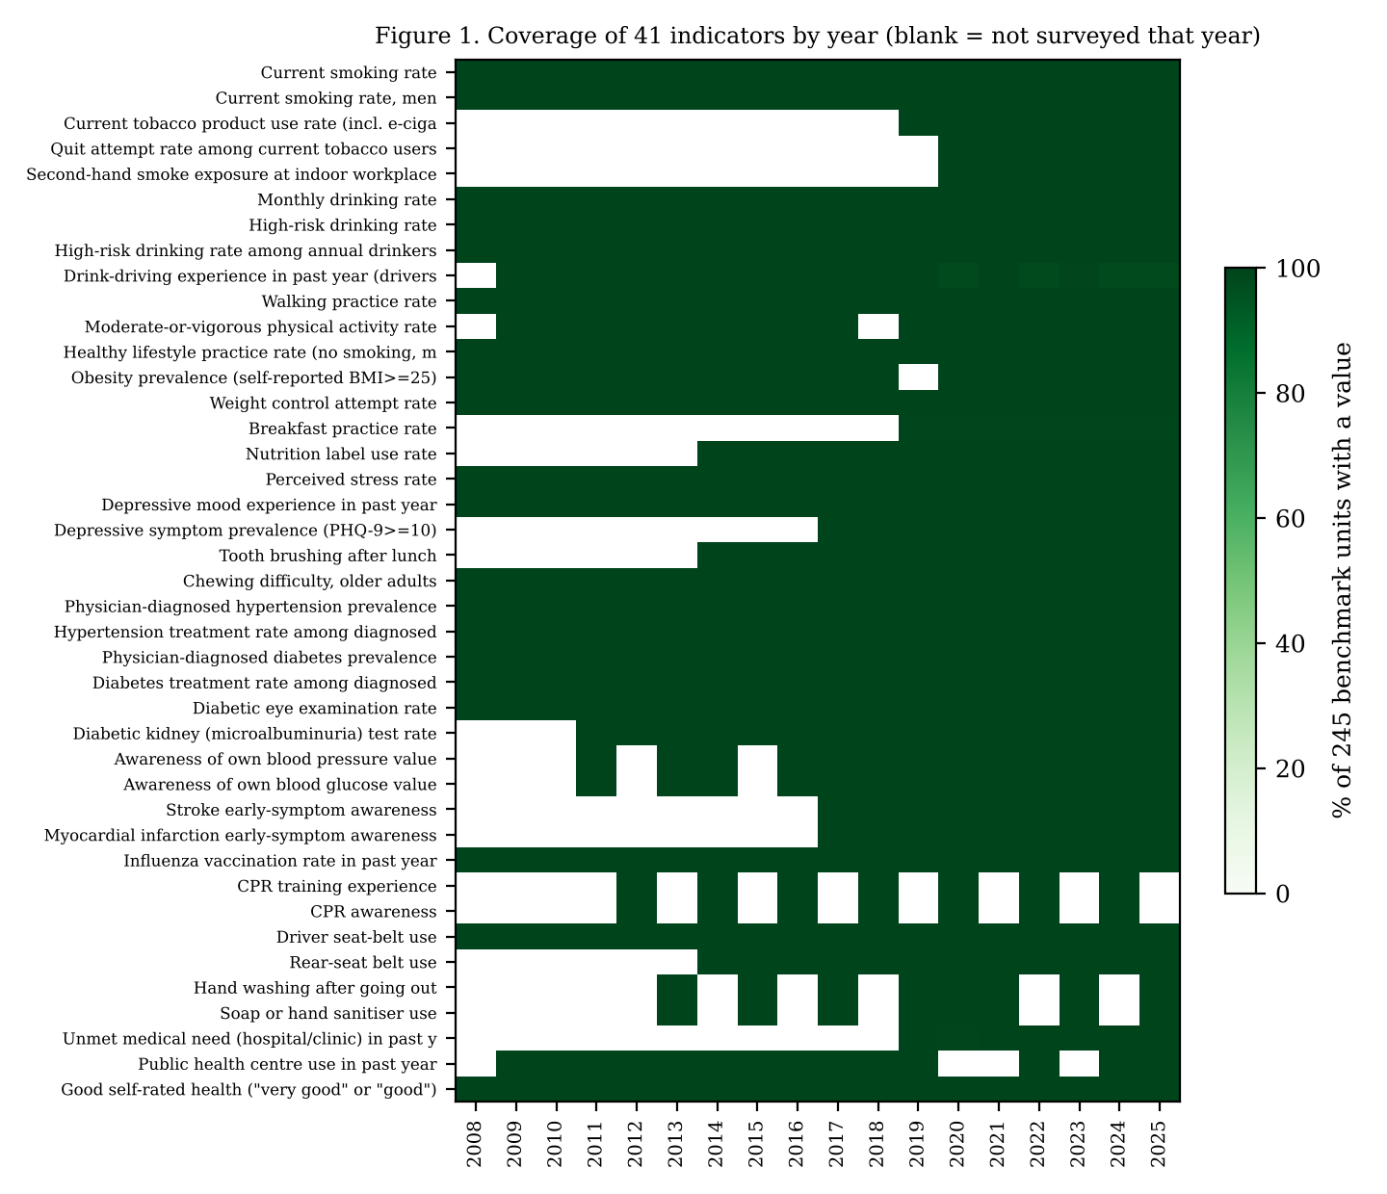
Figure 1. Share of the 245 benchmark units with a value, by indicator and year. White cells are years in which KDCA did not field the item.

6. Ethical Considerations
- Privacy protection. K-HALO contains only area-level aggregates already published by government agencies; no individual, household or facility records. Each estimate summarises roughly 900 survey respondents, so re-identification is not possible.
- Consent. Not applicable to K-HALO. The CHS is a statutory survey under the Regional Public Health Act, conducted by trained interviewers with respondents' agreement; only its published area-level estimates are used. No human-subject contact occurred in compiling K-HALO, so no additional ethics review was required.
- Anonymisation. Aggregation is the anonymisation step; no small-cell values below the producers' publication thresholds are introduced. Life-table estimates are suppressed for areas with fewer than 150 deaths in three years.
- Regulatory compliance and licensing. Source data are open under the Korea Open Government Licence Type 1 (attribution); K-HALO is released under CC BY 4.0 with full attribution. Derived HLE and deprivation values are labelled as research estimates, not official statistics.
- Bias awareness. Survey measures are self-reported; HLE is driven mainly by self-rated health; rural and deprived areas show larger forecast errors (Section 7). The equity audit (T3) is part of the benchmark so that model developers must report subgroup performance. K-HALO must not be used to stigmatise communities; the datasheet lists intended and out-of-scope uses.

7. Potential Applications and Benchmark Baselines
Intended AI and AgeTech use cases include: early warning of rising chronic-disease and risk-factor burden in specific communities; targeting of preventive and remote-monitoring programmes; explaining HLE gaps for healthy-longevity policy; transfer learning and multi-task models for small-area health; and fairness evaluation of public-health AI. Three tasks with fixed splits are provided (benchmarks/).
T1 target (age-standardised %) | Persistence | Mean last 3 y | Ridge | Gradient boosting
Chewing difficulty (65+) | 4.09 | 4.56 | 3.33 | 3.88
Hypertension prevalence | 1.84 | 1.65 | 1.52 | 1.56
Hypertension treatment | 3.06 | 2.52 | 2.45 | 2.47
Diabetes prevalence | 1.39 | 1.18 | 1.06 | 1.15
Diabetes treatment | 4.72 | 4.31 | 3.88 | 4.30
Depressive mood | 1.86 | 1.69 | 1.67 | 1.76
Walking practice | 6.02 | 6.37 | 5.45 | 5.66
Obesity | 2.94 | 2.58 | 2.30 | 2.35
Good self-rated health | 4.47 | 4.11 | 4.30 | 4.03
Influenza vaccination | 3.61 | 3.27 | 3.61 | 3.67
Mean | 3.40 | 3.22 | 2.96 | 3.08

Table 4. T1 one-step-ahead forecasting, test years 2024–2025 (about 490 unit-years per target; MAE in percentage points). Models use lags 1–3 of all 41 indicators and area type; trained on target years 2010–2023.
T2 model | n | MAE (years) | R²
mean (province-agnostic) | 228 | 1.44 | -0.08
ridge | 228 | 1.00 | 0.51
gradient boosting | 228 | 1.03 | 0.46

Table 5. T2 healthy life expectancy (2023) regression with leave-one-province-out validation (17 folds). Self-rated health is excluded from the features because it is an input to the HLE estimate.
Model | Evaluated on | Q1 (least) | Q3 | Q5 (most) | Q5/Q1
gradient boosting (lags of all 41 indicators) | (on T1 test, all 10 targets) | 2.88 | 3.01 | 3.65 | 1.27
persistence (last value) | (on T1 test, all 10 targets) | 3.13 | 3.40 | 4.13 | 1.32
mean (province-agnostic) | (on T2 LOPO) | 1.61 | 1.63 | 1.26 | 0.78
ridge | (on T2 LOPO) | 0.95 | 1.24 | 0.96 | 1.01
gradient boosting | (on T2 LOPO) | 0.86 | 1.36 | 1.04 | 1.21

Table 6. T3 equity audit: mean absolute error by area deprivation quintile.
Findings. A ridge model using the full indicator profile beats naive persistence for nine of ten targets, with one tie (mean skill 14%), but errors remain several percentage points, leaving clear headroom for spatio-temporal and multi-task models. HLE is moderately predictable from determinants across unseen provinces (R² = 0.51). Crucially, forecasting error is higher in the most deprived areas for both naive and learned models — precisely where AgeTech interventions are most needed — making K-HALO a natural benchmark for fairness-aware methods.
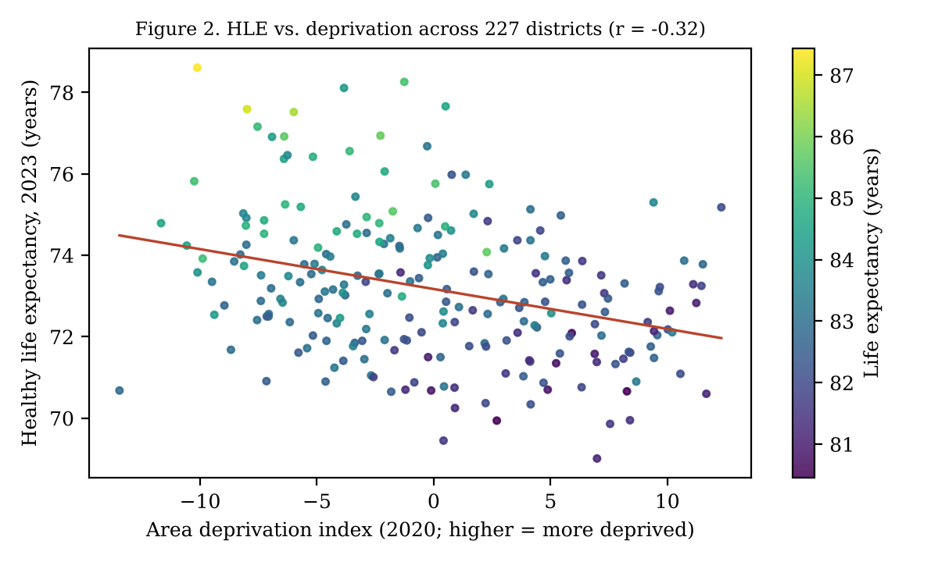
Figure 2. District healthy life expectancy vs. area deprivation, 2023; colour shows life expectancy.

8. Accessibility and Reproducibility
- Access. IEEE DataPort (open access). Package: data/ (7 CSV files + SQLite), metadata/data_dictionary.csv, croissant.json, DATASHEET.md, README.md, LICENSE.md, CITATION.cff, benchmarks/, qc/, tools/.
- Interoperability. Standard open formats (CSV UTF-8, SQLite); bilingual names (English/Korean); Statistics Korea codes for spatial joins; MLCommons Croissant 1.0 metadata with Responsible-AI fields for automatic loading in ML frameworks.
- Replication. python benchmarks/run_baselines.py data reproduces Tables 4–6 (pandas, scikit-learn; fixed seed). python qc/run_qc.py data reproduces Section 5 and the figures. tools/build_khalo.py rebuilds the data from the source statistics.
- Maintenance. Annual updates after each CHS release, with versioned changelog.

9. References
Chiang CL. The Life Table and Its Applications. Malabar, FL: Krieger; 1984.
Gebru T, Morgenstern J, Vecchione B, et al. Datasheets for datasets. Communications of the ACM. 2021;64(12):86–92.
Kang YW, Ko YS, Kim YJ, et al. Korea Community Health Survey data profiles. Osong Public Health and Research Perspectives. 2015;6(3):211–217.
Kim DJ, et al. Korean area deprivation index for health equity monitoring (in Korean). Korea Institute for Health and Social Affairs; 2013.
Korea Disease Control and Prevention Agency. Community Health Survey statistics, 2008–2025. KOSIS, https://kosis.kr (accessed Sep 2026).
MLCommons. Croissant format specification, version 1.0. 2024. https://mlcommons.org/croissant
Statistics Korea. Life tables, cause-of-death statistics and resident registration population. KOSIS, https://kosis.kr (accessed Sep 2026).
Sullivan DF. A single index of mortality and morbidity. HSMHA Health Reports. 1971;86(4):347–354.
United Nations, Department of Economic and Social Affairs. World Population Prospects 2024. New York: UN; 2024.

Appendix A. Indicator list
ID (KOSIS table) | Indicator | Population | Years | Higher is
DT_H_SM | Current smoking rate | Adults 19+ | 2008–2025 | worse
DT_H_SM_MALE | Current smoking rate, men | Men 19+ | 2008–2025 | worse
DT_TOBACCO_PRODUCT | Current tobacco product use rate (incl. e-cigarettes) | Adults 19+ | 2019–2025 | worse
DT_SM_TRY_V2 | Quit attempt rate among current tobacco users | Current tobacco users 19+ | 2020–2025 | better
DT_117075_SM_IND_WORK_V2 | Second-hand smoke exposure at indoor workplace (non-users) | Non-users 19+ | 2020–2025 | worse
DT_H_DR_MONTH | Monthly drinking rate | Adults 19+ | 2008–2025 | worse
DT_117075_H_DR_HIGH_WH | High-risk drinking rate | Adults 19+ | 2008–2025 | worse
DT_H_DR_HIGH | High-risk drinking rate among annual drinkers | Annual drinkers 19+ | 2008–2025 | worse
DT_117075_H_DR_DRIV | Drink-driving experience in past year (drivers) | Drivers 19+ | 2009–2025 | worse
DT_H_EX_WALK | Walking practice rate | Adults 19+ | 2008–2025 | better
DT_H_EX_PHY | Moderate-or-vigorous physical activity rate | Adults 19+ | 2009–2025 | better
DT_117075_H_HEALTHY | Healthy lifestyle practice rate (no smoking, moderate drinking, walking) | Adults 19+ | 2008–2025 | better
DT_H_OBE_OBE | Obesity prevalence (self-reported BMI>=25) | Adults 19+ | 2008–2025 | worse
DT_H_OBE_CONTROL | Weight control attempt rate | Adults 19+ | 2008–2025 | better
DT_117075_DIE_BF02 | Breakfast practice rate | Adults 19+ | 2019–2025 | better
DT_11775_NUT_LABEL_UTIL | Nutrition label use rate | Adults 19+ | 2014–2025 | better
DT_H_MENTAL_STRESS | Perceived stress rate | Adults 19+ | 2008–2025 | worse
DT_H_MENTAL_DEPRESS | Depressive mood experience in past year | Adults 19+ | 2008–2025 | worse
DT_117075_H_MENTAL_DEPRESS_SYM | Depressive symptom prevalence (PHQ-9>=10) | Adults 19+ | 2017–2025 | worse
DT_H_OR_BRUSH | Tooth brushing after lunch | Adults 19+ | 2014–2025 | better
DT_H_OR_INCONV | Chewing difficulty, older adults | Adults 65+ | 2008–2025 | worse
DT_HYPER_DOCTOR | Physician-diagnosed hypertension prevalence | Adults 30+ | 2008–2025 | worse
DT_HYPER_DOCTOR_DRUG | Hypertension treatment rate among diagnosed | Diagnosed adults 30+ | 2008–2025 | better
DT_DIA_DOCTOR | Physician-diagnosed diabetes prevalence | Adults 30+ | 2008–2025 | worse
DT_DIA_TREAT | Diabetes treatment rate among diagnosed | Diagnosed adults 30+ | 2008–2025 | better
DT_DIA_EYE | Diabetic eye examination rate | Diagnosed adults 30+ | 2008–2025 | better
DT_DIA_KIDNEY | Diabetic kidney (microalbuminuria) test rate | Diagnosed adults 30+ | 2011–2025 | better
DT_117075_HYPER_AWAR | Awareness of own blood pressure value | Adults 19+ | 2011–2025 | better
DT_117075_DIA_AWAR | Awareness of own blood glucose value | Adults 19+ | 2011–2025 | better
DT_117075_STR_EARLY_SYM | Stroke early-symptom awareness | Adults 19+ | 2017–2025 | better
DT_117075_MYO_EARLY_SYM | Myocardial infarction early-symptom awareness | Adults 19+ | 2017–2025 | better
DT_INFLUENZA | Influenza vaccination rate in past year | Adults 19+ | 2008–2025 | better
DT_CPR_EDU | CPR training experience | Adults 19+ | 2012–2024 | better
DT_CPR_AWAR | CPR awareness | Adults 19+ | 2012–2024 | better
DT_H_BELT | Driver seat-belt use | Drivers 19+ | 2008–2025 | better
DT_117075_H_BELT_BACK | Rear-seat belt use | Adults 19+ | 2014–2025 | better
DT_H_HAND_WASH | Hand washing after going out | Adults 19+ | 2013–2025 | better
DT_H_SOAP_USE | Soap or hand sanitiser use | Adults 19+ | 2013–2025 | better
DT_117075_NECE_NTR02 | Unmet medical need (hospital/clinic) in past year | Adults 19+ | 2019–2025 | worse
DT_NECE_CLINIC | Public health centre use in past year | Adults 19+ | 2009–2025 | –
DT_HEALTH_RECOG | Good self-rated health ("very good" or "good") | Adults 19+ | 2008–2025 | better

