[1]

Using Data to Learn About Unplanned Pregnancies

Sonia Kopel, Amber Widmer, and Christopher Mullinax, *College of Charleston*

*Abstract*—The issue of unplanned pregnancy is among the more divisive in the United States. The mission of this project is to further investigate existing data sets to gain a new insight into this problem. Specifically, we focused on targeting the causes of unplanned pregnancy and identify at risk groups in order to identify potential interventions that may result in fewer unplanned pregnancies nationwide. We also use survey data to study how these at risk groups feel about current public health policy. Analysis of twitter data showed that public sentiment regarding terminating unwanted pregnancies was strongly negative, which led us to seek interventions to lower unwanted conceptions rather than just unwanted births.

*Index Terms*—Unplanned pregnancy, public health, sexual education

# Introduction

U

NPLANNED pregnancy has the potential to ruin a woman’s financial stability, educational goals, and her personal relationships.

***We may want to exclude this *** In order to gain a basic level of insight into the historic trends of unplanned pregnancy in the United States, we examined a data set that summarized the number of unmarried births in the United States from 1940 to 2015 [1]. The trends are summarized in Figure 1. However, the assumption that all or even most of these unmarried births are unintentional is likely to be faulty. However,

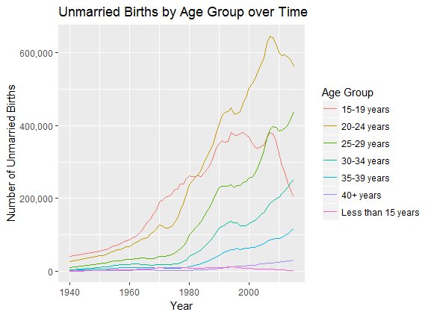

Figure 1: Trends in unmarried births by age group over time

Here is some background information. Here are some graphs that illustrate trends over time. We probably want a bunch of citations in this section.

# Methods

This study analyzed public data gathered from online sources. The analysis was for the most part exploratory and varied with the format of each analyzed data set. We used a number of mathematical techniques to model the

## Modelling Birth Control Efficacy with Markov Chains

We used a mathematical technique called a Markov Chain to model the probability of various birth control methods failing after a certain number of years. This was done to test the assumption that if one truly wishes to avoid having an unplanned pregnancy, the only truly “safe” bet is abstinence.

A Markov Chain shows how transition probabilities change over time and eventually converge. In order for the method to work, the sum of all entries in any row must equal one. This property is called ????????

We simulated a number of environments with varying assumptions. In each environment we tested the same methods of birth control: withdrawal, family planning (also known as the calendar method), intrauterine devices (IUD), condoms, injections, the pill, and implants. For all of these methods, the probability of having the birth control method fail within a year was provided by Planned Parenthood [2]. Those probabilities account for user error, so they were selected over the theoretical efficacy of a given method to simulate a more realistic environment. Because of the 100% efficacy of abstinence, this method was not included in the Markov Chain. The time step for all Markov Chains was one year.

## Twitter Sentiment Analysis

Do we even want to include this??

Could be good for establishing public sentiment toward abortion 🡪 want to focus more on prevention

## Chi Squared Testing

## Variable Correlations

## Association Learning

Table 1: Transition matrix for Markov Chain with absorbing pregnancy state and random switching after each step

|  |  |  |  |  |  |  |  |  |
| --- | --- | --- | --- | --- | --- | --- | --- | --- |
|  | **Withdraw** | **FAM** | **IUD** | **Condom** | **Injection** | **Pill** | **Implant** | **Pregnant** |
| **Withdraw** | 0.062 | 0.016 | 0.125 | 0.187 | 0.055 | 0.32 | 0.016 | 0.22 |
| **FAM** | 0.061 | 0.015 | 0.122 | 0.182 | 0.053 | 0.312 | 0.015 | 0.24 |
| **IUD** | 0.079 | 0.02 | 0.158 | 0.238 | 0.069 | 0.406 | 0.02 | 0.01 |
| **Condom** | 0.068 | 0.017 | 0.136 | 0.204 | 0.06 | 0.349 | 0.017 | 0.15 |
| **Injection** | 0.075 | 0.019 | 0.15 | 0.226 | 0.066 | 0.385 | 0.019 | 0.06 |
| **Pill** | 0.073 | 0.018 | 0.146 | 0.218 | 0.064 | 0.373 | 0.018 | 0.09 |
| **Implant** | 0.079 | 0.02 | 0.158 | 0.238 | 0.069 | 0.406 | 0.02 | 0.01 |
| **Pregnant** | 0 | 0 | 0 | 0 | 0 | 0 | 0 | 1 |

# Results

Our results were awesome. You’re welcome, America.

## Modelling Birth Control Efficacy with Markov Chains

The first simulation assumed pregnancy to be an absorbing state (meaning that once an individual becomes pregnant she is removed from the population). It was also assumed that after each step in the Markov Chain a woman would randomly switch her birth control. The probability of switching to any given birth control method (including the method that the woman was using at the current time step) was proportional to the percentage of Americans who used that particular method of birth control. Those probabilities were calculated from statistics provided by the Guttmacher Institute [3]. The probabilities were scaled to account for the probability of being put in the absorbing pregnant state. The transition matrix is given by Table 1.

The

# Conclusions

In conclusion, by this time next year, unplanned pregnancies will be a thing of the past.

# Future Work

Check that research journal for future work ideas. I think we had a list of them in there.

# Acknowledgments

This work would not have been possible without the help and support of Dr. Amy Langville, Abhishek Mehta, Brittany Box, and the entire Tresata team. We would also like to acknowledge the 2018 spring Operations Research Class at the College of Charleston for their thoughtful input and advice throughout the course of this project.

Data Sources and References

1. Centers for Disease Control and Prevention. (2018). Births to Unmarried Women by Age Group: United States [Data File]. Retrieved from https://www.healthdata.gov/dataset/nchs-births-unmarried-women-age-group-united-states
2. Planned Parenthood. *All About Birth Control Methods*. Retrieved from https://www.plannedparenthood.org/learn/birth-control
3. Guttmacher Institute. Contraceptive use in the United States. Retrieved from https://www.guttmacher.org/fact-sheet/contraceptive-use-united-states

1.