Worksheet 1A Cover letter
PhD Chemical Engineering • 7 October 2026 • Name _____________________
Task: Work in pairs. Draft a 120–150 word cover letter in 8 minutes, including peer feedback. Use the synthetic case below and choose a plausible journal. Verify its scope. Leave declarations unconfirmed unless you have evidence for them.
At 350 °C | Baseline | Modified
Conversion, three batches (%) | 61, 64, 67 | 72, 75, 78
Mean selectivity (%) | 89 | 87
Observation window | 8 h | 8 h

Synthetic teaching case only. Model reaction A to P, 1:1 molar basis. Conditions: 1 bar, 0.50 g catalyst, 100 standard cm³/min total flow, 10 mol% A in inert gas. Each value represents an independent batch. No mechanism or industrial lifetime evidence is available.

Journal and reader
________________________________________________________________________________
________________________________________________________________________________

Draft letter
________________________________________________________________________________
________________________________________________________________________________
________________________________________________________________________________
________________________________________________________________________________
________________________________________________________________________________
________________________________________________________________________________
________________________________________________________________________________
Peer check: quantified finding / scope / reader relevance / truthful declarations. Circle one unsupported word or claim and suggest a revision.

Worksheet 1B Reviewer response
8 minutes • Respond to the concern and revise the manuscript
Reviewer comment: “The manuscript claims industrial durability, but an 8 h observation period cannot establish industrial catalyst lifetime.”

Response to the reviewer
________________________________________________________________________________
________________________________________________________________________________
________________________________________________________________________________
________________________________________________________________________________
________________________________________________________________________________

Replacement manuscript sentence and location
________________________________________________________________________________
________________________________________________________________________________
________________________________________________________________________________
________________________________________________________________________________

Next experiment and its purpose
________________________________________________________________________________
________________________________________________________________________________
________________________________________________________________________________
Do not claim that you completed a new experiment. Distinguish work already done from proposed work.

Exit ticket
One supported contribution sentence and one requirement still to verify:
________________________________________________________________________________
________________________________________________________________________________

Worksheet 2A Figure redesign
14 October 2026 • 10 minutes • Name _____________________
The figure below reports the same catalyst case. Identify missing information, then design a figure that supports a precise comparison. You may sketch on the back of this page.
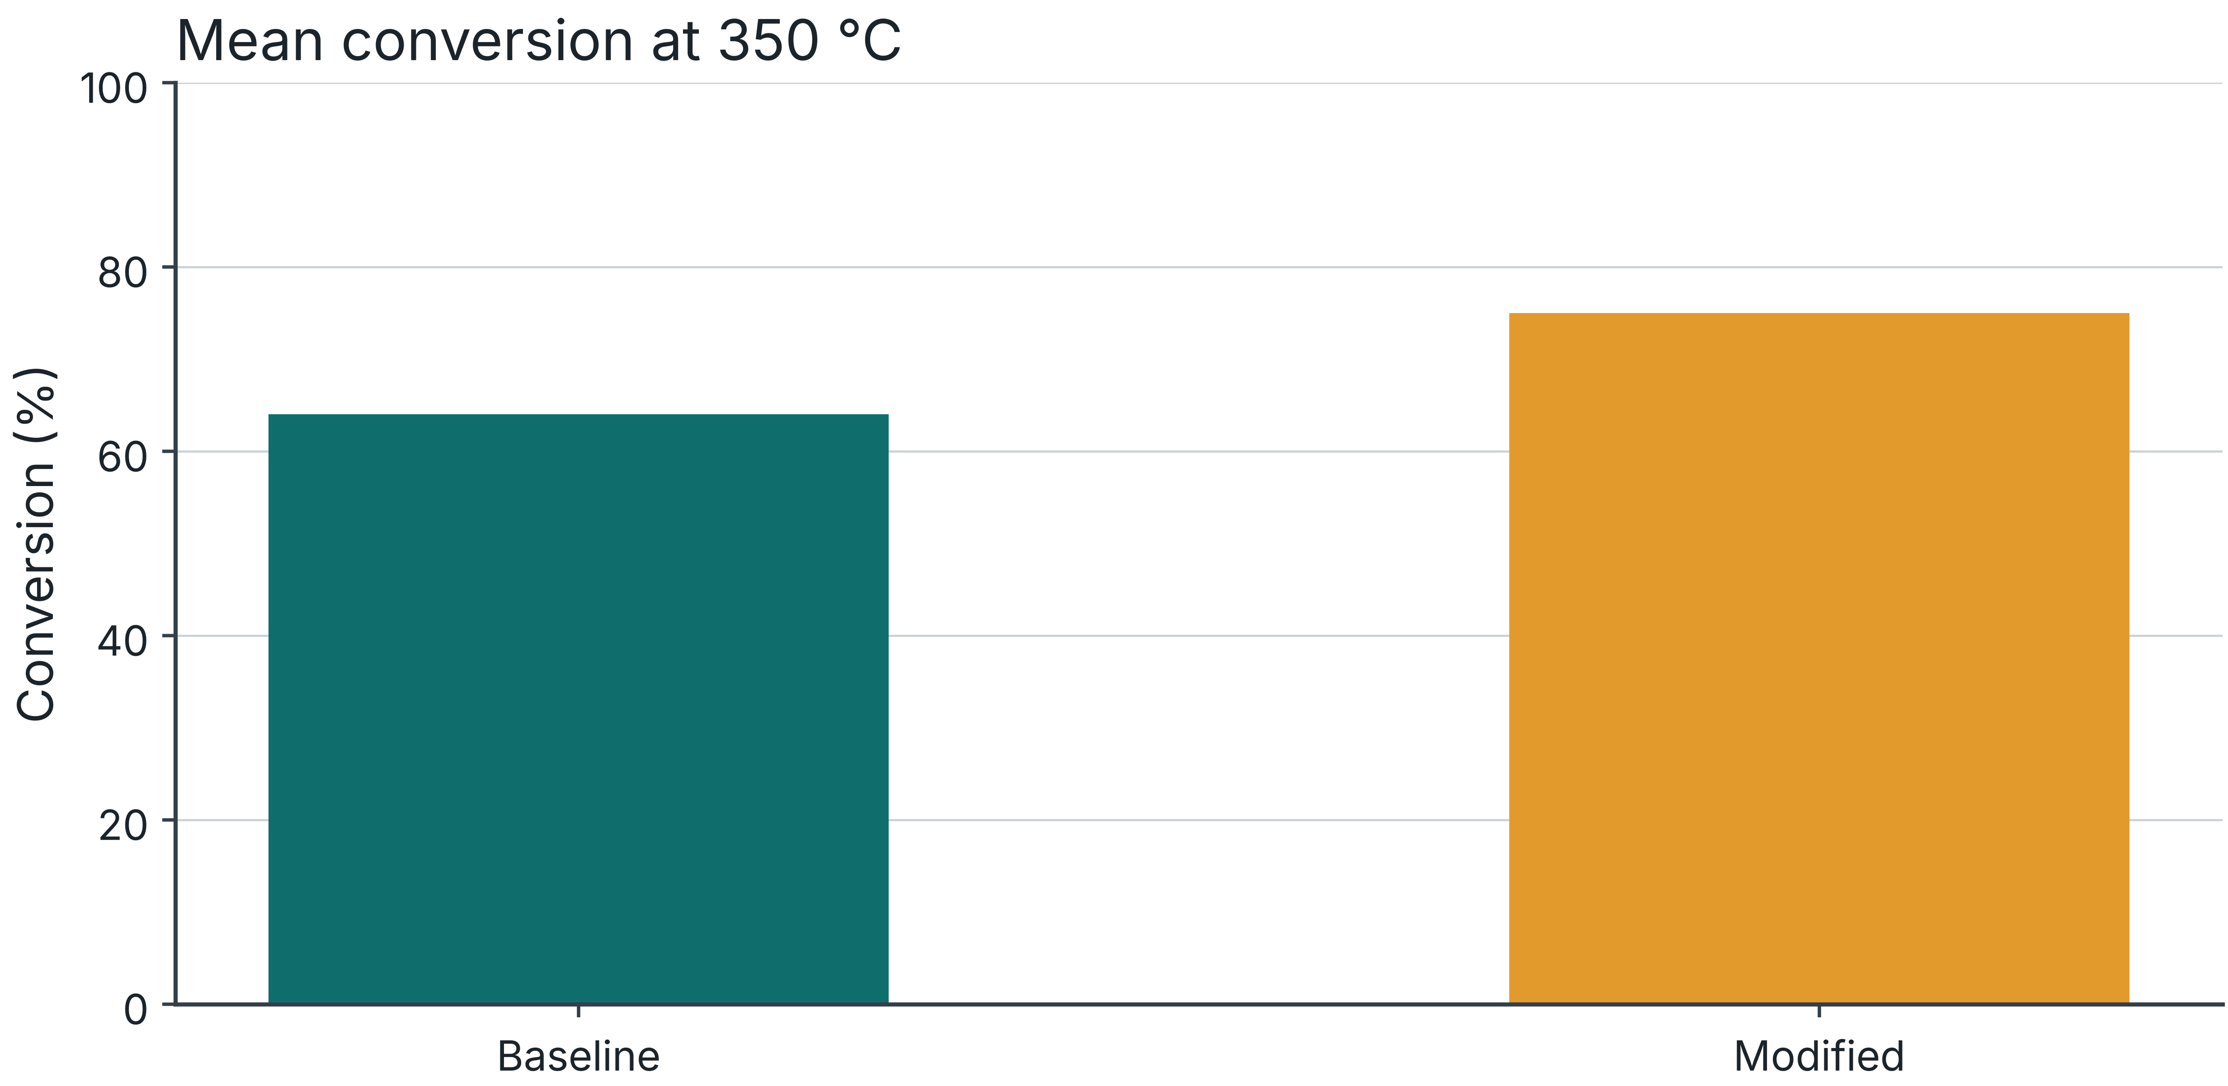
At 350 °C, independent batch values are baseline 61, 64, 67% and modified 72, 75, 78%. Conditions: 1 bar, 0.50 g catalyst, 100 standard cm³/min, 10 mol% A in inert gas. All values are synthetic.

Claim and display choice
________________________________________________________________________________
________________________________________________________________________________

Caption including conditions n and uncertainty
________________________________________________________________________________
________________________________________________________________________________
________________________________________________________________________________
Peer check: scientific question / axes and units / independent observations / uncertainty definition / reproducibility.

Worksheet 2B Uncertainty and prediction
Use the same synthetic data. Keep percentage points distinct from relative percent.
Quantity | Baseline | Modified
Mean conversion (%)
Sample SD (percentage points)
SE of the mean (percentage points)
95% t interval for the mean (%)

For this exercise assume independent, approximately normal observations. n = 3 per group. SE = SD / √n. Use t = 4.303 with 2 degrees of freedom. State what these assumptions leave uncertain.
________________________________________________________________________________
________________________________________________________________________________

Yield
At 350 °C, selectivity values paired with conversion are baseline 88, 89, 90% and modified 88, 87, 86%. Calculate each run’s yield = conversion × selectivity / 100, then average.
________________________________________________________________________________
________________________________________________________________________________

Prediction
Observed conversion = 20, 35, 50, 65, 80%. Predicted conversion = 25, 40, 55, 70, 85%. Calculate residuals as predicted minus observed. Explain why high correlation does not establish accuracy.
________________________________________________________________________________
________________________________________________________________________________
________________________________________________________________________________

Exit ticket
Which uncertainty measure fits your scientific question, and why?
________________________________________________________________________________
________________________________________________________________________________

Worksheet 3A Article format
21 October 2026 • 8 minutes • Name _____________________
Choose a suitable format for each situation. Give a reason, one missing requirement and a plausible alternative. Article names and requirements vary across journals.

Situation A
You have a curated adsorption-isotherm dataset with temperature, pressure, composition and calibration metadata. Your main contribution is reuse of the dataset.
Format and reason / missing requirement / alternative:
________________________________________________________________________________
________________________________________________________________________________

Situation B
Studies disagree about catalyst deactivation. You want to explain how feed, temperature and test duration affect the conclusions.
Format and reason / missing requirement / alternative:
________________________________________________________________________________
________________________________________________________________________________

Situation C
You hypothesize that a catalyst modification slows deactivation. You have not yet performed the comparison.
Format and reason / missing requirement / alternative:
________________________________________________________________________________
________________________________________________________________________________

Situation D
You have a focused new result with adequate controls. You want to report it in a short format suited to the target journal.
Format and reason / missing requirement / alternative:
________________________________________________________________________________
________________________________________________________________________________

Worksheet 3B One page proposal
Use your own project or the synthetic catalyst case. Prepare a 90-second pitch.

Question and evidence gap
What do we need to know, and why does it matter?
________________________________________________________________________________
________________________________________________________________________________

Hypothesis and primary outcome
What result would support or weaken your hypothesis?
________________________________________________________________________________
________________________________________________________________________________

Design and controls
What is the comparison basis? What is the independent experimental unit?
________________________________________________________________________________
________________________________________________________________________________

Analysis and decision
How will you estimate the effect and uncertainty? What size of effect matters?
________________________________________________________________________________
________________________________________________________________________________

Feasibility and fallback
What resources, risks and milestones affect the plan?
________________________________________________________________________________
________________________________________________________________________________
Partner challenge: identify one alternative explanation and one control that addresses it.

Worksheet 4A AI output audit
28 October 2026 • 10 minutes • Name _____________________
Evidence: at 350 °C, mean conversion is 64% for baseline and 75% for modified catalyst, with three independent batches per group. Evidence covers one feed and an 8 h window. No activation-energy study or industrial lifetime data exist. All values are synthetic.

Mock AI output for critique
“The modified catalyst improved conversion by 75% and performed better under all industrial conditions. This proves a lower activation energy and a long commercial lifetime. These findings agree with REF-X.”
REF-X is an intentionally invented placeholder. This paragraph is a teaching example written to contain errors, not a measured evaluation of any AI model.
Claim or change | Evidence check | Accept revise or reject

Corrected paragraph
________________________________________________________________________________
________________________________________________________________________________
________________________________________________________________________________
________________________________________________________________________________
________________________________________________________________________________

Verification record
Which checks did you perform yourself?
________________________________________________________________________________
________________________________________________________________________________

Worksheet 4B Ethics and disclosure
Explain the action and reason. Use the journal and institutional policies that apply.
1. A language-editing tool invents a reference in your manuscript.
________________________________________________________________________________
2. A collaborator plans to upload an unpublished industrial dataset to an unapproved AI service.
________________________________________________________________________________
3. An image generator produces a realistic SEM image for use as experimental evidence.
________________________________________________________________________________

AI use log
Tool and version, date and task: _____________________________________________________
Material shared and authority to share it: _____________________________________________________
Output retained and verification performed: _____________________________________________________
Disclosure required and responsible author: _____________________________________________________

Draft disclosure
Describe actual use only. Identify the tool, purpose and human review. Verify the required wording and location for the target journal.
________________________________________________________________________________
________________________________________________________________________________
________________________________________________________________________________
Policy example checked 6 October 2026: Elsevier generative AI policies for journals. Read the current page before submission:
https://www.elsevier.com/en-gb/about/policies-and-standards/generative-ai-policies-for-journals

