M.Tech — Fundamentals of Artificial Intelligence
Mini-Project Report
Student Performance Decision System
using Bayesian Reasoning
Mini-Project Topic No. 7 | Technique: Bayesian Reasoning (Naive Bayes, Bayesian Network, Decision Theory)
Submitted by
S.No. | Student Name | Roll Number
1 | Soorya S | RA2612044015063
2 | Vadivel | RA2612044015100
3

Date of submission: 31 October 2026

Contents
Right-click and choose Update Field to build the table of contents.

Abstract
Identifying students at risk of failing early enough to help them is a decision made under uncertainty: the available evidence (attendance, study habits, internal marks, previous grades, assignment completion) is noisy, partly missing, and only probabilistically related to the final result. This project builds a Student Performance Decision System that uses Bayesian reasoning to compute P(Fail | evidence) and then applies decision theory to recommend the intervention with the minimum expected cost. Two Bayesian models are implemented from scratch in Python: a Naive Bayes classifier and a Bayesian network with exact inference by enumeration. They are evaluated on a 2,000-student dataset and compared against an ID3 decision tree, a hand-written rule-based system and a prior-only baseline. The Bayesian network achieved the best cross-validated accuracy (85.9%), the best calibrated probabilities (lowest log loss) and the lowest average decision cost, while also handling missing inputs and supporting diagnostic queries that the alternatives cannot answer.

1. Problem Definition
Academic institutions want to identify students who are likely to fail a course while there is still time to intervene. Teachers usually rely on informal judgement, which is inconsistent, or on fixed rules (e.g. "attendance below 65% means at risk"), which ignore how the different factors combine and give no measure of confidence.
The problem has three characteristics that make it a natural fit for probabilistic AI:
- Uncertainty — two students with identical records can get different results; the relationship between evidence and outcome is probabilistic, not deterministic.
- Incomplete information — attendance may not be recorded or internal marks not yet published; the system must still reason with whatever is available.
- Asymmetric consequences — failing to help a student who goes on to fail is far more costly than giving extra support to a student who would have passed anyway.
Objective. Given any subset of a student's academic indicators, the system must (1) estimate the probability that the student will fail, (2) explain which evidence drove that estimate, and (3) recommend one of three actions — No action, Mentor & monitor, or Intensive intervention — that minimises expected cost.

2. AI Problem Formulation
The task is formulated as probabilistic inference followed by a decision under uncertainty. The world is described by six discrete random variables:
Variable | Type | States | Raw measure and cut-offs
StudyHours | Evidence | Low, Medium, High | hours/week (Low <5, Medium 5-12, High >=12)
Attendance | Evidence | Low, Medium, High | % (Low <65, Medium 65-85, High >=85)
PrevGPA | Evidence | Poor, Average, Good | out of 10 (Poor <6, Average 6-8, Good >=8)
InternalMarks | Evidence | Poor, Average, Good | out of 50 (Poor <20, Average 20-35, Good >=35)
Assignments | Evidence | Incomplete, Complete | submitted out of 10 (Incomplete <7, Complete >=7)
Result | Query (hidden) | Pass, Fail | Final course outcome
Table 1. Random variables of the model
Evidence. e = any subset of {StudyHours, Attendance, PrevGPA, InternalMarks, Assignments}; unobserved variables are left unknown rather than guessed.
Query. The posterior distribution P(Result | e).
Actions. A = {No action, Mentor & monitor, Intensive intervention}.
Cost model. Cost(a, s) for each action a and true outcome s (Table 2). Missing a failing student (No action, Fail) carries the largest cost.
Action | Cost if student Passes | Cost if student Fails
No action | 0 | 10
Mentor & monitor | 1 | 4
Intensive intervention | 3 | 1
Table 2. Cost matrix used by the decision layer
Decision rule (maximum expected utility / minimum expected cost):
a* = argmin_{a in A} EC(a), EC(a) = Σ_{s} P(s | e) · Cost(a, s)
Because EC(a) is linear in p = P(Fail | e), the rule is equivalent to two thresholds: No action if p < 0.143; Mentor & monitor if 0.143 ≤ p < 0.400; Intensive intervention if p ≥ 0.400. Note that a student is escalated at p = 0.4, not 0.5, because of the asymmetric costs.

3. Selection and Explanation of the AI Technique

3.1 Why Bayesian reasoning?
- It represents uncertainty explicitly as probabilities, which the decision layer needs in order to compute expected costs — a hard yes/no classifier cannot do this.
- It combines prior knowledge (base pass rate, causal structure) with evidence in a principled way, and updates beliefs incrementally as new evidence arrives.
- Missing evidence is handled exactly by marginalisation, with no ad-hoc imputation.
- It is explainable: each probability can be traced to counts and to the contribution of each piece of evidence.

3.2 Bayes' theorem
P(Result | e) = P(e | Result) · P(Result) / P(e)
The prior P(Result) is the belief before seeing the student; the likelihood P(e | Result) is how typical the evidence is of passing or failing students; the posterior P(Result | e) is the updated belief.
Worked example. Let P(Pass) = 0.7, P(Fail) = 0.3, P(Attendance=Low | Pass) = 0.2 and P(Attendance=Low | Fail) = 0.7. Then the unnormalised scores are 0.2 × 0.7 = 0.14 for Pass and 0.7 × 0.3 = 0.21 for Fail; normalising gives P(Fail | Low attendance) = 0.21 / 0.35 = 0.60. One observation moved the belief from 30% to 60% (this example is checked by a unit test).

3.3 Model A — Naive Bayes
Naive Bayes assumes every feature is conditionally independent of the others given Result:
P(Result | e₁, …, e_{n}) = α · P(Result) · Π_{i} P(e_{i} | Result)
Parameters are learned by counting with Laplace (add-one) smoothing, P(v | c) = (N_{v,c} + 1) / (N_{c} + |V|), so unseen combinations never get probability zero. Products are computed as sums of logarithms for numerical stability. The contribution of each observed feature is its log-likelihood ratio w = ln[P(v | Fail) / P(v | Pass)]: positive values push towards Fail. This gives a direct explanation of every prediction.

3.4 Model B — Bayesian network
The independence assumption of Naive Bayes is unrealistic: low study hours cause poor internal marks, so treating them as independent evidence double-counts the same signal. The Bayesian network encodes causal domain knowledge instead (Figure 1). The joint distribution factorises along the graph:
P(X₁, …, X_{n}) = Π_{i} P(X_{i} | Parents(X_{i}))
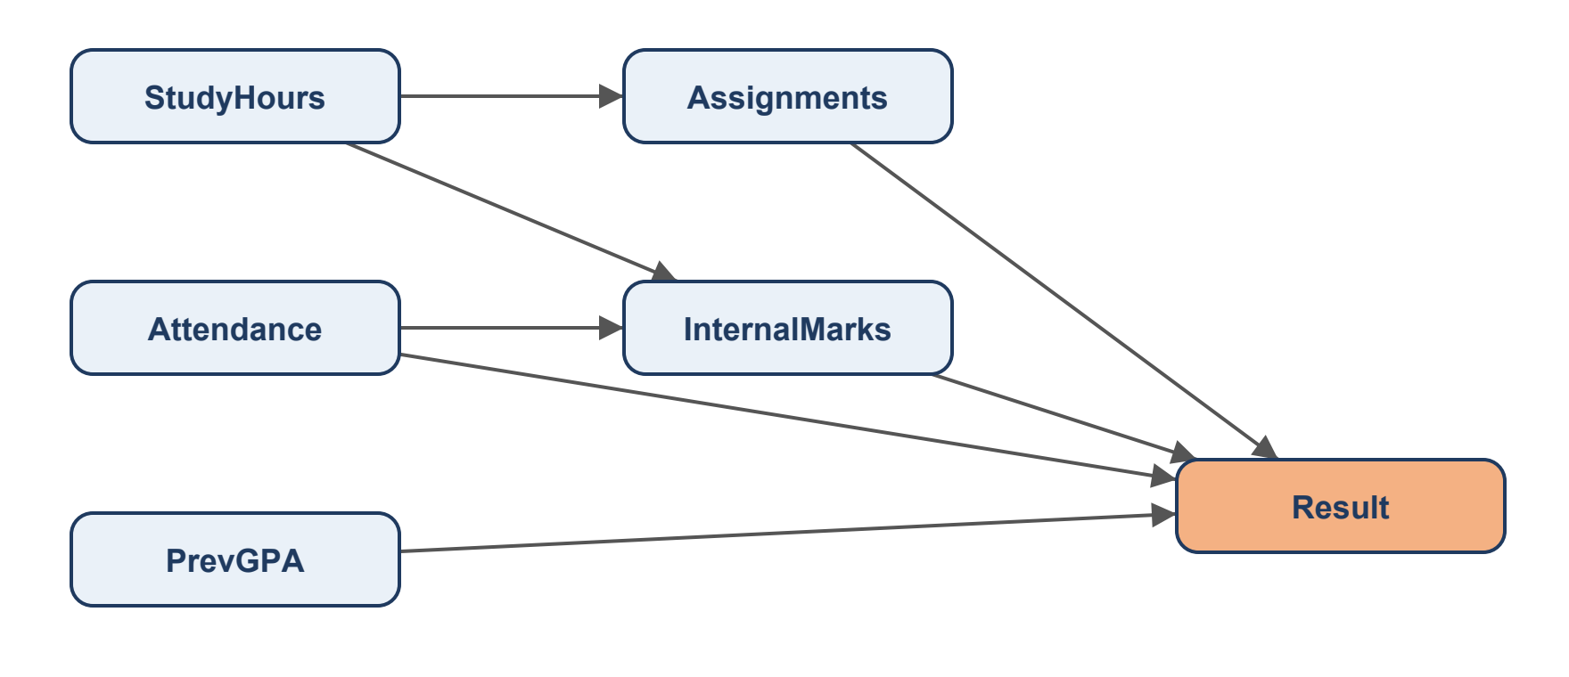
Figure 1. Bayesian network structure (Result shaded)
Learning. Each conditional probability table (CPT) is estimated by counting with Laplace smoothing; a row contributes to a CPT when the node and all its parents are observed.
Inference by enumeration. For a query variable Q, evidence e and hidden variables H:
P(Q | e) = α Σ_{h} Π_{i} P(x_{i} | parents(X_{i})), summed over all assignments h of H
With six variables of at most three states there are at most 3⁵ = 243 terms per query value, so exact enumeration is fast. The same routine answers predictive queries (P(Result | Attendance=Low)), diagnostic queries (P(StudyHours | Result=Fail)) and infers unobserved inputs (P(InternalMarks | e)).

3.5 Decision layer
The posterior from the Bayesian network is passed to the decision-theoretic rule of Section 2. The system therefore separates what is likely (inference) from what to do about it (decision), so the institution can change the costs without retraining any model.

4. Python Implementation
The system is implemented in Python 3 using only the standard library — every algorithm (Naive Bayes, Bayesian network learning and inference, ID3, metrics) is written from scratch. The code is organised as a package spds plus three entry-point scripts.
Module | Responsibility
spds/data.py | Variable definitions, discretisation, CSV loading, train/test and k-fold splits
spds/synthetic.py | Synthetic dataset generator (hidden-trait model)
spds/naive_bayes.py | Naive Bayes: learning, posterior, sequential update, evidence weights
spds/bayes_net.py | Bayesian network: topological order, CPT learning, exact enumeration
spds/decision.py | Cost matrix, expected-cost decision, analytic thresholds
spds/baselines.py | ID3 decision tree, rule-based system, prior-only baseline
spds/metrics.py | Accuracy, precision, recall, F1, log loss, Brier score, decision cost
spds/models.py | Bayesian network structure and model factory
run_experiment.py | Training, evaluation, comparison; writes results/report.md
demo.py | Interactive command-line prototype
tests/test_core.py | Unit tests
Table 3. Project modules

4.1 Naive Bayes posterior
def predict_proba(self, evidence):
log_scores = {c: math.log(self.prior[c]) for c in self.classes}
for f, v in self.observed(evidence):
for c in self.classes:
log_scores[c] += math.log(self.likelihood[f][c][v])
return normalise_log(log_scores)

4.2 Bayesian network — CPT learning and exact inference
def fit(self, records):
"""Learn every CPT by counting (maximum likelihood + Laplace smoothing).
A row only counts towards a CPT if the node and all its parents are
observed in that row (available-case analysis).
"""
a = self.alpha
for node in self.order:
pars = self.parents[node]
counts = defaultdict(Counter)
for r in records:
if r.get(node) is None or any(r.get(p) is None for p in pars):
continue
counts[tuple(r[p] for p in pars)][r[node]] += 1
values = self.states[node]
table = {}
for config in itertools.product(*(self.states[p] for p in pars)):
c = counts[config]
total = sum(c.values())
table[config] = {v: (c[v] + a) / (total + a * len(values)) for v in values}
self.cpt[node] = table
return self
def joint(self, assignment):
p = 1.0
for node in self.order:
config = tuple(assignment[q] for q in self.parents[node])
p *= self.cpt[node][config][assignment[node]]
return p
def query(self, variable, evidence):
"""Exact posterior P(variable | evidence) by enumeration."""
evidence = {k: v for k, v in evidence.items() if v is not None and k in self.parents}
if variable in evidence:
return {v: float(v == evidence[variable]) for v in self.states[variable]}
hidden = [n for n in self.order if n != variable and n not in evidence]
dist = {}
for value in self.states[variable]:
total = 0.0
for combo in itertools.product(*(self.states[h] for h in hidden)):
assignment = dict(evidence)
assignment[variable] = value
assignment.update(zip(hidden, combo))
total += self.joint(assignment)
dist[value] = total
return normalise(dist)

4.3 Decision layer
def expected_costs(posterior):
return {a: sum(posterior[s] * COST[a][s] for s in posterior) for a in ACTIONS}
def decide(posterior):
costs = expected_costs(posterior)
return min(costs, key=costs.get), costs
How to run. python generate_data.py creates the dataset; python run_experiment.py trains and evaluates all models; python demo.py starts the prototype; python -m unittest discover tests runs the tests.

5. Dataset and Test-Case Preparation

5.1 Dataset
A dataset of 2000 students is generated by spds/synthetic.py (seed 42, reproducible). Each student has two hidden traits, motivation and ability, drawn from a standard normal distribution. The observable measures are noisy functions of these traits — e.g. study hours and attendance depend on motivation, previous GPA on ability, internal marks on study hours, attendance and ability — and the final result depends on the observables plus Gaussian noise. The outcome is therefore genuinely uncertain given the evidence, as in real life. About 3% of values are blanked at random to simulate incomplete records. Raw values are discretised using the cut-offs in Table 1.
Variable | State counts | Missing
StudyHours | Low: 485, Medium: 1026, High: 427 | 62
Attendance | Low: 268, Medium: 1110, High: 557 | 65
PrevGPA | Poor: 425, Average: 1101, Good: 424 | 50
InternalMarks | Poor: 405, Average: 1156, Good: 374 | 65
Assignments | Incomplete: 967, Complete: 979 | 54
Result | Pass: 1361, Fail: 639 | 0
Table 4. Dataset summary (fail rate 31.9%)
Splits. A shuffled 70/30 hold-out split (1400 training / 600 test students) and 5-fold cross-validation on the full dataset. The same CSV format can be filled from a real dataset such as the UCI Student Performance dataset without changing any code.

5.2 Test cases
Unit tests verify the correctness of the reasoning engine. The key test checks that a Bayesian network with the naive structure (Result as the only parent of every feature) reproduces the Naive Bayes posterior to nine decimal places — two independent implementations agreeing.
Unit test | Result
test_worked_example | OK
test_actions_follow_thresholds | OK
test_numbers_labels_and_blanks | OK
test_bn_with_naive_structure_equals_naive_bayes | OK
test_cpts_are_distributions | OK
test_posteriors_sum_to_one | OK
test_sequential_update_matches_batch | OK
Table 5. Unit test results — 7 run, 0 failed

6. Performance Evaluation

6.1 Metrics
Fail is treated as the positive class because detecting at-risk students is the goal. Both classification quality and probability quality are measured, plus the quality of the final decisions.
Metric | Meaning
Accuracy | Fraction of students classified correctly (Fail if P(Fail) ≥ 0.5)
Precision (Fail) | Of the students flagged as Fail, the fraction who really failed
Recall (Fail) | Of the students who failed, the fraction the system caught — most important
F1 | Harmonic mean of precision and recall
Log loss | −mean ln P(true outcome); penalises confident wrong probabilities
Brier score | Mean squared error of P(Fail); probability calibration
Avg decision cost | Mean realised cost of the chosen actions (Table 2); lower is better
Table 6. Evaluation metrics

6.2 Hold-out test set
Model | Accuracy | Precision | Recall | F1 | Log loss | Brier | Avg cost
Bayesian Network | 0.858 | 0.864 | 0.702 | 0.775 | 0.349 | 0.109 | 1.113
Naive Bayes | 0.845 | 0.786 | 0.760 | 0.773 | 0.368 | 0.111 | 1.123
Decision Tree (ID3) | 0.847 | 0.826 | 0.707 | 0.762 | 0.357 | 0.114 | 1.185
Rule-based | 0.830 | 0.762 | 0.740 | 0.751 | 2.349 | 0.170 | 1.397
Prior only | 0.653 | 0.000 | 0.000 | 0.000 | 0.649 | 0.228 | 2.040
Table 7. Results on the 600-student hold-out test set
Model | Actual Fail, Pred. Fail (TP) | Actual Fail, Pred. Pass (FN) | Actual Pass, Pred. Fail (FP) | Actual Pass, Pred. Pass (TN)
Bayesian Network | 146 | 62 | 23 | 369
Naive Bayes | 158 | 50 | 43 | 349
Decision Tree (ID3) | 147 | 61 | 31 | 361
Rule-based | 154 | 54 | 48 | 344
Table 8. Confusion matrices on the hold-out test set

6.3 5-fold cross-validation
Model | Accuracy | Recall (Fail) | F1 | Log loss | Avg cost
Bayesian Network | 0.859 ± 0.014 | 0.691 ± 0.018 | 0.757 ± 0.021 | 0.339 ± 0.021 | 1.100 ± 0.049
Naive Bayes | 0.840 ± 0.016 | 0.733 ± 0.028 | 0.745 ± 0.024 | 0.361 ± 0.032 | 1.106 ± 0.078
Decision Tree (ID3) | 0.853 ± 0.016 | 0.670 ± 0.057 | 0.743 ± 0.030 | 0.340 ± 0.021 | 1.105 ± 0.046
Rule-based | 0.832 ± 0.013 | 0.719 ± 0.013 | 0.732 ± 0.013 | 2.321 ± 0.180 | 1.363 ± 0.099
Prior only | 0.680 ± 0.017 | 0.000 ± 0.000 | 0.000 ± 0.000 | 0.627 ± 0.014 | 1.958 ± 0.052
Table 9. 5-fold cross-validation results (mean ± standard deviation)
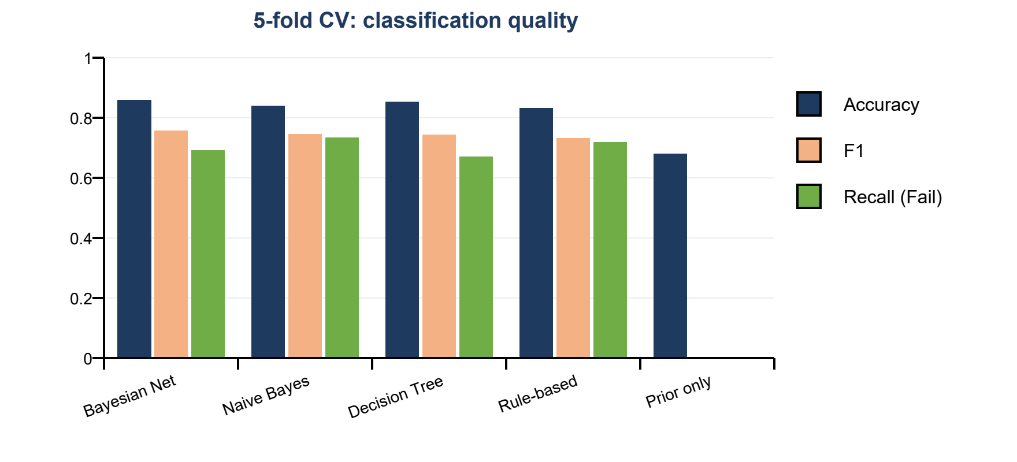
Figure 2. Classification metrics by model
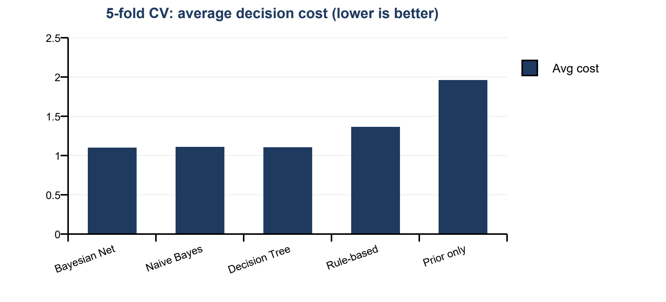
Figure 3. Average decision cost by model

7. Comparison with Alternative Approaches
Three alternative approaches were implemented to put the Bayesian models in context: an ID3 decision tree (information-gain splits, maximum depth 4, smoothed leaf probabilities), a rule-based system encoding typical teacher heuristics (at risk if attendance is Low, or internal marks are Poor, or previous GPA is Poor and assignments are incomplete), and a prior-only baseline that ignores the student.
Capability | Bayesian Net | Naive Bayes | Decision Tree | Rule-based
Calibrated probabilities | Yes (best) | Over-confident | Yes | No (0/1 only)
Handles missing inputs | Exact marginalisation | Skips feature | Stops at node | Partially
Infers unknown inputs | Yes | No | No | No
Diagnostic queries (effect → cause) | Yes | Limited | No | No
Uses domain knowledge | Graph structure | No | No | Hand-written rules
Explainability | CPTs + queries | Evidence weights | Tree paths (large) | Rules
Learns from data | Yes | Yes | Yes | No
Table 10. Qualitative comparison
- Bayesian network vs Naive Bayes. The network is more accurate and better calibrated. Naive Bayes has higher recall but more false alarms, and it is over-confident because it double-counts correlated evidence.
- Bayesian network vs Decision tree. Accuracy is similar, but the tree is a classifier only: it cannot answer diagnostic queries or infer missing inputs, and its learned structure (tens of leaves) is harder to explain than a six-node network.
- Bayesian models vs Rule-based. The rules are reasonable classifiers, but they are certain even when wrong, giving a log loss of 2.32 — about seven times worse. Without probabilities the expected-cost decision cannot be made, and their decision cost is the highest of all approaches except the prior-only baseline.
- Prior-only. Shows that the evidence adds real value: decision cost falls by almost half when the student's data is used.

8. Results and Discussion

8.1 Reasoning examples
Case | BN P(Fail) | NB P(Fail) | Decision (BN)
No evidence (prior) | 0.311 | 0.308 | Mentor & monitor
Low attendance | 0.545 | 0.657 | Intensive intervention
Low attendance + good internal marks | 0.393 | 0.016 | Mentor & monitor
High study hours + assignments complete (marks unknown) | 0.158 | 0.037 | Mentor & monitor
Weak on every measure | 0.955 | 0.999 | Intensive intervention
Mixed profile | 0.279 | 0.305 | Mentor & monitor
Table 11. Posterior probabilities and decisions for representative students
- Low attendance alone raises P(Fail) from about 0.31 to above 0.5, enough to trigger intensive intervention.
- Adding good internal marks shows the key difference between the models: Naive Bayes collapses to almost 0, treating the marks as independent strong evidence, while the network keeps a moderate risk because attendance also directly affects the final result. The network's answer is the more cautious and realistic one.
- With internal marks unknown, the network infers them from study hours and assignments — P(InternalMarks | e) = Poor 0.04, Average 0.55, Good 0.41, compared with the unconditional Poor 0.19, Average 0.62, Good 0.19.

8.2 Diagnostic reasoning
Reasoning from effect to cause: P(StudyHours) = Low 0.25, Medium 0.52, High 0.23, but P(StudyHours | Result = Fail) = Low 0.38, Medium 0.50, High 0.12. Knowing a student failed makes low study hours about 50% more likely — useful for planning remedial programmes.

8.3 Evidence strength (learned likelihoods)
Feature = value | P(v | Pass) | P(v | Fail) | Weight ln(ratio)
StudyHours = Low | 0.140 | 0.488 | +1.25
StudyHours = Medium | 0.558 | 0.450 | -0.21
StudyHours = High | 0.302 | 0.061 | -1.59
Attendance = Low | 0.066 | 0.283 | +1.46
Attendance = Medium | 0.544 | 0.626 | +0.14
Attendance = High | 0.390 | 0.092 | -1.45
PrevGPA = Poor | 0.130 | 0.395 | +1.11
PrevGPA = Average | 0.581 | 0.540 | -0.07
PrevGPA = Good | 0.289 | 0.065 | -1.49
InternalMarks = Poor | 0.026 | 0.600 | +3.15
InternalMarks = Average | 0.686 | 0.398 | -0.55
InternalMarks = Good | 0.288 | 0.002 | -4.80
Assignments = Incomplete | 0.374 | 0.738 | +0.68
Assignments = Complete | 0.626 | 0.262 | -0.87
Table 12. Naive Bayes likelihoods; positive weight pushes towards Fail
Poor internal marks are by far the strongest single indicator of failure (likelihood ratio above 20), followed by low attendance, low study hours and poor previous GPA. Good internal marks are almost conclusive evidence of passing.

8.4 Decisions
On the 600-student test set the system recommended: No action for 272, Mentor & monitor for 129, Intensive intervention for 199. The average realised cost fell from 1.96 (no student information) to 1.10 with the Bayesian network.

8.5 Limitations
- The data is synthetic; results should be validated on real institutional data.
- The network structure is designed by hand; it could be learned from data (e.g. hill-climbing with the BIC score).
- CPT learning ignores rows with missing parents; the EM algorithm would use all data.
- Continuous measures are discretised into three states, which loses some information.

9. Demonstration of the Working Prototype
The prototype demo.py is a command-line application. A user enters any of the five indicators as numbers (e.g. attendance 58) or category names (e.g. Low); anything left blank is treated as unknown. It can be run interactively (questions are asked one by one) or with arguments. For each student it shows the posterior from both models, the step-by-step Bayesian update, the strength of each piece of evidence, inferred values for unknown inputs, and the expected cost of each action with the recommendation.

Case 1 — at-risk student with incomplete data
python demo.py --attendance 58 --study-hours 4 --assignments 5
=== Evidence ===
StudyHours Low
Attendance Low
PrevGPA (unknown)
InternalMarks (unknown)
Assignments Incomplete
=== Posterior probability of the final result ===
Bayesian network P(Fail) = 0.805 [########################......] P(Pass) = 0.195
Naive Bayes P(Fail) = 0.925 [############################..] P(Pass) = 0.075
=== Step-by-step Bayesian update (Naive Bayes) ===
start from the prior -> P(Fail) = 0.320
observe StudyHours = Low -> P(Fail) = 0.595
observe Attendance = Low -> P(Fail) = 0.863
observe Assignments = Incomplete -> P(Fail) = 0.925
=== Which evidence mattered (log-likelihood ratio, + means towards Fail) ===
Attendance = Low P(v|Fail)=0.292 P(v|Pass)=0.068 weight +1.46 towards FAIL
StudyHours = Low P(v|Fail)=0.465 P(v|Pass)=0.149 weight +1.14 towards FAIL
Assignments = Incomplete P(v|Fail)=0.744 P(v|Pass)=0.380 weight +0.67 towards FAIL
=== Inferred values for unknown inputs (Bayesian network) ===
PrevGPA Poor=0.22 Average=0.56 Good=0.22
InternalMarks Poor=0.67 Average=0.31 Good=0.01
=== Decision (minimum expected cost, using the Bayesian network) ===
No action expected cost 8.05
Mentor & monitor expected cost 3.41
Intensive intervention expected cost 1.39 <== recommended
RECOMMENDATION: Intensive intervention
Previous GPA and internal marks were not supplied; the network inferred that the student most likely has poor internal marks and still recommends intensive intervention.

Case 2 — strong student
python demo.py --attendance 88 --study-hours 14 --prev-gpa 8.4 --internal-marks 38 --assignments 9
=== Evidence ===
StudyHours High
Attendance High
PrevGPA Good
InternalMarks Good
Assignments Complete
=== Posterior probability of the final result ===
Bayesian network P(Fail) = 0.015 [..............................] P(Pass) = 0.985
Naive Bayes P(Fail) = 0.000 [..............................] P(Pass) = 1.000
=== Step-by-step Bayesian update (Naive Bayes) ===
start from the prior -> P(Fail) = 0.320
observe StudyHours = High -> P(Fail) = 0.083
observe Attendance = High -> P(Fail) = 0.020
observe PrevGPA = Good -> P(Fail) = 0.004
observe InternalMarks = Good -> P(Fail) = 0.000
observe Assignments = Complete -> P(Fail) = 0.000
=== Which evidence mattered (log-likelihood ratio, + means towards Fail) ===
InternalMarks = Good P(v|Fail)=0.002 P(v|Pass)=0.285 weight -5.18 towards PASS
StudyHours = High P(v|Fail)=0.058 P(v|Pass)=0.298 weight -1.65 towards PASS
PrevGPA = Good P(v|Fail)=0.060 P(v|Pass)=0.292 weight -1.58 towards PASS
Attendance = High P(v|Fail)=0.086 P(v|Pass)=0.382 weight -1.49 towards PASS
Assignments = Complete P(v|Fail)=0.256 P(v|Pass)=0.620 weight -0.88 towards PASS
=== Decision (minimum expected cost, using the Bayesian network) ===
No action expected cost 0.15 <== recommended
Mentor & monitor expected cost 1.05
Intensive intervention expected cost 2.97
RECOMMENDATION: No action

10. Conclusion
This project developed a Student Performance Decision System based on Bayesian reasoning. The problem was formulated as probabilistic inference over six discrete random variables followed by a minimum-expected-cost decision over three interventions. Naive Bayes and a Bayesian network with exact inference by enumeration were implemented from scratch in Python, evaluated with classification, calibration and decision-cost metrics, and compared with a decision tree, a rule-based system and a prior-only baseline.
The Bayesian network gave the best overall performance — 85.9% cross-validated accuracy, the lowest log loss and the lowest average decision cost (1.10, against 1.96 without student information). More importantly, it did things the alternatives cannot: it reasoned correctly with missing data, inferred unobserved indicators, answered diagnostic questions, and avoided the over-confidence that Naive Bayes shows when evidence is correlated. Separating inference from the decision lets an institution adjust its intervention costs without retraining.
Future work: validate on real student records; learn the network structure from data; use EM to learn from incomplete records; add continuous (Gaussian) nodes; track students across the semester with a dynamic Bayesian network; and provide a web or GUI front end for teachers.

References
- S. Russell and P. Norvig, Artificial Intelligence: A Modern Approach, 4th ed., Pearson, 2021 — Chapters 12–13 (Quantifying uncertainty, Probabilistic reasoning) and 15–16 (Making simple decisions).
- J. Pearl, Probabilistic Reasoning in Intelligent Systems: Networks of Plausible Inference, Morgan Kaufmann, 1988.
- D. Koller and N. Friedman, Probabilistic Graphical Models: Principles and Techniques, MIT Press, 2009.
- J. R. Quinlan, "Induction of decision trees," Machine Learning, vol. 1, pp. 81–106, 1986.
- P. Cortez and A. Silva, "Using data mining to predict secondary school student performance," Proc. FUBUTEC, 2008 (UCI Student Performance dataset).

