**Business Requirements Document (BRD)**

**Project Title**: TrackLyze

**1. Project Overview**

The System is a centralized platform designed to streamline and optimize the sales management process. It provides sales managers/business owner with comprehensive tools to track, manage, and visualize critical sales metrics and activities. The system aims to enhance data-driven decision-making by offering real-time insights into forecasted and actual revenue, deal stages, pipeline progress, and conversion rates. Additionally, the platform facilitates the management of client relationships through structured modules for leads, accounts, contacts, deals, and client projects.

**2. Objectives**

* **Enhanced Sales Visibility :** 
  + Provide sales managers with a holistic view of the sales pipeline and revenue forecasts.
* **Optimized Lead and Deal Management**:
  + Improve lead tracking and nurturing through organized workflows.
  + Enhance deal progression through accurate tracking of deal stages and close probabilities.
* **Efficient Project Tracking**:
  + Enables to monitor client project statuses, deadlines, and priorities.
* **Improved Revenue Forecasting**:
  + Support the sales team in identifying revenue trends by month and deal stage.
* **User-Friendly Dashboard**:
  + Provide an intuitive, visually rich dashboard that offers KPIs and visual summaries.

.

**3. Key Features and Functionalities**

**Dashboard**:

* Real-time metrics for forecasted revenue, average deal value, and actual revenue.
* Visual breakdown of deal stages and deal progress over time.
* Conversion rates from lead generation to won deals.

**Lead, Account, and Contact Management**:

* Easy-to-navigate modules for updating and retrieving lead, account, and contact information.
* Automatic tracking of lead status changes and account priorities.

**Deal Management**:

* Stage-by-stage tracking of deal progression.
* Calculation of forecasted revenue based on deal value and close probability.
* Display of closed-won and closed-lost metrics to evaluate success rates.

**Client Project Management**:

* Real-time updates on client project statuses.
* Visibility into project priorities, start and end dates, and project progression.

**API Integration**:

* RESTful APIs for data access, updating, and integration with external systems if needed.
* Authentication and secure API endpoints to protect user data.

**Reporting**:

* Visual reports and exports for pipeline conversion rates, revenue trends, and deal analysis.
* Monthly or quarterly performance insights based on actual vs. forecasted revenue.

**4. API Documentation**

**4.1. Contacts Service**

Handles contact information and related data with accounts, projects, and deals.

* **GET /api/contacts** – Retrieve a list of all contacts
* **GET /api/contacts/{id}** – Retrieve details of a specific contact
* **POST /api/contacts/add** – Add a new contact
* **PUT /api/contacts/{id}/update** – Update information of an existing contact
* **DELETE /api/contacts/{id}** – Delete a contact
* **GET /api/contacts/account/{account_id}** – Retrieve all contacts associated with a specific account
* **GET /api/contacts/project/{project_id}** – Retrieve all contacts associated with a specific project

**4.2. Leads Service**

Manages lead information, tracking, and qualification statuses.

* **GET /api/leads** – Retrieve a list of all leads
* **GET /api/leads/{id}** – Retrieve details of a specific lead
* **POST /api/leads/add** – Add a new lead
* **PUT /api/leads/{id}/update** – Update details of an existing lead
* **DELETE /api/leads/{id}** – Delete a lead
* **GET /api/leads/status/{status}** – Retrieve all leads filtered by status (e.g., new lead, qualified, etc.)

**4.3. Deals Service**

Handles deal tracking, value, progress, and closing data.

* **GET /api/deals** – Retrieve a list of all deals
* **GET /api/deals/{id}** – Retrieve details of a specific deal
* **POST /api/deals/add** – Add a new deal
* **PUT /api/deals/{id}/update** – Update an existing deal’s status, stage, or other attributes
* **DELETE /api/deals/{id}** – Delete a deal
* **GET /api/deals/status/{stage}** – Retrieve all deals filtered by stage (e.g., new, proposal, negotiation)
* **GET /api/deals/account/{account_id}** – Retrieve all deals related to a specific account

**4.4. Accounts Service**

Manages customer accounts, associated contacts, and organizational information.

* **GET /api/accounts** – Retrieve a list of all accounts
* **GET /api/accounts/{id}** – Retrieve details of a specific account
* **POST /api/accounts/add** – Add a new account
* **PUT /api/accounts/{id}/update** – Update details of an existing account
* **DELETE /api/accounts/{id}** – Delete an account
* **GET /api/accounts/industry/{industry}** – Retrieve accounts filtered by industry
* **GET /api/accounts/priority/{priority}** – Retrieve accounts filtered by priority (e.g., low, medium, high)

**4.5. Client Projects Service**

Handles client project information, timelines, status, and prioritization.

* **GET /api/projects** – Retrieve a list of all client projects
* **GET /api/projects/{id}** – Retrieve details of a specific project
* **POST /api/projects/add** – Add a new client project
* **PUT /api/projects/{id}/update** – Update details of an existing project
* **DELETE /api/projects/{id}** – Delete a client project
* **GET /api/projects/status/{status}** – Retrieve projects filtered by status (e.g., not started, working, done)
* **GET /api/projects/priority/{priority}** – Retrieve projects filtered by priority (e.g., high, medium, low)

**4.6. Dashboard**

* **Revenue Metrics:**
  + /api/dashboard/forecasted-revenue
  + /api/dashboard/actual-revenue
  + /api/dashboard/average-won-deal-value
* **Deal Status Metrics:**
  + /api/dashboard/deal-status-distribution
* **Monthly Revenue Metrics:**
  + /api/dashboard/revenue/monthly
  + /api/dashboard/forecasted-revenue/monthly
* **Pipeline Metrics:**
  + /api/dashboard/pipeline-conversion
* **Deal Progress Metrics:**
  + /api/dashboard/deal-progress/monthly

**5. Functional Requirements**

**5.1. User Management and Authentication**

* **User Registration**: Admin can register new users and assign roles (Sales Manager/Business Owner).
* **Login/Logout**: Users must be able to log in and out securely.

**5.2. Leads Management**

* **Add New Lead**: Sales reps can add new leads with details like name, company, status, email, and phone number.
* **Update Lead Status**: Sales reps can update the status of a lead as they progress through the pipeline.
* **View Leads**: All users with appropriate permissions can view the list of leads and filter by status, company, or date added.

**5.3. Accounts Management**

* **Add New Account**: Sales reps or managers can create new accounts and input details such as priority, industry, and description.
* **Update Account Details**: Users with permissions can update account information as it changes.
* **View Accounts**: Users can view accounts associated with specific leads or deals.

**5.4. Contacts Management**

* **Add Contact**: Users can add contact details associated with an account, including email, phone, and title.
* **Link Contacts to Accounts and Deals**: Users can associate contacts with specific accounts or deals.
* **Update Contact Information**: Users can update contact details as they change.

**5.5. Deals Management**

* **Create New Deal**: Sales reps can create new deals, specifying stage, value, expected close date, and close probability.
* **Update Deal Stage and Value**: Users can move deals through various stages (e.g., new, proposal, negotiation) and update deal values.
* **View Deal Pipeline**: Sales Managers and Analysts can view deals organized by stage, value, or close date for pipeline tracking.

**5.6. Client Projects Management**

* **Add New Project**: Project Managers can add new projects associated with a specific account.
* **Update Project Status**: Users can update project progress and prioritize based on client requirements.
* **Track Deadlines**: Users can set and update start and end dates, and track overall progress.

**5.7. Dashboard and Reporting**

* **Real-Time Metrics Display**: The dashboard must display KPIs like forecasted revenue, actual revenue, pipeline conversion rate, and average deal value.
* **Data Visualizations**: Use charts (bar, line, pie) to show metrics like deal status distribution, revenue trends, and monthly deal progress.
* **Customizable Filters**: Allow filtering dashboard data by time period, deal stage, or account type.

**6. Non-Functional Requirements**

* **Performance:** The system should respond to user requests within 2 seconds for most actions, including dashboard loading and data retrieval.
* **Scalability**: The system should support the addition of servers to manage increased workloads without major changes to the architecture.
* **Security:** Encrypt all sensitive data both in transit and at rest. Implement strict access controls to ensure users can only access authorized data and features.
* **Usability:** Design the user interface with user experience in mind, making it easy for users to navigate between different modules.

**7. Stakeholders**

* **Admin**:   
  Manages user accounts and oversees permissions.
* **Sales Representative**:   
  Handles client and lead relationships, including generating and qualifying leads.
* **Project Manager**:   
  Manages client projects, from initiation to completion, including setting project priorities and tracking statuses.
* **Account Manager**:   
  Maintains relationships with assigned client accounts, focusing on retention and satisfaction.

**8. Timeline**

* **Phase 1 (5 days):** Admin & Sales Manager Core Features
* **Phase 2 (3 days):** Deals & Customer Management
* **Phase 3 (3 days):** Sales & Financial Reporting
* **Phase 4 (2 days):** Testing, Deployment, and Final Adjustments

**9. Success Metrics**

* Increase in Business Revenue: Measured by the percentage growth in monthly revenue.
* Improved Sales Efficiency: Measured by the increase in the number of closed deals & projects.
* Increase in Sales Volume: Measured by the percentage growth in the number of completed sales/deals won.

**10. Database Schema**

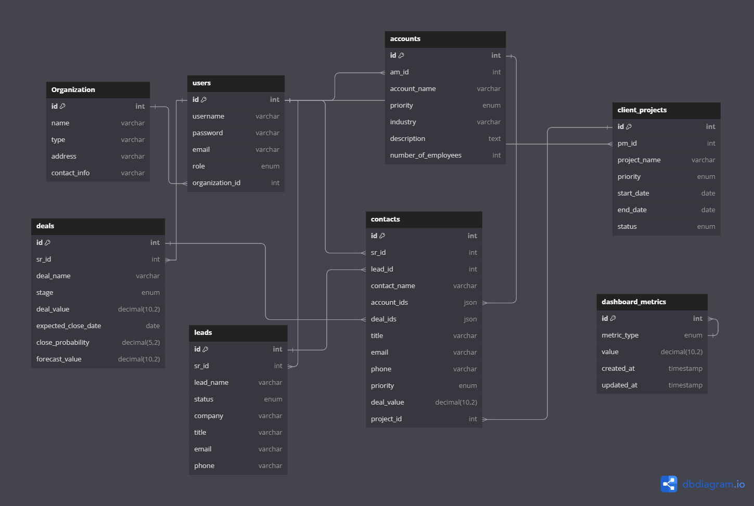

**11. UML Diagram**

