**TrackLyze**

* **Team Members:** 
  + **Member 1 :** Vishnu Chembakan
  + **Member 2 :** Soorya Thejus K V

* **Problem Statement:**

Organizations that manage sales, contacts, deals, projects, and team members often face challenges with fragmented systems and complex workflows. Current CRM and project management tools may not provide an integrated, streamlined experience for team collaboration, contact management, and tracking progress across deals and projects. There is a need of a system that aims to provide a unified platform for managing contacts, associated deals, projects, and team members of the organization while enhancing collaboration and efficiency involved in sales and project management.

**1. Understanding of the Problem statement**

**1.a. Problem Context**

**Business Case**: In many organizations, especially small to medium-sized ones, maintaining a comprehensive view of client interactions, deals, accounts and projects is challenging. Existing tools are often fragmented or overly complex, leading to inefficiencies and a lack of visibility into important business metrics like deal status, project progress, and client engagement. This platform will address these challenges by providing a centralized, user-friendly interface tailored to the needs of organizations that need clear visibility into their contacts and business dealings.

**Intended Users**: The primary users will be sales representatives and project managers who require up-to-date information on their clients and projects. Additionally, business administrators will benefit from data-driven insights on deal conversion rates and client prioritization, which help them make strategic decisions. This platform is also designed to be accessible to other team members who need a clear, comprehensive view of ongoing projects and client relationships.

**1.b. Key Requirements Identified**

* + **Contact Management**: The system must allow users to add potential customers, convert them to contacts and prioritize contacts. Each contact should be associated with relevant accounts, projects, and deals to provide a full view of interactions and business value.
  + **Deal Tracking**: Deals should be trackable with fields to input deal value, status such as "won" or "lost", and priority. Users should receive visual cues or warnings for high-priority deals and when deal statuses change.
  + **Project Integration**: Users need to link contacts to specific projects, with the ability to add and update a project associated with a contact.
  + **User Roles and Permissions**: The system should include role-based access control, with specific views and actions accessible only to roles like Admin, Project Manager, and Sales Rep.
  + **Dashboard Overview**: A dashboard should provide high-level insights into deal conversion rates, lead conversion rates the distribution of deal and lead statuses, revenue metrics and forecast charts to give users immediate visibility into business metrics.
  + **Basic Reporting and Filtering**: Users should be able to filter contacts, deals, and projects by status, priority, or date to facilitate quick decision-making.

**2. Solution Overview**

**2.a. Solution Summary**

This platform combines CRM and project management capabilities tailored for sales and project teams. The unified solution enables users to manage leads, track deals, oversee projects, and organize teams effectively. By consolidating these functions, the platform reduces the need for multiple tools and simplifies task management, data sharing, and collaboration. This solution caters specifically to the needs of sales representatives, project managers, and admins, who rely on timely updates and accurate data to support their workflows.

**2.b. Objective**

* + **Enhance Operational Efficiency** by integrating essential business functions like lead tracking, project management, and account management.
  + **Facilitate Better Decision-Making** with a real-time dashboard showing conversion rates, deal distributions, and priority levels.
  + **Increase Data Accuracy and Collaboration** by enabling team members to work within a single, shared platform.
  + **Empower Role-Based Access and Accountability** to ensure users have access only to relevant information, improving data security and focus.

**Intended Impact**:

* + The platform will reduce the time spent on managing multiple tools and increase focus on high-priority tasks.
  + Improved visibility into contacts and deals will lead to better client management and satisfaction.
  + Enhanced project tracking and prioritization will ensure that high-impact tasks receive timely attention, ultimately supporting business growth.

.

**3. Features and Functionalities**

**3.a. Core Features**

* + **Leads Management**
    - Track lead status (e.g., qualified, unqualified, won, lost) with alert prompts to confirm status changes.
    - View, edit, and update leads based on priority and current status.
  + **Contacts Management**
    - A contacts table displaying fields such as contact name, associated accounts, deals, projects, priority, phone, email, and deal value.
    - Ability to edit contact details and associate contacts with accounts, deals, and single projects, as well as set priority.
  + **Accounts Management**
    - Manage account details including actions-add edit or delete.
  + **Deals Management**
    - Track deal progress with status updates, deal value and forecasted deal value
    - Visual aids such as progress bars and pie charts on the dashboard for an overview of deal distribution and conversion rates.
  + **Projects Management**
    - Assign each contact to a project and set project priority, with visibility of project status and completion.
    - Edit and add projects, with restricted access based on user roles (e.g., Project Managers and Admins).
  + **Teams Management**
    - Admin access to add manage and view team members across roles like sales reps and project managers.
    - Dropdown options to filter team members by role for better organization.
  + **Dashboard with Real-Time Metrics**
    - Provides a snapshot of deal conversion rates, deal status distribution, and project priorities through charts and progress bars.
    - A central hub where users can monitor overall team performance, task completion, and prioritize based on metrics.
  + **Role-Based Access and Authentication**
    - Role-based routing and access control to direct users to relevant sections.
    - Profile and authentication management, with role details displayed in the Navbar.

**3.b. Additional Features**

* + **Editable Records**
    - Users can click on edit within the table to open an editable form, allowing them to update details such lead, account, deals, projects, and more.
  + **Real-time Deal Conversion Rate and Distribution Insights**
    - Dashboard elements display a progress bar for deal conversion rates and a pie chart for deal status distribution, allowing users to quickly assess sales performance.
  + **Role-Specific Navigation and Access Control**
    - Based on role, certain navigation links (like "Team" for Admins) are visible in the sidebar. Role-based access controls allow Project Managers and Admins to edit or add specific records.
  + **Dashboard Layout Customization**
    - Widgets and charts are organized into distinct grids to improve dashboard readability and alignment.

**3.c. User Flows**

* + **Admin User Flow**
    - **Sign Up/Login**: Admins access the system and view a dashboard showing contacts, deals, forecast, revenue metrics.
    - **Manage Team**: Admins can view, add, or remove team members and assign roles.
    - **Track Leads, Contacts, Deals, and Projects**: Access comprehensive tables to manage leads, contacts, deals, projects, and accounts.
    - **Monitor Metrics**: View key metrics such as conversion rates, and prioritize tasks using dashboard widgets and visual insights.
  + **Project Manager User Flow**
    - **Login**: Project managers log in to see contacts, deals, and projects assigned to them.
    - **Manage Projects and Tasks**: They edit projects, assign priorities, and track task progress.
    - **Collaborate on Deals and Contacts**: Work with sales reps to track contacts, prioritize deals, and view project details.
  + **Sales Rep User Flow**
    - **Login**: Sales reps access their own dashboard, showing their contacts, deals, and assigned projects.
    - **Add and Manage Leads and Contacts**: Sales reps can add, edit, and update lead, contact details and associated accounts or deals.
    - **Track Deal Progress**: Update deal status, prioritize tasks, and receive alerts for status changes or priority updates.

**4. Architecture Diagram**

**4.a. System Architecture**

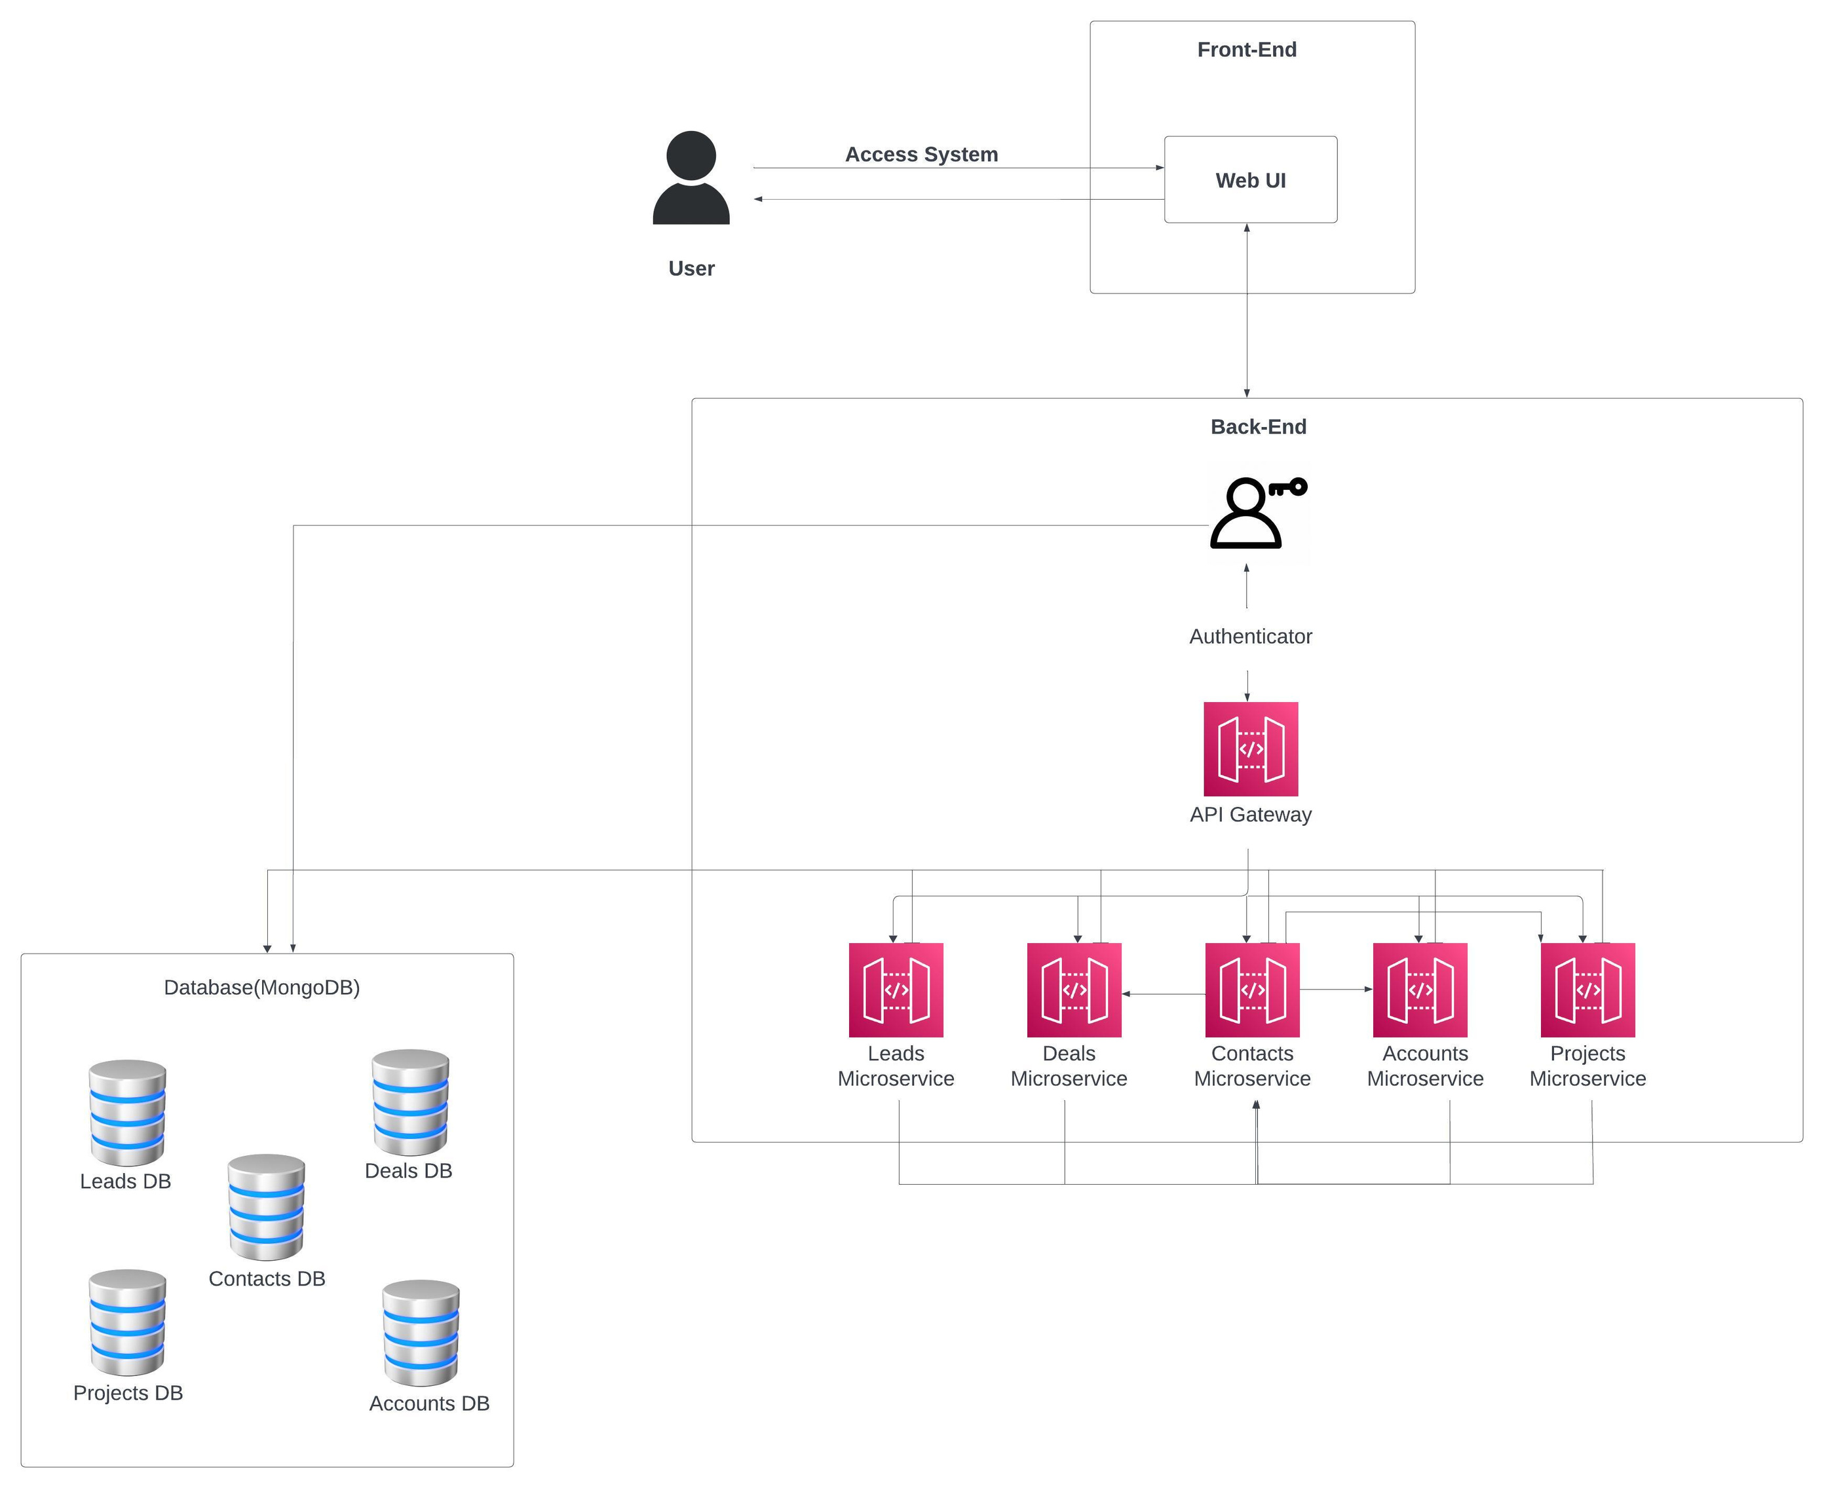

**4.b. Key Components**

* + **Leads Management Service**:
    - Manages all lead-related data and actions.
    - Track lead statuses (qualified, unqualified, won, lost).
    - Edit, view, and prioritize leads.
    - Progress indicators (e.g., progress bars) and metrics on the dashboard for quick lead status overviews and conversion rates.
  + **Contact Management Service**:
    - Manages the contacts database and interactions.
    - View and edit contact information (name, email, phone, associated accounts).
    - Link contacts with accounts, deals, and projects.
  + **Accounts Management Service**:
    - Manages information about business accounts and client organizations.
    - Fields for contact information, account history.
  + **Deal Management Service**:
    - Tracks and updates deals.
    - Deal status, value, and associated contacts or accounts.
    - Visual alerts for high-priority deals and status changes.
    - Progress indicators (e.g., progress bars) and metrics on the dashboard for quick deal status overviews and conversion rates.
  + **Project Management Service**:
    - Handles data and actions related to projects, including:
    - Linking each contact to a single project, assigning project priority, and tracking project completion.
    - Role-based restrictions, ensuring that only Project Managers can edit or create new projects.

**5. Technical Stack**

**5.a. Frontend**

React with TypeScript for a responsive user interface, utilizing reusable components for forms, dashboards, and reporting

**5.b. Backend**

Node.js and TypeScript for handling server requests and providing RESTful APIs. Microservices architecture supports separation of concerns.

**5.c. Database**

MongoDB for managing non-relational data (financial and project details), ensuring scalability and flexibility in data storage.

**5.4. Other Technologies and Tools**

Tailwind CSS for frontend components, JWT for secure access, Docker for containerization and Kafka for real-time data visualization.

**6. Prerequisites and Requirements**

**6.a. Technical Requirements**

* + Node.js environment for backend development.
  + React development environment for frontend.
  + Access to a MongoDB instance for data storage.

**6.b. Data Requirements**

* + Sample sales metrics data for testing.
  + Lead, contact, deal, project, and accounts data for validation.

**6.c. Access Permissions**

* + Git repository access for code collaboration.
  + CI/CD pipeline setup for deployment.

**6.d. Other Dependencies**

* + Libraries for JWT (jsonwebtoken), Docker for containerization, and additional UI libraries

**7. Future Improvements**

**7.a. Planned Enhancements:**

* + Automated Task and Workflow Management.
  + Advanced Reporting and Predictive Analytics.
  + Integration with External Communication.

**7.b. Scalability Considerations:**

* + Cloud-based database scaling.
  + Load balancing and microservices expansion to accommodate increased data and users.

**8. Conclusion**

**8.a. Summary of Achievements:**

This system is a unified platform tailored for teams involved in sales and project execution. By consolidating essential tasks such as lead tracking, deal management, project oversight, and team collaboration into a single interface.

**8.b. Value Provided:**

The platform significantly improves operational efficiency by consolidating vital business functions and promoting better decision-making through real-time insights.