[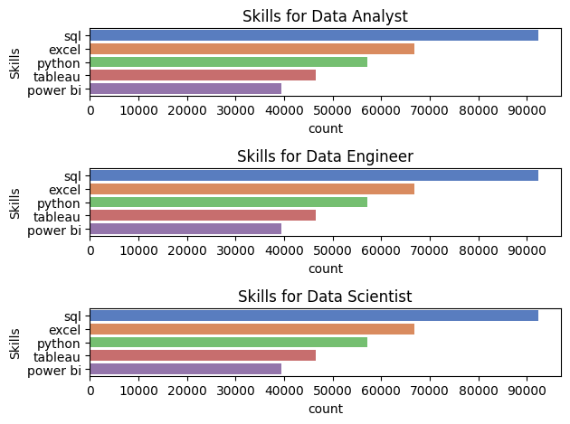](https://github.com/sooryanshi/data-analysis-project-01/edit/main/README.md)