Software Requirements
Specification

For

VOYAGE
(Tour Management System)

Prepared by :-
Soorya Thejas V S
TABLE OF CONTENTS

1. INTRODUCTION 3
  - PURPOSE 4
  - SCOPE 5
  - OBJECTIVES 6

2. FUNCTIONAL REQUIREMENTS 8
2.1 PRIMARY ACTORS OF THE SYSTEM 8
2.2 USE CASE DIAGRAMS 9
2.3 USER STORIES 12
2.4 BUSINESS PROCESS DIAGRAM 15

3. NON-FNCTIONAL REQUIREMENTS 15
4. TECHNICAL REQUIREMENTS 16
5. CONCLUSION 18

1.INTRODUCTION

Voyage (Tour Management System) is an online tour booking and travel consultancy platform developed to streamline travel planning and tour management activities. The system provides a centralized platform where agencies, consultants, and customers can interact efficiently for booking tours, managing travel packages, handling refunds, and providing travel guidance.

The platform helps travel agencies manage tour packages, advertisements, consultants, customer reviews, and refund processes. Consultants can assist customers with ticket reservations, visa application procedures, travel insurance, and travel-related support services. Customers can search and filter tour packages, view price details, book tours, contact consultants, provide feedback, and manage cancellations and refunds through the platform.

Voyage aims to improve customer satisfaction by offering convenient online services and better communication between users, while also reducing manual work, saving time, and improving the overall efficiency of travel management operations.

  - PURPOSE

The purpose of this Software Requirements Specification (SRS) document is to clearly define and describe the requirements of the Voyage Tour Management System. This document provides a detailed description of the system’s features, functions and overall behaviour to ensure proper understanding among developers, designers, testers, and stakeholders.

The main purpose of this SRS is to capture and document both the functional and non-functional requirements of the system. Functional requirements describe the services and operations provided by the system, such as user registration, tour package booking, payment processing, review management, consultant services, and package management. Non-functional requirements define the quality attributes of the system, including security, performance, reliability, usability, and scalability.

This document acts as a reference throughout the software development life cycle and helps ensure that the Voyage Tour Management System is developed according to user needs and business objectives.

  - SCOPE

The Voyage Tour Management System is a web-based application developed using a Java full-stack architecture and Angular frontend to simplify and manage tour and travel booking activities for customers, travel agencies, and consultants. The system provides an online platform where users can explore tour packages, make bookings, manage travel-related services, and communicate with travel consultants efficiently.

The main functionalities and features included in the system are:
- User registration and login for customers, agency, and consultants.
- Tour package management, including adding, updating, deleting, and viewing tour packages.
- Online tour booking and reservation facilities.
- Review, rating, feedback, and complaint management.
- Refund management for cancelled bookings.
- Vacancy or availability posting by consultants.
- Location tracking and travel notes management.
- Terms and conditions management by the agency admin.
- Customer profile management and booking history tracking.

The system caters to the following user roles:
1. Customer
➨ Register and log in to the system.
➨ Search and book tour packages.
➨ Provide ratings, reviews, and feedback.
➨ View booking history and travel details.

2. Agency Admin
➨ Manage tour packages and advertisements.
➨ Monitor reviews, complaints, refunds, and feedback.
➨ Add consultants and provide login credentials.
➨ Manage terms and conditions, incentives, and location tracking.

3. Consultant
➨ Assist customers with ticket reservations, visa applications, and travel insurance.
➨ Add and manage tour packages.
➨ Monitor customer feedback and complaints.
➨ Post travel vacancies or availability updates.

  - OBJECTIVES
The main objective of the Voyage Tour Management System is to provide an efficient, reliable, and user-friendly platform for managing tour and travel booking activities online. The system is designed to simplify the interaction between customers, travel agencies, and consultants by automating various travel management processes.

The high-level objectives of the system are:

- To provide customers with an easy and convenient way to search, view, and book tour packages online.
- To help travel agencies efficiently manage tour packages, advertisements, customer feedback, complaints, refunds, and consultant activities.
- To enable consultants to assist customers with ticket reservations, visa processing, travel insurance, and travel-related guidance.
- To improve communication and coordination between customers, agency admins, and consultants.
- To maintain proper records of bookings, reviews, ratings, and customer activities.
- To reduce manual paperwork and administrative workload through automation.
- To ensure secure and organized management of travel and booking information.
- To increase customer satisfaction by providing quick access to travel services and support.

- FUNCTIONAL REQUIREMENTS

  - Primary Actors Of the System :-
The primary actors of the Voyage Tour Management System are the users and external entities that interact directly with the system to perform various operations based on their roles and permissions.
1. Customer
- Main users who access the platform to search and book tour packages.
- Activities include registering, logging in, viewing tour packages and travel details, booking tours, making payments, providing ratings, reviews, feedback, and submitting complaints or refund requests.
2. Agency Admin
- Manages and controls the overall operations of the system.
- Responsibilities include managing tour packages and advertisements, monitoring bookings, refunds, reviews, and complaints, adding and managing consultants, managing terms and conditions, tracking locations, maintaining travel notes, and monitoring system activities.
3. Consultant
- Assists customers with travel-related services and support.
2.2 USE CASE DIAGRAMS :-

AGENCY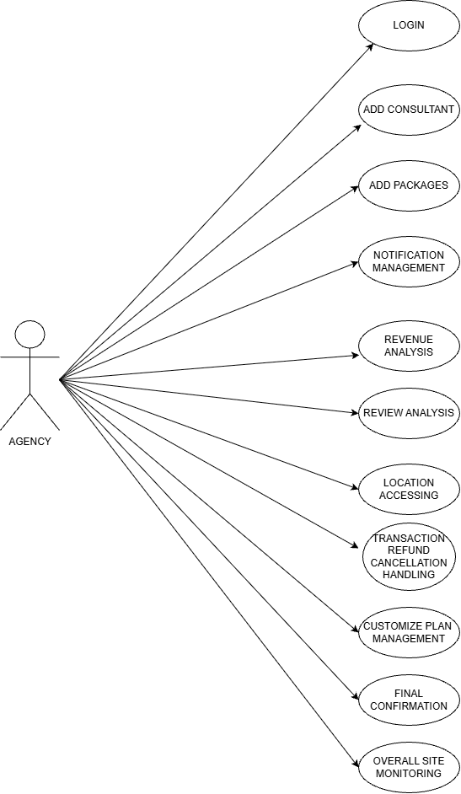
CONSULTANT
- . 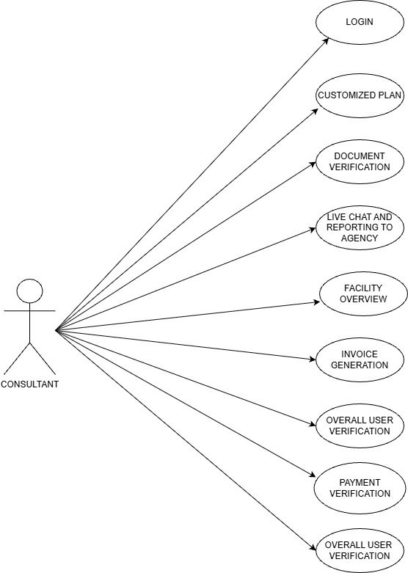
- CUSTOMER
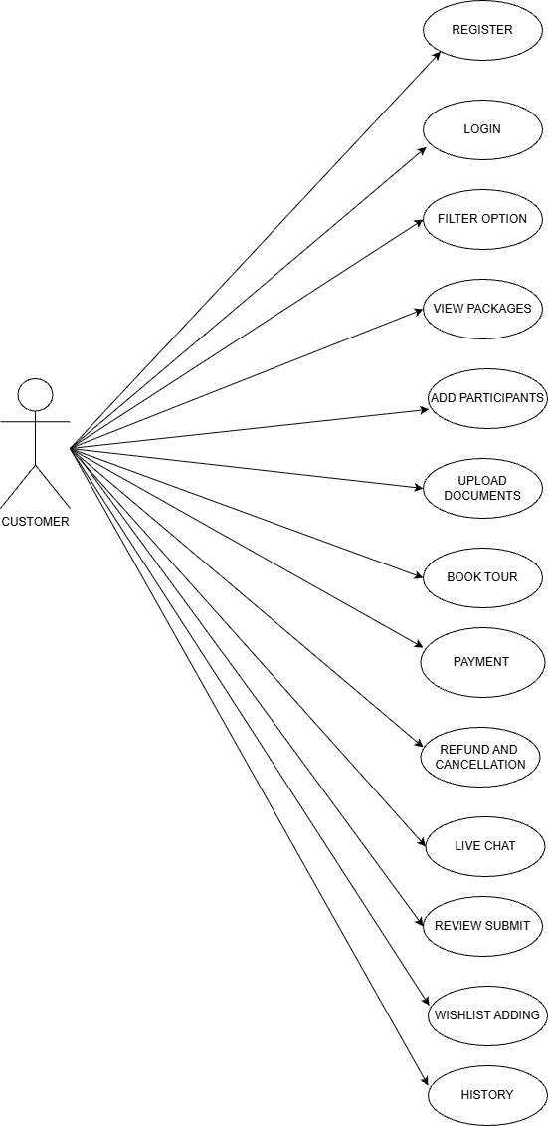

2.3 USER STORIES

AGENCY
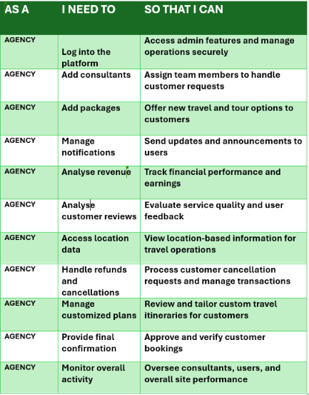

CONSULTANT
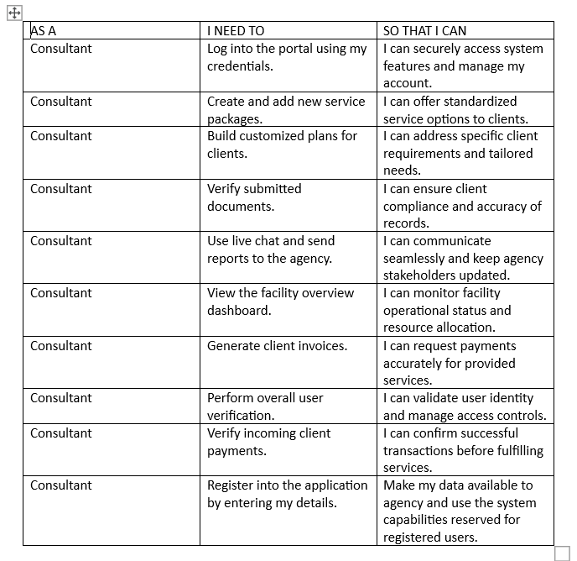

CUSTOMER
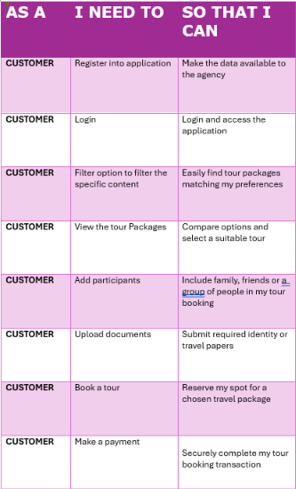
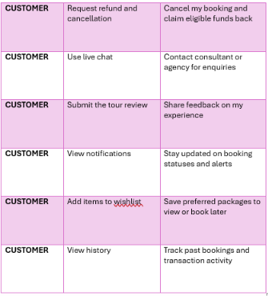
2.4 BPMN :-
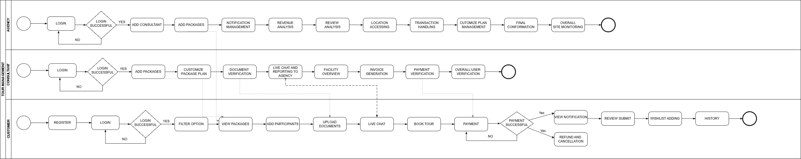
3.NON-FUNCTIONAl REQUIREMENTS

- Performance: Must respond quickly under normal conditions, handle concurrent users seamlessly, and process searches/bookings efficiently.

- Reliability: Ensures minimal downtime, reliable storage of transactional data, proper recovery from failures, and backup mechanisms.

- Security: Requires secure logins, role-based access control, encrypted passwords, SSL/TLS data transfer protection, and payment gateway integration.

- Usability: Features a simple, user-friendly, and intuitive interface with clear navigation and error messages.

- Availability: Accessible continuously except during scheduled maintenance.

- Scalability: Designed to support future growth in users, packages, and workloads.

4. TECHNICAL REQUIREMENTS
1. HARDWARE REQUIREMENTS
Server Side
➨ Processor: AMD Ryzen 5 or higher
➨ RAM: Minimum 8 GB
➨ Storage: Minimum 500 GB hard disk or SSD
➨ Network: Stable internet connection with adequate bandwidth
Client Side
➨ Computer, laptop, tablet, or smartphone
➨ Minimum 4 GB RAM
➨ Stable internet connection
➨ Web browser support

2. SOFTWARE REQUIREMENTS
Operating System
➨ Windows 10/11
Web Browsers
➨ Google Chrome
➨ Mozilla Firefox
➨ Microsoft Edge
Database Management System

➨ MySQL
3. Programming languages
Frontend
➨ HTML
➨ CSS
➨ JAVASCRIPT
Backend
➨ Java
4. Frameworks and technologies
➨ Bootstrap for responsive user interface
➨ Angular for front end development
➨ Java Spring API for communication between frontend and backend systems
5. Compatibility Requirements
➨ The system should support desktop and mobile devices.
➨ The application should function properly across multiple operating systems and web
browsers.
6. Security Requirements
➨ SSL/TLS encryption should be used for secure communication.
➨ Passwords should be stored in encrypted format.
➨ Secure authentication and authorization mechanisms should be implemented.
➨ The system should support secure online payment gateway integration.

5. CONCLUSION
The Software Requirements Specification (SRS) document for the Tour Hub Tour Booking System provides a detailed description of the system’s objectives, scope, functional requirements, non-functional requirements, technical requirements, user roles, and overall system functionalities. The document clearly explains how the system will support customers, agency admins, and consultants in managing tour booking and travel-related services efficiently.
It is recommended that the system be developed using secure and scalable technologies with proper testing and maintenance procedures. Future enhancements such as mobile application support, AI-based travel recommendations, real-time GPS tracking, and multilingual support can also be added to improve the overall functionality and user experience of the system.

