Hypertext Transfer Protocol (HTTP) is an application protocol that is, currently, the foundation of data communication for the World Wide Web.

Difference between HTTP/1.1 and HTTP/2 are:

HTTP/1.1 | HTTP/2
It works on the textual format. | It works on the binary protocol.
There is head of line blocking that blocks all the requests behind it until it doesn’t get its all resources. | It allows multiplexing so one TCP connection is required for multiple requests.
It uses requests resource Inlining for use getting multiple pages | It uses PUSH frame by server that collects all multiple pages
It compresses data by itself. | It uses HPACK for data compression.

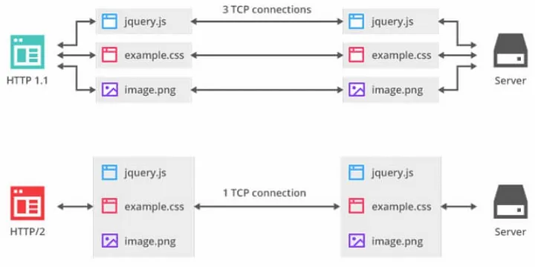

2.Write a blog about objects and its internal representation in Javascript

- Objects are important data types in javascript. Objects are different than primitive datatypes (i.e. number, string, boolean, etc.).

- Primitive data types contain one value but Objects can hold many values in form of Key: value pair.

- These keys can be variables or functions and are called properties and methods, respectively, in the context of an object.

- Every object has some property associated with some value. These values can be accessed using these properties associated with them.
Ex:
var myCar = new Object();
myCar.make = 'Suzuki';
myCar.model = 'Altros';
myCar.year = 1978;
myCar.wheels = 2;
After creating myCar object, the value inside the object can be accessed using keys.
i.e.
myCar.year
Output: 1978

