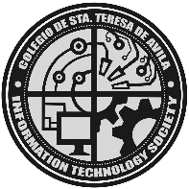COLEGIO DE STA. TERESA DE AVILA

6 Kingfisher Corner Skylark Streets, Zabarte Subdivision

Novaliches, Quezon City 1123 Philippines

Telephone: 939-69-83 / 939-91-38 Telefax: 930-57-85

**SCHOOL OF INFORMATION TECHNOLOGY**

**ACADEMIC GRADING AND STUDENT’S PERFORMANCE WITH MONITORING SYSTEM**

A Research Presented to Colegio De Sta. Teresa De Avila School Year 2025-2026

In Partial Fulfillment of the Requirements for Information Management BSIT 2-1

By:

Dela Cruz, Kenneth Dave

Duaso, Sandra

Marianito, Joyce

Pantoliano, Ralph

Rocas, Clarenz Kyle

**ACKNOWLEDGEMENT**

**ABSTRACT**

**TABLE OF CONTENTS**

**Chapter 1**

**THE PROBLEM AND ITS BACKGROUND**

This chapter presents the problem and its background, highlighting the importance of the study and the need for its development. It outlines the objectives of the research, the scope and limitations of the project, and the individuals or groups who may benefit from it. Furthermore, it discusses the issues being addressed and the proposed solution that the study aims to provide.

**Background of the Study**

In today’s rapidly evolving technological era, the constancy of change outweighs any semblance of certainty, positioning every organization within what is known as a VUCA world – Volatility, Uncertainty, Complexity and Ambiguity [1]. This continual shift in technologies, tools and systems requires institutions to continuously adapt and innovate. Within the realm of higher education, these strategies encompass a range of initiatives designed to foster creativity, adaptability, and efficiency. Innovation in educational institutions often involves the integration of advanced technologies [2]. In line with this, digital technology concept had been recognized as a powerful tool that enhances teacher’s and student’s effectiveness [3]. In the Philippine context, a study at Adamson University developed an Integrated Educational Management Tool that automates examination and grading, reduces redundancy in records, and improves efficiency and accessibility [4]. Similarly, a study among higher education teachers in Romania revealed that about 17.95% regularly use a variety of digital assessment tools, while roughly 12.82% systematically use digital feedback methods [5]. Despite the growing presence of web-based and online systems, challenges such as unstable internet connectivity, limited resources, and accessibility issues remain prevalent in many academic institutions. These realities highlight the need for reliable alternatives that can function even without constant online access. For instance, Moodle has incorporated offline grading workflows that allow teachers to download grading sheets, work offline, and later re-upload results when connectivity is restored [6]. Similarly, in the Philippine context, the Integrated Educational Management Tool developed at Adamson University was designed with features to make class records and examinations available offline with online synchronization [7]. These examples emphasize that developing an offline or desktop-based grading system provides a practical solution—ensuring that teachers can efficiently manage, record, and compute student grades regardless of connectivity constraints, while still maintaining accuracy, reliability, and ease of use.

Colegio de Sta. Teresa de Avila, Inc. (CSTA), established in 2007 and located in Novaliches, Quezon City, is an educational institution that provides quality and innovative education that transcend. CSTA currently offer five courses: Bachelor of Science in Hospitality Management (BSHM), Bachelor of Science in Tourism Management (BSTM), Bachelor of Secondary Education (BSED), Bachelor of Elementary Education (BEED) and Bachelor of Science in Information Technology (BSIT). CSTA has been well known for producing globally competitive and productive graduates throughout the years.

**Overview of the Current State of Technology**

**Objectives of the Study**

The general objective of this study is to design and develop AGSPMS: Academic Grading and Student’s Performance with Monitoring System, a desktop-based grading system for Colegio de Sta. Teresa de Avila.

In line with this, the project aims to achieve the following specific objectives:

1. Design and develop AGSPMS with the following features and functionalities:
2. Admin Dashboard;
3. Department Admin Dashboard;
4. Faculty Dashboard;
5. Student Dashboard;
6. User Management Module;
7. Student Information Module;
8. Faculty Management Module;
9. Curriculum and Subject Management Module;
10. Grades Management Module;
11. Reports Generation Module
12. Design and develop said system using the following materials and technologies:
13. VB.NET;
14. SQLyog;
15. ODBC
16. To test the developed system in terms of functionality and usability.
17. Evaluate the developed system based on functional suitability, performance efficiency, compatibility, usability, reliability, security, maintainability and portability using the ISO 25010 standard.

**Conceptual Framework**

In this study, a conceptual framework is presented to illustrate the structure and flow of the proposed Academic Grading and Student’s Performance with Monitoring System. The framework serves as a guide in understanding how the different components of the system interact with one another to achieve the desired objectives. It identifies the independent variables (inputs), mediating variables (processes), dependent variables (outputs), and control variables, and shows how they are related. By doing so, the framework provides a clear visualization of how user roles, data, and system processes are integrated to produce accurate and reliable grade reports.

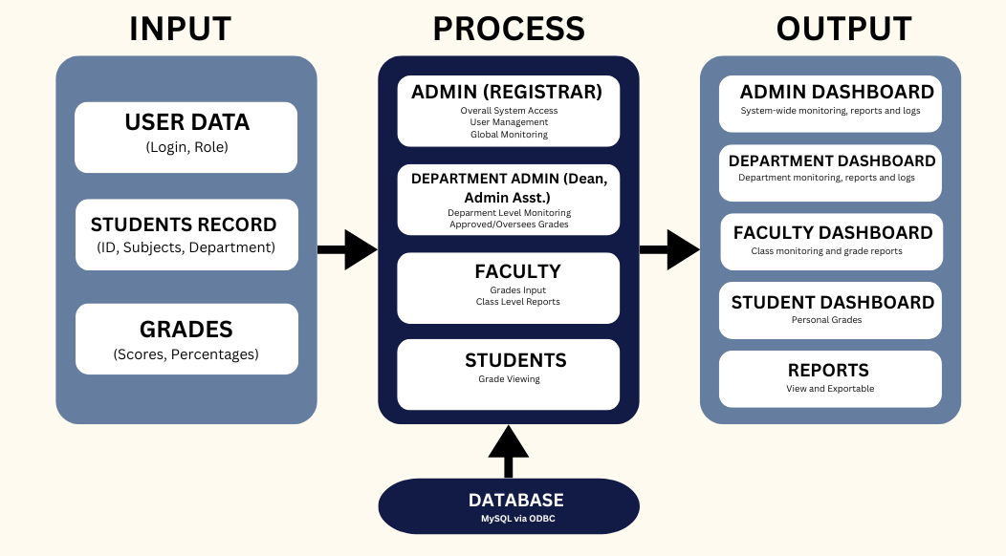

The conceptual framework of the proposed Academic Grading and Student’s Performance with Monitoring System shows how the system functions to ensure efficient and accurate grade monitoring. It shows the relationship between the variables. The input serves as the independent variables handles the user roles, user data, students records and grades data. These inputs serve as the raw information that drives the system. Meanwhile, the mediating variables are the system processes that transform the inputted data into meaningful results. These includes authentication, database operation and validation to ensure the accurate and secure outcome. The output serves as the dependent variable in the system; they are the outputs generated by the system. It consists of the dashboards for each role, reports that they can view and even monitoring activities. Lastly, the control variables are the fixed technological components, in our system we have VB.NET as the application platform, ODBC as the connector and SQLyog as the database. These provides a stable foundation for our system that guarantees consistent performance.

In summary, the framework illustrates how the system connects its main components through a centralized database. Each interaction ensures smooth flow of information from input to final output.

**Significance of the Study**

Below is a list of significant contributions of the study.

* Colegio de Sta. Teresa de Avila, Inc., the study will support the school identify and minimize operational bottlenecks, thereby streamlining academic and administrative processes. It enhances overall management efficiency by improving workflow and organizational strategies, leading to a more effective educational environment.
* Faculty Members, the study will provide a more efficient grading process by managing student grades and submitting grades will be faster as the proposed system can be access, increasing efficiency and productivity.
* Deans, the study will assist the deans in crediting and checking students’ grades, thus increasing their time for other workloads.
* Students, the study will help students get some documents and report cards faster thus speeding up campus operations and gaining timely and accurate grade reports, which improves transparency in academic performance. This promotes fairness and motivates students to track and enhance their academic progress more effectively.
* Future Researchers, the study will back up them by using it as a reference for their own studies. It serves as a valuable reference for future system developers and researchers who aim to improve grading and academic management systems. It provides insights into the challenges of traditional methods and demonstrates how technology can be applied to resolve them.

**Scope and Limitations**

**Definition of Terms**

**Chapter 2**

**REVIEW OF RELATED LITERATURE**

This chapter presents the related literature and studies that support the development of the proposed system. It provides an overview of existing works, both local and foreign, that highlight the importance of computerized systems in record management. The discussion is arranged thematically to emphasize the relevance of these studies to the present research.