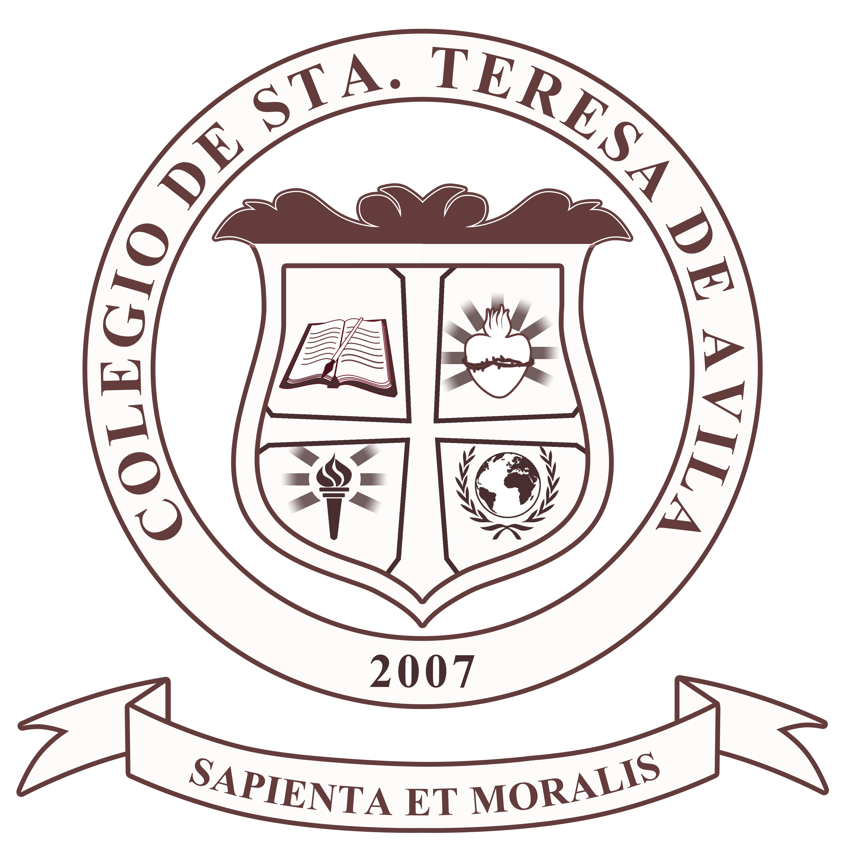
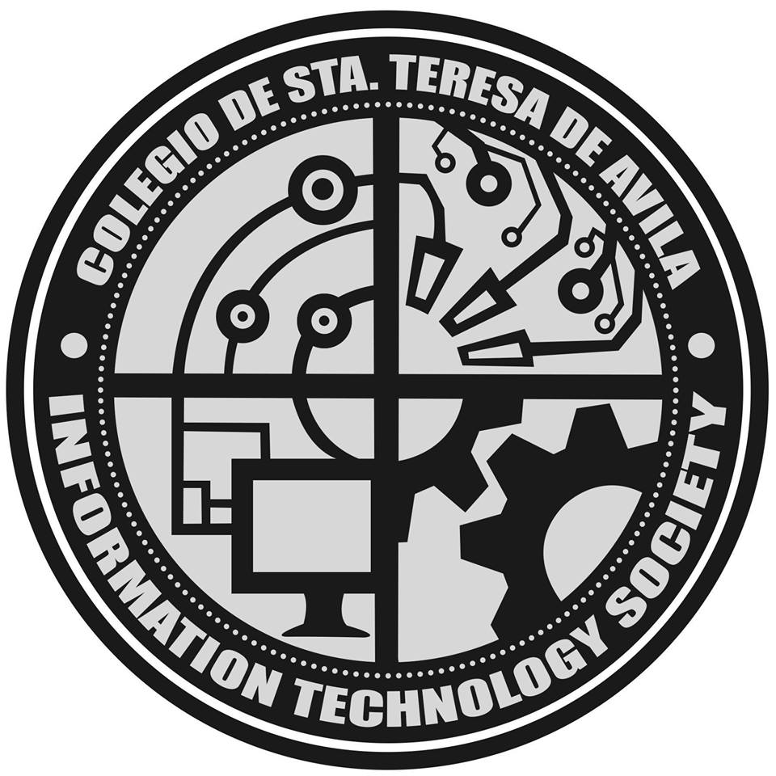
COLEGIO DE STA. TERESA DE AVILA
6 Kingfisher Corner Skylark Streets, Zabarte Subdivision
Novaliches, Quezon City 1123 Philippines
Telephone: 939-69-83 / 939-91-38 Telefax: 930-57-85

SCHOOL OF INFORMATION TECHNOLOGY

<Date>

<Name of Contact Person>
<Designation/Position>
<Company Name>
<Company Address>

Dear Sir/Ma’am:
Greetings!
We, <Name of Students separated by commas>, are second-year Bachelor of Science in Information Technology students of Colegio de Sta. Teresa de Avila, currently working on our Information Management Project entitled <Project Title>.
In line with this, we respectfully request permission from your good office to conduct an interview and obtain relevant data, information, and sample forms that are vital for the completion of our proposed study. These resources will assist us in identifying the challenges or limitations of the existing system and in formulating a suitable solution that can contribute to improving the organization’s processes and achieving its goals.
We sincerely assure you that all documents and information that may be shared with us will be used solely for academic purposes and will be treated with the highest degree of confidentiality.
We hope for your favorable consideration of our request.
Thank you very much, and may you be blessed with continued success and strength.
Respectfully yours,

<Student Name>
Group Leader

Noted By:

Harold R. Lucero, MIT
Dean, School of Information Technology

Endorsed by:

James Jomar Linawan
Adviser, Information Management

Image Marie Y. Maiquez
Adviser, Information Management

