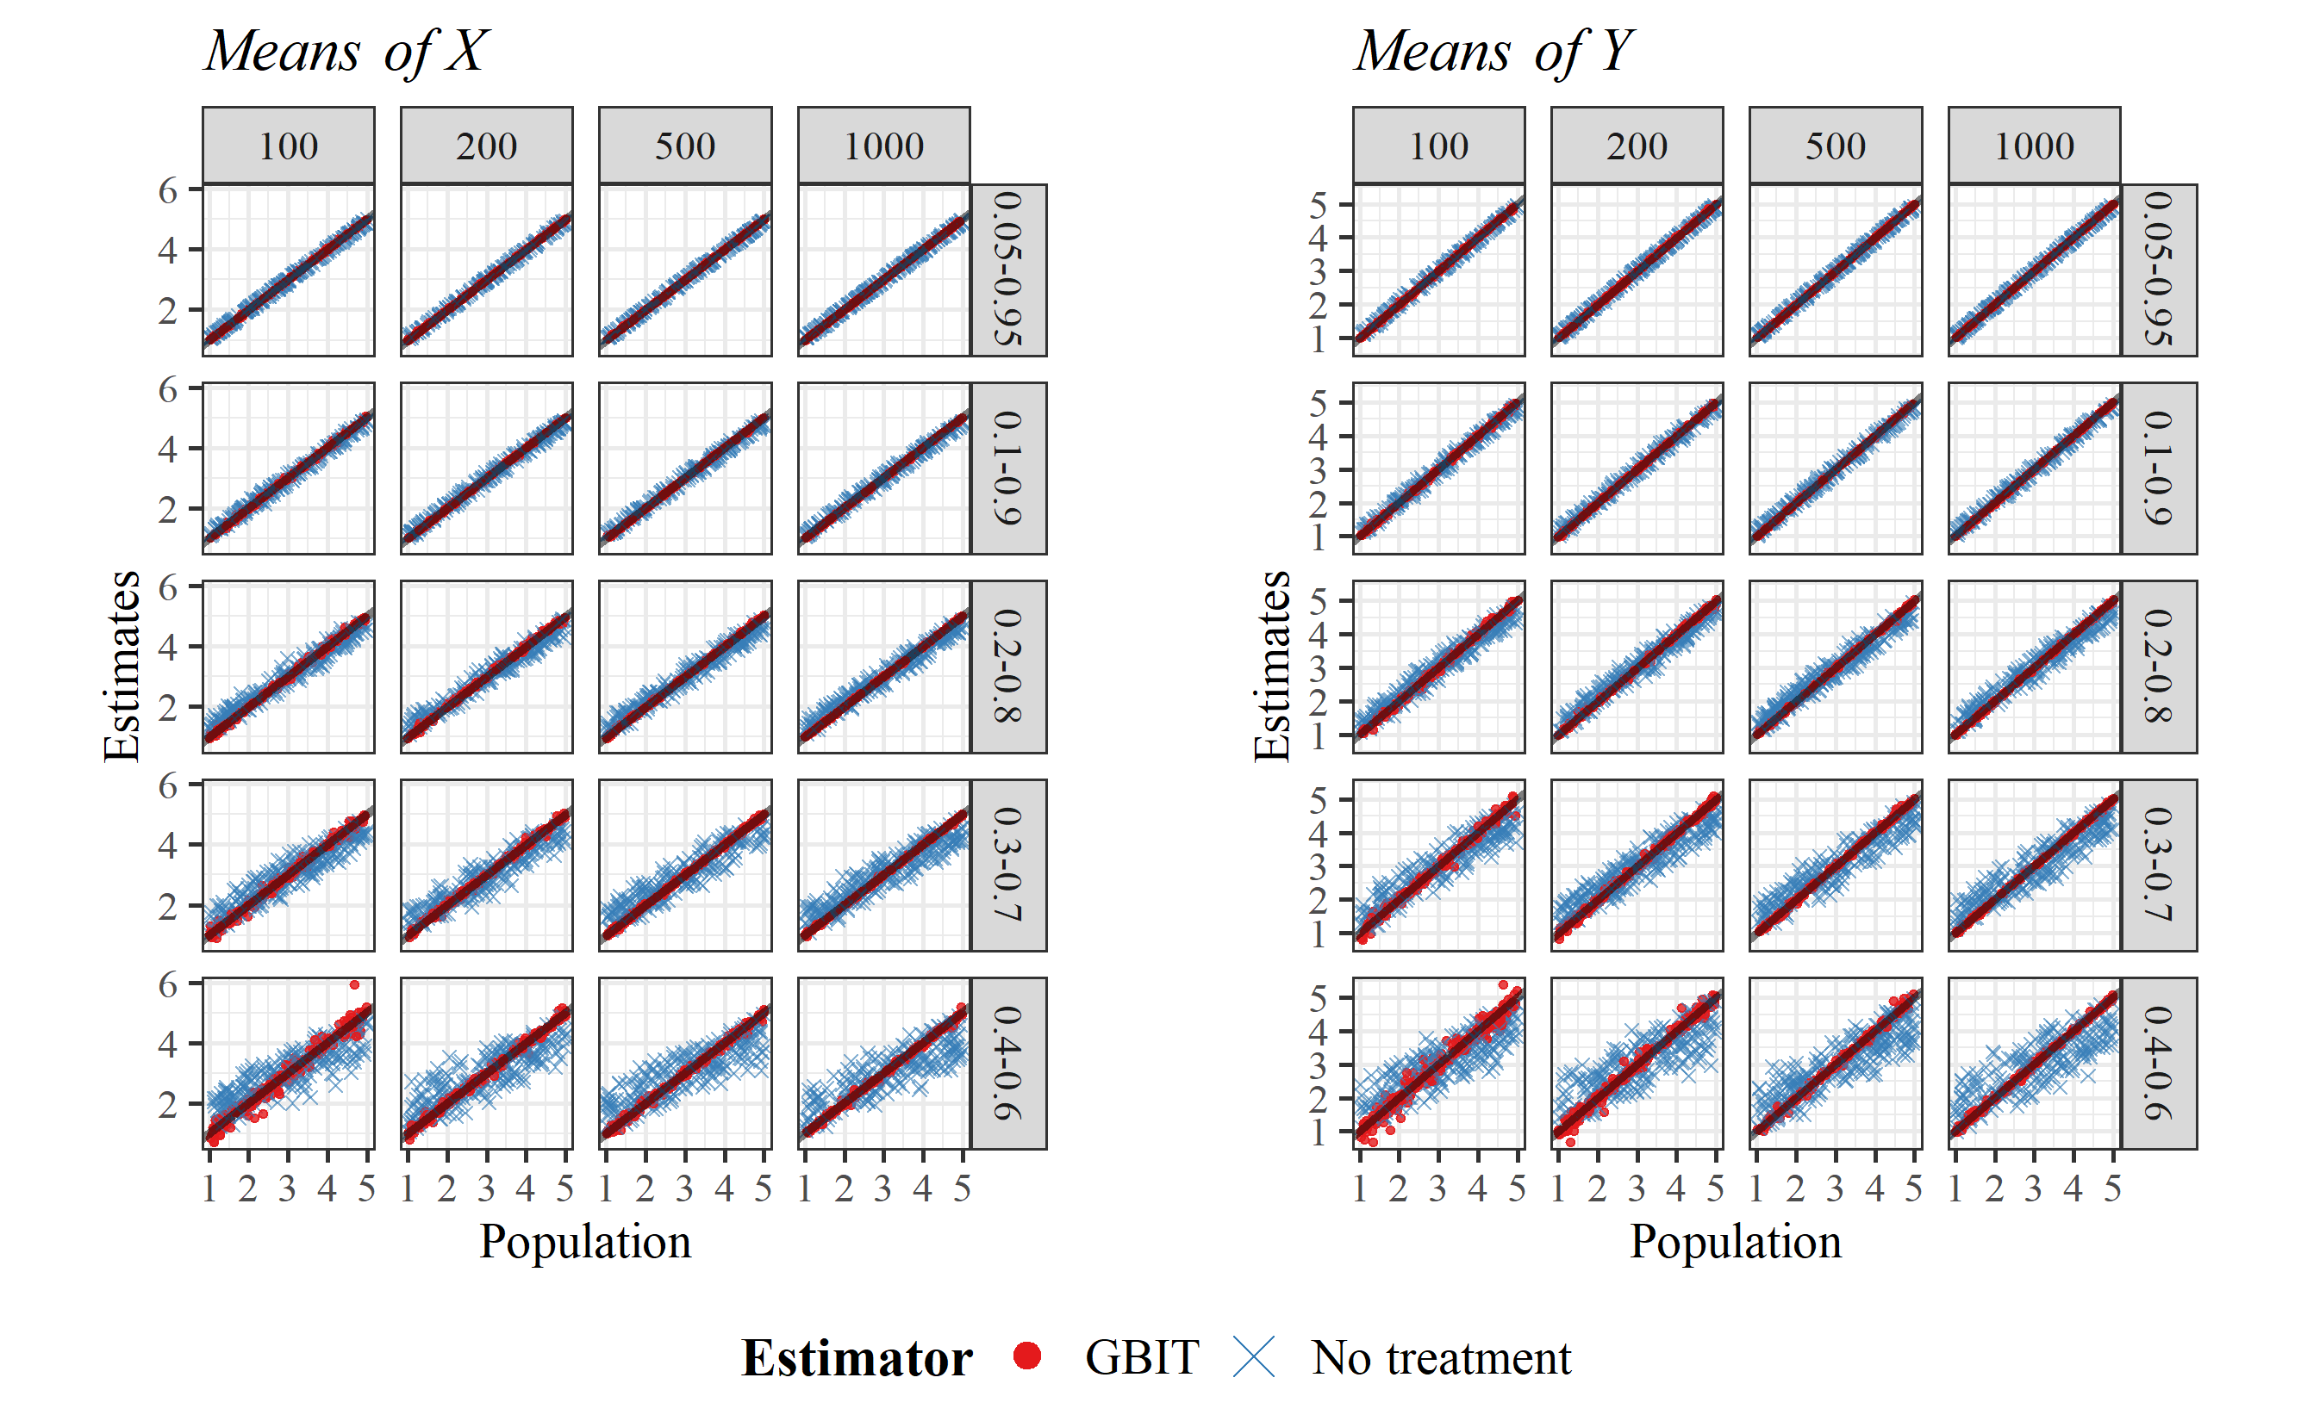

Figure 4.1. Estimates of doubly-censored bivariate means across sample sizes and censoring proportions

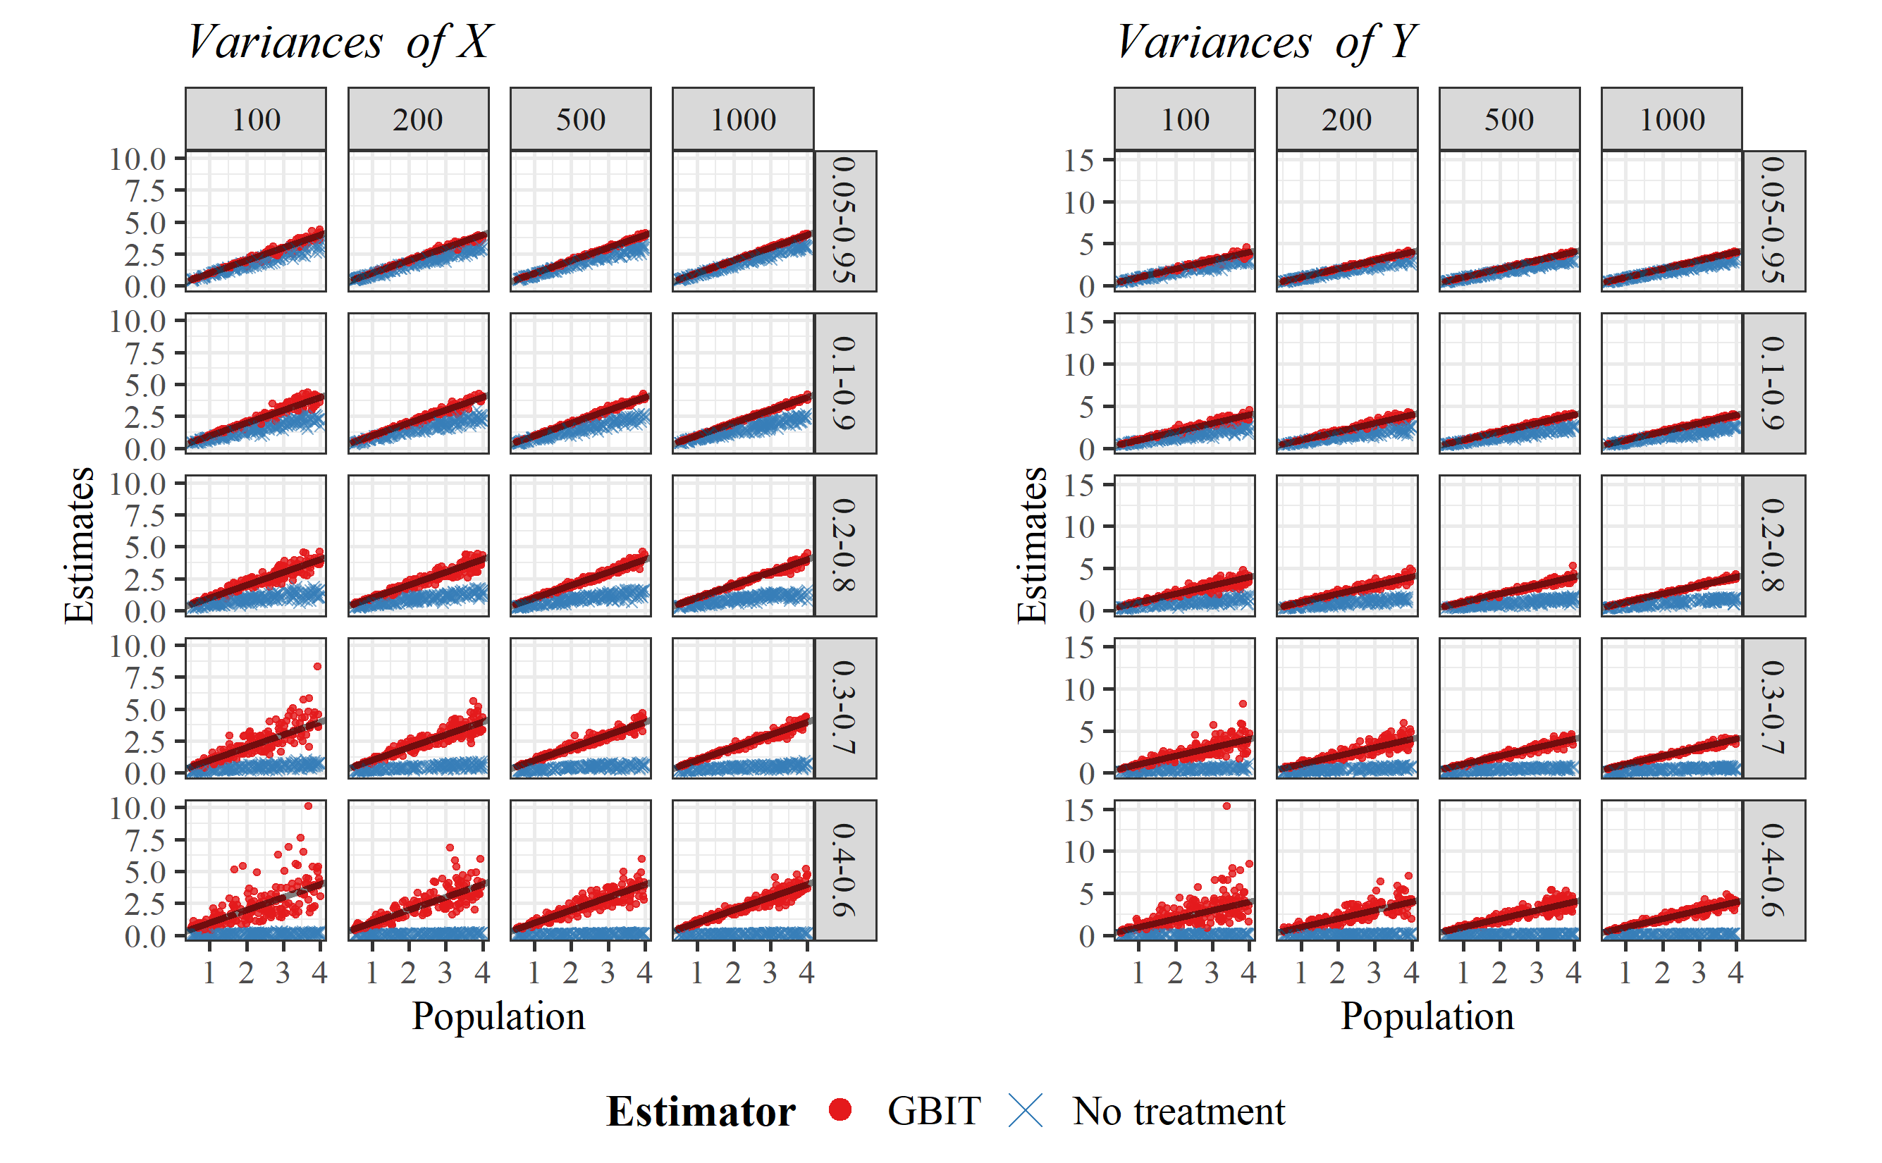

Figure 4.2. Estimates of doubly-censored bivariate variances across sample sizes and censoring proportions

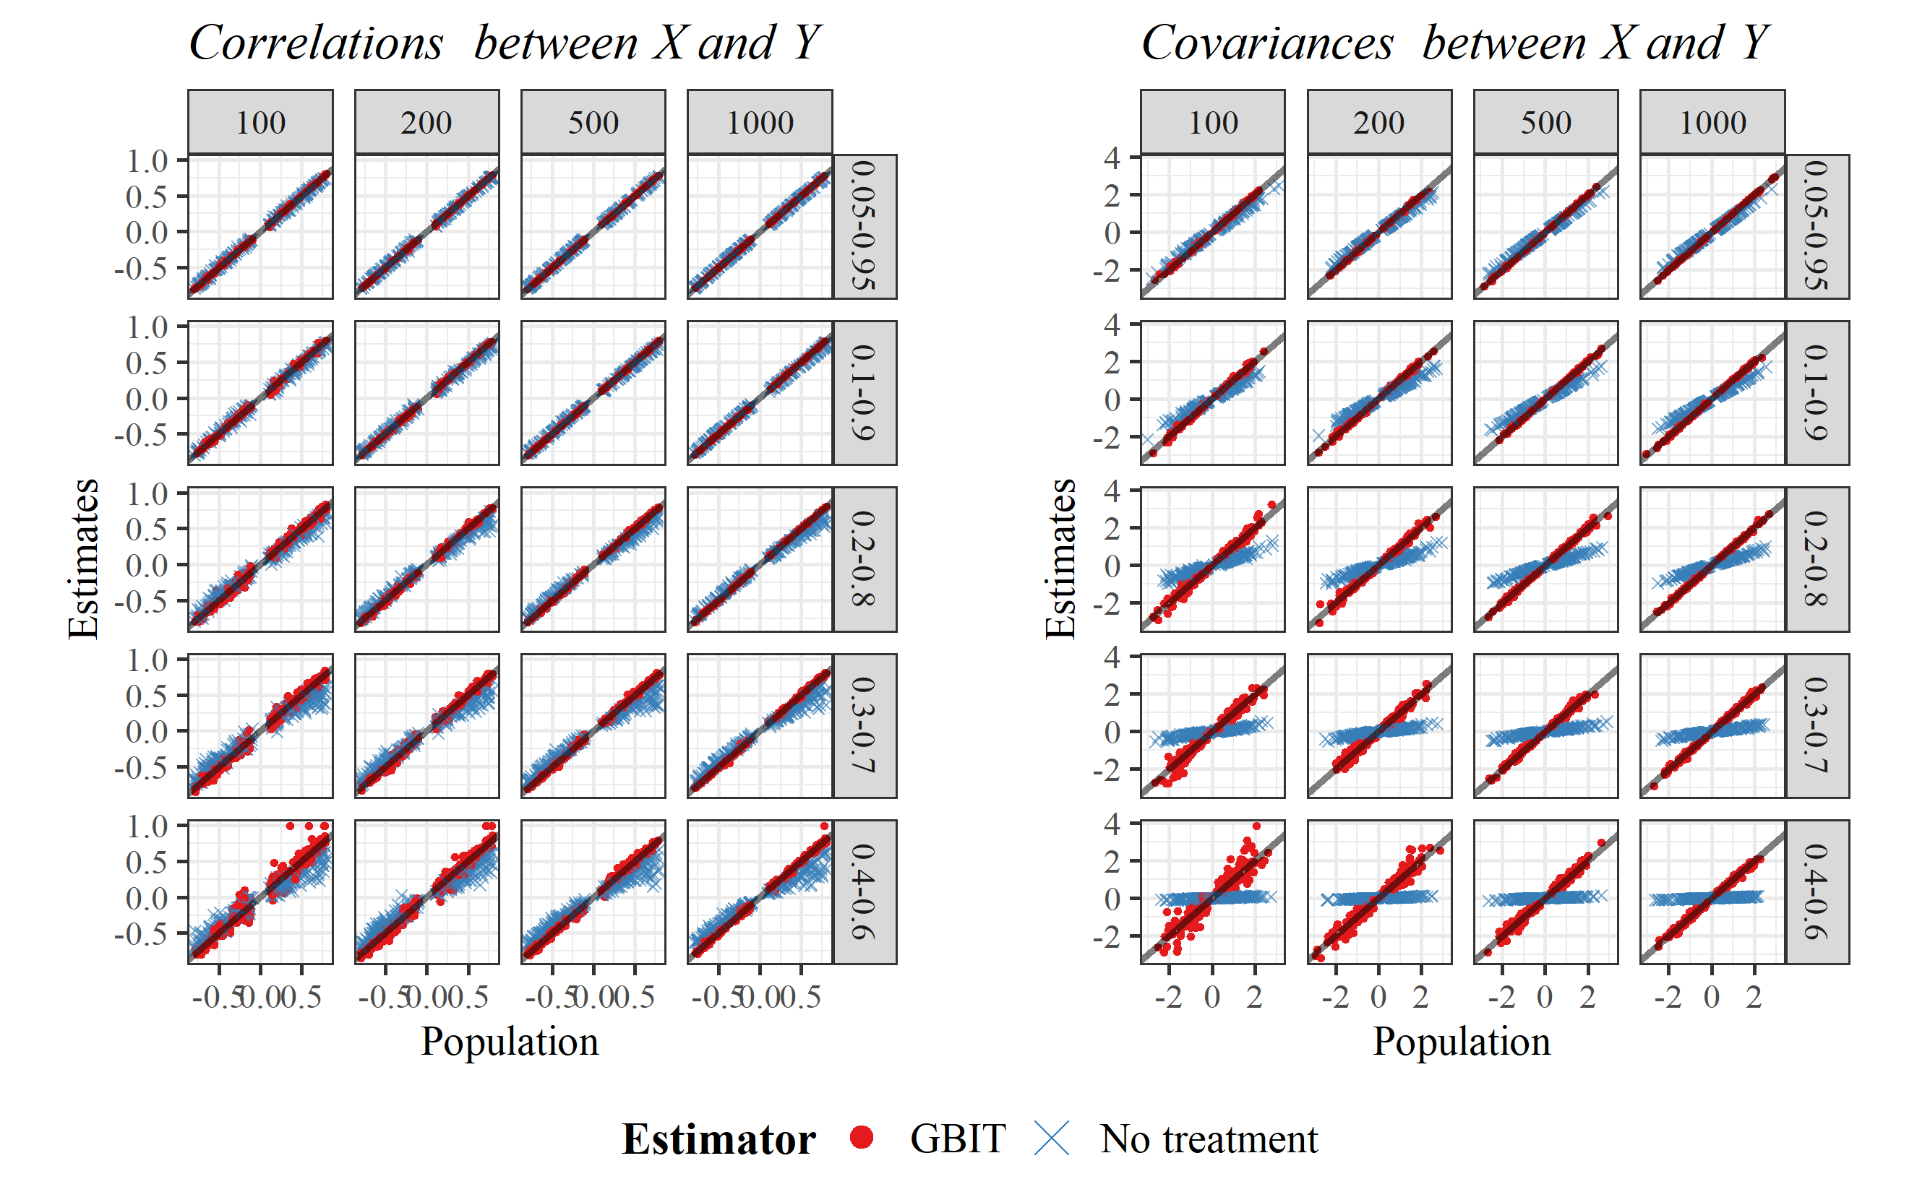

Figure 4.3. Estimates of doubly-censored bivariate correlations and covariances across sample sizes and censoring proportions