Role of Universal Healthcare Coverage in Building Resilience Against the Public Health Crisis – Case Study of COVID-19 Pandemic and Immunization Coverage

**Introduction**

Achieving universal health care coverage (UHC) is one of the key elements of Sustainable Development Goal 3 (SDG-3). Under UHC, people can receive needed health services across the full spectrum of care, from treatment to prevention and health promotion, without experiencing financial hardship. Positive impact of UHC has been proven in myriads of studies. ….. However, less is understood in terms of whether UHC can contribute to country’s response to public health crisis. Country’s progress toward UHC not only requires overall health system strengthening but also a sustainable and risk-pooling funding mechanism. As a result, in theory, countries who achieved UHC should be more agile at responding to public health crisis and more resilient to external shocks.

COVID-19 pandemic has been a public health crisis of the scale like no other. Across the globe, over the past year, it has posed severe burden on country’s healthcare system, causing varying degrees of disruption in essential and needed care delivery. From the ballpark perspective, country’s progress toward UHC before COVID-19 seems almost irrelevant to the amount of damage any country has received. In addition, measuring COVID-19’s impact on country’s health system is challenging at the moment due to the innate delay in relevant statistics being released. For example, globally compiled annual health statistics, such as maternal and child mortality, or infectious disease-attributed morbidity and mortality by country, requires at least a year before it gets released. Due to the over-burdened health system across the globe, this delay will most likely be longer for the 2020 data. However, timely evidence synthesis to understand the importance of UHC in building system’s resilience against the external shock like COVID-19 pandemic is critical for policymakers to be better prepared for the next public health crises. In addition, under the setting where, due to both logistical and ethical reasons, synthesis of high-level evidence on causal effect of the UHC on country’s response to public health crisis is challenging, COVID-19 pandemic can serve as a perfect natural experiment.

Immunization is part of the essential health services in any given country. Every country is equipped with its national immunization program, aiming to provide universal access to all relevant vaccines to susceptible population. For example, child immunization represented by DTP-3 coverage among children and HPV vaccine coverage among teenage population are one of the composites of UHC essential service coverage index score calculated by the World Health Organization (WHO) for each country. Access to safe and effective vaccines is also explicitly called out in the SDG-3. Even in resource constrained countries, where health service provision is poor, immunization programs perform relatively well compared to other service areas. For example, the second dose coverage of measles-containing vaccine (MCV-2) in low income countries is around 61.3%, 30% less than 90.5% coverage in high income countries, whereas ……… In this sense, effective immunization coverage for selected subset of essential vaccines could serve as a relatively objective indicator to measure any fracture in resilience of the health system.

In this paper, we aimed to demonstrate the role of UHC in building country’s health system resilience against the public health crisis. To do so, we adopted a quasi-experimental difference-in-difference design to assess the pre-post difference in immunization coverage based on country’s progress towards UHC. The findings from our study will show the significant role of UHC not only in times of peace but also in times of crisis.

**Method**

Data

We used the WHO-UNICEF joint estimates of immunization coverage available on the UNICEF website. This data contains an immunization coverage in absolute number and percentage by country, by year, and by type of vaccines, and covers 180 countries and 14 types of vaccines between year 1997 and 2020. We then merged the immunization data with the UHC service coverage index 2019 (UHC SCI 2019) from the Institute for Health Metrics and Evaluation (IHME) by matching two data by country. In addition, we merged World Bank’s data on country’s income group classification to assign each country into a category of High, Upper Middle, Lower Middle, or Low income country. The full list of countries with their UHC SCI 2019 (Table S1-1), as well as a complete dataset used in the analysis is provided in the supplementary material.

Analysis

Our main hypothesis was that higher progress towards UHC enables country’s health system to be more resilient to the external shocks, such as COVID-19 pandemic. To test this hypothesis, we adopted the concept of quasi-experimental design using difference-in-difference (DiD) analysis. Typical DiD is used to assess the causal effect of the policy or program (intervention) by comparing it with the control group before- and after the intervention where a clear temporal cutoff of pre-intervention and post-intervention exists. It also needs to satisfy three assumptions – 1) parallel pre-trend of outcome between intervention and control group, 2) no external spill-over of outcome across two groups, 3) intervention unrelated to outcome at baseline (randomization). We made following assumptions to support our analysis accordingly:

1. Public health crisis like COVID-19 pandemic will increase the overall health system burden, which, in turn, causes disruption to the routine public health activities, such as national immunization program.
2. Country’s health system progress towards UHC is associated with the resilience of the healthcare system to public health crisis, such as COVID-19 pandemic. When public health crisis happens, countries with UHC will experience less disruption in their routine public health activities.
3. In non-crisis situation (pre-COVID-19-pandemic), countries in both high level UHC and low level UHC group will show similar trend in immunization coverage (parallel trend).
4. Health system resilience due to high level of UHC is not directly associated with country’s immunization coverage unless external shock is introduced (randomization).
5. One country’s demand on vaccine will not affect other country’s vaccine supply (no external spill-over).

We divided countries into two groups using UHC SCI 2019. For the main analysis, we stratified using the cutoff value of UHC SCI 2019 >=80 and assigned 1 for countries with UHC index above or equal to 80 (high level UHC, Table 1), and 0 for the rest. These two groups correspond to “intervention” and “control” group in traditional DiD and is represented by “UHC category” variable in the equation.. Subsequently, we used the low cutoff value of <50 and assigned 1 if country’s UHC Index was below or equal to 50 (low level UHC, Table 1), and 0 if not, to test the same DiD hypothesis.

Table 1. Countries with high UHC SCI 2019 (>=80) and low UHC SCI 2019 (<50)

|  |  |
| --- | --- |
| **Countries with UHC SCI 2019 >= 80 (n=31)** | Australia, Austria, Belgium, Canada, Czechia, Denmark, Estonia, Finland, France, Germany, Greece, Iceland, Ireland, Israel, Italy, Japan, Kuwait, Luxembourg, Malta, Netherlands, New Zealand, Norway, Portugal, Qatar, Republic of Korea, Singapore, Slovenia, Spain, Sweden, Switzerland, United States |
| **Countries with UHC SCI 2019 <= 50 (n=54)** | Afghanistan, Angola, Azerbaijan, Benin, Burkina Faso, Burundi, Cameroon, Central African Republic, Chad, Comoros, Congo, Democratic Republic of the Congo, Djibouti, Equatorial Guinea, Eritrea, Ethiopia, Fiji, Gambia, Ghana, Guinea, Guinea Bissau, Guyana, Haiti, India, Indonesia, Kiribati, Lao People’s Democratic Republic, Lesotho, Liberia, Madagascar, Mali, Federated States of Micronesia, Mongolia, Mozambique, Myanmar, Nepal, Niger, Nigeria, Pakistan,  Papua New Guinea, Saint Vincent and the Grenadines, Samoa, Senegal, Sierra leone, Solomon Islands, Somalia, South Sudan, Tajikistan, Timor Leste, Togo, Turkmenistan, Uzbekistan, Vanuatu, Yemen |

In our analysis, we used the COVID-19 pandemic to introduce a “Prepost” variable where the years prior to 2020 was defined as pre- (0) and the year of 2020 was defined as post- (0). Unlike typical DiD design, the COVID-19 pandemic happened across the globe, thus to countries in both UHC and non-UHC countries. However, we assumed that the ‘resiliency against COVID-19’, which is an intervention effect of interest, is only present in the group with higher level UHC and only kicked into effect when COVID-19 pandemic happened. Therefore, although seems unusual, our study design falls into the definition of DiD.

We used country’s immunization coverage as an outcome and conducted the analysis for overall immunization coverage and for specific types of vaccine. We excluded yellow fever vaccine (YFV) and the first dose of inactived polio vaccine (IPV-1) from the analysis due to the following reason: yellow fever vaccine is only administered in a limited number of high-risk country, therefore does not have a balanced number of coverage data in stratified UHC categories; IPV-1 was only introduced into the dataset after 2015 and the data was irregularly collected. As a result, the analysis included 12 types of vaccines, namely Bacille Calmette-Guérin (BCG); first and third dose of diphtheria and tetanus toxoid and pertussis containing vaccine (DTP1, DTP3); birth dose of hepatitis B vaccine (HEPB-3); third dose of hepatitis B containing vaccine (HEPBB); third dose of *Haemophilus influenzae* type B containing vaccine (HIB3); first and second doses of measles containing vaccine (MCV1, MCV2); third dose of pneumococcal conjugate vaccine (PCV3); third dose of polio containing vaccine (POL3); second or third dose of rotavirus vaccine (ROTAC); and the first dose of rubella containing vaccine (RCV1).

For all analyses performed, we adjusted for year, country’s WB income group, country’s geographical region according to WHO classification, and type of vaccine as presented as a vector Z in the equation.

$$\left(Immunization Coverage\right)= β_{1}+β_{2}*prepost+β_{3}*UHC category+β_{4}*prepost*UHC category +Z+ϵ$$

**Results**

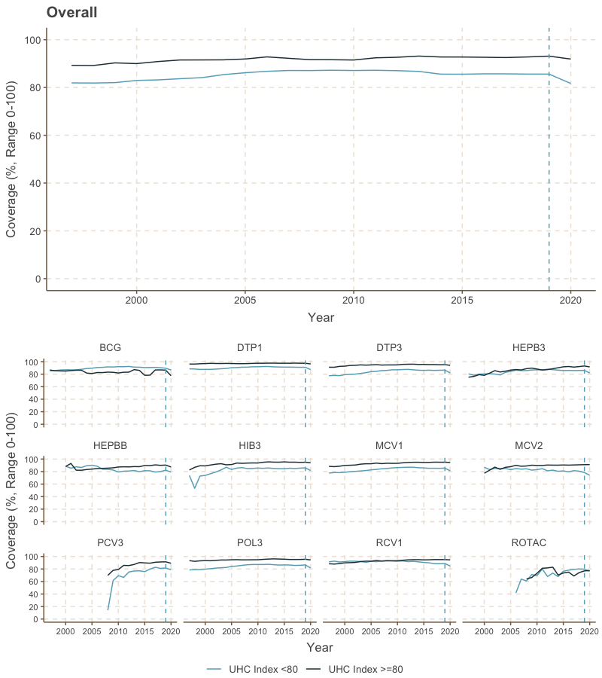

Figure 1. Change in immunization coverage over time by UHC SCI 2019 category (>=80 vs. the rest)

Figure 1 shows the mean immunization coverage by year for two groups. We noticed that before 2010, a lot of countries, especially with lower UHC Index, showed rapid improvement in immunization coverage each year. To withhold the parallel pre-trend assumption, we performed DiD on the data from 2010 and onwards.

Table 2 shows the result of the regression analysis without difference-in-difference interaction term (base model) and with DiD interaction term (DiD model) comparing the countries with high level of UHC (UHC SCI 2019 >=80) with the rest. In both models, immunization coverage did not change significantly over years (coefficient 0.01, p-value = 0.84 for base model; 0.82 for DiD model). Compared to high income countries, countries in upper-middle-, lower-middle-, and low income country resulted in significantly higher immunization coverage when controlled for all covariates (coefficient 17.41, 11.99, 7.63 respectively, p-value <0.01 for all coefficients). Countries in the Southeast Asian region and European region showed significantly higher coverage than countries in Americas region by 4.12% and 2.98% respectively (p-value <0.01 for both coefficients) when controlled for other covariates.

In the base model, when controlled for year, WB income group, and the geographical region, countries with high level of UHC resulted in lower immunization coverage compared to those with the UHC index score below 80 (coefficient -2.39, p-value <0.01). Post-pandemic immunization coverage was also significantly lower by 2.78% compared to pre-pandemic years (p-value <0.01). In the difference-in-difference model, coefficient for the DiD term was positive with significant p-value (coefficient 2.87, p-value = 0.01), suggesting that the health system resilience due to UHC was able to avert immunization coverage drop by 2.87% against the pandemic shock.

The same analysis comparing the countries with lower level of UHC (UHC SCI 2019 <50) with the rest is available in the supplementary material (Table S2-13). In brief, countries with lower level of progress towards UHC had significantly higher immunization coverage than the rest, when controlled for all covariates (coefficient 8.26, p-value <0.01). the DiD coefficient was not significant (coefficient -0.59, p-value = 0.44), suggesting the difference in system resilience due to UHC was not significantly different between two groups.

Table 2. Difference-in-difference regression analysis of overall immunization coverage after COVID-19 pandemic by UHC SCI 2019 (>=80 vs. the rest)

|  |  |  |  |  |  |  |
| --- | --- | --- | --- | --- | --- | --- |
|  | Base model | | | Difference-in-difference model | | |
| Variable | Coefficient | Standard Error | p-value | Coefficient | Standard Error | p-value |
| Intercept | 63.28 | 74.62 | 0.40 | 64.08 | 74.61 | 0.39 |
| Year | 0.01 | 0.04 | 0.81 | 0.01 | 0.04 | 0.82 |
| World Bank Income Group (Reference category: High) | | | | | | |
| Low | 7.63 | 0.35 | <0.01 | 7.62 | 0.35 | <0.01 |
| Lower-middle | 11.99 | 0.38 | <0.01 | 11.99 | 0.38 | <0.01 |
| Upper-middle | 17.41 | 0.44 | <0.01 | 17.40 | 0.44 | <0.01 |
| WHO Region (Reference category: Americas) | | | | | | |
| Europe | 2.98 | 0.32 | <0.01 | 2.98 | 0.32 | <0.01 |
| Western Pacific | -0.17 | 0.39 | 0.66 | -0.16 | 0.39 | 0.68 |
| Eastern Mediterranean | -0.46 | 0.38 | 0.22 | -0.45 | 0.38 | 0.23 |
| Southeast Asia | 4.12 | 0.50 | <0.01 | 4.13 | 0.50 | <0.01 |
| Africa | -0.69 | 0.37 | 0.06 | -0.69 | 0.37 | 0.06 |
| Vaccine type (Reference category: BCG) | | | | | | |
| DTP1 | 0.57 | 0.47 | 0.22 | 0.57 | 0.47 | 0.22 |
| DTP3 | -3.85 | 0.47 | <0.01 | -3.85 | 0.47 | <0.01 |
| HEPB3 | -4.71 | 0.47 | <0.01 | -4.71 | 0.47 | <0.01 |
| HEPBB | -11.58 | 0.61 | <0.01 | -11.57 | 0.61 | <0.01 |
| HIB3 | -4.96 | 0.47 | <0.01 | -4.96 | 0.47 | <0.01 |
| MCV1 | -4.51 | 0.47 | <0.01 | -4.51 | 0.47 | <0.01 |
| MCV2 | -10.80 | 0.50 | <0.01 | -10.79 | 0.50 | <0.01 |
| PCV3 | -11.09 | 0.54 | <0.01 | -11.09 | 0.54 | <0.01 |
| POL3 | -3.93 | 0.47 | <0.01 | -3.93 | 0.47 | <0.01 |
| RCV1 | -2.99 | 0.50 | <0.01 | -2.99 | 0.50 | <0.01 |
| ROTAC | -14.15 | 0.63 | <0.01 | -14.16 | 0.63 | <0.01 |
| Difference-in-difference variables | | | | | | |
| Pre/Post | -2.94 | 0.41 | <0.01 | -3.32 | 0.44 | <0.01 |
| UHC SCI 2019 >=80 | -2.39 | 0.39 | <0.01 | -2.58 | 0.40 | <0.01 |
| Pre/Post * UHC SCI >=80 |  |  |  | 2.87 | 1.07 | 0.01 |

*: p-value <0.05, **: p-value<0.01

Table 3 shows DiD coefficient from each regression analysis performed for individual types of vaccine, comparing countries with high level progress towards UHC (UHC SCI 2019 >=80) and the rest. None of the DiD coefficient for individual type of vaccine was significant with the p-value below the alpha cutoff value of 0.05, while for some vaccines, namely MCV-1, HEPB-3, and RCV-1, the DiD coefficient was positive with the p-value below 0.20. Given that the overall immunization coverage resulted in the significantly positive value, there is a chance that insignificant DiD coefficient from these sub-analyses is due to the smaller sample size, 180 countries compared to 180 countries times 13 vaccine types, resulting in lack of insufficient statistical power. The full tables of result from regression analysis for each vaccine are available in the supplementary material (Table S2-14 ~ S2-25).

Table 3. Difference-in-difference coefficient for individual types of vaccine

|  |  |  |  |
| --- | --- | --- | --- |
| Vaccine type | DiD coefficient | Standard Error | p-value |
| All vaccines | 2.87 | 1.07 | 0.01 |
| BCG | -1.82 | 6.15 | 0.77 |
| DTP-1 | 2.57 | 2.16 | 0.23 |
| DTP-3 | 2.70 | 2.84 | 0.34 |
| HEPB3 | 5.40 | 3.43 | 0.12 |
| HEPBB | -0.93 | 11.52 | 0.94 |
| HIB-3 | 2.06 | 3.35 | 0.54 |
| MCV1 | 4.16 | 2.79 | 0.14 |
| MCV-2 | 4.23 | 3.96 | 0.29 |
| PCV-3 | -2.49 | 5.12 | 0.63 |
| POL-3 | 3.45 | 2.72 | 0.21 |
| ROTAC | 0.51 | 6.37 | 0.94 |
| RCV1 | 4.63 | 2.42 | 0.06 |

Discussion

In this paper, we empirically explored the UHC’s contribution in building health system resilience against external shocks by observing the immunization coverage after COVID-19 in countries with varying levels of progress across UHC. Using difference-in-difference method, we were able to quantify the causal effect of UHC-attributed resilience in reducing the impact of COVID-19 in disrupting the essential routine immunization activities. The findings suggest that countries with higher progress towards achieving UHC, as represented by the high score of UHC service coverage index, was able to reduce the decrease in post-pandemic immunization coverage significantly, as shown by the significant coefficient for DiD variable even after adjusted for the country’s income, geographical region, and type of vaccine. Although this significant impact was not observed for the regression performed on each individual type of vaccine, this is most likely due to the lack of sufficient statistical power stemming from inherently small sample size given the limited number of countries in the world.

Limited studies prior to this analysis tried to show the empirical evidence of UHC’s positive impact on building health system resilience. Our study not only corroborates these earlier findings but also, to our knowledge, is the first to quantify the causal effect of UHC in supporting how country’s health system responds to the COVID-19 pandemic. While the findings are simple and needs more supporting evidence, both quantitatively and qualitatively, as moving forward, timeliness of the study can aid policymakers to advocate the importance of country’s commitment in achieving UHC even in times of public health crisis.

We believe the study can be further improved in couple of ways. Firstly, once the immunization coverage data for subsequent years become available, the same hypothesis can be tested using a comparative interrupted time series analysis. The equation below describes how this can be done by introducing additional interaction terms. The coefficient $β_{4}$ will represent the one-time change in immunization coverage post-pandemic attributed to UHC and its associated resilience, which is analogous to the DiD coefficient in our study, and $β_{8}$ will show the year-by-year change in immunization coverage post-pandemic attributed to UHC and its associated resilience. $$\left(Immunization Coverage\right)= β_{1}+β_{2}*prepost+β_{3}*UHC category+β_{4}*prepost*UHC category +β_{5}*prepost*year+β_{6}*year*UHC category+β_{8}*year*prepost*UHC category+Z+ϵ$$

This way, not only will we be able to quantify the causal effect of UHC-attributed system resilience on responding to the external shock, but also to observe the causal effect of it on the speed of system recovery in following years. We aim to monitor this data in following years so that we can provide further evidence on the positive role of UHC in supporting countries to better respond to public health crisis and to fastly recover from it.

Using different indicators than immunization coverage, which serve as a proxy measure of essential health service delivery, can further strengthen our findings. We believe indicators associated with HIV continuum of care, such as patients’ CD4+ count or viral load monitoring data, or maternal, newborn, and childcare-related indicators, such as neonatal-, under-5-, or maternal mortality can be great candidates. For now, we couldn’t perform these analyses due to the lack of post-pandemic data available for these indicators. However, once the data becomes available, we strongly believe that replicating the same analysis using alternative indicators can reinforce our finding, hence the important role of UHC. In addition, by merging different dataset for several indicators, we will be able to generate bigger dataset, which will improve the statistical power of the analysis, to produce stronger evidence.