Zambia 7-1-7 Synthesis Report

## 2024/09/02

## Events detected between Jan 2024 - Jun 2024

### Key messages and insights

Zambia adopted the 7-1-7 performance improvement framework in 2023. This framework includes three timeliness metrics with specific targets to assess and improve real-world performance of early detection and response systems:

* 7 days to **detect** a suspected public health threat
* 1 day to **notify** a public health authority responsible for action
* 7 days to **complete early response** actions.

This is the 2nd edition of the 7-1-7 synthesis report aimed at providing feedback to stakeholders on the outbreak management performance of the health system, bottlenecks identified, remedical actions completed, and recommendations that can inform prioritization of activities for the next cycle of annual operational planning.

In this reporting period, 7-1-7 performance was evaluated for 1 events, with all of these events presented at **national public health security meetings**. Among these events, 100 % (1/1) met the 7-day detection target, 100 % (1/1) met the 1-day notification target, 0 % (0/1) met the 7-day response target, and 0 % (0/1) met the full 7-1-7 target.

Most frequently occuring bottleneck categories include:

* Lack of available resources for response initiation or rapid resource mobilization
* Low awareness or clinical suspicion by health workers
* Lack of diagnostic commodities (lab reagents, RDTs, specimen collection kits)

This report also shows that 48 of 69 (70%) remedial actions proposed from 1 during national public health security meetings were completed.

### Overview of 7-1-7 performance

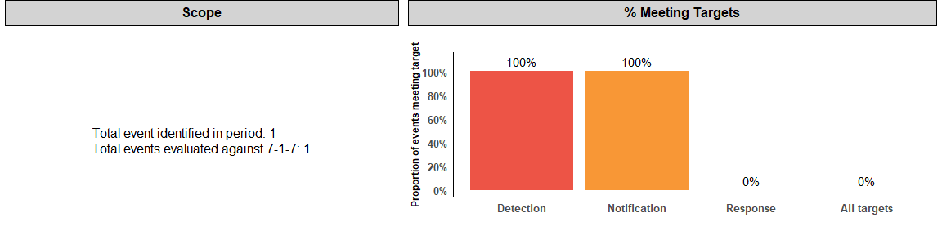

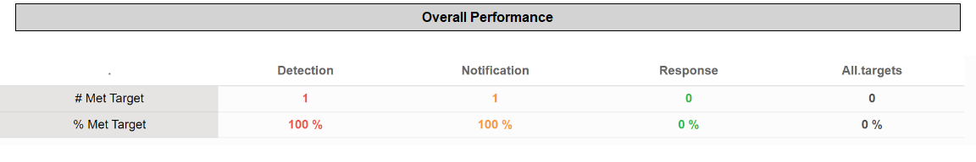

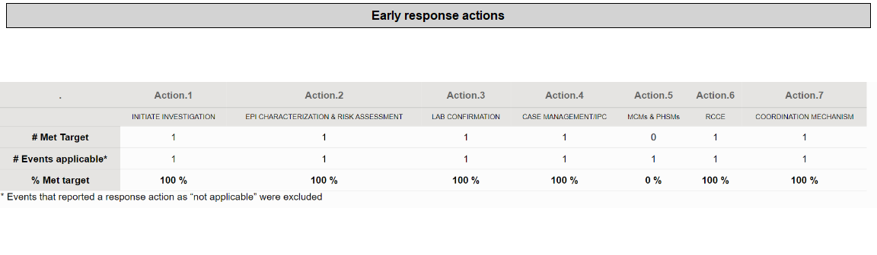

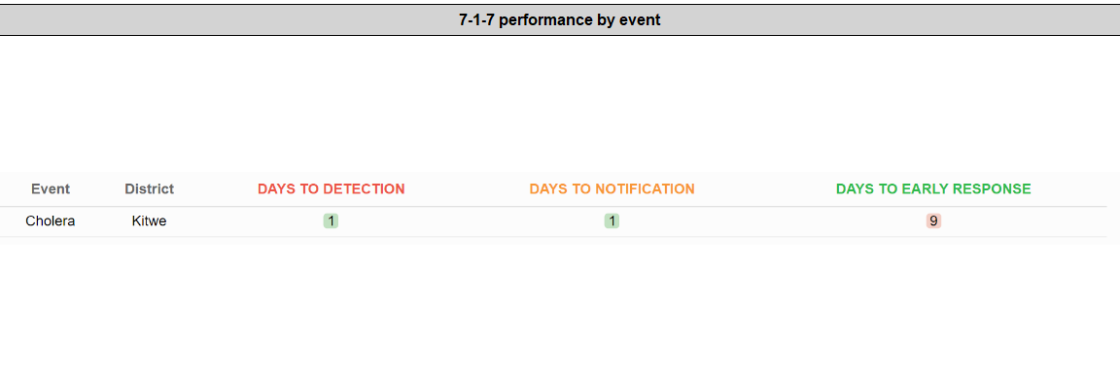

### Bottlenecks

Bottlenecks were identified from all 1 events, across the detection, notification, and response metrics. The identified bottlenecks were synthesized, further categorized, and aligned to relevant technical areas of the National Action Plan for Health Security (NAPHS). The table below highlights the number of most common bottlenecks by categories, along with corresponding NAPHS technical areas and recommendations.

| NAPHS area | Bottleneck category | # of identified bottlenecks | Recommendations |
| --- | --- | --- | --- |
| D2. Surveillance | Low awareness or clinical suspicion by health workers | 7 | NA |
| P2. Financing | Lack of available resources for response initiation or rapid resource mobilization | 7 | NA |
| D1. National laboratory systems laboratory | Delayed specimen collection | 2 | NA |
| D1. National laboratory systems laboratory | Delayed specimen transportation | 2 | NA |
| D1. National laboratory systems laboratory | Human resources gaps for public health | 2 | NA |
| D1. National laboratory systems laboratory | Lack of diagnostic commodities (lab reagents, RDTs, specimen collection kits) | 2 | NA |
| D2. Surveillance | Health professional with no training in surveillance and response | 2 | NA |
| P2. Financing | Logistics and shipment delays | 2 | NA |
| P5. Zoonotic disease | Lack of one health information sharing/collaboration | 2 | NA |
| R1. Health emergency management | Inadequate risk assessments, preparedness, or response plans | 2 | NA |
| R1. Health emergency management | Lack of available resources for response initiation or rapid resource mobilization | 2 | NA |
| R1. Health emergency management | weak response coordination, including incident management and rapid response team capacity | 2 | NA |
| R3. Health services provision | Lack of diagnostic commodities (lab reagents, RDTs, specimen collection kits) | 2 | NA |
| R5. RCCE | Risk communications or community engagement | 2 | NA |

### Actions to improve future 7-1-7 performance

Of the 1 events presented at public health security meetings, a total of 48 remedial actions were completed (see Annex 2). An additional 12 are in progress and 9 actions were proposed for consideration in the NAPHS.

### Enablers of 7-1-7 performance

| . |
| --- |
| ·       Adequate knowledge by the facility staff on what type of diarrhea for cholera and equipped with knowledge on the standard case definitions for cholera |
| None |
| Trained District health staff in Contact tracing |

### Annex 1. Detailed performance for all events



### Annex 2. Remedial actions completed in this reporting period

|  | Action | Bottleneck addressed |
| --- | --- | --- |
| 1 | Sample Collection Skills Orientation | Inadequate skills training in Sample collection at Facility and District level. |
| 2 | Workshop training/orientation among Clinicians in ND’s Case definitions and Management | Low index of suspicion of Anthrax among Clinicians |
| 3 | Procurement of adequate Lab Materials | Inadequate lab reagents and media for sample collection and transportation. |
| 4 | Health Promotion and Community Sensitization | Poor health seeking behavior in the community. |
| 5 | Workshop training/orientation and Distribution of ND’s Case definitions in Health facilities and among Clinicians | Low index of suspicion of Anthrax among Clinicians. |
| 6 | Deployment of Reagents in the District | Inadequate lab reagents and media for sample collection and transportation. |
| 7 | Convene Regular EPPC & MC meetings in the Sinazongwe district | Weak One Health Approach |
| 8 | Maintenance of nonfunctional Motor Bikes. | Inadequate Transport to conduct contact tracing of cases and other response activities. |
| 9 | Cooperating partners to offer Motor bikes | NA |
| 10 | -Provincial Supporting District with Transport | NA |
| 11 | Conduct training/orientation and Distribution of ND’s Case definitions in Health facilities and among Clinicians | Low index of suspicion of Cholera among Clinicians |
| 12 | Designation of Specific Vehicle for response activities | Inadequate Transport to conduct contact tracing of cases and other response activities. |
| 13 | Funds for Fuel, and Hiring of Speedboat | Lack of land and marine transport to investigate or respond to the affected areas |
| 14 | Creating more Treatment Centers | Inadequate space for cholera treatment centre (cholera beds) |
| 15 | IDSR training | IDSR knowledge gaps at the facility level. |
| 16 | Engagement of key stakeholders to participate in data review meetings | Case definition for suspected cholera (AWD) is under-sensitized among HCW |
| 17 | Incorporate more content on epi analysis/risk assessment in PHEM trainings | Knowledge gaps in Epi analysis, Risk assessment and burden analysis at District and Regional levels that lead to rapid recommendations. |
| 18 | Lobby from partners | Inadequate resources to Conduct Control and Preventive measures effectively. |
| 19 | Lobby Vehicles from provincial level | Inadequate transport to conduct contact tracing of cases and other response activities. |
| 20 | IMS trainings | IMS coordination with stakeholders |
| 21 | Print and distribute case definitions | Low utilization of case definitions at Mukusi RHC |
| 22 | Circulate surveillance data capturing tools | Gaps in filing of notified cases |
| 23 | Staff and CBVs training in RCCE implementation | Inadequate knowledge in RCCE implementation |
| 24 | Training in anthrax diagnostic and case management | Low suspicion Index for non cutaneous forms of anthrax |
| 25 | Orientation of Lab and clinicians on sample collection and transportation | Knowledge gaps in sample collection and transportation to lab |
| 26 | Train District staff in IMS | Knowledge gaps in IMS coordination |
| 27 | Orient District staff in STREP and IAP formulation | Knowledge gaps in STREP and IAP formulation |
| 28 | Orientation on cholera | Low suspicion of the index at Mapanza RHC |
| 29 | Mendatory displaying of case definations by all facilities | Lack of display of Case definitions of priority diseases on the wall in the screening rooms |
| 30 | The Provincial health office to disseminate the tools | Lack of risk assessment tool to complete risk assessment |
| 31 | The labs to process orders through ZAMMSA in ELMIS | Lack of RDT at Mapanza RHC and Macha Hospital |
| 32 | Submit request to ZAMMSA | Lack of IPC WASH commodities |
| 33 | Distribution of Chlorine in fishing camps (hotspots) | inadequate countor mesures |
| 34 | Conduct sensitization activities such as radio programs, community engengment meetings and Public Adress System | knowledge gaps in the community of prevention |
| 35 | Lobby for resouces from partners/stakeholders to transport samples to the reference lab | limited resouces to transport samples |
| 36 | Lobby for Cholera RDTs | Lack of cholera RDTs |
| 37 | Lobby for Emergency kit | No Emergency kit |
| 38 | Construction of water points (Borholes) in fishing camps (hot spots) | NA |
| 39 | Procure a vehicle to be used for public Health Emergencies | NA |
| 40 | Capacity build staff | Empower staff with knowledge on cholera management and standard case definitions and early reporting |
| 41 | -Risk communication Community engagement Timely provision adequate IEC material from national level | Inadquate IEC and poor health seeking behavour in the community leading to late reporting to health facilities by patients |
| 42 | Provision of fuel To ensure quick and prompt action is taken on time to respond to outbreak | Limited resources to transport RRT teams |
| 43 | Capacity Build of staff | Equip staff with knowledge on standard case definitions on cholera |
| 44 | Provide Pool vehicle specific for surveillance Unit | Delay of transportation of patients and other Logistics |
| 45 | Engaged local carpenter to make beds | Lack of cholera beds |
| 46 | Lobby disinfectants from PHO (Pynol and chlorine) | Inadequate Liquid Chlorine |
| 47 | Lobby from stakeholders | Inadequate Food supplies for the CTC |
| 48 | Engaged Procurement office to facilitate buying of food for patients | Inadequate food for patients |

### Annex 3. Bottlenecks by 7-1-7 interval

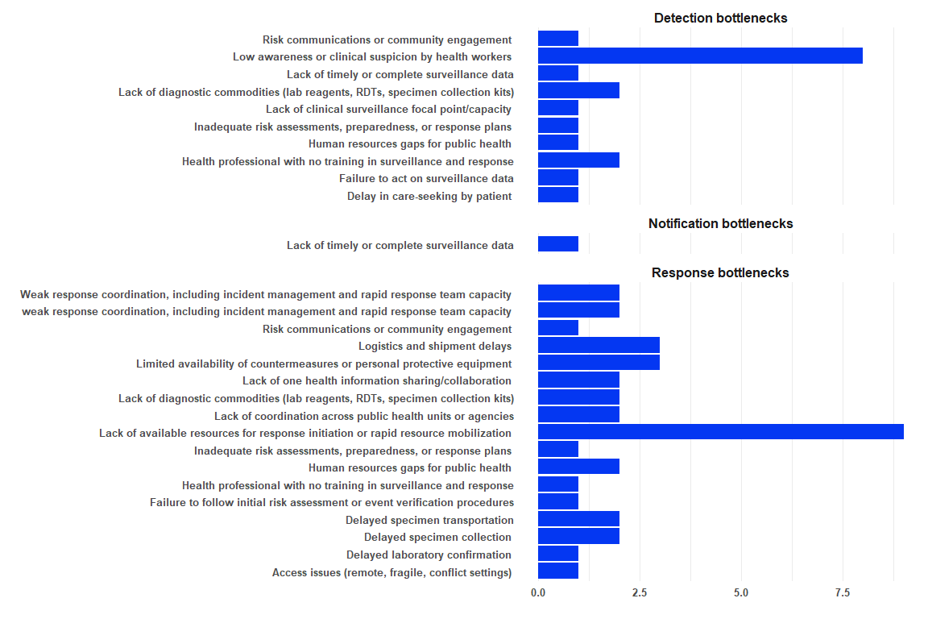

#### Bottlenecks by health system level

