RATA

**RMSg API Test Automation**

F R A M E W O R K

RATA stands for RMSg API Test Automation.

In this project, Internal APIs which are used for RMS are tested and automated in [**SOAP UI**](http://www.soapui.org).

RATA Framework is designed to achieve following things:

1. Maintain the Test Data Outside the scripts

2. Develop generic test scripts so that it can be executed in any environment

3. Verification of response in JSON format using groovy script

RATA Framework is developed and implemented using SOAP UI (Free version)

Pre-Requisites:

1. Basic knowledge of API testing

2. Following concepts from SOAP UI:

a. Properties

b. Workspace, Project, TestSuite, TestCase, TestSteps

c. Assertions

e. WADL/WSDL

f. Set-Up/TearDown scripts

g. SOAP UI groovy

3. JAVA and Groovy Scripting (Intermediate level)

RATA Framework Flow Diagram:

Endpoint/WADL

Interfaces generated

Creation of Project

SOAP Assertion

Script Assertion

Report Generation

Script Execution with Test Data

Provide input data and expected data in the text file generated in above step

Files and Folder generated for respective Test Suite/Cases/Step to provide the Test Data

Script Execution without Test Data

Test Scenarios

Creation of Test Scripts (TestSuites, TestCases, TestSteps)

Step Wise Usage of RATA Framework:

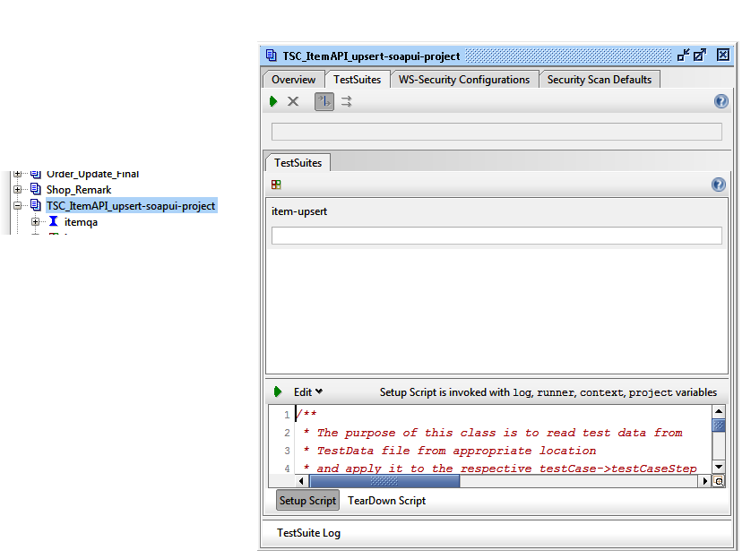

Double Click

Set Up script

1. In order to create test scripts for any API for automation, it is necessary that we should have WADL/Endpoints for the respective APIs.

a. Open SOAP UI > Go to -> File -> New REST Project/ New Generic Project based on availability of endpoint/WADL

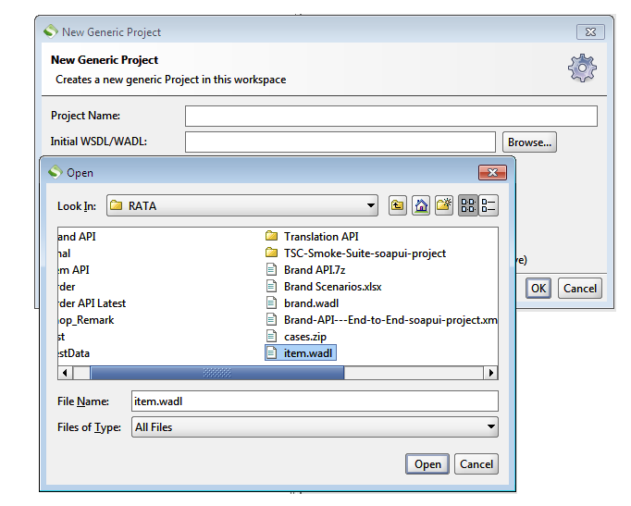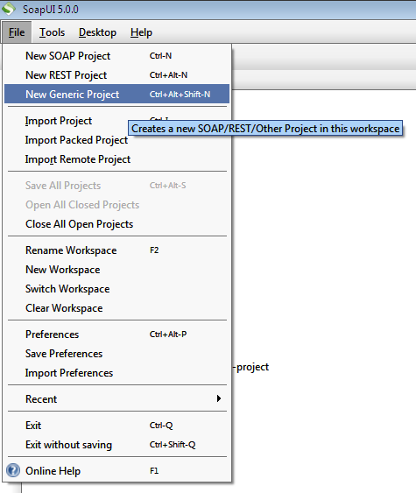b. Add the endpoint/WADL and Click on OK

Note:

If Endpoint is added: Interface is created that contains an endpoint of the API to be tested.

If WADL is added: Interfaces are created that contains list of Endpoints related to the API to be tested.

c. Once the Project is created, we need to add the Set Up script. The purpose of the Set-Up script is:

1. Creates Folder and File structure in the same workspace path for the providing the Test Data

2. Compares the Actual Result with Expected Result

3. Generates report based on the above comparison



Double Click

Set Up script