TP01

Java Data Output

# Remark

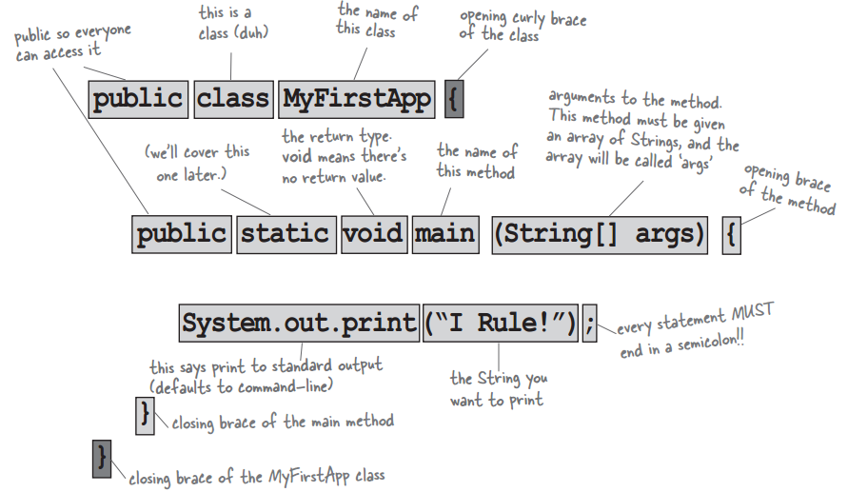

# TP01.1. Hello One’s Name

Implement an application Java that displays “Hello *<your_name>*!” where *<your_name>* represents your own name. Example, in case your name is: Visal, then:

Hello Visal!

# TP01.2. Display a Paragraph

Implement an application Java that displays the following paragraph:

\n Line break.  
\t Tabulation.  
\’ Single Quote.  
\” Double Quote.  
\\ \ Sign.  
\\\\ \\ Sign.  
// Line Comment.  
/* ... */ Block Comment.  
"""

Text block.  
"""

# TP01.3. Asterisks

Write a program in Java to display shapes as below:

A.

*************************  
 * *  
 * *  
 * *  
 * *  
 *************************

B.

*  
 ***  
 *****  
 *******  
 *********

C.

*  
 ***  
 *****  
 *******  
 *********

D.

*  
 ***  
 *****  
 *******  
 *********

E.

*  
 ***  
 *****  
 ***  
 *

F.

*  
 ***  
 *****  
 ***  
 *

G.

*****  
 ***  
 *  
 ***  
 *****

H.

*  
 * *  
 * *  
 * *  
 *

# Notes:

1. In Java, there is a class name *String* that replace *char \** in C. Example: *“Hello, it is a String”*.
2. We can concatenate 2 or more Strings using operator *+*  just like adding between 2 numbers.   
   Example: *“Kingdom” + “ of” + “ Wonder!”*   
   Example2:

String dice = “DICE students”;  
 String action = “are so”;  
 String adj = “so friendly!”;

String sentence = dice + “ “ + action + “ “ + adj;

1. To display text on the console, we use:

System.out.print(“String or Variable”);

Or:

System.out.println(“String or Variable”);

Or:

System.out.printf(“format ex: %s”, “Hello”);