“Київський фаховий коледж зв’язку”

Циклова комісія Комп’ютерної інженерії

**ЗВІТ ПО ВИКОНАННЮ**

**ЛАБОРАТОРНОЇ РОБОТИ №1**

з дисципліни: «Операційні системи»

**Тема: «Знайомство з робочим середовищем віртуальних машин та особливостями**

**операційної системи Linux»**

Виконала студентка

групи РПЗ-13б

Дімітрова С.П.

Перевірив викладач

Сушанова В.С.

Київ 2024

**Мета роботи:**

1. Знайомство з гіпервізорами різного типу, віртуалізацією при роботі з операційними

системами.

1. Знайомство з основними видами сучасних ОС, короткий огляд їх можливостей.

**Матеріальне забезпечення занять:**

1. ЕОМ типу IBM PC.
2. ОС сімейства Windows (Windows 7).
3. Віртуальна машина – Virtual Box (Oracle).
4. Операційна система GNU/Linux – CentOS.
5. Сайт мережевої академії Cisco netacad.com та його онлайн курси по Linux

**Завдання для попередньої підготовки:**

1. Прочитайте короткі теоретичні відомості до лабораторної роботи та зробіть невеличкий словник базових англійських термінів з питань класифікації віртуальних середовищ.

|  |  |
| --- | --- |
| Термін англійською | Термін українською |
| **Virtual machine** | Віртуальна машина |
| **Operating System** | Операційна система |
| **Shared hosting** | Віртуальний хостинг |
| **Dedicated hosting** | Виділений хостинг |
| **Hypervisor** | Гіпервізор |
| **Binary translation** | Двійковий (бінарний) переклад |
| **Host operating system** | Операційна система хоста |
| **Guest operating system** | Гостьова операційна система |
| **Open Source** | Відкритий код |
| **Distribution** | Дистрибутив |
| **Graphical user interface** | Графічний інтерфейс користувача |
| **Command line interface (CLI)** | Командний рядок |
| **Kernel of the system** | Ядро системи |
| **Package Manager** | Менеджер пакетів |
| **Multi-tasking** | Багатозадачність |

1. Прочитавши матеріал з коротких теоретичних відомостей дайте відповіді   
   на наступні питання:
   1. Охарактеризуйте поняття «гіпервізор». Які бувають їх типи?

A hypervisor, or virtual machine monitor (VMM), is virtualization software that creates and manages multiple virtual machines (VMs) from a single physical host machine. Hypervisors separate a system's operating system (OS) and resources from the physical machine. They organize these separated resources into files called virtual machines (VMs), hence the pseudonym virtual machine monitor. Then, they assign computing power, data, and storage to each one. A hypervisor prohibits these files from interfering with one another, thereby maintaining the system. There are two types of hypervisors:

* *Type 1 (Bare-metal):* Runs directly on the hardware, offering top-notch performance and security. Think VMware ESXi or Microsoft Hyper-V.
* *Type 2 (Hosted):* Runs on top of an existing OS, making it easier to use but with slightly lower performance. Examples include Oracle VirtualBox and VMware Workstation.
  1. Перерахуйте основні компоненти та можливості гіпервізорів відповідно до свого варіанту (порядковий номер по журналу – 8 варіант Xen).

*Xen is an open-source type-1* or baremetal hypervisor, which makes it possible to run many instances of an operating system or indeed different operating systems in parallel on a single machine (or host). It offers: Strong security through direct hardware access.Enhanced Performance: Paravirtualization boosts VM performance, especially for non-hardware-assisted setups, making it ideal for cloud deployments and resource consolidation. Support for various OSes like Linux, Windows, and Solaris.

*Xen hypervisor consists of three components:*

* Xen Core - the central management engine of the Xen hypervisor.
* Xen Domain 0 (Dom0) - the primary control domain. This domain hosts Xen utilities used to manage the lifecycle of User Domains.
* One or more User Domains (DomU) - the various user/application domains. These domains run user applications and operating systems.

1. Вивчіть матеріали онлайн-курсу “NDG Linux Essentials” від академії Cisco:   
   Chapter 1 - Introduction to Linux та Chapter 2 - Operating Systems

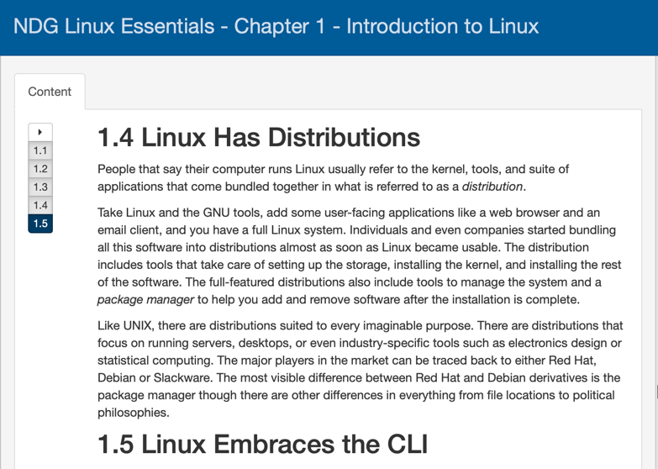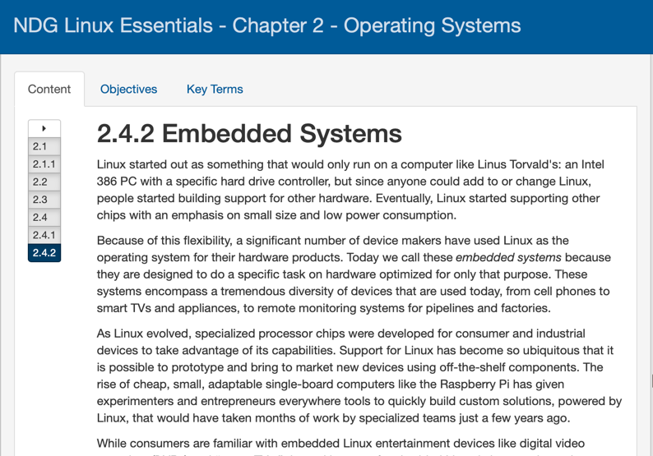

1. Пройдіть тестування у курсі NDG Linux Essentials за такими темами: Chapter 02 Exam.

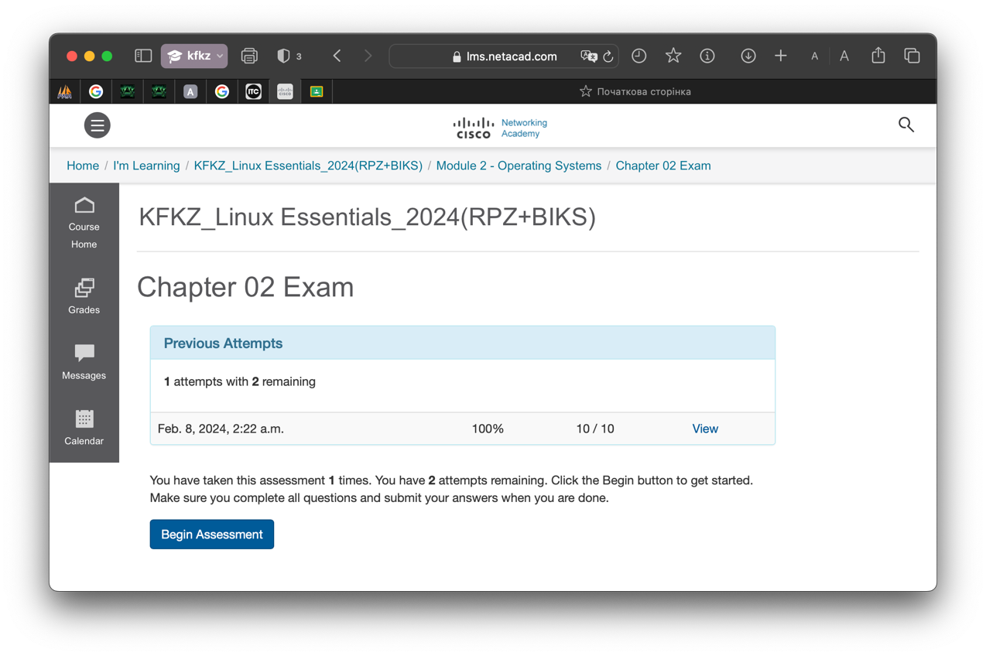

**Хід роботи.**

2. Після перегляду відео дайте відповіді на наступні питання:

2.1. Перерахуйте етапи для розгортання операційної системи на базі віртуальної машини VirtualBox.

* Open VirtualBox and click "New."
* Choose a descriptive name and select the type of OS you'll install (Linux).
* Allocate RAM based on your OS and available resources.
* Create a new virtual hard disk (VDI). Choose “Dynamically allocated” option. Add a disk storage size and click create. (at least 20 GB)
* Start the virtual machine.
* Click "Storage" and attach the downloaded OS ISO image.
* Boot the virtual machine from the ISO.
* Follow the on-screen instructions to install the operating system.

2.2. Чи є якісь апаратні обмеження при встановленні 32- та 64-бітних ОС?

*32-bit VM:* Limited to maximum memory allocation allowed by host (typically 4GB).

*64-bit VM:* Can be allocated more memory than the host's physical memory, but actual usable memory depends on host limitations.

VirtualBox can usually emulate various hardware features within the VM, so limitations are less common here. However, some older devices may not have drivers available for both 32-bit and 64-bit architectures, potentially limiting their function within the VM. To run 64-bit guests, your CPU must support hardware virtualization (such as Intel VT-x or AMD-V). Without this support, you won’t be able to install 64-bit operating systems in your VMs.

* 1. Які основні етапи при встановленні CentOS в текстовому режимі?

1. Timezone settings
2. Language settings
3. Software selection
4. Installation source
5. Network settings
6. Install Destination
7. Set root password
8. Create user
   1. Яким чином можна до установити графічні оболонки Gnome та KDE на CentOS, якщо вона вже встановлена в текстовому режимі (вкажіть необхідні команди та пакети)?

A group of packages: KDE Desktop , X Window System , Fonts , Desktop Platform.

* *Gnome command:* Check that the system is connected to the Internet and run (yum groupinstall "GNOME Desktop" "X Window System" "Fonts", "Dekstop Platform")
* *KDE command:* (yum groupinstall "KDE Desktop" "X Window System", "Fonts", "Dekstop Platform").

2.5. Дайте коротку характеристику графічних інтерфейсів, що використовуються в різних дистрибутивах Linux відповідно до свого варіанту (порядковий номер по журналу – 8 варіант Gnome та JWM).

*The GNOME* desktop environment has been a popular choice for many Linux users over the years. It’s popularity is due to the clean, minimalistic look.

* Target Audience: Designed for both beginners and experienced users.
* Appearance: Modern, polished, customizable themes.
* Resource Usage: More resource-intensive, suitable for modern computers.
* Package Management: Uses standard Linux package managers like apt or yum.
* Distros that include it by default are : Fedora, Ubuntu, Debian and OpenSUSE.
* Features: Efficient multitasking. Accessibility for people with disabilities. Active community of developers.

*JWM (Joe's Window Manager):*

* Target audience: Power users who appreciate the economical use of resources.
* Appearance: Simple, without unnecessary elements, with a focus on functionality.
* Resource usage: Extremely lightweight, works well on older computers.
* Package management: Often requires manual configuration or special scripts.
* Examples of distributions: AntiX, ArchBang, Void Linux.
* Features: Easy and fast work. Flexibility of customization. Low resource consumption

**Відповіді на контрольні запитання:**

1. Порівняйте гіпервізори типу 1 та типу 2, яка між ними відмінність та сфера їх застосування?

*Type 1 (Bare Metal):*

* Runs on: Underlying physical host machine hardware.
* Hardware access: Direct access to host system resources (CPU, memory, storage, I/O).
* Maximizes performance and security: Direct hardware access provides dedicated resources, leading to faster VMs and stronger isolation.
* Complex setup and management: Requires deep technical expertise for installation and configuration.
* Scope: Ideal for server virtualization, mission-critical environments, cloud infrastructures, high-performance computing.

*Type 2 (Hosted):*

* Runs on: Underlying operating system (host OS).
* Hardware access: Indirect access through the host OS, impacting performance.
* Easy setup and user-friendly: Runs as an application on the host OS, making it simple to install and manage.
* Lower performance and security: Shares resources with the host OS, impacting performance and potentially creating security vulnerabilities.
* Suitable for: Desktop virtualization, development and testing environments,smaller deployments.

1. Розкрийте поняття «GNU GPL», яка його основна концепція?

*The GNU General Public License (GNU GPL)* is a powerful free software license. The purpose of the GNU GPL is to grant the user the rights to copy, modify, and distribute the program and the obligation that users of all derivative programs will also receive these rights.

The concept of a *Copyleft license* is that the author of a copyrighted work gives up all rights to the work, but places one restriction on it: if you use it as the basis for your own work or distribute it in some way, you must also make the source code freely available. This doesn't stop you from selling the code, but it does mean that you have to show people the work you've done and the changes you've made to the original work. This provision is the basis of the GNU GPL license.

1. В чому суть програмного забезпечення з відкритим кодом?

The essence of *open source* software lies in its innovative approach to development, which fosters collaboration, transparency, and community-driven evolution. In simple terms, open source software refers to applications whose source code is accessible, modifiable, and distributable by anyone.

1. Що таке дистрибутив?

*Distribution* (Linux context): a specific package of software built on top of the Linux kernel. Includes the kernel, additional system tools, libraries, and desktop environments. Each distribution has its own software selection, user interface, and configuration options. Examples include Ubuntu, Debian, Fedora, Arch Linux, Mint, etc.

1. Які задачі системного адміністрування можна реалізувати на базі ОС Linux?

* Manage users and groups
* Manage packages and software
* Network configuration
* Disk and file system management
* Monitoring and troubleshooting
* Ensuring security
* Automation
* Server administration

1. Як пов'язані між собою ОС Android та Linux?

*Android* is a Linux distribution that provides a platform for mobile users, but lacks the traditional GNU/Linux packages that make it compatible with desktop Linux distributions. Android uses the Dalvik virtual machine with Linux, providing a robust platform for mobile devices such as phones and tablets. However, lacking the traditional packages that are often distributed with Linux (such as GNU and Xorg), Android is generally incompatible with desktop Linux distributions.

Common features:

* Linux kernel: Both operating systems are based on the Linux kernel, which provides basic functions such as memory management, device drivers, and security.
* Open source: Android and the Linux kernel rely heavily on open source development, allowing for customization and community contributions.

1. Основні можливості та сфера використання Embedded Linux?

*Embedded Linux* is an open-source, dedicated edition of the Linux operating system for devices that we use daily. Embedded Linux is not a single product but a set of tools, libraries, and frameworks that allow the developer to create their operating system for the target devices. This operating system is used to:

* Power IoT devices like fitness trackers, smart speakers, smart watches, and patient monitoring systems in healthcare.
* Control smart home applications like refrigerators, stoves, and microwaves.
* Introduce new features to smart TV’s functionality.
* Power infotainment systems in the automotive industry.
* Power tablets and smartphones, as many Android-based devices use embedded Linux systems as their primary OS.

1. Яким чином можна змінити типу завантаження Linux: в текстовому режимі (3 рівень) або графічному (рівень 5)? Чим відрізняються режими CLI та GUI?

*The procedure is as follows to change into a text mode runlevel under systemd:*

1. Open the terminal application.
2. For remote Linux servers, use the ssh command.
3. Find which target unit is used by default: **systemctl get-default**
4. To change boot target to the text mode: **sudo systemctl set-default multi-user.target**
5. Reboot the system using the reboot command: **sudo systemctl reboot**

*Command to launch the GUI from the multi-user.target:*

**sudo systemctl isolate graphical.target**

*Differences between CLI and GUI modes:*

|  |  |  |
| --- | --- | --- |
|  | Graphics User Interface | Command Line Interface |
| 1 | Сonsumes more memory and requires a mouse and keywords. | It takes up less memory and required only a keyboard. |
| 2 | The processing speed of the graphical user interface is slower than that of the command-line interface. | The processing speed of the command-line interface is much faster than that of the graphical user interface. |
| 3 | In Graphics User Interface we have graphics and menus which help us in managing all the functions. | In the command-line interface, we don’t have graphics and menus, so we have to write commands for each function we want to execute. |
| 4 | In graphics, user interface spelling mistakes and typing errors are avoided. | Spelling and typing errors are unavoidable in the command line interface. |
| 5 | Graphics User Interface is user-friendly and it is easy to work on the graphical user interface. | Command Line Interface is not user-friendly and more difficult to use than the Graphics User Interface. |

**Висновки:**

During the laboratory work, important aspects of the virtual machine environment and the Linux operating system were explored. In particular, different types of hypervisors and their role in operating system virtualization were considered. The process of deploying an operating system based on a VirtualBox virtual machine, including installing CentOS in text mode, was considered and described in more detail. Thus, this laboratory work allowed me to gain a deeper understanding of the functionality of virtual machines and Linux operating systems.