Contents

**I.** **Introduction** 2

**II.** **Use Cases /User Story** 2

**III.** **Domain Class** 3

IV. **Use Case Description and Workflow Diagram** 5

**V.** **Screen Layout** 6

**Ticket System Implementation**

# **Introduction**

A ticket System is software designed to organize and distribute customer support request. It is also known as an online ticketing system, a support ticketing system, or a ticket management system, which usually comes as a feature part of most help desk software solutions available on the market.

# **Use Cases /User Story**

|  |  |
| --- | --- |
| Use Case | Description |
| Create / Update / Delete Ticket information for bug | Create (new), Update (existing) or delete Ticket information. PA can create, Update and Delete. |
| Look up Ticket information | Using Ticket number or customer name or phone or priority status to lookup ticket information |
| Create /Update / Delete Ticket type information | Create (new), Update (existing) or delete Ticket type information. PM can only create Ticket type |
| Lookup Ticket type information | Using ticket type to lookup ticket type information |
| Resolve Ticket | Mark Ticket resolved only by RD |
| Create / Update /Delete customer information | Create (new), Update (existing) or delete customer information |
| Lookup customer information | Using customer name or phone to lookup customer information |
| Create / Update / Delete user information | Create (new), Update(existing) or delete user information |
| Create / Update/ Delete Role information | Create(new), Update (existing) or delete Role information. It’s user type such as QA, RD, PM |
| Look up Role information | Using user type to lookup Role information |
| Create /Update / Delete Page information | Create (new), Update (existing) or Delete Page information. The pages refer to the feature of the system such as customer, user, ticket and ticket type, role. |
| Lookup Page information | User page name to lookup page information |
| Create/Update/ Delete Role permission information | Create, Update(existing) or delete Role permission information. |
|  |  |

# **Domain Class**

|  |  |  |
| --- | --- | --- |
| **Object Classes** | **Attribute** | **Description** |
| User | Id, UserName, Password, FullName, RoleId, Status,AddBy,AddDate,UpdateBy,UpdateDate,DeleteBy,DeleteDate | User for user |
| Role | Id, RoleName, Description, AddBy,AddDate,UpdateBy,UpdateDate,DeleteBy,DeleteDate | User type information such as QA, RD, PM |
| Customer | Id, CustomerName,Sex,Address, Phone, Email, AddBy,AddDate,UpdateBy,UpdateDate,DeleteBy,DeleteDate |  |
| Ticket | Id,DateIssue,TicketTitle, Summary ,Description, Status, AddBy,AddDate,UpdateBy,UpdateDate,DeleteBy,DeleteDate, DesolveBy,DesolveDate | - Status (Dissolved, Pending, In progress)  - Summary and Description are required |
| TicketType | Id, TypeName, Description |  |
| Page | Id, PageName, Description |  |
| Permission | Id, PageId, RoleId, Add, Update, Delete, Dissolve, View |  |
|  |  |  |

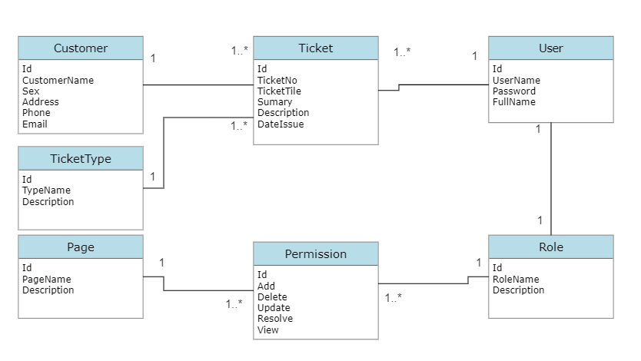

# **Use Case Description and Workflow Diagram**

# **Screen Layout**

