Exercises 40 mins (100 points)
- Create a function to print an equilateral triangle using (*) (5 points)

*
***
*****
*******
*********

#include <iostream>
using namespace std;

void printEquilateralTriangle(int n) {
for (int i = 0; i < n; i++) {

for (int j = 0; j < n - i - 1; j++) {
cout << " ";
}

for (int j = 0; j < 2 * i + 1; j++) {
cout << "*";
}
cout << endl; // Move to next line
}
}

int main() {
int rows = 5;
printEquilateralTriangle(rows);
return 0;
}

2.Write a function to sort an array using Bubble Sort [5, 3, 8, 1, 2] (5 points)

#include <iostream>
using namespace std;

void bubbleSort(int arr[], int n) {
for (int i = 0; i < n - 1; i++) {
for (int j = 0; j < n - i - 1; j++) {
if (arr[j] > arr[j + 1]) {

int temp = arr[j];
arr[j] = arr[j + 1];
arr[j + 1] = temp;
}
}
}
}

void printArray(int arr[], int n) {
for (int i = 0; i < n; i++)
cout << arr[i] << " ";
cout << endl;
}

int main() {
int arr[] = {5, 3, 8, 1, 2};
int n = sizeof(arr) / sizeof(arr[0]);

cout << "Original array: ";
printArray(arr, n);

bubbleSort(arr, n);

cout << "Sorted array: ";
printArray(arr, n);

return 0;
}

3. ​​Write a function to check whether a given number is a prime number (n) (5 points)

#include <iostream>
using namespace std;

bool isPrime(int n) {
if (n <= 1) {
return false;
}
for (int i = 2; i * i <= n; i++) {
if (n % i == 0) {
return false;
}
}
return true;
}

int main() {
int n;
cout << "Enter a number: ";
cin >> n;

if (isPrime(n)) {
cout << n << " is a prime number." << endl;
} else {
cout << n << " is not a prime number." << endl;
}

return 0;
}

4. ​​Write a function to find the maximum number and second maximum number in a List (5 points)
[5, 1, 8, 3, 8, 2]
#include <iostream>
#include <climits> // for INT_MIN
using namespace std;

void findMaxAndSecondMax(int arr[], int n, int &max1, int &max2) {
max1 = INT_MIN; // maximum
max2 = INT_MIN; // second maximum

for (int i = 0; i < n; i++) {
if (arr[i] > max1) {
max2 = max1;
max1 = arr[i];
} else if (arr[i] > max2 && arr[i] != max1) {
max2 = arr[i];
}
}
}

int main() {
int arr[] = {5, 1, 8, 3, 8, 2};
int n = sizeof(arr) / sizeof(arr[0]);
int max1, max2;

findMaxAndSecondMax(arr, n, max1, max2);

cout << "Maximum number: " << max1 << endl;
cout << "Second maximum number: " << max2 << endl;

return 0;
}

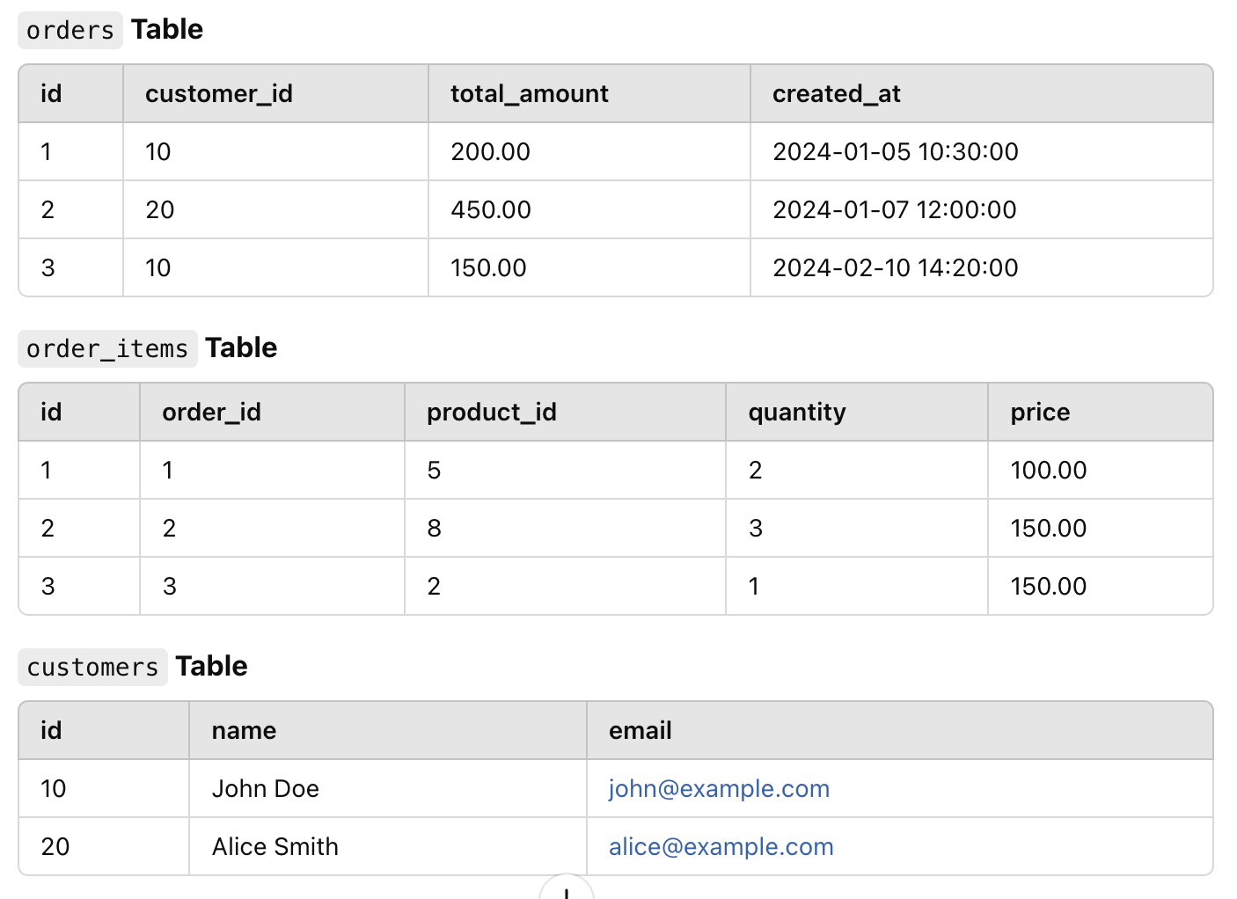
5. Database Optimization (10 points)

- Write an optimized SQL query to find the top 5 customers who spent the most in the last 6 months. (5 points)

SELECT
c.id AS customer_id,
c.name,
c.email,
SUM(o.total_amount) AS total_spent
FROM customers c
JOIN orders o ON c.id = o.customer_id
WHERE o.created_at >= DATE_SUB(CURDATE(), INTERVAL 6 MONTH)
GROUP BY c.id, c.name, c.email
ORDER BY total_spent DESC
LIMIT 5;

- Write an optimized SQL query to fetch orders with their items in a single query (avoiding the N+1 problem). (5 points)
SELECT
o.id AS order_id,
o.customer_id,
o.total_amount,
o.created_at,
oi.id AS order_item_id,
oi.product_id,
oi.quantity,
oi.price
FROM orders o
LEFT JOIN order_items oi ON o.id = oi.order_id
ORDER BY o.id;

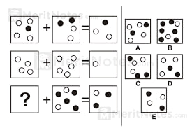
6. Please choose the correct answer for this logic below (20 points)

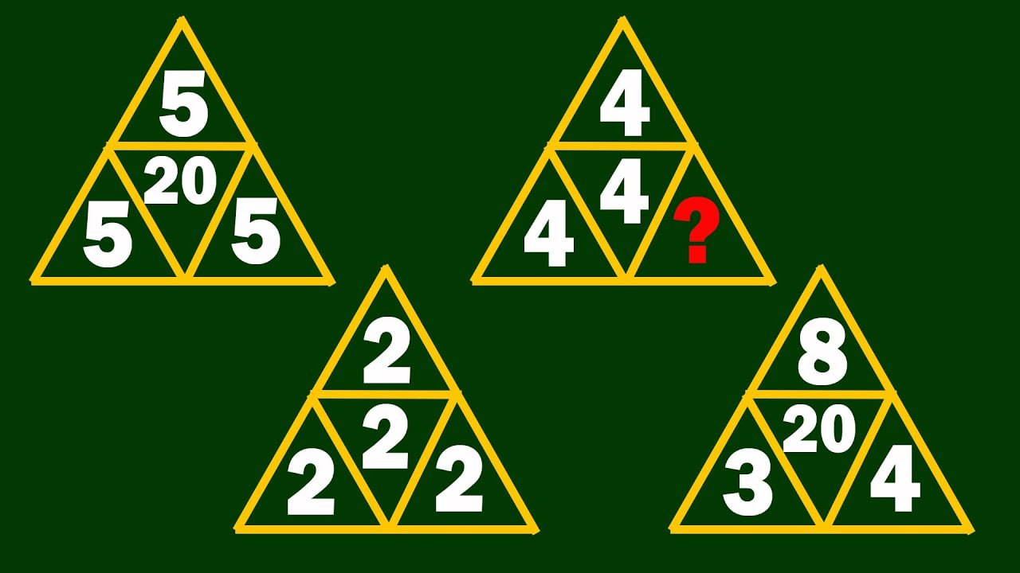

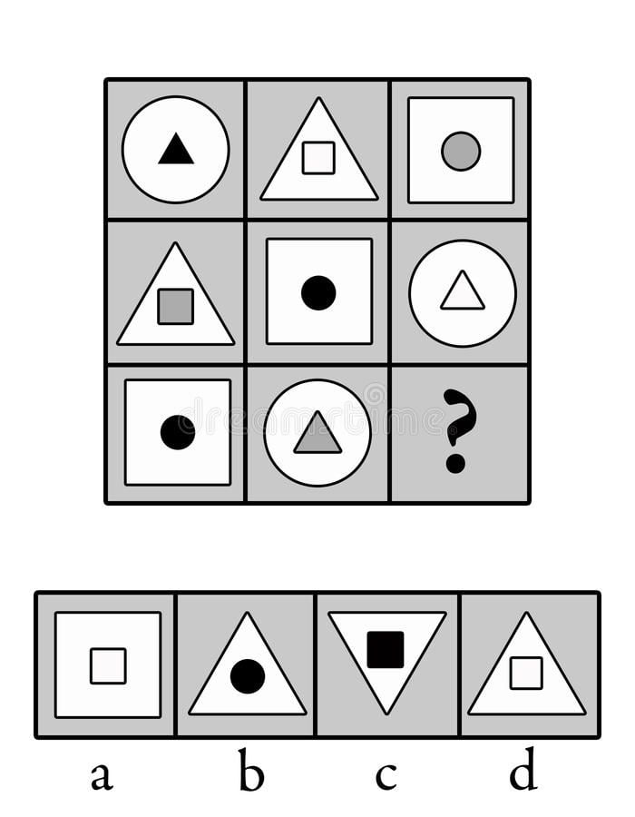
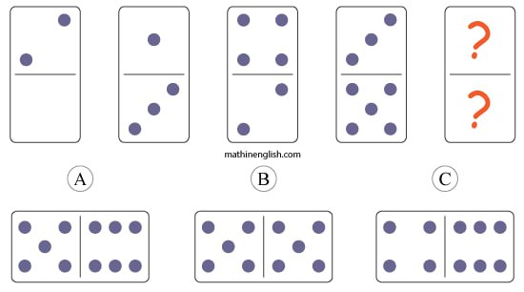
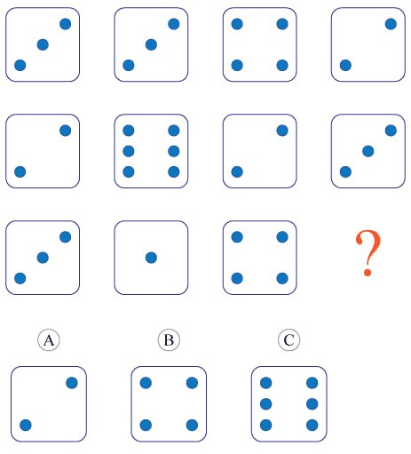
Answer= 12 answer= B

Answer= C Answer= B Answer= b

- Fill in (?) with a specific value as below (10 points)


- 13
- 14
- 15
- 16
- 17

Answer= B



- 3
- 4
- 5
- 6
- 7

Answer= D

8. Which HTTP header helps prevent Clickjacking attacks? (5 points)
  - Content-Security-Policy
  - X-Frame-Options
  - XSS-Protection
  - Strict-Transport-Security

Answer= b

9. Which HTTP status code is returned when a resource is successfully created? (5 points)
  - 200
  - 201
  - 204
  - 404
Answer= b
10. What is the primary security risk if user inputs are not sanitized in an SQL query? (5 points)
  - Cross-Site Scripting (XSS)
  - SQL Injection
  - Buffer Overflow
  - CSRF
Answer= b

11. Javascript (10 points)
Description:
- Write a function to count the working days of the provided year.
Provided holiday dates
- Half a day of Saturday
- Sunday
- 7 January
- 13,14,15 April
- 9 November

function countWorkingDays(year) {
const holidays = [
`${year}-01-07`,
`${year}-04-13`,
`${year}-04-14`,
`${year}-04-15`,
`${year}-11-09`
];

let workingDays = 0;

for (let month = 0; month < 12; month++) {
const daysInMonth = new Date(year, month + 1, 0).getDate();

for (let day = 1; day <= daysInMonth; day++) {
const date = new Date(year, month, day);
const dayOfWeek = date.getDay(); // 0 = Sunday, 6 = Saturday
const isoDate = date.toISOString().slice(0, 10);

if (holidays.includes(isoDate)) continue;
if (dayOfWeek === 0) continue; // Sunday
if (dayOfWeek === 6) workingDays += 0.5; // Saturday
else workingDays += 1; // Weekday
}
}

return workingDays;
}

12. MySQL (15 points)
Table: staffs
#id (PK)
name
sex (M or F)
date_of_birth
address
Phone

Table: positions
#id (PK)
staff_id
position
start_date
end_date (If this is the current position, the end_date value will be null)

1. Please set each field's data type and length in all the above tables’ fields. (5 points)

- Table: staffs
CREATE TABLE staffs (
id INT PRIMARY KEY,
name VARCHAR(100),
sex ENUM('M', 'F'),
date_of_birth DATE,
address TEXT,
phone VARCHAR(20)
);

- Table: positions
CREATE TABLE positions (
id INT PRIMARY KEY,
staff_id INT,
position VARCHAR(100),
start_date DATE,
end_date DATE,
FOREIGN KEY (staff_id) REFERENCES staffs(id)
);

2. Write a raw query to select data for the following list. (5 points)

| Staff ID | Name | Sex | Date of Birth | Address | Phone | Current Position |
SELECT
s.id AS 'Staff ID',
s.name AS 'Name',
s.sex AS 'Sex',
s.date_of_birth AS 'Date of Birth',
s.address AS 'Address',
s.phone AS 'Phone',
p.position AS 'Current Position'
FROM staffs s
JOIN positions p ON s.id = p.staff_id
WHERE p.end_date IS NULL;

3. Write a raw query to select staff who have worked more than 5 years. (5 points)

| Staff ID | Name | Sex | Date of Birth | Address | Phone | Current Position |
SELECT
s.id AS 'Staff ID',
s.name AS 'Name',
s.sex AS 'Sex',
s.date_of_birth AS 'Date of Birth',
s.address AS 'Address',
s.phone AS 'Phone',
p.position AS 'Current Position'
FROM staffs s
JOIN positions p ON s.id = p.staff_id
WHERE DATEDIFF(COALESCE(p.end_date, CURDATE()), p.start_date) > 365 * 5;

