|  |  |  |  |  |  |  |  |  |  |  |  |  |  |  |
| --- | --- | --- | --- | --- | --- | --- | --- | --- | --- | --- | --- | --- | --- | --- |
| |  |  | | --- | --- | | Mobile GIS Project  Report | | |  |  | | **Autoren**: |  | |  |  | | **Datum:** | 2.2.2019 | | **Version:** | 1.0 | |  |  |

# Concept

The app was designed to cover the perceived gap of a comprehensive online source for locations of Automatic Teller Machines (ATMs). As target customers we identified larger muncipalities, such as the City of Vienna, who would like to provide the location and additional information on ATMs to its residents. A city employee that is experienced in the usage of mobile GIS systems would then visit the locations and map the ATMs on site. An alternative strategy would be to make the app freely accessible and then build a ATM database with the help of voluntary contributers.

2. Describe your experiment (all steps from the design to the execution) and your findings***(50 points)***

## Planing:

We defined a route along which our test-ursers were asked to map all ATMs they could find. The route features seven ATM locations and the test users were required to find and save the corresponding information (Bank, number of ATMs, opening hours, etc.). We created a detailed info sheet for our test-users that describes their task in seven easy steps and includes a basic anonymous demographic questionnaire. It was decided to split our test users in two groups and provide each group with a different google-map layer in the background (satellite view and map view).

## The Test:

Before starting on the route the test-users were asked to complete a spatial abilities questionnaire and were given a short intro into the core functionality of our app. In order to come close to real life conditions non of the testers had previously seen the app. All tests were conducted at midday on the 16.1.2019 in clear conditions with temperatures around 6-8°C. We had seven participating test users, that were in turn provided with Nexus One mobil phones that featured the bankomat application.

## The Evaluation:

Task description, questionnaires and mapped sessions we’re collected and transferred into Excel sheets. For UEQ a pre-existing evaluation sheet by Dr. Martin Schrepp was used, the TLX and SBSOS were evaluated according to specifications of these tests and our task sheet along with completion time and errors was evaluated with the help of scatter plots.

***TLX Workload:***

The workload questionnaire by NASA asks the subjects to rate the workload in different

categories on a scale from 0 to 100 (in steps of 5). The categories can be weighted according to the needs of the study or a RawTLX can be conducted. The ratings are adjusted accordingly and the sum of the adjusted result is divided by 15 for the weighted rating

A screenshot of a cell phone

Description generated with very high confidence

Figure 1: TLX weighting and rating of Tester2 with a focus on temporal demand as opposed to mental demand.

TLX results:

|  |  |  |  |  |  |  |  |
| --- | --- | --- | --- | --- | --- | --- | --- |
| **subject** | Tester 1 | Tester 2 | Tester 3 | Tester 4 | Tester 5 | Tester 6 | Tester 7 |
| **weighted rating** | 27.667 | 44.333 | 0.667 | 29.667 | 22.667 | 33.667 | 29.500 |

SBSOS:

According to the specifications provided to us by the lecturer we decided to use three Questionnaires that were provided to us:

* Spatial abilities (Santa Barbara sense-of-direction scale (SBSOS))
* Workload (NASA Task Load Index)
* User Experience Questionnaire (UEQ)

The first two are designed to capture independent variables of the experiment, e.g.: the users proficiency in using a mobile GIS system, while

1. Describe your mobile GIS application functionalities and explain the reasons for your design and general choices ***(30 points)***

***1.*** Display a map and current location on map

a. You can use any map provider you prefer (e.g., Google Maps, OSM)

Bankomap uses Google Maps because of better integration within Andriod Studio.

**Hint:** *Take a look at the provided API reference and identify if the predefined functionality is good for you*

2. Display current location on map ***(15 points)***

3. Add manual location mapping functionality ***(20 points)***

a. The user should be able to start a mapping session

b. The user should be able to register a single location point and also log all possible meta data (e.g., number of satellites)

*Example: If you want to register all cafes in Vienna, you go at each of these places and map the location, e.g., by pressing a button.*

4. Add annotation functionality for each mapped point ***(20 points)***

a. The user should be able to describe each registered coordinate

*Example: café, restaurant, etc.*

5. Add session visualization functionality ***(15 points)***

a. The user should be able to see what is already mapped during a session

b. The user should be able to open and visualize on the map any previously mapped session

6. Add export session functionality ***(15 points)***

a. The user should be able to export the captured data

Evaluation: anmerkungen

- man hätte die Definition der Bankomaten besser angeben sollen, nur Sachen, die für die Geldausgabe da sind, sonst nicht

wird in Banken drinnen sehr schnell unübersichtlich

- die Definition des Öffnungszeiten hätte besser sein sollen, Bankomaten, die in einer Bank sind, können meist mit Bankomatkarte erreicht werden,

somit gibt es keine Öffnungszeiten

- Standpunktsgenauigkeit ist sehr abhängig von Handy, Verbesserung durch manuelle Änderung der Koordinaten

- Höhenangaben der GPS-Messungen sind sehr ungenau, variieren bis zu 67m!

- bei Bankomaten die einzeln draußen stehen oder in Geschäften stehen, waren die Angaben sehr einheitlich

- alle Bankomaten wurden von allen gefunden

Studie: Anmerkungen

-mehr Handys für schnelleren Ablauf

-Route war gut gewählt, viele ATMs und große Variation der Arten

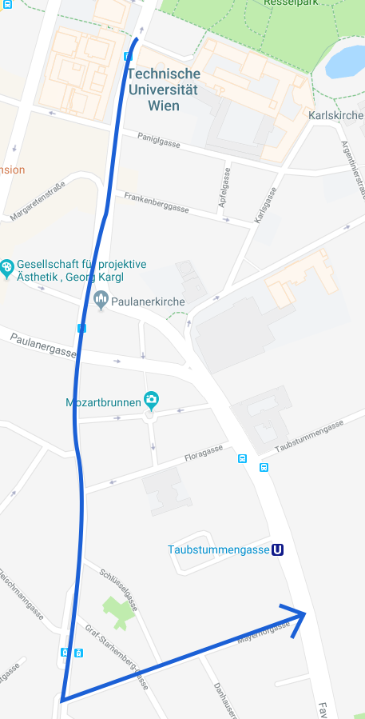**BankoMap - Experiment**

**General**

How old are you? _______________

Gender: □ Female □ Male

How experienced are you using a smartphone?

not □ □ □ □ □ □ □ very

Are you a geodesy-student? □ yes □ no

How experienced are you with Mobile GIS?

not □ □ □ □ □ □ □ very

**Task**

* Complete questionnaire on spatial abilities
* Map all automatic teller machines (ATMs) in the **test area** on both sides of the street, and store available information in the app (opening hours, number of ATMs, take a picture,…).
* ATMs, that are located outside of bank-building but are belonging to that bank, should be mapped together with the ones inside the building.
* The intersection at the start and at the finish are not part of the test area.
* Please complete the route at your normal walking pace.
* How easy is it for you to look up the latitude of an ATM?

easy □ □ □ □ □ □ □ hard

* Please fill out the questionnaires on workload and user experience.

**Test area:** Blue line in the map above (first walk down Wiedner Hauptstraße from Resselgasse to Mayerhofgasse, then turn left and follow Mayerhofgasse until Favoritenstraße)

**Thank you very much for your participation!**

**To be filled out by BankoMap-Team**

Time, date: ___________________________

Outside conditions: __________________________________________________________

Completion Time: ___________

Map-View: □ Map □ Satellite-image