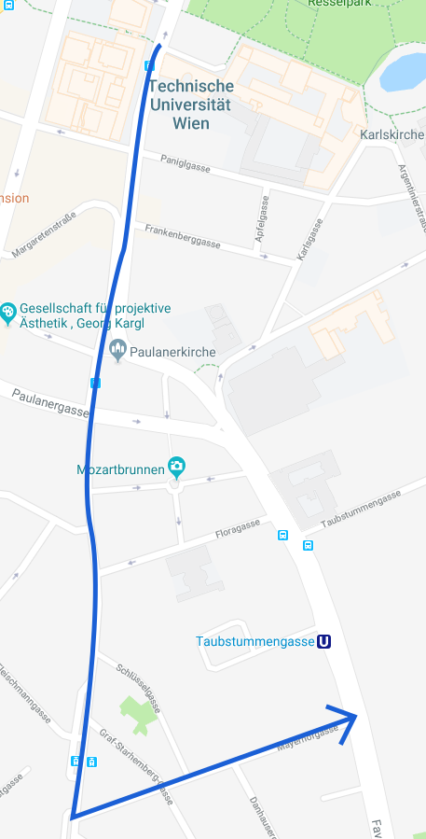
BankoMap - Experiment
General
How old are you? _______________
Gender: □ Female □ Male
How experienced are you using a smartphone?
not □ □ □ □ □ □ □ very
Are you a geodesy-student? □ yes □ no
How experienced are you with Mobile GIS?
not □ □ □ □ □ □ □ very
Task
- Complete questionnaire on spatial abilities
- Map all automatic teller machines (ATMs) in the test area on both sides of the street, and store available information in the app (opening hours, number of ATMs, take a picture,…).
- ATMs, that are located outside of bank-building but are belonging to that bank, should be mapped together with the ones inside the building.
- The intersection at the start and at the finish are not part of the test area.
- Please complete the route at your normal walking pace.
- How easy is it for you to look up the latitude of an ATM?
easy □ □ □ □ □ □ □ hard
- Please fill out the questionnaires on workload and user experience.

Test area: Blue line in the map above (first walk down Wiedner Hauptstraße from Resselgasse to Mayerhofgasse, then turn left and follow Mayerhofgasse until Favoritenstraße)
Thank you very much for your participation!

To be filled out by BankoMap-Team
Time, date: ___________________________
Outside conditions: __________________________________________________________
Completion Time: ___________
Map-View: □ Map □ Satellite-image

