SM5 PCIE SIGNAL DEBUGGER USER MANUAL

Preparations
Hardware
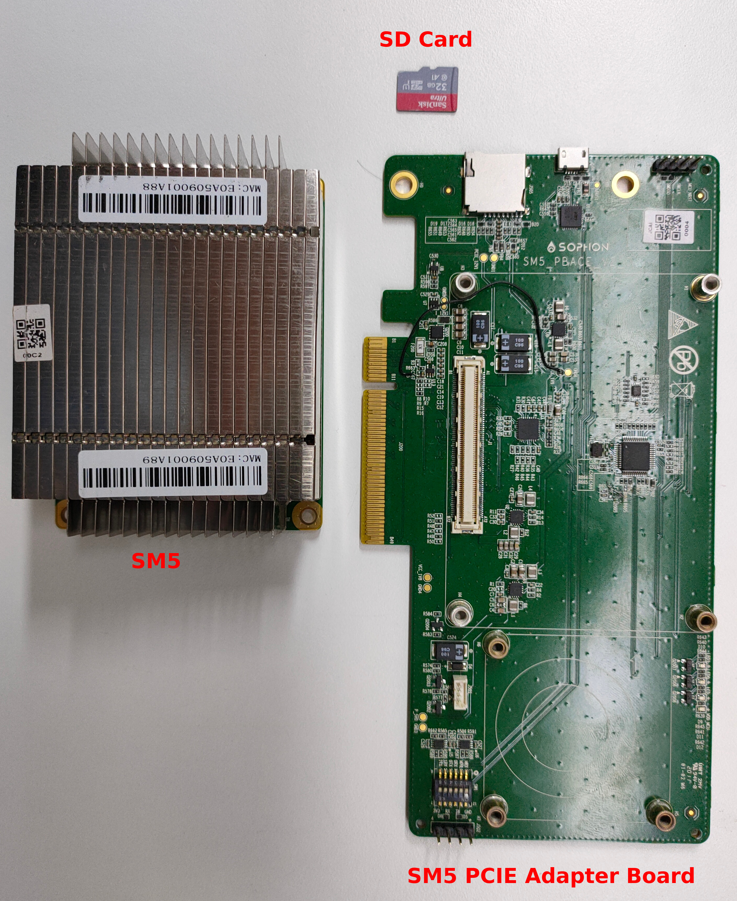
Software
- Linux based PC with root privilige
- PCIE signal debugger PC tools – pcie-signal-debugger
- Waveform viewer – gwave or gaw
You can install gwave though apt-get install on ubuntu.

sudo apt-get install gwave

gaw seems cannot be installed by package manager, but you can download source code from http://gaw.tuxfamily.org/
Either gwave or gaw is enough, you need not install both.

Warning:
Both pcie-signal-debugger and SM5 PCIE adapter board should format you SD card!
You will lose all data in your SD card!

SD Card Initialization
This step is optional, if an SD card is not format as expected. SM5 PCIE adapter will acquire signal as long as SD card can store.
You can special how long you want to acquire by adding some data on SD card. You can achieve it by pcie-signal-debugger tools.
- Connect SD card on PC
- Find device file of your SD card, here /dev/sdb as an example
- sudo pcie-signal-debugger -s -t 3600 /dev/sdb
It means acqure signal for 3600 seconds into SD card.
You just need initialize once for one SD card, unless you want to change the setting. Acquire time specified by pcie-signal-debugger tool is the max time adapter board will acquire. You can power off or remove SM5 PCIE adapter board on any time you want or you need. It will not damage signal data which has been stored into SD card. But remember, every time adapter powered on, it will store signal data from the beginning. SD card always saves data last time acquired. Any signal data previously acquired will loss.

Acquire Signal
Plugin SD card into SM5 PCIE adapter board. Plugin SM5 PCIE adapter to PCIE slot, you should see three user leds flick one after another even if PCIE 12V has no power supply. Now it acquiring signal.
Remove adapter board from PCIE slot at any time you want.

Export Acquired Signal Data
- Plugin SD card on PC
- sudo pcie-signal-debugger -o pcie-signal.w /dev/sdb
Export signal data in SD card /dev/sdb to file pcie-signal.w

View Signal On gaw
Open gaw. File-->Open-->All files-->Select pcie-signal.w
Drag signal you want to view to panel.
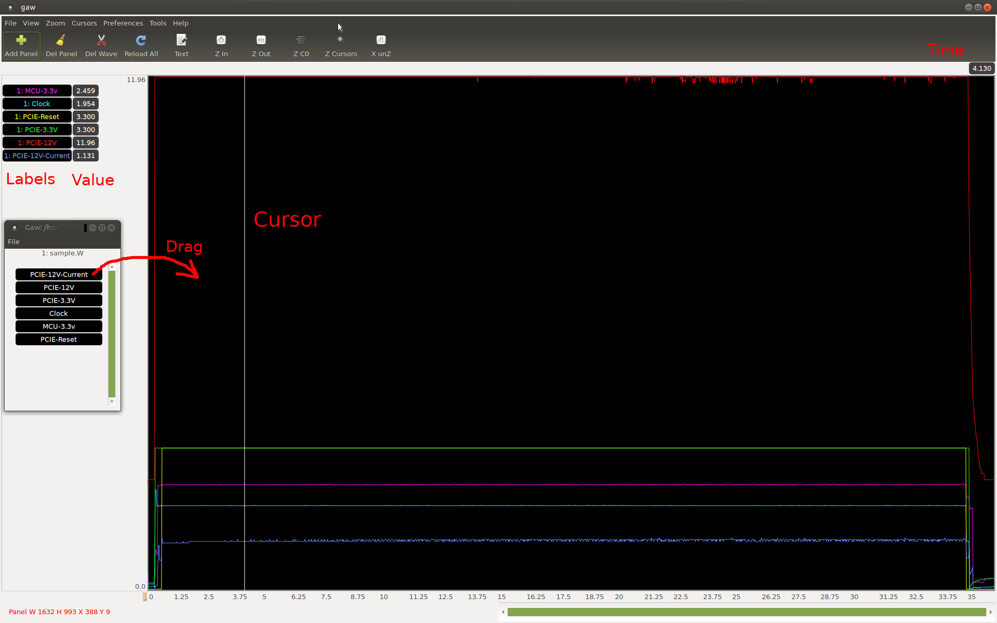
More about how to use
gaw: http://gaw.tuxfamily.org/
gwave: http://gwave.sourceforge.net/

Chao Wei
chao.wei@bitmain.com
2020-04-09

