1. **What are three conclusions we can make about Kickstarter campaigns given the provided data?**
2. The campaign number of the Kickstarter reached its peak in 2015. However with the campaign number increasing, the success rate got diluted.
3. If you’re thinking about fundraising in Kickstarter, the Music project is most likely to be successful, and the Journalism project is least likely to be successful.

Theater, Music and Technology are the Top 3 categories in Kickstarter, while Music, Theater and Film & Video are the Top 3 categories that have the highest success rate. Journalism is the smallest category and has zero success rate.

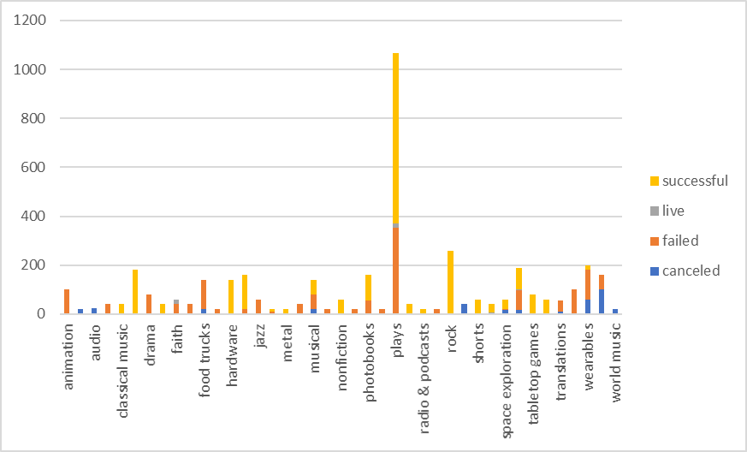

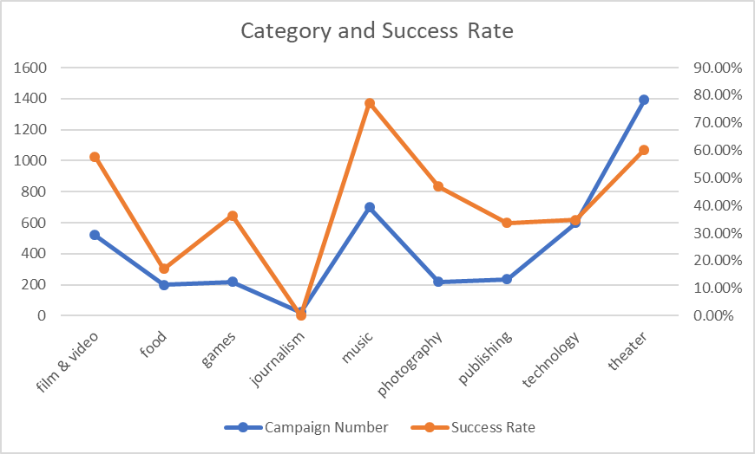

1. In Kickstarter, most campaigns are in the U.S. Therefore the U.S. campaigns dominate the trends in Kickstarter.

**2. What are some of the limitations of this dataset?**

A. The dataset can point out “what”, but not “why”. Here are some examples.

1. We can’t tell why the Journalism category is hard to succeed and why there are least Journalism campaigns.
2. In 2014, the campaign number increased almost 4 times. We can’t explain why.

B. The dataset is hard to see the quantitative relationship between two sets. For example, we need the regression analysis to see the relationship between campaign numbers and success rate.

**3. What are some other possible tables/graphs that we could create?**

A. Pie charts for donation to see what categories get the most funding.

B. Line charts to see the backer number change over months/years.

C. Line charts or bar charts to see the average donation over months/years.

D. Scatter charts to see the relation between backers and success rate, so that we can tell how active the community is.